Supplementary Table 1 Regularised partial correlation coefficients for different edges
 | RE1 | RE2 | RE3 | RE4 | RE5 | AV6 | AV7 | AV8 | AV9 | AV10 | AV11 | AV12 | HA13 | HA14 | HA15 | HA16 | HA17 | AZ | DZ
RE1 | 0.000
RE2 | 0.637 | 0.000
RE3 | 0.946 | 1.074 | 0.000
RE4 | 1.415 | 0.000 | 1.09477 | 0.000
RE5 | 0.000 | 1.089 | 0.548 | 0.000 | 0.000
AV6 | 0.000 | 0.136 | 0.000 | 0.952 | 0.487 | 0.000
AV7 | 0.526 | 0.163 | 0.679 | 0.198 | 0.080 | 2.719 | 0.000
AV8 | 0.000 | 0.000 | 0.000 | 0.000 | 0.356 | 0.602 | 0.531 | 0.000
AV9 | 0.146 | 0.000 | 0.000 | 0.000 | 0.504 | 0.218 | 0.000 | 0.400 | 0.000
AV10 | 0.231 | 0.000 | 0.000 | 0.000 | 0.000 | 0.000 | 0.444 | 0.000 | 1.803 | 0.000
AV11 | 0.000 | 0.000 | 0.173 | 0.000 | 0.000 | 0.000 | 0.301 | 0.133 | 0.757 | 1.406 | 0.000
AV12 | 0.000 | 0.290 | 0.000 | 0.000 | 0.502 | 0.000 | 0.559 | 0.413 | 0.000 | 0.669 | 1.350 | 0.000
HA13 | 0.175 | 0.158 | 0.000 | 0.220 | 0.097 | 0.434 | 0.000 | 0.000 | 0.505 | 0.000 | 0.8172 | 0.000 | 0.000
HA14 | 0.000 | 0.000 | 0.000 | 0.000 | 0.296 | 0.000 | 0.000 | 0.183 | 0.120 | 0.235 | 0.761 | 0.000 | 0.318 | 0.000
HA15 | 0.235 | 0.218 | 0.000 | 0.000 | 0.000 | 0.000 | 0.286 | 0.213 | 0.760 | 0.000 | 0.6632 | 0.000 | 0.67282 | 1.205 | 0.000
HA16 | 0.000 | 0.094 | 0.000 | 0.000 | 0.5904 | 0.000 | 0.395 | 0.000 | 0.160 | 0.000 | 0.19718 | 0.597 | 0.146 | 0.746 | 0.87746 | 0.000
HA17 | 0.000 | 0.000 | 0.000 | 0.270 | 0.26579 | 0.000 | 0.000 | 0.000 | 0.21619 | 0.145 | 0.000 | 0.000 | 0.551 | 0.582 | 0.2105 | 1.796 | 0.000
AZ | 0.000 | 0.000 | 0.35136 | 0.000 | 0.535 | 0.000 | 0.000 | 0.000 | 0.000 | 0.568 | 0.0514 | 0.000 | 0.473 | 0.000 | 0.29477 | 0.478 | 0.122 | 0.000
DZ | 0.000 | 0.375 | 0.000 | 0.000 | 0.000 | 0.000 | 0.000 | 0.000 | 0.548 | 0.401 | 0.000 | 0.742 | 0.000 | 0.000 | 0.19829 | 0.000 | 0.194 | 1.595 | 0.000

Supplementary table 2 Specific values for the centrality indicator
 | Betweenness | Closeness | Strength | ExpectedInfluence
RE1 | -1.062 | -1.572 | -0.707 | -0.707
RE2 | -0.585 | -0.359 | -0.781 | -0.781
RE3 | -0.226 | -0.794 | -0.168 | -0.168
RE4 | -0.585 | -1.061 | -0.863 | -0.863
RE5 | 1.207 | 1.228 | 0.302 | 0.302
AV6 | 0.849 | 0.428 | 0.495 | 0.495
AV7 | 1.804 | 0.973 | 1.789 | 1.789
AV8 | -1.062 | -1.584 | -2.143 | -2.143
AV9 | 0.013 | 0.768 | 1.067 | 1.067
AV10 | -0.226 | 0.771 | 0.838 | 0.838
AV11 | 0.61 | 0.912 | 1.525 | 1.525
AV12 | 1.924 | 2.107 | 0.081 | 0.081
HA13 | -0.823 | -0.09 | -0.458 | -0.458
HA14 | -1.062 | -1.009 | -0.578 | -0.578
HA15 | -0.226 | -0.195 | 0.772 | 0.772
HA16 | 1.446 | 0.661 | 1.007 | 1.007
HA17 | -0.943 | -0.578 | -0.667 | -0.667
AZ | -0.346 | -0.198 | -0.554 | -0.554
DZ | -0.704 | -0.409 | -0.957 | -0.957

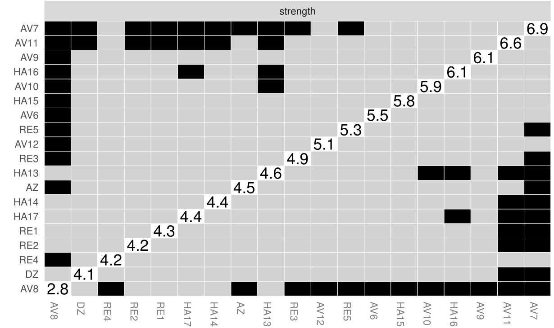
Supplementary Fig. 1 Bootstrapped difference test for node strength in network structure

