Supplementary document

From Demand to Circularity: Rethinking National Strategy on Automobile Battery Supply Chain for Sustainability

Yi Dou¹, Aya Heiho², Yasunori Kikuchi^{1,3,4}

¹ Institute for Future Initiatives, The University of Tokyo, 7-3-1 Hongo Bunkyo-ku, Tokyo 113-8654, Japan
² Faculty of Environmental Studies, Tokyo City University, 3-3-1 Ushikubo-Nishi, Tsuzuki-Ku, Yokohama, Kanagawa 224-8551 ,Japan
³ Presidential Endowed Chair for “Platinum Society”, Organization for Interdisciplinary Research Project, The University of Tokyo, 7-3-1 Hongo, Bunkyo-ku, Tokyo 113-8656, Japan
⁴ Department of Chemical System Engineering, The University of Tokyo, 7-3-1 Hongo, Bunkyo-ku, Tokyo 113-8654, Japan

CONTENTS

Acronyms and abbreviations 6
1. Model Overview 7
1.1 Goal and Scope 7
1.2 Model Framework 7
1.3 Indicator Selection 11
1.4 Overall Assumptions and Parameter Settings 12
2. Submodules and Intermediate Calculations 18
2.1 Passenger Car Ownership 18
2.2 Inflow, Outflow, and In-Use Stock in the Passenger Car Market 25
2.3 EV Penetration in the Passenger Car Market 31
2.4 Battery Chemistry 35
2.5 Collection and Secondary Use of Spent Batteries 39
2.6 Recycling of Spent Batteries 41
2.7 Tracking and Mandatory Collection of Batteries 42
3. Supplementary Information on Scenario Analysis 44
3.1 Material Flow and Circularity Changes by Elements 44
3.2 Detailed Results from Scenario Matrix for Policy Assessment 47
3.3 Additional Scenarios 52
3.4 Sensitivity Analysis 53
References: 55

FIGURES
Figure S1. Model framework and system boundary. 7
Figure S2. LIB supply chain policy options and scenarios setting. 9
Figure S3. Interconnections between influencing factors and linkage to the calculation flow. 10
Figure S4. Definition of inflow, outflow, open loop and closed loop. 11
Figure S5. Population of Japan (1990-2019) and its prediction (2020-2070). 17
Figure S6. The changes of the number of households and household size in Japan (1970-2019) and the projections (2020-2050). 18
Figure S7. The proportion of registered car-sharing users relative to the total population (2005-2024) and its projection (2025-2050). 18
Figure S8. Total actual length of paved roads in Japan (1990-2024) and its projection (2025-2050). 19
Figure S9. The density of densely inhabited district (DID) in Japan (1970-2024) and the assumption on future changes (2025-2050). 20
Figure S10. The ownership of passenger vehicles in Japan (1966-2024) and its projection (2025-2050). 21
Figure S11. The ownership of various vehicles in Japan (1966-2020). 22
Figure S12. Actual survival rate of passenger cars in Japan (2019) and its fitted curve by Weibull distribution. 23
Figure S13. Actual passenger car ownership (1993-2019) and the comparison to the calculation result backwards from 2019. 24
Figure S14. Estimated changes in vehicle age distribution of passenger cars in the past (adjusted with actual ownership) 24
Figure S15. Projection of changes in vehicle age distribution of passenger cars in the future 25
Figure S16. New passenger car registration and deregistration (1993-2019) and future projection (2020-2050) in Japan. 26
Figure S17. Export of new passenger cars from Japan to overseas (2017-2023) and its projection (2024-2050). 27
Figure S18. Export of used passenger cars from Japan (2017-2023) and its projection (2024-2050). 28
Figure S19. Market share of different types of passenger vehicles in new passenger cars sales market of Japan (2008-2022) and the projection (2023-2050). 29
Figure S20. Market share of new passenger car sales in Japan (2008-2024) and projection (2025-2050) 30
Figure S21. Changes of passenger car fleets in Japan (2008-2024) and the projection (2025-2050). 31
Figure S22. Shares of passenger cars exported from Japan (2017-2023) and the projection (2024-2050). 32
Figure S23. Overseas ownership BEV and PHEV passenger cars exported from Japan. 32
Figure S24. Market sharing of different LIB chemistry in annual new battery sales. 35
Figure S25. Final collection of spent automotive LIBs in scenarios 37
Figure S26. In-use capacity of automobile LIBs in scenarios 38
Figure S27. Used car export (2017-2023) and the projection (2024-2050) 41
Figure S28. Material flow changes of lithium in automobile LIBs 42
Figure S29. Material flow changes of cobalt in automobile LIBs 43
Figure S30. Material flow changes of nickel in automobile LIBs 44
Figure S31. Material flow changes of copper in automobile LIBs 45
Figure S32. Changes on circulation rate of critical minerals in automotive LIBs 46
Figure S33. Indicators comparison between integrated scenarios 47
Figure S34. Annual virgin material input of critical minerals in automotive LIBs in 2035 and 2050. 48
Figure S35. Reduction rates relative to the maximum annual virgin material input of critical minerals in automotive LIBs in 2035 and 2050. 48
Figure S36. Inflow circulation rate of critical minerals in automotive LIBs in 2035 and 2050. 49
Figure S37. Synergy effects of paired policies on the reduction rate of virgin material input of critical minerals in 2035 and 2050. 50
Figure S38. Synergy effects of paired policies on the circulation rate of virgin material input of critical minerals in 2035 and 2050. 51
Figure S39. Additional scenarios under NCX-oriented strategy. 52
Figure S40. Additional scenarios under secondary use of all spent LIBs. 53
Figure S41. Sensitivity analysis on virgin material input and inflow circulation rate. 55

TABLES
Table S1. Policy and measure options in LIB supply chain and parameter settings. 14
Table S2. Statistical data collected from the national statistics and reports. 15
Table S3. Parameter settings regarding the future socio-economic changes of Japan. 16
Table S4. Coefficients calibrated for estimating passenger car ownership 17
Table S5. A simplified table for calculating the survival ratio of passenger cars. 27
Table S6. Calculation of sales-weighted average capacity of BEVs and PHEVs. 34
Table S7. Sales-weighted average battery weight and critical minerals included. 34
Table S8. Lifetime parameter settings for LIBs. 37
Table S9. Policy options regarding secondary use of spent automotive LIBs 39
Table S10. Recycling progress under three assumed levels 40
Table S11. Parameter settings for tracing and mandatory collection 40
Table S12. Sensitivity analysis on virgin material input and inflow circulation rate. 54

Acronyms and abbreviations

EV | Electric vehicle
HEV | Hybrid electric vehicle
BEV | Battery electric vehicle
PHEV | Plug-in hybrid electric vehicle
ICEV | Internal-combustion engine vehicle
FCV | Fuel cell vehicle
CNF | Carbon neutral fuel
LIB | Lithium-ion battery
LFP | Lithium iron phosphate
NCA | Lithium Nickel Cobalt Aluminum Oxide
NMC | Lithium Nickel Manganese Cobalt Oxide
LMO | Lithium manganese oxide
Li-S | Lithium-sulfur battery
Li-Air | Lithium-air battery
MFA | Material flow analysis
DID | Densely inhabited district
IEA | International Energy Agency
JAMA | Japan Automobile Manufacturers Association

1. Model Overview

1.1 Goal and Scope
This document is a supplementary document for the manuscript “From Demand to Circularity: Rethinking Japan’s Automobile Battery Supply Chain for Sustainability”.

The goal of this study is to evaluate how supply chain interventions can accelerate the circularity of critical minerals such as Li, Ni, Co and Mn, in the context of the world and Japan’s rapidly electrifying transport sector. To this end, we develop a dynamic material flow analysis (MFA) model that integrates eight key influencing factors and eighteen targeted policy measures affecting various stages of the automotive lithium-ion battery (LIB) supply chain. The scope of the analysis includes both short-term (to 2035) and long-term (to 2050) time horizons, examining the individual and synergistic impacts of policies on resource conservation and material circularity. By simulating multiple policy scenarios, the study aims to inform integrated, stage-sensitive strategies that align resource security, circular economy goals, and decarbonization in national EV transition planning.

1.2 Model Framework
The model framework and system boundary are illustrated in Figure S1. We consider a closed-loop supply chain for automotive LIBs that can be directly managed within Japan or by the Japanese automobile industry. The supply chain encompasses the manufacturing and primary use of LIBs, followed by the collection, optional secondary use, recycling, and final waste management of spent LIBs. Although mining is excluded from the closed loop, Japan is assumed to import primary minerals when necessary. Outflows of recovered critical minerals to other industries are assumed to be restricted, while inflows of recovered minerals from external industries are considered outside the system boundary. The simulated vehicle fleet includes only passenger cars, excluding buses and trucks, as these may adopt hydrogen-based fuel cell technologies rather than battery-based systems in the future. EVs that are directly imported into Japan or exported from Japan are included within the supply chain under the control of Japanese manufacturers. However, used vehicles exported overseas are excluded from the model due to weak traceability. Accordingly, we define two types of material losses for critical minerals: “loss in recycling,” representing inefficiencies during recycling processes, and “loss in tracking,” representing losses associated with incomplete collection of spent LIBs and the export of used vehicles.

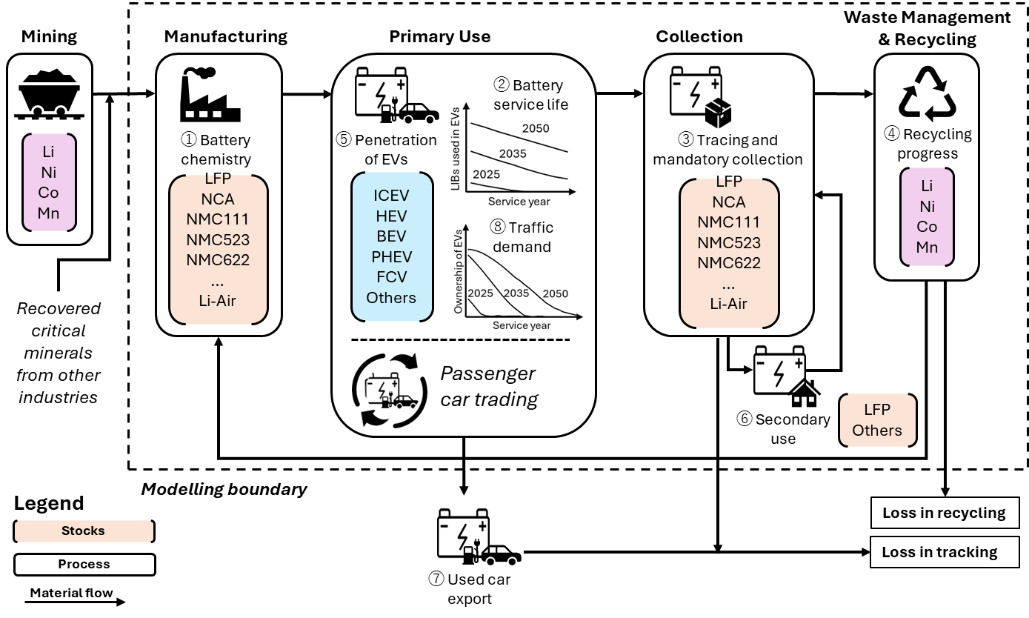
Figure S1. Model framework and system boundary.

In the model framework, critical minerals are initially input into battery manufacturing for the production of automotive lithium-ion batteries (LIBs). These newly manufactured LIBs are embedded in newly sold passenger cars, which are either used in the domestic market or exported overseas through vehicle trade. Once these batteries reach the guaranteed lifespan set by automotive manufacturers—or when the vehicles reach the end of their service life (i.e., registration cancellation)—spent LIBs are collected by dealerships or dismantlers. Following collection, depending on policy decisions, some spent LIBs are repurposed for secondary use in stationary energy storage, while others are directly sent for recycling to recover critical minerals for new LIB production. A proportion of deregistered passenger cars are exported abroad, and policy may determine whether their embedded LIBs should be removed and collected prior to export. Recovered critical minerals from the recycling process are then reintroduced into the manufacturing of new LIBs. As shown in Figure S1, the critical minerals considered in this study include lithium (Li), nickel (Ni), cobalt (Co), and manganese (Mn), in alignment with the majority of existing literature. The model accounts for a wide range of battery chemistries, including LFP, NCA, NMC111, NMC523, NMC622, NMC622–Graphite (Si), NMC811–Graphite (Si), NMC955–Graphite (Si), Li–Sulfur, and Li–Air, consistent with the projections in Xu et al.’s previous study on market shares of LIB chemistrie¹. Vehicle fleets in the simulation include internal combustion engine vehicles (ICEVs), hybrid electric vehicles (HEVs), battery electric vehicles (BEVs), plug-in hybrid electric vehicles (PHEVs), fuel cell vehicles (FCVs), and others, following the scenario settings defined by the Japan Automobile Manufacturers Association (JAMA)².

The integrated dynamic material flow simulator has the capacity to account for all policies and measures related to the LIB supply chain, automatically calculating annual changes in the proposed indicators to assess material flow dynamics. Not only does Japan, as an automobile-exporting country, have the ability to implement strategies for battery technology, recycling, and secondary usage and indirect factors such as traffic demand reduction, but it can also influence the overseas use of automotive LIBs through its sales networks, and international rule-making. Based on the defined system boundary of the automotive LIB supply chain, we identify eight key influencing factors, labeled ①–⑧ in Figure S1, where policies can be introduced to reshape the supply chain by controlling material quantities, altering composition, or redirecting flows. For each intervention point, we consider two to three policy options that could be implemented by government or industry, categorized by their level of ambition and intervention intensity (denoted as a, b, and c). These policy options are further classified into supplier-side and user-side interventions, as summarized in Figure S2(a). Supplier-side interventions include battery chemistry, battery service life, traceability & mandatory collection and recycling processes—factors primarily affecting supply management. In contrast, user-side interventions involve electric vehicle penetration, secondary use of batteries, used-car exports, and traffic demand management, which mainly relate to demand-side control.

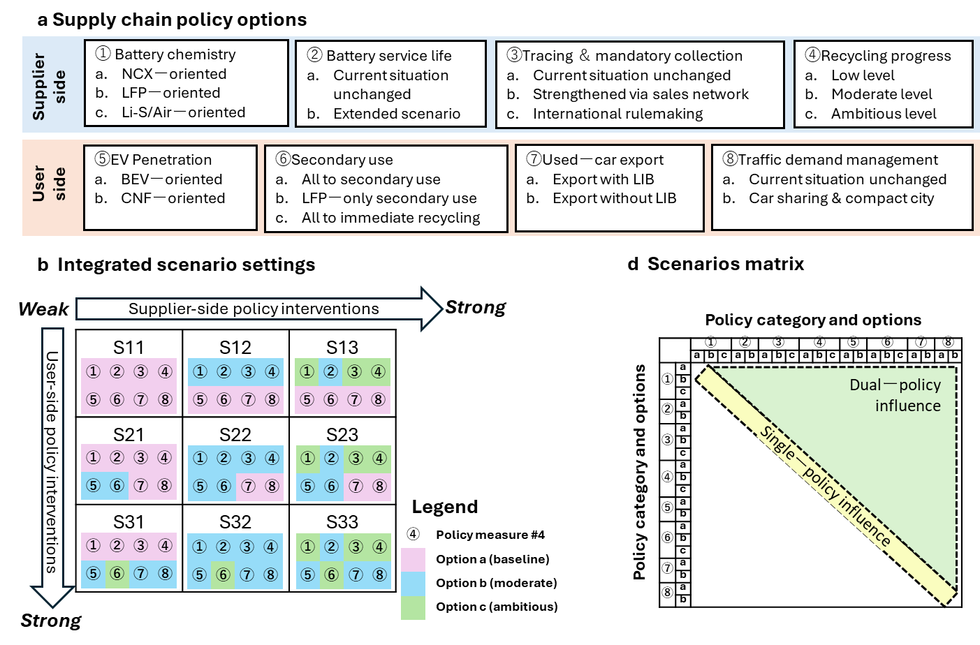
Figure S2. LIB supply chain policy options and scenarios setting.

Given that the twenty defined policy options can yield 1,296 possible combinations, we organize them into a more interpretable structure. As illustrated in Figure S2(b), we construct a two-dimensional matrix with supplier-side and user-side policy interventions as the two axes. Along each axis, policy parameters are adjusted according to intervention type and intensity. For instance, along the supplier-side axis, only interventions ①–④ are escalated from option a (baseline), to b (moderate), and c (ambitious). This design allows us to group the 1,296 policy combinations into nine representative scenarios, labeled S11 through S33. S11 represents minimal intervention on both axes, while intermediate scenarios (e.g., S12, S21, S22) reflect moderate interventions. Scenarios S23, S32, and S33 denote ambitious interventions, requiring greater commitment from both government and industry to meet more aggressive targets. Among them, S22 serves as a balanced reference case, with moderate interventions and corresponding stakeholder effort aimed at achieving moderate improvements in resource conservation and circularity. To further evaluate the impact of individual and paired policy interventions, we establish an additional scenario matrix, as shown in Figure S2(c), which includes all single-policy and dual-policy combinations. This enables us to identify key leverage points as well as potential synergies or trade-offs between policies.

Figure S3 illustrates the interconnections among policy options, parameter inputs, and key assumptions, as well as their linkage to the overall calculation flow.
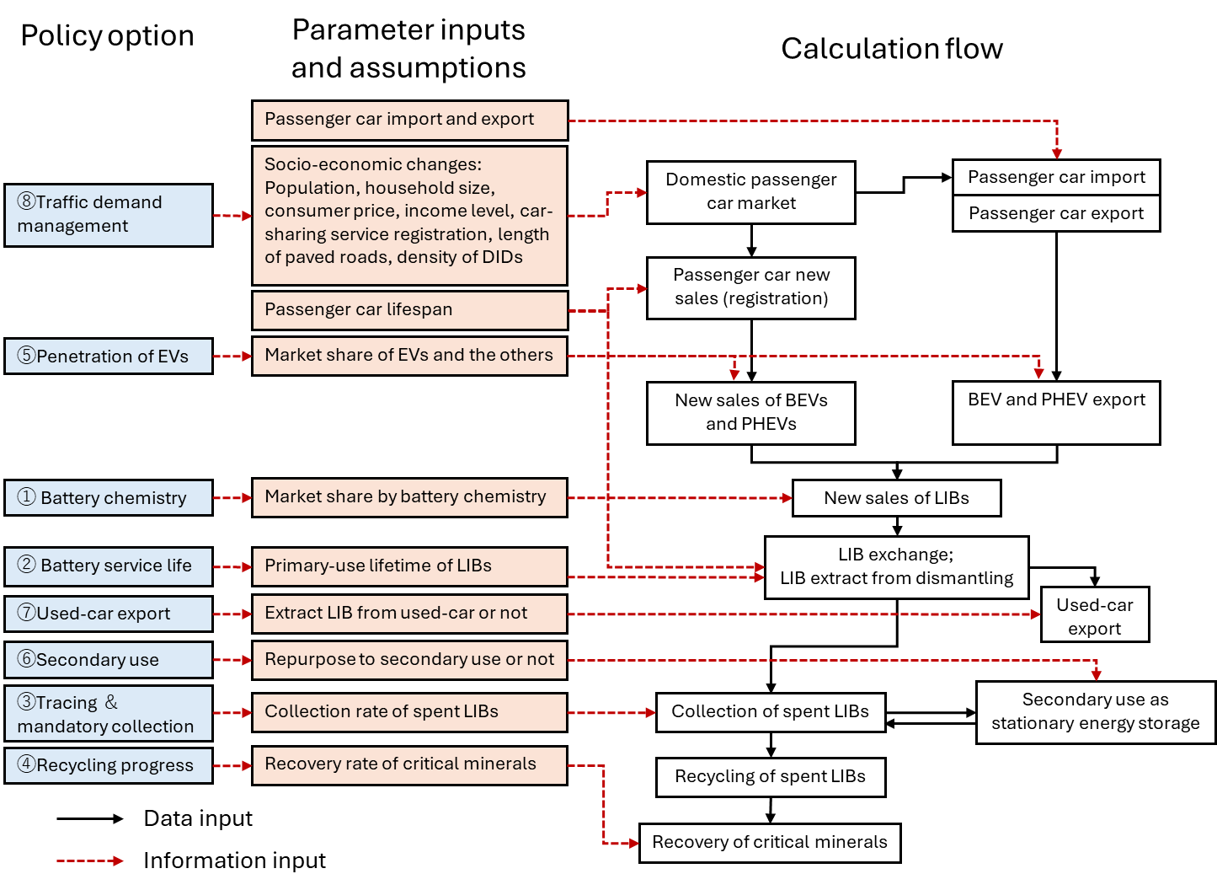
Figure S3. Interconnections between influencing factors and linkage to the calculation flow.

1.3 Indicator Selection
To evaluate the impact of policy interventions on the circularity of critical minerals, we employ three key indicators: cumulative input of virgin critical minerals, annual input of virgin critical minerals, and the circulation rate. The first indicator captures the total virgin material input from 2025 to the target year, reflecting long-term pressure on mineral extraction and international trade. The second indicator tracks annual virgin material demand, highlighting potential supply–demand mismatches and indicating how effectively recovered materials substitute primary inputs amid rapidly growing battery demand. The third indicator, the circulation rate, is assessed across three dimensions—inflow circulation, outflow circulation, and a weighted average circulation rate—following the framework proposed by the World Business Council for Sustainable Development³. Comparing shifts in these dimensions reveals how quickly and to what extent recycling of spent LIBs contributes to overall material circularity. An effective policy combination is expected to simultaneously increase circulation rates while reducing both cumulative and annual virgin material inputs. Together, these indicators offer a comprehensive lens to assess how supply chain interventions reshape the material flow of critical minerals in the automotive battery sector.

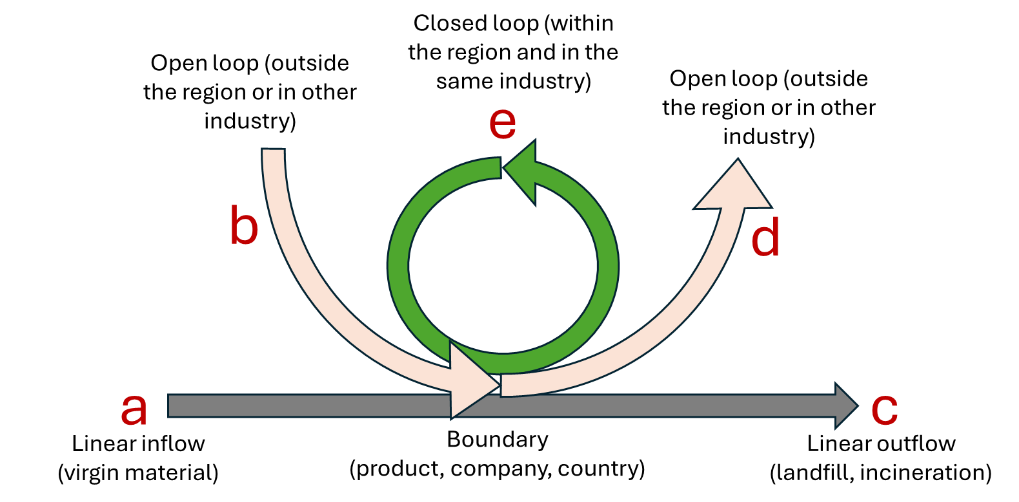
Figure S4. Definition of inflow, outflow, open loop and closed loop.

Three indicators are employed to assess the circularity of critical minerals in the supply chain. The inflow circulation rate denotes the proportion of recycled materials in the total input for battery production. The outflow circulation rate reflects the proportion of materials recovered through recycling relative to total waste outflows. The weighted average circulation rate represents a composite measure that integrates both inflow and outflow dimensions. These indicators are defined as follows:
Inflow circulation rate $R_{in}=\frac{e}{a+b+e}$ (Equation 1)
Outflow circulation rate $R_{out}=\frac{e}{c+d+e}$ (Equation 2)
Weighted average circulation rate $\overline{R}=\frac{R_{in}·(a+b+e)+R_{out}·(c+d+e)}{(a+b+e)+(c+d+e)}$ (Equation 3)
let $a$ represent the inflow of virgin raw materials, $b$ and $d$ denote open-loop recycling from and to other industries or countries, $c$ represent final disposal, and $e$ indicate closed-loop recycling within Japan’s automotive supply chain. Given the lack of clear data on cross-industry flows of recycled materials ($b$ and $d$), these are excluded from the calculation. As a result, the indicators focus exclusively on closed-loop dynamics within the automotive LIB supply chain.

1.4 Overall Assumptions and Parameter Settings
The integrated dynamic material flow simulator developed in this study relies on numerous adjustable parameters and assumptions, which inevitably introduce uncertainty regarding future developments.

First, although the global transition to EVs is broadly anticipated, consumer preferences and policy trajectories remain highly fluid, influencing adoption rates⁴. While Western countries are enforcing stringent recycling requirements within their regulatory frameworks, emerging economies such as Thailand are also advancing toward domestic EV production mandates⁵. The future competitiveness of Japanese EVs and battery technologies further compounds the uncertainty surrounding Japan’s domestic market and export potential. We assume that Japan can keep his advantages in automobile industry during the transition to EVs.

Second, ongoing innovations in battery technology are likely to yield a wider array of chemistries and usage scenarios, shaped by factors such as energy density, cost, safety, and integration with power grids⁶. These developments may exceed current projections, leading to highly variable adoption patterns for both EVs and battery chemistries. We follow the projection of domestic car market sharing by JAMA², the projection of world car market sharing by International Energy Agency (IEA)⁷, and the projection of battery chemistry sharing changes provided by Xu et al¹. These projections adopted in the dynamic MFA model can be revised anytime before operating.

Third, the actual service life of EVs remains uncertain. For instance, recent studies indicate that EVs in China have significantly shorter lifespans than ICEVs⁸, while evidence from Great Britain suggests parity in longevity between EVs and ICEVs⁹. We assume all types of passenger cars have the same lifespan referred to the age distribution in 2019 and remain the same from then on.

Fourth, market trends increasingly favor higher-capacity batteries to support longer travel distances and heavy-duty transport. Advances in technologies such as all-solid-state batteries—which promise higher voltage and energy density—may mitigate the resulting increase in critical mineral demand¹⁰. Thus, we assume a fixed battery capacity per vehicle and remain the same during the EV transition.

This study also incorporates several assumptions in modeling material flow allocation. On the one hand, it is assumed that spent LIBs used in secondary usage remain fully within the automotive supply chain and are 100% collected after retirement. However, losses are acknowledged at the stages involving dismantlers and used-car exporters, due to insufficient regulation and legal enforcement. On the other hand, the model assumes no capacity constraints in the secondary-use market, whereby all collected spent LIBs can be repurposed for stationary energy storage worldwide. Additionally, battery refurbishment is included as a strategy to extend service life. For simplification, all primary-use stationary energy storage systems are assumed to utilize only LFP batteries. More detailed assumptions can be found in the following descriptions of submodules.

The eight influencing factors, twenty policy options, and key parameter settings are summarized in Table S1. Further details are provided in the following sections.

Table S1. Policy and measure options in LIB supply chain and parameter settings.
Factors | Policy and measure options | Descriptions
①Battery chemistry | a. NCX-oriented | NMC batteries are dominant in the automobile market.
①Battery chemistry | b. LFP-oriented | LFP batteries are dominant in the automobile market.
①Battery chemistry | c. Li-S/Air-oriented | Li-S/Air batteries are dominant in the automobile market.
②Battery service life | a. Current situation unchanged | The guarantee periods of LIBs for BEVs, PHEVs and stationary energy storage are set to be 7, 8, and 10 years, respectively¹¹.
②Battery service life | b. Extended situation | The guarantee periods set above are extended to 11, 12, and 15 years, respectively (average during 2025-2050)¹².
③Tracing and mandatory collection | a. Current situation unchanged | 75% of spent LIBs in domestic and 10% in overseas are collected by closed loop¹³.
③Tracing and mandatory collection | b. Strengthened by sales network | 95% of spent LIBs in domestic and 40% in overseas are collected by closed loop.
③Tracing and mandatory collection | c. Strengthened by international rule-making | 95% of spent LIBs in domestic and 90% in overseas are collected by closed loop.
④Recycling progress | a. Low level | LFP batteries are not recycled; the recycling rate for Li is 50%, and it for Ni, Co, and Mn reaches 90%¹⁴.
④Recycling progress | b. Moderate level | LFP batteries are recycled; the recycling rate for Li, Ni, Co, and Mn reaches 90%.
④Recycling progress | c. Ambitious level | LFP batteries are recycled; the recycling rate for Li, Ni, Co, and Mn reaches 99%.
⑤Penetration of EVs | a. BEV-oriented | ICEVs quit the domestic new sales market by 2035, while BEVs dominate the market by 2050. Overseas market share changes are referred to as the prediction by IEA⁷.
⑤Penetration of EVs | b. CNF-oriented | ICEVs quit the domestic new sales market by 2035, while BEVs and PHEVs divide the market equally by 2050. Overseas market share changes are referred to as the prediction by IEA⁷.
⑥Secondary use | a. All for secondary use | All spent LIBs are accepted for stationary energy storage and used worldwide.
⑥Secondary use | b. LFPs for secondary use | The capacity required for domestic stationary energy storage is limited so that excessive spent LIBs have to be immediately recycled. The capacity limit in Japan is assumed to be proportional to the world tendency referred to IRENA¹⁵.
⑥Secondary use | c. All for immediate recycling | All spent LIBs are immediately recycled. Instead, the required capacity for stationary energy storage is covered by new LFP batteries. The substitution ratio of spent LIBs to new LIBs is set as 80% (SoH=80%).
⑦Used-car export | a. Export with LIB | LIBs are exported with used cars as usual.
⑦Used-car export | b. Export without LIB | LIBs are regulated not to be exported with used cars.
⑧Traffic demand management | a. Current situation unchanged | No reduction in road infrastructure or promotion of car-sharing domestically.
⑧Traffic demand management | b. Car-sharing and compact city | Reducing road infrastructure due to depopulation and promoting car-sharing domestically.

Table S2 summarizes the statistical and estimated data from referenced sources that are used as model inputs for tracking historical changes and conducting trend analyses.

Table S2. Statistical data collected from the national statistics and reports.
Statistics | Period | Reference | Status
Ownership of passenger vehicles | 1966-2023 | Automobile Inspection & Registration Information Association ¹⁶ | Statistic value
Population; Number of households | 1990-2019 | National census of Japan ¹⁷ | Statistic value
Average household income | 2005‐2018 | Comprehensive Survey of Living Conditions ¹⁸ | Statistic value
Average purchase price of passenger vehicles | 2005-2023 | Current Survey of Production ¹⁹ | Statistic value
Number of car-sharing members | 2002‐2023 | Survey by Foundation for Promoting Personal Mobility and Ecological Transportation ²⁰ | Statistic value
Fleet composition of passenger vehicles | 2019.3 | Automobile Inspection & Registration Information Association ²¹ | Statistic value
Prospects of number of households | 2021-2050 | “Future prospection of number of households in Japan” by National Institute of Population and Social Security Research ²² | Estimated value
Prospects of population | 2021-2050 | “Future prospection of population in Japan” by National Institute of Population and Social Security Research ²³ | Estimated value
New passenger cars export | 2017-2023 | The statistics of trade²⁴ | Statistic value
Used-car export | 2017-2023 | The statistics of trade²⁴ | Statistic value

Table S3 summarizes the referenced sources used to estimate future socio-economic changes related to purchasing power in the domestic passenger car market.

Table S3. Parameter settings regarding the future socio-economic changes of Japan.
Socio-economic prospection | Period | Value | Reference | Status
Average purchase price of passenger vehicles | 2021-50 | - | Assume to follow the changes of CPI ²⁵ | Referential value
Annual increase of employees' income | 2021-30 | 1.6% | “Initiative of Future Society 2050” by Mitsubishi Research Institute ²⁵ | Referential value
Annual increase of employees' income | 2031-40 | 1% |  | Referential value
Annual increase of employees' income | 2041-50 | 0.9% |  | Referential value
Consumer Price Index | 2021-30 | 1.6% |  | Referential value
Consumer Price Index | 2031-40 | 1.7% |  | Referential value
Consumer Price Index | 2041-50 | 1.9% |  | Referential value

2. Submodules and Intermediate Calculations

2.1 Passenger Car Ownership
The passenger car fleet simulation is based on projections of car ownership and the survival curve of passenger cars. First, the ownership of passenger cars in domestic ($S$) is calculated as follows:
$S=\frac{N·γ·(1-η·δ)}{1+α·exp⁡(-β·\frac{\overline{I}}{\overline{P}})}$ (Equation 4)
where $N·γ·(1-η·δ)$ represents the potential passenger car market, which is negatively affected by the ratio of average annual household income $\overline{I}$ to average vehicle purchase price $\overline{P}$. $N$ is the number of households in Japan, $η$ is the car-sharing membership rate, and $δ$ is the reduction rate in car ownership due to car sharing. This equation is adapted from the study by Nakamura et al. ²⁸, with modifications to incorporate the substitution effect of car-sharing on passenger car ownership, based on findings from a report on the environmental load reduction due to car-sharing by the Foundation for Promoting Personal Mobility and Ecological Transportation²⁹. The parameter $γ$ is estimated as shown below:
$γ=ε_{1}·r^{ε_{2}}·{D_{DID}}^{-ε_{3}}$ (Equation 5)
where $r$ is the length of paved roads per capita and $D_{DID}$ is the population density of densely inhabited district (DID). The coefficients $α$, $β$, $ε_{1}$, $ε_{2}$ and $ε_{3}$ are parameters calibrated for the Japanese context, as summarized in Table S4.

Table S4. Coefficients calibrated for estimating passenger car ownership
Coefficients | $$α$$ | $$β$$ | $$ε_{1}$$ | $$ε_{2}$$ | $$ε_{3}$$ | $$δ$$
Value | 10.5 | 0.791 | 19900 | 0.299 | 0.487 | 62.2%

The estimation of future changes in the number of households in Japan from 2021 to 2050 is based on projections of total population and average household size published by the National Institute of Population and Social Security Research²³. The population forecast includes nine scenarios, combining three levels of birth rates and three levels of death rates (low, medium, and high). As shown in Figure S5, our simulation adopts the medium-birth-rate and medium-death-rate scenario, which lies between the highest and lowest projections, with a difference of approximately 5 million people by 2050. In this medium scenario, Japan’s population is projected to decline from 126.15 million in 2020 to 104.69 million in 2050.

Figure S5. Population of Japan (1990-2019) and its prediction (2020-2070).

As shown in Figure S6, the future trend in average household size in Japan mirrors the projected decline in total population, based on estimates from the same research institute mentioned above²². By 2019, the average household size had already declined to 2.27, and it is projected to decrease further to 1.92 by 2050. Consequently, the total number of households is expected to increase to nearly 60 million by 2030, before declining to 54.62 million by 2050.

Figure S6. The changes of the number of households and household size in Japan (1970-2019) and the projections (2020-2050).

As there is currently no authoritative projection for the future uptake of car-sharing services in Japan, we estimate future growth based on a polynomial approximation of the observed trend from 2005 to 2024, as shown in Figure S7. According to this approximation, the proportion of registered car-sharing users relative to the total population is projected to increase steadily, reaching approximately 20% by 2050.

Figure S7. The proportion of registered car-sharing users relative to the total population (2005-2024) and its projection (2025-2050).

The factors described above provide a baseline perspective on future socioeconomic changes in Japan. In addition, two further factors are considered to be policy-dependent, particularly through compact city planning, which may influence long-term passenger car ownership. In this context, compact city planning refers to the reconsolidation of populations from remote areas into regions along established public transit networks, thereby maintaining the population density of Densely Inhabited Districts (DIDs).

The first factor is the total actual length of paved roads in Japan, which increased from approximately 0.8 million km in 1990 to over 1 million km by 2024. In the baseline scenario—where urban form remains unchanged—it is assumed that this value has peaked in 2024 and will remain constant thereafter. In contrast, under a compact city planning scenario, the total paved road length is assumed to decrease proportionally with national depopulation, in order to maintain DID density. Given that highways and national roads account for approximately 20% of the paved road network, and local roads make up the remaining 80%, only the latter are assumed to decline in proportion to population reduction. The equation used to estimate the future total length of paved roads is defined as follows:
$r_{t}=r_{t0}·(0.2+0.8×\frac{{POP}_{t}}{{POP}_{t0}})$ (Equation 6)
where $r_{t}$ and$r_{t0}$ represent the total length of paved roads in the current year $t$ and base year $t0$, respectively, and ${POP}_{t}$ and ${POP}_{t0}$ denote the population in the current year $t$ and base year $t0$, respectively. The result is shown as Figure S8.

Figure S8. Total actual length of paved roads in Japan (1990-2024) and its projection (2025-2050).

Accordingly, the other factor—the population density of densely inhabited districts (DID)—is assumed to remain constant in the future under the compact city planning scenario. In contrast, if urban forms remain unchanged, the density is expected to decrease proportionally with Japan’s population decline. From 1970 to 2024, the DID density has already decreased from 8,690 to approximately 6,700 persons/km². Without compact city planning, this figure is projected to decline further to around 5,600 persons/km² by 2050. The scenario results are illustrated in Figure S9.

Figure S9. The density of densely inhabited district (DID) in Japan (1970-2024) and the assumption on future changes (2025-2050).

Taking all the factors mentioned above into account, future changes in passenger car ownership in Japan can be estimated, as illustrated in Figure S10. Historically, car ownership has shown an increasing trend from the 1960s to the 2020s, though the growth rate has gradually slowed. The projections indicate that ownership will peak in the 2020s and then begin to decline by 2050. In the business-as-usual scenario, the number of owned vehicles peaks at over 60 million in 2024 and is expected to decrease to approximately 53 million by 2050. However, with the promotion of car-sharing services and compact city planning, ownership could decline further to around 47 million vehicles.

Figure S10. The ownership of passenger vehicles in Japan (1966-2024) and its projection (2025-2050).

Can the passenger car market account for the majority of LIBs used in the domestic automotive industry? As shown in Figure S11, more than three-quarters of all vehicles are passenger cars, followed by cargo vehicles. Given the longer transport distances typically associated with cargo transport, hydrogen fuel remains a likely option for this sector. Therefore, it is reasonable to focus exclusively on the passenger car market in this simulation.

Figure S11. The ownership of various vehicles in Japan (1966-2020).

As of 2024, Japan remains the largest automobile exporter in the world. Therefore, our simulation includes the export of electric vehicles (EVs) from Japan, reflecting the Japanese automobile industry's ability to manage global supply chains through its extensive sales network. However, due to the lack of concrete evidence or reliable projections regarding the industry's future global performance, we assume that Japan will maintain its current level of passenger car exports. Accordingly, the material flow analysis (MFA) model estimates the annual export of new passenger cars without incorporating data on global market demand. In other words, for the domestic market, material flows are simulated based on in-use stock (passenger car ownership) and outflow (vehicles de-registered) to estimate inflow (new passenger car sales). In contrast, for the overseas market, the simulation uses inflow and outflow data to estimate in-use stock. Further methodological details are provided in the following section.

2.2 Inflow, Outflow, and In-Use Stock in the Passenger Car Market
As noted earlier, in the case of Japan's domestic passenger car market, the MFA approach estimates new passenger car sales based on in-use stock (passenger car ownership) and outflow (annual vehicle deregistrations). To project the number of vehicles deregistered from 2020 to 2050, we apply a survival rate curve based on a Weibull distribution, calibrated using historical data on vehicle survival rates by age from a 2019 report by the Automobile Inspection & Registration Information Association²¹. The equation of Weibull distribution is as follows:
$F\left(t\right)=1-⁡e^{-{(\frac{t}{})}^{m}}$ (Equation 7)
where $F\left(t\right)$ is the survival rate of a passenger car when it services $t$ years. Parameters $m$ and μ are calibrated as 1.93 and 16.02, respectively.

As illustrated in Figure S12, the estimated survival rate declines more rapidly for newer vehicles but more slowly for older ones. This reflects the general trend that newer cars tend to have longer lifespans than older models. While a more accurate approach would involve fitting separate Weibull distributions for vehicles manufactured in different years, such an approach requires extensive statistical data and computational effort. Although recent trends suggest that ICEVs and HEVs have increasingly longer lifespans, there remains considerable uncertainty regarding the longevity of BEVs, which current evidence suggests may have shorter lifespans. Given this uncertainty, we assume that all types of passenger cars follow the same Weibull distribution and that no further extension in lifespan occurs over time.

Figure S12. Actual survival rate of passenger cars in Japan (2019) and its fitted curve by Weibull distribution.

Since the dynamic MFA model requires information on historical passenger car fleets and their age distribution to estimate future deregistrations, we applied a Weibull distribution to retrodict the car fleet composition from 2019 back to 1993. However, this approach tends to slightly underestimate the total number of passenger cars compared to actual records (Figure S13), likely due to a higher proportion of older vehicles in the fleet during the early 2000s, particularly between 2000 and 2005.

Figure S13. Actual passenger car ownership (1993-2019) and the comparison to the calculation result backwards from 2019.

To align with the actual historical ownership of passenger cars, the estimated age distribution retrodicted from 2019 was proportionally adjusted so that the total number of passenger cars matches observed data. Figure S14 illustrates a portion of the estimated changes in vehicle age distribution over time.

Figure S14. Estimated changes in vehicle age distribution of passenger cars in the past (adjusted with actual ownership)

Accordingly, it is possible to project future changes in the age distribution of passenger cars, as shown in Figure S15. Notably, the ownership of new passenger cars declines more significantly under scenarios that promote car-sharing and compact city planning.

a. urban forms unchanged

b. car-sharing & compact city planning
Figure S15. Projection of changes in vehicle age distribution of passenger cars in the future

Regarding new car registrations and deregistrations in Japan’s domestic market (Figure S16), both metrics decrease substantially under these policy scenarios—by approximately one-tenth and one-seventh, respectively, by 2050—compared to a baseline scenario in which urban form remains unchanged.

a. urban forms unchanged

b. car-sharing & compact city planning
Figure S16. New passenger car registration and deregistration (1993-2019) and future projection (2020-2050) in Japan.

Table S5 is a simplified table for calculating survival ratio of passenger cars.

Table S5. A simplified table for calculating the survival ratio of passenger cars.
Years in service | 1 | 2 | 3 | 4 | 5 | 6 | 7 | 8 | 9 | 10
Survival ratio (%) | 98.75 | 98.23 | 96.58 | 92.93 | 91.57 | 89.16 | 88.40 | 83.59 | 80.77 | 77.55
Years in service | 11 | 12 | 13 | 14 | 15 | 16 | 17 | 18 | 19 | 20
Survival ratio (%) | 70.31 | 61.90 | 57.54 | 47.54 | 41.10 | 30.78 | 24.74 | 17.05 | 14.55 | 11.04
Years in service | 21 | 22 | 23 | 24 | 25 | 26 | 27 | 28 | 29
Survival ratio (%) | 9.05 | 7.17 | 6.19 | 5.22 | 4.56 | 4.28 | 3.61 | 3.66 | 2.93

Beyond the domestic passenger car market, Japan is also a leading exporter in the global automotive industry. Between 2017 and 2023, Japan exported an average of 3.82 million automobiles annually, according to trade statistics²⁴. As there is currently no concrete evidence or reliable projection regarding the future performance of Japan’s automobile industry in global markets, this study assumes a constant annual export volume of 3.82 million new passenger cars from 2025 to 2050 (Figure S17).

Figure S17. Export of new passenger cars from Japan to overseas (2017-2023) and its projection (2024-2050).

Since the focus of this simulation is on the penetration of electric vehicles (EVs), the model does not estimate the overall changes in global passenger car fleets related to Japan’s automobile exports. Section 2.3 presents projections specifically for changes in global EV fleets linked to Japan’s exports.

Furthermore, Japan is also a leading exporter of used passenger cars. Between 2017 and 2023, Japan exported approximately 1 million used passenger cars annually, with ICEVs and HEVs comprising the majority, according to trade statistics²⁴. Due to the lack of concrete evidence or reliable projections regarding the future competitiveness of Japanese used cars, the export volume of used cars is assumed to remain a fixed proportion—25%—of annual passenger car deregistrations, based on the average during 2017–2023.

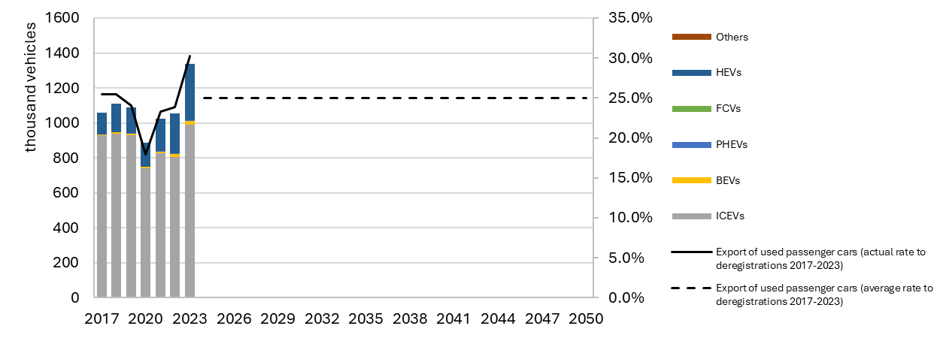
Figure S18. Export of used passenger cars from Japan (2017-2023) and its projection (2024-2050).

2.3 EV Penetration in the Passenger Car Market
Regarding the penetration of EVs in the domestic passenger car market, our assumptions are based on two key policy declarations by the Japanese government. First, both the government and major automobile associations have set ambitious targets to end the sale of ICEVs domestically by the early 2030s. Second, the transport sector is expected to achieve full decarbonization by 2050, in line with the carbon-neutral pledge announced by Prime Minister Suga in 2020²⁶. This implies that ICEVs should exit the domestic passenger car market by 2035, while HEVs—which still rely primarily on fossil fuels—should also be phased out before 2050. Given the current limitations of FCVs, including high purchase costs and insufficient infrastructure, BEVs and PHEVs are anticipated to dominate the new car market by 2050. However, a strategic juncture arises regarding the relative share of BEVs versus PHEVs. Although BEVs powered by renewable electricity represent an ideal decarbonization pathway, they require substantial inputs of critical minerals. Alternatively, advancements in carbon-neutral biofuel technologies present an opportunity to increase the adoption of PHEVs, which could reduce reliance on mineral-intensive BEVs. This strategic divergence is reflected in scenario settings proposed by the JAMA², where PHEVs and BEVs may each account for approximately half of new car sales by 2050 if biofuels become widespread. Based on this context, we define two future scenarios to model decarbonization pathways in the transport sector: a BEV-oriented scenario and a CNF (carbon-neutral fuel)-oriented scenario, as illustrated in Figure S19.

a. BEV-oriented scenario

b. CNF-oriented scenario
Figure S19. Market share of different types of passenger vehicles in new passenger cars sales market of Japan (2008-2022) and the projection (2023-2050).

Accordingly, the projected new sales of different types of passenger cars in Japan are illustrated in Figure S20. In the BEV-oriented scenario, and without accounting for the impacts of car-sharing or compact city planning, BEVs are expected to dominate the new car market, reaching approximately 3.5 million units sold annually by 2050. In the CNF-oriented scenario, PHEVs are projected to account for half of the new car sales by 2050.

a. BEV-oriented scenario

b. CNF-oriented scenario
Figure S20. Market share of new passenger car sales in Japan (2008-2024) and projection (2025-2050)

Based on this information, the projected changes in the passenger car fleet are shown in Figure S21. In both the BEV-oriented and CNF-oriented scenarios, the share of ICEVs is expected to decline to nearly zero by 2050. However, HEVs will still account for approximately one-third of the fleet, which could pose a challenge to achieving full decarbonization if CNF and carbon capture, utilization, and storage (CCUS) technologies are not sufficiently implemented in the transport sector. In contrast, BEVs and PHEVs will make up around two-thirds of the fleet, while FCVs will account for the remaining 5%.

a. BEV-oriented scenario

b. CNF-oriented scenario
Figure S21. Changes of passenger car fleets in Japan (2008-2024) and the projection (2025-2050).

Regarding the export of passenger cars from Japan, the share of BEVs was only 0.2% in 2017 but increased significantly to 5.2% by 2023²⁴. According to the Global EV Outlook 2024 by the IEA, in the Announced Pledges Scenario, the sales share of BEVs and PHEVs is projected to reach approximately 48% by 2030 and 67% by 2035⁷. Based on this projection, we estimate the future market share of new passenger car sales globally and assume that Japan’s vehicle exports will follow this trend. The results are presented in Figure S22.

Figure S22. Shares of passenger cars exported from Japan (2017-2023) and the projection (2024-2050).

Following this trend, the number of BEVs and PHEVs exported from Japan and remaining in use is projected to increase to approximately 40 million vehicles by 2050, assuming that the “survival rate” of exported passenger cars is the same as that of domestic ones (Figure S23).

Figure S23. Overseas ownership BEV and PHEV passenger cars exported from Japan.

2.4 Battery Chemistry
Battery chemistry data used in the dynamic material flow analysis (MFA) model are primarily drawn from Xu et al.¹, which identifies ten LIB types: LFP, NCA, NMC111, NMC523, NMC622, NMC622-Graphite (Si), NMC811-Graphite (Si), NMC955-Graphite (Si), Li–Sulphur, and Li–Air. Unlike Xu et al., who differentiated EVs by size class (small, medium, large), this study does not disaggregate the passenger car fleet by vehicle size. Accordingly, battery-related coefficients were adapted to represent sales-weighted average values per vehicle. Using the market share and battery capacity data for different EV size classes reported by Xu et al., we derived the average battery capacity per BEV and PHEV, as shown in Table S6.

Table S6. Calculation of sales-weighted average capacity of BEVs and PHEVs.
BEVs | Sales market share | Required battery capacity (kWh) | Sales-weighted average capacity (kWh) | PHEVs | Sales market share | Required battery capacity (kWh) | Sales-weighted average capacity (kWh)
Small BEV | 19% | 33 | 72 | Small PHEV | 23% | 17 | 11
Mid-size BEV | 48% | 66 | 72 | Mid-size PHEV | 45% | 8 | 11
Large BEV | 34% | 100 | 72 | Large PHEV | 32% | 12 | 11

Accordingly, we adjusted the sales-weighted average battery weight and associated critical mineral content based on the market share of each EV size class. The results are summarized in Table S7. Overall, BEVs incorporate a greater quantity of critical minerals than PHEVs. Among battery chemistries, NMC-based batteries generally contain much more critical minerals than LFP, Li–Sulphur, or Li–Air batteries.

Table S7. Sales-weighted average battery weight and critical minerals included.
unit: kg
Pack level | LFP | NCA | NMC111 | NMC523 | NMC622 | NMC622-Graphite (Si) | NMC811-Graphite (Si) | NMC955-Graphite (Si) | Li-Sulphur | Li-Air
BEVs | 558.90 | 405.74 | 450.24 | 442.30 | 415.87 | 387.32 | 374.37 | 356.81 | 233.02 | 187.21
PHEVs | 138.42 | 92.36 | 101.04 | 99.45 | 93.55 | 88.88 | 86.75 | 83.95 | 47.30 | 38.64
BEVs
Li | 7.14 | 7.38 | 10.16 | 9.86 | 8.56 | 8.69 | 8.08 | 7.24 | 0.63 | 0.51
Ni | 0.00 | 47.72 | 24.99 | 36.35 | 37.74 | 38.52 | 47.72 | 47.99 | 0.00 | 0.00
Co | 0.00 | 8.98 | 25.09 | 14.60 | 12.63 | 12.89 | 5.99 | 2.82 | 0.00 | 0.00
Mn | 0.00 | 0.00 | 23.39 | 20.41 | 11.77 | 12.02 | 5.58 | 2.50 | 0.00 | 0.00
PHEVs
Li | 1.15 | 1.18 | 1.62 | 1.57 | 1.36 | 1.38 | 1.29 | 1.16 | 0.10 | 0.08
Ni | 0.00 | 7.58 | 3.97 | 5.77 | 5.99 | 6.11 | 7.57 | 7.62 | 0.00 | 0.00
Co | 0.00 | 1.43 | 3.98 | 2.32 | 2.01 | 2.05 | 0.95 | 0.45 | 0.00 | 0.00
Mn | 0.00 | 0.00 | 3.71 | 3.24 | 1.87 | 1.91 | 0.89 | 0.40 | 0.00 | 0.00

Regarding projections of the market share of LIB chemistries, Xu et al.¹ proposed three scenarios to simulate the future evolution of battery technology: (1) LFP-oriented scenario, in which LFP remains dominant in the long term due to its cost advantage and technological maturity; (2) NCX-oriented scenario, where NMC chemistries gradually become predominant owing to their relatively low cost and high energy density; and (3) Li–S/Air-oriented scenario, which assumes the rapid diffusion of lithium–sulfur and lithium–air batteries driven by their lower reliance on critical mineral resources. Among these, the NCX-oriented scenario is considered the most probable and is adopted as the baseline in this study. The other two scenarios are included as alternative strategies for reducing critical mineral demand in the battery industry (Figure S24). Transition from NCX-oriented strategy to LFP-oriented strategy is relatively easy because LFP is stable in performance and has been widely used in stationary energy storage due to high technology maturity, while transition to Li-S/Air-oriented strategy remains more difficulty due to low technology maturity but has great potential in reducing inputs of critical minerals.

a. NCX-oriented scenario

b. LFP-oriented scenario

c. Li-S/Air-oriented scenario
Figure S24. Market sharing of different LIB chemistry in annual new battery sales.

Regarding the lifetime of automotive LIBs, although a more precise estimation can be achieved using a Weibull distribution to reflect the decline in state of health (SOH) over time, in practice, manufacturers often specify a fixed warranty period for battery performance. LIBs are typically collected once they reach the end of this guaranteed service life. According to previous studies, including those by Xu et al.¹ and Zeng et al.¹¹, the primary-use lifetime of LIBs in EVs is commonly assumed to be 7–8 years, while their secondary-use lifespan in stationary energy storage applications is approximately 10 years. Looking ahead, technological advancements may enable LIB lifetimes to extend to roughly twice the current duration¹². Therefore, in the extended-lifetime scenario, we assume a 1.5-fold increase in average service life (Table S8).

Table S8. Lifetime parameter settings for LIBs.
LIB lifetime (years) | Guarantee lifetime | Expected lifetime
Primary use in BEVs | 7 | 11
Primary use in PHEVs | 8 | 12
Secondary use in stationary energy storage | 10 | 15

2.5 Collection and Secondary Use of Spent Batteries
Automotive LIBs are assumed to be collected either at the end of their guaranteed service life or upon vehicle deregistration. Depending on policy, a portion, all, or none of these batteries may subsequently be directed to secondary use in stationary energy storage systems. Figure S25 illustrates the projected changes in final collection volumes of spent automotive LIBs across different scenarios (note: values are expressed in pack weight). The results indicate that promoting secondary use significantly delays final collection by approximately 10 years, as observed in comparisons between scenarios S11 and S21/S31. Additionally, extending the lifetime of LIBs contributes notably to postponing final collection, as seen when comparing S11 with S12 and S13. Notably, recycling of LFP batteries presents a significant challenge: in scenarios S11, S21, and S31, LFP batteries are excluded from collection due to economic infeasibility. Only in scenario S32—where LFP collection is mandated and secondary use is limited—is a substantial recycling capacity for LFP required. Overall, the wide range of outcomes across scenarios highlights the substantial uncertainty surrounding the scale of investment needed for future LIB recycling infrastructure.

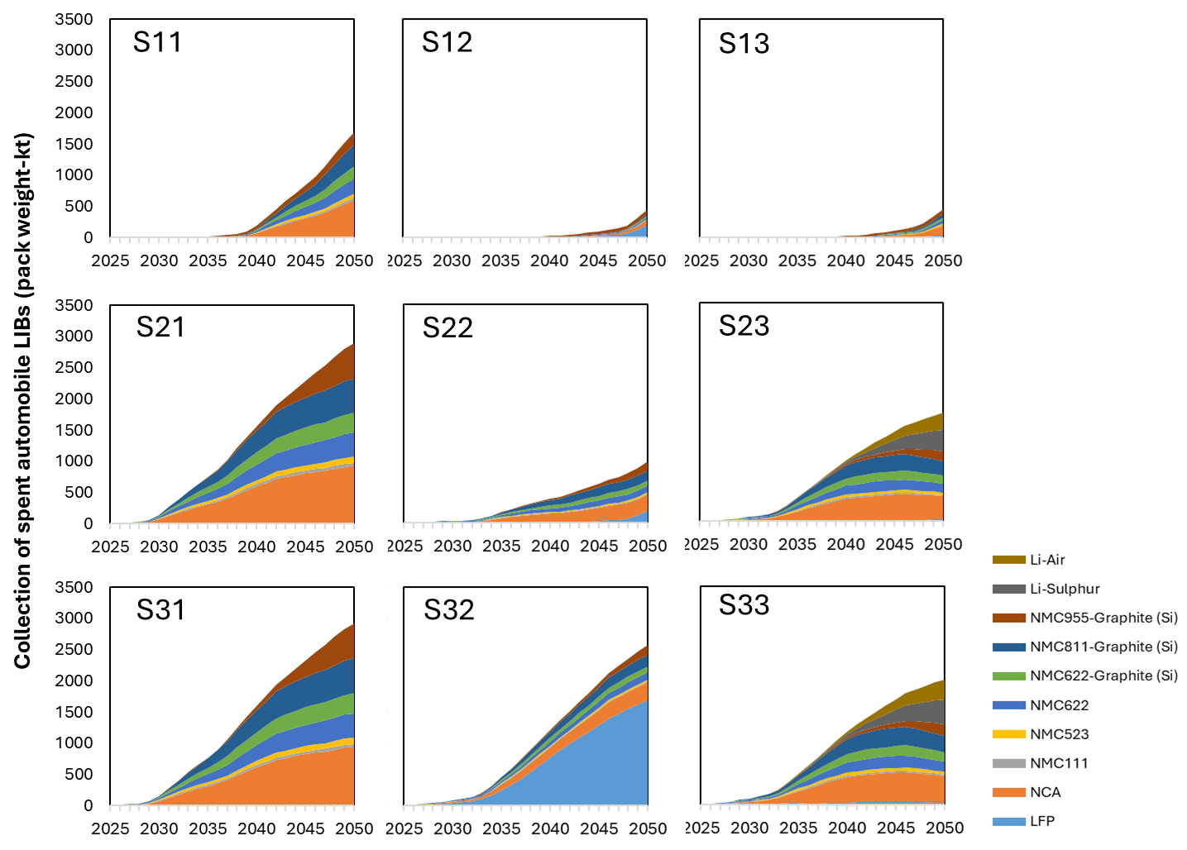
Figure S25. Final collection of spent automotive LIBs in scenarios

This study assumes no upper limit on the capacity for repurposing spent LIBs in stationary energy storage systems under scenarios promoting secondary use. However, in practice, the stationary energy storage market is likely to have finite capacity. According to projections by IRENA, the global market for stationary energy storage may be sufficient to absorb all spent LIBs originating from Japan, while the domestic Japanese market alone may not¹⁵. Figure S26 illustrates that the demand for secondary use capacity increases under two key conditions: (1) policy-driven promotion of secondary use across all LIB types (scenarios S11, S12, S13), and (2) widespread adoption of LFP batteries with corresponding diversion of spent LFP cells to secondary applications.

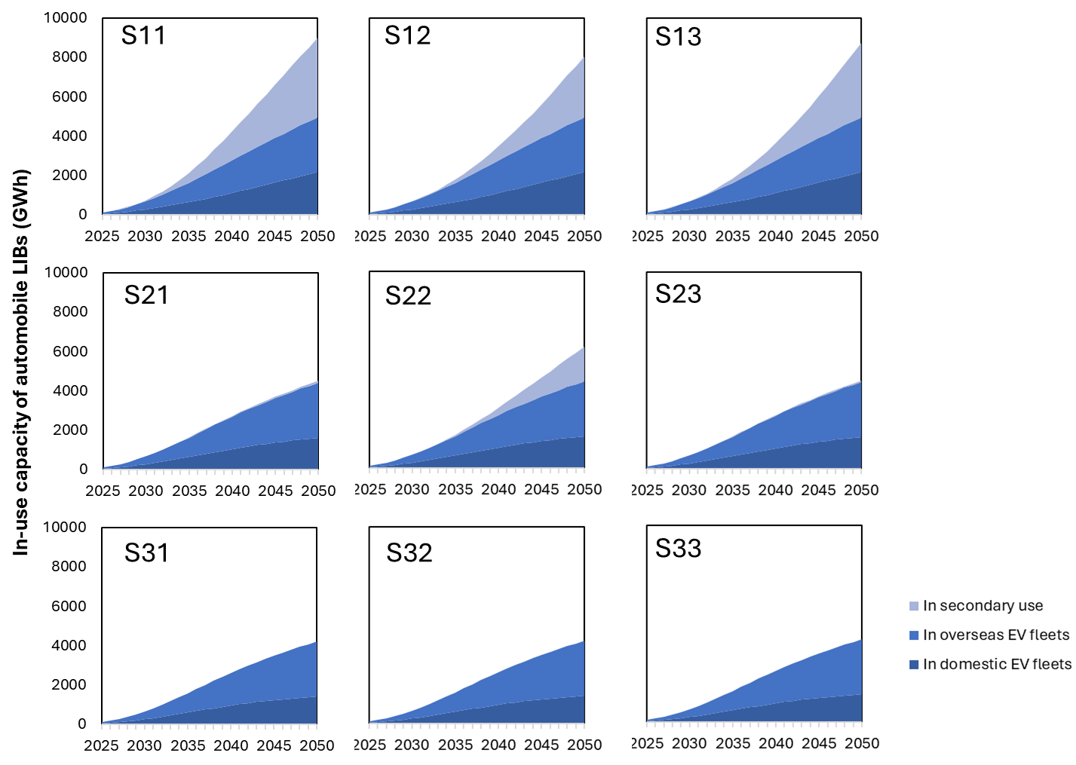
Figure S26. In-use capacity of automobile LIBs in scenarios

The policy options regarding secondary use are repeated in Table S9.

Table S9. Policy options regarding secondary use of spent automotive LIBs
Policy option  Battery type | ⑥a: all for secondary use | ⑥b: LFPs for secondary use | ⑥c: all for immediate recycling
Spent LFP batteries | ○ | ○ | ◊
Other spent batteries | ○ | ◊ | ◊
○: repurpose to secondary use, ◊: immediately recycle

2.6 Recycling of Spent Batteries
As a dynamic MFA of the entire LIB supply chain, this study does not model the technical selection or process optimization of specific recycling methods—such as hydrometallurgical, pyrometallurgical, or direct recycling techniques—but instead assumes three levels of critical mineral recovery rates. Here, the recovery rate refers to the proportion of critical minerals reclaimed from spent LIBs that can be directly reintroduced into new LIB production, fully substituting virgin material inputs. In theory, nearly all materials used in LIBs can be recycled to high purity through hydrometallurgical processes, provided there is no constraint on economic investment. However, in practice, the purity of recovered materials often limits their direct substitution for virgin inputs. For example, recycled materials may constitute 90% of the input blend, complemented by 10% virgin materials, to maintain 95% of the performance level of batteries made from entirely virgin inputs. As detailed in Table S10, under a low-recycling scenario, LFP batteries are not recovered due to their relatively low economic value, and lithium recovery is 50% recovered under a combined pyro- and hydrometallurgical treatment assumption. In a moderate scenario, increased investment enables the recycling of LFP batteries and improved lithium extraction. Under the ambitious scenario, all critical minerals are recovered at ultra-high rates, reflecting optimal technological effort and financial commitment.

Table S10. Recycling progress under three assumed levels
Policy option | ④a: low level | ④b: expected level | ④c: ambitious level
Recycle LFP batteries? | No | Yes | Yes
Recovery rate (Li) | 50% | 90% | 99%
Recovery rate (Ni, Co, and Mn) | 90% | 90% | 99%

2.7 Tracking and Mandatory Collection of Batteries
The collection rate of spent automotive LIBs is a pivotal factor influencing the material flow of critical minerals. According to a survey conducted by METI¹³, approximately 75% of spent automotive LIBs currently remain in Japan, where they are directed either to recycling or secondary use, while the remaining 25% are exported. Based on this, we assume an initial domestic collection rate of 75%, which could be further improved through enhanced traceability systems and mandatory collection policies. In contrast, the overseas collection rate—defined here as the proportion of spent LIBs exported in vehicles that are eventually returned to Japan through a closed-loop supply chain—is initially set at 10%. This low figure reflects the limited collection infrastructure in some importing regions, particularly ASEAN countries, which currently receive about 40% of Japan’s passenger car exports and generally lack robust end-of-life vehicle policies. Conversely, major importers such as the United States and European Union have made significant progress in developing local recycling systems for spent LIBs. If Japanese automotive manufacturers enhance battery traceability through their international sales networks, the overseas collection rate could increase to approximately 40%. Moreover, if international regulations are established that mandate producer responsibility for the collection and recycling of exported batteries, the overseas collection rate could potentially reach 90%. These scenarios are summarized in Table S11.

Table S11. Parameter settings for tracing and mandatory collection
Collection rate of spent LIBs | ③a: current situation unchanged | ③b: strengthened by sales network | ③c: international rulemaking
Domestic | 75% | 95% | 95%
Overseas | 10% | 40% | 90%

The export of used vehicles is also affected by policies related to battery traceability and mandatory collection. Japan remains one of the world’s largest exporters of used vehicles, with approximately 1 million used passenger cars exported annually between 2017 and 2024 (Figure S18). These exported vehicles are included in official statistics as part of the deregistered fleet, accounting for roughly 25% of total annual deregistrations—a proportion that forms the basis for future projections in this study. Aligned with the projected evolution of Japan’s passenger car fleet, the export volume of BEVs and PHEVs is expected to remain relatively low through 2035 but increase rapidly thereafter, reaching an estimated 500,000 units by 2050 (Figure S27). Nevertheless, this figure remains modest when compared to annual new passenger car sales, which are projected to reach approximately 10 million units globally. Consequently, extracting automotive LIBs from used vehicles prior to export has only limited potential to enhance the circularity of critical minerals on a large scale.

a. Urban form unchanges

b. Compact city and car sharing
Figure S27. Used car export (2017-2023) and the projection (2024-2050)

3. Supplementary Information on Scenario Analysis

3.1 Material Flow and Circularity Changes by Elements
As shown in Figure 3 of the manuscript, nickel constitutes the largest share among the four key critical minerals—lithium, nickel, cobalt, and manganese. However, greater attention is currently directed toward Li and Co. This is due to the high sensitivity of lithium recovery rates to the effectiveness of recycling systems and policy targets, and to the significant socio-economic and ethical concerns associated with cobalt mining and extraction at the global level. Therefore, this section provides a more detailed analysis of the material flows and circularity trends of each individual element.

Figure S28 illustrates the evolution of lithium flows under various combinations of policy measures. In scenarios with underdeveloped recycling systems (e.g., S11, S21, S31), the predominant loss of lithium occurs during the recycling process rather than during collection or tracking. In scenarios such as S12 and S22, reductions in virgin lithium demand are limited, primarily due to the lower energy density of LFP batteries and the delay in recycling resulting from their secondary use.

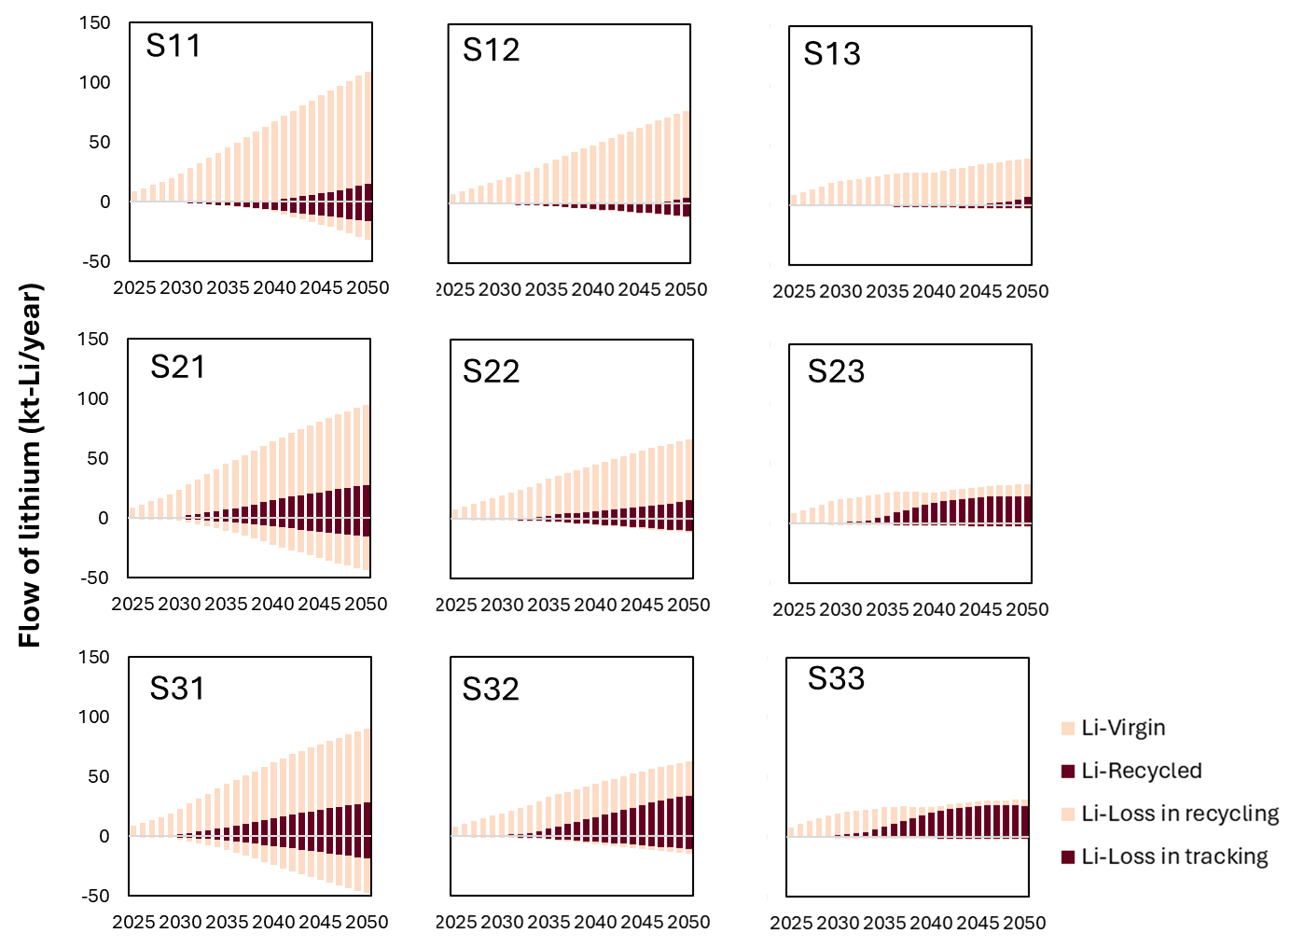
Figure S28. Material flow changes of lithium in automobile LIBs

In contrast, cobalt shows a higher responsiveness to policy interventions. As demonstrated in Figure S29, the implementation of ambitious policies—such as the adoption of cobalt-free chemistries, immediate recycling, and advanced recovery technologies—could significantly reduce the demand for virgin cobalt, potentially approaching zero as early as 2040.

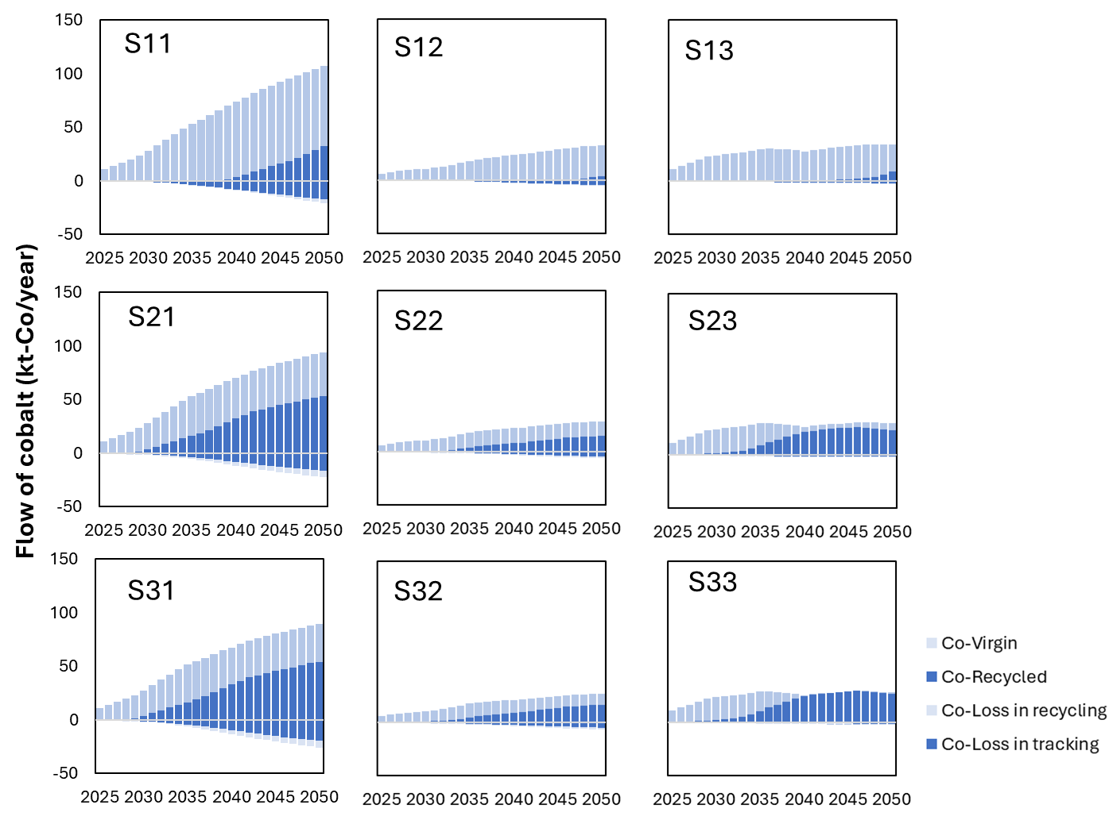
Figure S29. Material flow changes of cobalt in automobile LIBs

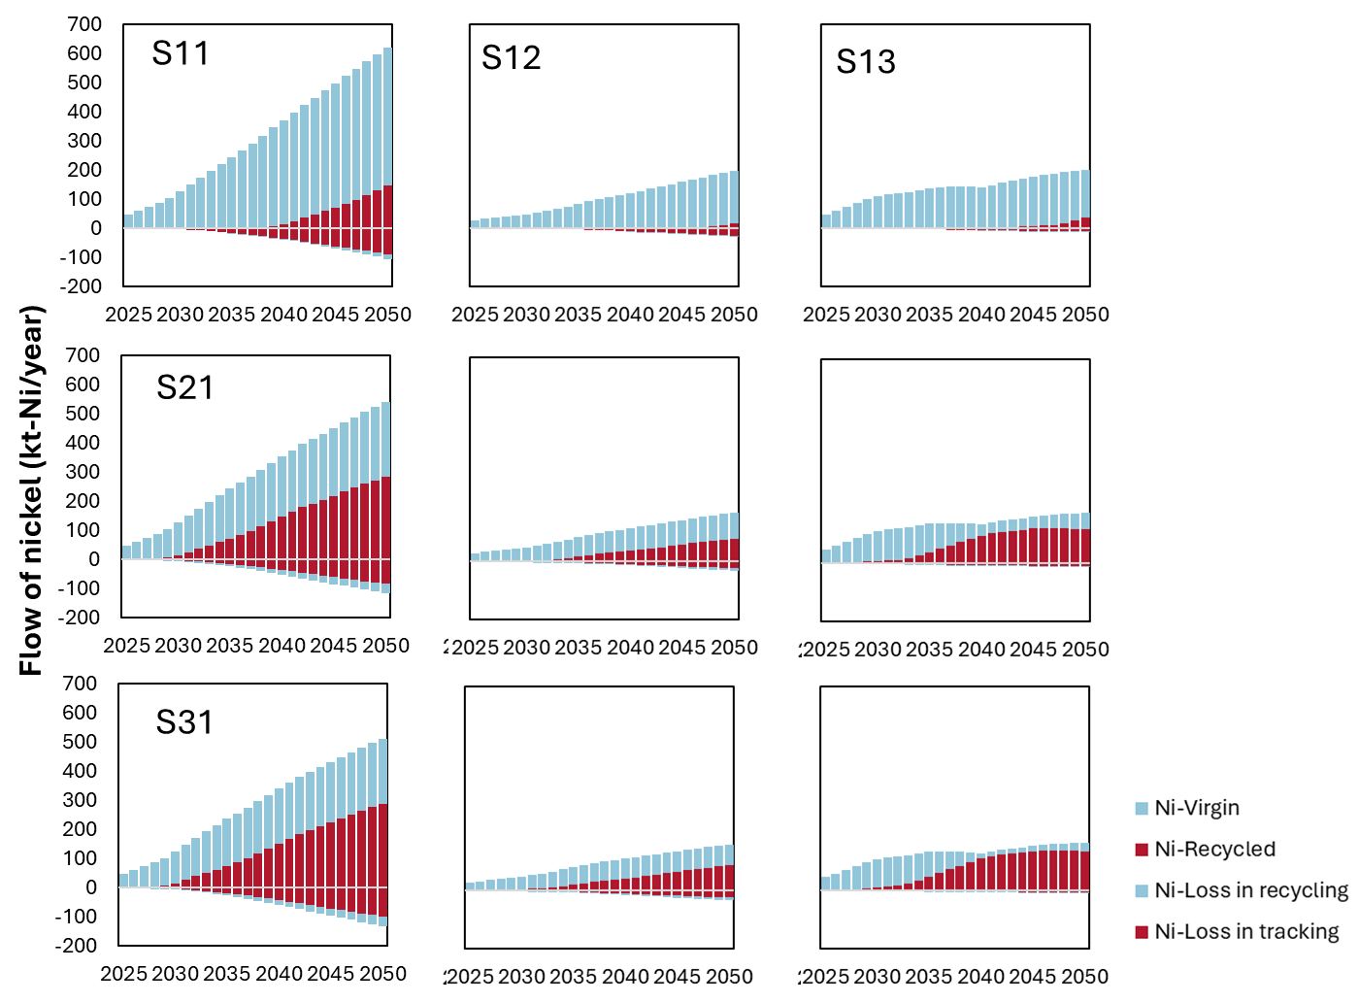
Figure S30. Material flow changes of nickel in automobile LIBs

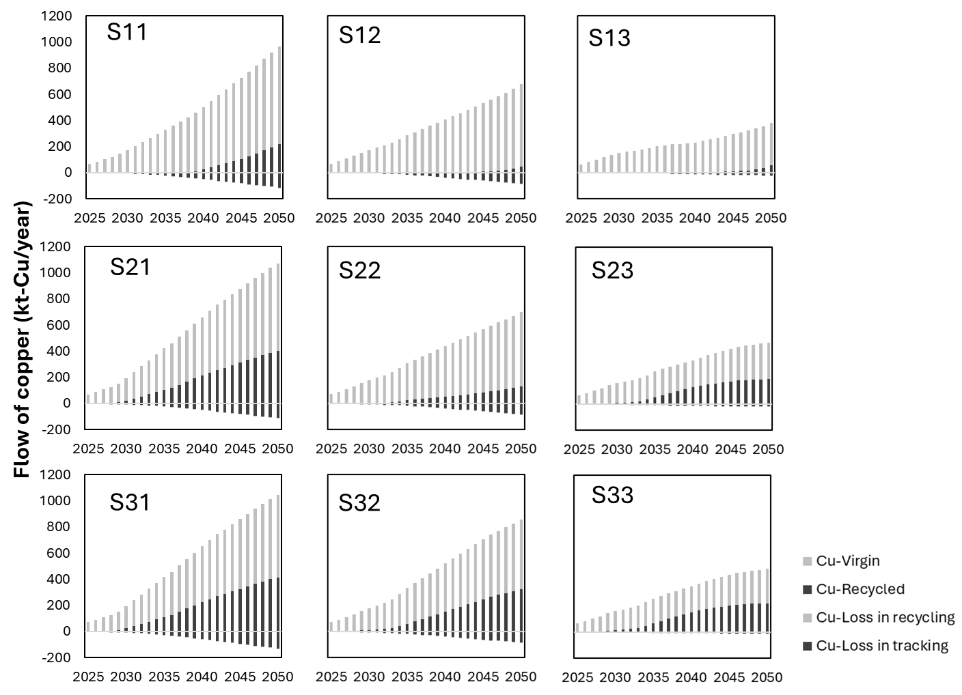
Figure S31. Material flow changes of copper in automobile LIBs

Figure S32 illustrates the variation in the circulation rates of critical minerals in automotive LIBs under different policy scenarios. As discussed in the main text, the circulation rate does not increase rapidly in the early stages due to a temporal mismatch between the accelerated initial demand and the delayed emergence of secondary supply, even in scenarios with advanced recycling systems. Notably, the circulation rate of lithium proves particularly difficult to improve. This is largely attributable to the lower material value of LFP batteries and the economic challenges associated with lithium recovery, especially through pyrometallurgical processes. Furthermore, across all scenarios, the circulation rates of lithium and nickel remain consistently lower than those of cobalt and manganese. This outcome reflects recent trends in battery chemistry development, as newer battery types are engineered to reduce the use of cobalt and manganese.

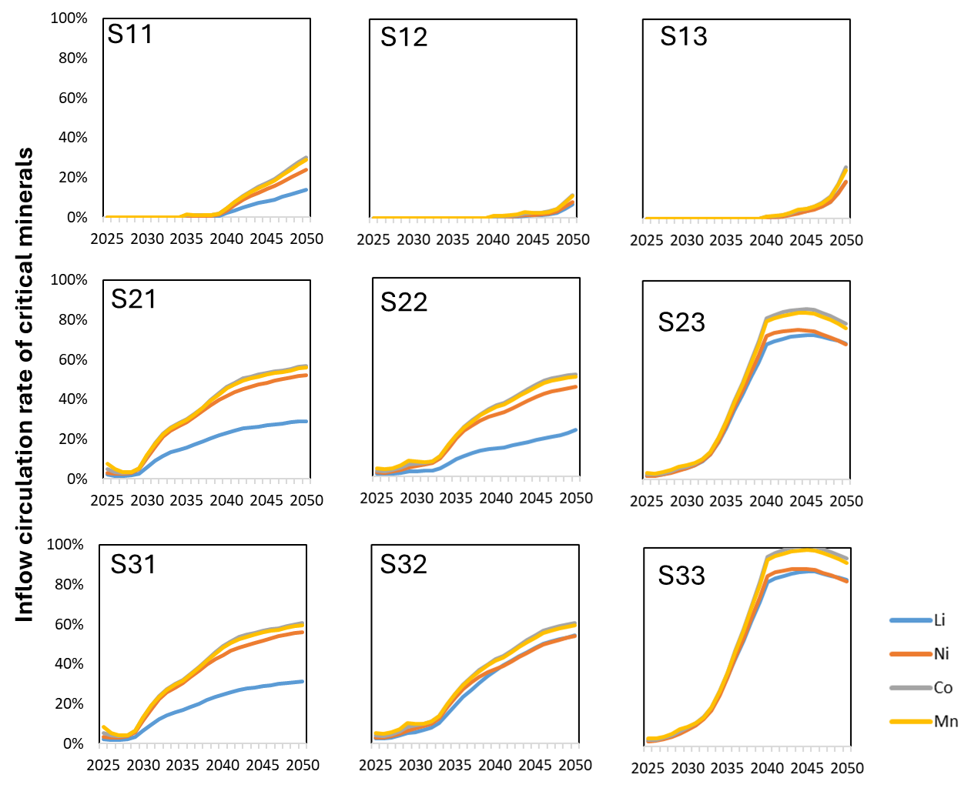
Figure S32. Changes on circulation rate of critical minerals in automotive LIBs

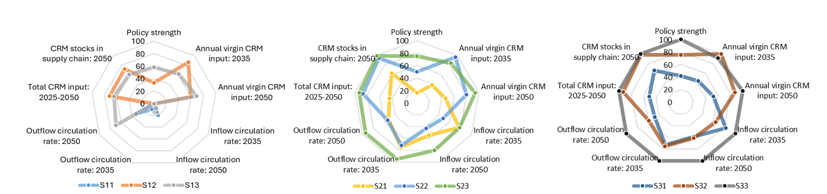
a. Comparison between supplier-side policy options
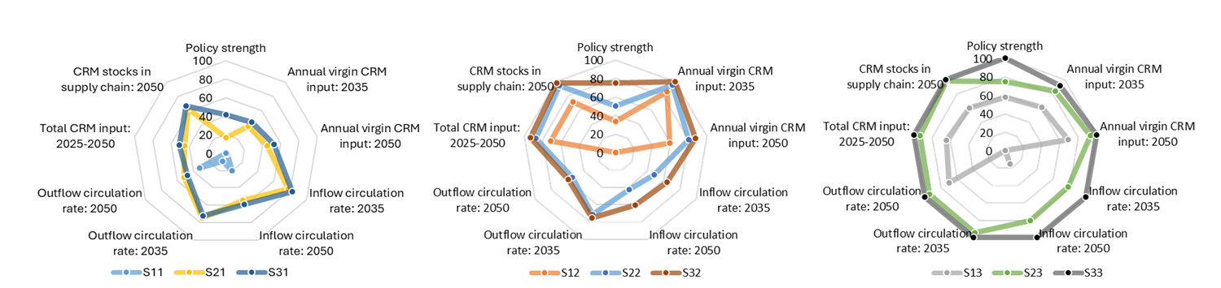
b. Comparison between user-side policy options
Figure S33. Indicators comparison between integrated scenarios

3.2 Detailed Results from Scenario Matrix for Policy Assessment
In the main text, we presented the results of the scenario matrix to evaluate the effectiveness of individual policies and the synergistic effects of paired policy combinations, using tables highlighted with color-coded hotspots. This section provides the detailed numerical values corresponding to each cell in those tables. Figure S34 shows the annual virgin material input of critical minerals in automotive LIBs in 2035 and 2050.

a. 2035
b. 2050
Figure S34. Annual virgin material input of critical minerals in automotive LIBs in 2035 and 2050.

Figure S35 presents the reduction rates relative to the maximum annual virgin material input of critical minerals in automotive LIBs for the same years.

a. 2035
b. 2050
Figure S35. Reduction rates relative to the maximum annual virgin material input of critical minerals in automotive LIBs in 2035 and 2050.

Figure S36 presents the inflow circulation rate of critical minerals in automotive LIBs in 2035 and 2050, considering various policies and their pairs.

a. 2035
b. 2050
Figure S36. Inflow circulation rate of critical minerals in automotive LIBs in 2035 and 2050.

Given the complexity and dynamic nature of the system, quantifying the synergy effects between paired policies presents a significant challenge. However, based on the results shown in Figures S35 and S36, we evaluate the synergy effects using the following equation:
S=E_{A+B}​−max(E_{A}, E_{B}) (equation 8)
where E_{A+B} represents the outcome of implementing both policies A and B together, and E_{A} and E_{B} represent the outcomes of implementing policy A and policy B individually, respectively. The calculated results are presented in Figures S37 and S38. These findings are discussed in detail in the main text.

a. 2035
b. 2050
Figure S37. Synergy effects of paired policies on the reduction rate of virgin material input of critical minerals in 2035 and 2050.

a. 2035
b. 2050
Figure S38. Synergy effects of paired policies on the circulation rate of virgin material input of critical minerals in 2035 and 2050.

3.3 Additional Scenarios
In addition to the nine scenarios previously defined, we conducted supplementary scenario analyses assuming Japan adopts an NCX-oriented strategy for battery technology development. This reflects a situation in which the promotion of Li-S/Air batteries progresses more slowly than anticipated, and Japan faces challenges in producing economically competitive LFP batteries. Under such conditions, policy efforts would need to align with the NCX-oriented trajectory. Figure S39 presents three such scenarios, corresponding to low-level (identical to S11), moderate-level (SS2), and ambitious-level (SS3) policy combinations along the battery supply chain.

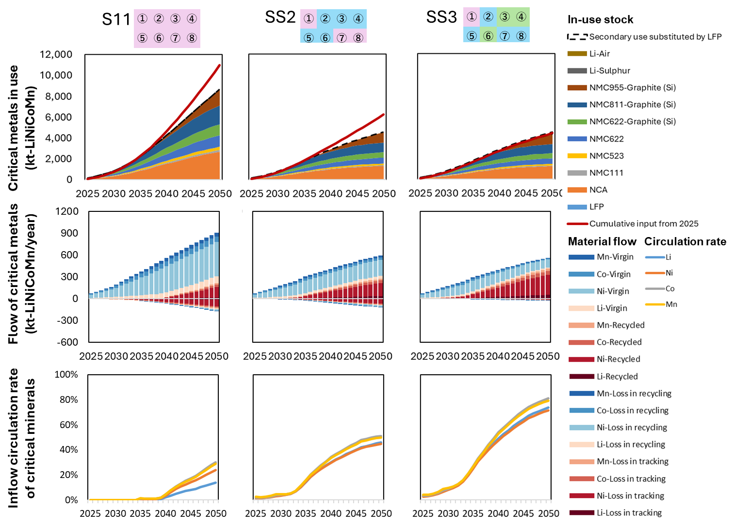
Figure S39. Additional scenarios under NCX-oriented strategy.

Figure S40 presents three scenarios under full secondary usage of all spent LIBs, corresponding to low-level (identical to S11), moderate-level (SS2), and ambitious-level (SS3) policy combinations along the battery supply chain.

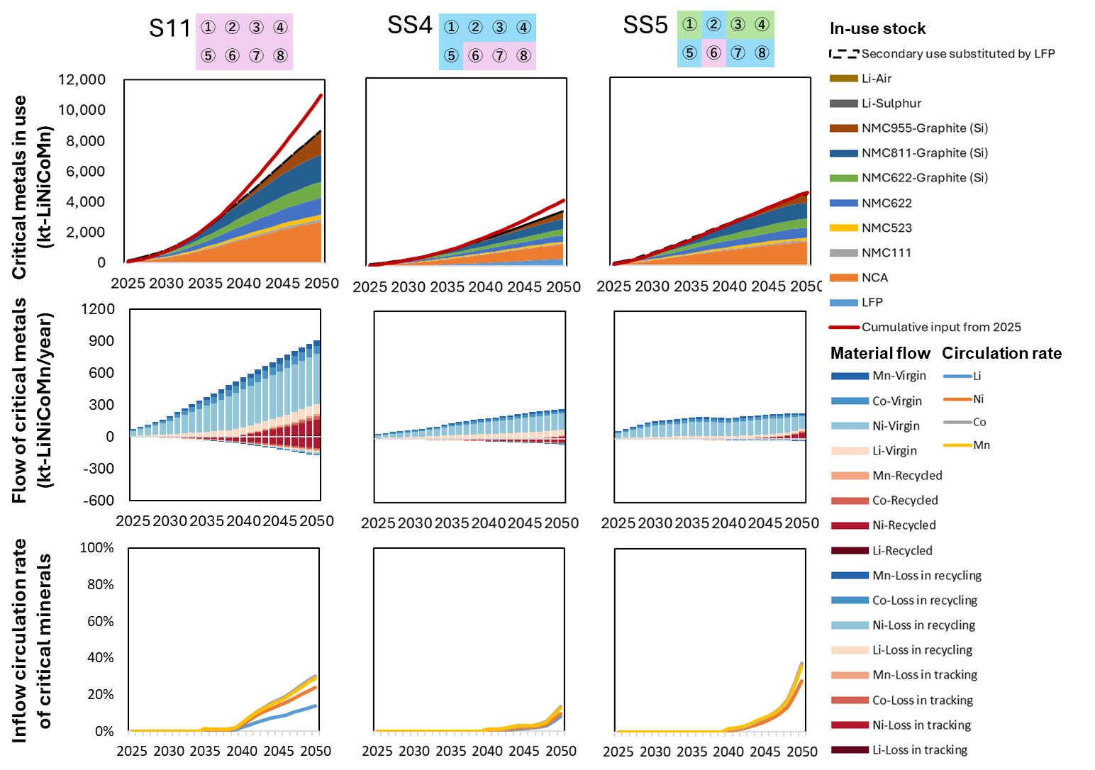
Figure S40. Additional scenarios under secondary use of all spent LIBs.

3.4 Sensitivity Analysis
To evaluate the potential uncertainties arising from factors treated as assumptions rather than scenario variables, we conducted a sensitivity analysis on population, required battery capacity per EV, vehicle lifespan, passenger car exports, and used-car exports. Table S12 and Figure S41 present the impacts on virgin material input and the circulation rate of critical minerals under ±10% variations of these factors, using Scenario S22 as the baseline. The results suggest that a larger population significantly reduces virgin material input and enhances the circulation rate by 2050, despite a slight increase in virgin material input and a decrease in circulation rate in the short term. This trend likely reflects the assumed high collection rate of spent LIBs in the domestic passenger car market, which strengthens internal resource circularity in Japan. The required capacity per EV shows a linear relationship with both virgin material input and circularity metrics. Changes in vehicle lifespan (±1.2 year) exert only a marginal influence. Passenger car exports substantially affect virgin material input but have limited impact on circulation. The exclusion of LIB extraction prior to used-car exports slightly affects both virgin material input and circularity. It should be noted that the magnitude of these effects may vary depending on the choice of baseline scenario.

Table S12. Sensitivity analysis on virgin material input and inflow circulation rate.
Indicator | Rate | S22 (reference) | Population in 2050 | Required capacity per EV | Vehicle lifespan | Passenger car exports | Used-car exports
Virgin material input  (kt-LiNiCoMn, 2035) | -10% | 121.36 | 120.28 | 123.85 | 121.68 | 113.85 | 120.89
Virgin material input  (kt-LiNiCoMn, 2035) | 0% | 121.36 | 121.36 | 121.36 | 121.36 | 121.36 | 121.36
Virgin material input  (kt-LiNiCoMn, 2035) | +10% | 121.36 | 122.39 | 118.87 | 121.10 | 128.86 | 121.81
Virgin material input  (kt-LiNiCoMn, 2050) | -10% | 164.39 | 183.30 | 175.85 | 164.64 | 153.36 | 162.44
Virgin material input  (kt-LiNiCoMn, 2050) | 0% | 164.39 | 164.39 | 164.39 | 164.39 | 164.39 | 164.39
Virgin material input  (kt-LiNiCoMn, 2050) | +10% | 164.39 | 146.77 | 152.94 | 164.20 | 175.43 | 166.30
Circulation rate  (%, 2035) | -10% | 0.17 | 0.17 | 0.15 | 0.17 | 0.17 | 0.17
Circulation rate  (%, 2035) | 0% | 0.17 | 0.17 | 0.17 | 0.17 | 0.17 | 0.17
Circulation rate  (%, 2035) | +10% | 0.17 | 0.17 | 0.19 | 0.17 | 0.17 | 0.17
Circulation rate  (%, 2050) | -10% | 0.41 | 0.38 | 0.37 | 0.41 | 0.41 | 0.42
Circulation rate  (%, 2050) | 0% | 0.41 | 0.41 | 0.41 | 0.41 | 0.41 | 0.41
Circulation rate  (%, 2050) | +10% | 0.41 | 0.44 | 0.45 | 0.41 | 0.41 | 0.40
Change rate on virgin material input  (%, 2035) | -10% | - | -0.9% | 2.1% | 0.3% | -6.2% | -0.4%
Change rate on virgin material input  (%, 2035) | 0% | - | 0.0% | 0.0% | 0.0% | 0.0% | 0.0%
Change rate on virgin material input  (%, 2035) | +10% | - | 0.8% | -2.1% | -0.2% | 6.2% | 0.4%
Change rate on virgin material input  (%, 2050) | -10% | - | 11.5% | 7.0% | 0.1% | -6.7% | -1.2%
Change rate on virgin material input  (%, 2050) | 0% | - | 0.0% | 0.0% | 0.0% | 0.0% | 0.0%
Change rate on virgin material input  (%, 2050) | +10% | - | -10.7% | -7.0% | -0.1% | 6.7% | 1.2%
Change rate on circulation rate  (%, 2035) | -10% | - | 0.2% | -10.0% | -0.2% | 1.1% | 1.9%
Change rate on circulation rate  (%, 2035) | 0% | - | 0.0% | 0.0% | 0.0% | 0.0% | 0.0%
Change rate on circulation rate  (%, 2035) | +10% | - | -0.2% | 10.0% | 0.2% | -1.0% | -1.8%
Change rate on circulation rate  (%, 2050) | -10% | - | -7.0% | -10.0% | 0.3% | 0.7% | 1.7%
Change rate on circulation rate  (%, 2050) | 0% | - | 0.0% | 0.0% | 0.0% | 0.0% | 0.0%
Change rate on circulation rate  (%, 2050) | +10% | - | 7.4% | 10.0% | -0.2% | -0.6% | -1.7%

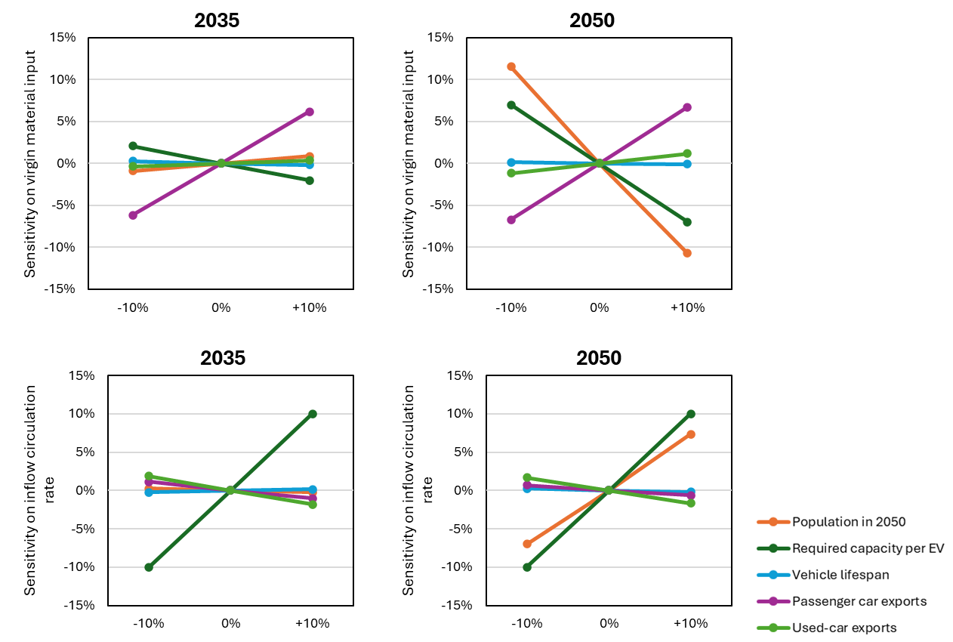
Figure S41. Sensitivity analysis on virgin material input and inflow circulation rate.

References:

1 Xu, C. J. et al. Future material demand for automotive lithium-based batteries. Commun Mater 1 (2020). https://doi.org/10.1038/s43246-020-00095-x
2 JAMA. Transitioning to Carbon Neutrality by 2050: A Scenario-Based Analysis. (Japan Automobile Manufacturers Association (JAMA), Tokyo, 2022).
3 WBCSD. Circular Transition Indicators V4.0: Metrics for business, by business. (World Business Council for Sustainable Development (WBCSD), 2023).
4 Egbue, O. & Long, S. Barriers to widespread adoption of electric vehicles: An analysis of consumer attitudes and perceptions. Energy Policy 48, 717-729 (2012). https://doi.org/https://doi.org/10.1016/j.enpol.2012.06.009
5 Investment, T. B. o. in BOI NEWS (2023).
6 Cano, Z. P. et al. Batteries and fuel cells for emerging electric vehicle markets. Nature Energy 3, 279-289 (2018). https://doi.org/10.1038/s41560-018-0108-1
7 IEA. Global EV Outlook 2024. (International Energy Agency (IEA), Paris, https://www.iea.org/reports/global-ev-outlook-2020, 2024).
8 News, B. (2023).
9 Nguyen-Tien, V., Zhang, C., Strobl, E. & Elliott, R. J. R. The closing longevity gap between battery electric vehicles and internal combustion vehicles in Great Britain. Nature Energy 10, 354-364 (2025). https://doi.org/10.1038/s41560-024-01698-1
10 Janek, J. & Zeier, W. G. A solid future for battery development. Nature Energy 1, 16141 (2016). https://doi.org/10.1038/nenergy.2016.141
11 Zeng, A. et al. Battery technology and recycling alone will not save the electric mobility transition from future cobalt shortages. Nature Communications 13, 1341 (2022). https://doi.org/10.1038/s41467-022-29022-z
12 Yu, Z. et al. Molecular design for electrolyte solvents enabling energy-dense and long-cycling lithium metal batteries. Nature Energy 5, 526-533 (2020). https://doi.org/10.1038/s41560-020-0634-5
13 METI. Presentation by the Study Group on the Sustainability of Batteries: Interim Summary. (Ministry of Economy, Trade and Industry of Japan (METI), Tokyo, 2022).
14 Dai, Q. et al. EverBatt: A Closed-loop Battery Recycling Cost and Environmental Impacts Model (Argonne National Laboratory). (2019).
15 IRENA. Global Renewables Outlook: Energy Transformation 2050. (The International Renewable Energy Agency (IRENA), 2020).
16 AIRIA. The ownership of automobiles in Japan (1966-2024). (Automobile Inspection & Registration Information Association (AIRIA), Tokyo, 2024).
17 SBJ. 2020 Population Census. (Statistics Bureau of Japan (SBJ), Tokyo, 2021).
18 MHLWJ. Comprehensive Survey of Living Conditions (2005-2018). (Ministry of Health, Labour and Welfare of Japan (MHLWJ), Tokyo, 2019).
19 METI. Current Survey of Production 2005-2019. (Ministry of Economy, Trade and Industry of Japan (METI), Tokyo, 2020).
20 ECOMO. Number of car-sharing members in Japan (2002-2020). (Foundation for Promoting Personal Mobility and Ecological Transportation (ECOMO), Tokyo, 2021).
21 AIRIA. Fleet composition of the passenger vehicles in Japan. (Automobile Inspection & Registration Information Association, Tokyo, 2024).
22 IPSS. Household Projection for Japan : 2015-2050. (National Institute of Population and Social Security Research, Tokyo, 2018).
23 IPSS. Population Projections for Japan (2021-2070). (National Institute of Population and Social Security Research (IPSS), Tokyo, 2023).
24 MOF. Trade Statistics of Japan. (Ministry of Finance of Japan (MOF), Tokyo, 2024).
25 MRI. Social and Economic Impacts of Carbon Neutrality in 2050. (Mitsubishi Research Institute (MRI), Tokyo, 2022).
26 METI. Green Growth Strategy Through Achieving Carbon Neutrality in 2050. (The Ministry of Economy, Trade and Industry (METI), Tokyo, 2021).
27 METIJ. Japan’s Roadmap to “Beyond-Zero” Carbon. (Ministry of Economy, Trade and Industry (METI) of Japan, Tokyo, 2020).
28 Nakamura, K., Kato, H. & Hayashi, Y. Forecast of Motorization Progress Considering Railway Improvement Timing In Asian Developing Mega-Cities. Journal of Japan Society of Civil Engineers, Ser. D3 (Infrastructure Planning and Management) 68, I_823-I_830 (2012). https://doi.org/10.2208/jscejipm.68.I_823
29 ECOMO. Verification of the eco effects brought about from car-sharing. (Foundation for Promoting Personal Mobility and Ecological Transportation (ECOMO), Tokyo, 2013).

