Supplementary Files-
Climate hazards and water insecurity, by geographic and economic vulnerabilities

Authors: Indira Bose, Edward A. Frongillo, Claire Dooley, Thalia Sparling, Suneetha Kadiyala, Sera Young

Figure S1: Geospatial data on water insecurity experiences collected in the 2020 Gallup World Poll in 29 low-and-middle-income countries
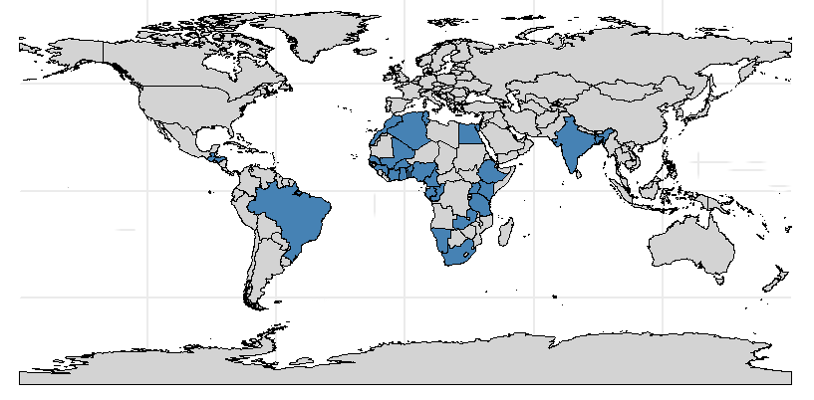

Table S1: Number of individuals among the sample included in the 2020 Gallup World Poll, who were exposed to reported floods and droughts, by high and low Standard Precipitation Index (SPI) classifications, respectively
 | SPI High | SPI Not High | Total
Floods | 13,501 | 1,924 | 15,425
No Floods | 14,177 | 6,740 | 20,917
Total | 27,678 | 8,664 | 36,342
 | SPI Low | SPI Not Low | Total
Droughts | 754 | 101 | 855
No Droughts | 17,573 | 17,914 | 35,487
Total | 18,327 | 18,015 | 36,342

Table S2: Full results of the multinomial regression model investigating the relative risk of experiencing three categories of water insecurity associated with exposure to Reported Climate Events in the analytical sample collected during the 2020 Gallup World Poll (n=36,342)
Predictors | Multinomial model (with Climate Disasters) Model 1
 | Low |  |  | Moderate |  |  | High
 | RRR | LCI | UCI | RRR | LCI | UCI | RR | LCI | UCI
Reported flood events | 1.252 | 1.158 | 1.354 | 1.219 | 1.118 | 1.329 | 1.340 | 1.184 | 1.517
Reported storm events | 1.123 | 0.952 | 1.326 | 1.311 | 1.096 | 1.569 | 1.490 | 1.158 | 1.917
Reported drought events | 1.015 | 0.809 | 1.275 | 1.206 | 0.949 | 1.534 | 1.423 | 1.022 | 1.983
Climate zone (ref: Temperate)
Arid | 1.370 | 1.219 | 1.539 | 1.356 | 1.188 | 1.549 | 1.510 | 1.242 | 1.836
Tropical | 1.071 | 0.959 | 1.197 | 1.036 | 0.915 | 1.173 | 1.314 | 1.102 | 1.566
Urbanicity (ref Rural)
Peri-Urban/Urban | 0.990 | 0.922 | 1.062 | 0.986 | 0.912 | 1.066 | 1.038 | 0.927 | 1.162
Income quintile (ref: Lowest three quintiles)
Highest two brackets | 0.921 | 0.863 | 0.984 | 0.789 | 0.732 | 0.850 | 0.728 | 0.650 | 0.815
Wealth tertile based on International Wealth Index (ref Bottom two tertiles)
Upper tertile | 0.984 | 0.914 | 1.059 | 0.942 | 0.866 | 1.024 | 0.790 | 0.696 | 0.897
Gender (ref: Men)
Women | 1.070 | 1.009 | 1.135 | 0.968 | 0.907 | 1.034 | 1.085 | 0.986 | 1.195
Age | 0.993 | 0.991 | 0.995 | 0.991 | 0.989 | 0.994 | 0.986 | 0.983 | 0.990
HH size | 1.009 | 1.000 | 1.019 | 1.041 | 1.029 | 1.052 | 1.047 | 1.030 | 1.064
Education (ref: Primary)
Secondary | 1.227 | 1.143 | 1.316 | 1.222 | 1.130 | 1.321 | 0.922 | 0.822 | 1.034
Tertiary | 1.066 | 0.941 | 1.207 | 1.061 | 0.918 | 1.225 | 0.974 | 0.781 | 1.215
Difficulty getting by on income (ref: Getting by or living comfortably)
Difficult or very difficult | 1.383 | 1.298 | 1.474 | 2.227 | 2.070 | 2.396 | 3.459 | 3.073 | 3.893
Lives disrupted by COVID (ref Not at all)
Some | 1.435 | 1.324 | 1.555 | 1.572 | 1.429 | 1.729 | 1.435 | 1.232 | 1.671
A lot | 1.579 | 1.461 | 1.708 | 2.271 | 2.077 | 2.484 | 2.845 | 2.482 | 3.262
Country (ref: Algeria)
Bangladesh | 0.045 | 0.032 | 0.064 | 0.060 | 0.042 | 0.086 | 0.157 | 0.098 | 0.250
Benin | 0.845 | 0.670 | 1.066 | 0.649 | 0.497 | 0.848 | 0.429 | 0.273 | 0.674
Brazil | 0.401 | 0.320 | 0.502 | 0.327 | 0.250 | 0.429 | 0.312 | 0.194 | 0.502
Burkina Faso | 0.836 | 0.659 | 1.059 | 1.212 | 0.941 | 1.561 | 1.538 | 1.045 | 2.264
Cameroon | 1.528 | 1.153 | 2.024 | 3.917 | 2.948 | 5.204 | 7.228 | 4.845 | 10.783
Congo Brazzaville | 0.638 | 0.504 | 0.810 | 0.545 | 0.416 | 0.716 | 0.275 | 0.167 | 0.452
Egypt | 0.478 | 0.381 | 0.599 | 0.444 | 0.343 | 0.574 | 0.442 | 0.290 | 0.673
Ethiopia | 1.399 | 1.101 | 1.779 | 1.755 | 1.354 | 2.276 | 1.724 | 1.151 | 2.582
Gabon | 1.085 | 0.847 | 1.389 | 1.394 | 1.066 | 1.823 | 1.672 | 1.112 | 2.515
Ghana | 0.631 | 0.500 | 0.798 | 0.535 | 0.409 | 0.698 | 0.204 | 0.122 | 0.343
Guatemala | 0.592 | 0.474 | 0.740 | 0.380 | 0.291 | 0.496 | 0.366 | 0.235 | 0.570
Guinea | 0.887 | 0.701 | 1.123 | 0.823 | 0.631 | 1.074 | 0.294 | 0.178 | 0.484
Honduras | 1.307 | 0.995 | 1.718 | 1.459 | 1.084 | 1.963 | 1.983 | 1.285 | 3.061
India | 0.241 | 0.191 | 0.305 | 0.171 | 0.128 | 0.227 | 0.157 | 0.097 | 0.254
Ivory Coast | 1.042 | 0.824 | 1.316 | 0.614 | 0.464 | 0.811 | 0.552 | 0.353 | 0.863
Kenya | 1.213 | 0.956 | 1.541 | 1.375 | 1.061 | 1.782 | 2.389 | 1.623 | 3.516
Mali | 0.633 | 0.500 | 0.802 | 0.427 | 0.323 | 0.564 | 0.228 | 0.137 | 0.380
Mauritius | 0.668 | 0.534 | 0.836 | 0.412 | 0.313 | 0.543 | 0.157 | 0.085 | 0.288
Morocco | 0.244 | 0.195 | 0.306 | 0.131 | 0.097 | 0.178 | 0.450 | 0.301 | 0.673
Namibia | 0.489 | 0.384 | 0.623 | 0.576 | 0.444 | 0.747 | 1.056 | 0.715 | 1.559
Nigeria | 0.724 | 0.574 | 0.911 | 0.704 | 0.544 | 0.912 | 0.729 | 0.480 | 1.108
Senegal | 0.347 | 0.274 | 0.440 | 0.158 | 0.118 | 0.212 | 0.160 | 0.101 | 0.255
South Africa | 0.448 | 0.358 | 0.561 | 0.568 | 0.445 | 0.724 | 0.568 | 0.375 | 0.861
Tanzania | 0.658 | 0.519 | 0.833 | 0.964 | 0.745 | 1.247 | 1.843 | 1.248 | 2.722
Togo | 0.802 | 0.633 | 1.016 | 0.676 | 0.517 | 0.882 | 0.507 | 0.329 | 0.782
Tunisia | 0.649 | 0.526 | 0.802 | 0.476 | 0.370 | 0.612 | 0.410 | 0.263 | 0.640
Uganda | 0.856 | 0.668 | 1.095 | 0.643 | 0.487 | 0.849 | 0.413 | 0.262 | 0.649
Zambia | 1.290 | 0.983 | 1.693 | 1.468 | 1.096 | 1.965 | 1.591 | 1.017 | 2.488

Figure S2: The relative risk of experiencing three categories of water insecurity associated with exposure to High and Low SPI in the analytical sample collected during the 2020 Gallup World Poll (n=36,342)*
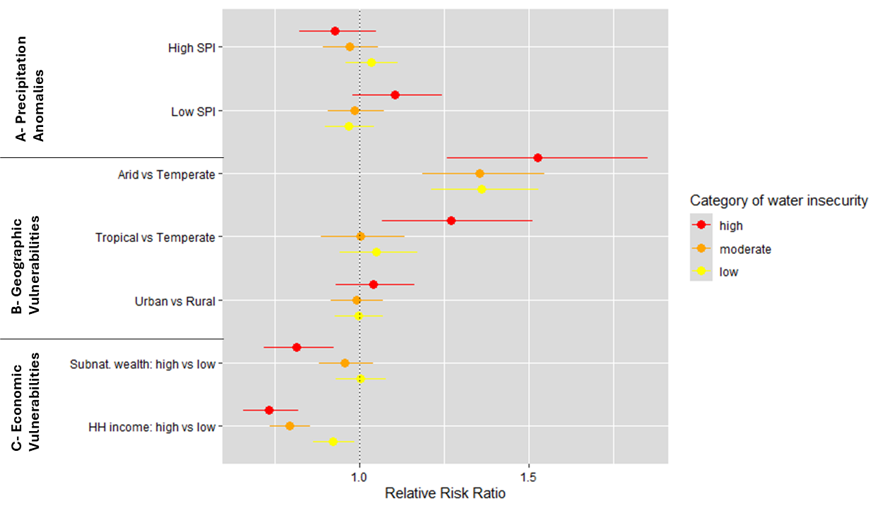
*Adjusted for perceived adequacy of household income, gender, age, household size, marital status, education level and COVID-19 pandemic-related life disruptions and country-level fixed effects.

Table S3 Full results of the multinomial regression model investigating the relative risk of experiencing three categories of water insecurity associated with exposure to High and Low SPI in the analytical sample collected during the 2020 Gallup World Poll (n=36,342)
Predictors | Multinomial model (with SPI) Model 2
 | Low |  |  | Moderate |  |  | High
 | RRR | LCI | UCI | RRR | LCI | UCI | RRR | LCI | UCI
Low SPI | 0.968 | 0.898 | 1.043 | 0.985 | 0.906 | 1.071 | 1.104 | 0.979 | 1.245
High SPI | 1.033 | 0.959 | 1.113 | 0.969 | 0.892 | 1.053 | 0.928 | 0.821 | 1.048
Climate zone (ref: Temperate)
Arid | 1.361 | 1.212 | 1.529 | 1.354 | 1.186 | 1.546 | 1.528 | 1.259 | 1.854
Tropical | 1.050 | 0.940 | 1.172 | 1.002 | 0.886 | 1.133 | 1.270 | 1.067 | 1.512
Urbanicity (ref Rural)
Peri-Urban/Urban | 0.995 | 0.927 | 1.068 | 0.989 | 0.915 | 1.069 | 1.039 | 0.928 | 1.163
Income quintile (ref: Lowest three quintiles)
Highest two brackets | 0.921 | 0.863 | 0.983 | 0.791 | 0.734 | 0.852 | 0.732 | 0.654 | 0.820
Wealth tertile based on International Wealth Index (ref Bottom two tertiles)
Upper tertile | 1.001 | 0.930 | 1.077 | 0.957 | 0.880 | 1.040 | 0.814 | 0.718 | 0.923
Gender (ref: Men)
Women | 1.072 | 1.011 | 1.137 | 0.970 | 0.909 | 1.036 | 1.087 | 0.988 | 1.197
Age | 0.993 | 0.991 | 0.995 | 0.991 | 0.989 | 0.994 | 0.986 | 0.983 | 0.990
HH size | 1.010 | 1.000 | 1.020 | 1.041 | 1.030 | 1.053 | 1.047 | 1.030 | 1.064
Education (ref: Primary)
Secondary | 1.224 | 1.141 | 1.313 | 1.220 | 1.128 | 1.320 | 0.918 | 0.819 | 1.029
Tertiary | 1.064 | 0.939 | 1.205 | 1.057 | 0.915 | 1.221 | 0.961 | 0.771 | 1.198
Difficulty getting by on income (ref: Getting by or living comfortably)
Difficult or very difficult | 1.380 | 1.296 | 1.471 | 2.222 | 2.066 | 2.390 | 3.417 | 3.037 | 3.845
Lives disrupted by COVID (ref Not at all)
Some | 1.429 | 1.319 | 1.549 | 1.568 | 1.426 | 1.725 | 1.439 | 1.236 | 1.675
A lot | 1.576 | 1.457 | 1.704 | 2.267 | 2.073 | 2.479 | 2.840 | 2.478 | 3.255
Country (ref: Algeria)
Bangladesh | 0.046 | 0.032 | 0.065 | 0.067 | 0.046 | 0.096 | 0.216 | 0.135 | 0.348
Benin | 0.869 | 0.689 | 1.095 | 0.672 | 0.515 | 0.877 | 0.458 | 0.292 | 0.719
Brazil | 0.407 | 0.326 | 0.508 | 0.357 | 0.273 | 0.465 | 0.366 | 0.228 | 0.586
Burkina Faso | 0.841 | 0.659 | 1.075 | 1.279 | 0.983 | 1.663 | 1.866 | 1.250 | 2.785
Cameroon | 1.506 | 1.131 | 2.007 | 4.021 | 3.004 | 5.382 | 8.242 | 5.465 | 12.431
Congo Brazzaville | 0.691 | 0.544 | 0.878 | 0.623 | 0.473 | 0.820 | 0.362 | 0.220 | 0.597
Egypt | 0.502 | 0.398 | 0.632 | 0.484 | 0.372 | 0.630 | 0.549 | 0.358 | 0.843
Ethiopia | 1.560 | 1.226 | 1.984 | 1.986 | 1.531 | 2.577 | 2.392 | 1.597 | 3.582
Gabon | 1.046 | 0.808 | 1.353 | 1.455 | 1.100 | 1.926 | 1.972 | 1.287 | 3.019
Ghana | 0.662 | 0.525 | 0.836 | 0.572 | 0.438 | 0.745 | 0.234 | 0.140 | 0.391
Guatemala | 0.621 | 0.497 | 0.775 | 0.441 | 0.339 | 0.574 | 0.509 | 0.330 | 0.787
Guinea | 0.904 | 0.713 | 1.145 | 0.875 | 0.670 | 1.142 | 0.330 | 0.200 | 0.544
Honduras | 1.469 | 1.137 | 1.899 | 1.891 | 1.432 | 2.498 | 3.132 | 2.082 | 4.713
India | 0.281 | 0.222 | 0.355 | 0.208 | 0.157 | 0.276 | 0.232 | 0.144 | 0.374
Ivory Coast | 1.123 | 0.891 | 1.417 | 0.685 | 0.520 | 0.904 | 0.660 | 0.423 | 1.030
Kenya | 1.246 | 0.974 | 1.594 | 1.508 | 1.153 | 1.973 | 3.162 | 2.121 | 4.714
Mali | 0.613 | 0.481 | 0.781 | 0.436 | 0.327 | 0.581 | 0.264 | 0.157 | 0.445
Mauritius | 0.663 | 0.529 | 0.831 | 0.426 | 0.323 | 0.562 | 0.159 | 0.086 | 0.294
Morocco | 0.242 | 0.193 | 0.303 | 0.130 | 0.096 | 0.176 | 0.453 | 0.303 | 0.677
Namibia | 0.515 | 0.405 | 0.655 | 0.614 | 0.474 | 0.796 | 1.230 | 0.834 | 1.812
Nigeria | 0.750 | 0.595 | 0.944 | 0.746 | 0.576 | 0.966 | 0.825 | 0.543 | 1.254
Senegal | 0.401 | 0.317 | 0.509 | 0.189 | 0.141 | 0.254 | 0.231 | 0.145 | 0.368
South Africa | 0.481 | 0.385 | 0.600 | 0.639 | 0.502 | 0.813 | 0.718 | 0.476 | 1.085
Tanzania | 0.704 | 0.552 | 0.897 | 1.086 | 0.834 | 1.415 | 2.483 | 1.667 | 3.698
Togo | 0.850 | 0.671 | 1.077 | 0.727 | 0.557 | 0.950 | 0.566 | 0.367 | 0.874
Tunisia | 0.700 | 0.567 | 0.864 | 0.529 | 0.411 | 0.680 | 0.506 | 0.325 | 0.787
Uganda | 0.985 | 0.769 | 1.261 | 0.781 | 0.591 | 1.033 | 0.607 | 0.385 | 0.958
Zambia | 1.275 | 1.005 | 1.618 | 1.665 | 1.291 | 2.149 | 2.096 | 1.410 | 3.117

Table S4: Full results of the logistic regression model investigating the odds of experiencing moderate-to-high water insecurity associated with exposure to Reported Climate Events in the analytical sample collected during the 2020 Gallup World Poll (n=36,342)
Predictors | Logistic model (with Climate Disasters)  Model 3
 | Moderate-to-high WI
 | OR | LCI | UCI
Reported flood events | 1.115 | 0.994 | 1.251
Reported storm events | 1.286 | 1.031 | 1.603
Reported drought events | 1.239 | 0.959 | 1.600
Climate zone (ref: Temperate)
Arid | 1.196 | 1.013 | 1.411
Tropical | 1.068 | 0.913 | 1.249
Urbanicity (ref Rural)
Peri-Urban/Urban | 1.002 | 0.902 | 1.112
Income quintile (ref: Lowest three quintiles)
Highest two brackets | 0.807 | 0.732 | 0.889
Wealth tertile based on International Wealth Index (ref Bottom two tertiles)
Upper tertile | 0.913 | 0.819 | 1.017
Gender (ref: Men)
Women | 0.963 | 0.882 | 1.050
Age | 0.993 | 0.990 | 0.997
HH size | 1.037 | 1.022 | 1.053
Education (ref: Primary)
Secondary | 1.029 | 0.926 | 1.144
Tertiary | 1.000 | 0.868 | 1.152
Difficulty getting by on income (ref: Getting by or living comfortably)
Difficult or very difficult | 2.109 | 1.913 | 2.325
Lives disrupted by COVID (ref Not at all)
Some | 1.304 | 1.142 | 1.490
A lot | 1.937 | 1.707 | 2.198
Country (ref: Algeria)
Bangladesh | 0.180 | 0.115 | 0.283
Benin | 0.630 | 0.444 | 0.894
Brazil | 0.467 | 0.332 | 0.657
Burkina Faso | 1.371 | 0.947 | 1.986
Cameroon | 3.500 | 2.467 | 4.967
Congo Brazzaville | 0.584 | 0.406 | 0.841
Egypt | 0.620 | 0.448 | 0.860
Ethiopia | 1.392 | 0.994 | 1.949
Gabon | 1.363 | 0.961 | 1.933
Ghana | 0.563 | 0.387 | 0.819
Guatemala | 0.478 | 0.343 | 0.667
Guinea | 0.719 | 0.490 | 1.054
Honduras | 1.317 | 0.929 | 1.869
India | 0.290 | 0.223 | 0.378
Ivory Coast | 0.573 | 0.395 | 0.833
Kenya | 1.385 | 1.022 | 1.878
Mali | 0.454 | 0.323 | 0.638
Mauritius | 0.420 | 0.289 | 0.611
Morocco | 0.327 | 0.236 | 0.454
Namibia | 0.960 | 0.703 | 1.310
Nigeria | 0.815 | 0.592 | 1.122
Senegal | 0.257 | 0.182 | 0.364
South Africa | 0.808 | 0.581 | 1.122
Tanzania | 1.393 | 0.994 | 1.951
Togo | 0.680 | 0.481 | 0.960
Tunisia | 0.565 | 0.406 | 0.787
Uganda | 0.602 | 0.413 | 0.879
Zambia | 1.262 | 0.901 | 1.769

Table S5 Number of people among the sample included in the 2020 Gallup World Poll, who exposed to each type of climate event in each stratified model
 |  | Floods | Droughts | Storms
Climate Zone | Tropical | 7423 | 55 | 2209
Climate Zone | Temperate | 4501 | 650 | 493
Climate Zone | Arid | 3501 | 150 | 265
Urbanicity | Rural | 6641 | 163 | 1061
Urbanicity | Urban | 8784 | 692 | 1906
Subnational wealth | Low | 11297 | 657 | 1965
Subnational wealth | High | 4128 | 198 | 1002
Individual Income | Low | 8416 | 374 | 1371
Individual Income | High | 7529 | 481 | 1688
All |  | 15425 | 855 | 2967

Table S6: Full results of the logistic regression model investigating the odds of experiencing moderate-to-high water insecurity associated with exposure to Reported Climate Events stratified by Climate Zone (n=36,342)
Predictors | Logistic model (with Climate Disasters) Model 4
 | Tropical |  |  | Arid |  |  | Temperate
 | OR | LCI | UCI | OR | LCI | UCI | OR | LCI | UCI
Reported flood events | 1.200 | 1.015 | 1.418 | 1.174 | 0.933 | 1.478 | 0.924 | 0.704 | 1.214
Reported storm events | 1.345 | 1.012 | 1.787 | 0.374 | 0.133 | 1.049 | 1.723 | 1.131 | 2.626
Reported drought events | 1.554 | 0.701 | 3.442 | 0.519 | 0.269 | 1.003 | 1.483 | 1.052 | 2.089
Urbanicity (ref Rural)
Peri-Urban/Urban | 1.067 | 0.928 | 1.227 | 0.867 | 0.697 | 1.078 | 1.073 | 0.839 | 1.372
Income quintile (ref: Lowest three quintiles)
Highest two brackets | 0.752 | 0.658 | 0.860 | 0.823 | 0.675 | 1.002 | 0.964 | 0.786 | 1.182
Wealth tertile based on International Wealth Index (ref Bottom two tertiles)
Upper tertile | 0.877 | 0.752 | 1.022 | 0.738 | 0.566 | 0.962 | 1.054 | 0.826 | 1.345
Gender (ref: Men)
Women | 0.874 | 0.774 | 0.986 | 1.190 | 0.996 | 1.421 | 0.995 | 0.832 | 1.189
Age | 0.987 | 0.982 | 0.992 | 1.001 | 0.995 | 1.008 | 1.000 | 0.992 | 1.007
HH size | 1.046 | 1.025 | 1.066 | 1.030 | 1.004 | 1.057 | 1.019 | 0.981 | 1.057
Education (ref: Primary)
Secondary | 1.105 | 0.960 | 1.272 | 0.820 | 0.661 | 1.018 | 1.034 | 0.812 | 1.317
Tertiary | 1.108 | 0.908 | 1.353 | 0.726 | 0.542 | 0.973 | 0.970 | 0.724 | 1.298
Difficulty getting by on income (ref: Getting by or living comfortably)
Difficult or very difficult | 2.132 | 1.862 | 2.440 | 1.956 | 1.605 | 2.386 | 2.303 | 1.885 | 2.814
Lives disrupted by COVID (ref Not at all)
Some | 1.273 | 1.069 | 1.516 | 1.450 | 1.101 | 1.908 | 1.237 | 0.906 | 1.689
A lot | 2.002 | 1.692 | 2.368 | 1.947 | 1.509 | 2.511 | 1.765 | 1.310 | 2.377
Country (ref: Algeria)
Bangladesh |  |  |  |  |  |  | 0.088 | 0.022 | 0.354
Benin | 3.484 | 2.189 | 5.543 | 1.263 | 0.226 | 7.073
Brazil | 2.899 | 1.760 | 4.777 | 2.111 | 0.721 | 6.174 | 0.184 | 0.106 | 0.319
Burkina Faso | 10.078 | 5.501 | 18.465 | 2.015 | 1.197 | 3.393
Cameroon | 20.016 | 12.355 | 32.428 | 5.820 | 2.791 | 12.134 | 1.689 | 0.186 | 15.299
Congo Brazzaville | 3.254 | 2.025 | 5.229
Egypt |  |  |  | 1.112 | 0.717 | 1.724
Ethiopia | 6.349 | 3.473 | 11.609 | 3.342 | 1.638 | 6.820 | 1.283 | 0.814 | 2.021
Gabon | 7.761 | 4.883 | 12.334
Ghana | 3.024 | 1.872 | 4.883
Guatemala | 2.406 | 1.461 | 3.961 |  |  |  | 0.397 | 0.249 | 0.631
Guinea | 3.945 | 2.421 | 6.430
Honduras | 7.639 | 4.771 | 12.232 |  |  |  | 0.422 | 0.186 | 0.955
India | 1.641 | 1.063 | 2.535 | 0.551 | 0.353 | 0.862 | 0.278 | 0.182 | 0.424
Ivory Coast | 3.125 | 1.932 | 5.054
Kenya | 7.134 | 4.328 | 11.757 | 6.404 | 2.745 | 14.939 | 1.103 | 0.737 | 1.650
Mali | 2.739 | 1.654 | 4.536 | 0.742 | 0.416 | 1.324
Mauritius | 2.424 | 1.473 | 3.990 |  |  |  | 0.317 | 0.127 | 0.790
Morocco |  |  |  | 0.570 | 0.337 | 0.966 | 0.258 | 0.167 | 0.398
Namibia |  |  |  | 1.830 | 1.168 | 2.867
Nigeria | 4.593 | 2.894 | 7.291 | 1.408 | 0.799 | 2.481
Senegal | 0.361 | 0.137 | 0.950 | 0.464 | 0.274 | 0.786
South Africa |  |  |  | 2.072 | 1.208 | 3.555 | 0.565 | 0.361 | 0.885
Tanzania | 6.912 | 4.233 | 11.287 | 3.983 | 1.785 | 8.885 | 1.466 | 0.826 | 2.601
Togo | 3.724 | 2.360 | 5.875
Tunisia |  |  |  | 1.131 | 0.679 | 1.885 | 0.324 | 0.205 | 0.512
Uganda | 3.035 | 1.869 | 4.927 |  |  |  | 1.007 | 0.250 | 4.061
Zambia | 6.690 | 2.943 | 15.207 | 3.813 | 1.278 | 11.378 | 0.911 | 0.601 | 1.381

Table S7: Full results of the logistic regression model investigating the odds of experiencing moderate-to-high water insecurity associated with exposure to Reported Climate Events stratified by Urbanicity in the analytical sample collected during the 2020 Gallup World Poll (n=36,342)
Predictors | Logistic model (with Climate Disasters) Model 5
 | Rural |  |  | Urban
 | OR | LCI | UCI | OR | LCI | UCI
Reported flood events | 1.334 | 1.058 | 1.681 | 1.013 | 0.882 | 1.164
Reported storm events | 0.956 | 0.647 | 1.413 | 1.477 | 1.133 | 1.925
Reported drought events | 2.023 | 1.217 | 3.364 | 1.067 | 0.788 | 1.444
Climate zone (ref: Temperate)
Arid | 1.232 | 0.897 | 1.691 | 1.183 | 0.966 | 1.448
Tropical | 0.966 | 0.723 | 1.290 | 1.127 | 0.931 | 1.363
Income quintile (ref: Lowest three quintiles)
Highest two brackets | 0.949 | 0.788 | 1.143 | 0.753 | 0.671 | 0.844
Wealth tertile based on International Wealth Index (ref Bottom two tertiles)
Upper tertile | 0.707 | 0.541 | 0.923 | 0.973 | 0.863 | 1.098
Gender (ref: Men)
Women | 0.973 | 0.827 | 1.144 | 0.964 | 0.869 | 1.070
Age | 0.994 | 0.988 | 1.001 | 0.993 | 0.989 | 0.998
HH size | 1.047 | 1.023 | 1.071 | 1.032 | 1.013 | 1.052
Education (ref: Primary)
Secondary | 0.968 | 0.795 | 1.179 | 1.038 | 0.915 | 1.177
Tertiary | 1.020 | 0.756 | 1.378 | 0.999 | 0.851 | 1.174
Difficulty getting by on income (ref: Getting by or living comfortably)
Difficult or very difficult | 2.065 | 1.712 | 2.490 | 2.115 | 1.887 | 2.372
Lives disrupted by COVID (ref Not at all)
Some | 1.242 | 0.976 | 1.581 | 1.331 | 1.134 | 1.562
A lot | 1.834 | 1.463 | 2.298 | 1.966 | 1.687 | 2.292
Country (ref: Algeria)
Bangladesh | 0.017 | 0.002 | 0.153 | 0.175 | 0.110 | 0.280
Benin | 1.124 | 0.383 | 3.296 | 0.572 | 0.389 | 0.840
Brazil | 0.393 | 0.130 | 1.191 | 0.484 | 0.335 | 0.698
Burkina Faso | 1.790 | 0.649 | 4.942 | 1.327 | 0.873 | 2.015
Cameroon | 5.044 | 1.719 | 14.804 | 3.309 | 2.261 | 4.843
Congo Brazzaville | 0.505 | 0.184 | 1.389 | 0.719 | 0.472 | 1.095
Egypt | 0.853 | 0.268 | 2.716 | 0.635 | 0.450 | 0.895
Ethiopia | 1.384 | 0.522 | 3.669 | 1.559 | 1.061 | 2.293
Gabon | 1.966 | 0.753 | 5.133 | 1.277 | 0.847 | 1.925
Ghana | 1.050 | 0.390 | 2.825 | 0.479 | 0.307 | 0.749
Guatemala | 0.752 | 0.274 | 2.060 | 0.446 | 0.310 | 0.643
Guinea | 1.445 | 0.482 | 4.331 | 0.628 | 0.411 | 0.959
Honduras | 1.882 | 0.706 | 5.017 | 1.249 | 0.836 | 1.867
India | 0.389 | 0.159 | 0.951 | 0.271 | 0.203 | 0.362
Ivory Coast | 1.064 | 0.355 | 3.189 | 0.521 | 0.345 | 0.786
Kenya | 1.736 | 0.682 | 4.418 | 1.372 | 0.973 | 1.934
Mali | 0.548 | 0.216 | 1.394 | 0.427 | 0.278 | 0.658
Mauritius | 0.797 | 0.268 | 2.367 | 0.371 | 0.245 | 0.561
Morocco | 0.893 | 0.342 | 2.330 | 0.267 | 0.184 | 0.387
Namibia | 1.418 | 0.581 | 3.460 | 0.671 | 0.451 | 1.000
Nigeria | 0.942 | 0.352 | 2.520 | 0.828 | 0.583 | 1.175
Senegal | 0.250 | 0.098 | 0.638 | 0.297 | 0.196 | 0.451
South Africa | 1.004 | 0.392 | 2.573 | 0.835 | 0.572 | 1.218
Tanzania | 1.680 | 0.637 | 4.426 | 1.436 | 0.975 | 2.116
Togo | 1.176 | 0.445 | 3.109 | 0.603 | 0.406 | 0.896
Tunisia | 1.148 | 0.371 | 3.555 | 0.545 | 0.385 | 0.771
Uganda | 0.669 | 0.244 | 1.833 | 0.672 | 0.433 | 1.042
Zambia | 0.809 | 0.287 | 2.280 | 1.476 | 1.021 | 2.133

Table S8 Number of people among the sample included in the 2020 Gallup World Poll, who were exposed to each type of SPI exposure in each stratified model
 |  | High SPI | Low SPI
Climate Zone | Tropical | 14064 | 9246
Climate Zone | Arid | 6884 | 3973
Climate Zone | Temperate | 6730 | 5108
Urbanicity | Rural | 10074 | 5312
Urbanicity | Urban | 17604 | 13015
Subnational wealth | Low | 19955 | 13154
Subnational wealth | High | 7723 | 5173
Individual Income | Low | 13593 | 8883
Individual Income | High | 14085 | 9444
All |  | 27678 | 18327

Table S9: Key results of the logistic regression model investigating the odds of experiencing moderate-to-high water insecurity associated with exposure to High and Low SPI: All; A) stratified by Climate Zone; B) stratified by Urbanicity; C) stratified by Subnational Wealth; D) stratified by Income Group in the analytical sample collected during the 2020 Gallup World Poll (n=36,342)*
Predictors | Logistic models (with SPI)
 | All Model 6 |  |  | - CLIMATE ZONE Model 7 |  |  |  |  |  |  |  |  | - URBANICITY Model 8
 |  |  |  | Tropical |  |  | Arid |  |  | Temperate |  |  | RURAL |  |  | URBAN
 | OR | LCI | UCI | OR | LCI | UCI | OR | LCI | UCI | OR | LCI | UCI | OR | LCI | UCI | OR | LCI | UCI
Low SPI | 1.030 | 0.921 | 1.153 | 1.015 | 0.869 | 1.187 | 1.142 | 0.932 | 1.399 | 0.954 | 0.726 | 1.254 | 1.189 | 0.981 | 1.440 | 0.970 | 0.844 | 1.115
High SPI | 0.947 | 0.848 | 1.056 | 0.985 | 0.843 | 1.152 | 0.929 | 0.724 | 1.194 | 0.882 | 0.713 | 1.091 | 1.046 | 0.847 | 1.292 | 0.901 | 0.789 | 1.029
 |  |  |  | - SUBNATIONAL WEALTH Model 11 |  |  |  |  |  | - INDIVIDUAL WEALTH Model 12
 |  |  |  | Low Subnational Wealth |  |  | High Subnational Wealth |  |  | Low individual Income Group |  |  | High individual Income Group
 |  |  |  | OR | LCI | UCI | OR | LCI | UCI | OR | LCI | UCI | OR | LCI | UCI
Low SPI |  |  |  | 1.027 | 0.907 | 1.163 | 1.133 | 0.827 | 1.554 | 1.044 | 0.902 | 1.208 | 1.010 | 0.850 | 1.202
High SPI |  |  |  | 0.941 | 0.834 | 1.062 | 1.087 | 0.780 | 1.514 | 0.934 | 0.810 | 1.076 | 0.957 | 0.806 | 1.135

*Adjusted for perceived adequacy of household income, gender, age, household size, marital status, education level and COVID-19 pandemic-related life disruptions, and country-level fixed effects; climate zone (for all except models stratified by climate zone A); urbanicity (for all except models stratified by urbanicity B); subnational wealth (for all except models stratified by subnational wealth C); and individual wealth (for all except models stratified by individual income D)
Table S10: Full results of the logistic regression model investigating the odds of experiencing moderate-to-high water insecurity associated with exposure to Reported Climate Events stratified by Subnational Wealth (n=36,342)
Predictors | Logistic model (with Climate Disasters) Model 9
 | Low Subnational Wealth |  |  | High Subnational Wealth
 | OR | LCI | UCI | OR | LCI | UCI
Reported flood events | 1.058 | 0.922 | 1.214 | 0.981 | 0.709 | 1.358
Reported storm events | 1.537 | 1.195 | 1.976 | 0.619 | 0.366 | 1.044
Reported drought events | 1.075 | 0.815 | 1.417 | 1.442 | 0.397 | 5.241
Climate zone (ref: Temperate)
Arid | 1.236 | 1.017 | 1.503 | 0.974 | 0.591 | 1.606
Tropical | 1.124 | 0.942 | 1.340 | 0.742 | 0.485 | 1.134
Urbanicity (ref Rural)
Peri-Urban/Urban | 0.971 | 0.866 | 1.089 | 1.177 | 0.883 | 1.569
Income quintile (ref: Lowest three quintiles)
Highest two brackets | 0.825 | 0.738 | 0.921 | 0.761 | 0.618 | 0.937
Gender (ref: Men)
Women | 0.967 | 0.876 | 1.067 | 0.974 | 0.804 | 1.180
Age | 0.996 | 0.992 | 1.000 | 0.986 | 0.978 | 0.993
HH size | 1.041 | 1.024 | 1.058 | 1.023 | 0.989 | 1.058
Education (ref: Primary)
Secondary | 1.042 | 0.925 | 1.175 | 0.976 | 0.773 | 1.233
Tertiary | 1.036 | 0.881 | 1.217 | 0.927 | 0.690 | 1.247
Difficulty getting by on income (ref: Getting by or living comfortably)
Difficult or very difficult | 2.126 | 1.903 | 2.374 | 2.112 | 1.717 | 2.598
Lives disrupted by COVID (ref Not at all)
Some | 1.314 | 1.132 | 1.526 | 1.342 | 0.995 | 1.810
A lot | 1.929 | 1.673 | 2.224 | 2.052 | 1.552 | 2.712
Country (ref: Algeria)
Bangladesh | 0.161 | 0.092 | 0.282 | 0.316 | 0.136 | 0.731
Benin | 0.729 | 0.484 | 1.100 | 0.548 | 0.251 | 1.195
Brazil | 0.522 | 0.346 | 0.790 | 0.380 | 0.202 | 0.712
Burkina Faso | 1.461 | 0.938 | 2.274 | 1.666 | 0.797 | 3.482
Cameroon | 3.664 | 2.437 | 5.508 | 4.621 | 2.138 | 9.992
Congo Brazzaville | 0.482 | 0.309 | 0.752 | 1.406 | 0.644 | 3.071
Egypt | 0.728 | 0.501 | 1.058 | 0.458 | 0.208 | 1.010
Ethiopia | 1.583 | 1.059 | 2.366 | 1.353 | 0.639 | 2.863
Gabon | 1.432 | 0.967 | 2.121
Ghana | 0.576 | 0.368 | 0.901 | 0.842 | 0.387 | 1.830
Guatemala | 0.475 | 0.316 | 0.714 | 0.550 | 0.280 | 1.081
Guinea | 0.745 | 0.476 | 1.164 | 0.949 | 0.419 | 2.148
Honduras | 1.145 | 0.758 | 1.732 | 3.501 | 1.562 | 7.847
India | 0.353 | 0.254 | 0.492 | 0.337 | 0.194 | 0.587
Ivory Coast | 0.687 | 0.445 | 1.062 | 0.578 | 0.243 | 1.375
Kenya | 1.531 | 1.062 | 2.207 | 1.562 | 0.829 | 2.942
Mali | 0.516 | 0.348 | 0.765 | 0.325 | 0.132 | 0.799
Mauritius | 0.442 | 0.292 | 0.670
Morocco | 0.362 | 0.245 | 0.535 | 0.317 | 0.144 | 0.697
Namibia | 1.225 | 0.845 | 1.775 | 0.618 | 0.297 | 1.284
Nigeria | 0.873 | 0.595 | 1.280 | 1.040 | 0.533 | 2.030
Senegal | 0.259 | 0.173 | 0.386 | 0.450 | 0.196 | 1.031
South Africa | 0.869 | 0.591 | 1.278 | 0.811 | 0.387 | 1.700
Tanzania | 1.431 | 0.949 | 2.160 | 1.979 | 1.017 | 3.852
Togo | 0.785 | 0.524 | 1.178 | 0.638 | 0.293 | 1.393
Tunisia | 0.727 | 0.487 | 1.085 | 0.343 | 0.185 | 0.634
Uganda | 0.662 | 0.426 | 1.029 | 0.846 | 0.360 | 1.988
Zambia | 1.341 | 0.904 | 1.989 | 1.536 | 0.376 | 6.274

Table S11: Full results of the logistic regression model investigating the odds of experiencing moderate-to-high water insecurity associated with exposure to Reported Climate Events stratified by Income Group (n=36,342)
Predictors | Logistic model (with Climate Disasters) Model 10
 | Low individual Income |  |  | High individual Income
 | OR | LCI | UCI | OR | LCI | UCI
Reported flood events | 1.162 | 1.000 | 1.351 | 1.028 | 0.862 | 1.228
Reported storm events | 1.292 | 0.968 | 1.724 | 1.327 | 0.954 | 1.845
Reported drought events | 1.230 | 0.869 | 1.741 | 1.319 | 0.909 | 1.914
Climate zone (ref: Temperate)
Arid | 1.329 | 1.067 | 1.654 | 1.025 | 0.800 | 1.314
Tropical | 1.184 | 0.964 | 1.454 | 0.874 | 0.689 | 1.109
Urbanicity (ref Rural)
Peri-Urban/Urban | 1.087 | 0.951 | 1.243 | 0.849 | 0.719 | 1.001
Wealth tertile based on International Wealth Index (ref Bottom two tertiles)
Upper tertile | 0.926 | 0.799 | 1.073 | 0.912 | 0.780 | 1.067
Gender (ref: Men)
Women | 0.998 | 0.890 | 1.120 | 0.886 | 0.777 | 1.011
Age | 0.993 | 0.988 | 0.997 | 0.995 | 0.990 | 1.001
HH size | 1.056 | 1.038 | 1.076 | 0.999 | 0.974 | 1.025
Education (ref: Primary)
Secondary | 1.042 | 0.913 | 1.188 | 1.020 | 0.852 | 1.221
Tertiary | 0.949 | 0.760 | 1.183 | 1.037 | 0.843 | 1.276
Difficulty getting by on income (ref: Getting by or living comfortably)
Difficult or very difficult | 2.060 | 1.803 | 2.354 | 2.200 | 1.909 | 2.535
Lives disrupted by COVID (ref Not at all)
Some | 1.107 | 0.928 | 1.321 | 1.689 | 1.379 | 2.069
A lot | 1.835 | 1.557 | 2.163 | 2.118 | 1.736 | 2.585
Country (ref: Algeria)
Bangladesh | 0.217 | 0.121 | 0.388 | 0.145 | 0.072 | 0.292
Benin | 0.964 | 0.610 | 1.522 | 0.313 | 0.180 | 0.547
Brazil | 0.712 | 0.458 | 1.109 | 0.220 | 0.129 | 0.376
Burkina Faso | 1.800 | 1.099 | 2.950 | 0.879 | 0.517 | 1.494
Cameroon | 4.599 | 2.864 | 7.385 | 2.343 | 1.406 | 3.904
Congo Brazzaville | 0.746 | 0.457 | 1.218 | 0.431 | 0.257 | 0.722
Egypt | 0.734 | 0.479 | 1.125 | 0.518 | 0.319 | 0.839
Ethiopia | 1.811 | 1.147 | 2.860 | 1.015 | 0.634 | 1.626
Gabon | 1.756 | 1.102 | 2.798 | 0.955 | 0.573 | 1.592
Ghana | 0.758 | 0.464 | 1.241 | 0.363 | 0.205 | 0.645
Guatemala | 0.652 | 0.419 | 1.017 | 0.311 | 0.195 | 0.496
Guinea | 0.739 | 0.445 | 1.225 | 0.725 | 0.417 | 1.261
Honduras | 1.592 | 0.997 | 2.542 | 1.032 | 0.624 | 1.705
India | 0.445 | 0.313 | 0.632 | 0.151 | 0.103 | 0.220
Ivory Coast | 0.741 | 0.450 | 1.220 | 0.413 | 0.240 | 0.713
Kenya | 1.962 | 1.294 | 2.974 | 0.817 | 0.534 | 1.248
Mali | 0.459 | 0.289 | 0.728 | 0.465 | 0.286 | 0.758
Mauritius | 0.632 | 0.392 | 1.020 | 0.218 | 0.119 | 0.398
Morocco | 0.499 | 0.327 | 0.760 | 0.159 | 0.096 | 0.263
Namibia | 1.351 | 0.893 | 2.046 | 0.559 | 0.354 | 0.882
Nigeria | 1.071 | 0.704 | 1.629 | 0.552 | 0.343 | 0.890
Senegal | 0.268 | 0.171 | 0.420 | 0.271 | 0.161 | 0.459
South Africa | 0.996 | 0.646 | 1.537 | 0.622 | 0.388 | 0.997
Tanzania | 1.882 | 1.186 | 2.985 | 0.913 | 0.573 | 1.455
Togo | 1.024 | 0.647 | 1.620 | 0.356 | 0.216 | 0.587
Tunisia | 0.891 | 0.576 | 1.380 | 0.246 | 0.151 | 0.398
Uganda | 0.702 | 0.426 | 1.158 | 0.496 | 0.286 | 0.861
Zambia | 1.704 | 1.081 | 2.686 | 0.792 | 0.487 | 1.287

Table S12: Full Questions for the Individual Water Insecurity Experiences (IWISE) Scale items
 | Questions
1 | In the last 12 months how often did you worry that you would not have enough water for all of your needs?
2 | How often has your main water source been interrupted or limited in any way in the last 12 months?
3 | How often have problems with water meant that your clothes could not be washed?
4 | How often did you have to change schedules or plans because of problems with water in the last 12 months?
5 | Still thinking about the last 12 months, how often did you change what you ate because of problems with water?
6 | How often were you not able to wash your hands after dirty activities because of problems with water in the last 12 months?
7 | How often were you not able to wash your body because of problems with water in the last 12 months?
8 | How often did you not have as much water to drink as you would have liked in the last 12 months?
9 | Still thinking about the last 12 months, how often did you feel angry because of problems you were experiencing with water?
10 | How often did you go to sleep thirsty because there was no water to drink in the last 12 months?
11 | How often did you have no usable or drinkable water whatsoever in the last 12 months?
12 | How often did you feel shame because of problems you were experiencing with water during the last 12 months]?

Table S13. Chi squared test results for distributions of Water Insecurity (WI) categories of all respondents with complete IWISE responses vs all non-flagged respondents with complete IWISE responses (i.e. those whose geolocation could be determined accurately to high spatial resolution), for each country.
All p-values are greater than 0.05 indicating that, for each county, there is no significant difference between distributions of WI categories for non-flagged respondents versus all respondents. These results suggest that we are not introducing bias in the prevalence of WI levels by excluding flagged respondents. Sample weights were used to calculate proportions of flagged respondents and distributions of WI categories.
Country | N | Proportion of  flagged respondents | Chi-squared  p-values
Algeria | 996 | 0.03 | 1.00
Bangladesh | 1007 | 0.01 | 1.00
Benin | 999 | 0.09 | 0.96
Brazil | 990 | 0.01 | 1.00
Burkina Faso | 980 | 0.32 | 0.56
Cameroon | 996 | 0.04 | 0.97
Congo Brazzaville | 878 | 0.20 | 0.62
Egypt | 980 | 0.01 | 1.00
Ethiopia | 1001 | 0.08 | 0.99
Gabon | 987 | 0.07 | 0.89
Ghana | 955 | 0.22 | 0.75
Guatemala | 1101 | 0.06 | 0.99
Guinea | 962 | 0.19 | 0.75
Honduras | 927 | 0.02 | 1.00
India | 12,349 | 0.00 | 1.00
Ivory Coast | 935 | 0.18 | 0.53
Kenya | 984 | 0.07 | 0.98
Mali | 926 | 0.00 | 1.00
Mauritius | 949 | 0.00 | 1.00
Morocco | 955 | 0.03 | 0.96
Namibia | 944 | 0.04 | 0.99
Nigeria | 1,002 | 0.02 | 1.00
Senegal | 978 | 0.00 | 1.00
South Africa | 981 | 0.06 | 0.96
Tanzania | 980 | 0.05 | 0.95
Togo | 955 | 0.07 | 0.96
Tunisia | 951 | 0.08 | 1.00
Uganda | 939 | 0.06 | 0.97
Zambia | 976 | 0.04 | 1.00

Supplementary Text 1: Sensitivity analysis on Urbanicity
In the GWP survey respondents were also asked to self-report their level of urbanicity. Although most classifications concurred between the self-reports of urbanicity and the DEGURBA classifications, some diverged (63.9% of urbanicity concurred after being grouped into rural vs urban). We, therefore, conducted sensitivity analysis using the self-reported urbanicity variable to understand how this might affect our interpretation of the model stratified by level of urbanicity.

Results
44% of individuals were classified as rural and 56% were classified as urban based on self-reporting. Whereas 73% were classified as urban and 28% as rural using DEGURBA. The sensitivity analysis that explored the effect of using self-reported classifications of urbanicity compared to using the DEGURBA classifications found that this did not substantially alter the associations between climate events and water insecurity found across rural and urban areas (see Figure S3)

Figure S3: Sensitivity analysis comparing the results using different urban classifications A- Reported Urbanicity; B- DEGURBA classifications (used in main analysis)*

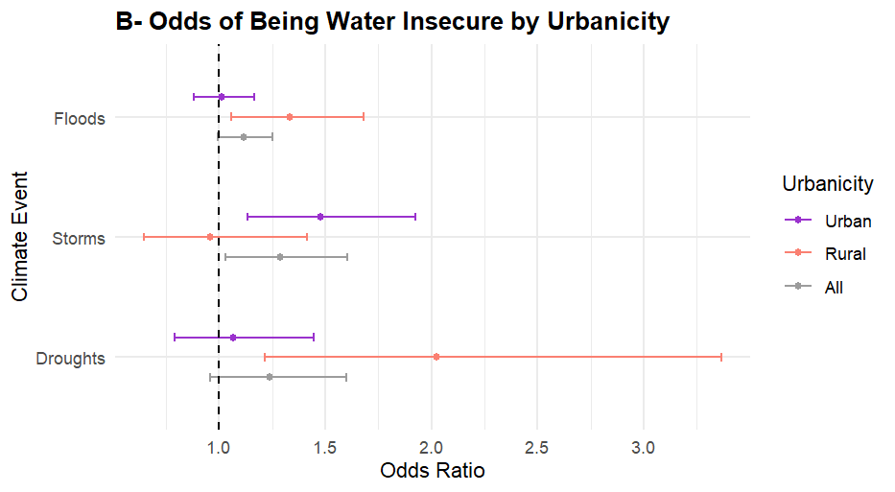
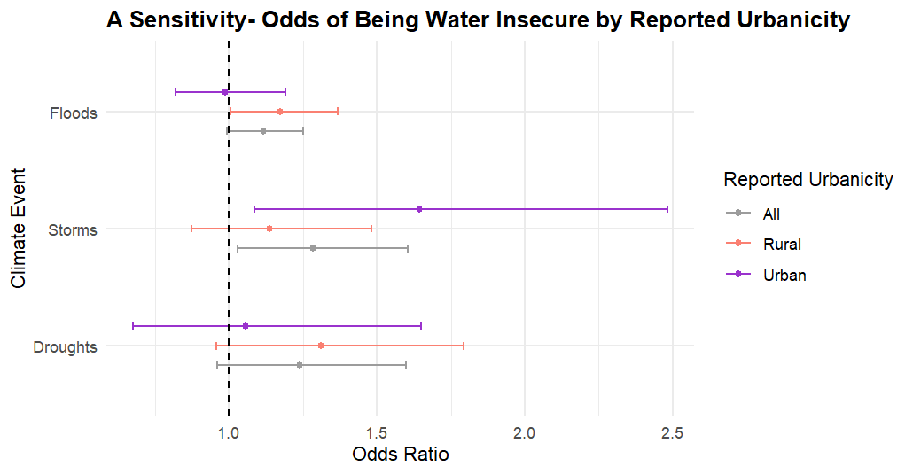

*Adjusted for perceived adequacy of household income, gender, age, household size, marital status, education level and COVID-19 pandemic-related life disruptions, climate zone, subnational wealth, individual income, and country-level fixed effect

