Figure S1: Time series of daily average variabilities of PM_{2.5} in northwest India retrieved through ground based CPCB station, and the red line represented the NAAQS standard concentration for comparison.
Figure S2: The Pearson's correlation between the auxiliary meteorological variables, AOD and PM_{2.5.}
Figure S3: The MAE and MSE after cross-validation and hyper-tuning the parameters for better estimation of PM_{2.5} over the study region..
Figure S4: Feature Importance analysis of variables used as input for machine learning models (RF, SVM, XGBoost, and AdaBoost) to estimate the PM_{2.5} over northwest India.
Table S1: The spatial and temporal resolution of variables used to estimate the PM_{2.5} concentration over northwest Indian region.
Table S2: The descriptive statistics of all the parameters used in the study to estimate PM_{2.5}.

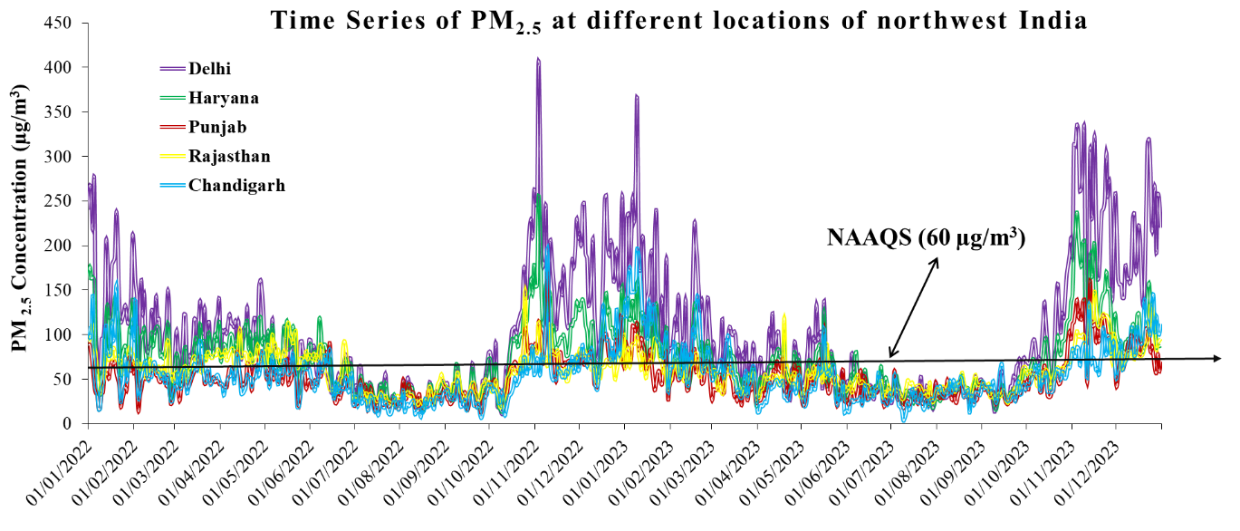
Figure S1: Time series of daily average variabilities of PM_{2.5} in northwest India retrieved through ground based CPCB station, and the red line represented the NAAQS standard (60 µg/m³) concentration for comparison.

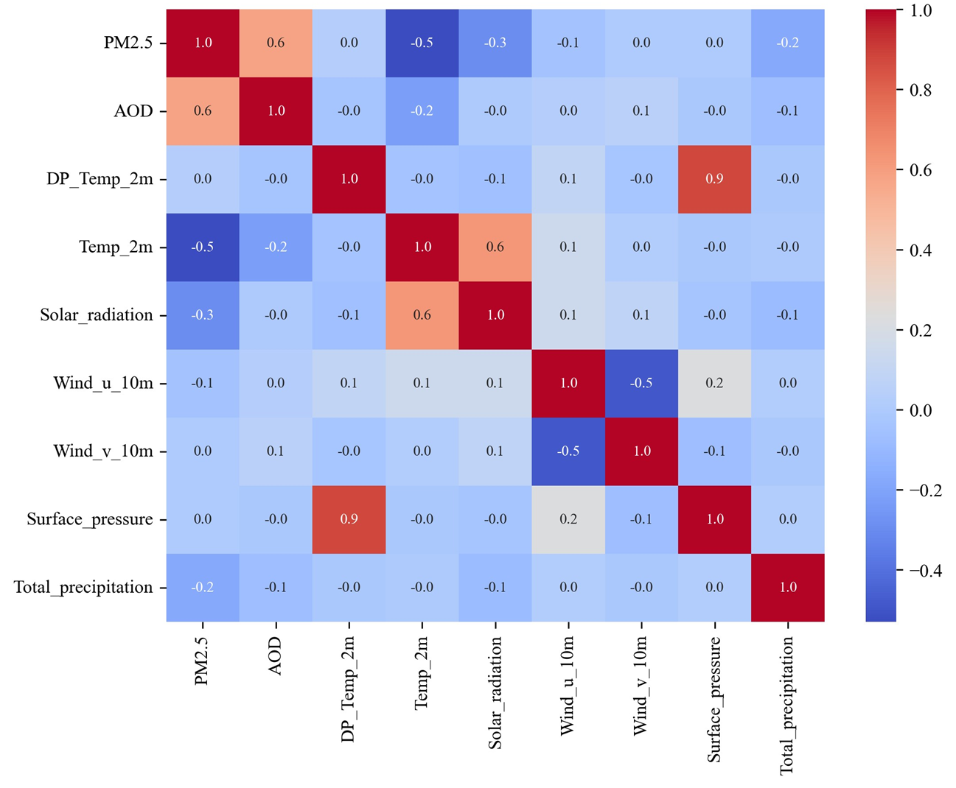
Figure S2: The Pearson's correlation between the auxiliary meteorological variables, AOD and PM_{2.5.}
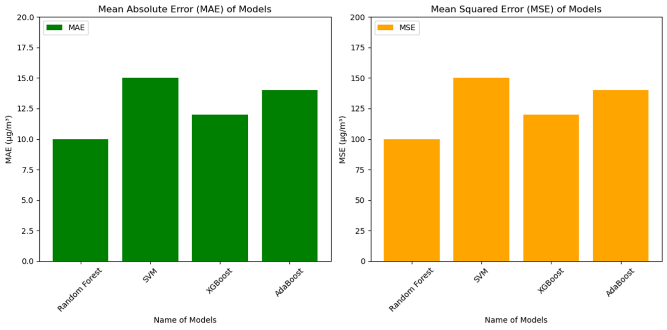
Figure S3: The MAE and MSE after cross-validation and hyper-tuning the parameters for better estimation of PM_{2.5} over the study region.

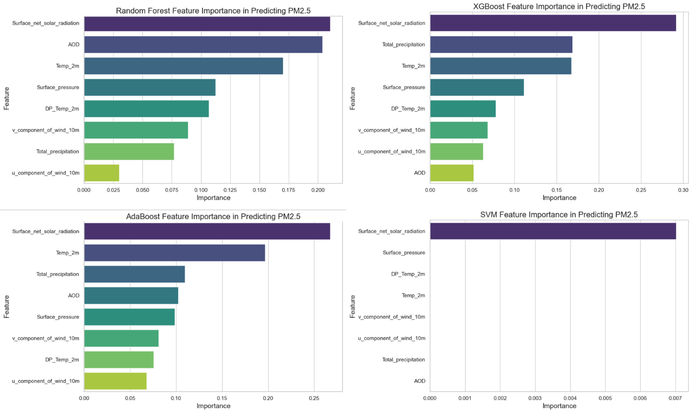
Figure S4: Feature Importance analysis of variables used as input for machine learning models (RF, SVM, XGBoost, and AdaBoost) to estimate the PM_{2.5} over northwest India.

Table S1: The spatial and temporal resolution of variables used to estimate the PM_{2.5} concentration over northwest Indian region.
Sl. No. | Variable | Spatial Resolution | Temporal Resolution | Unit
1 | PM_{2.5} (CPCB) | Station Point | 15 minutes | µg/m³
2 | MAIAC AOD | 1km | Daily | -
3 | Dew point temperature | 0.1° × 0.1° | Hourly | K
4 | Temperature at 2m | 0.1° × 0.1° | Hourly | K
5 | Surface Pressure | 0.1° × 0.1° | Hourly | Pa
6 | Total Precipitation | 0.1° × 0.1° | Hourly | mm/day
7 | Net Solar Radiation | 0.1° × 0.1° | Hourly | w/m²
8 | u and v components of wind | 0.1° × 0.1° | Hourly | m/s

Table S2: The descriptive statistics of all the parameters used in the study to estimate PM_{2.5}.

Descriptive  Statistics | PM_{2.5} (µg/m³) | AOD | DP_Temp (K) |  | Temp_2m  (K) | u_component_of_wind_10m (m/s) | v_component_of_wind_10m(m/s) | Surface_pressure (Pa) | Surface_net_solar_radiation  (W/m²) | Total_precipitation (mm/day)
Mean | 71.05 | 0.51 |  | 279.11 | 290.45 | 0.32 | -0.57 | 93684.78 | 1.468221e+07 | 1.414313e-03
Std. Dev | 37.01 | 0.24 |  | 7.56 | 11.26 | 1.41 | 1.05 | 9645.11 | 1.468221+06 | 5.181644e-03
Min | 17.96 | 0.01 |  | 252.41 | 260.60 | 0.32 | -3.07 | 71216.66 | 1.479490e+06 | 0.000000e+00
Max | 221.36 | 2.21 |  | 292.50 | 308.77 | 4.22 | 3.59 | 99573.80 | 2.300000e+07 | 6.686551e-02

