Supplementary Information for
The unexpected relationship between extreme shear events and AMO

Weiteng Qiuª, Xiaodong Yanª, *

Xiaodong Yan
Email: yxd@bnu.edu.cn

This PDF file includes:

Figures S1 to S8

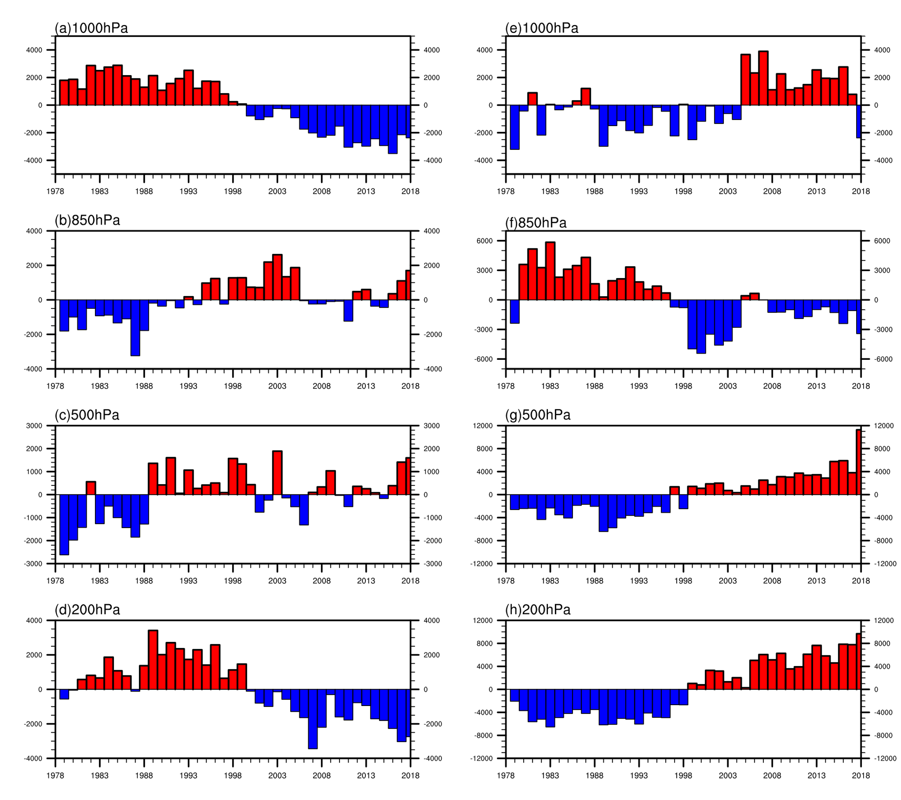

Figure. S1. The anomalies of the number of light shear events (a, b, c, d) and severe shear events (e, f, g, h) at four different pressure levels: 1000 hPa (a, e), 850 hPa (b, f), 500 hPa (c, g) and 200 hPa (d, h).

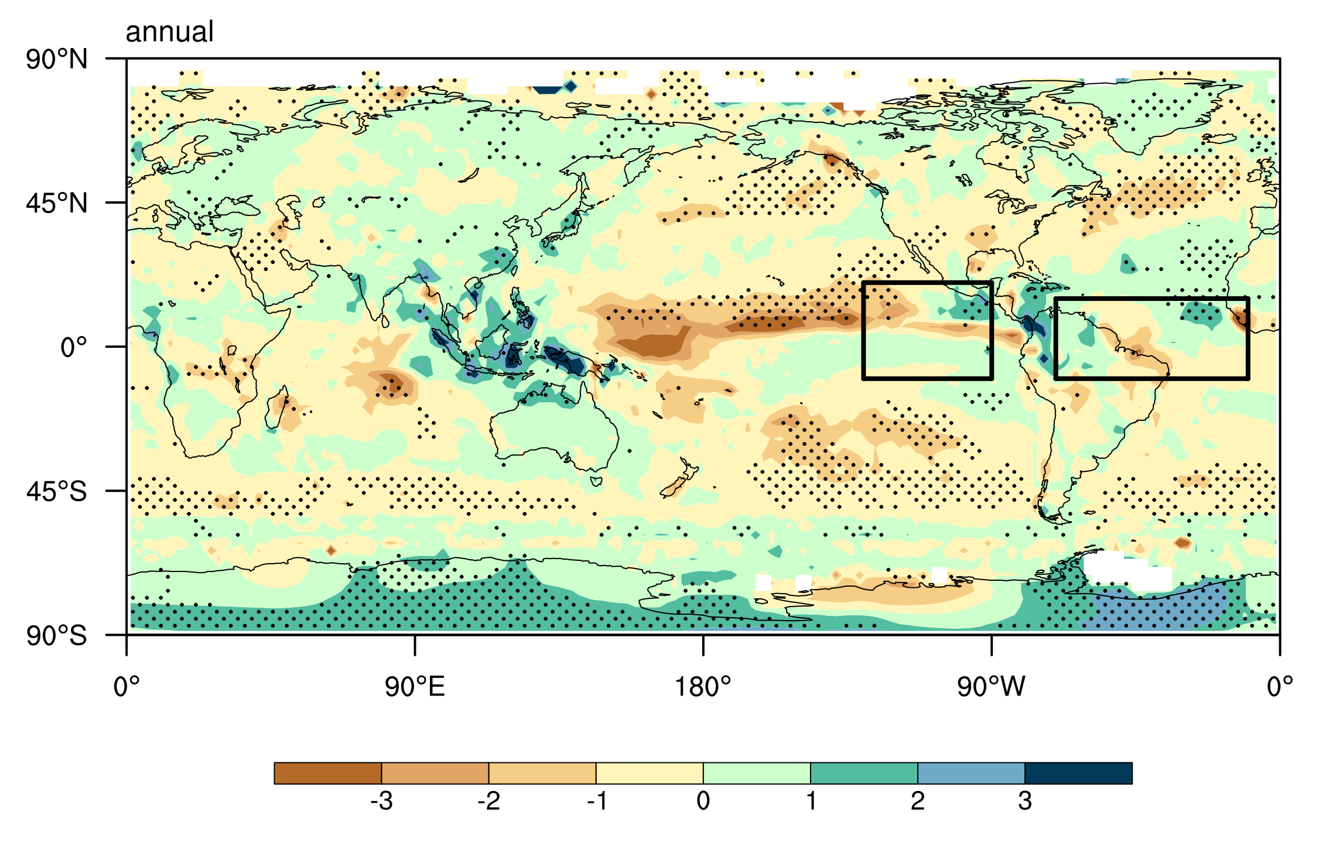Figure. S2. Global precipitation (units: mm/day) regressed on AMO index. Significant trends are indicated by stippling (two-tailed t-test; P < 0.10; n = 40).

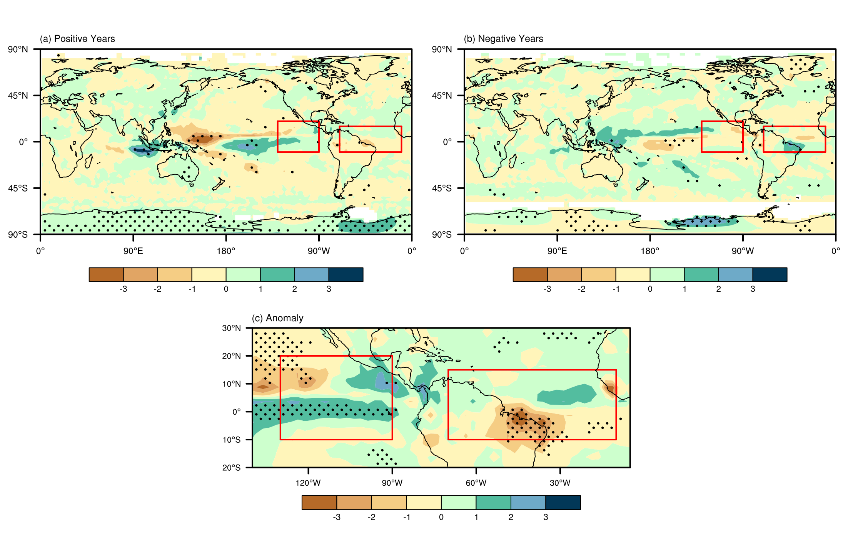
Figure. S3. Global precipitation calculated by composite years (units: mm/day). (a) is for AMO positive phase years. (b) is for AMO negative phase years. (c) is for the anomaly between (a) and (b). Significant trends are indicated by stippling (two-tailed t-test; P < 0.10; n = 40).

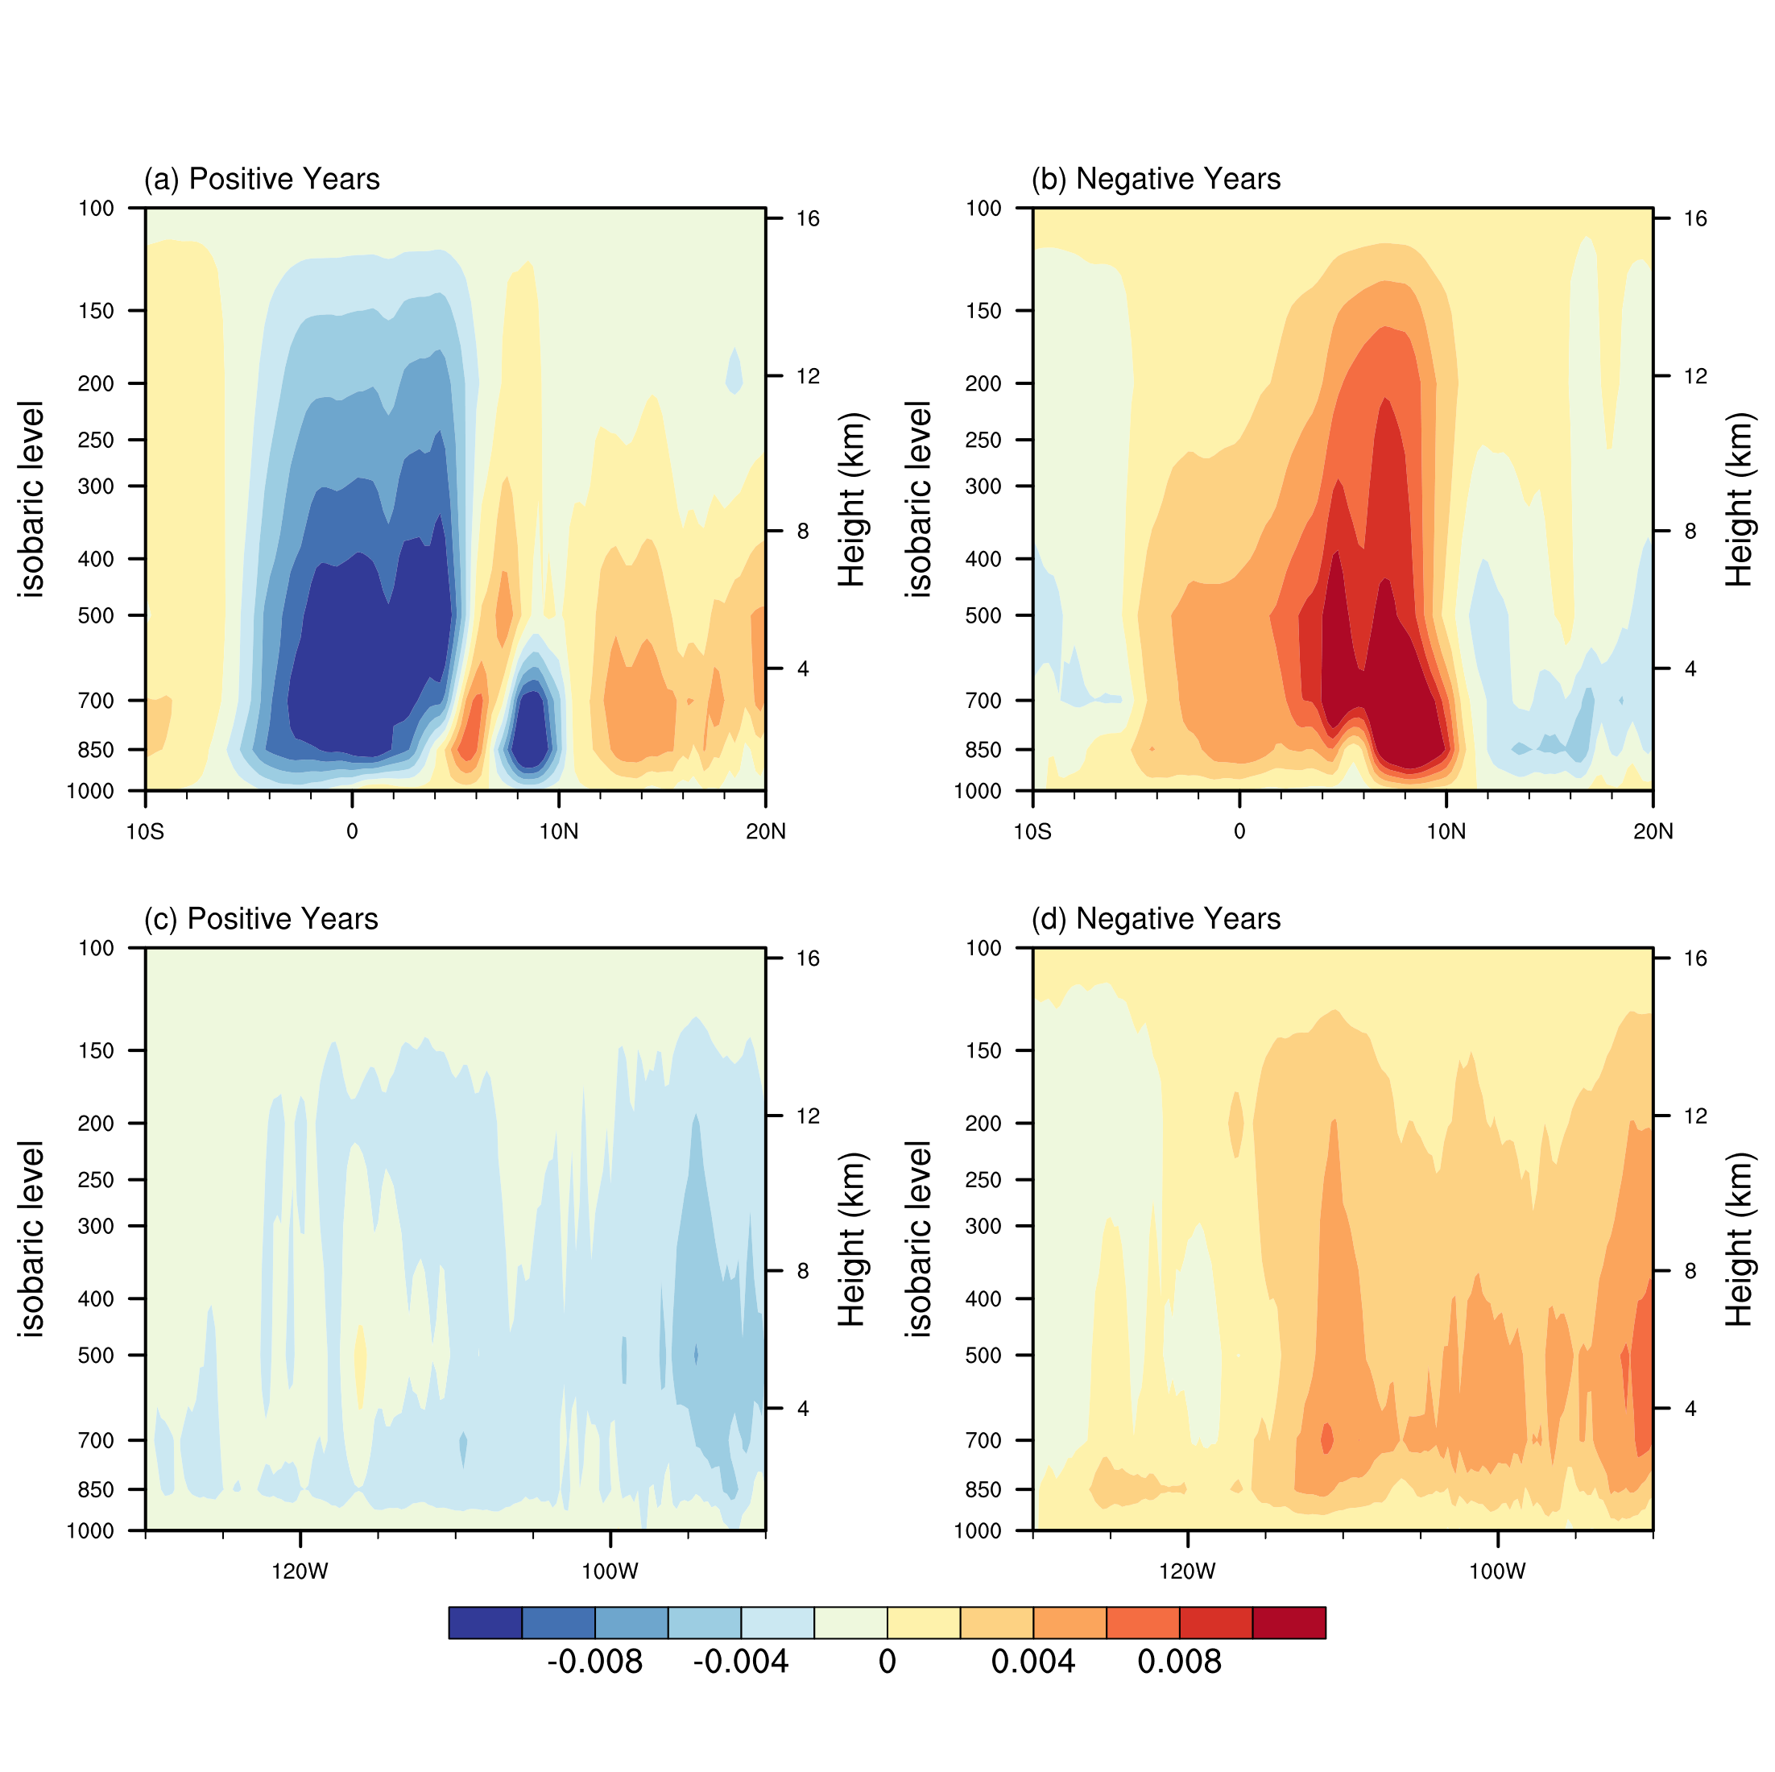
Figure. S4. Vertical velocity of East Pacific (units: Pa/s). (a) and (c) are for positive phase. (b) and (d) are for negative phase.

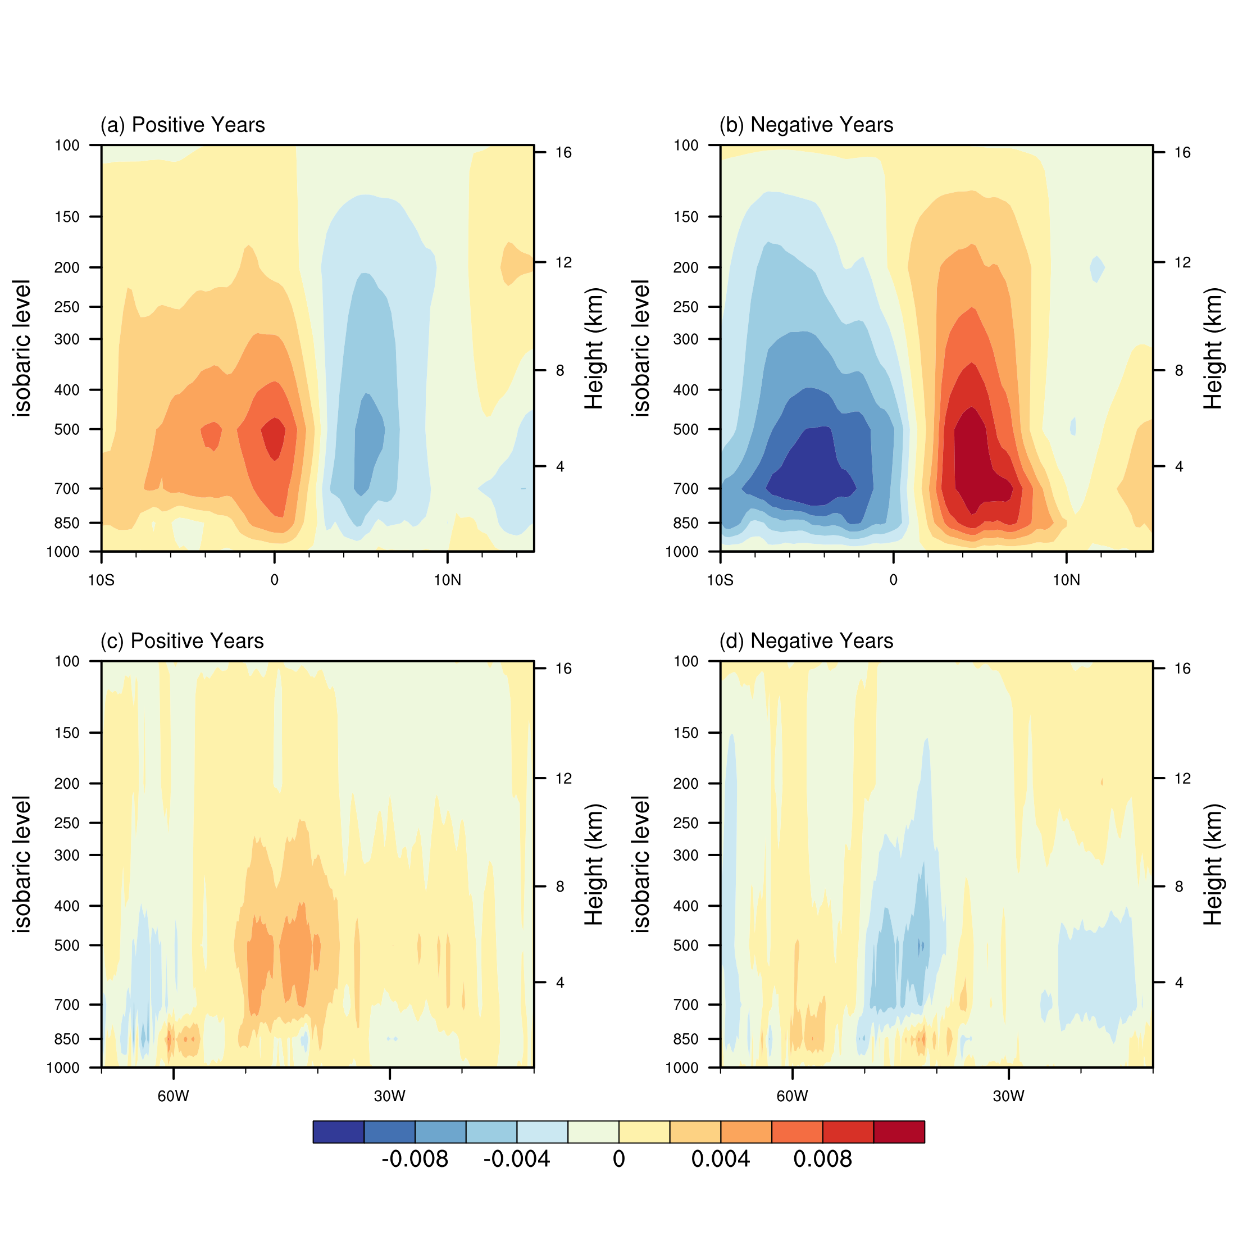
Figure. S5. As in Figure. S4, but for Atlantic.

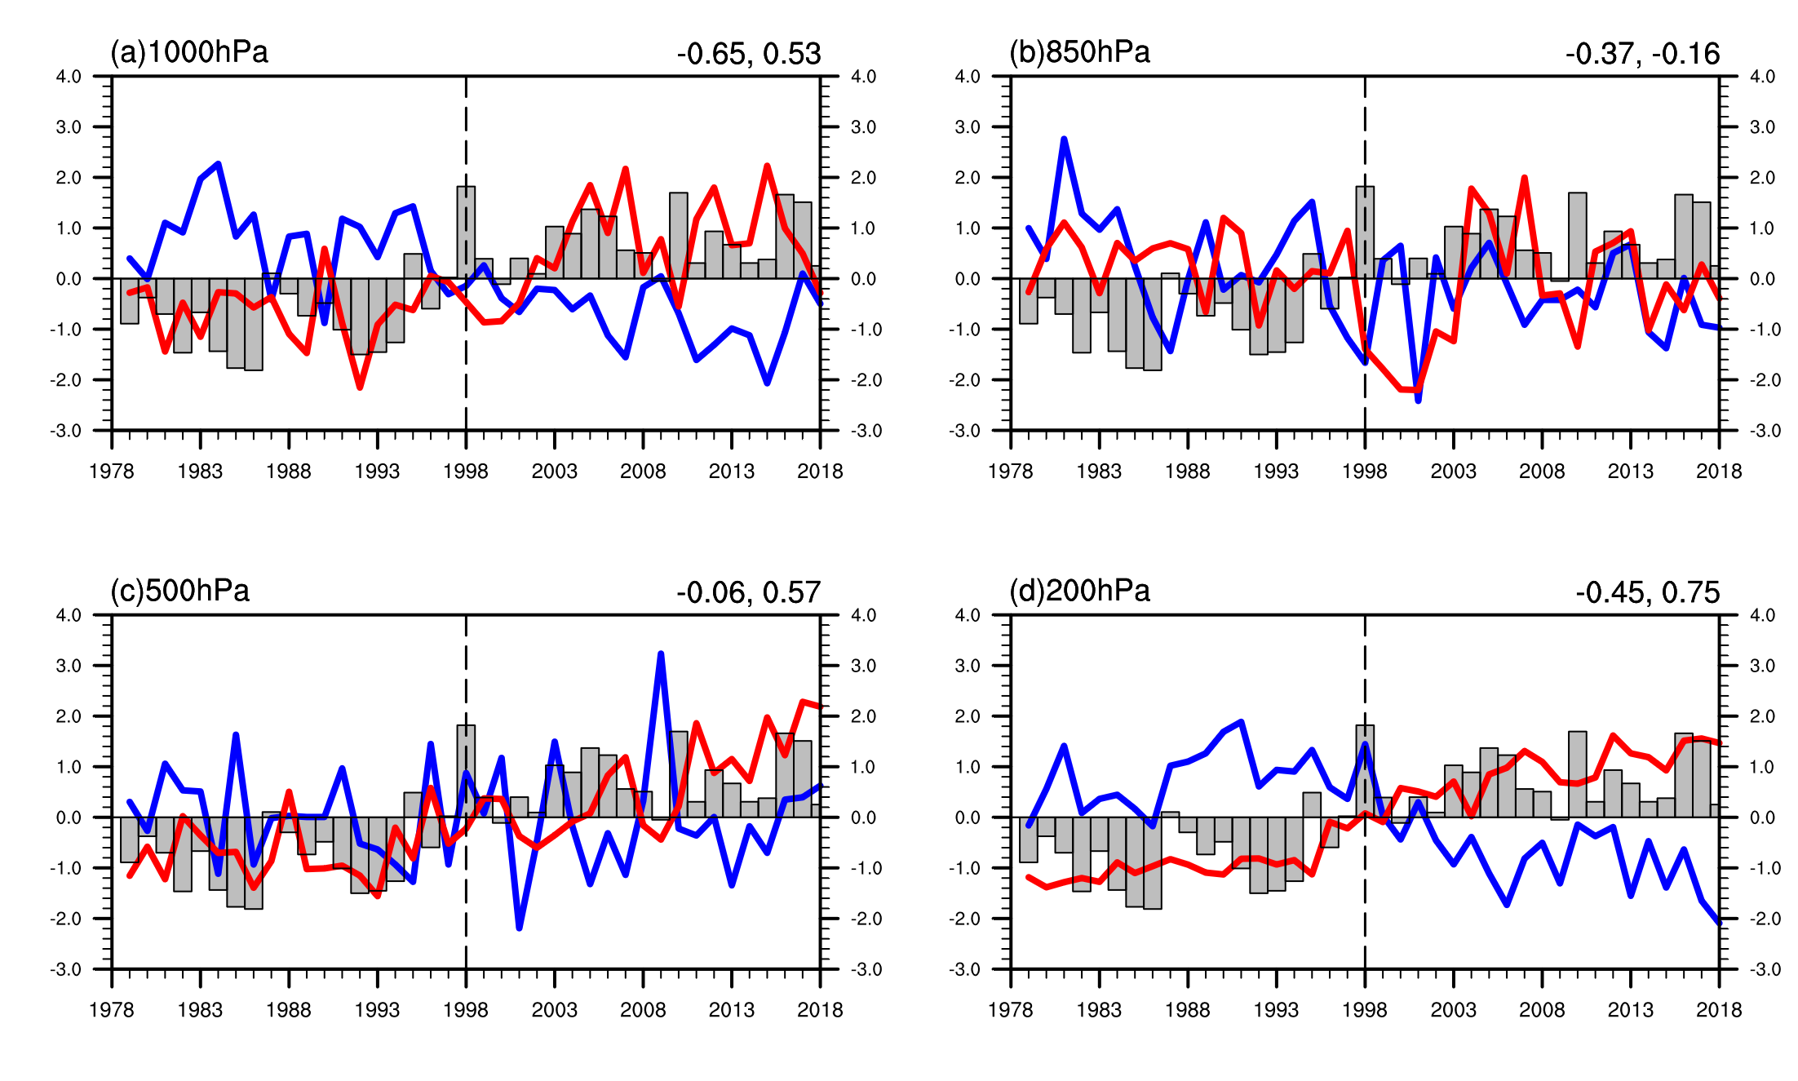
Figure. S6. The relationships between AMO index (grey bar) and the number of light shear events (blue line) and the number of severe shear events (red line) in boreal winter, respectively. (a)-(d) represent the 1000 hPa, 850 hPa, 500 hPa and 200 hPa pressure levels.

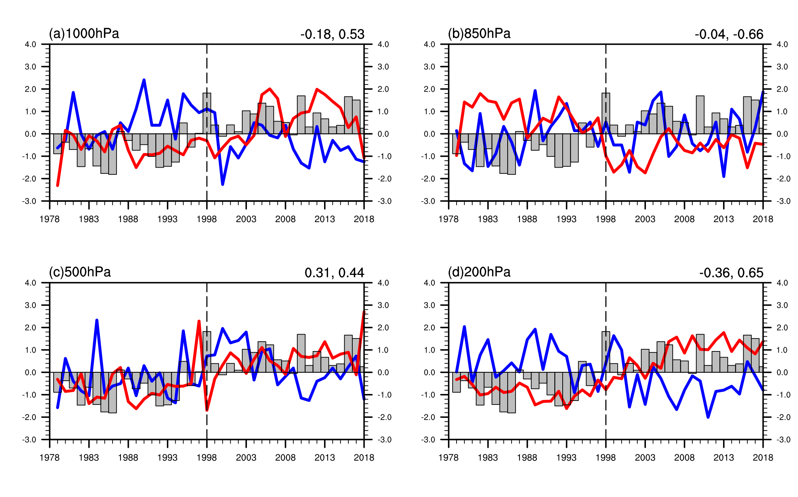
Figure. S7. The relationships between AMO index (grey bar) and the number of light shear events (blue line) and the number of severe shear events (red line) in boreal summer, respectively. (a)-(d) represent the 1000 hPa, 850 hPa, 500 hPa and 200 hPa pressure levels.

Figure. S8. The distribution of aviation crashes from 1979 to 2018. The red points denote the crashes locations and the contour areas over the land denote the altitude.

