Supplementary
Supplementary Figures:

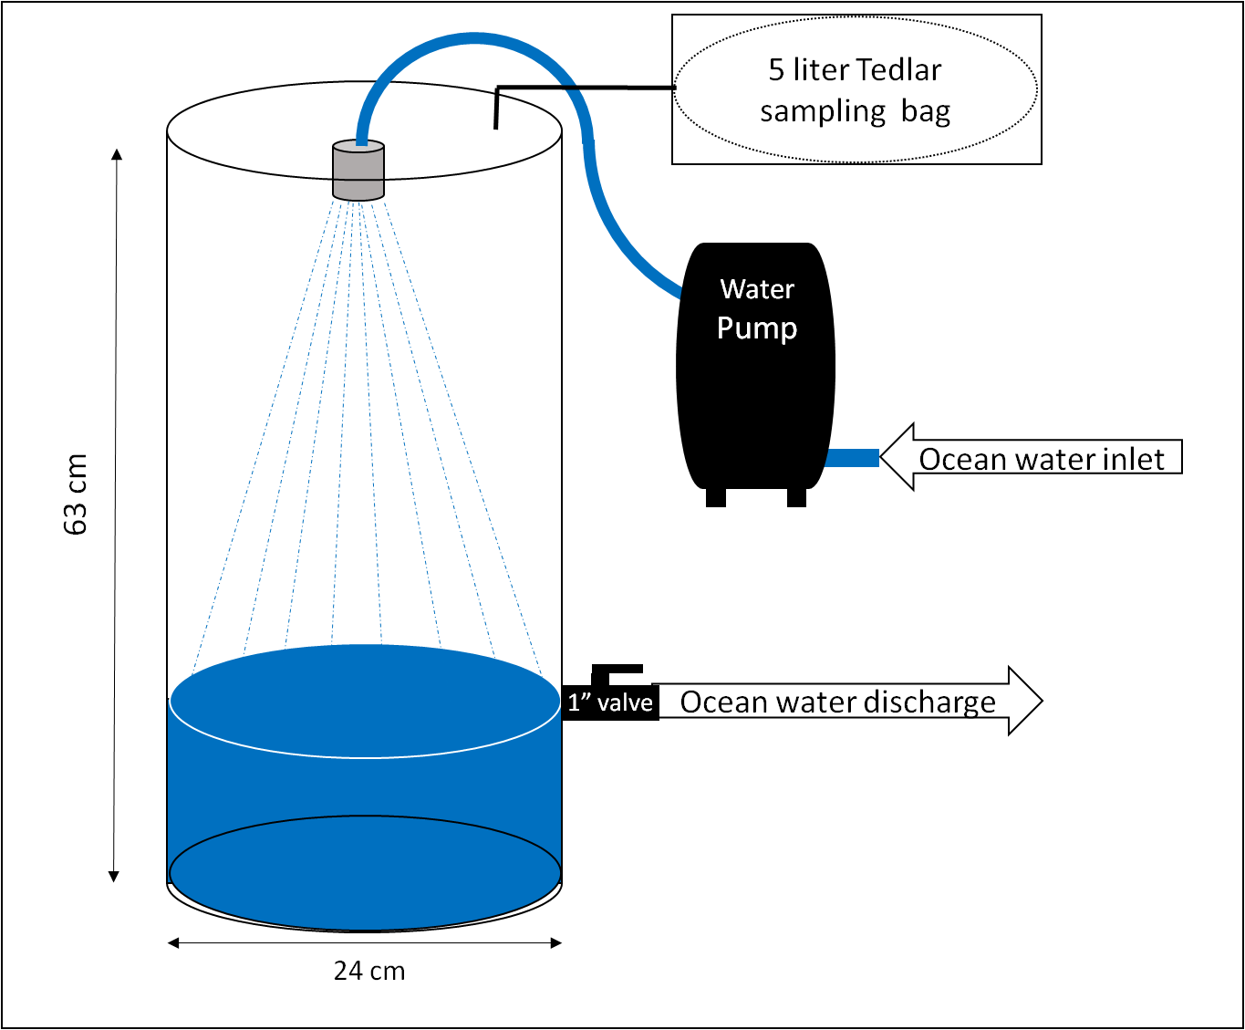
Supplementary Figure 1. Schematic figure of the air-seawater equilibrator used for measurements of aqueous COS, CS2, and DMS.

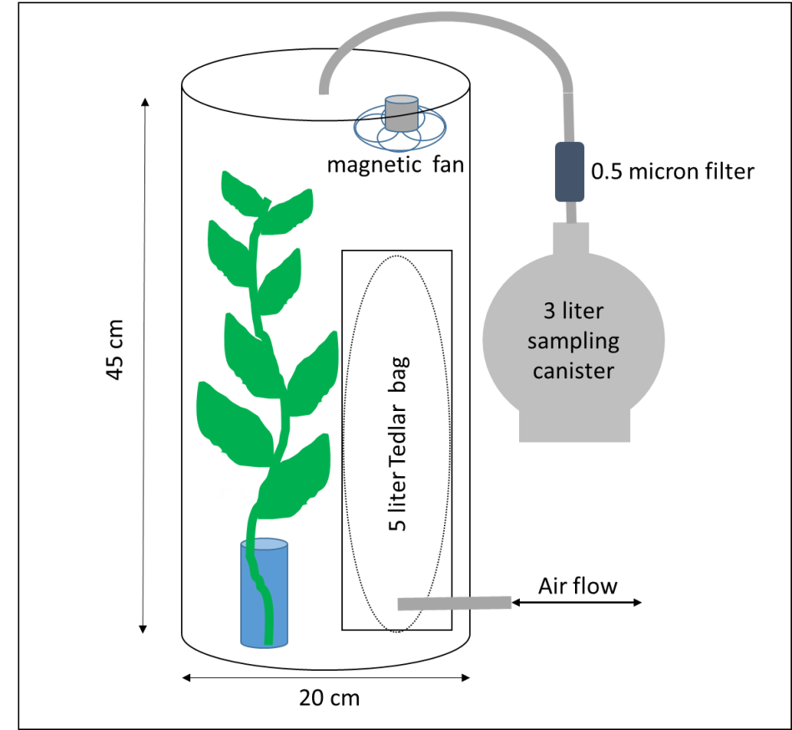
Supplementary Figure 2. Schematic figure of the plant chamber.
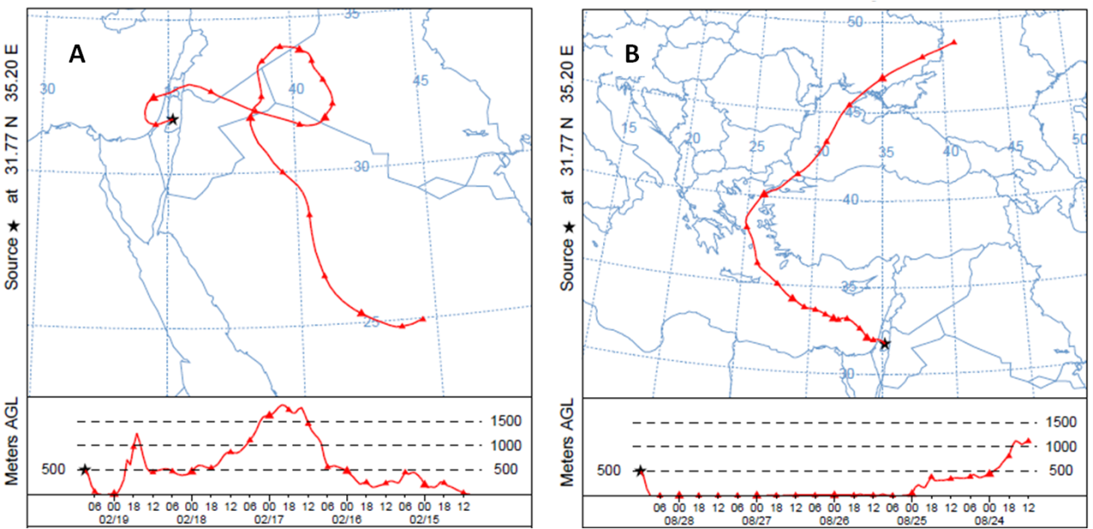
Supplementary Figure 3. Examples of land-influenced air mass (A) and sea-influenced air mass (B) back trajectories, calculated for 5 days before sampling in Israel (produced by NOAA HYSPLIT MODEL¹).

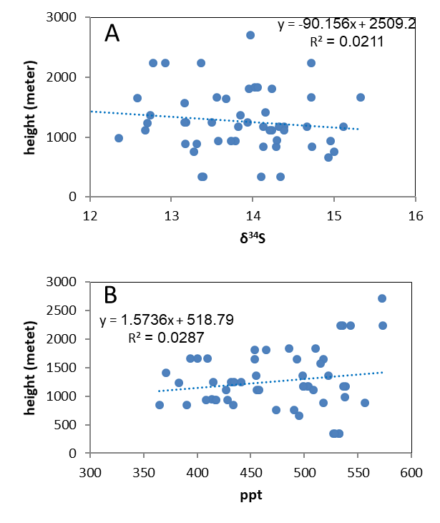
Supplementary Figure 4. A. Boundary layer height vs COS isotopic values; B. Boundary layer height vs COS concentration. Neither charts show any correlation, indicating that the non-seasonal variability we observed is mostly dominated by horizontal advection and not vertical mixing.

Supplementary Table 1. Detailed locations of air samples and seawater-equilibrated-air samples (sea samples).
 | Location | Lat/Long | n
Air samples | Jerusalem, Israel | 31°46'12''N/35°11'52''E | 52
Air samples | Haifa, Israel | 32°47'35''N/35°4'32''E | 4
Air samples | Arava Valey, Israel | 30°28'50''N/35°10'21''E | 4
Air samples | Eilat, Israel | 29°30'7''N/34°55'3''E | 6
Air samples | Mizpe Ramon, Israel | 30°36'17''N/34°48'5''E | 3
Air samples | Fuerteventura, The Canary Islands, Spain | 28°43'30''N/13°50'33''W | 4
Air samples | Harvard Forest, Massachusetts, U.S.A | 42°53'78''N/72°17'14''W | 8
Air samples | Cabo da Roca, Portugal | 38°4'26''N/9°29'6''E | 4
Air samples | Southern Ocean | 34°41'42''S/21°47'62''E | 1
Air samples | New Delhi, India | 28°60'52''N/77°24'19''E | 3
Sea samples | Red Sea | 29°30'70''N/34°55'30''ºE | 12
Sea samples | Mediterranean Sea (along a ~20 km transaction, ~50 west of the northern shore of Israel) | 32°89'00''N/34°93'63''E  to  33°03'67''N/34°29'30'' | 10

Supplementary information:
1. Vertical mixing: In this work, we neglect small sources and sinks of the tropospheric COS for the sake of simplicity. However stratospheric oxidation was suggested to have a strong fractionation factor of ~70%.² Such a strong fractionation should have a dramatic effect on COS isotopes and may not be ignored. More recent studies suggest that the stratospheric oxidation factor is much smaller, with a fractionation factor of -2.3‰ to -8‰^{3,4} Yet to neglect stratospheric oxidation from the isotopic mass balance, it is crucial to verify that vertical mixing does not affect our air samples. Thus, to examine the vertical mixing effect, we compared the atmospheric boundary layer height (derived from ERA5, Copernicus Climate Change Service (C3S) (2017): ERA5: Fifth generation of ECMWF atmospheric reanalysis of the global climate. Copernicus Climate Change Service Climate Data Store (CDS), date of access 02.02.2020. https://cds.climate.copernicus.eu/cdsapp#!/home) of each air sample to its δ³⁴S values and found no correlation (R²=0.02), and also no correlation with COS concentrations (R²=0.03) (supplementary figure 4). This indicates that the non-seasonal variability we observed is mostly dominated by horizontal advection and not vertical mixing, and implies that the stratospheric COS oxidation process does not have a large fractionation factor.
2. Harvard forest sampling: In this work, we mainly discussed the plant uptake, anthropogenic, and oceanic effects on tropospheric COS isotopic value. However, recent studies emphasize the role of other ecosystem processes such as soil bacterial uptake and production on the COS budget.^{5,6} Our sampling campaigns in Harvard Forest, Massachusetts U.S.A (HFM; 42.5378°N/72.1714°W) were done immediately before and after the growing season (April 25th, 2019 and August 29th, 2019). The concentrations measurements show the known strong COS seasonal cycle at this site, with 520±10 ppt on April and 360±20ppt on August (NOAA monitoring program HFM station show on similar dates 470±1 ppt and 378±0.5 ppt respectively; provided by NOAA ESRL Global Monitoring Laboratory, Boulder, Colorado, USA (https://esrl.noaa.gov/gmd/)⁷). However, isotopic measurements did not show a significant seasonal difference, with δ³⁴S values of 13.9±0.1 in April and 13.4±0.4 in August. These unexpected results may be related to soil bacterial uptake/production or plant COS release due to heat stress. According to Commane et al,⁶ nighttime flux, associated with soil bacterial uptake, in Harvard Forest accounted for ~28% of total uptake during 2011. Furthermore, they reported strong emissions of COS during midday hours in late July 2011, when soil moisture was lowest and the temperature was warmest (this phenomenon may be associated with soil or plant stress). ⁶ It is reasonable that the processes discussed above have a unique isotopic signature, and thus, may have a strong effect on local COS δ³⁴S values. The isotopic approach presented here, together with soil chamber experiments, may provide new insights on the processes discussed above.

References

1 Stein, A. et al. SUPPLEMENT: DETAILED DESCRIPTION OF THE MODEL UPDATES. Bulletin of the American Meteorological Society 96, ES203-ES207 (2015).
2 Leung, F. Y. T., Colussi, A. J., Hoffmann, M. R. & Toon, G. C. Isotopic fractionation of carbonyl sulfide in the atmosphere: Implications for the source of background stratospheric sulfate aerosol. Geophysical Research Letters 29, 112-111-112-114 (2002).
3 Hattori, S. et al. Ultraviolet absorption cross sections of carbonyl sulfide isotopologues OC 32 S, OC 33 S, OC 34 S and O 13 CS: isotopic fractionation in photolysis and atmospheric implications. Atmospheric Chemistry and Physics 11, 10293-10303 (2011).
4 Schmidt, J. A. et al. OCS photolytic isotope effects from first principles: sulfur and carbon isotopes, temperature dependence and implications for the stratosphere. Atmospheric Chemistry and Physics 13, 1511-1520 (2013).5 Whelan, M. E. et al. Reviews and syntheses: Carbonyl sulfide as a multi-scale tracer for carbon and water cycles. Biogeosciences 15, 3625-3657 (2018).
6 Commane, R. et al. Seasonal fluxes of carbonyl sulfide in a midlatitude forest. Proceedings of the National Academy of Sciences 112, 14162-14167 (2015).
7 Montzka, S. et al. On the global distribution, seasonality, and budget of atmospheric carbonyl sulfide (COS) and some similarities to CO2. Journal of Geophysical Research: Atmospheres 112 (2007).

