Assessing strong consistency of symmetrical solid-state supercapacitors based on three-dimensional porous carbon material
P.A. Le¹, Van Qui Le^{2,3}, Thi Viet Bac Phung¹*, Nghia Trong Nguyen⁴*
¹ Institute of Sustainability Science, Vietnam-Japan University, Vietnam National University-Hanoi, Hanoi, Vietnam.
² Laboratory of Advanced Materials Chemistry, Advanced Institute of Materials Science,
Ton Duc Thang University, Ho Chi Minh, Vietnam.
³ Faculty of Applied Sciences, Ton Duc Thang University, Ho Chi Minh, Vietnam.
⁴ School of Chemical Engineering, Hanoi University of Science and Technology, Hanoi, Vietnam.
*Corresponding author:
Nghia Trong Nguyen; E-mail: nghia.nguyentrong@hust.edu.vn
Thi Viet Bac Phung; E-mail: ptv.bac@vju.ac.vn

1 Powder characterization
1.1 BET data in this report
1.1.1 Commercial activated carbon
Summary Report
Surface Area
Single point surface area at P/Po = 0.202185304: 889.2957 m²/g
BET Surface Area: 885.5030 m²/g
Langmuir Surface Area: 1158.6500 m²/g
t-Plot Micropore Area: 552.2905 m²/g
t-Plot External Surface Area: 333.2126 m²/g
BJH Adsorption cumulative surface area of pores
between 1.7000 nm and 300.0000 nm diameter: 245.682 m²/g
BJH Desorption cumulative surface area of pores
between 1.7000 nm and 300.0000 nm diameter: 263.6999 m²/g
Pore Volume
Single point adsorption total pore volume of pores
less than 196.3680 nm diameter at P/Po = 0.990058070: 0.602542 cm³/g
t-Plot micropore volume: 0.249866 cm³/g
BJH Adsorption cumulative volume of pores
between 1.7000 nm and 300.0000 nm diameter: 0.319187 cm³/g
BJH Desorption cumulative volume of pores
between 1.7000 nm and 300.0000 nm diameter: 0.321838 cm³/g
Pore Size
Adsorption average pore width (4V/A by BET): 2.72181 nm

BJH Adsorption average pore diameter (4V/A): 5.1967 nm
BJH Desorption average pore diameter (4V/A): 4.8819 nm
1.1.2 Commercial black carbon
Summary Report
Surface Area
Single point surface area at P/Po = 0.200128086: 51.9548 m²/g
BET Surface Area: 49.6578 m²/g
Langmuir Surface Area: 64.5366 m²/g
t-Plot Micropore Area: 49.0396 m²/g
t-Plot External Surface Area: 0.6183 m²/g
BJH Adsorption cumulative surface area of pores
between 1.7000 nm and 300.0000 nm diameter: 17.463 m²/g
BJH Desorption cumulative surface area of pores
between 1.7000 nm and 300.0000 nm diameter: 21.2019 m²/g
Pore Volume
Single point adsorption total pore volume of pores
less than 354.6759 nm diameter at P/Po = 0.994535210: 0.148730 cm³/g
t-Plot micropore volume: 0.022863 cm³/g
BJH Adsorption cumulative volume of pores
between 1.7000 nm and 300.0000 nm diameter: 0.134164 cm³/g
BJH Desorption cumulative volume of pores
between 1.7000 nm and 300.0000 nm diameter: 0.135393 cm³/g
Pore Size
Adsorption average pore width (4V/A by BET): 11.98043 nm
BJH Adsorption average pore diameter (4V/A): 30.7307 nm
BJH Desorption average pore diameter (4V/A): 25.5436 nm
1.1.3 Carbon P
Summary Report
Surface Area
Single point surface area at P/Po = 0.204014519: 1335.4627 m²/g
BET Surface Area: 1348.1072 m²/g
Langmuir Surface Area: 1783.4169 m²/g
t-Plot Micropore Area: 765.8650 m²/g
t-Plot External Surface Area: 582.2422 m²/g
BJH Adsorption cumulative surface area of pores
between 1.7000 nm and 300.0000 nm diameter: 289.409 m²/g
BJH Desorption cumulative surface area of pores
between 1.7000 nm and 300.0000 nm diameter: 289.0496 m²/g
Pore Volume
Single point adsorption total pore volume of pores
less than 314.5005 nm diameter at P/Po = 0.993829229: 0.655554 cm³/g
t-Plot micropore volume: 0.339081 cm³/g
BJH Adsorption cumulative volume of pores
between 1.7000 nm and 300.0000 nm diameter: 0.193942 cm³/g
BJH Desorption cumulative volume of pores
between 1.7000 nm and 300.0000 nm diameter: 0.190626 cm³/g
Pore Size
Adsorption average pore width (4V/A by BET): 1.94511 nm
BJH Adsorption average pore diameter (4V/A): 2.6805 nm
BJH Desorption average pore diameter (4V/A): 2.6380 nm
1.2 Carbon P
Figure S1 SEM imagine of highly porous carbon P at various magnification.

1.3 Electrochemical characterization
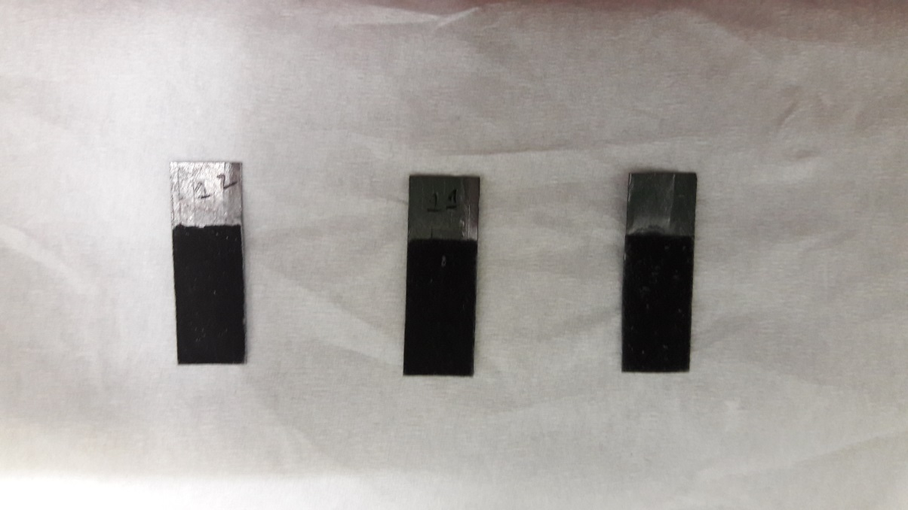
Figure S2 Images of working electrode: carbon P (12), activated carbon (11), and black carbon (10), respectively.
Figure S3 Electrochemical properties of activated carbon and black carbon: (a, b) CV curves and (c, d) GCD curves, respectively.

Electronic Supplementary Video 1


Electronic Supplementary Video 2

