Extended Data Table 1 | Comparison of swelling characterization techniques.
Type | In-situ detection | Dynamic detection | Detection parameters | Temporal resolution | Spatial resolution | Detection range | Ref
EQCM-D | No | Yes | Film quality | ~5 ms | No | sub-ng ~ μg | ^{8,15,18,53-58}
GIWAXS | Yes | No | Crystal lattice | No | ~mm | / | ^{15,18,19,59}
4D-STEM | No | No | Crystal lattice | No | ~10 nm | / | ¹⁷
AFM | Yes | No | Film thickness | No | ~0.1 nm (X/Y axis)  ~10 pm  (Z axis) | pm ~ μm | ^{16,18}
ESM | Yes | No | Film thickness | No | ~0.1 nm (X/Y axis)  ~10 pm  (Z axis) | pm ~ μm | ^{16,18}
LDV-M | Yes | Yes | Film thickness | ~10 ns | ~1 μm  (X/Y axis)  ~600 pm  (Z axis) | nm ~ mm | This  work

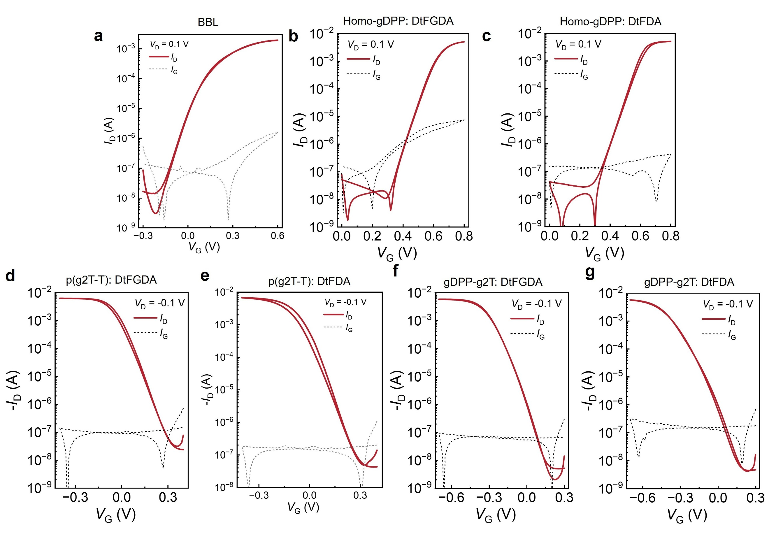
Extended Data Fig. 1 | Representative transfer curves of vOECTs with different OMIECs. (a)BBL; (b) Homo-gDPP:GDA; (c) Homo-gDPP:DA; (d) p(g2T-T):GDA; (e) p(g2T-T):DA; (f) gDPP-g2T:GDA; (g) gDPP-g2T:DA.
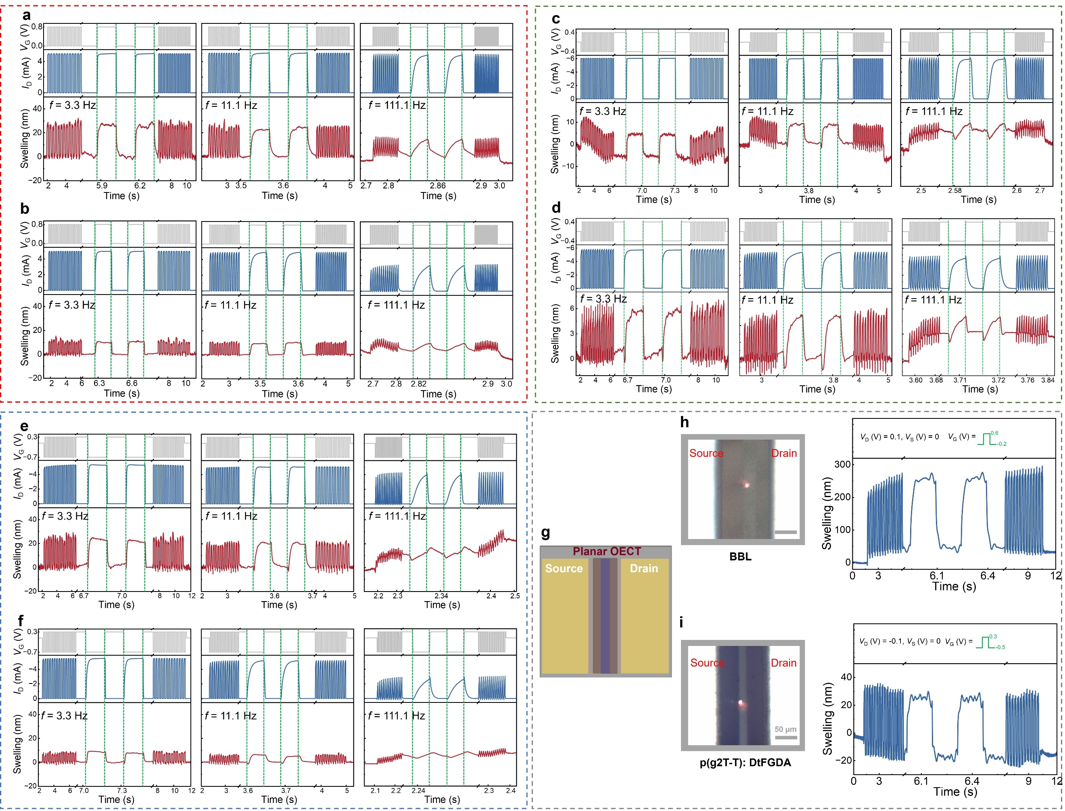
Extended Data Fig. 2 | Single-point swelling behavior of OECT channels based on various polymers. Swelling behavior of vOECT channels based on (a) Homo-gDPP:GDA, (b) Homo-gDPP:DA, (c) p(g2T-T):GDA, (d) p(g2T-T):DA, (e) gDPP-g2T:GDA, and (f) gDPP-g2T:DA, respectively, under switching frequencies of 3.3 Hz, 11.1 Hz, and 111.1 Hz. g, Illustration of the planar OECT. h, Laser spot position of LDV-M on a planar OECT based on BBL and single point swelling behaviors. i, Laser spot position of LDV-M on a planar OECT based on p(g2T-T):GDA and single point swelling behaviors. 3.3Hz V_{G} switching frequency is applied. Note that the active swelling magnitudes in planar OECTs are obviously larger than those in vOECTs (Figs. 2c and Extended Data Fig. 2c), indicating that vertical architecture can effectively suppress the swelling of the channel³⁹.

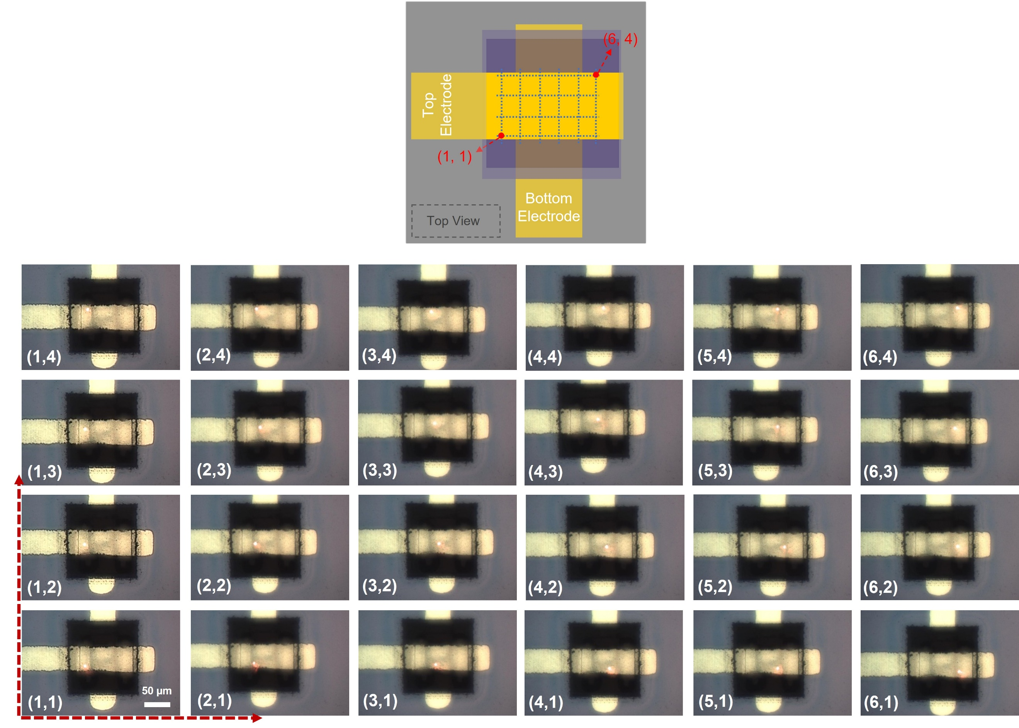
Extended Data Fig. 3 | Laser spot position during mapping. 3D swell mapping is performed by subsequently monitoring the swelling of each point. Specifically, starting from the lower left corner (1,1), the system collects the swelling data step-by-step from (1,1) to (6,1), then moves to (2,1), continuing to collect the data from (2,y). Following this sequence, swelling of the whole vOECT channel is measured point-by-point until reaching point (6,4). Note, the displacement process is controlled by the planar electrical positioning stage, which enables displacement regulation with 1 μm precision. Note, faster mapping can be enabled with a laser equipped with a micro mirror, where the mirror controls the laser spot on the channel, instead of by moving the stage holding the OECT.

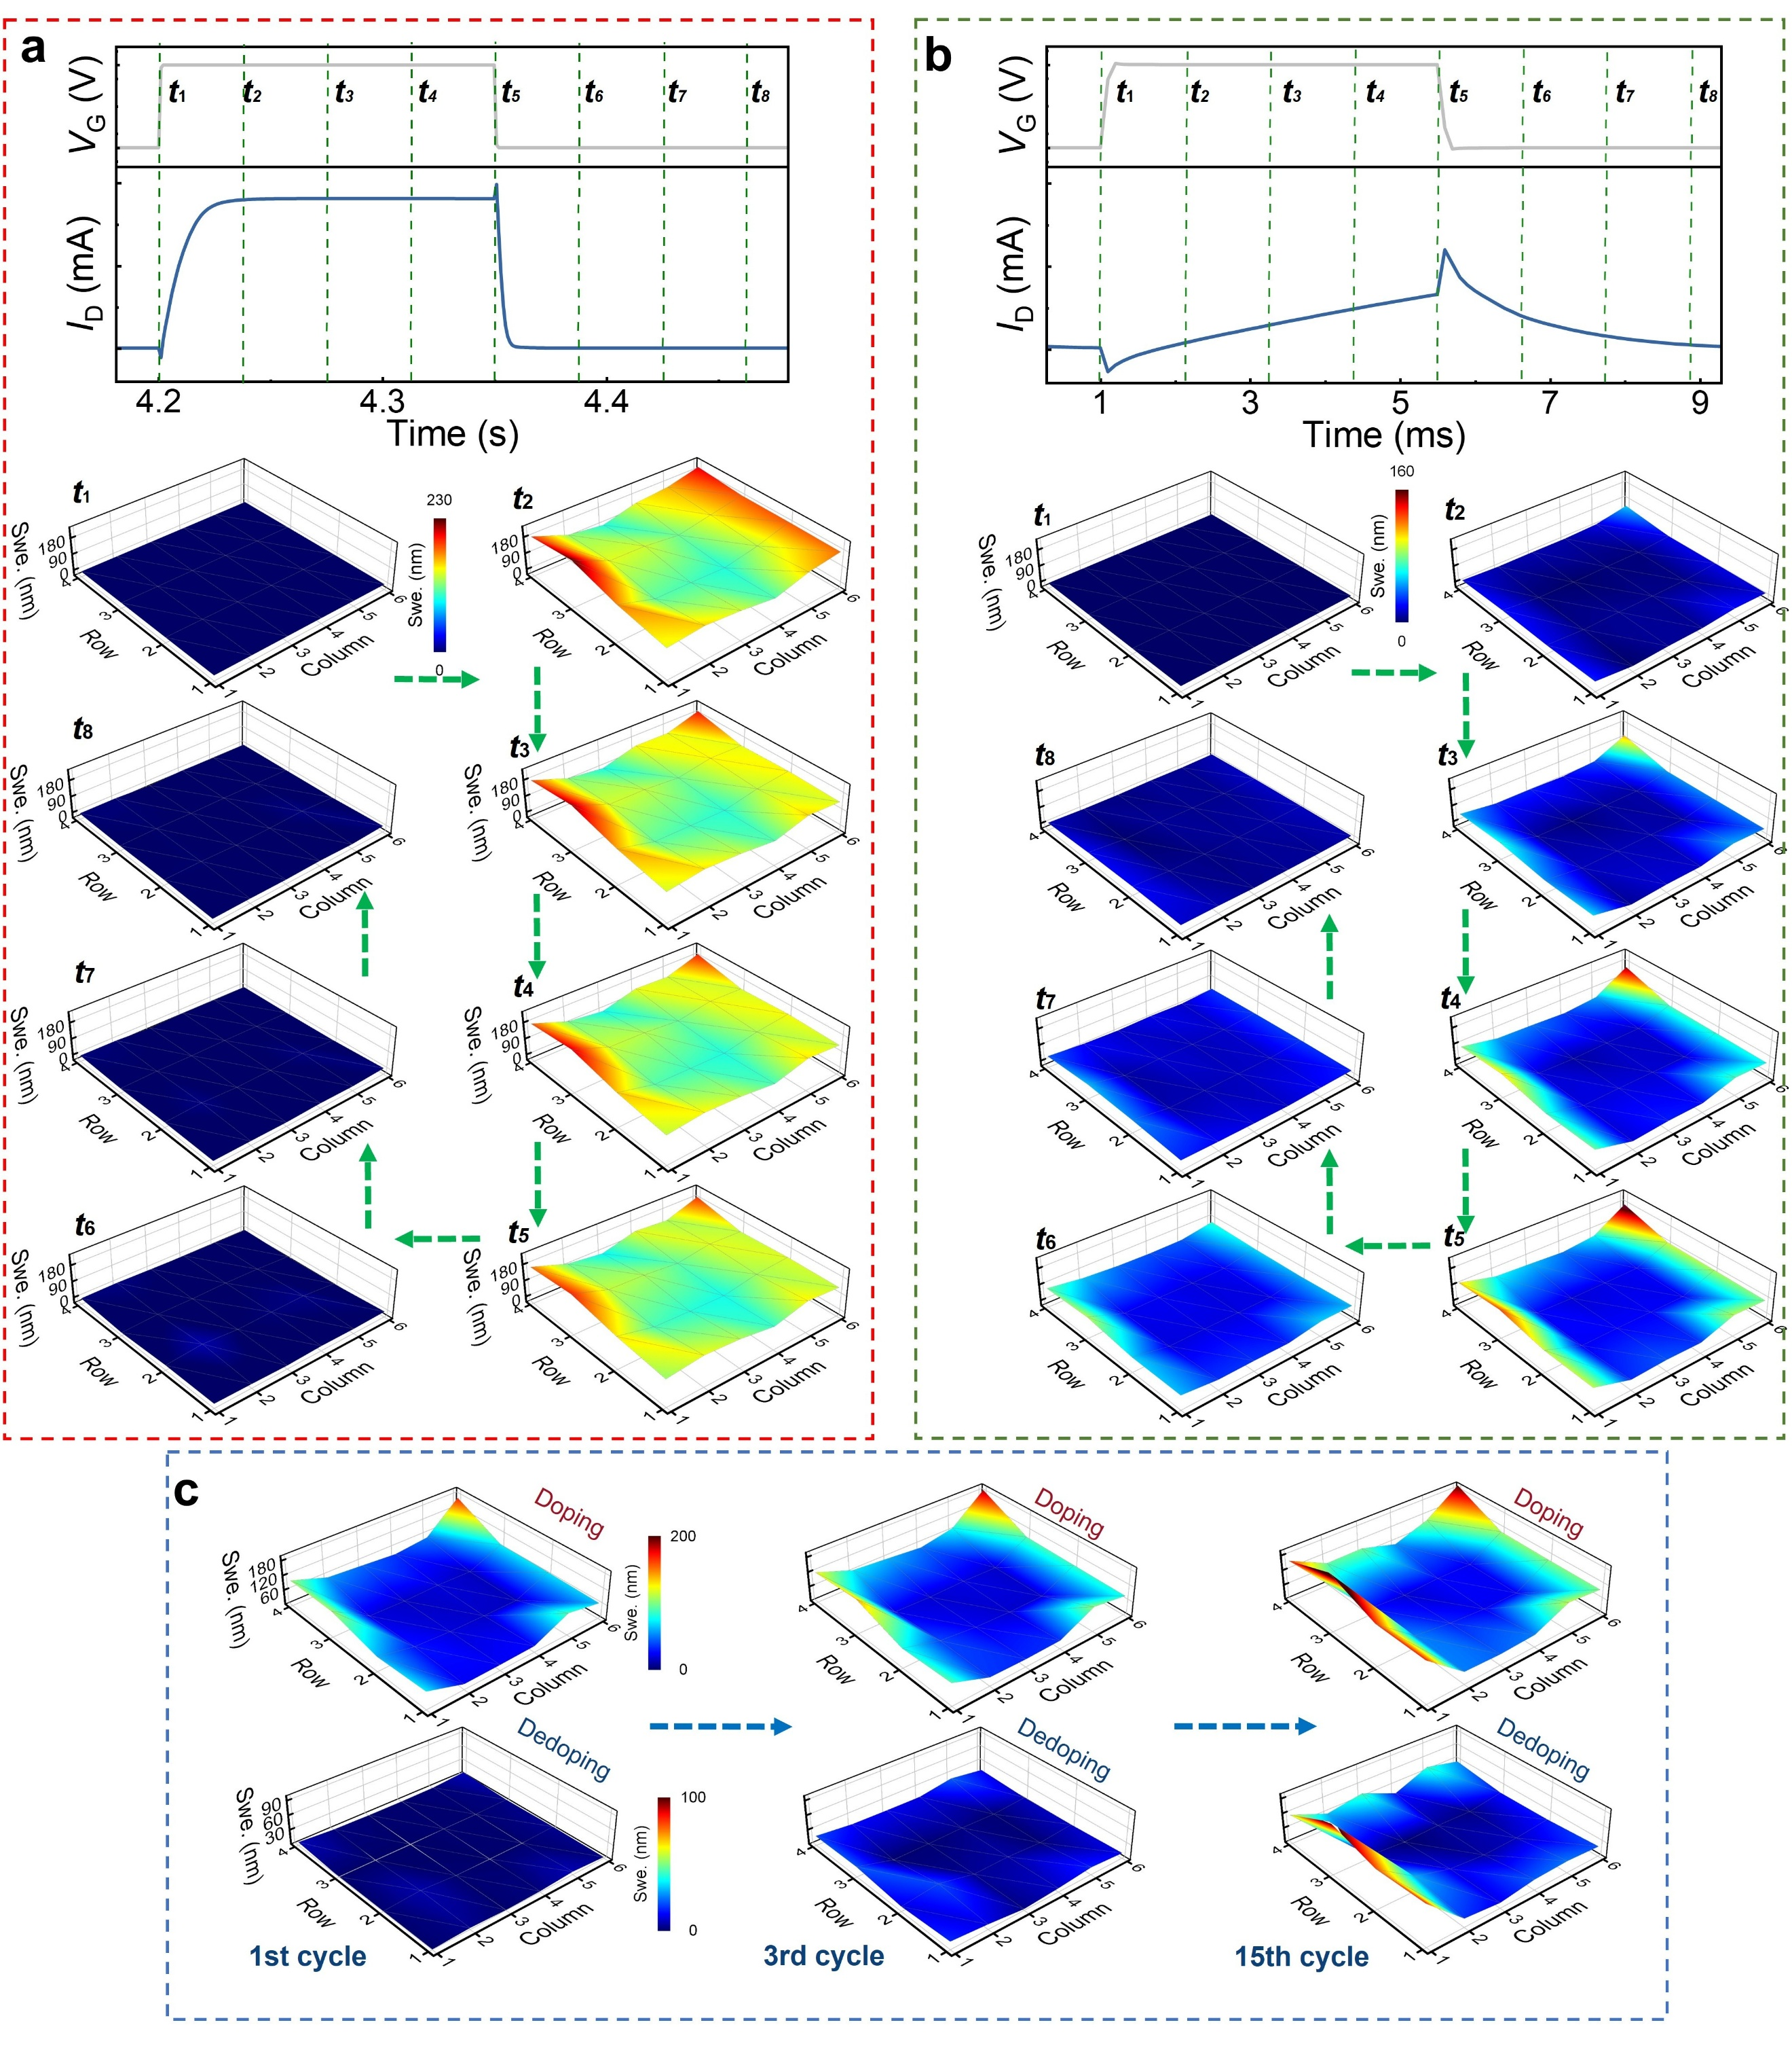
Extended Data Fig. 4 | 3D swell mapping of BBL channel under different switching frequencies and different cycles. a-b, 3D swell mapping under 3.3 Hz and 111.1 Hz switching frequencies, along with an I_{D} switching cycle and corresponding 3D swell mapping frames for each. c, 3D swell mapping of BBL-based vOECT during indicated cycling numbers (111.1 Hz switching frequency).

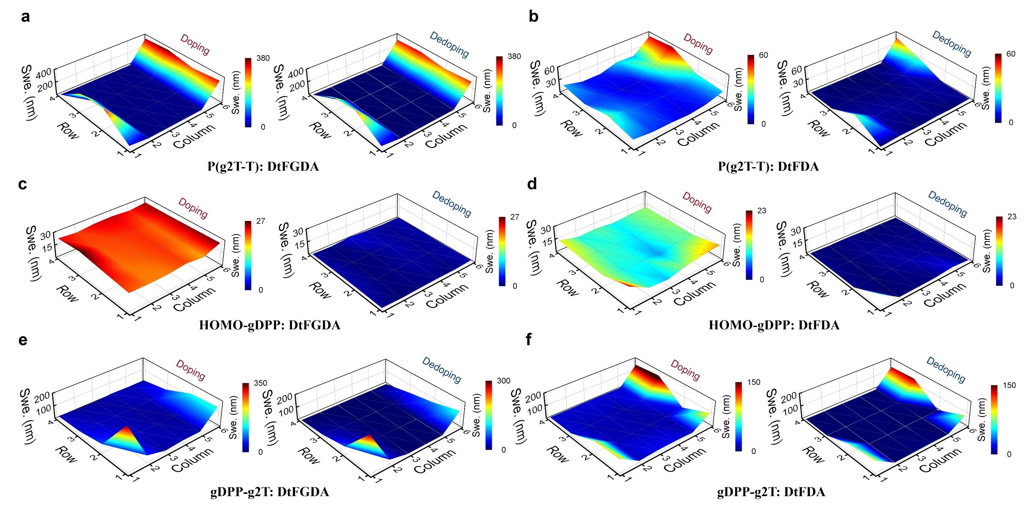
Extended Data Fig. 5 | 3D swell mappings of vOECTs based on different polymers. a, p(g2T-T):GDA, (b) p(g2T-T):DA, (c) Homo-gDPP:GDA, (d) Homo-gDPP:DA, (e) gDPP-g2T:GDA, (f) gDPP-g2T:DA-based vOECTs. Note, the doping and dedoping frames are all from a 3.3 Hz switching frequency upon a relatively stable I_{D} after 15 switching cycles.

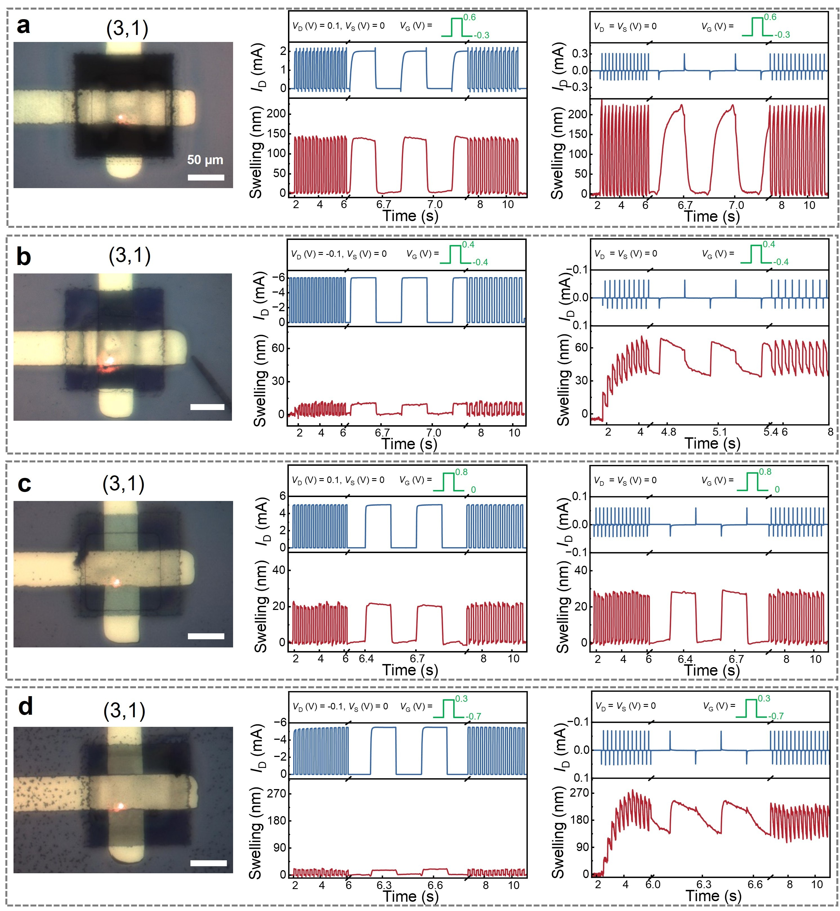
Extended Data Fig. 6 | Effect of vertical Coulombic forces on swelling. (a) BBL, (b) p(g2T-T):GDA, (c) Homo-gDPP:GDA, and (d) gDPP-g2T:GDA-based vOECTs demonstrating the optical microscope images of the channels with a laser spot positioned at location (3,1), along with the channel swelling behaviors with two different bias situations (V_{D} = 0.1 V, V_{S} = 0 V; or V_{D} = V_{S} = 0 V).

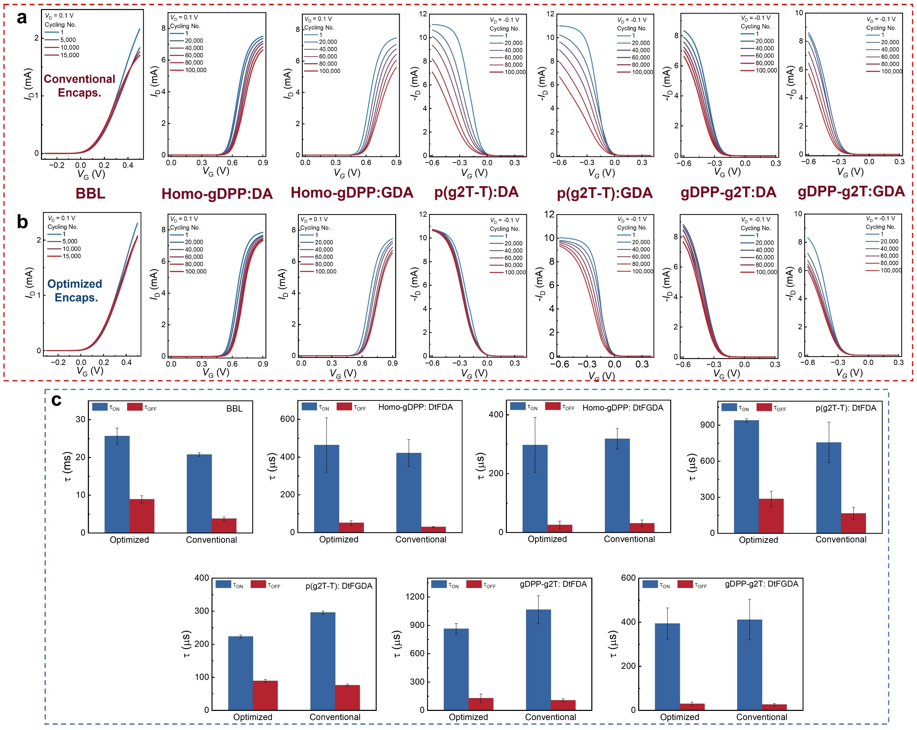
Extended Data Fig. 7 | Transfer characteristics of vOECTs with conventional or optimized encapsulations after indicated switching cycles, along with their I_{D} switching transient times. Transfer characteristic curves of vOECTs based on different materials (BBL, Homo-gDPP:DA, Homo-gDPP:GDA, p(g2T-T):DA, p(g2T-T):GDA, gDPP-g2T:DA, and gDPP-g2T:GDA) under (a) optimized encapsulations and (b) conventional encapsulations at different switching cycles. c, Their transient response times under different encapsulation methods (Standard deviations are based on the performance of at least 3 devices).

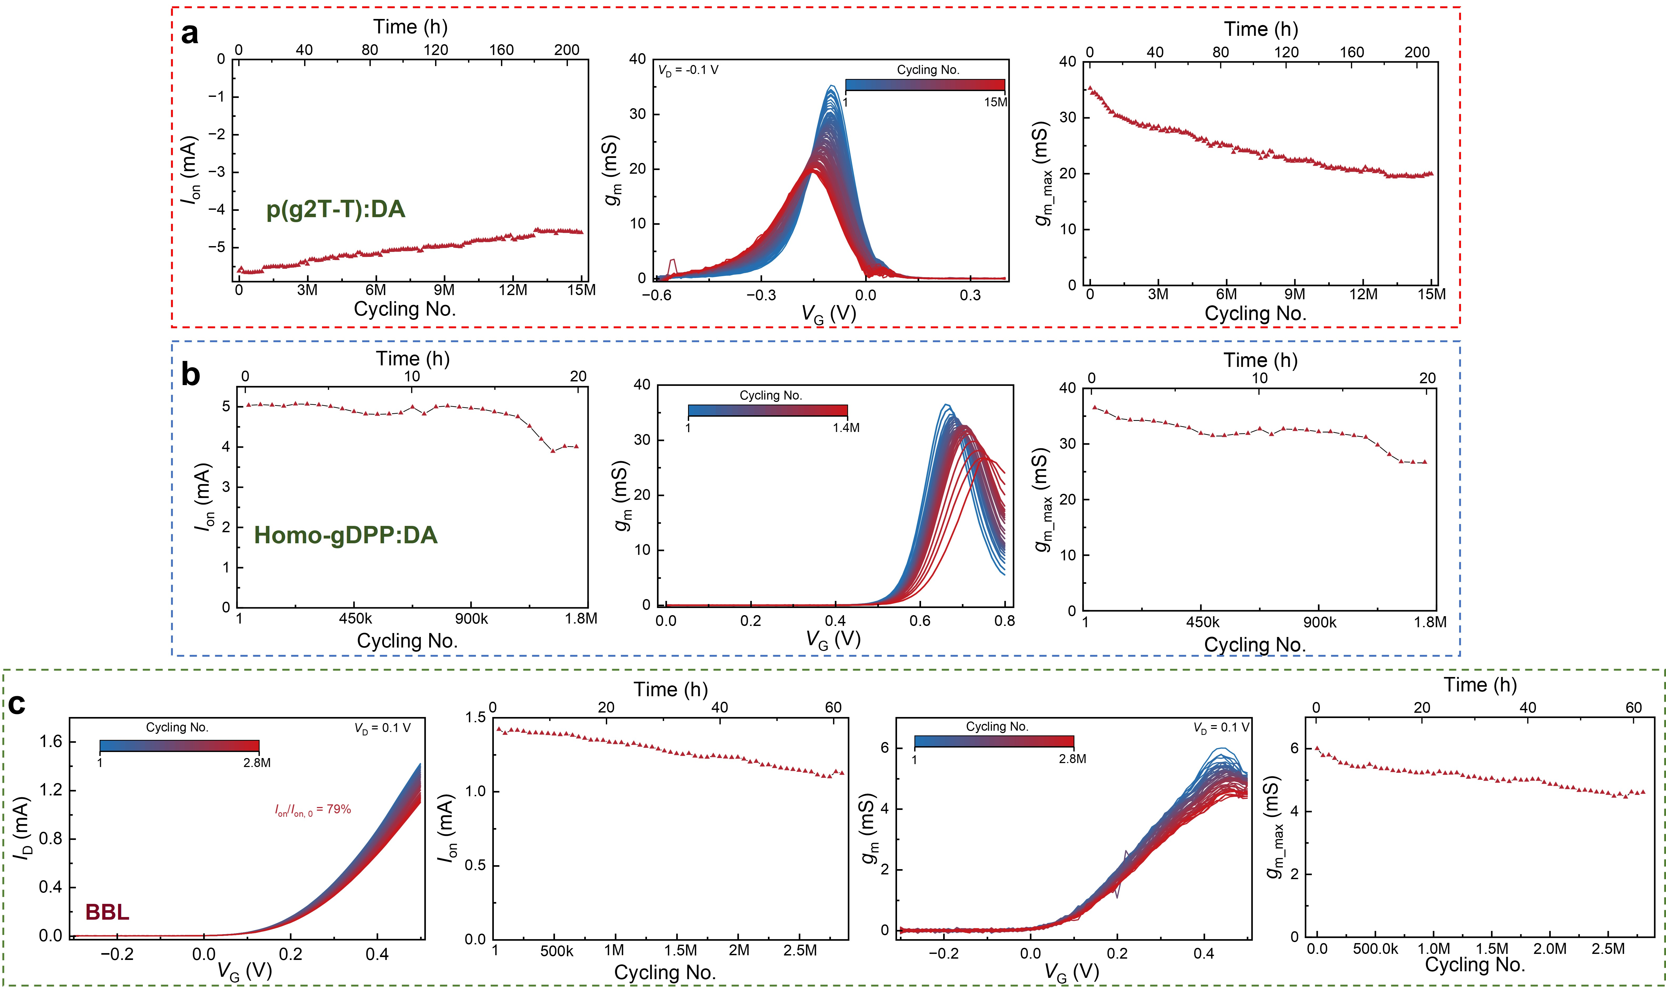
Extended Data Fig. 8 | Cycling stability of vOECTs. During cyclic stability measurements: I_{D} current decay trends, transconductance curves, and g_{m_max} decay trends for (a) p(g2T-T):DA and (b) Homo-gDPP:DA-based vOECTs; and for (c) BBL-based vOECT, these parameters plus I_{D} current curves.

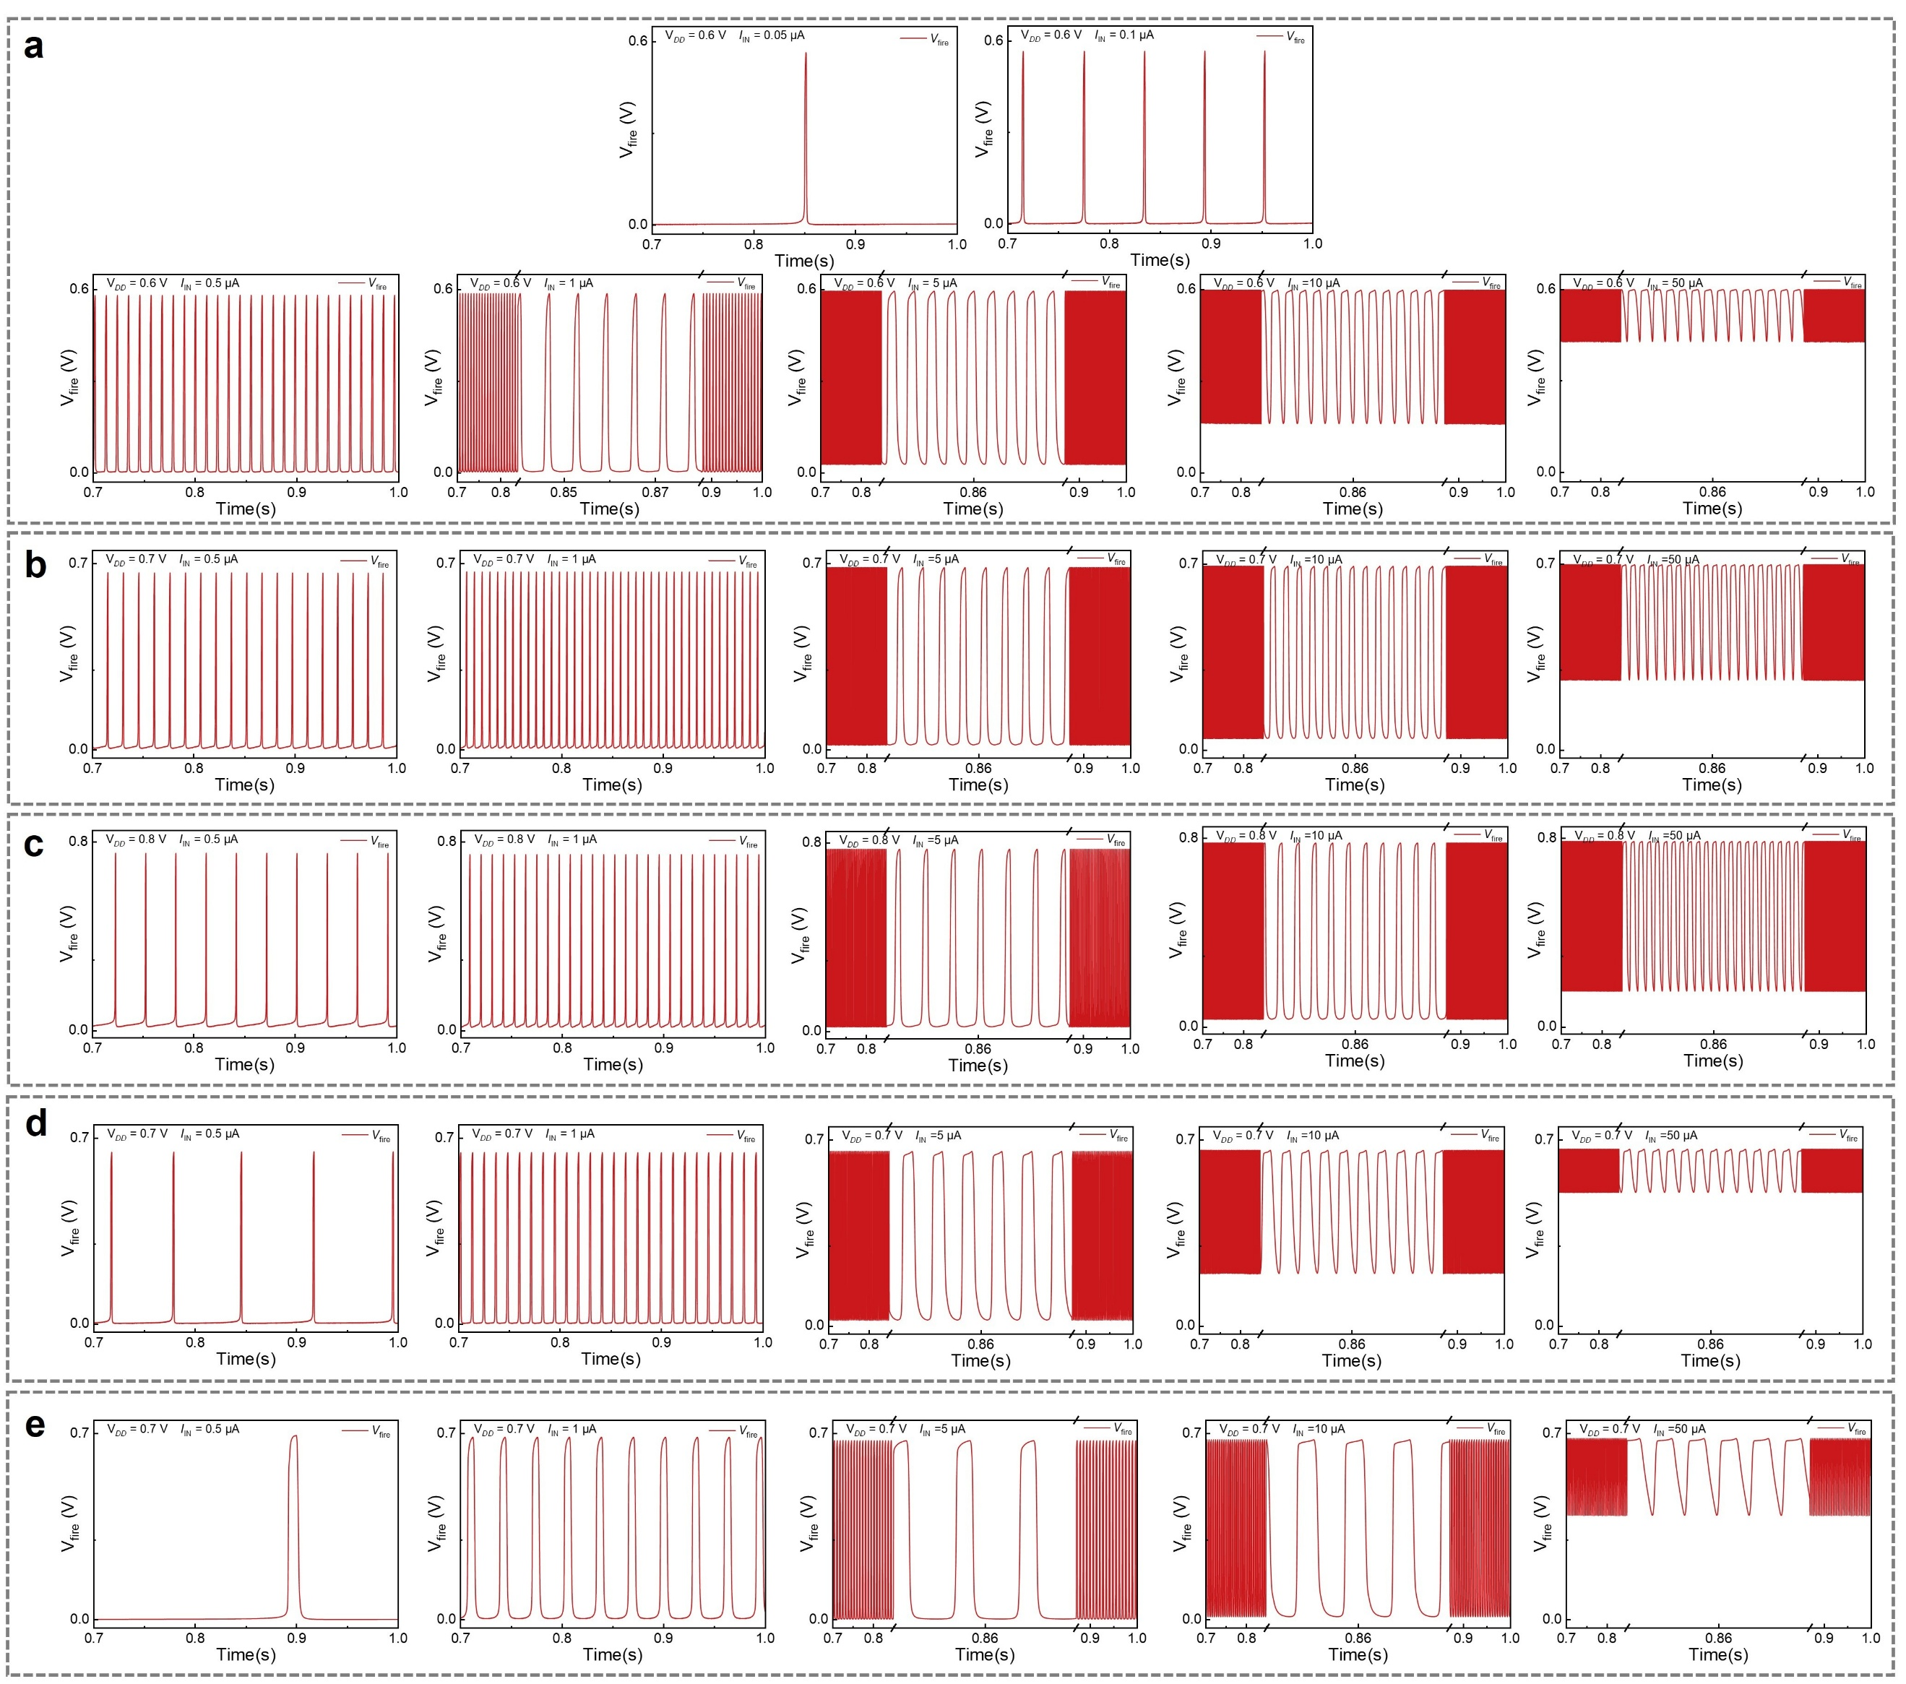
Extended Data Fig. 9 | vOECNs spiking characteristics. (a–c) Spiking patterns under different input currents at C_{mem} = 500 pF and V_{DD} = 0.6, 0.7, 0.8 V. (d, e) spiking patterns at V_{DD} = 0.7 V with I_{IN} = 0.5, 1, 5, 10, 50 μA and C_{mem} = 10, 50 nF. The vOECN circuit operates as follows: the I_{IN} is integrated through the C_{mem}, causing the membrane voltage (V_{mem}) to gradually increase. When V_{mem} reaches a specific threshold, the output terminal generates neuron-like pulses (V_{fire}). Specifically, the amplification module exhibits a steep increase in gain when V_{mem} exceeds the transition voltage (V_{T}), driving the rise of V_{fire}. When V_{fire} reaches a sufficient level, T_{reset} is conducted, discharging C_{mem} and decreasing V_{mem}. Once V_{mem} drops back to V_{T}, the feedback loop activates, causing V_{fire} to decrease in response to minor changes in V_{mem} rapidly. Eventually, V_{fire} returns to its initial state, T_{reset} turns off, terminating the pulse and initiating the next cycle.
References
53 Maria, I. P. et al. The Effect of Alkyl Spacers on the Mixed Ionic‐Electronic Conduction Properties of N‐Type Polymers. Adv. Funct. Mater. 31, 2008718 (2021). https://doi.org/10.1002/adfm.202008718
54 Nicolini, T. et al. A Low‐Swelling Polymeric Mixed Conductor Operating in Aqueous Electrolytes. Adv. Mater. 33, 2005723 (2020). https://doi.org/10.1002/adma.202005723
55 Sun, Z. et al. Controlling Ion Uptake in Carboxylated Mixed Conductors. Adv. Mater. 37, 2414963 (2024). https://doi.org/10.1002/adma.202414963
56 Ohayon, D., Druet, V. & Inal, S. A guide for the characterization of organic electrochemical transistors and channel materials. Chem. Soc. Rev. 52, 1001-1023 (2023). https://doi.org/10.1039/d2cs00920j
57 Jackson, S. R., Kingsford, R. L., Collins, G. W. & Bischak, C. G. Crystallinity Determines Ion Injection Kinetics and Local Ion Density in Organic Mixed Conductors. Chem. Mater. 35, 5392-5400 (2023). https://doi.org/10.1021/acs.chemmater.3c00657
58 Wu, R., Paulsen, B. D., Ma, Q. & Rivnay, J. Mass and Charge Transport Kinetics in an Organic Mixed Ionic–Electronic Conductor. Chem. Mater. 34, 9699-9710 (2022). https://doi.org/10.1021/acs.chemmater.2c02476
59 Paulsen, B. D. et al. Time-Resolved Structural Kinetics of an Organic Mixed Ionic–Electronic Conductor. Adv. Mater. 32, 2003404 (2020). https://doi.org/https://doi.org/10.1002/adma.202003404

