Supplementary Information for

Operando High-Resolution Swell Mapping for Mixed Ionic-Electronic Channel

Ziyi Deng¹, Siyu Zhang¹, Jiahao Wang¹, Donghao Li¹, Jinhao Zhou¹, Miao Xie¹, Yixin Zhou¹, Yueping Lai², Dan Zhao¹, Jianhua Chen³, Ligang Huang⁴, Yuhua Cheng¹, Liang-Wen Feng^{2,}*, Cong Chen^{1,}*, Wei Huang^{1,}*

^{1.} School of Automation Engineering, University of Electronic Science and Technology of China (UESTC), Chengdu 611731, China.
^{2.} Key Laboratory of Green Chemistry & Technology, Ministry of Education, College of Chemistry, Sichuan University, Chengdu 610065, China.
^{3.} Department of Chemical Science and Technology, Yunnan University, Kunming 650091, China.
^{4.} Key Laboratory of Optoelectronic Technology & Systems (Education Ministry of China), Chongqing University, Chongqing 400044, China.
*Email: liangwenfeng@scu.edu.cn, cong_chen@uestc.edu.cn, whuang@uestc.edu.cn

This file includes:
Figs. S1 to S13
Tables S1 to S4
References

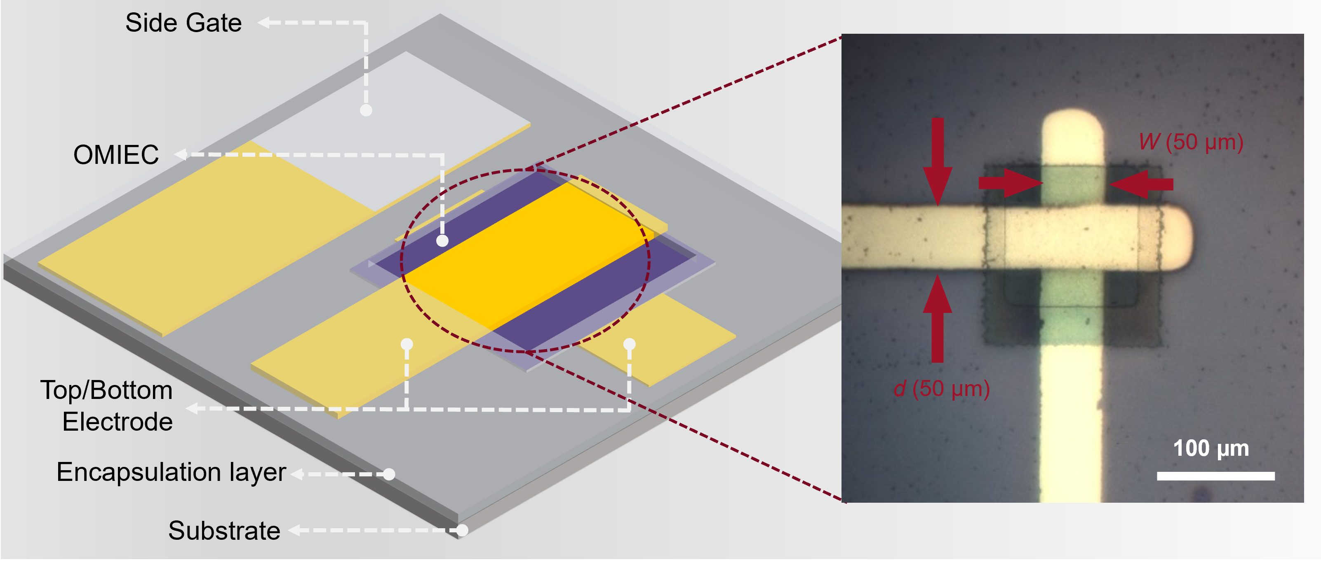
Fig. S1. Side-gated vOECT architecture along with a microscope photo of the channel area.

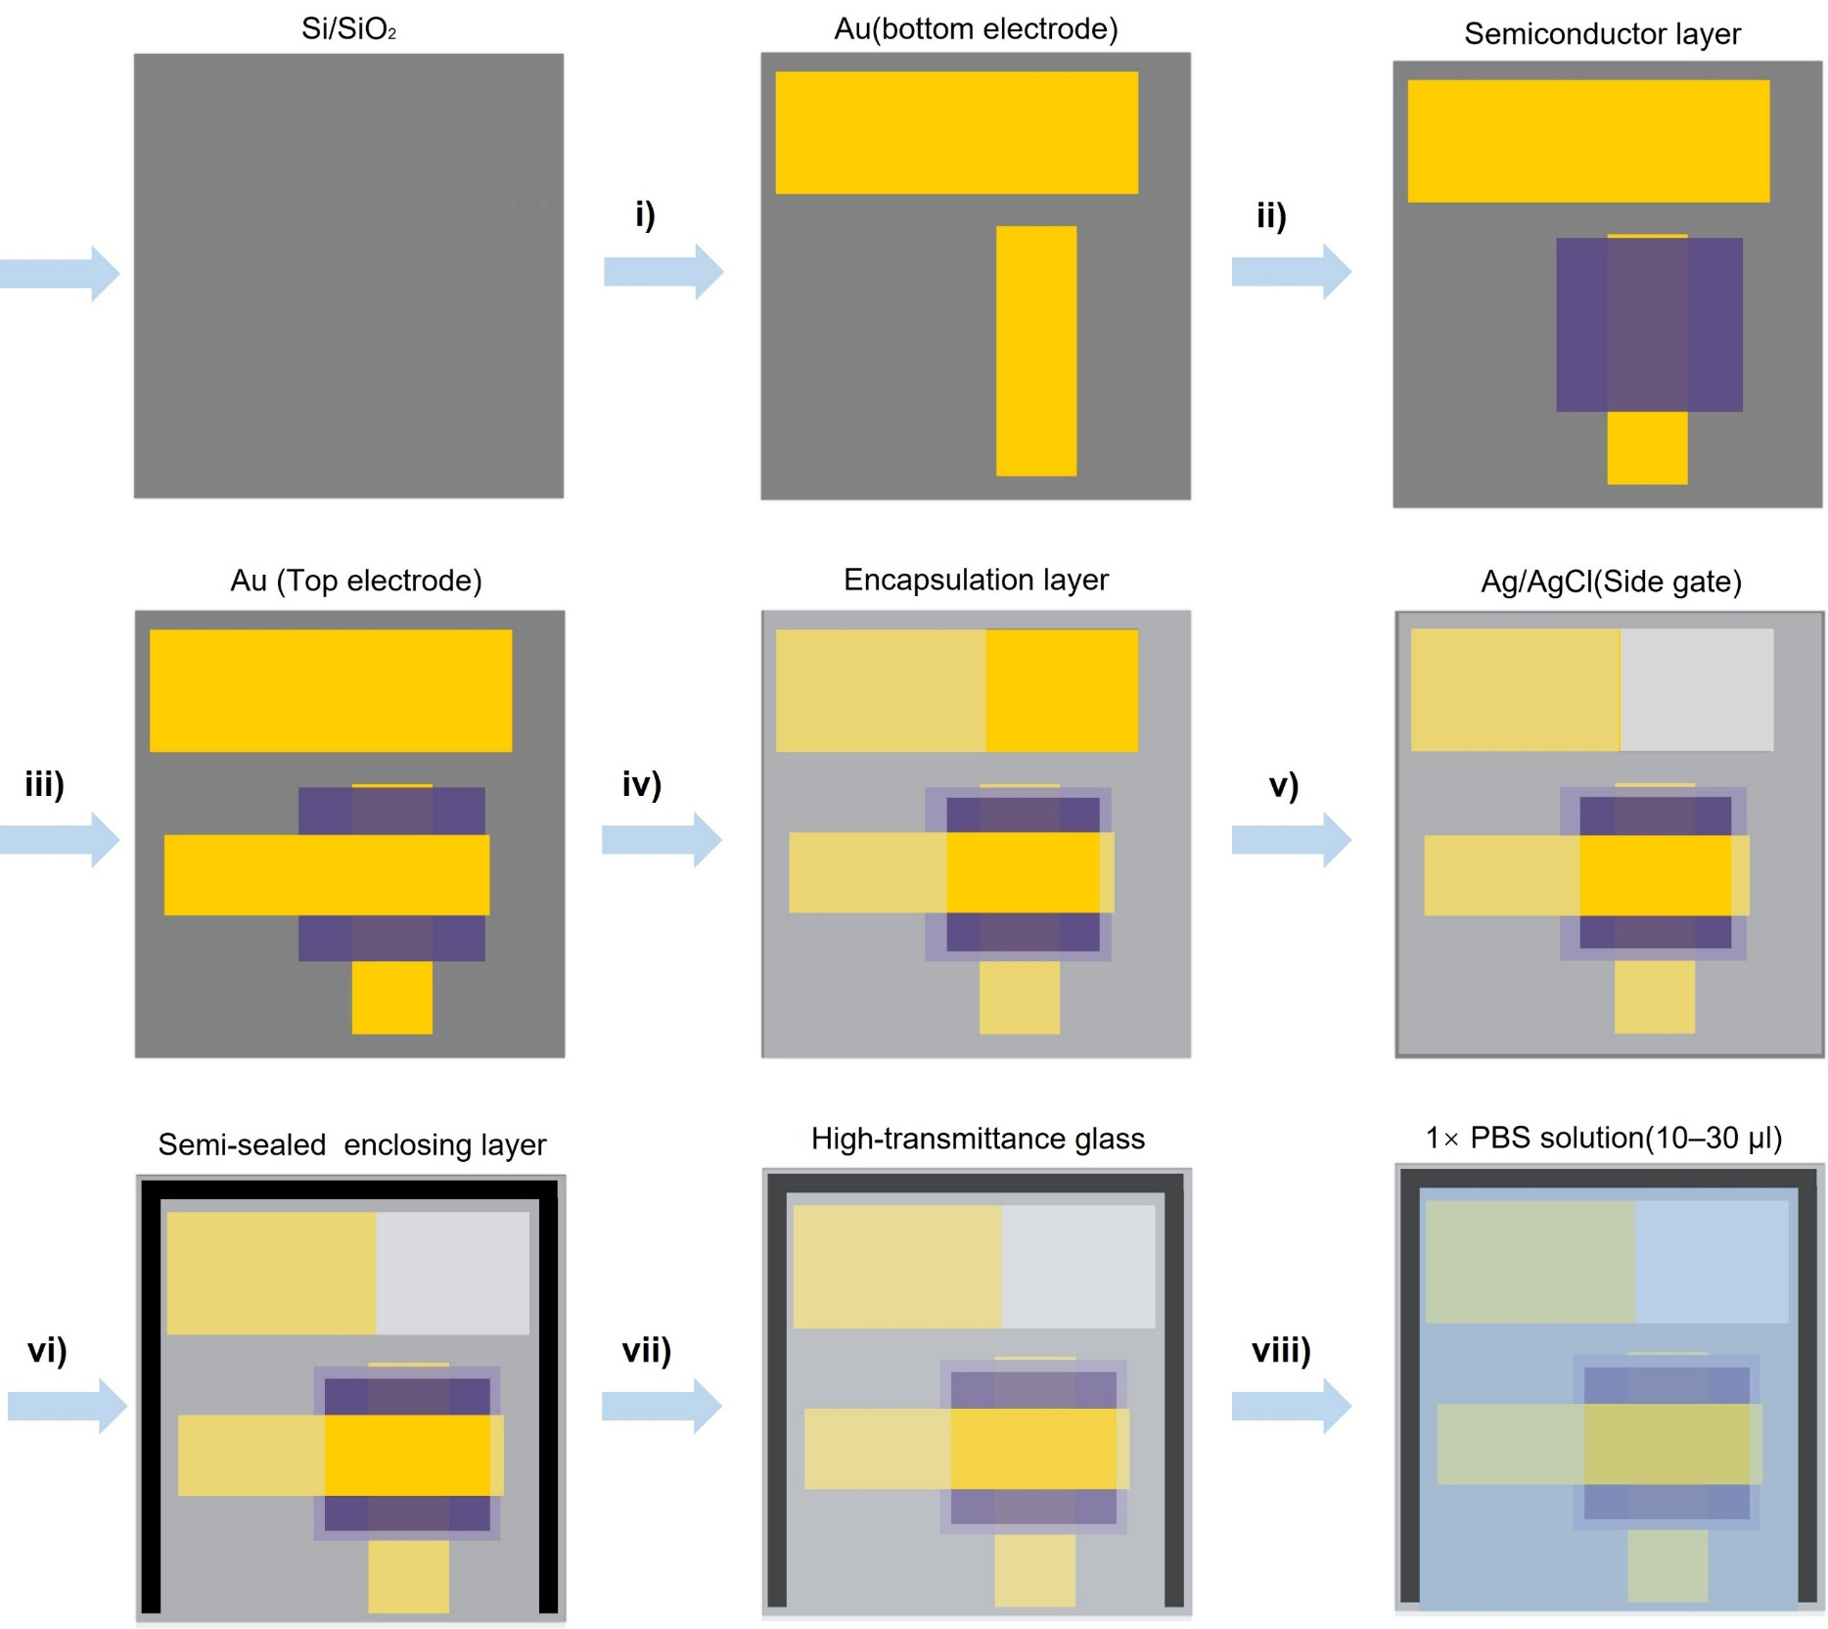
Fig. S2. Fabrication process of the side-gated vOECT. i) Thermal evaporation of the bottom and gate electrodes with a shadow mask; ii) Spin-coating and photo-patterning of the p- or n-type OMIEC channel layer; iii) Thermal evaporation of the top electrode with a shadow mask; iv) Spin-coating and photopatterning of the SU-8 encapsulation layer, where the channel areas are left open. v) Drop casting of Ag/AgCl paste as the gate electrode; vi) Coating uncured PDMS solution around the device and adhering polyimide template (PI, with a thickness of 0.3 mm) to the PDMS; vii) Placing a high-transmittance glass (with a thickness of 0.7 mm) on the PI template to achieve semi-sealing of the device; viii) Application of 1× PBS solution (10–30 μL) into the vacancy between the glass and the vOECT.

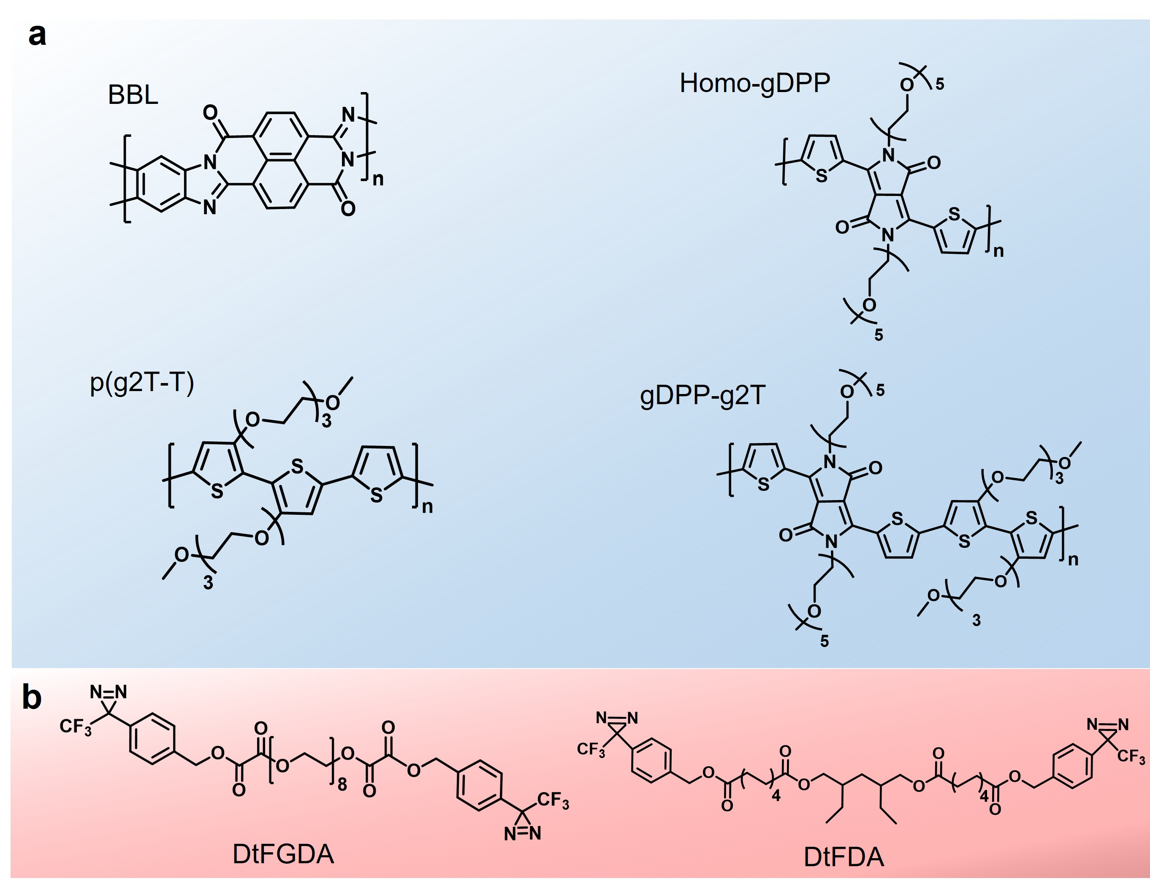
Fig. S3. Chemical structures of used materials. a, OMIECs, including BBL, Homo-gDPP, p(g2T-T), and gDPP-g2T. b, Crosslinkers, including GDA and DA.
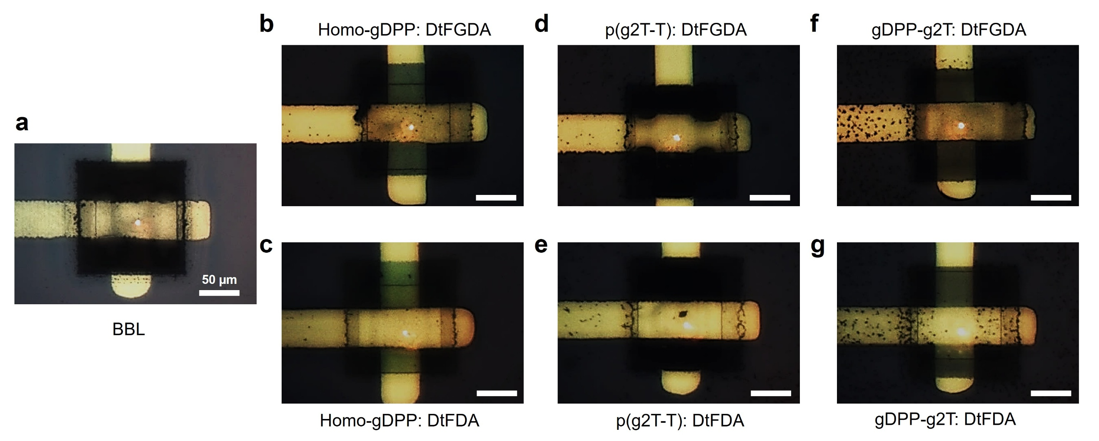
Fig. S4. Laser spot position of LDV-M on vOECT channels with different OMIECs. (a)BBL; (b) Homo-gDPP:GDA; (c) Homo-gDPP:DA; (d) p(g2T-T):GDA; (e) p(g2T-T):DA; (f) gDPP-g2T:GDA; (g) gDPP-g2T:DA.

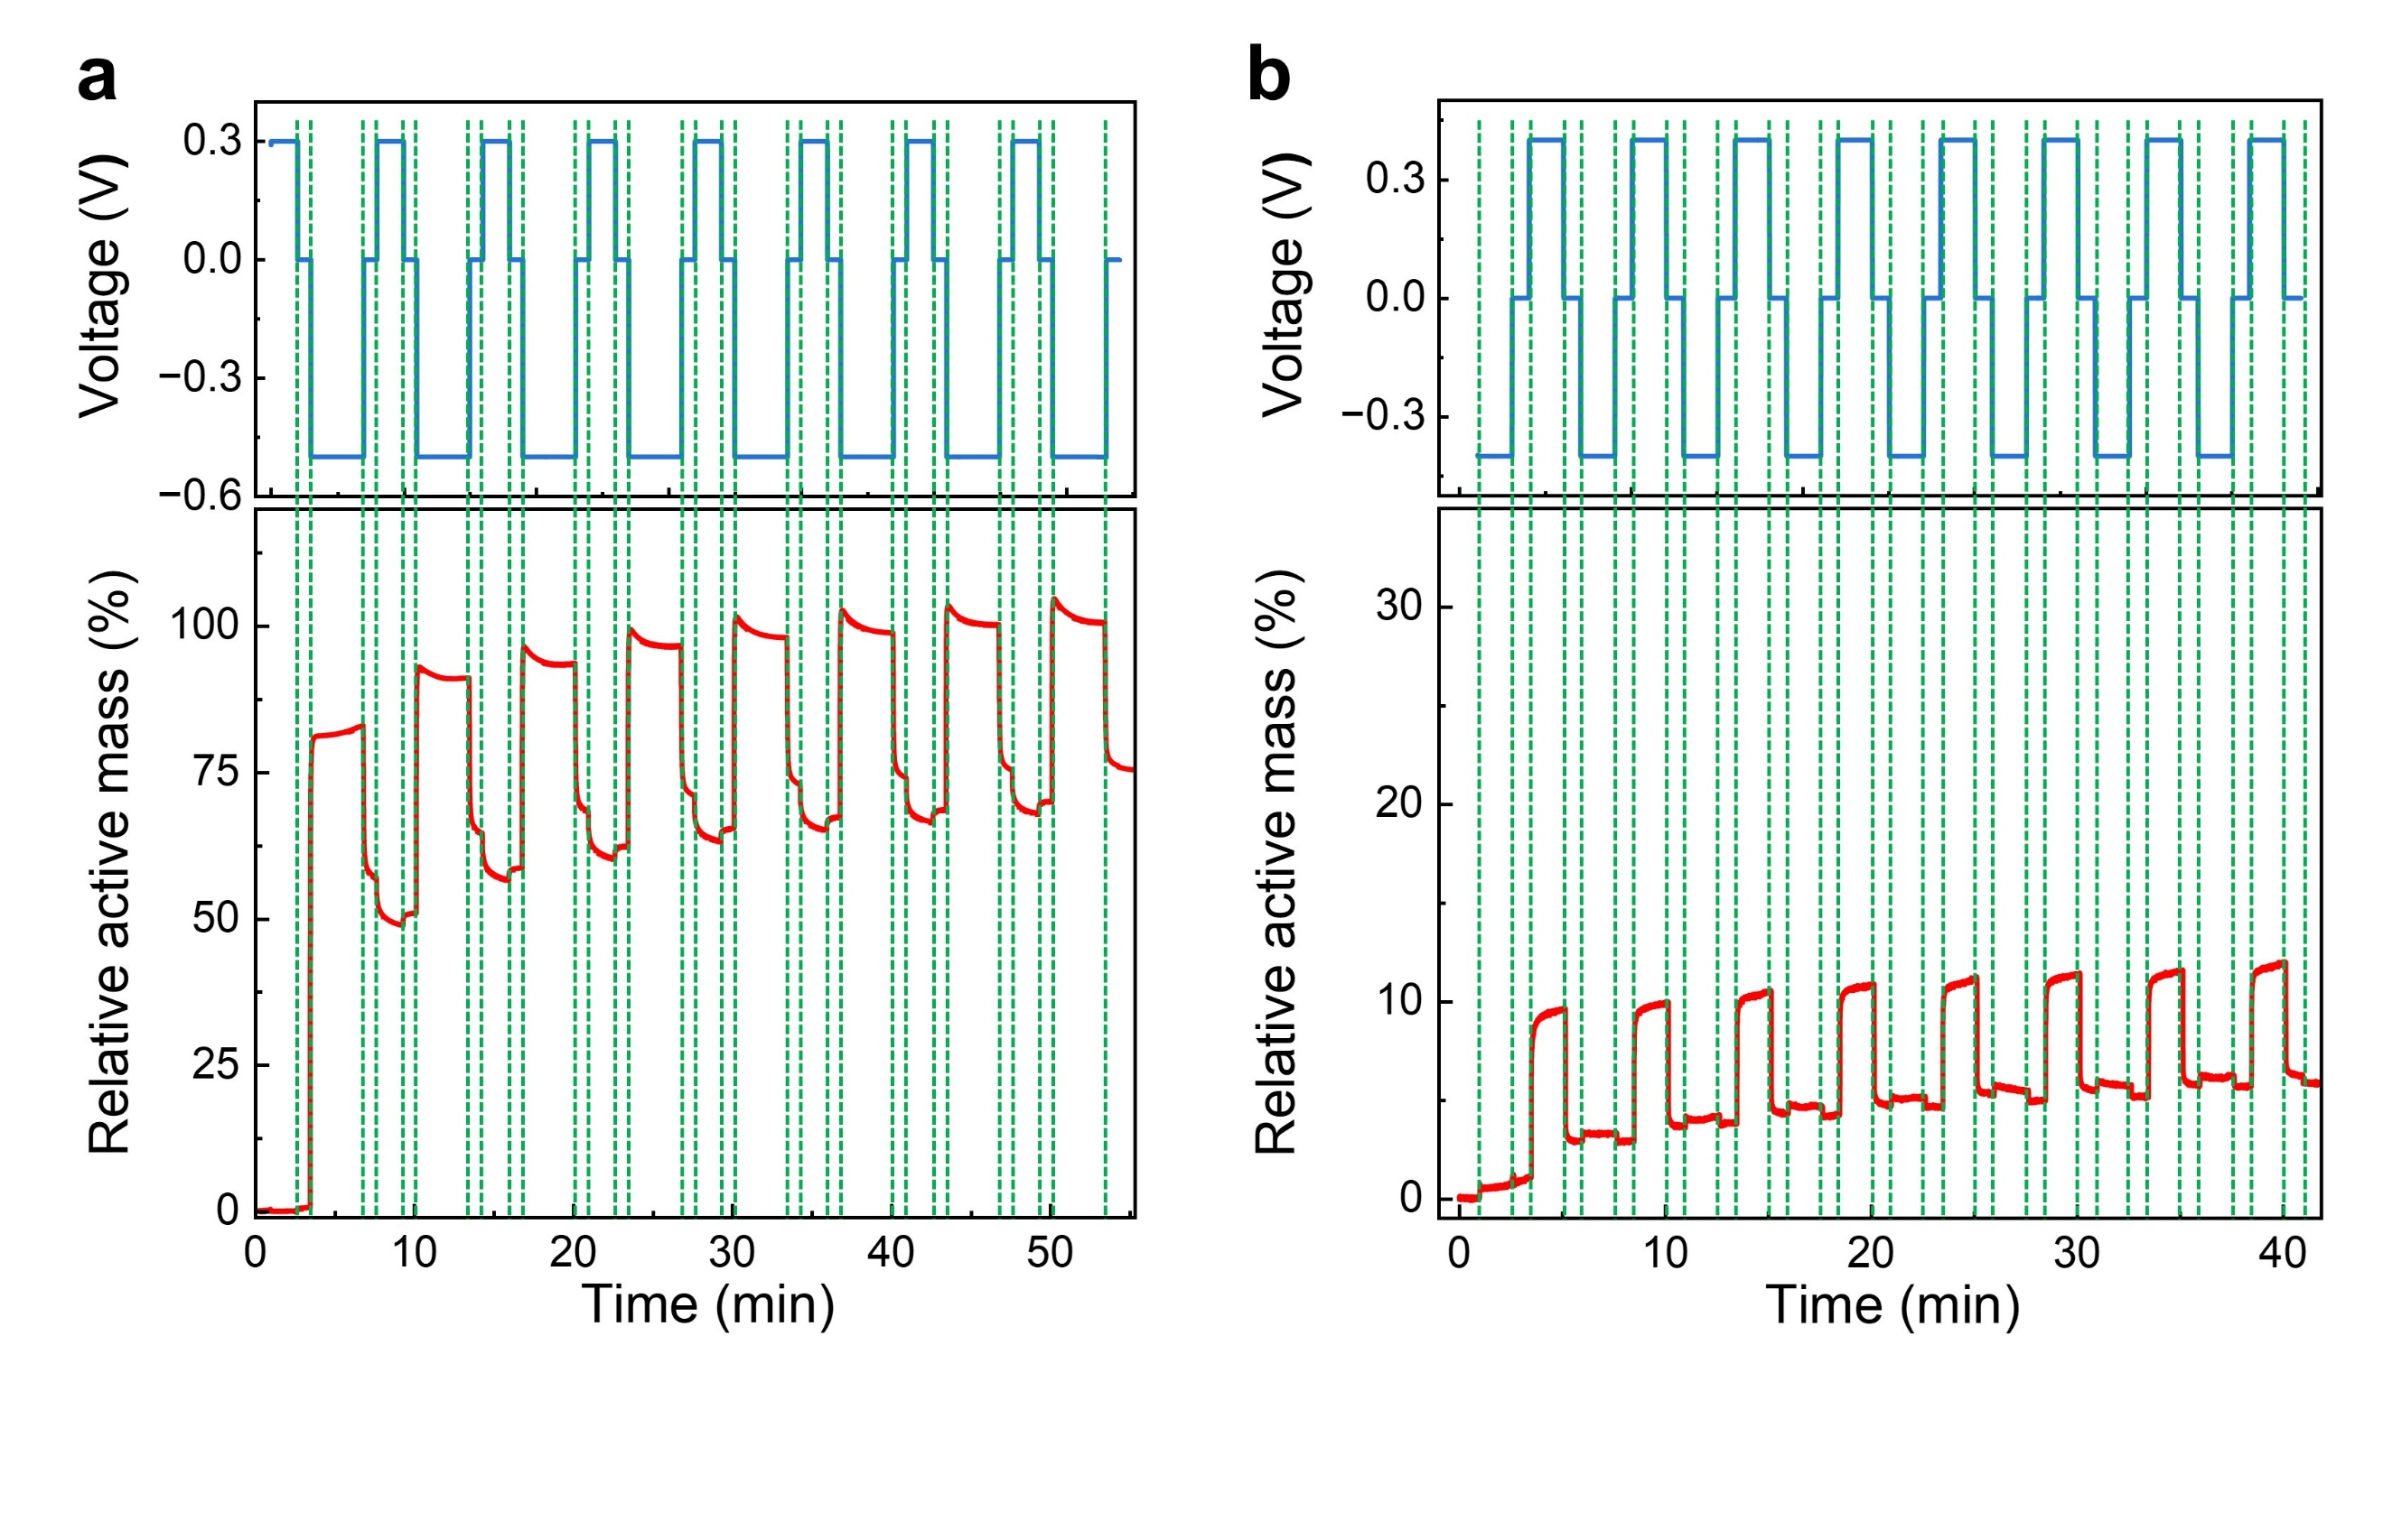
Fig. S5. OMIEC film swelling characterized by EQCM. Relative active swelling responses of (a) BBL and (b) p(g2T-T):DA films under varying working electrode biases.

Table. S1. Summary of active swelling characteristics of different OMIECs.
Type | Drain current  transient time | Film  Thickness  (nm) | f = 3.3 Hz |  |  | f = 11.1 Hz |  |  | f = 111.1 Hz
Type | Drain current  transient time | Film  Thickness  (nm) | Swelling  magnitude^{a)}  (nm) | Swelling percentage^{b)} | Swelling  magnitude^{a)}  (nm) |  | Swelling percentage^{b)} | Swelling  magnitude^{a)}  (nm) |  | Swelling percentage^{b)}
BBL | 7.6 ms (ON)  1.5 ms (OFF) | 130.2±7.8 | 115.9±1.5 | 89.2±1.1% | 106.6±1.8 |  | 82.0±1.4% | 19.5±0.7 |  | 15.0±0.5%
Homo-gDPP: GDA | 1.0ms (ON)  0.2 ms (OFF) | 113.5±5.6 | 22.8±1.1 | 20.7±1.0% | 22.2±1.7 |  | 20.2±1.5% | 16.8±1.3 |  | 15.3±1.1%
Homo-gDPP: DA | 5.8 ms (ON)  0.4 ms (OFF) | 110.1±4.5 | 10.9±2.7 | 9.9±2.5% | 9.0±1.6 |  | 8.2±1.5% | 5.8±1.6 |  | 5.3±1.5%
p(g2T-T): GDA | 0.8 ms (ON)  0.2 ms (OFF) | 80.2±3.8 | 10.1±0.5 | 12.6±0.6% | 8.8±0.6 |  | 11±0.8% | 4.7±0.8 |  | 5.9±1.0%
p(g2T-T): DA | 6.8 ms (ON)  0.8 ms (OFF) | 78.8±3.1 | 4.1±0.2 | 5.1±0.3% | 3.9±0.4 |  | 4.9±0.5% | 2.5±0.4 |  | 3.1±0.5%
gDPP-g2T: GDA | 2.6 ms (ON)  0.2 ms (OFF) | 106.4±4.8 | 20.0±1.4 | 18.8±1.3% | 17.5±1.8 |  | 16.5±1.7% | 9.8±0.42 |  | 9.2±0.4%
gDPP-g2T: DA | 6.7ms (ON)  0.5 ms (OFF) | 104.1±5.1 | 7.6±1.3 | 7.1±1.2% | 6.7±1.5 |  | 6.3±1.4% | 4.9±1.0 |  | 4.6±0.9%
a) Standard deviations are based on the performance of at least 5 cycles.
b) Percentage of swelling magnitude compared to original film thickness. The original film thickness was characterized by AFM before the film made contacts with electrolyte.

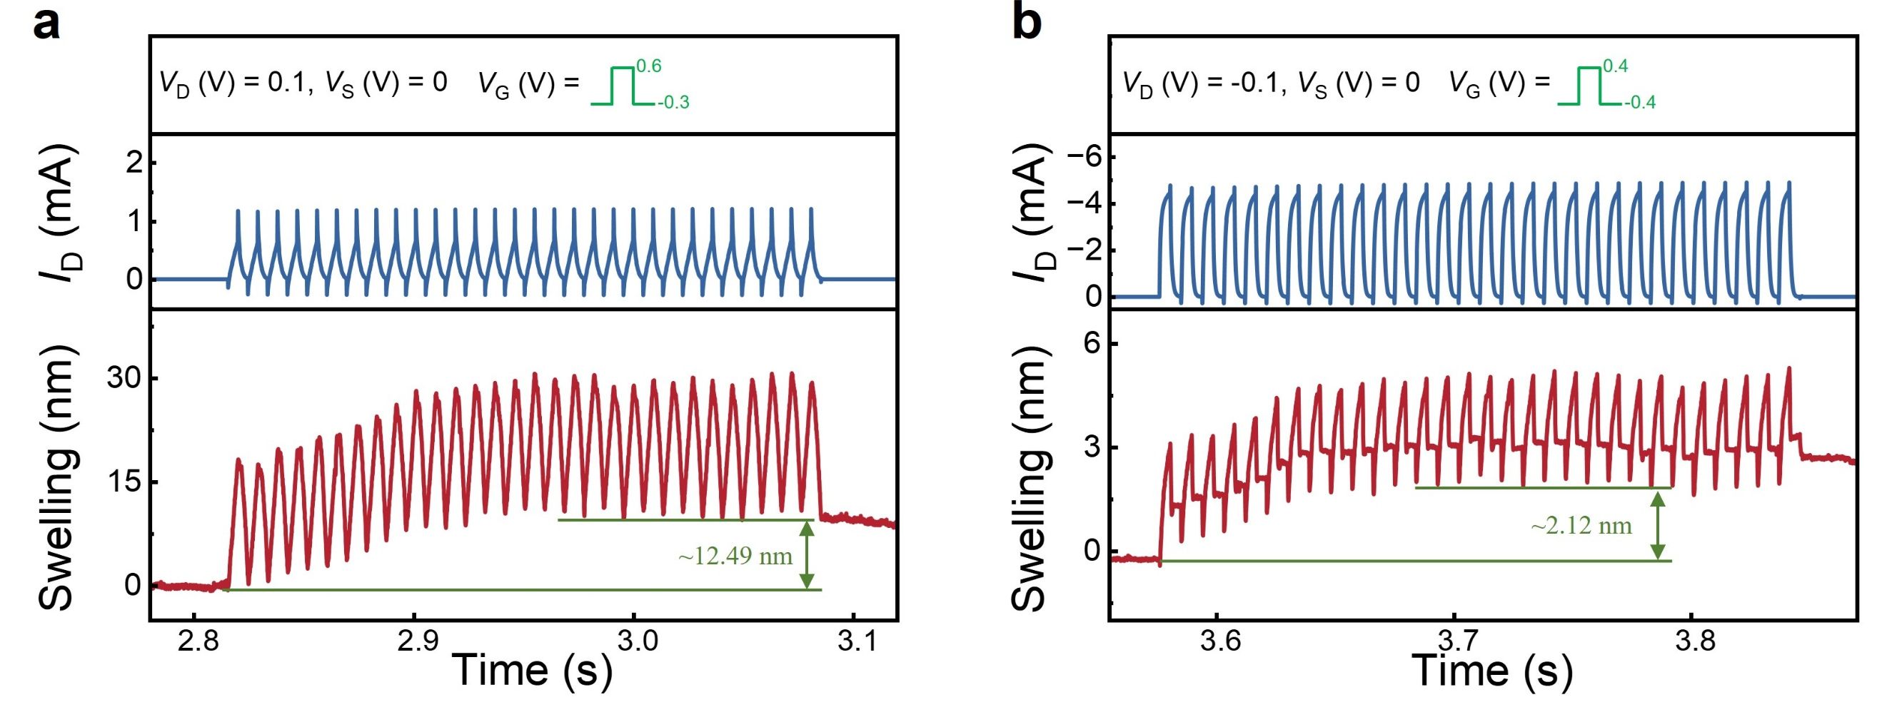
Fig. S6. Swelling baseline shifts under 111.1 Hz switching frequencies. vOECTs based on (a) BBL and (b) p(g2T-T):DA, respectively.

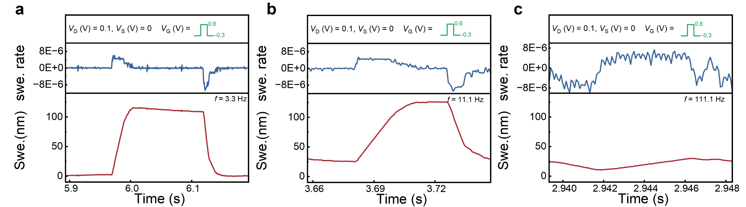
Fig. S7. Active swelling rate of vOECT based on BBL. Active swelling rate at switching frequencies of (a) 3.3Hz, (b) 11.1Hz, and (c) 111.1Hz. The active swelling rate is calculated by taking the first-order derivative of the swelling curves under different operating frequencies.

Table. S2. Summary of active swelling response times of vOECTs with different OMIECs.
Type | Active swelling response time (ms) ^{a)}
Type | (3, 3) ^{b)} | (1, 3) ^{b)} | (3, 4) ^{b)}
BBL | 22.2±0.4 | 10.0±0.3 | 10.3±0.2
Homo-gDPP:GDA | 4.8±0.3 | 4.5±0.5 | 4.6±0.1
Homo-gDPP:DA | 5.0±0.4 | 4.6±0.3 | 4.6±0.2
p(g2T-T):GDA | 9.1±0.6 | 2.7±0.3 | 4.9±0.9
p(g2T-T):DA | 21.1±0.8 | 9.3±0.8 | 13.4±0.9
gDPP-g2T:GDA | 11.1±0.5 | 7.8±0.4 | 8.7±0.6
gDPP-g2T:DA | 26.3±1.5 | 18.1±0.5 | 18.9±0.9
- Standard deviations are based on the data of at least 5 cycles.
- Laser spot position.

The calculation method for active swelling response time is as follows: First, the moment a doping V_{G} is applied is selected as the starting time point of active swelling. Then, the moment when active swelling reaches 90% of saturation is chosen as the endpoint. The time difference between these two points is assigned as the active swelling response time.

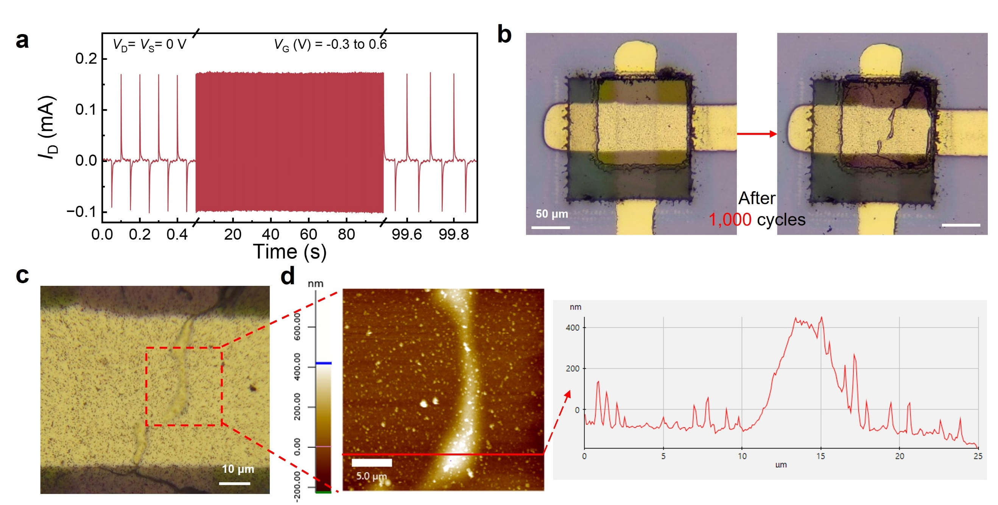
Fig. S8. BBL channel morphological variations characterized by optical microscope and AFM. a, I_{D} transient curve of the device switched 1000 times with V_{D} = V_{S} = 0V. b, Optical images of the device channel area before and after 1000 switching cycles. c, Zoomed in optical image of the device channel region after operation, and (d) height image characterized by AFM with obvious swelling.
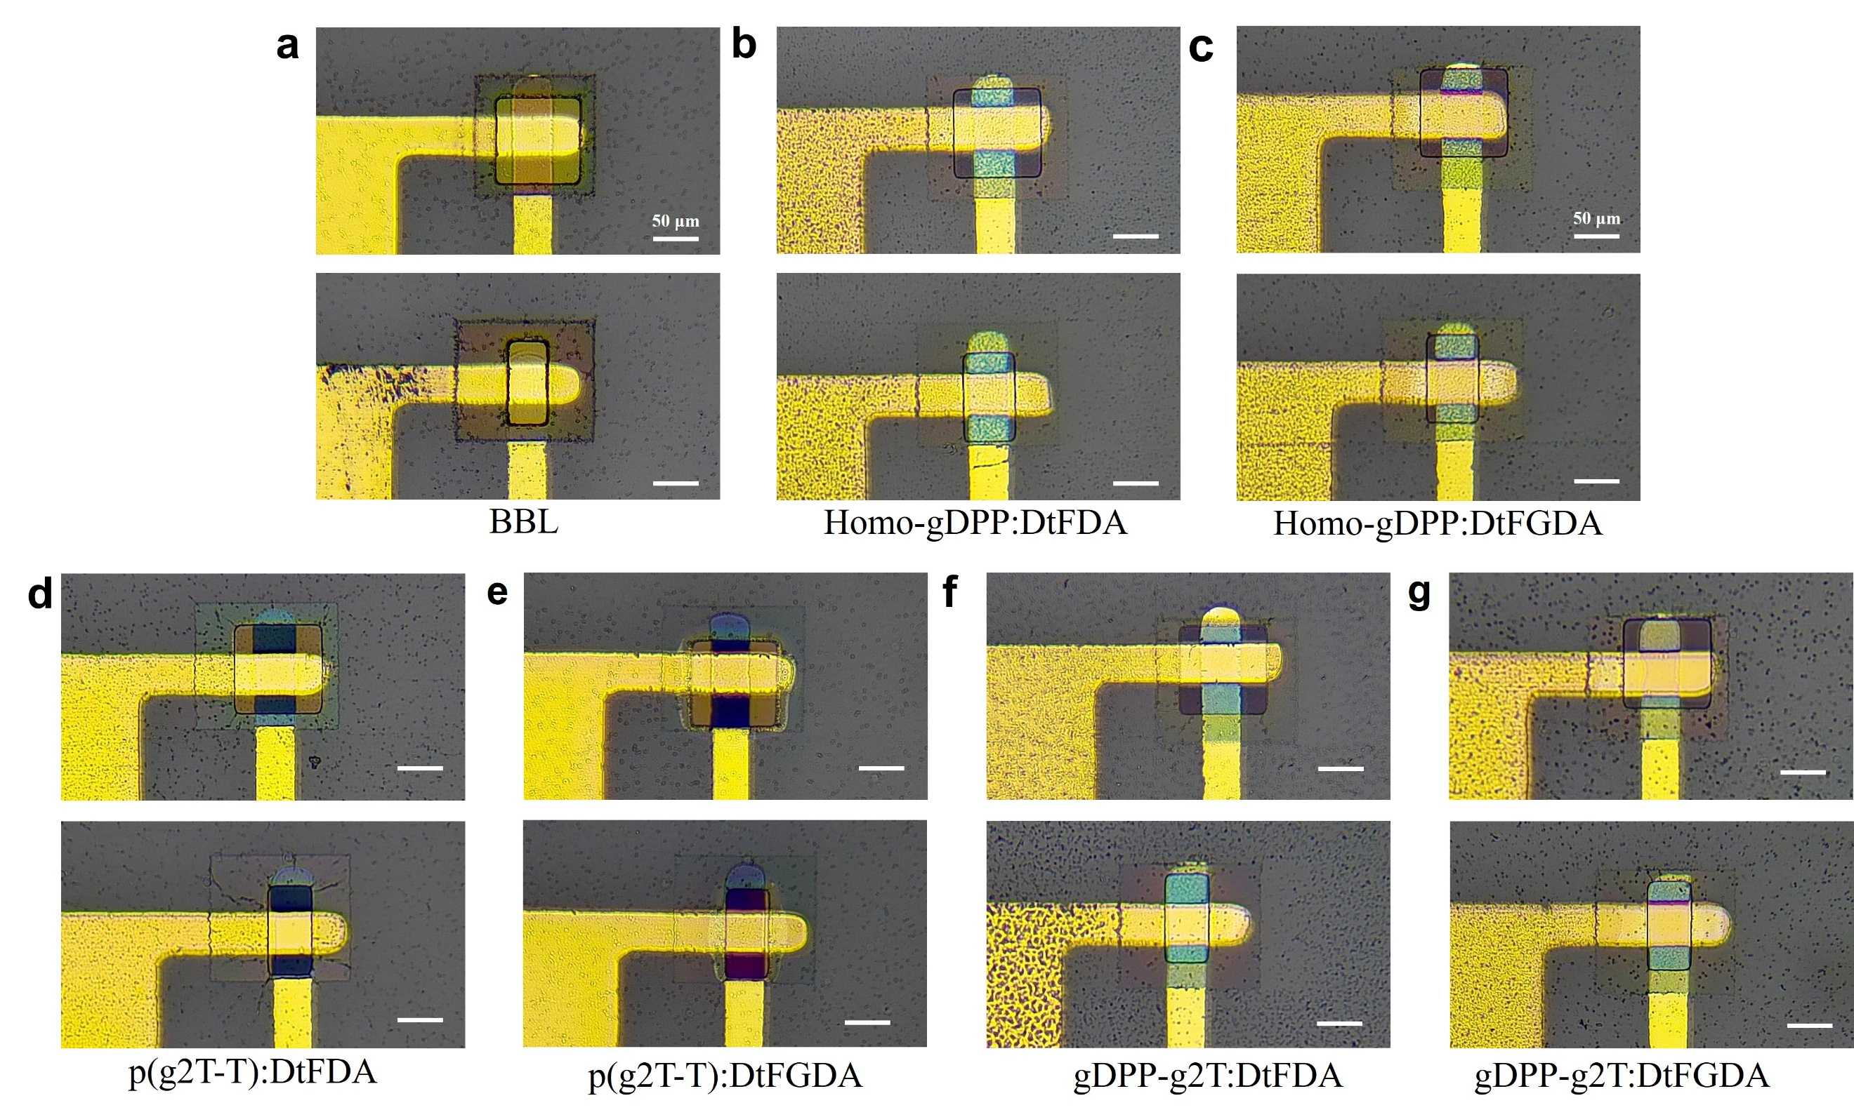
Fig. S9. Optical images of vOECTs with conventional and optimized encapsulations. vOECT channels based on (a) BBL, (b) Homo-gDPP:DA, (c) Homo-gDPP:GDA, (d) p(g2T-T):DA, (e) p(g2T-T):GDA, (f) gDPP-g2T:DA, and (g) gDPP-g2T:GDA.

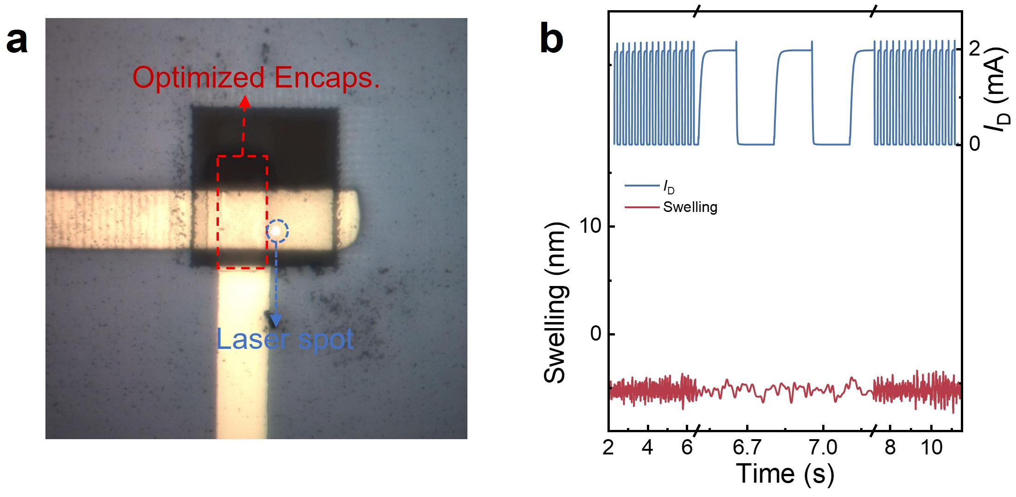
Fig. S10. Channel with optimized encapsulation. a, Optical image of the channel, where the red box indicates the encapsulated layer opening and the blue circle marks the position of the laser spot. Notably, the spot is outside the encapsulated layer opening. b, Swelling behavior of the device at the laser spot position, showing no swelling at this location, indicating that encapsulation can effectively suppress swelling.

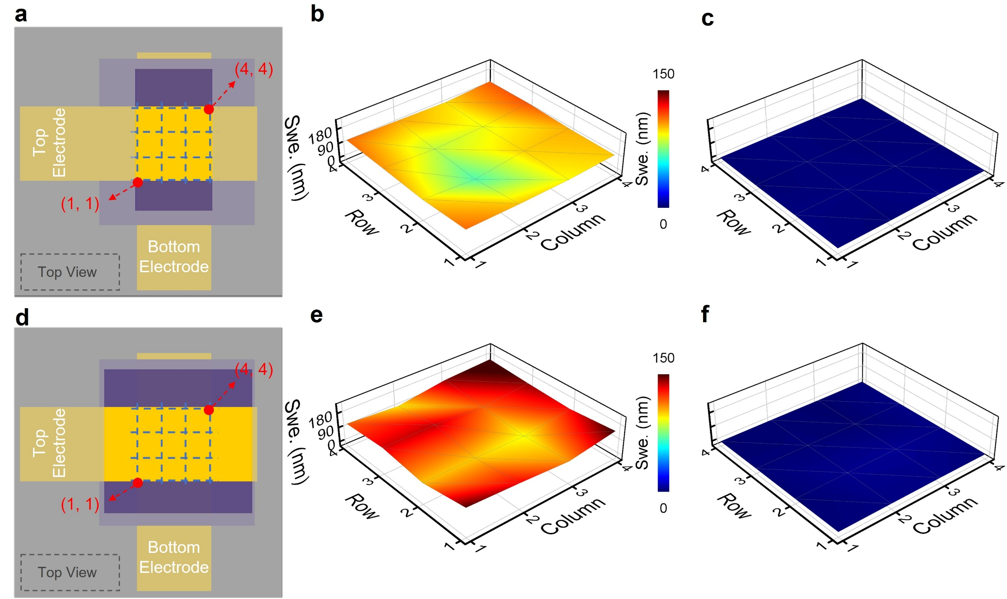
Fig. S11. 3D swell mapping of BBL-based vOECTs with different encapsulations. a, Top view of the channel with optimized encapsulation and 4 × 4 mapping point diagram, along with the swell mapping of the channel under (b) doping and (c) dedoping states under a switching frequency of 3.3 Hz. d, Top view of the channel with conventional encapsulation and 4 × 4 mapping point diagram, along with the swell mapping of the channel under (e) doping and (f) dedoping states with a switching frequency of 3.3 Hz.

Table. S3. Summary of reported cycling stability of OECTs.
Architecture | Transistor  type | Material | Cycling number | Operation time (h) | Current retention | Ref
cOECT ^{a)} | P | h-DPP-g2T | 1,500 | 1.7 | / | ¹
cOECT ^{a)} | P | PDPP-3EG | 600 | 1.5 | 99% | ²
cOECT ^{a)} | P | PDPP-4EG | 600 | 1.5 | 88% | ²
cOECT ^{a)} | P | P3 | 60 | 0.2 | / | ³
cOECT ^{a)} | P | p(gPyDPP-MeOT2) | 400 | 0.4 | 92% | ⁴
cOECT ^{a)} | P | gBDT-MeOT2 | 300 | 0.5 | 93% | ⁵
cOECT ^{a)} | P | p(g1T2-g5T2) | 720 | 2 | 98% | ⁶
cOECT ^{a)} | P | p(g0T2-g6T2) | 720 | 2 | 98% | ⁶
cOECT ^{a)} | P | P(g₄2T-TT) | 510 | 1.4 | 85% | ⁷
cOECT ^{a)} | P | p(g3T2):C₆₀F₄₈ | 4,600 | 25 | 61% | ⁸
vOECT | P | p(g2T-T): DA | 100,000 | 1.1 | 99% | ⁹
vOECT | P | gDPP-g2T: Cin-Cell | 50,000 | 1.4 | / | ¹⁰
vOECT | N | Homo-gDPP: Cin-Cell | 50,000 | 1.4 | / | ¹⁰
vOECT | P | p(g2T-T): DA | 200,000 | 4.4 | / | ¹¹
vOECT | N | BBL/PEI | 1M | 2.8 | 97% | ¹²
vOECT | P | p(g2T-T): DA | 1M | 13.9 | 100% | This work
vOECT | P | p(g2T-T): DA | 5M | 69.4 | 95% | This work
vOECT | P | p(g2T-T): DA | 10M | 138.9 | 89% | This work
vOECT | P | p(g2T-T): DA | 15M | 208.3 | 82% | This work
vOECT | N | Homo-gDPP: DA | 1M | 13.9 | 98% | This work
vOECT | N | Homo-gDPP: DA | 1.4M | 19.4 | 79% | This work
vOECT | N | BBL | 126,000 | 2.8 | 100% | This work
vOECT | N | BBL | 1M | 22.2 | 95% | This work
vOECT | N | BBL | 2.8M | 62.2 | 79% | This work
- cOECT: conventional planar OECT.
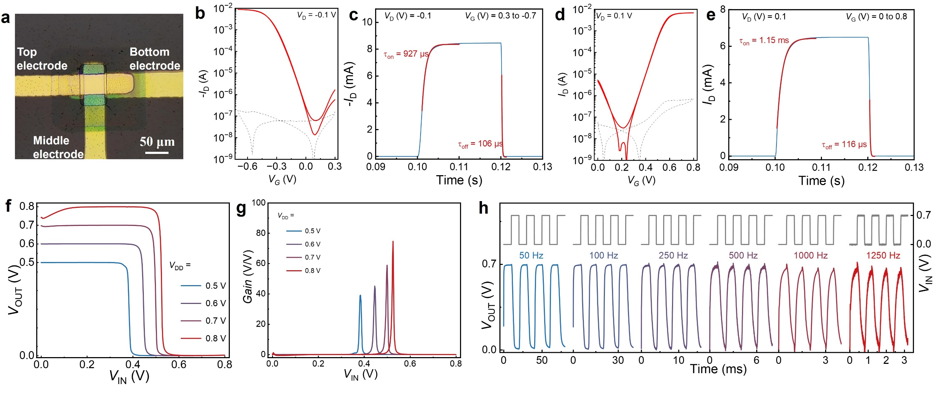
Fig. S12. Complementary inverter based on vOECTs with optimized encapsulation. a, Microscope image of the inverter. b, Transfer and (c) transient curves of a p-type vOECT. d, Transfer and (e) transient curves of an n-type vOECT. (f) Voltage transfer curves and (g) gain characteristics of the vOECT-based inverter with V_{DD} varying from 0.5 V to 0.8 V. (h) Switching behavior of the inverter with V_{IN} switching between 0 V and 0.7 V at frequencies ranging from 50 Hz to 1,250 Hz.

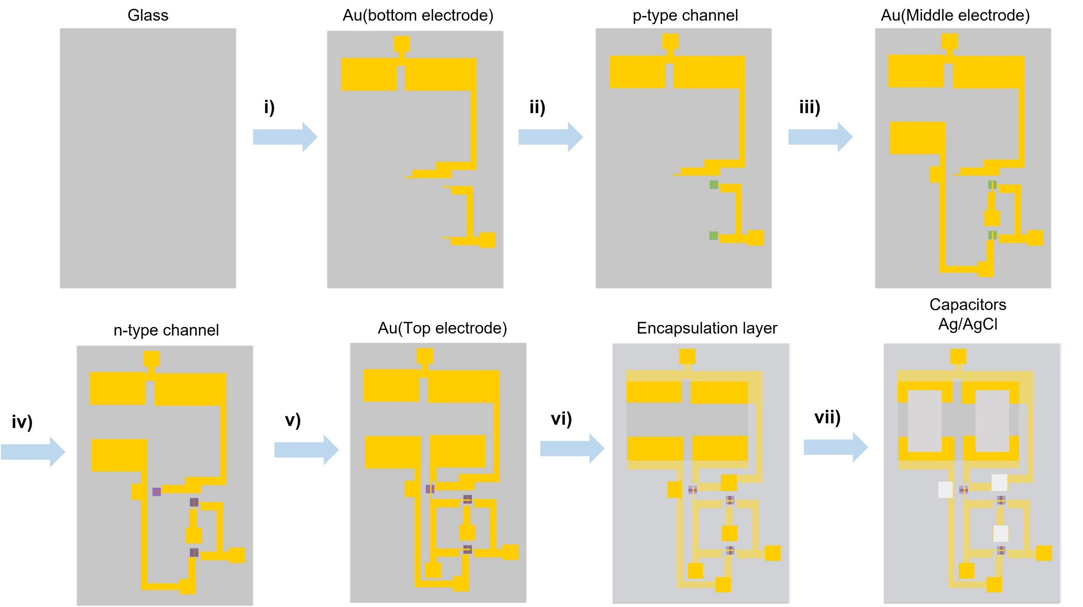
Fig. S13. Fabrication process of a vOECN. i) thermal evaporation of the bottom electrodes with a shadow mask; ii) Spin-coating of the p-type semiconducting layer and pattern the polymer with LPKF R4; iii) thermal evaporation of the middle electrodes with a shadow mask; iv) Spin-coating of the n-type semiconducting layer and pattern the polymer with LPKF R4; v) thermal evaporation of top electrodes with a shadow mask; vi) Spin-coating/photopatterning/developing of the SU-8 encapsulation layer, where the channel areas are left open; vii) Drop casting of Ag/AgCl and capacitor pasting.

Table. S4. Types and fire frequency range of different organic neurons.
Type | Membrane capacitance  (nF) | Input current  (μA) | Fire frequency  (Hz) | Footprint  (mm²) | Ref
Multi-  order  complexity | / | 30 | 32 | 1.6×10⁻³  (wiring pads excluded) | ¹³
Multi-  order  complexity | / | 1.8 | 1.4 | 1.6×10⁻³  (wiring pads excluded) | ¹³
Axon- Hillock | 1 | 100 | 147.1 | 3.7×10¹ | ¹⁴
Axon- Hillock | 1,000 | 0.2 | 0.13 | 3.7×10¹ | ¹⁴
Axon- Hillock | 100 | 10 | 0.25 | 1.2×10³ | ¹⁵
Axon- Hillock | 10,000 | 1 | 0.05 | 1.2×10³ | ¹⁵
Axon- Hillock | 0 | 3 | 11 | / | ¹⁶
Axon- Hillock | 0 | 0.6 | 2 | / | ¹⁶
Axon- Hillock | 0 | 6 | 1.9 | / | ¹⁷
Axon- Hillock | 0 | 0.25 | 1 | / | ¹⁷
Axon- Hillock | 0 | 100 | 55 | / | ¹²
Axon- Hillock | 0 | 5 | 8 | / | ¹²
Axon- Hillock | 2.2 | 0.3 | 5.0 | 5×10¹ | ¹⁸
Axon- Hillock | 15 | 0.3 | 1.0 | 5×10¹ | ¹⁸
Hodgkin-Huxley | 1,000 | 40 | 8.3 | / | ¹⁹
Hodgkin-Huxley | 2,200 | 30 | 1.7 | / | ¹⁹
Hodgkin-Huxley | 1,000 | 6.3 | 100 | 2×10² | ²⁰
Hodgkin-Huxley | 1,000 | 2 | 5 | 2×10² | ²⁰
Hodgkin-Huxley | 100 | 10 | 23 | / | ²¹
Hodgkin-Huxley | 500 | 3 | 1.8 | / | ²¹
Axon- Hillock | 0.5 | 50 | 1,111.1 | 3×10¹ | This work
Axon- Hillock | 50 | 0.5 | 0.5 | 3×10¹ | This work

References
1 Chen, J. et al. Highly stretchable organic electrochemical transistors with strain-resistant performance. Nat. Mater. 21, 564-571 (2022). https://doi.org/10.1038/s41563-022-01239-9
2 Jo, I.-Y. et al. High-Performance Organic Electrochemical Transistors Achieved by Optimizing Structural and Energetic Ordering of Diketopyrrolopyrrole-Based Polymers. Adv. Mater. 36, 2307402 (2024). https://doi.org/https://doi.org/10.1002/adma.202307402
3 He, R. et al. Organic Electrochemical Transistor Based on Hydrophobic Polymer Tuned by Ionic Gels. Angew. Chem. Int. Ed. Engl. 62, e202304549 (2023). https://doi.org/https://doi.org/10.1002/anie.202304549
4 Giovannitti, A. et al. Energetic Control of Redox-Active Polymers toward Safe Organic Bioelectronic Materials. Adv. Mater. 32, 1908047 (2020). https://doi.org/https://doi.org/10.1002/adma.201908047
5 Giovannitti, A. et al. Redox-Stability of Alkoxy-BDT Copolymers and their Use for Organic Bioelectronic Devices. Adv. Funct. Mater. 28, 1706325 (2018). https://doi.org/https://doi.org/10.1002/adfm.201706325
6 Moser, M. et al. Side Chain Redistribution as a Strategy to Boost Organic Electrochemical Transistor Performance and Stability. Adv. Mater. 32, 2002748 (2020). https://doi.org/https://doi.org/10.1002/adma.202002748
7 Zhang, S. et al. Toward Stable p-Type Thiophene-Based Organic Electrochemical Transistors. Adv. Funct. Mater. 33, 2302249 (2023). https://doi.org/https://doi.org/10.1002/adfm.202302249
8 Le, V. N. et al. Improved organic electrochemical transistor stability using solvent degassing and chemical doping. Nat. Electron. 8, 116-126 (2025). https://doi.org/10.1038/s41928-024-01297-8
9 Xie, M. et al. Gate bias modulation towards organic electrochemical transistors with ultra-high cycling stability. J. Mater. Chem. A 12, 15753-15761 (2024). https://doi.org/10.1039/d4ta02276a
10 Huang, W. et al. Vertical organic electrochemical transistors for complementary circuits. Nature 613, 496-502 (2023). https://doi.org/10.1038/s41586-022-05592-2
11 Gao, L. et al. High-loading homogeneous crosslinking enabled ultra-stable vertical organic electrochemical transistors for implantable neural interfaces. Nano Energy 129, 110062 (2024). https://doi.org/https://doi.org/10.1016/j.nanoen.2024.110062
12 Wang, S. et al. A high-frequency artificial nerve based on homogeneously integrated organic electrochemical transistors. Nat. Electron. 8, 254-266 (2025). https://doi.org/10.1038/s41928-025-01357-7
13 Ji, J. et al. Single-transistor organic electrochemical neurons. Nat. Commun. 16, 4334 (2025). https://doi.org/10.1038/s41467-025-59587-4
14 Yao, Y. et al. An organic electrochemical neuron for a neuromorphic perception system. Proc. Natl. Acad. Sci. U S A. 122, e2414879122 (2025). https://doi.org/10.1073/pnas.2414879122
15 Harikesh, P. C. et al. Organic electrochemical neurons and synapses with ion mediated spiking. Nat. Commun. 13, 901 (2022). https://doi.org/10.1038/s41467-022-28483-6
16 Liu, T. et al. Ground-state electron transfer in all-polymer donor:acceptor blends enables aqueous processing of water-insoluble conjugated polymers. Nat. Commun. 14, 8454 (2023). https://doi.org/10.1038/s41467-023-44153-7
17 Wu, H.-Y. et al. Stable organic electrochemical neurons based on p-type and n-type ladder polymers. Mater. Horiz. 10, 4213-4223 (2023). https://doi.org/10.1039/d3mh00858d
18 Mirshojaeian Hosseini, M. J. et al. Organic electronics Axon-Hillock neuromorphic circuit: towards biologically compatible, and physically flexible, integrate-and-fire spiking neural networks. J. Phys. D: Appl. Phys. 54, 104004 (2020). https://doi.org/10.1088/1361-6463/abc585
19 Harikesh, P. C. et al. Single organic electrochemical neuron capable of anticoincidence detection. Sci. Adv. 11, eadv3194 (2025). https://doi.org/doi:10.1126/sciadv.adv3194
20 Harikesh, P. C. et al. Ion-tunable antiambipolarity in mixed ion-electron conducting polymers enables biorealistic organic electrochemical neurons. Nat. Mater. 22, 242-248 (2023). https://doi.org/10.1038/s41563-022-01450-8
21 Laswick, Z. et al. Tunable anti-ambipolar vertical bilayer organic electrochemical transistor enable neuromorphic retinal pathway. Nat. Commun. 15, 6309 (2024). https://doi.org/10.1038/s41467-024-50496-6

