Online Resource
Structured aggression and dominance dynamics in long-lived colonial African penguins (Spheniscus demersus)

Online Resource 1. Individual attributes of the African penguin colony of the Budapest Zoo . Columns: ID - the registered name of the individuals, Sex - represents the sex of the penguins (f-female, m – male), Age - integer number of the actual age of individuals at the beginning of the observation rounded up to a full year, Age category - individuals not moulted into their adult plumage as juveniles, and individuals with adult plumage as adults, Rearing - discrete categories such as Parent, if the bird was reared exclusively by its parents, Hand, if the bird was exclusively reared by zookeepers, and Mix, if the bird was reared both by its parents and zookeepers.
ID | Sex | Age | Age category | Rearing
AUGUSTUS | f | 3 | Adult | Parent
BARNA | f | 23 | Adult | Mix
BERISZLO | f | 3 | Adult | Mix
BOLDIZSAR | f | 2 | Adult | Parent
BPFEH | f | 27 | Adult | Parent
BRIAN | m | 1 | Juvenile | Mix
CHARLIE | f | 15 | Adult | Hand
CRYSTALL | m | 16 | Adult | Parent
DOMOTOR | f | 3 | Adult | Parent
ELZA | m | 8 | Adult | Mix
EUME | m | 10 | Adult | Parent
FANNI | f | 4 | Adult | Mix
HILDA | m | 1 | Juvenile | Mix
IVY | m | 22 | Adult | Hand
IZAURA | m | 1 | Juvenile | Mix
JOY | f | 15 | Adult | Hand
JUNIOR | m | 9 | Adult | Parent
KAMILLA | m | 17 | Adult | Hand
MAZSOLA | f | 10 | Adult | Parent
POFATLAN | m | 10 | Adult | Parent
PULCSI | f | 4 | Adult | Mix
RICO | m | 8 | Adult | Mix
ROSIE | f | 7 | Adult | Mix
SANYI | m | 1 | Juvenile | Mix
SISU | m | 6 | Adult | Mix
SKIPPY | m | 6 | Adult | Mix
STAN | m | 2 | Adult | Parent
SUMMER | f | 2 | Adult | Parent
ZENO | m | 18 | Adult | Parent

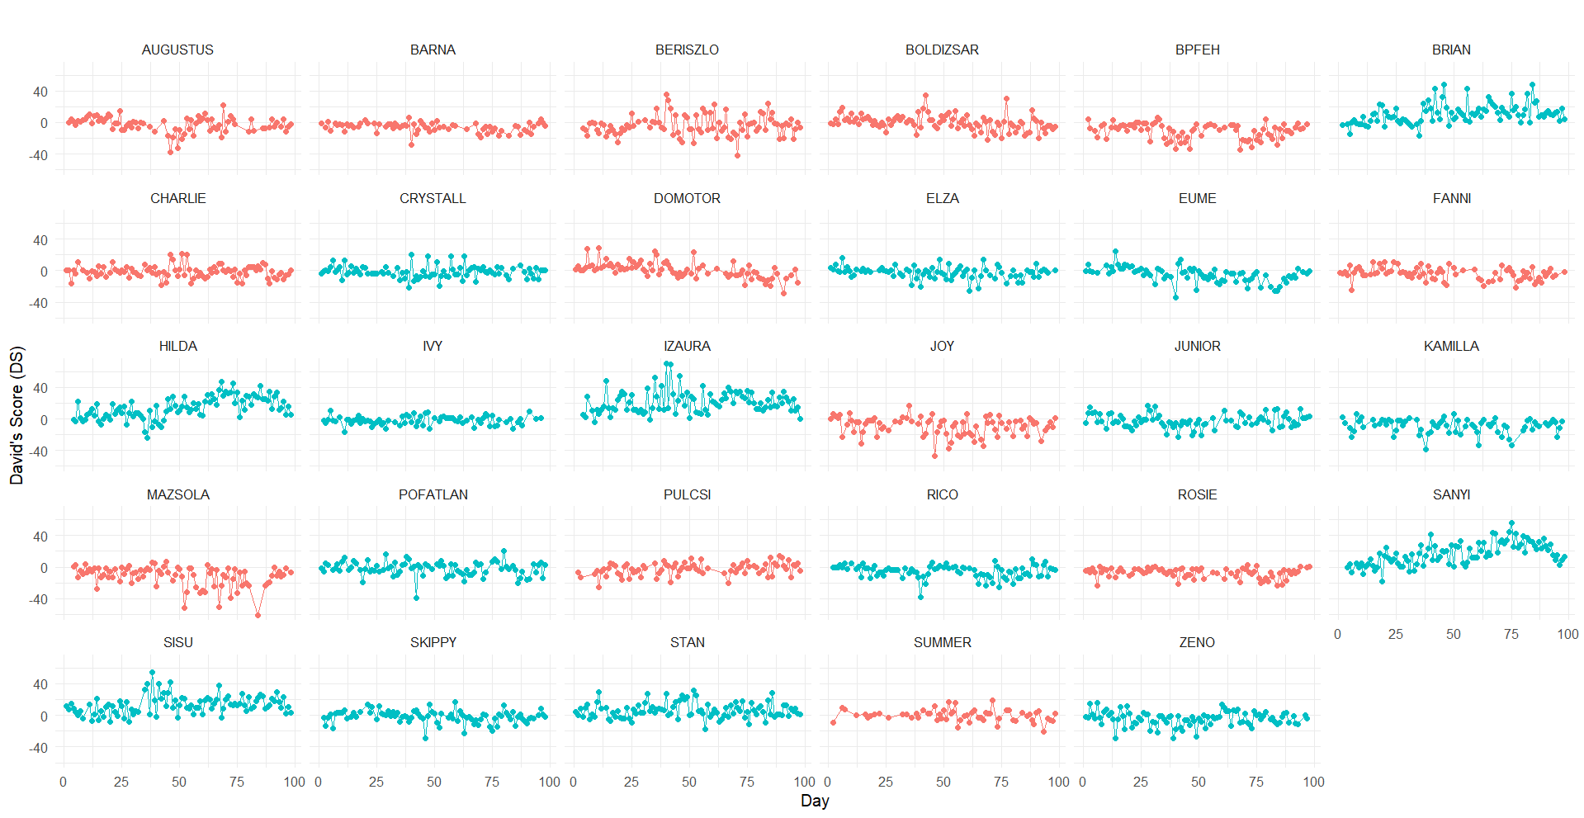
Online Resource 2. Temporal changes in David’s Score (DS) of individual African penguins over the 97-day study period. Color coding: light blue – males; red – females.

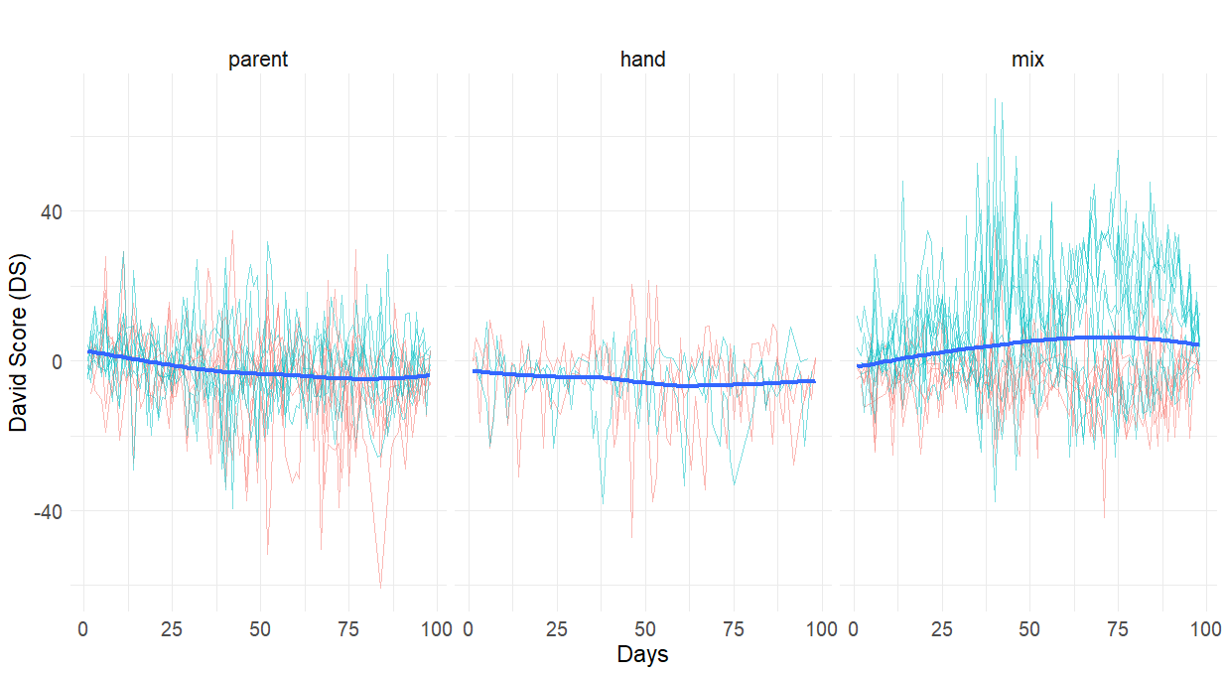
Online Resource 3. Temporal changes in David’s Score (DS) of individual African penguins over the 97-day study period are distinguished by rearing categories. Color coding: light blue – males; red – females.

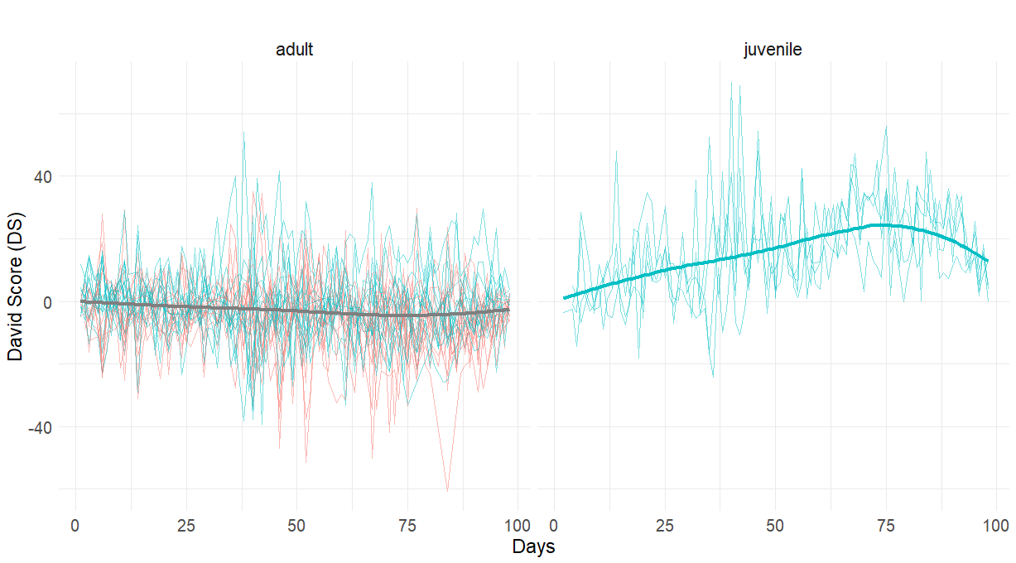
Online Resource 4. Temporal changes in David’s Score (DS) of individual African penguins over the 97-day study period distinguished by age categories. Color coding: light blue – males; red – females.

