Transcriptome sequencing of Hodgkin lymphoma Hodgkin and Reed-Stenberg cells reveals escape from NK cell recognition and an unfolded protein response

Roshal el al.

SUPPLEMENTARY METHODS

Immunohistochemistry (IHC)

The following antibodies were used for IHC: CD48 (1:100, rabbit monoclonal, clone EPR4108, Abcam, RRID:AB_10703015), PDIA6 (1:1000, Rabbit polyclonal, Proteintech, RRID:AB_10805765), BCMA (1:200, mouse monoclonal, clone D-6, Santa Cruz Biotechnology) and LMO2 (1:2000, mouse monoclonal, clone 1A9-1, Santa Cruz Biotechnology, RRID:AB_2136572) was accomplished using the Bond III auto stainer (Leica Microsystems, Illinois, USA). FFPE tissue sections were first baked and deparaffinized. Antigens were then retrieved by heating the slides at 99-100°C in Bond Epitope Retrieval Solution 2 for 20 minutes for CD48 and 30 minutes for BCMA and LMO2, and in Bond Epitope Retrieval Solution 1 for 30 minutes for PDIA6. Sections were then incubated sequentially with the endogenous peroxidase block for 5 minutes, primary antibody for 15 minutes (PDIA6 and CD48) or 30 minutes (BCMA and LMO2), polymer (equivalent to tertiary antibody) for 8 minutes, diaminobenzidine (DAB) for 10 minutes and hematoxylin for 5 minutes (Bond Polymer Refine Detection, Leica Microsystems). The stained slides were then dehydrated in 100% ethanol and mounted by using LeicaCV5030 Glass Coverslipper (Leica Microsystems).

Data Input and Preprocessing

Raw RNA-seq data in FASTQ format was converted into fasta format and then divided into smaller files containing 100,000 reads each, to speed alignment. Each was mapped in parallel on a computational cluster using Basic Local Alignment Search Tool (BLAST, RRID:SCR_004870) (67) to a reference sequence composed of the full set of spliced mRNA transcripts derived from hg19 RefSeq (RRID:SCR_003496). BLAST output was sorted by sequence read id, gene name, and position on the query read, and compressed and formatted on the fly to keep only fields informative for fusions, to reduce the consumption of disk space. Degeneracy on the level of genes was addressed by collapsing hits to multiple different isoforms of the same gene from the same query to one hit per gene per query. Sorted and reduced alignment results were combined back into a single larger file and two mutually exclusive lists were then created: one containing individual reads that mapped exclusively to one gene, and another which contained only reads that mapped uniquely to two or more distinct genes. The former was used to search for split-insert read pairs and the latter for split-reads.

Virus discovery
RNA-seq files were tested for the presence of viral genomes using the virdetect tool (37). Pre-prepared viral genomes in FASTA format are available for download with the virdetect; these are curated vertebrate viral genomes are obtained from GenBank and then optimized to increase specificity by masking the viral genomes for (a) areas of human homology and (b) areas of low complexity. Following alignment with STAR (with hg38 reference), reads that could not be mapped to the human genome were then mapped to the prepared viral genomes (list of 1893 viruses) by the software.

SUPPLEMENTARY RESULTS

Supplementary Table S1. Patient characteristics
Patient # | Age | cHL subtype | Corresponding published case  (ref)
2 | 32 | NS | 2 (1)
3 | 25 | NS | 3 (1)
4 | 58 | CLL+CHL | 4 (1)
5 | 40 | NS | 5 (1)
6 | 51 | NS | 6 (1)
7 | 29 | NS | 7 (1)
8 | 21 | NS | 8 (1)
9 | 76 | MC | 9 (1)
10 | 62 | MC | 10 (1)
11 | 12 | NS | IID_H198432 (2)
12 | 13 | MC | IID_H198438 (2)
13 | 12 | NS | IID_H198431 (2)
14 | 17 | NS | IID_H201345 (2)
15 | 20 | NS | IID_H201358 (2)
16 | 11 | NS | IID_H198451 (2)
17 | N/A | N/A | N/A
18 | 18 | cHL, NOS | N/A
19 | 69 | NS | IID_H198428 (2)

Supplementary Table S2. Genes differentially expressed in opposite directions in Roshal et al and Steidl et al.

Gene Name | log2FC_Roshal | adj.P.Val_Roshal | log2FC_Steidl | adj.P.Val_Steidl
ARHGAP11A | 4.03449127 | 1.11E-07 | -2.722466 | 4.30E-12
CCNA2 | 4.38307052 | 1.36E-08 | -2.8073549 | 5.60E-13
CDKN3 | 4.89290494 | 1.10E-12 | -2.8678965 | 2.00E-13
CENPE | 3.9896341 | 6.23E-09 | -2.3785116 | 9.20E-15
CLU | 6.62875812 | 0.00058648 | -4.7655347 | 8.60E-13
DEPDC1 | 6.41120313 | 1.58E-10 | -2.9448584 | 1.00E-14
E2F8 | 6.93514416 | 4.17E-08 | -2.4059924 | 2.90E-14
FEN1 | 2.93961117 | 9.38E-10 | -2.3504972 | 1.10E-12
HTR3A | -8.0382608 | 2.03E-14 | -3.6667566 | 2.70E-13
ITK | 4.57370943 | 0.000153 | -2.7004397 | 0.00000057
KIF11 | 4.12991817 | 1.22E-08 | -2.4329594 | 3.30E-15
KIF18A | 2.76598644 | 0.00012244 | -2.722466 | 5.50E-12
MAD2L1 | 3.29989895 | 1.74E-11 | -3.169925 | 2.50E-13
MND1 | 3.25072017 | 1.69E-07 | -2.9634741 | 7.10E-14
PANK1 | 4.58122435 | 4.53E-08 | -2.3785116 | 7.50E-10
PHACTR1 | -5.4042134 | 3.87E-09 | 2.48542683 | 0.0000021
PLK4 | 3.62207487 | 5.11E-07 | -2.3504972 | 2.60E-13
SPRED2 | 2.88427631 | 0.00022787 | -3.5484366 | 2.20E-14
TCF4 | -2.6847646 | 1.33E-11 | 3.15380534 | 3.40E-12
TOM1L1 | 5.06489046 | 0.00035108 | -2.4059924 | 4.9E-08

Supplementary Figure S1. Comparison of gene expression between HRS cells and intra-tumoral B cells using two different approaches. Volcano plot for genes that are differentially regulated between HRS and intratumoral B cells, (A) HL cell lines with intratumoral B cells and (B) HRS cells and HL cell lines. Gene expression concordance was assessed between RNA sequencing data from flow-cytometry purified HRS cells and previously published data by Steidl et al, which used laser-capture microdissection and Affymetrix GeneChip HG133 V2.0 arrays (3). Fold-change concordance plots are shown for (C) all expressed genes, and (D) genes meeting the differential expression significance cutoff (FDR<0.001; fold change >5) for HRS cells versus intra-tumoral B cells.

Supplementary Figure S2. Expression of UPR signature in multiple myeloma and diffuse large B cell lymphoma. (A) Gene set enrichment analysis (GSEA) for the Hallmark of Unfolded Protein Responses (UPR) was performed on multiple myeloma (MM) vs germinal centre B cells (GCB). (B) Enrichment of UPR signatures across MM and different sub-classifications of diffuse large B cell lymphoma (DLBCL), using expression data from Agirre et al. (4). (C) Heatmaps of genes associated with Hallmark of unfolded protein response (UPR) pathway as shown in Figure 2F in MM and different sub-classifications of diffuse large B cell lymphoma (DLBCL) in panel B. (D)GSEA for the Hallmark of Unfolded Protein Responses (UPR) analysis for DLBCL samples separated to performed on multiple myeloma (MM) vs germinal centre B cells (GCB). ABC-DLBCL=Activated B-cell-like diffuse large B cell lymphoma; GCB-DLBCL=germinal center B-cell-like diffuse large B cell lymphoma; uncl-DLCBL=unclassified-DLBCL. Colors in B and D represents relative expression: red indicates higher and blue indicates lower expression relative to the gene’s mean.

Supplementary Figure S3. Downregulation of B cell signalling and activation pathways in HRS cells. (A) Gene ontology analysis of genes downregulated in HRS compared to intra-tumoral B cells (adjp≤0.05; logFC≥ 1 or logFC ≤ -1). Heatmaps for (B) B cell receptor (BCR) signalling and (C) B cell activation genes differentially regulated between HRS and intra-tumoral B cells (adjp≤0.05; logFC≥ 1 or logFC ≤ -1). (D) Transcription factor target over-representation analysis was conducted using ChIP-X Enrichment Analysis version 3 (ChEA3) for genes downregulated in HRS relative to intra-tumoral B cells (adj-p≤0.001, logFC≤-2.32). Colors in B and C represents relative expression: red indicates higher and blue indicates lower expression relative to the gene’s mean.

Supplementary Figure S4. Comparison of HRS cell signature with other lymphoma subsets. (A) Gene set enrichment analysis (GSEA) for genes upregulated in CD30+ cells (Weniger et al) comparing HRS to intra-tumoral B cells. (B) Cibersortx analysis estimating the signature contribution of germinal centre B cells (GCBs) and naïve B cells in HRS, intra-tumoral B cells and cell line samples.

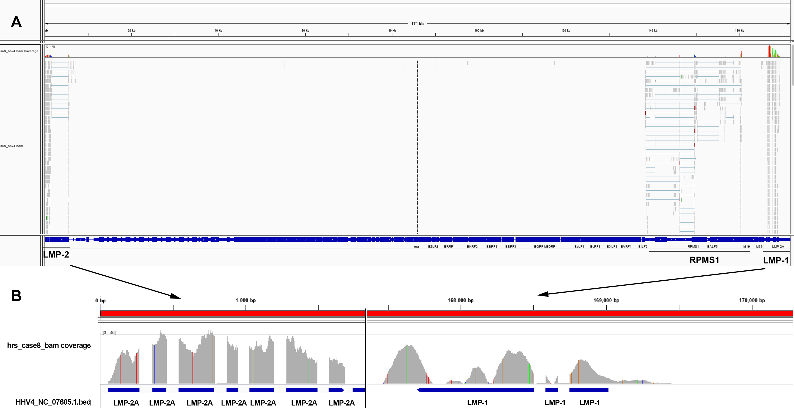

Supplementary Figure S5. Detection of EBV in cHL. Alignment of transcripts from Case 8 with a reference EBV genome using Integrative Genomics Viewer (IGV) is shown. (A) The entire genome shows most reads aligning to the regions surrounding the terminal repeats, which are at the beginning and end of the linear genome, where LMP-1 and LMP1 are located, although some reads were found in the RPMS1 region as well. (B) A higher scale view of the coverage in the LMP-2A and LMP1 genes shows expression of these genes is provided.

REFERENCES

1. Reichel J, Chadburn A, Rubinstein PG, Giulino-Roth L, Tam W, Liu Y, et al. Flow sorting and exome sequencing reveal the oncogenome of primary Hodgkin and Reed-Sternberg cells. Blood 2015;125(7):1061-72 doi 10.1182/blood-2014-11-610436.
2. Maura F, Ziccheddu B, Xiang JZ, Bhinder B, Rosiene J, Abascal F, et al. Molecular Evolution of Classic Hodgkin Lymphoma Revealed Through Whole-Genome Sequencing of Hodgkin and Reed Sternberg Cells. Blood Cancer Discov 2023;4(3):208-27 doi 10.1158/2643-3230.BCD-22-0128.
3. Steidl C, Diepstra A, Lee T, Chan FC, Farinha P, Tan K, et al. Gene expression profiling of microdissected Hodgkin Reed-Sternberg cells correlates with treatment outcome in classical Hodgkin lymphoma. Blood 2012;120(17):3530-40 doi 10.1182/blood-2012-06-439570.
4. Agirre X, Meydan C, Jiang Y, Garate L, Doane AS, Li Z, et al. Long non-coding RNAs discriminate the stages and gene regulatory states of human humoral immune response. Nat Commun 2019;10(1):821 doi 10.1038/s41467-019-08679-z.
5. Rosenwald A, Wright G, Leroy K, Yu X, Gaulard P, Gascoyne RD, et al. Molecular diagnosis of primary mediastinal B cell lymphoma identifies a clinically favorable subgroup of diffuse large B cell lymphoma related to Hodgkin lymphoma. J Exp Med 2003;198(6):851-62 doi 10.1084/jem.20031074.

