Supplementary Document for “Explainable Ensemble-Based Unsupervised Anomaly Detection in Urban Air Pollution Time Series”
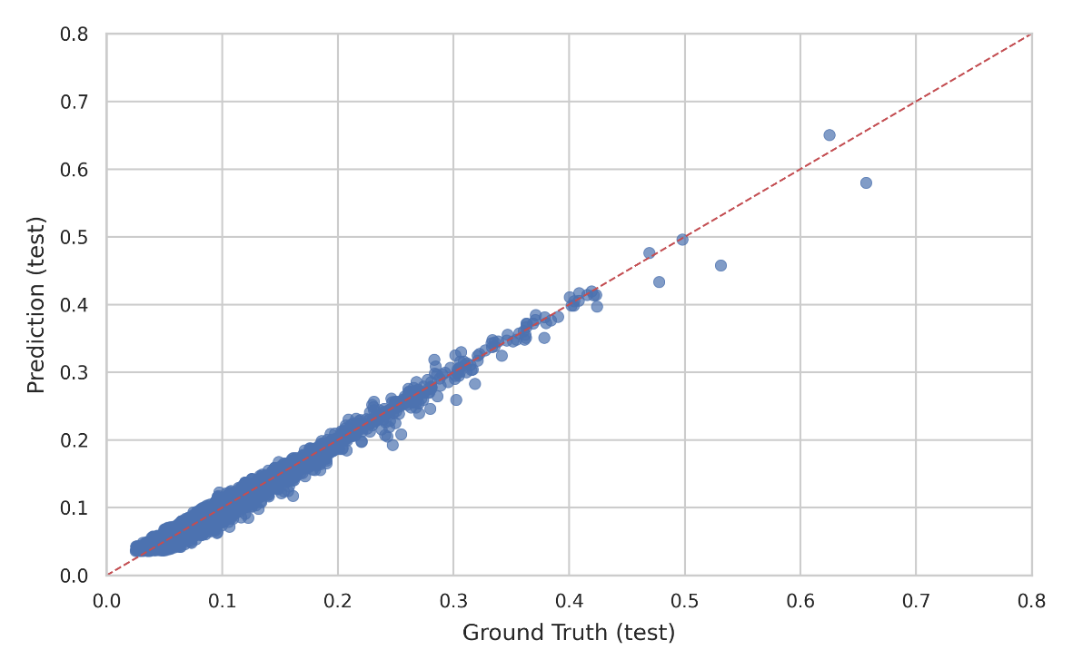
Fig. S1: Scatter plot of predicted versus ground truth values on the test dataset, showing a strong alignment along the 1:1 line and indicating high predictive accuracy.
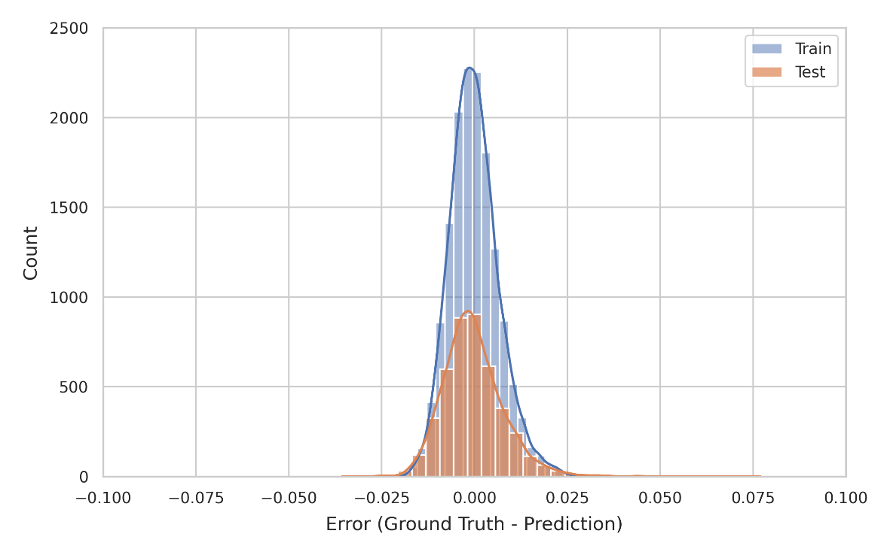
Fig. S2: Distribution of prediction errors for training and test datasets, showing a narrow concentration around zero with slightly higher variance in the test set.
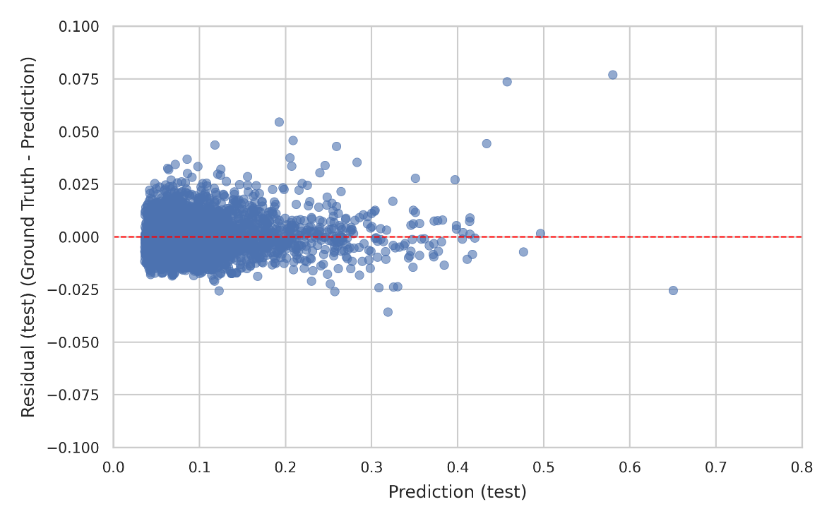
Fig. S3: Residuals of the test dataset plotted against predicted values, illustrating homoscedasticity with minor dispersion at higher prediction ranges.

