Supplementary Material
Depth constrains carbohydrate turnover in mangrove sediments through microbial assembly and functional loss
Qi Yan ª, Ming Sheng Ng ^{a,b}, Mindia A. S. Haryono ^{c}, Krithika Arumugam ^{d}, Benjamin J. Wainwright ª, Rohan B. H. Williams ^{c}, Ying Chang ^{a,b}*
ª Department of Biological Sciences, National University of Singapore, Singapore 117558
^{b} Yale-NUS College, National University of Singapore, 16 College Avenue West, Singapore 138527, Singapore
^{c} Singapore Centre for Environmental Life Sciences Engineering, National University of Singapore, Singapore 117456
^{d} Singapore Centre for Environmental Life Sciences Engineering, Nanyang Technological University, Singapore 637551

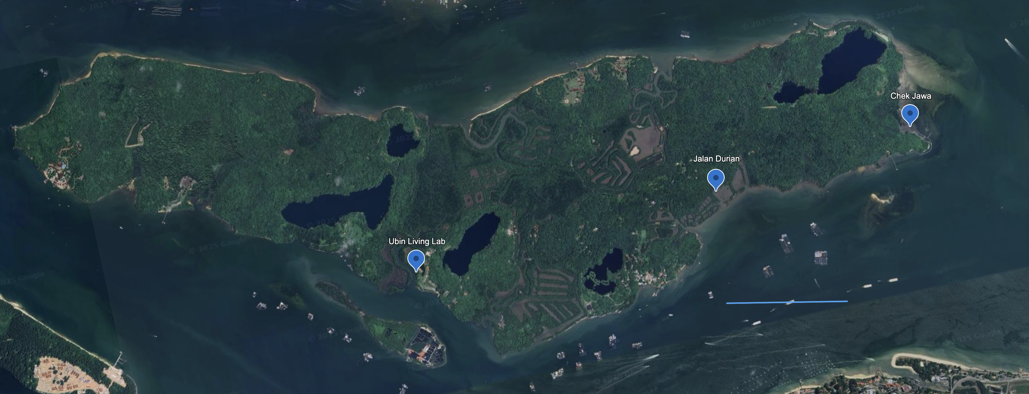
Fig S1 Map of Pulau Ubin showing the sediment sampling sites.
1 km
Fig S2 Summary statistics of raw sequencing reads, GC content, and quality scores (Q20/Q30) across metagenomic samples. Group differences were assessed using the Kruskal–Wallis test.

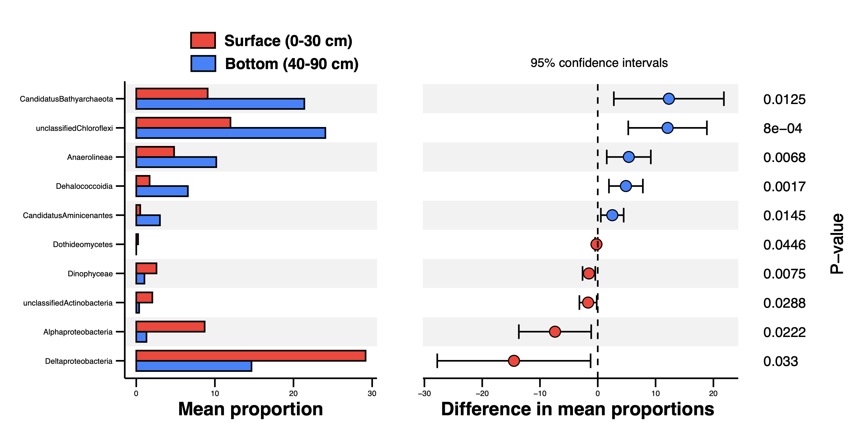 Fig S3 Comparison of microbial community composition between the surface layer (0–30 cm) and bottom layer (40–90 cm) based on STAMP analysis.
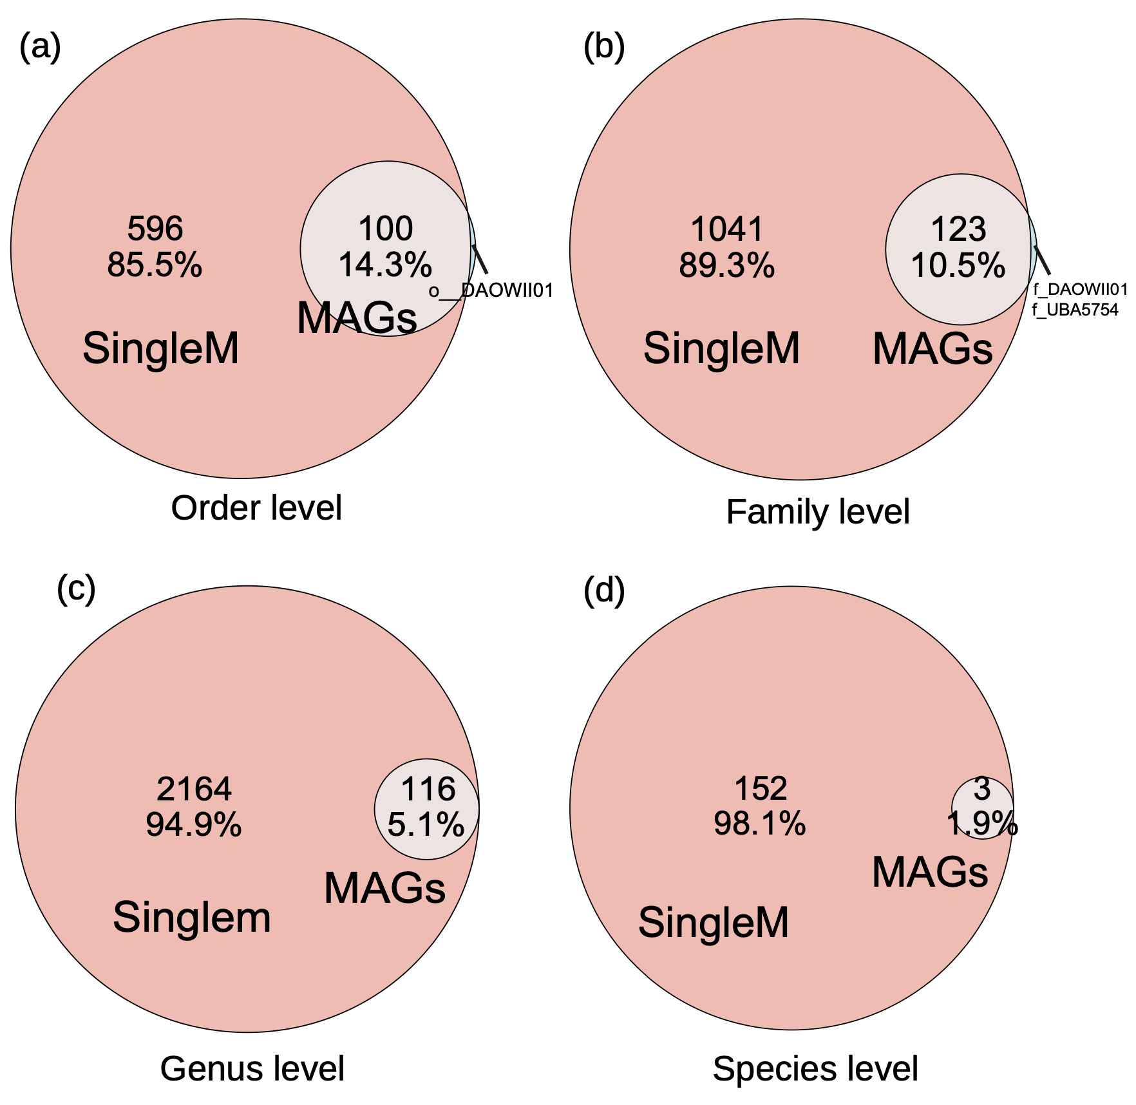
Fig S4 Venn diagrams illustrating the taxonomic comparisons of all metagenomic samples based on SingleM (orange) and MAGs (grey) classifications. Panels (a) to (d) correspond to comparisons at the order, family, genus, and species levels, respectively. The numbers within each circle indicate the number of taxonomic units and their corresponding relative percentages.
Fig S5 The abundance of CAZyme families in metagenomic samples from different sediment depths with the within-class scaling. Heatmap showing RPKM values of non-redundant CAZyme-encoding genes across sediment samples. Abundances were calculated using CoverM and normalized as RPKM.
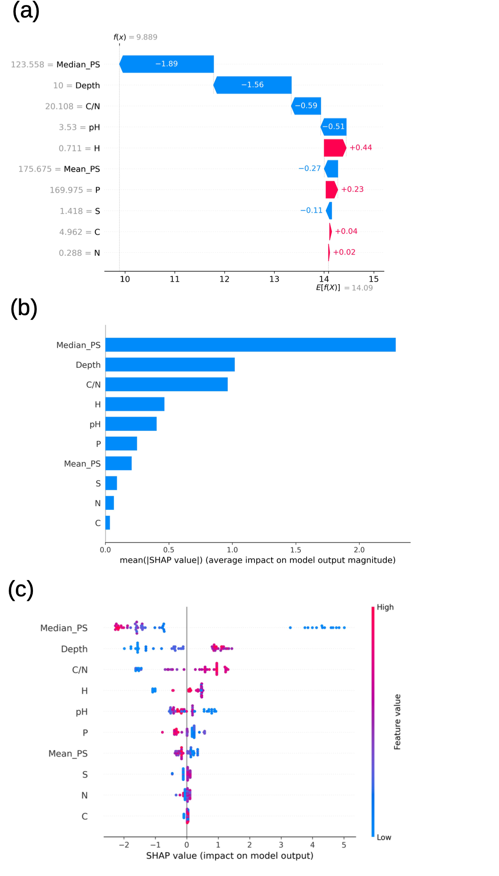
Fig S6 The results of SHAP analysis. (a) Individual example of a single sample, in which adding the SHAP value of each variable and the base value produces prediction value f(x). (b) Bar plot of the mean absolute SHAP values of drivers affecting Anaerolineae abundance. (c) A set of bee swarm plots; in which each dot corresponds to a sediment metagenome sample in this study. The dot position on x axis displays the impact that variable has on the model's prediction for that sample.

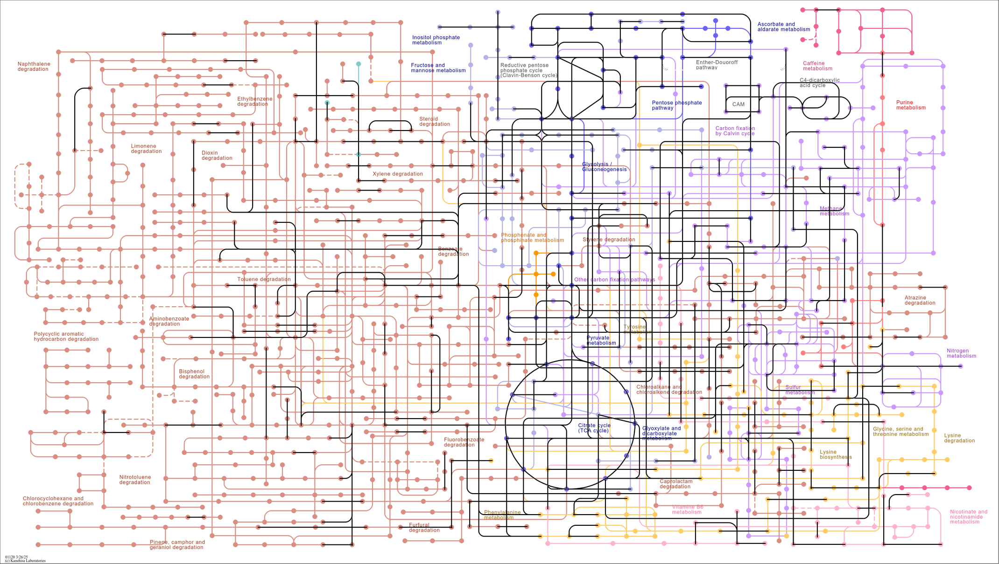
Fig S7 Mapping of 65 Anaerolineae MAGs to the KEGG carbohydrate metabolism pathway (map01120). Different colors indicate distinct metabolic modules. Black lines represent genes or pathways identified within the MAGs, indicating their potential involvement in corresponding metabolic functions.

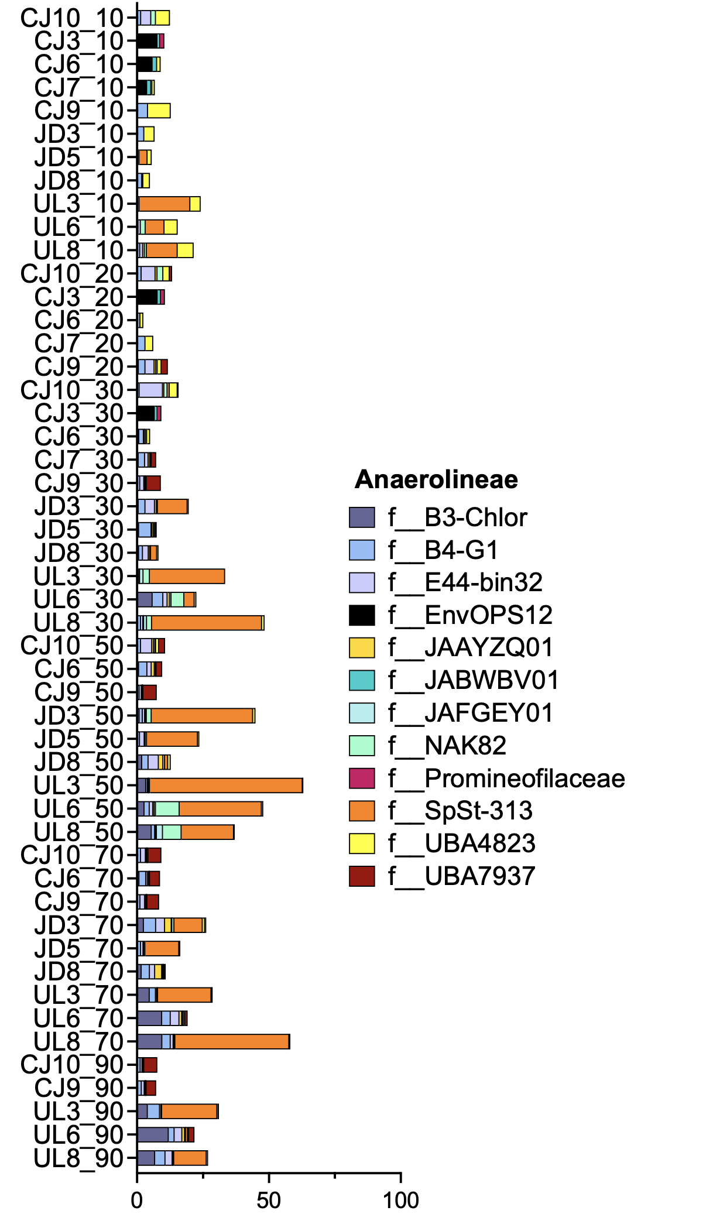
Fig S8 Relative abundances (%) of Anaerolineae MAGs across different families in 50 sediment samples.

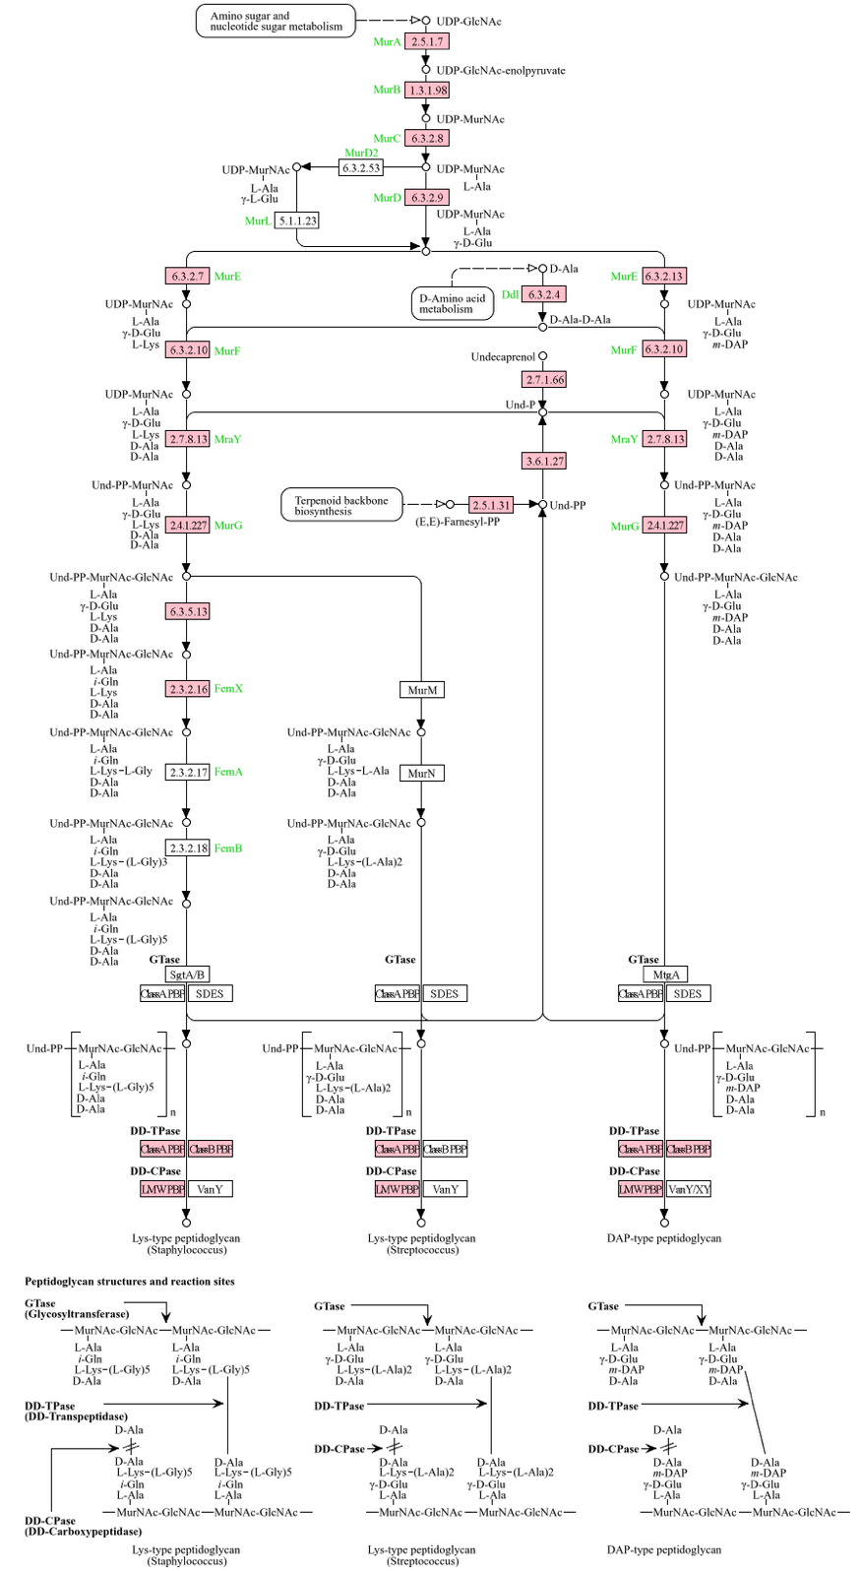
Fig S9 Mapping of 65 Anaerolineae MAGs to the KEGG peptidoglycan biosynthesis pathway (map00550). Pink highlights indicate genes that were detected in at least one MAG.

