Supplementary Information

Investigation of dissimilatory nitrate reduction to ammonium (DNRA) microbial communities in sediments of urban river network along the Huangpu River
Tong Zhang ^{a, b, c, d}, Xuming Zhuang ^{e}, Shakeel Ahmad ^{f}, Taeho Lee ^{g}, Chengbo Cao ^{c, *}, Shou-Qing Ni ^{a, b, d, *}
ª Shandong Provincial Key Laboratory of Water Pollution Control and Resource Reuse, School of Environmental Science and Engineering, Shandong University, Qingdao, Shandong, 266237, China
^{b} Suzhou Research Institute, Shandong University, Suzhou, Jiangsu, 215123, China
^{c} Institute of Light Textile and Medicial Materials, School of Chemistry and Chemical Engineering, Shandong University, Jinan, Shandong 250061, China
^{d} State Key Laboratory of Estuarine and Coastal Research, Shanghai, 200241, China
^{e} College of Chemistry and Chemical Engineering, Yantai University, Yantai, Shandong, 264005, China
^{f} Department of Soil and Environmental Sciences, Muhammad Nawaz Shareef University of Agriculture, Multan, Pakistan
^{g} Department of Civil and Environmental Engineering, Pusan National University, Pusan 609-735, Republic of Korea.

∗ Corresponding author：Chengbo Cao & Shou-Qing Ni, Shandong University, China. E-mail: cbcao@sdu.edu.cn, sqni@sdu.edu.cn.

Number of pages: 6 (including cover page)
Number of figures: 4
Number of tables: 1
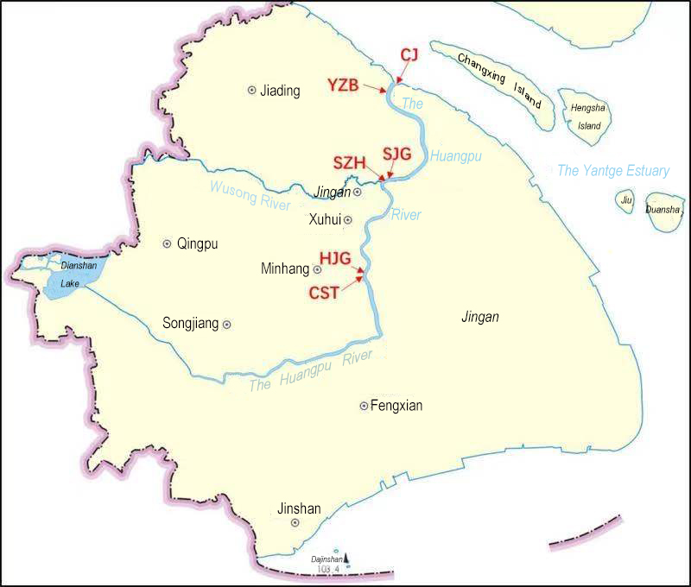
Fig. S1. Sampling sites in the Huangpu River, Shanghai, China.
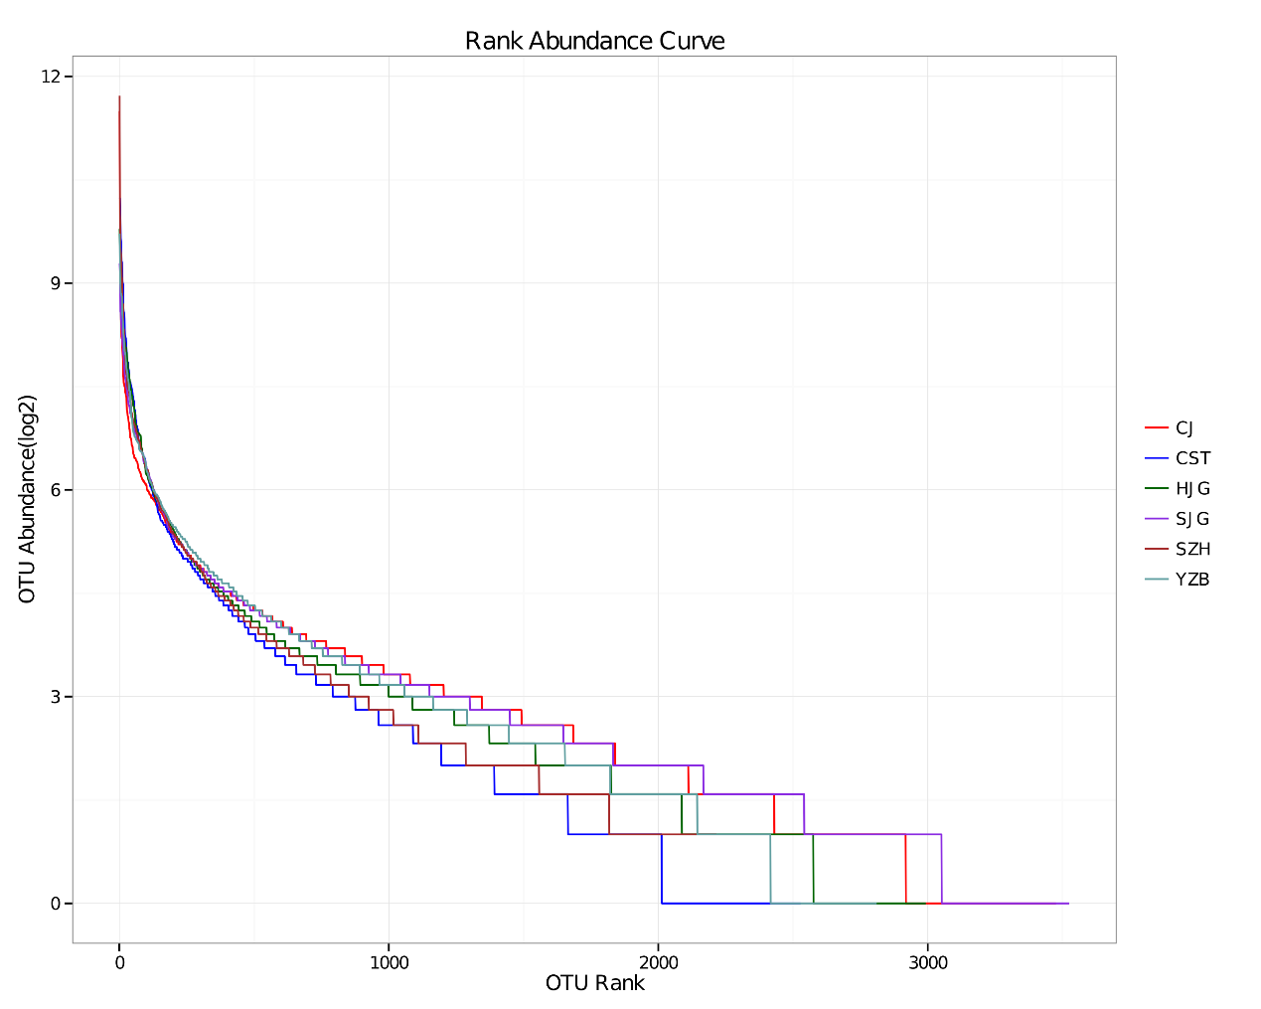
Fig. S2. Rank abundance curve based on nrfA sequencing in the Huangpu River.

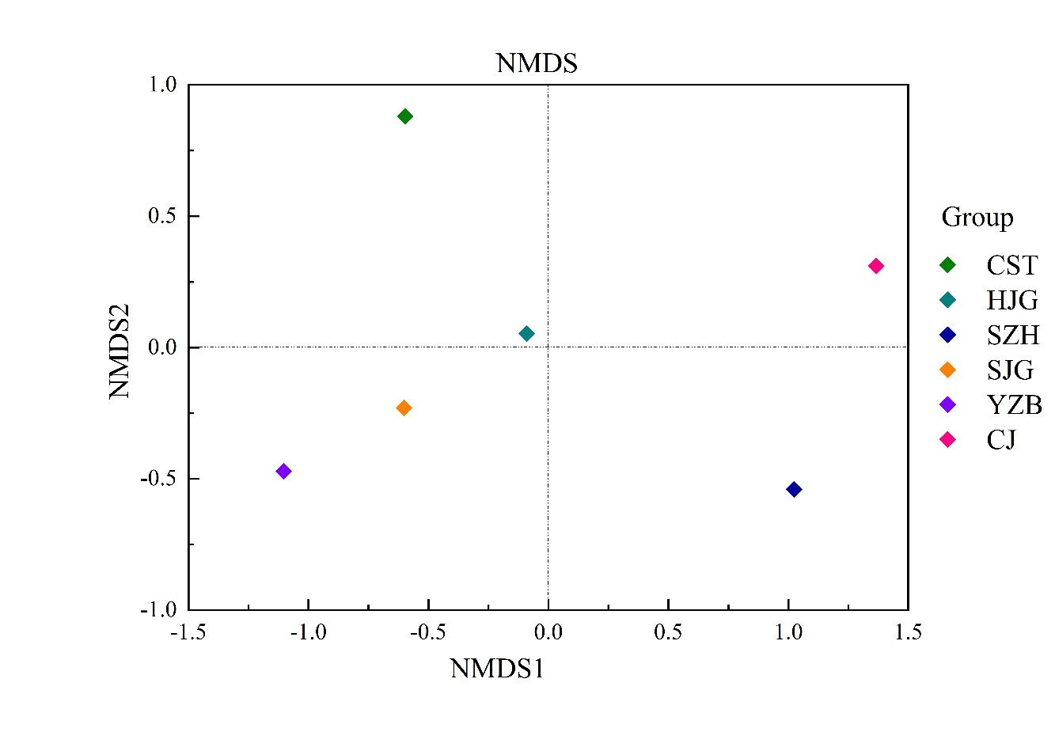
Fig. S3. NMDS analysis of genus-level community composition.

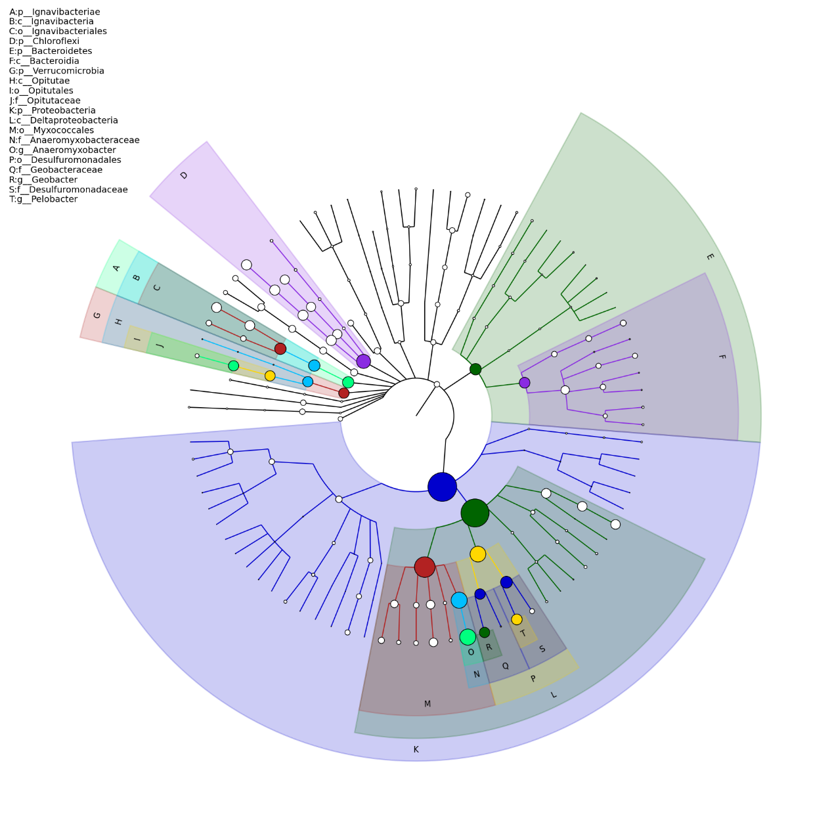
Fig. S4. Hierarchical tree of dominant microbial populations

Table S1 Environmental parameters of sediments in the Huangpu River

Site | pH | Salinity（‰） | Extractable  NO₃⁻-N  （μmol N/g） |  | Extractable  NO₂⁻-N  （μmol N/g） | Extractable  NH₄⁺-N  (μmol N/g) | Soil Organic Carbon (SOC) (g/kg) | Moisture content（%）
CST | 7.38 | 0.19 |  | 6.34 | 5.22 | 3.39 | 13.17 | 0.42
HJG | 7.71 | 0.19 |  | 5.97 | 13.41 | 3.38 | 15.53 | 0.41
SJG | 7.40 | 0.18 |  | 5.71 | 8.90 | 4.97 | 13.40 | 0.35
SZH | 7.35 | 0.18 |  | 4.51 | 6.45 | 5.53 | 9.76 | 0.30
YZB | 7.41 | 0.20 |  | 5.20 | 4.40 | 8.01 | 15.94 | 0.31
CJ | 7.50 | 0.21 |  | 4.77 | 5.63 | 0.34 | 11.63 | 0.41

