Supplementary Information

The Scalability and Carbon Removal Potential of Ocean Alkalinity Enhancement
Connor J. Mack^{1*}, Ryan Hanna^{2,3}, Daniela Faggiani-Dias¹, David G. Victor^{1,3,4,5}

1 Scripps Institution of Oceanography, University of California San Diego, La Jolla, CA 92093, USA
2 Center for Energy Research, University of California San Diego, La Jolla, CA 92093, USA
3 Deep Decarbonization Initiative, University of California San Diego, La Jolla, CA 92093, USA
4 School of Global Policy and Strategy, University of California San Diego, La Jolla, CA 92093, USA
5 The Brookings Institution, Washington, D.C. 20036

* Corresponding author e-mail address: cjmack@ucsd.edu (C.J. Mack)

Supplementary Figures
Figure # | Description | Page #
Figure S1 | Detailed conceptual schematic of the modeling framework | 3
Figure S2 | Conceptual schematic of net carbon removal calculations | 7
Figure S3 | Conceptual schematic of alkalinity distribution | 8
Figure S4 | The current size of the OAE industry | 10
Figure S5 | Three historical analogs for OAE and data | 11
Figure S6 | Carbon intensity of electricity by region | 14
Figure S7 | Carbon intensity of electricity by country | 15
Figure S8 | Full climate modeling results | 19
Figure S9 | Tornado Sensitivity Plot | 20
Figure S10 | Net CO₂ removals by historical analog | 22
Figure S11 | Net CO₂ removals across by initial OAE industry size | 23
Figure S12 | Net CO₂ removals across the year of first deployment | 24
Figure S13 | Technology attributes and ordering sensitivities | 25

Supplementary Tables
Table # | Description | Page #
Table S1 | Model parameters and variables | 4
Table S2 | Model Equations | 5
Table S3 | Ordering of alkalinity injection across deployment zones | 6
Table S4 | Climate Model Equations | 9
Table S5 | Energy use and process emissions | 12
Table S6 | Alkalinity feedstock conversion factors | 13
Table S7 | Model parameter space | 16
Table S8 | Three modes of OAE deployment | 17
Table S9 | Full model sensitivities | 20

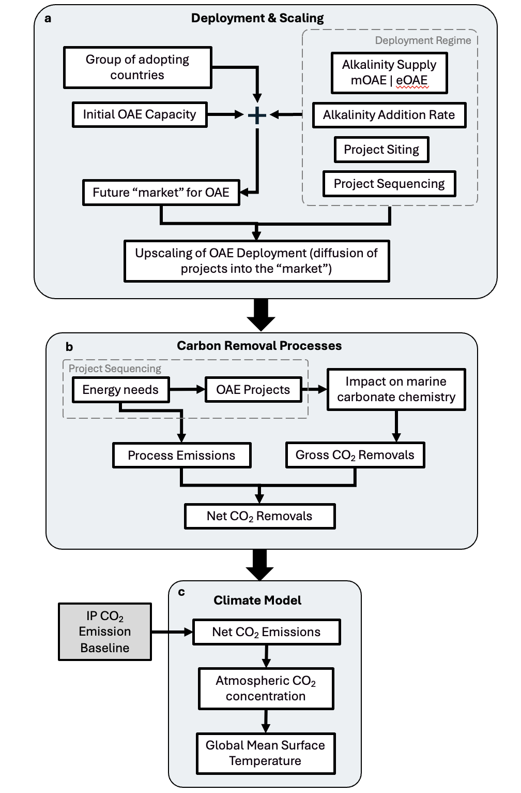
Supplementary Figure 1 | Detailed conceptual schematic of the modeling framework. The model calculates impacts on the climate system due to OAE by integrating modeling of a, innovation and upscaling of OAE technologies; b, alterations to the marine carbonate system due to OAE interventions, associated process emissions, gross and net CO₂ removals; and c, the impact of net CO₂ removals from OAE on atmospheric CO₂ concentration and global mean surface temperature, given background CO₂ emissions from illustrative pathways (IPs) in the IPCC’s Sixth Assessment Report.^{1,2}

Supplementary Table 1 | Model parameters and variables. Parameters, intermediate, and cumulative variables included in the OAE scaling projections and net CO₂ removal modeling. TA–total alkalinity; MPA–marine protected area; EEZ–exclusive economic zone; CESM2–Community Earth System Model; IAM–integrated assessment model
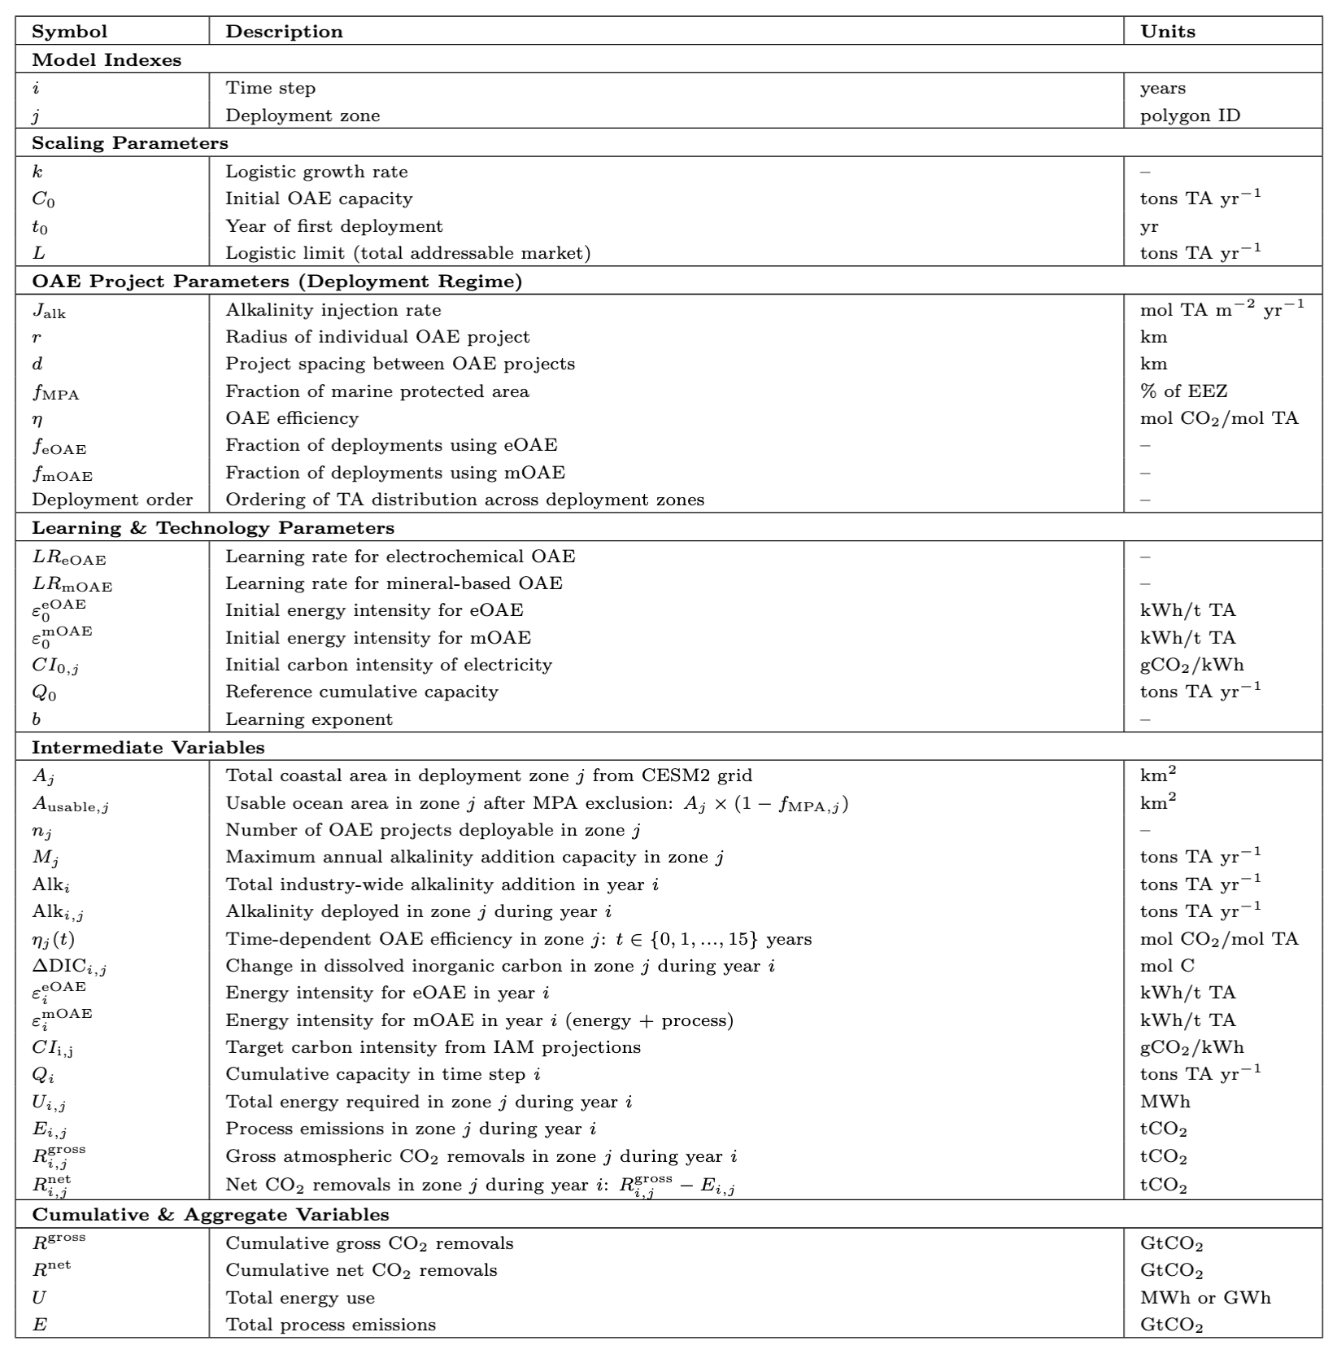

Supplementary Table 2 | Model equations. Equations are organized by deployment and scaling (Eq. 1-7), gross carbon removal (Eq. 8-14) and net carbon removal (Eq. 15-19). 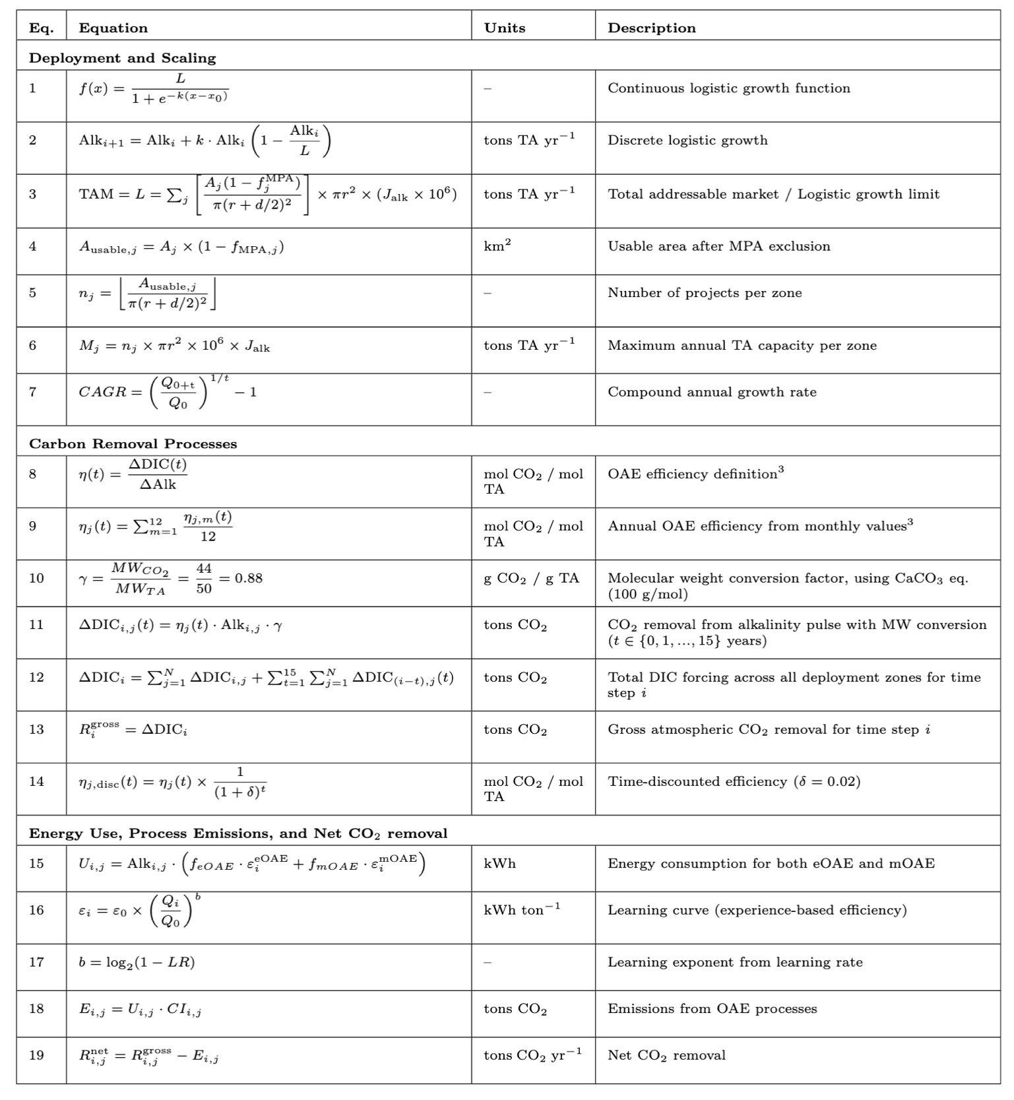

Supplementary Table 3 | Ordering of alkalinity injection across deployment zones. Logic for distributing alkalinity across deployment zones. For efficiency-based orderings, the reverse order (low efficiency first) was also tested. For country-grouping-based orderings, alkalinity is allocated first to all deployment zones in Europe until those zones reach their maximum capacity (Supplementary Table 2, Eq. 6), then to OECD zones and finally to zones in the rest of the world. Within each grouping, the ordering follows the secondary sorting criteria (OAE efficiency, grid carbon intensity, or random assignment). Efficiency metrics are adapted from Zhou et al. 2024 (ref. 3).
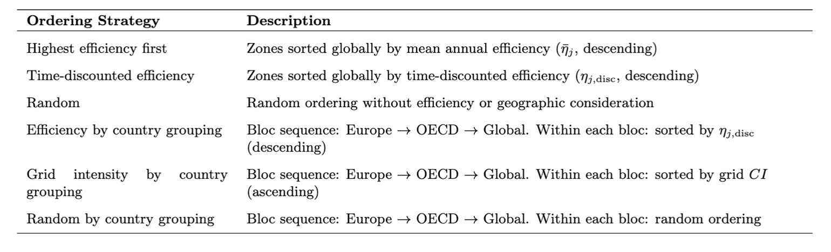

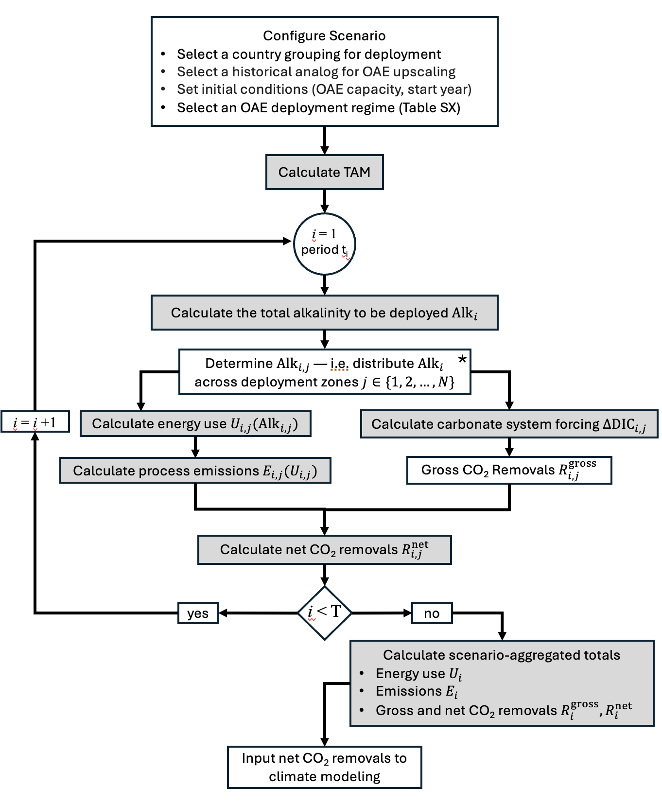
Supplementary Figure 2 | Conceptual schematic of net carbon removal calculations. First, a scenario is configured and the total addressable market (TAM) is calculated (Supplementary Table 2, Eq. 3). The model then steps through time i and makes three main calculations. First, it calculates the overall volume of alkalinity to be distributed across deployment zones according to the scenario’s chosen logic (Supplementary Table 3). The alkalinity distribution algorithm is shown in more detail in Supplementary Fig. 3. Second, the model calculates carbonate system forcing for 15 years post-alkalinity injection, per the approach in Zhou et al. 2024³, generating an estimate for gross CO₂ removal in years i–i+15 from addition in year i. Third, it calculates energy use and process emissions (Supplementary Table 5) and, from these, net CO₂ removals. When the model finishes annual calculations, it concludes by calculating scenario-aggregated totals and inputs results to the climate model. *Denotes calculations expanded upon in Supplementary Fig. 3.
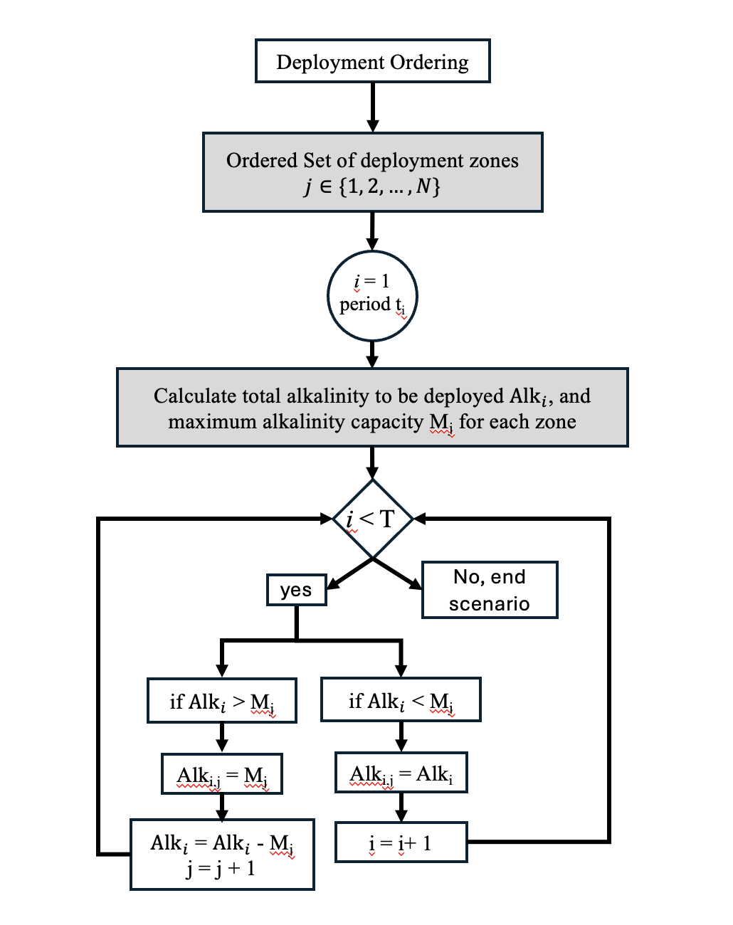
Supplementary Figure 3 | Conceptual schematic of alkalinity distribution. The sequential allocation of alkalinity across ordered deployment zones j ∈ {1, 2, ..., N} in each time period i. For each time step, the model calculates the total available alkalinity (Alk_{i}) and the maximum alkalinity capacity (M_{j}) for each zone. Alkalinity is distributed sequentially: if Alk_{i} exceeds a zone's capacity M_{j}, the zone is filled and the remaining alkalinity (Alk_{i} - M_{j}) continues to the next zone (j = j + 1), and the process repeats. If Alk_{i} is less than M_{j}, all remaining alkalinity is allocated to the current zone and the model advances to the next time period (i = i + 1). This sequential filling process continues until the final time period T is reached. The ordering of deployment zones follows different logics (efficiency-based, grid carbon intensity, random, or by country grouping) as detailed in Supplementary Table 3.

Supplementary Table 4 | Climate model equations. Key differential equations and relationships in the FaIR v1.6.2 climate model used for probabilistic climate projections. Variable names are endogenous to the FaIR modeling framework and are unrelated to those found in Supplementary Table 1. R_{i} – carbon pool i; E – annual CO₂ emissions α – time constant scaling factor; C_{acc} – cumulative carbon uptake by land and ocean; iIRF – integrated impulse response function; T – global mean surface temperature anomaly; F – effective radiative forcing; F_{ext} – non-CO₂ forcing; D – time to CO₂ doubling at 1% yr−1 growth. The four carbon pools represent geological re-absorption (τ0), deep ocean invasion (τ1), biosphere/thermocline uptake (τ2), and rapid mixed-layer processes (τ3). Equations are based on Smith et al. 2018 (ref. 4) and citations therein^{5–7}.

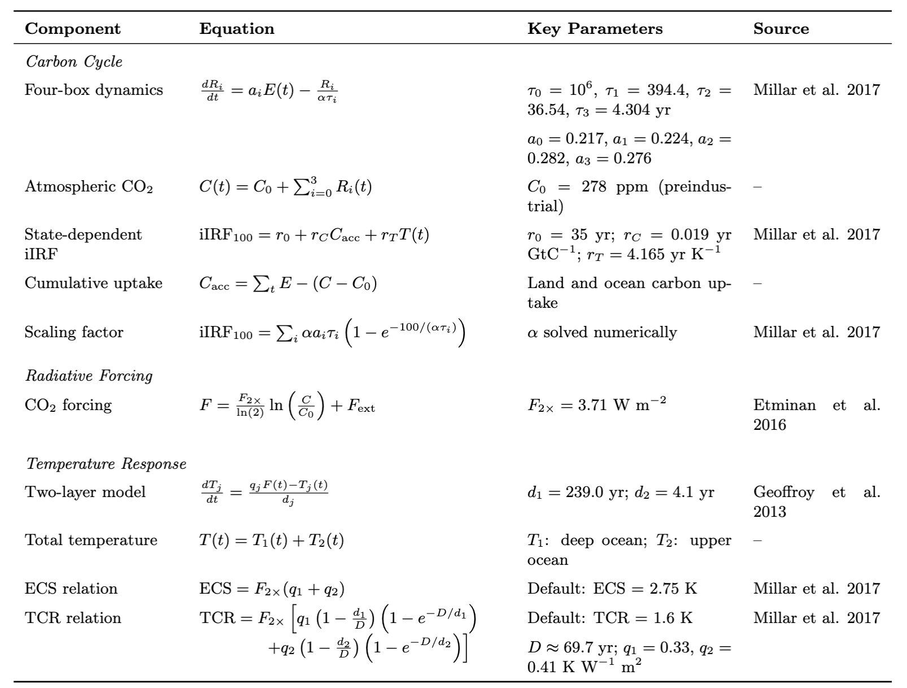

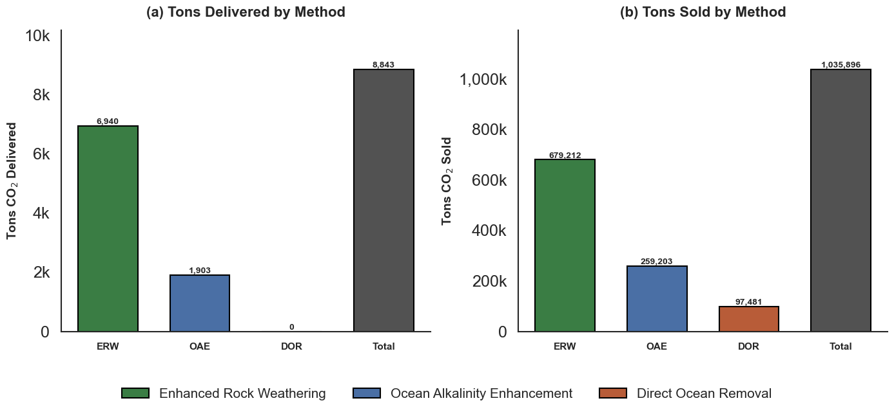
Supplementary Figure 4 | The current size of the OAE industry. Tons of CDR delivered, and credits sold using OAE and similar or related approaches. Enhanced rock weathering (ERW) leverages the same geological weathering process as mOAE, but is done on land (farmland, grasslands, etc.). CDR delivered and sold via ERW is indicative of the market’s ability to move and spread certain kinds of crushed rocks, which is illustrative for OAE because it requires similar process inputs. Direct ocean capture (DOR) uses electrochemical seawater processing techniques (very similar to eOAE) and, along similar lines, indicates the market’s ability to build and power seawater processing facilities for CDR. Data are from cdr.fyi⁸ and are current as of fall 2025. Total will likely grow as new projects come online.

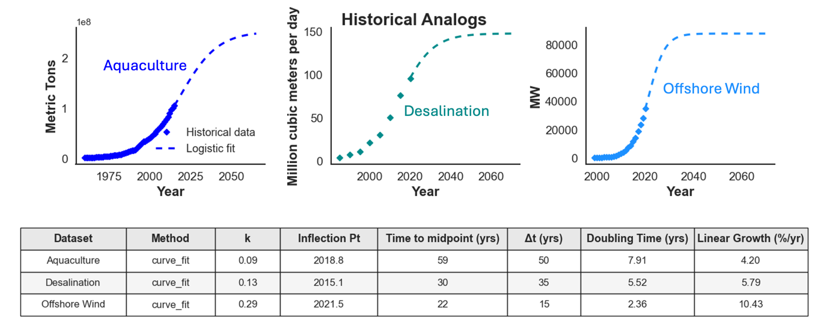

Supplementary Figure 5 | Three historical analogs for OAE and data. Data on the historical analogs identified for OAE technologies. Offshore wind represents rapid deployment of marine engineering infrastructure with substantial policy support. Desalination represents an industry with onshore processing of large amounts of seawater. Aquaculture is an example of nearshore interventions in ocean biogeochemistry at industrial scales. Table shows logistic growth parameters derived from the historical data, where k is the logistic growth coefficient, inflection point marks the year of maximum growth rate, time to midpoint indicates years from start to 50% market saturation, ∆t is the duration of the main growth phase (10-90%), doubling time shows how quickly capacity doubles during exponential growth, and linear growth rate represents the maximum compound annual growth rate (CAGR) around the inflection point. Diamonds denote observed values in the historical record; dashed lines represent logistic fit projections into the future. Data is from the HATCH dataset⁹ and included in the data repository to this paper.

Supplementary Table 5 | OAE energy use and process emissions. Energy intensities (a, b) and efficiency learning rates (c) derived from the literature for mOAE and eOAE processes. Values for eOAE include estimations of energy intensity for electrolysis and bi-polar electrodialysis (BPMED)^{10–13}. Values for mOAE capture solar calcination at the low end (~200 kWh/tCO₂^{14,15}) through conventional calcination at the high end (~2000 kWh/tCO₂^{14,15}), and a range of energy consumption values for olivine-like minerals grinded to 5 µm (~300–2500^{16–19}). Both mineral feedstocks (lime derivatives and crushed olivine) are included under mOAE scenarios. Supplementary Table 6 outlines relevant conversion factors for mineral feedstocks. Conservative, baseline, and optimistic energy intensities (b) are chosen for the year of first deployment based on the ranges found in the literature (a). Reductions in energy intensity over time are modeled based on technoeconomic projections of mineral supply chains and similar electrochemical processes.^{18,20–23}
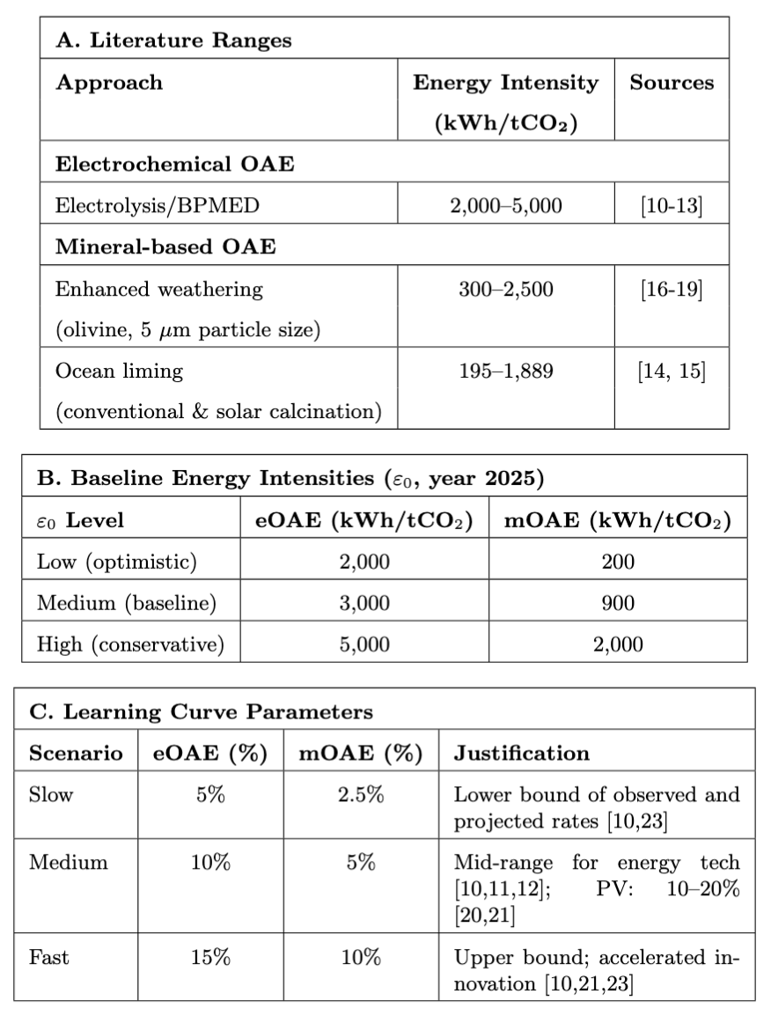

Supplementary Table 6 | Alkalinity feedstock conversion factors. Stochiometric relationships between alkalinity feedstocks. Total alkalinity (TA) is expressed in terms of CaCO₃ equivalents. Sodium hydroxide (NaOH) is the alkalinity source produced by eOAE processes. Calcium hydroxide (Ca(OH)₂) and olivine (Mg₂SiO₄) are the specific feedstocks with process emissions represented in this model. Brucite (Mg(OH)₂) is included for reference as another source of alkalinity commonly discussed with OAE potential. Conversion factors represent (1) tonnes of feedstock needed to provide the same alkalinity as one tonne of CaCO₃ and (2) tons of CaCO₃ equivalent alkalinity provided by one tonne of feedstock.
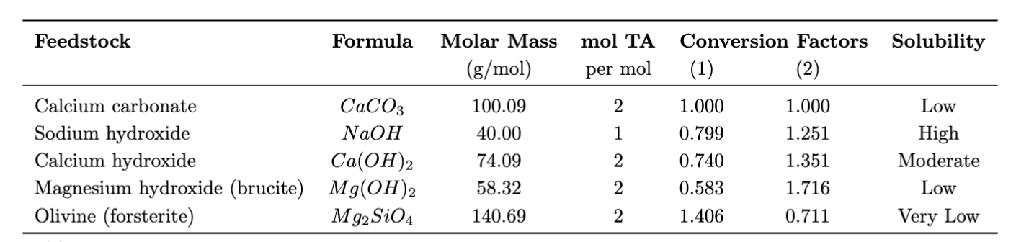

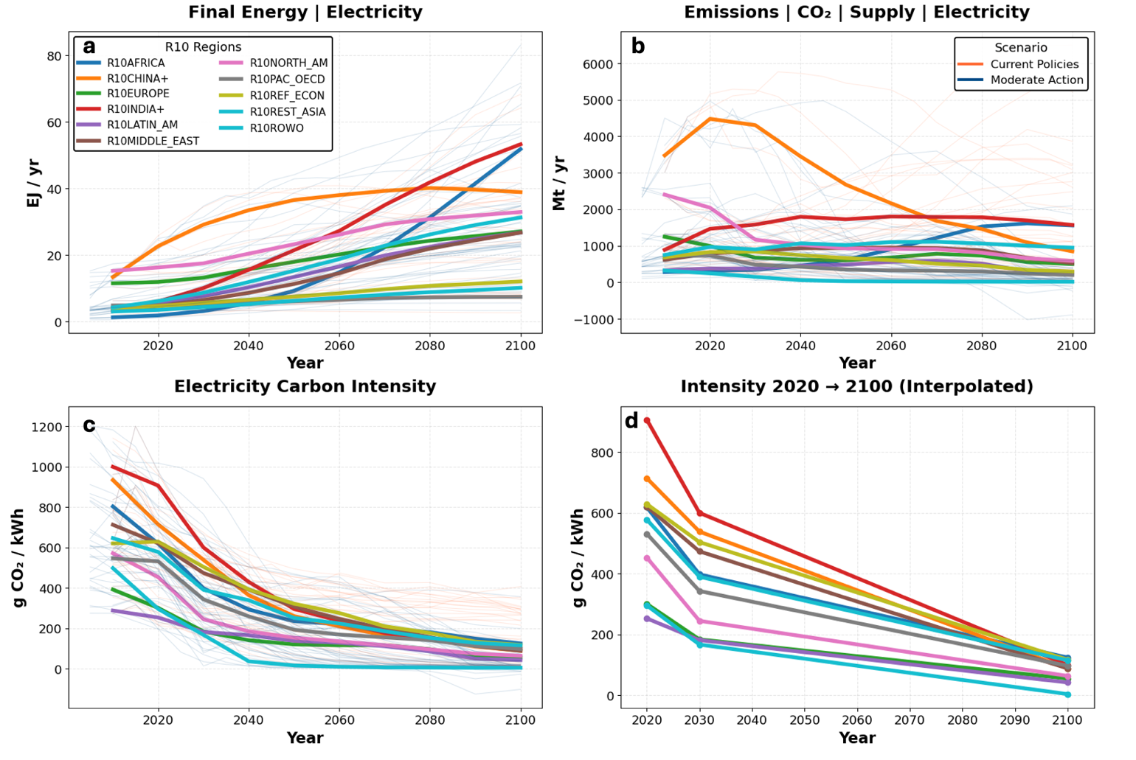
Supplementary Figure 6 | Carbon intensity of electricity by region. Regional projections from the AR6 database for the carbon intensity of electricity production under the CurPol and ModAct illustrative pathways. Carbon intensity of electricity (c) is calculated as ratio between CO₂ emissions due to electricity production (b) and overall electricity usage (a). Regional values are linearly interpolated between 2020, 2030 and 2100 for a conservative approximation (d).

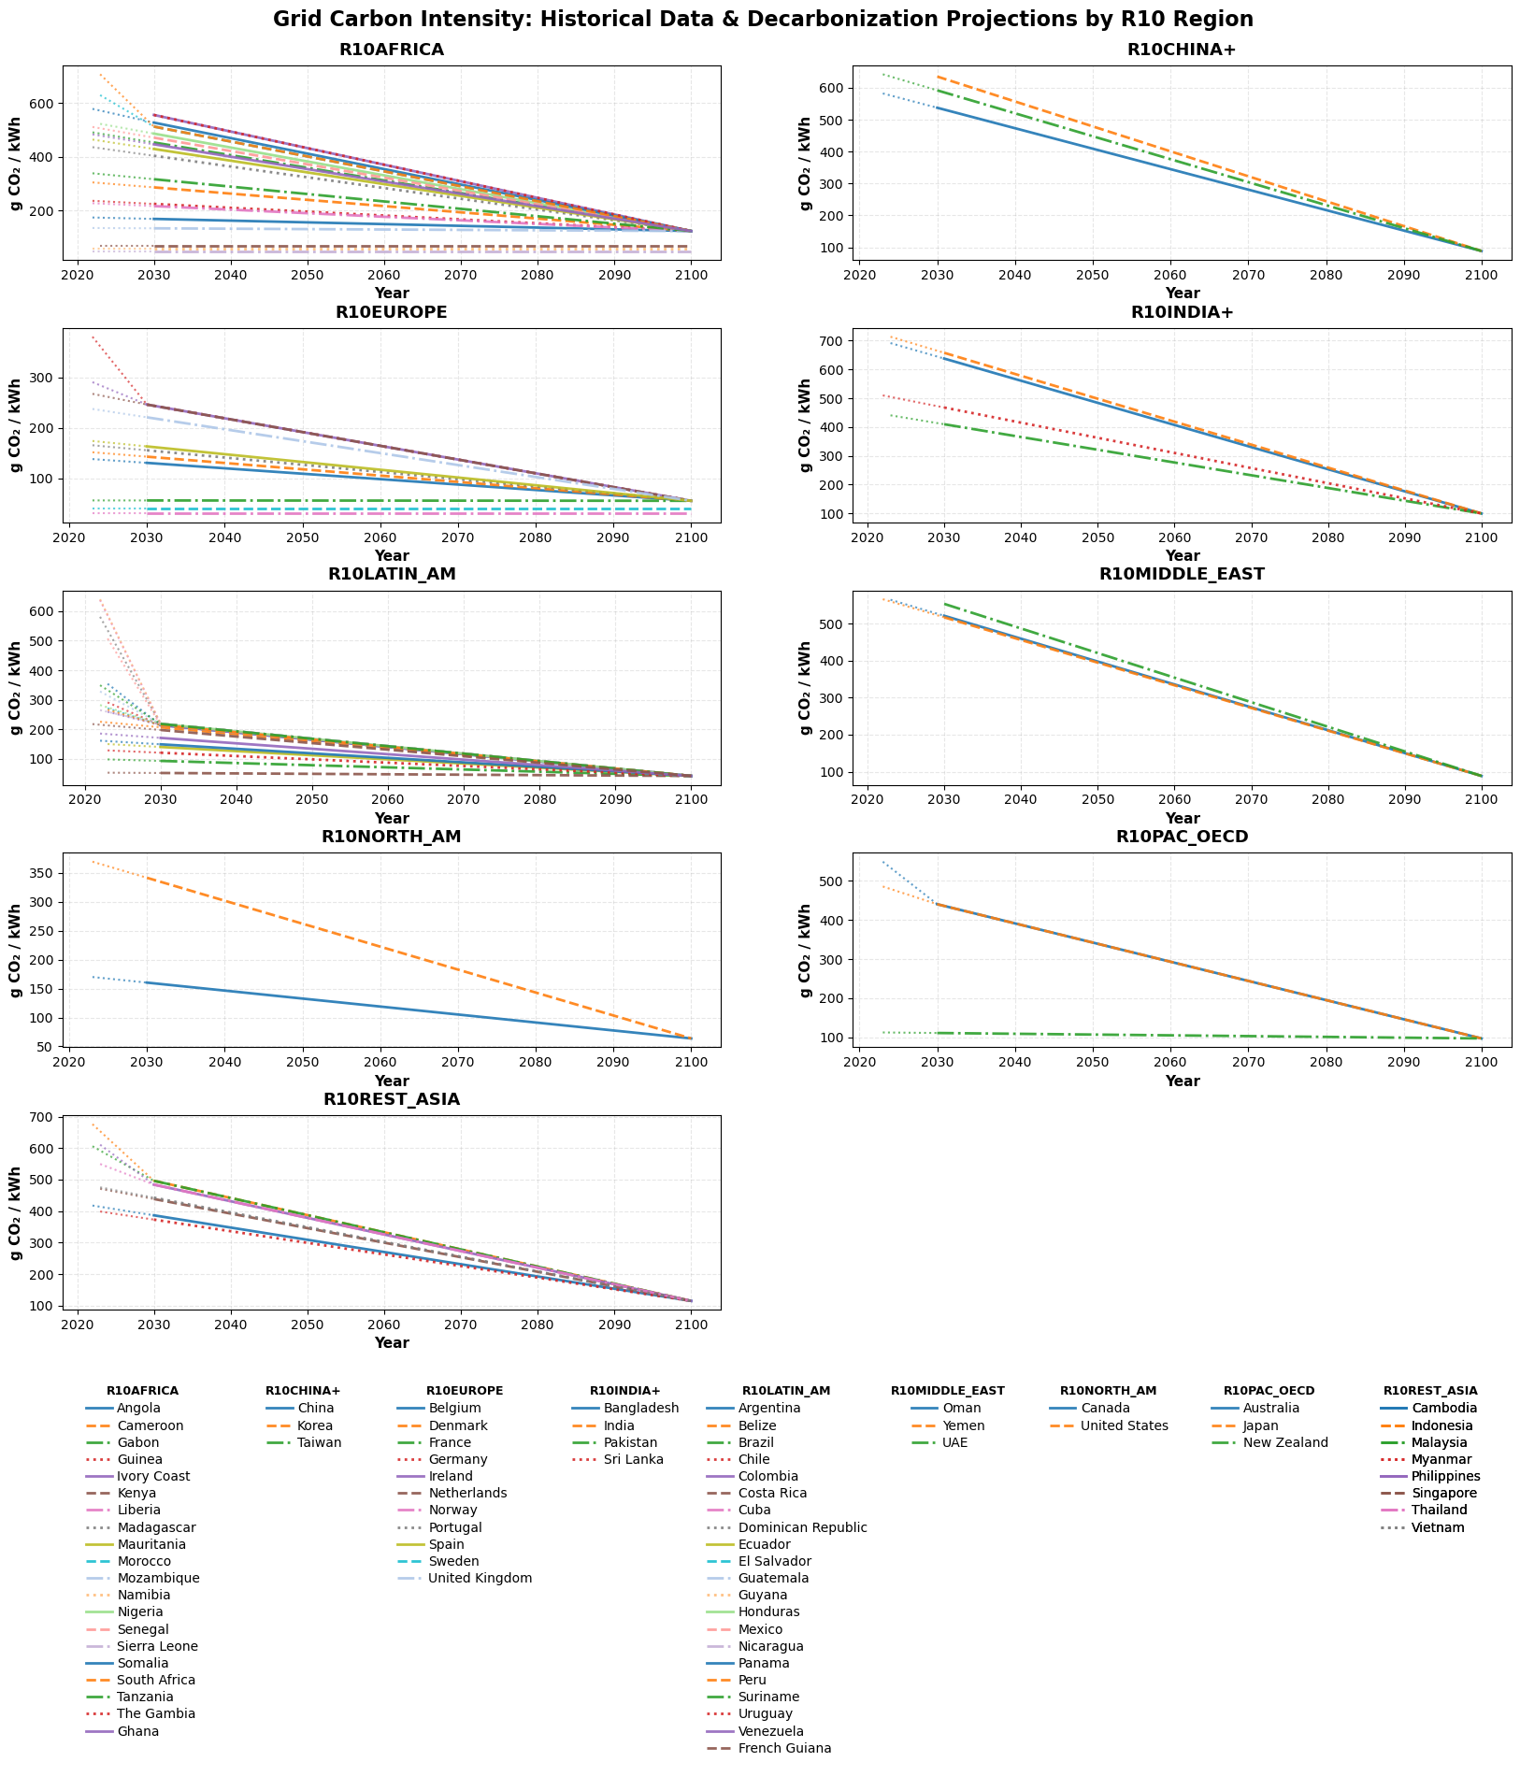
Supplementary Figure 7 | Carbon intensity of electricity by country. Interpolated decarbonization timelines for all coastal countries included in this analysis starting with present day grid intensity values⁶⁶ interpolated linearly to regional 2030 projections from IAM output, and then to 2100. If a country is already below the regional 2030 projection, grid intensity is interpolated directly to 2100. For modeling out to 2150, carbon intensities are held to 2100 values.

Supplementary Table 7 | Model parameter space. Parameter space for the OAE scaling model. and naming conventions for model output. Parameters are ordered by position (1-10) in the file naming convention. Parameters are organized into four categories: model indexes (temporal and spatial), scaling parameters (diffusion of OAE technologies), OAE process parameters (deployment regime), and learning & technology parameters. Deployment regime parameters are primarily based on He & Tyka 2023²⁴ and deployment ordering are outlined in Supplementary Table 3. Source for learning and technology are outlined in more detail in Supplementary Table 6. The baseline scenario uses mid-range values across all dimensions for sensitivity analysis. The core scenario cluster uses Offshore Wind analog with 10^6 tons initial capacity starting in 2035. Complete ensemble comprises 87,480 scenarios across all parameter combinations and three country groupings (Europe/OECD/Global). CI – carbon intensity derived from refs.^{25,26}; WDPA – World Database on Protected Areas, ref.²⁷
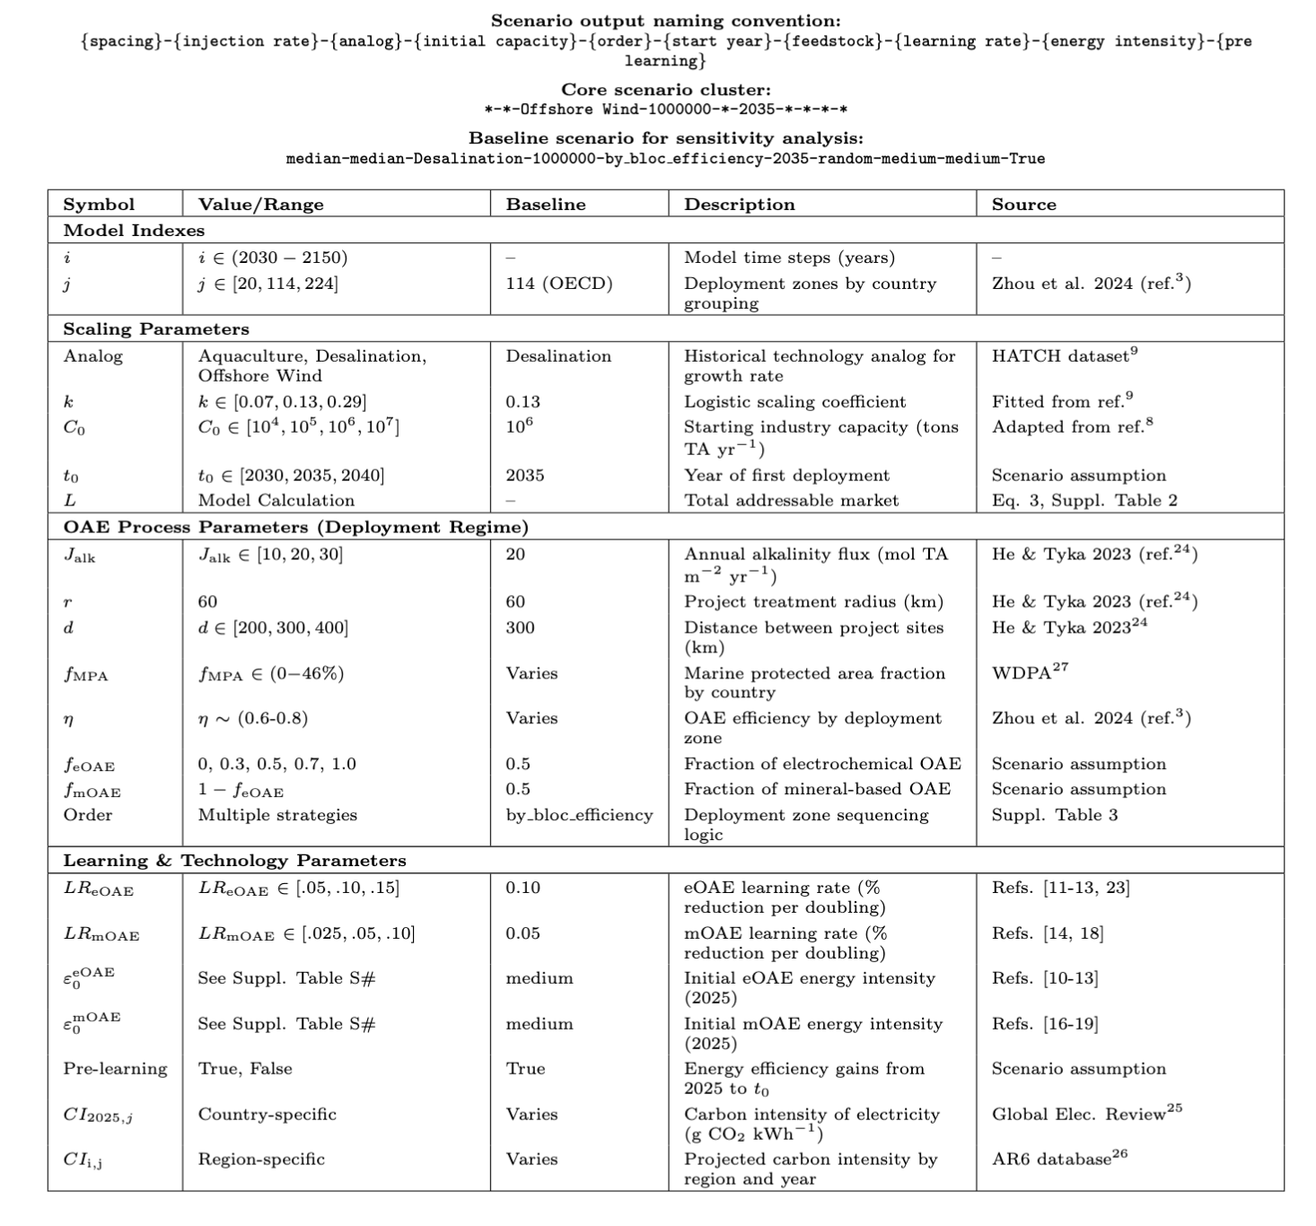

Supplementary Table 8 | Three modes of OAE deployment. Country groupings for each mode of multilateral OAE deployment included in our model, representative of a small group of motivated first movers (Europe Only), a larger group of followers made up of advanced economies (OECD), and the largest sub-group made up of all coastal countries (Global). Number of countries cumulate, as does the number of polygons (deployment zones), and the total coastal area implicated by each mode. Polygons and total EEZ area are defined with the CESM2 grid framework used in Zhou et al.³. Polygons shared by multiple countries are included only once.
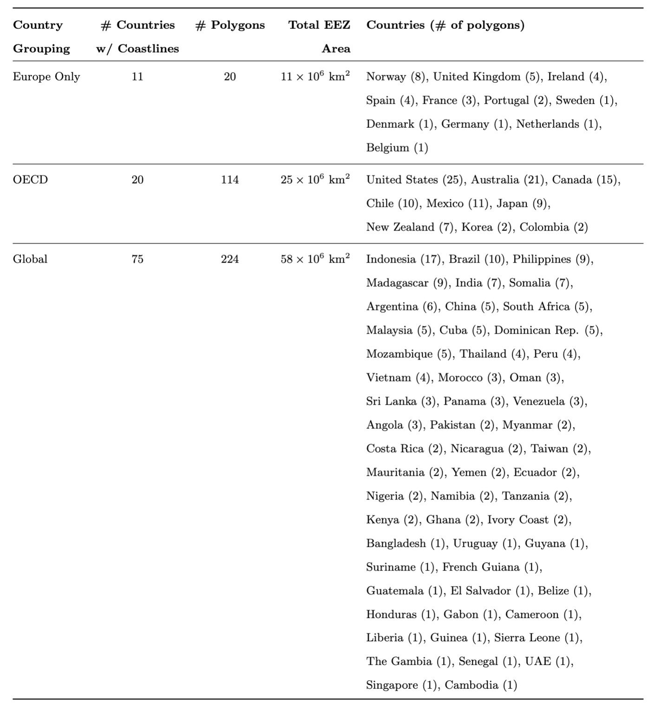

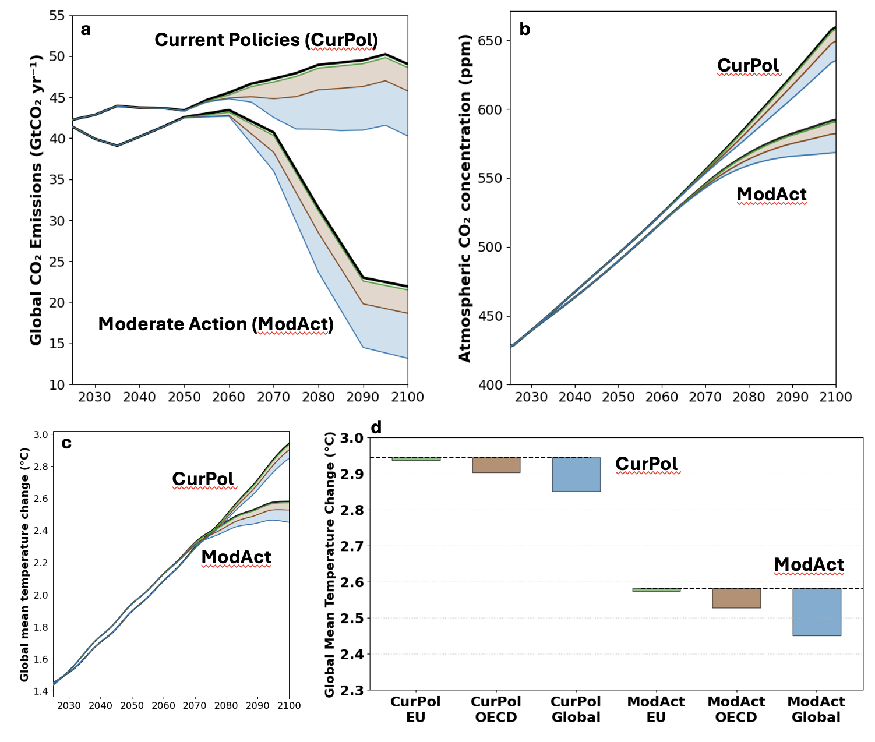
Supplementary Figure 8 | Full climate modeling results. Climate system response to OAE deployment under Current Policies (CurPol) and Moderate Action (ModAct) emission scenarios across three deployment regimes (EU, OECD, Global – green, brown and blue respectively). a, Global CO₂ emissions trajectories showing baseline scenarios (black lines) and net emissions after OAE removals (colored envelopes represent the full range of min–max scenarios) b, Atmospheric CO₂ concentrations resulting from emission pathways in panel a. c, Global mean surface temperature projections through 2100. d, Temperature changes in 2100 relative to baseline scenarios (dashed lines). Temperature differences in panel d reflect the integrated climate response to cumulative net CO₂ removals from OAE deployment, with larger deployment regimes (Global) producing greater but still limited climate impacts.

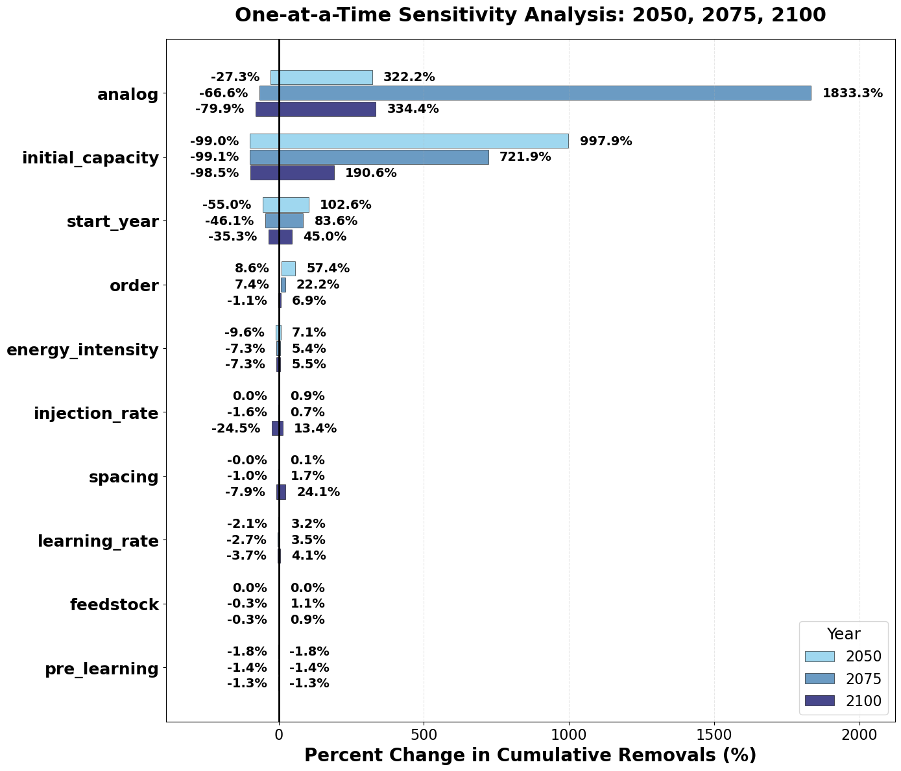
Supplementary Figure 9 | Tornado sensitivity plot (OECD Scenarios). Percent change in cumulative net CO₂ removals for each model parameter varied individually while holding all others at baseline values (median-median-Desalination-1000000-by_bloc_grid-2035-all_random-medium-medium-True). Horizontal bars show the range of outcomes (minimum to maximum) for 2050 (light blue), 2075 (medium blue), and 2100 (dark blue). Parameters are ordered by average sensitivity across all three time horizons, negative values indicate reductions in cumulative removals relative to baseline; positive values indicate increases. Scaling parameters dominate with analog choice and initial capacity producing order-of-magnitude variations in cumulative removals by mid-century. Project-level parameters (deployment order, injection rate, project spacing) show increasing influence over longer time scales. Process efficiency parameters (energy_intensity, learning_rate, feedstock, pre_learning) have relatively modest impacts across all time periods.

Supplementary Table 9 | Full model sensitivities (OECD Scenarios). Complete one-at-a-time sensitivity analysis showing percent changes in cumulative net CO₂ removals for all model parameters across three future years (2050, 2075, 2100). Each parameter is varied individually while holding all others at their baseline value. Ranges represent minimum and maximum percent changes relative to baseline cumulative removals. Parameters are grouped by their role in the modeling framework. This table extends the main text Table 2 by including all parameters (energy intensity, learning rate, feedstock distribution, and pre-learning) that show relatively modest impacts compared to scaling and project parameters. Analog choice and initial capacity dominate sensitivity at all time scales, with order-of-magnitude variations possible depending on parameter selection.
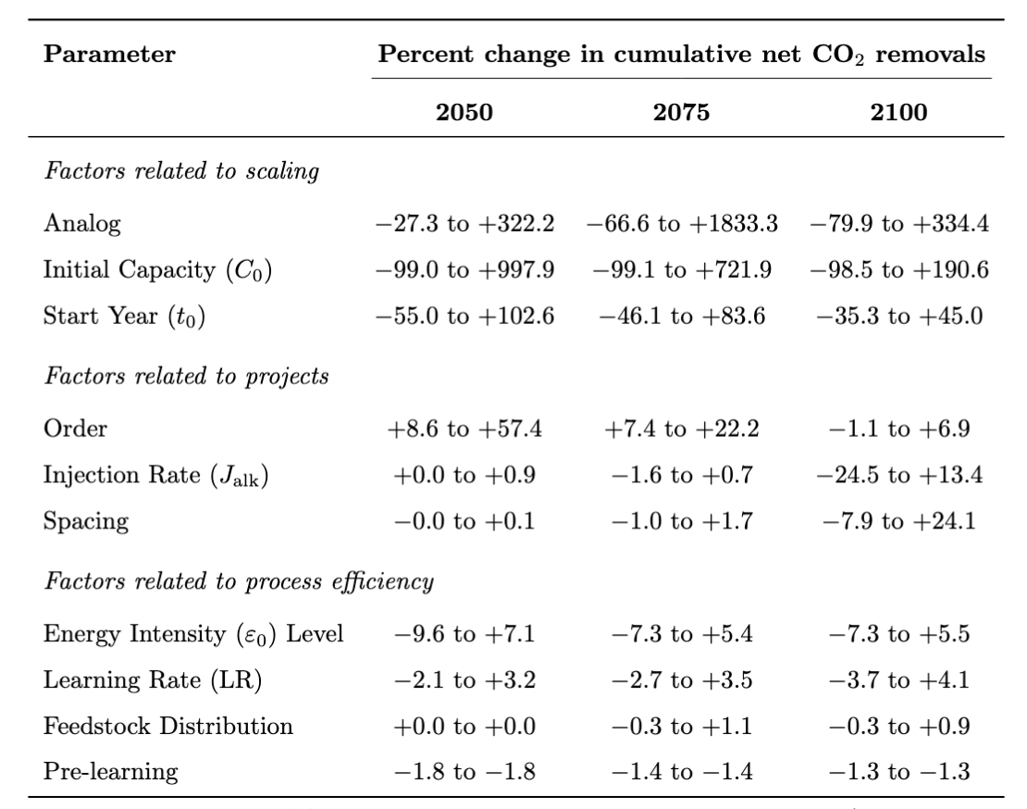
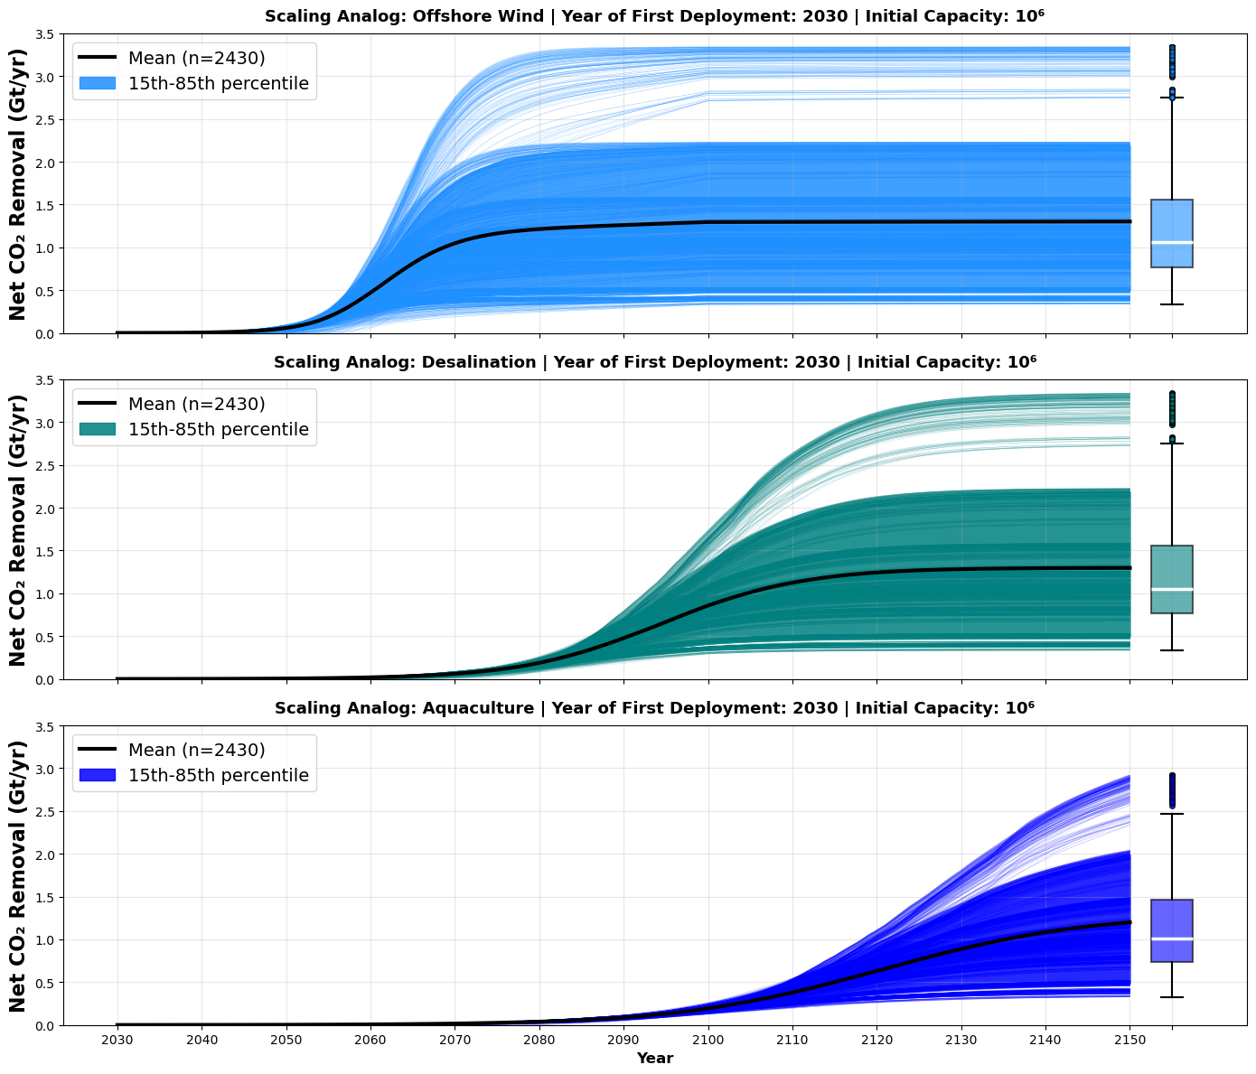
Supplementary Figure 10 | Net CO₂ removal by historical analog. Net CO₂ removal pathways for OECD deployment scenarios using three historical technology analogs: a, Offshore Wind (k=0.29, fastest scaling), b, Desalination (k=0.13, moderate scaling), and c, Aquaculture (k=0.07, slowest scaling). All scenarios begin deployment in 2030 with initial capacity of 10⁶ tons TA yr⁻¹. Individual trajectories (thin lines) represent different combinations of project-level and process efficiency parameters (n=2,430 scenarios per analog); shaded envelopes show 15th–85th percentile ranges; bold lines denote the ensemble means. Box plots (right) display distribution of cumulative net removals by 2150. Box denotes IQR, line denotes median, whiskers denote 1.5x IQR.

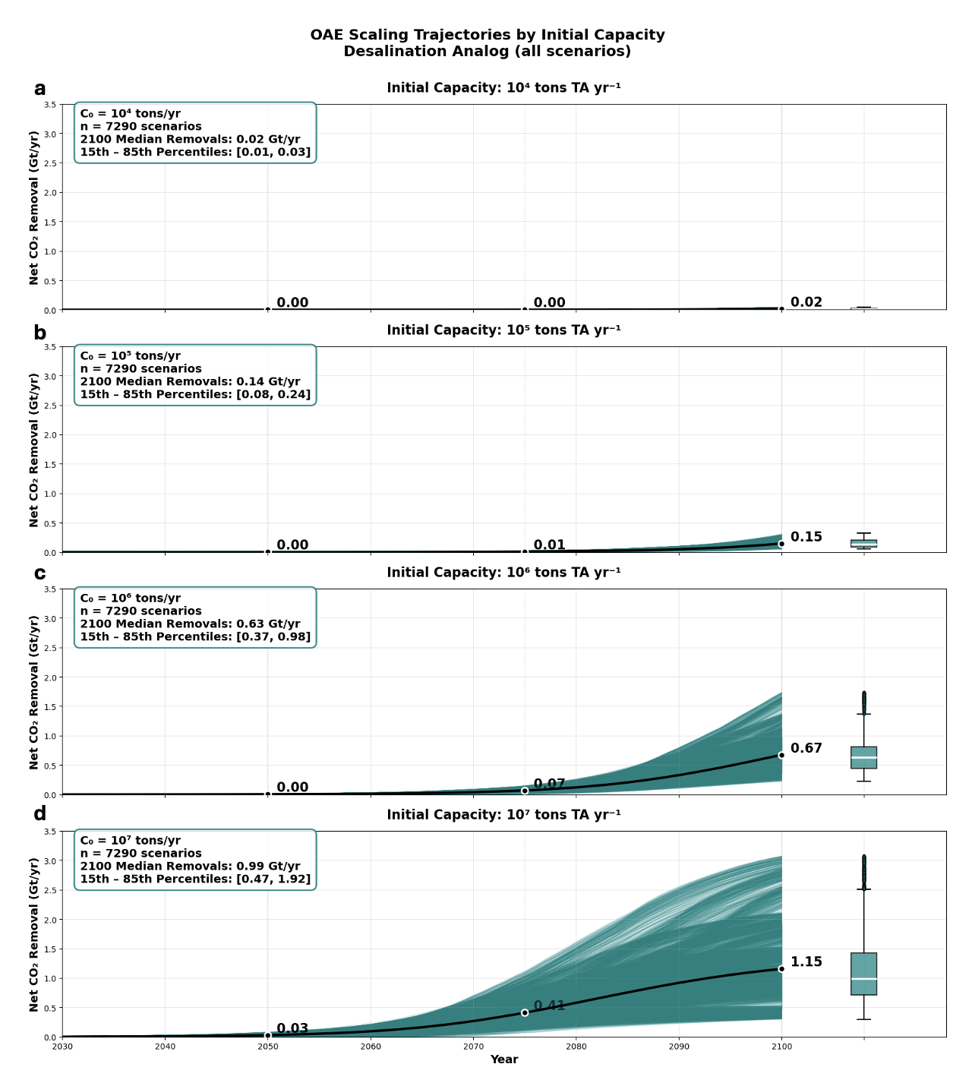

Supplementary Figure 11 | Net CO₂ removals by initial OAE industry size. Net CO₂ removal for OECD scenarios using the Desalination analog (k=0.13) across four initial OAE industry sizes: a, 10⁴ tons TA yr⁻¹, b, 10⁵ tons TA yr⁻¹, c, 10⁶ tons TA yr⁻¹, and d, 10⁷ tons TA yr⁻¹. Each panel shows the ensemble of all parameter combinations (n=7,290 scenarios per capacity level) with individual trajectories (thin lines), 15th–85th percentile envelope (shading), and mean trajectory (bold black line). Box plots (right) display the distribution of annual removals in 2100. White circles with labels mark mean values in 2050, 2075, and 2100.
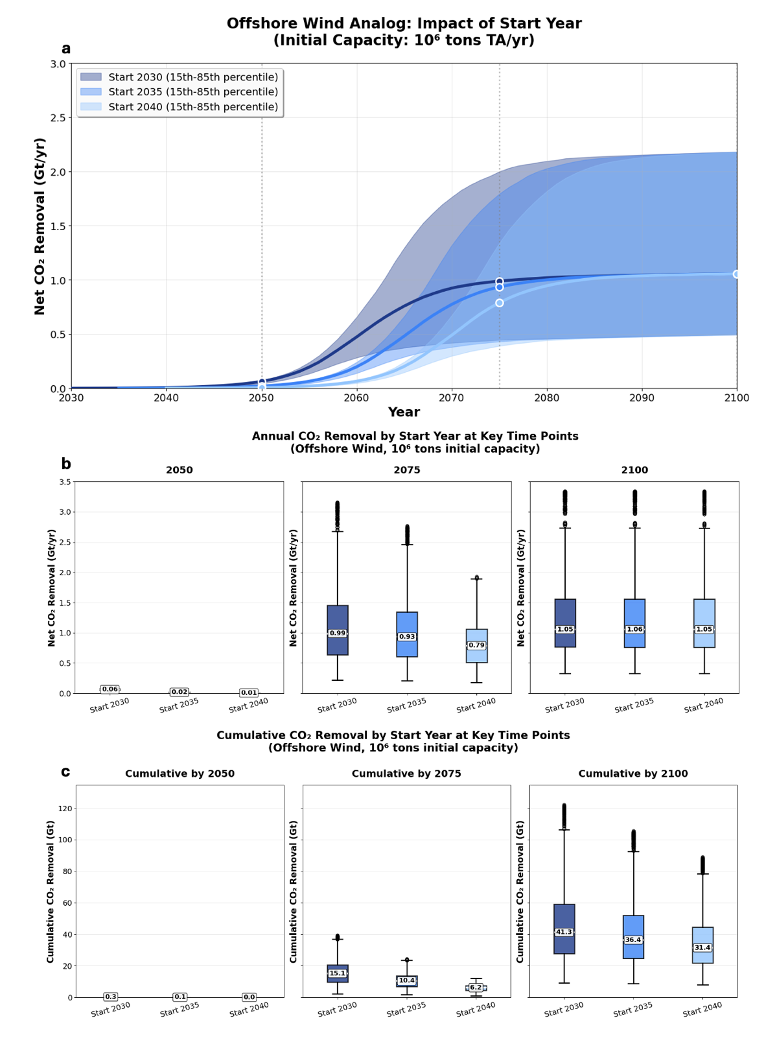

Supplementary Figure 12 | Net CO₂ removals across the year of first deployment. Net CO₂ removal for Offshore Wind scenarios (10⁶ capacity) starting in 2030, 2035, or 2040. Showing a, 15th–85th percentile envelopes and median trajectories. Labels correspond to annual removals in 2050, 2075 and 2100; b, box plots of removals in 2050, 2075, and 2100. Earlier deployment yields substantially higher mid-century removals (2050: 0.06 Gt CO₂ yr⁻¹ for 2030 start vs 0.01 Gt CO₂ yr⁻¹ for 2040 start) but all scenarios converge to similar end-of-century rates (~1.05 Gt CO₂ yr⁻¹ in 2100), and c, box plots of cumulative removals in each key year. Delaying deployment until 2040 reduces cumulative removals by about a quarter by 2100.
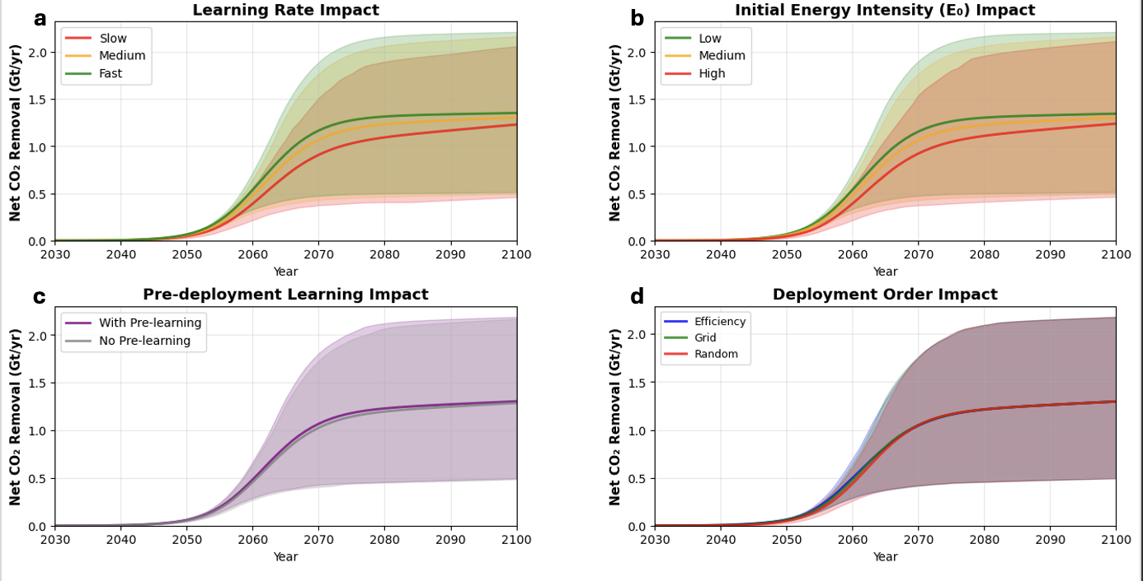

Supplementary Figure 13 | Technology attribute and ordering sensitivities. Net CO₂ removal trajectories showing sensitivity to process efficiency parameters and deployment ordering strategies for OECD scenarios. All panels use baseline scaling parameters (Desalination analog, 10⁶ initial capacity, 2030 start year and half eOAE/mOAE) while varying: a, learning rate scenarios (Supplementary Table 6); b, initial energy intensity levels (Supplementary Table 6); c, pre-deployment learning between 2025 and start year, representing efficiency gains before deployment at scale begins; and d, deployment zone ordering strategies (Supplementary Table 3). See Supplementary Table 6 for more detail on the values considered in panels a, b, and c. Shaded envelopes show 15th–85th percentiles across all other parameter variations; lines show median trajectories. Supplementary Fig. 9 and Supplementary Table 10 show these results in detail for key years.

References

1. Kikstra, J. S. et al. The IPCC Sixth Assessment Report WGIII climate assessment of mitigation pathways: from emissions to global temperatures. Geosci. Model Dev. 15, 9075–9109 (2022).
2. Kikstra, J. S. et al. Climate assessment of long-term emissions pathways: IPCC AR6 WGIII version. Zenodo https://doi.org/10.5281/ZENODO.6624519 (2025).
3. Zhou, M. et al. Mapping the global variation in the efficiency of ocean alkalinity enhancement for carbon dioxide removal. Preprint at https://doi.org/10.21203/rs.3.rs-4124909/v1 (2024).
4. Smith, C. J. et al. FAIR v1.3: a simple emissions-based impulse response and carbon cycle model. Geosci. Model Dev. 11, 2273–2297 (2018).
5. Millar, R. J., Nicholls, Z. R., Friedlingstein, P. & Allen, M. R. A modified impulse-response representation of the global near-surface air temperature and atmospheric concentration response to carbon dioxide emissions. Atmospheric Chem. Phys. 17, 7213–7228 (2017).
6. Etminan, M., Myhre, G., Highwood, E. J. & Shine, K. P. Radiative forcing of carbon dioxide, methane, and nitrous oxide: A significant revision of the methane radiative forcing. Geophys. Res. Lett. 43, (2016).
7. Geoffroy, O. et al. Transient Climate Response in a Two-Layer Energy-Balance Model. Part I: Analytical Solution and Parameter Calibration Using CMIP5 AOGCM Experiments. J. Clim. 26, 1841–1857 (2013).
8. CDR.fyi. “Tracking the Carbon Removal Industry.”
9. Nemet, G., Greene, J., Müller-Hansen, F. & Minx, J. C. Dataset on the adoption of historical technologies informs the scale-up of emerging carbon dioxide removal measures. Commun. Earth Environ. 4, 397 (2023).
10. NASEM. A Research Strategy for Ocean-Based Carbon Dioxide Removal and Sequestration. 26278 (National Academies Press, Washington, D.C., 2022). doi:10.17226/26278.
11. Charles‐François de Lannoy et al. Indirect ocean capture of atmospheric CO 2 : Part I. Prototype of a negative emissions technology. Int. J. Greenh. Gas Control 70, 243–253 (2017).
12. Eisaman, M. D. et al. Indirect ocean capture of atmospheric CO2: Part II. Understanding the cost of negative emissions. Int. J. Greenh. Gas Control 70, 254–261 (2018).
13. Ferella, F. et al. Ocean Alkalinity Enhancement Using Bipolar Membrane Electrodialysis: Technical Analysis and Cost Breakdown of a Full-Scale Plant. Ind. Eng. Chem. Res. 64, 7085–7099 (2025).
14. Strefler, J., Kowalczyk, K., Hofbauer, V., Dorndorf, T. & Baumstark, L. Ocean liming can help achieve the Paris climate target. Environ. Res. Lett. 20, 094004 (2025).
15. Foteinis, S., Andresen, J., Campo, F., Caserini, S. & Renforth, P. Life cycle assessment of ocean liming for carbon dioxide removal from the atmosphere. J. Clean. Prod. 370, 133309 (2022).
16. Renforth, P. & Henderson, G. Assessing ocean alkalinity for carbon sequestration. Rev. Geophys. 55, 636–674 (2017).
17. Spyros Foteinis, James Campbell, & Phil Renforth. Life Cycle Assessment of Coastal Enhanced Weathering for Carbon Dioxide Removal from Air. Environ. Sci. Technol. 57, 6169–6178 (2023).
18. Marco, S. D., Caserini, S., Amann, T. & Grosso, M. Energy demand and savings opportunities in the supply of limestone and olivine-rich rocks for geochemical carbon dioxide removal. Environ. Res. Lett. 19, 073009 (2024).
19. Strefler, J., Amann, T., Bauer, N., Kriegler, E. & Hartmann, J. Potential and costs of carbon dioxide removal by enhanced weathering of rocks. Environ. Res. Lett. 13, 034010 (2018).
20. Nemet, G. F. Beyond the learning curve: factors influencing cost reductions in photovoltaics. Energy Policy 34, 3218–3232 (2006).
21. Louwen, A., Van Sark, W. G. J. H. M., Faaij, A. P. C. & Schropp, R. E. I. Re-assessment of net energy production and greenhouse gas emissions avoidance after 40 years of photovoltaics development. Nat. Commun. 7, 13728 (2016).
22. Malhotra, A. & Schmidt, T. S. Accelerating Low-Carbon Innovation. Joule 4, 2259–2267 (2020).
23. Wang, R. & He, W. Cost Assessment of Bipolar Membrane Electrodialysis for Carbon Dioxide Removal Via Synergy Mapping. Preprint at https://doi.org/10.2139/ssrn.5177066 (2025).
24. Jing He & Michael D. Tyka. Limits and CO₂ equilibration of near-coast alkalinity enhancement. Biogeosciences 20, 27–43 (2023).
25. Małgorzata Wiatros-Motyka, Nicolas Fulghum, Dave Jones, Katye Altieri, Richard Black, Hannah Broadbent, Chelsea Bruce-Lockhart, Matt Ewen, Phil & MacDonald, Kostantsa Rangelova. Global Electricity Review 2024.
26. Byers, E. et al. AR6 Scenarios Database. Integrated Assessment Modeling Consortium & International Institute for Applied Systems Analysis https://doi.org/10.5281/ZENODO.5886911 (2022).
27. UNEP. World Database on Protected Areas. Protected Planet www.protectedplanet.net/en/thematic-areas/wdpa?tab=WDPA. Accessed 24 Feb. 2025.

