Supplementary Information for Urbanization and Climate Change Shape Urban Latent Heat Flux: Three Critical Thresholds

Yizhao Wei¹, Jinhui Jeanne Huang^{1,2*}
¹College of Environmental Science and Engineering/Sino-Canada Joint R&D Centre for Water and Environmental Safety, Nankai University, Tianjin 300071, PR China
Corresponding author:Jinhui Jeanne Huang
¹Sino-Canada R&D Centre on Water and Environmental Safety, College of Environmental Science and Engineering, Nankai University, Tianjin 300071, PR China;
²Shenzhen Research Institute of Nankai University, Shenzhen 518057, China
Email: huangj@nankai.edu.cn

Supplementary Figures
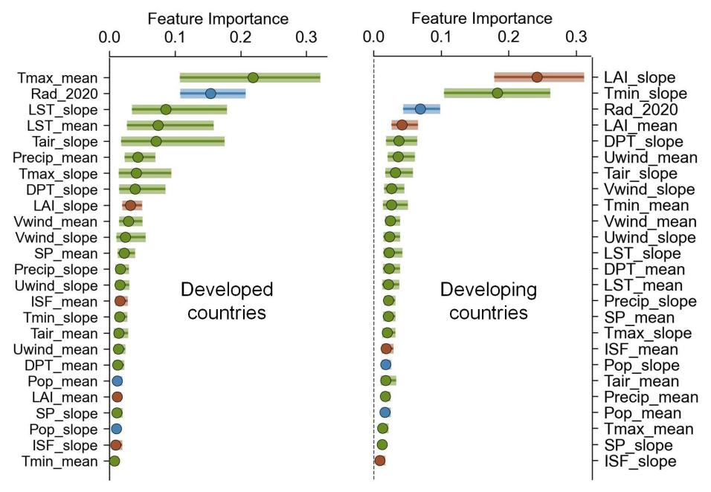
Supplementary Figure 1. Ranked importance of variables driving vegetation change trends in cities of developed and developing countries.
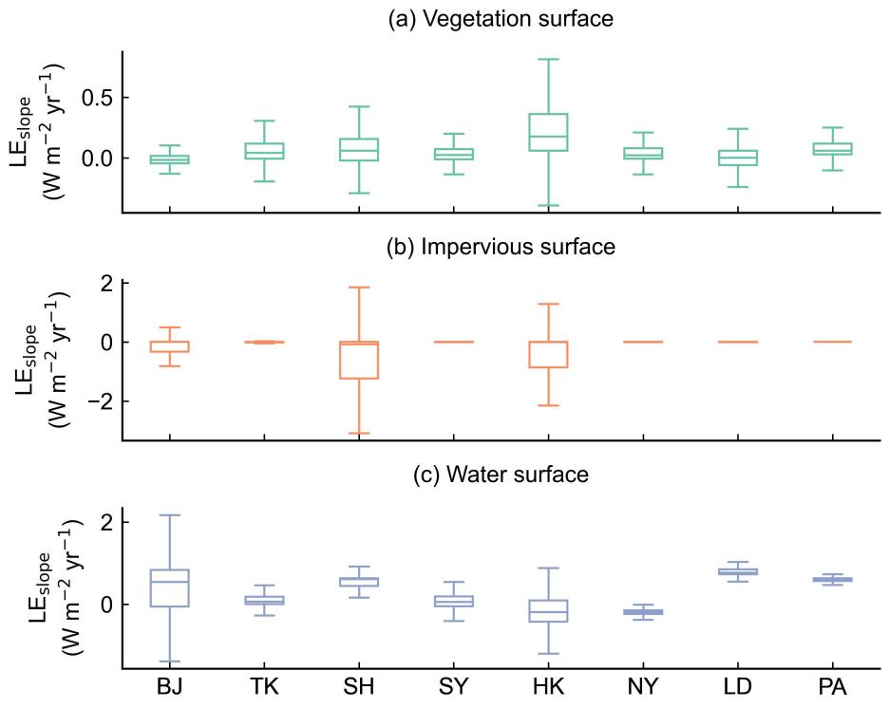
Supplementary Figure 2. Distribution of urban LE flux trends (1990-2022) across different surface types in global cities. City abbreviations: BJ = Beijing, TK = Tokyo, SH = Shanghai, SY = Sydney, HK = Hong Kong–Shenzhen, NY = New York, LD = London, PA = Paris.
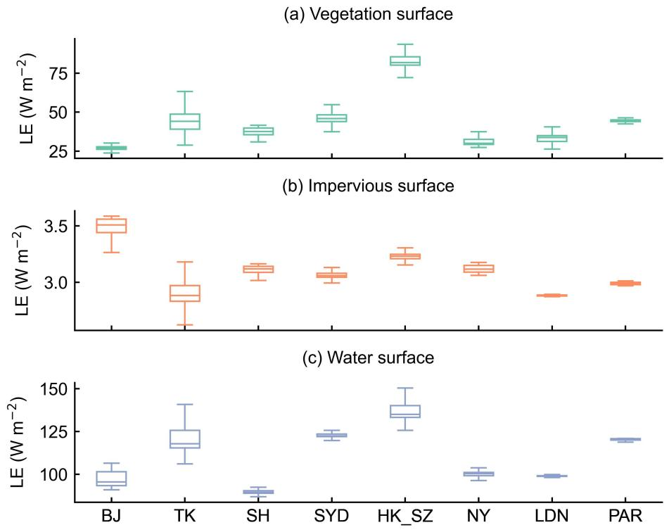
Supplementary Figure 3. Distribution of urban LE flux values in 2022 across different surface types in global cities. City abbreviations: BJ = Beijing, TK = Tokyo, SH = Shanghai, SY = Sydney, HK = Hong Kong–Shenzhen, NY = New York, LD = London, PA = Paris.
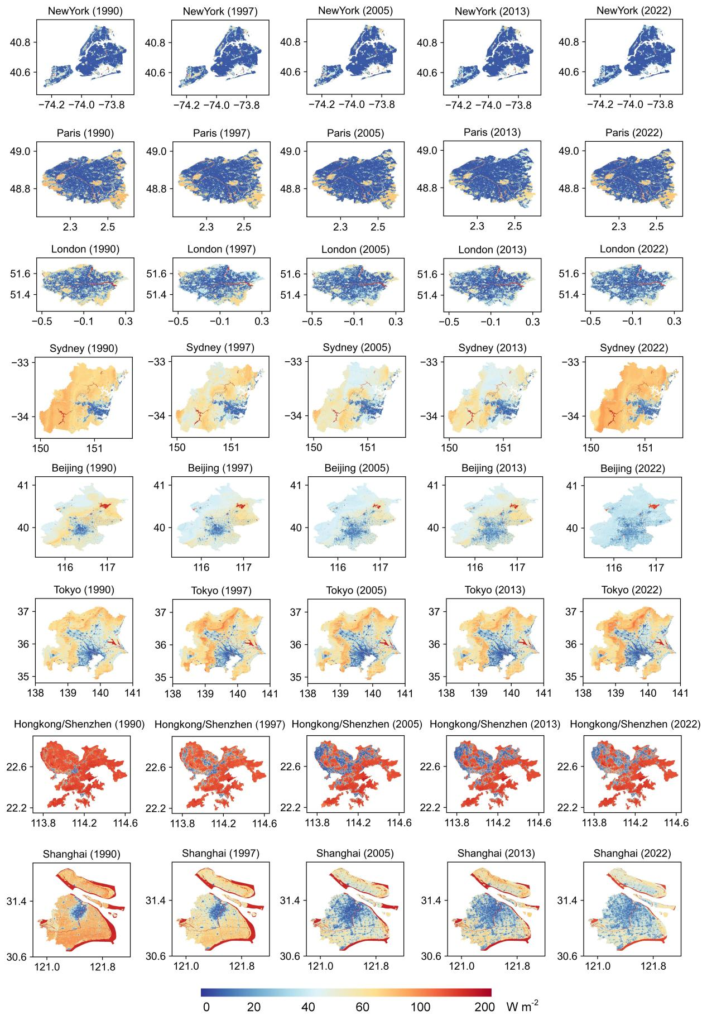
Supplementary Figure 4. Spatial distribution of annual average LE across eight representative cities from 1990 to 2022. Each row corresponds to a specific city, and each column represents one of five selected years (1990, 1997, 2005, 2013, and 2022).
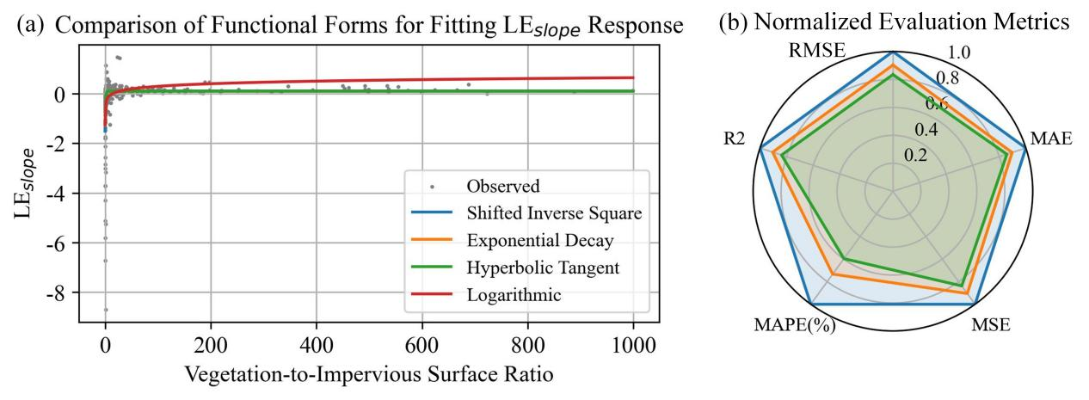
Supplementary Figure 5. (a) Comparison of functional forms for fitting the relationship between vegetation fraction and LE_{slope}. (b) Normalized radar chart comparing fitting performance across functions.
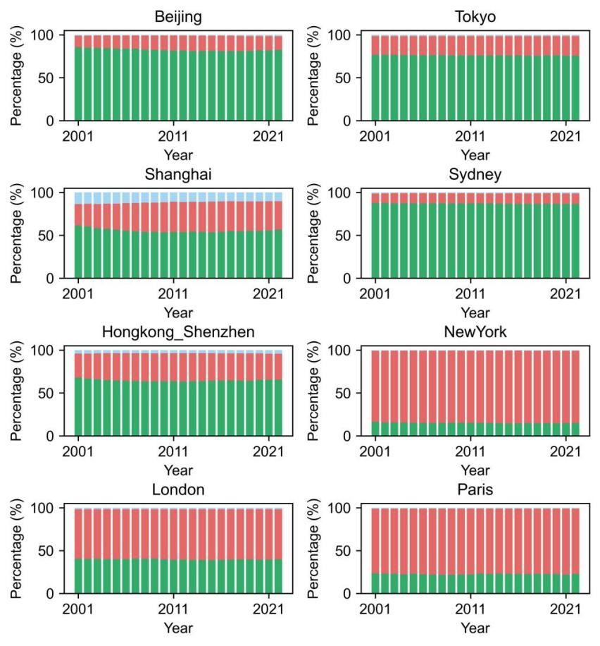
Supplementary Figure 6. Changes in land cover composition (vegetation, impervious surfaces, and water) from 2001 to 2021 in eight global cities.

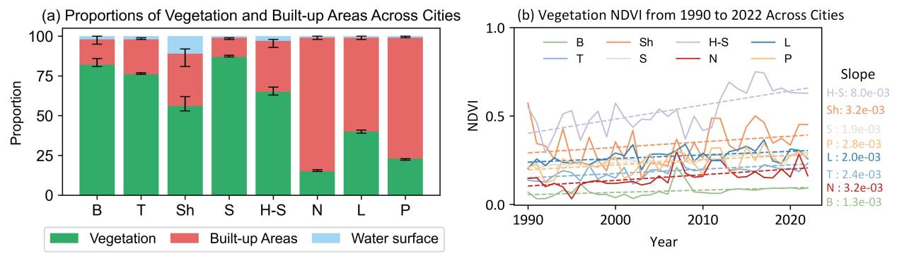
Supplementary Figure 7. (a) Proportional composition of vegetation, impervious surfaces, and water bodies in eight representative global cities. (b) Temporal variation in NDVI of vegetated areas from 1990 to 2022, reflecting long-term greenness trends.

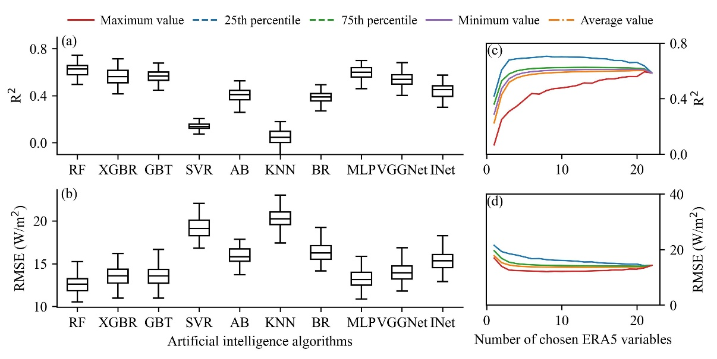
Supplementary Figure 8. Performance of AI models and variable combinations in simulating vegetation LE flux (a, b) R² and RMSE of ten artificial intelligence models used to simulate vegetation LE flux. (c, d) R² and MSE of the optimal variable combinations across different combination sizes. Performance metrics were evaluated using cross-validation across global city samples.

Supplementary Tables
Supplementary Table 1. Variables and data sources for urban LE analysis.
 | Description | Data Source
LAI_mean | Mean annual urban Leaf Area Index (LAI) from 2001 to 2022 | MODIS/061/MCD15A3H
LAI_slope | Temporal trend in annual urban LAI from 2001 to 2022 | MODIS/061/MCD15A3H
LST_mean | Mean annual urban land surface temperature (LST) from 2001 to 2022 | MODIS/006/MOD11A2
LST_slope | Temporal trend in annual urban LST from 2001 to 2022 | MODIS/006/MOD11A2
Pop_mean | Mean annual urban population count from 2001 to 2022 | WorldPop/GP/100m/pop
Pop_slope | Temporal trend in urban population count from 2001 to 2022 | WorldPop/GP/100m/pop
ISF_mean | Mean annual fraction of impervious surfaces in urban areas from 2001 to 2022 | MODIS/006/MCD12Q1
ISF_slope | Temporal trend in impervious surface fraction in urban areas from 2001 to 2022 | MODIS/006/MCD12Q1
Rad_2020 | Average nighttime light radiance in urban areas in 2020 | NOAA/VIIRS/DNB/MONTHLY_V1/VCMSLCFG
Tair_mean | Mean annual air temperature at 2 m | ECMWF/ERA5_LAND/MONTHLY_AGGR
Tair_slope | Temporal trend of air temperature at 2 m | ECMWF/ERA5_LAND/MONTHLY_AGGR
Tmax_mean | Mean annual maximum air temperature at 2 m | ECMWF/ERA5_LAND/MONTHLY_AGGR
Tmax_slope | Temporal trend of maximum air temperature at 2 m | ECMWF/ERA5_LAND/MONTHLY_AGGR
Tmin_mean | Mean annual minimum air temperature at 2 m | ECMWF/ERA5_LAND/MONTHLY_AGGR
Tmin_slope | Temporal trend of minimum air temperature at 2 m | ECMWF/ERA5_LAND/MONTHLY_AGGR
Precip_mean | Mean annual total precipitation | ECMWF/ERA5_LAND/MONTHLY_AGGR
Precip_slope | Temporal trend of total precipitation | ECMWF/ERA5_LAND/MONTHLY_AGGR
Uwind_mean | Mean annual east-west wind speed at 10 m | ECMWF/ERA5_LAND/MONTHLY_AGGR
Uwind_slope | Temporal trend of east-west wind speed at 10 m | ECMWF/ERA5_LAND/MONTHLY_AGGR
Vwind_mean | Mean annual north-south wind speed at 10 m | ECMWF/ERA5_LAND/MONTHLY_AGGR
Vwind_slope | Temporal trend of north-south wind speed at 10 m | ECMWF/ERA5_LAND/MONTHLY_AGGR
SP_mean | Mean annual surface pressure | ECMWF/ERA5_LAND/MONTHLY_AGGR
SP_slope | Temporal trend of surface pressure | ECMWF/ERA5_LAND/MONTHLY_AGGR
DPT_mean | Mean annual dew point temperature at 2 m | ECMWF/ERA5_LAND/MONTHLY_AGGR
DPT_slope | Temporal trend of dew point temperature at 2 m | ECMWF/ERA5_LAND/MONTHLY_AGGR

Supplementary Table 2. Parameters potentially associated with LE from ERA5-land.
Serial number | Parameter Name | Abbreviation | Description | Serial number | Parameter Name | Abbreviation | Description
1 | temperature_2m | T | Temperature at 2 meters above ground level. | 12 | soil_temperature_level_4 | ST4 | Soil temperature at depth approximately 100-289 cm.
2 | dewpoint_temperature_2m | DT | Dewpoint temperature at 2 meters above ground level. | 13 | skin_temperature | ST | Skin temperature (temperature of the Earth's surface).
3 | u_component_of_wind_10m | UW | Eastward wind component at 10 meters above ground level. | 14 | surface_latent_heat_flux_sum | SLE | Total sum of LE at the surface.
4 | v_component_of_wind_10m | VW | Northward wind component at 10 meters above ground level. | 15 | surface_net_thermal_radiation_sum | STR | Total net thermal radiation at the surface.
5 | surface_pressure | SP | Air pressure at the surface. | 16 | surface_sensible_heat_flux_sum | SSH | Total sum of sensible heat flux at the surface.
6 | leaf_area_index_high_vegetation | LIH | Leaf area index for high vegetation. | 17 | surface_solar_radiation_downwards_sum | SRD | Total downward solar radiation at the surface.
7 | leaf_area_index_low_vegetation | LIL | Leaf area index for low vegetation. | 18 | volumetric_soil_water_layer_1 | SW1 | Volumetric soil water content at depth approximately 0-7 cm.
8 | surface_net_solar_radiation_sum | R_{n} | Total net solar radiation at the surface. | 19 | volumetric_soil_water_layer_2 | SW2 | Volumetric soil water content at depth approximately 7-28 cm.
9 | soil_temperature_level_1 | ST1 | Soil temperature at depth approximately 0-7 cm. | 20 | volumetric_soil_water_layer_3 | SW3 | Volumetric soil water content at depth approximately 28-100 cm.
10 | soil_temperature_level_2 | ST2 | Soil temperature at depth approximately 7-28 cm. | 21 | volumetric_soil_water_layer_4 | SW4 | Volumetric soil water content at depth approximately 100-289 cm.
11 | soil_temperature_level_3 | ST3 | Soil temperature at depth approximately 28-100 cm. | 22 | forecast_albedo | FA | The reflectivity of the Earth's surface.

Supplementary Table 3. Summary of LE_{slope} model thresholds and rationale for eight global cities.
City | Climate type | LEA (W m⁻² yr⁻¹) | DIT (veg to build) | ST (veg to build) | Rationale
Beijing | Semi-arid continental | 0.03 | 0.58 | 3.01 | LEA is low, DIT and ST are high, indicating limited vegetation effect and high greening requirements.
Tokyo | Temperate humid | 0.08 | 0.38 | 2.81 | Moderate LEA, low DIT indicates sensitive LE_slope response to vegetation change.
Shanghai | Subtropical humid | 0.09 | 0.66 | 2.92 | High LEA with slightly elevated DIT, suggesting morphological suppression of vegetative effects.
Sydney | Temperate oceanic | 0.08 | 0.63 | 3.06 | Similar to Shanghai, with a flatter LE_slope curve and delayed saturation benefits.
Hong Kong-Shenzhen | Subtropical humid + anthropogenic heat | 0.12 | 0.35 | 2.78 | High LEA and low DIT, indicative of a highly sensitive and vegetation-dependent urban heat regulation system.
New York | Temperate continental | 0.10 | 0.38 | 2.81 | Slightly higher LEA, with moderate DIT reflecting a stable ecological response.
London | Temperate oceanic | 0.10 | 0.28 | 2.71 | Very sensitive city with the lowest DIT, indicating that minor greening variations rapidly affect LE_slope behavior.
Paris | Temperate oceanic | 0.08 | 0.49 | 2.92 | Stable profile with moderate vegetation response and a slightly higher saturation threshold.
Table Notes: This table summarizes the theoretical LE response capacity (LEA), vegetation sensitivity threshold (DIT), and saturation point (ST) derived from nonlinear curve fitting of the LE_{slope}-vegetation relationship. The final column provides interpretative assessments of each city’s ecological and climatic response characteristics, contextualizing their position along the urbanization-climate adaptation spectrum.

Supplementary Methods

Supplementary Method 1 ERA5-Land Variable Selection and Combination Strategy
A total of 22 ERA5-Land variables potentially associated with LE flux—including air temperature, radiation, soil moisture at multiple depths, and wind components—were considered (Supplementary Table 1). These variables were grouped into five categories: atmospheric conditions, surface energy balance, soil thermal properties, hydrological variables, and near-surface meteorology.
To identify the most effective input combinations, we conducted a brute-force variable combination analysis covering all 4,194,304 non-redundant subsets (1–22 variables). For each subset, models were trained and validated using ten machine-learning algorithms representing seven major categories:
(1) Tree-based (Random Forest (Breiman 2001); XGBoost (Chen and Guestrin 2016); Gradient Boosting Trees (Friedman 2001)),
(2) Kernel-based (Support Vector Regressor (Cortes and Vapnik 1995)),
(3) Ensemble methods (Adaptive Boosting (Margineantu and Dietterich 1997)),
(4) Nearest-neighbor-based (K-Nearest Neighbors (Cover and Hart 1967)),
(5) Bayesian,
(6) Neural networks (Multi-layer Perceptron (Taud and Mas 2018)), and
(7) Deep learning (VGGNet, Inception Network).
Each model underwent 100 iterations of 10-fold cross-validation, and the best-performing subset was identified based on mean R² and RMSE.
The resulting model was further validated against FLUXNET2015 tower measurements, and all trained models are openly available at https://zenodo.org/records/17430581.

Supplementary Method 2 Function Selection and Fitting Analysis of LE Response
To assess the nonlinear relationship between LE and the vegetation-to-impervious surface ratio, we compared four candidate functions: a shifted inverse-square, an exponential decay, a hyperbolic tangent, and a logarithmic function. Each function is defined as a nonlinear response y = f(x), where x is the normalized vegetation-to-impervious surface ratio, y is the corresponding LE value, and a, b, and c are fitted parameters. A small constant (ε = 10⁻⁶) was introduced to avoid division or logarithmic errors near zero. Observations with x ≤ 0 were excluded, and model fitting was performed using nonlinear least squares via Python’s curve_fit.
Shifted inverse-square function:
$$f(x)=-\frac{a}{(x+c)^{2}+10^{-6}}+b$$
Exponential decay function:
$$f(x)=a⋅e^{-bx}+c$$
Hyperbolic tangent function:
$$f(x)=a⋅\tanh{(}-bx)+c$$
Logarithmic function function:
$$f(x)=-a⋅\log{(}x+c+10^{-6})+b$$
Model performance was evaluated using five metrics—RMSE, MAE, MSE, MAPE(%), and R²—all normalized to [0, 1] (Supplementary Figure 5). A more outward and uniform radar shape indicates stronger overall performance. The shifted inverse-square function outperformed the others (RMSE = 0.776, R² = 0.210), followed by the exponential decay and hyperbolic tangent models. The logarithmic function had the weakest fit (R² = 0.153), indicating limited suitability.
To guide model selection beyond statistical fit, we introduced three physical criteria: (1) LE slope should asymptotically stabilize at high x, reflecting saturation; (2) a sharp decline should occur below a threshold, indicating loss of evaporative regulation; (3) as x approaches zero, the LE slope should diverge negatively, capturing degradation in sealed urban surfaces.
Taken together, the shifted inverse-square function was selected as the most suitable model. It captures key nonlinearities, aligns with physical expectations, and enables robust application in mechanistic interpretation and spatial modeling.

Supplementary References
Breiman L, 2001. Random Forests. Mach Learn. 45, 5-32. 10.1023/A:1010933404324.
Chen T, Guestrin C (2016) Xgboost: A scalable tree boosting system. In. pp. 785--794.
Cortes C, Vapnik V, 1995. Support-vector networks. Mach Learn. 20, 273-297. https://doi.org/10.1007/BF00994018.
Cover T, Hart P, 1967. Nearest neighbor pattern classification. Ieee T Inform Theory. 13, 21--27. https://doi.org/10.1109/TIT.1967.1053964.
Friedman JH, 2001. Greedy function approximation: a gradient boosting machine. Ann Stat., 1189--1232. http://www.jstor.org/stable/2699986.
Margineantu DD, Dietterich TG (1997) Pruning adaptive boosting. In. pp. 211--218. (Citeseer)
Taud H, Mas J, 2018. Multilayer perceptron (MLP). Geomatic Approaches for Modeling Land Change Scenarios., 451--455. https://doi.org/10.1007/978-3-319-60801-3_27.

