Supporting Information
Hierarchical Porous 2D α-Al₂O₃ Nanosheet Catalyst for Aminolytic Upcycling of PET Plastic Waste
Mudavath Arun Kumarª, Bhattu Swapnaª, Nittan Singhª, Giridhar Madras^{b}, Putla Sudarsanam*^{,a}
ªDepartment of Chemistry, Indian Institute of Technology Hyderabad, Kandi 502284, Telangana, India
^{b}Department of Chemical Engineering, Indian Institute of Technology Hyderabad, Kandi 502284, Telangana, India
*Email: sudarsanam.putla@chy.iith.ac.in

S1. Characterization studies
To investigate the phase formation and crystal structure of the α-Al₂O₃ catalysts, powder X-ray diffraction (XRD) was performed using a Malvern PANalytical Empyrean-DY2584 diffractometer (45 kV, 40 mA), with Ni-filtered Cu Kα radiation over a 2θ range of 5–90°. Raman spectroscopy was conducted on a Horiba LabRAM spectrometer equipped with a 532 nm laser, scanning from 100–1400 cm⁻¹ to identify metal oxide phases. The morphology and particle size were analyzed using transmission electron microscopy (TEM) on a JEOL JEM-F200 operated at 200 kV, with samples prepared on carbon-coated 200 mesh Cu grids. The morphology of α-Al₂O₃ catalysts and the PET reaction mechanism were studied by SEM analysis (SEM CARL ZEISS EVO18 instrument) in a scanning range from 50 nm to 1 mm using an electron beam range of 200 V–30 kV. The samples were prepared in an ethanol solution, subsequently spin-coated onto a silicon surface, and then sputtered with gold.
Textural properties, including specific surface area and porosity, were determined via N₂ adsorption–desorption isotherms using a Micromeritics Tristar 3000 analyzer at −196 °C. The chemical states of Al and O were studied using X-ray photoelectron spectroscopy (XPS) on a Thermo Fisher K-Alpha system with Al Kα radiation; binding energies were calibrated using the C 1s peak at 284.6 eV. Acidity was evaluated using NH₃ temperature-programmed desorption (NH₃-TPD) on a BEL/CAT2 system. Samples were pretreated in helium at 150 °C for 80 min, saturated with NH₃/He for 60 min, and purged with He to remove physisorbed NH₃. Atomic force microscopy (AFM) images were obtained using a Bruker Multimode Veeco 8 instrument. The α-Al₂O₃ 550 sample, dispersed in ethanol, was drop-cast onto silicon wafers for imaging. Tapping mode AFM was employed, utilizing a probe with a tip radius of less than 10 nm, a force constant of approximately 200 N·m⁻¹, and a resonance frequency in the range of 459–506 kHz.
The monomer product bis(2-aminoethyl) terephthalamide (BAET), formed via PET aminolysis, was characterized by ¹H, ¹³C, and DEPT NMR on a Bruker Avance III 400 MHz spectrometer. Its crystallinity was verified using powder XRD, while functional groups were identified using FT-IR spectroscopy (Bruker Alpha, 600–4000 cm⁻¹, DTGS detector). High-resolution mass spectrometry (HR-MS) was carried out on an Agilent 6538 UHD Q-TOF using both ESI and APCI modes. Thermal stability was assessed via thermogravimetric analysis (TGA) on a TA SDT Q600 from 50–800 °C at 10 °C/min under nitrogen. The melting behavior was determined using differential scanning calorimetry (DSC) on a TA Q200 instrument.

Figure S1. HR-TEM of fresh α-Al₂O₃ 550 catalyst.

Figure S2. (a) Al 2p XP and (b) O 1s XP spectra of fresh and spent α-Al₂O₃ 550 catalysts.

Figure S3: FT-IR spectrum of PET, AOET (dimer), and BAET.
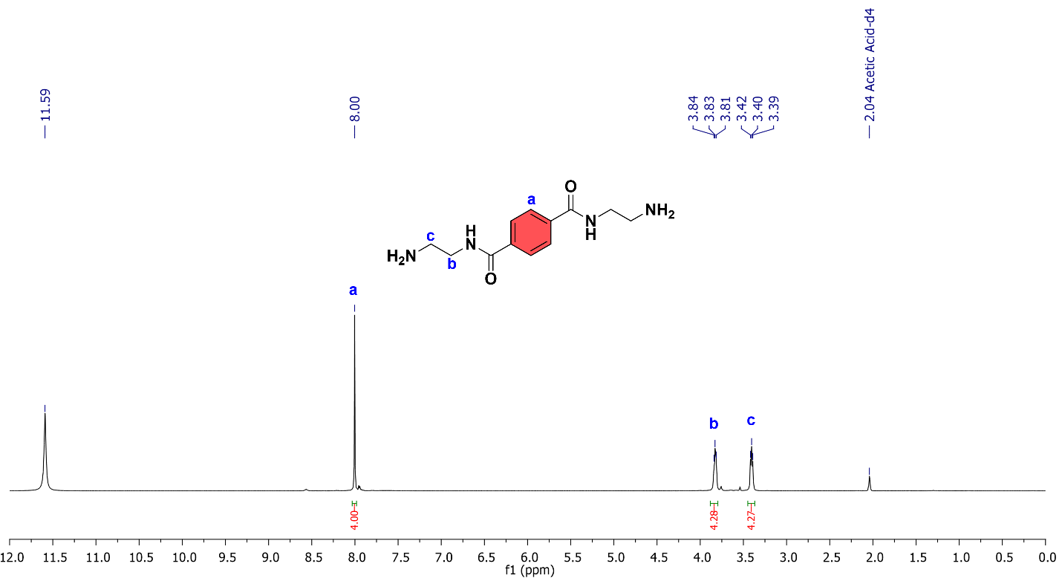
Figure S4. ¹H NMR of BAET monomer.
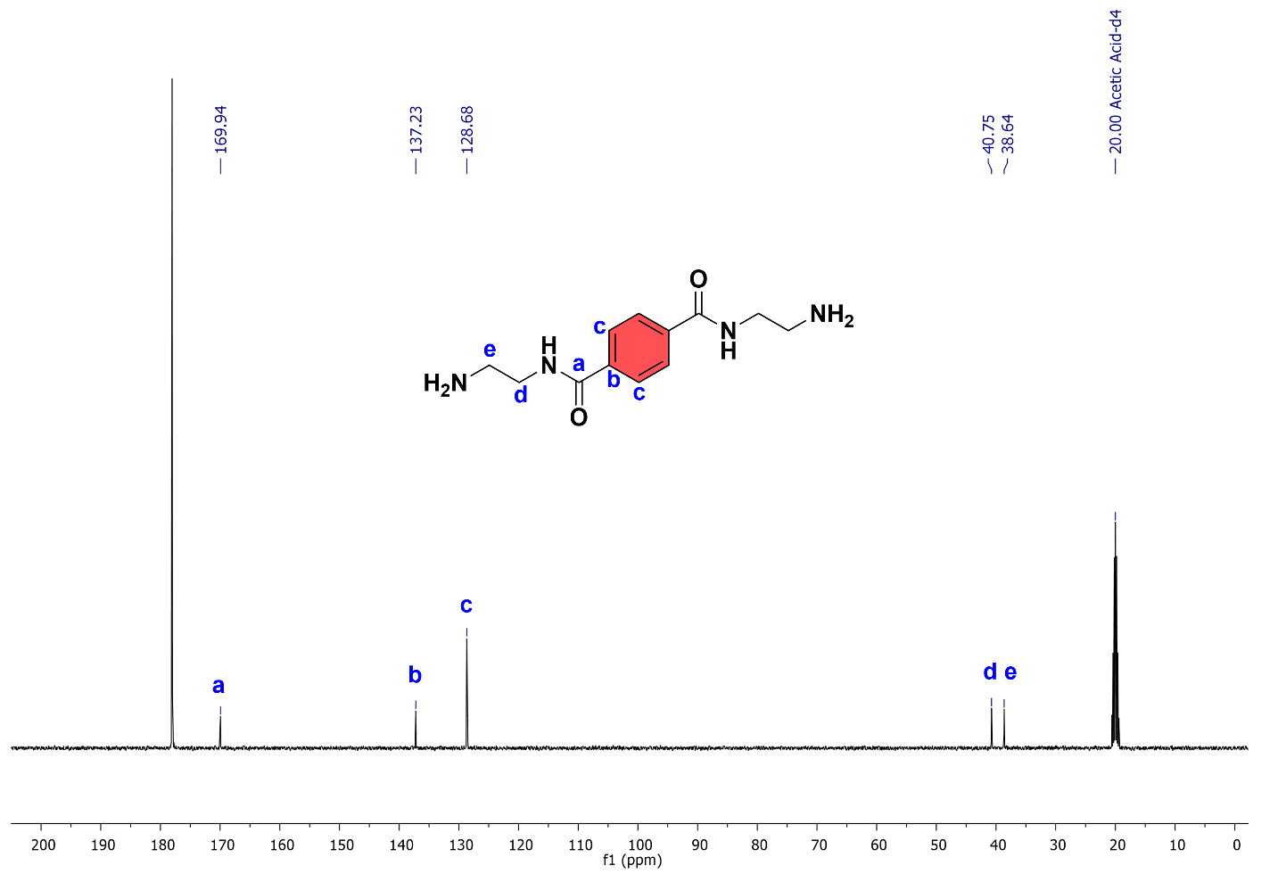Figure S5. ¹³C NMR of BAET monomer.
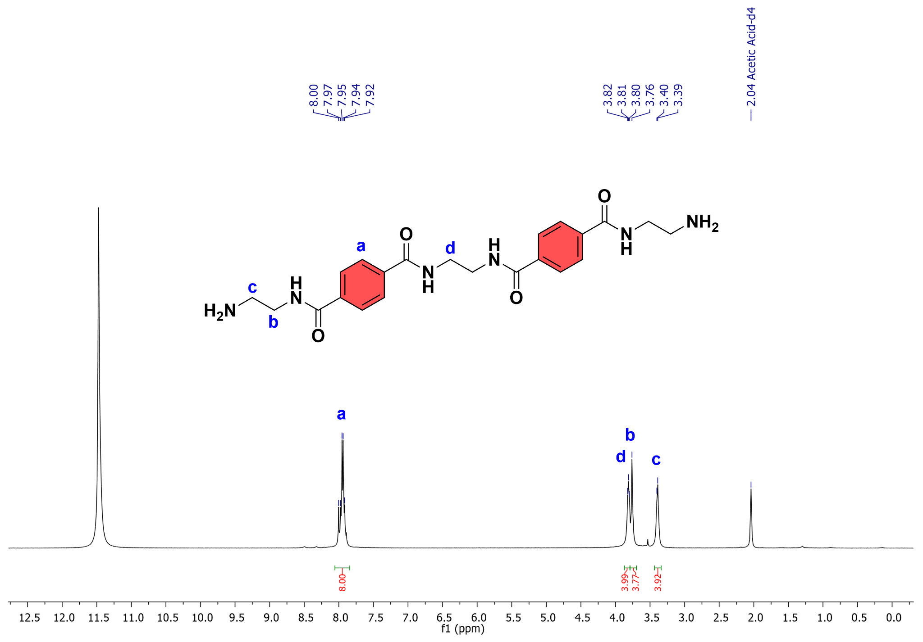
Figure S6. ¹H NMR of AOET (dimer).
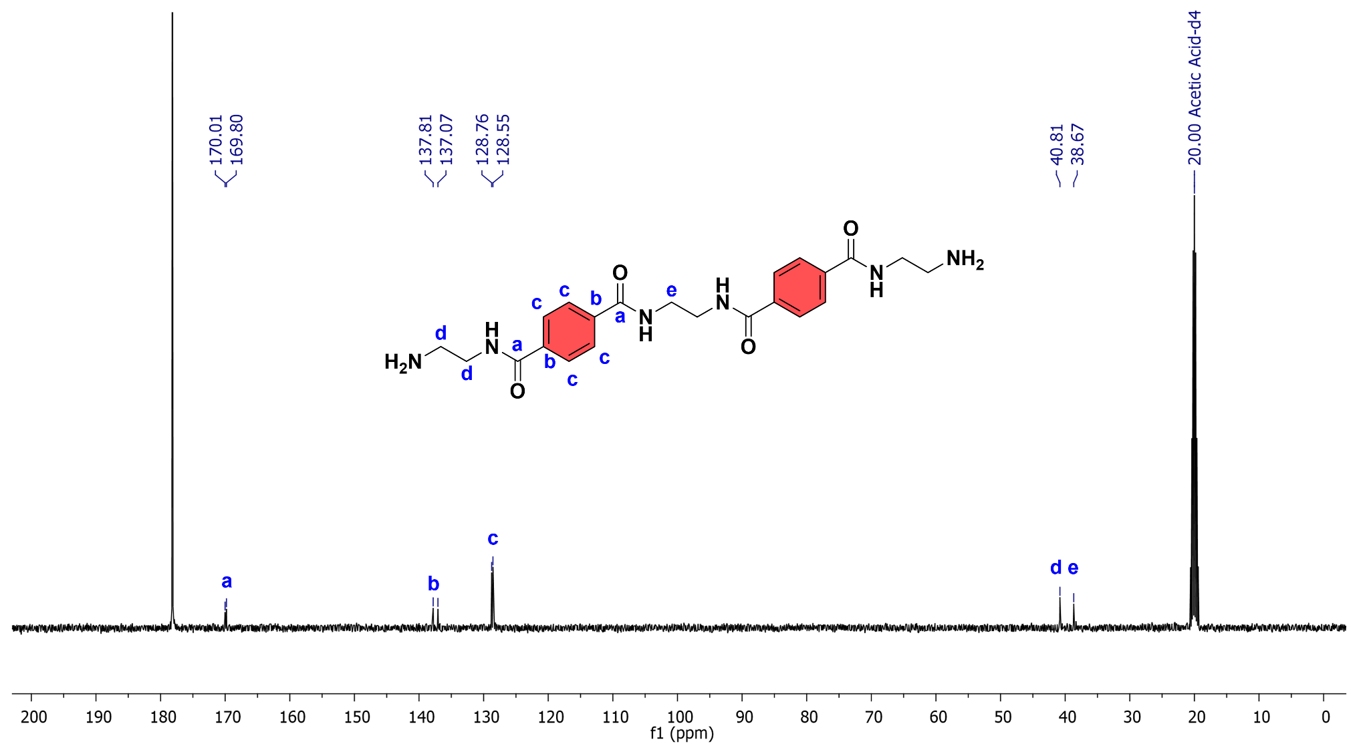Figure S7. ¹³C NMR of AOET (dimer).
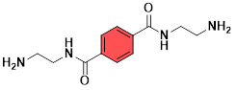
bis(2-amino ethyl) terephthalamide (BAET)
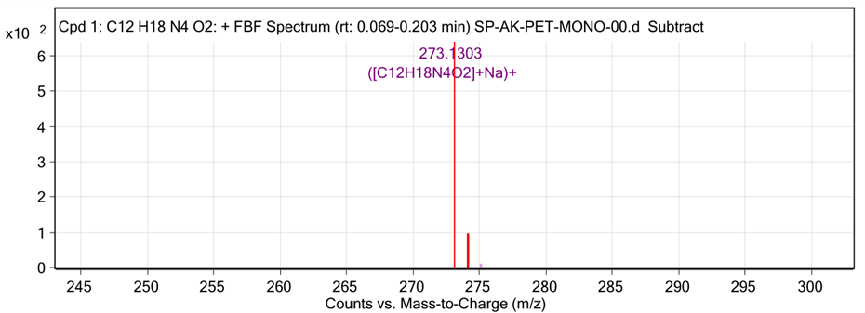
Figure S8. HR-MS m/z: [M + Na]⁺ calculated for bis(2-amino ethyl) terephthalamide (BAET) (C₁₂H₁₈N₄O₂) (found 250.1430)

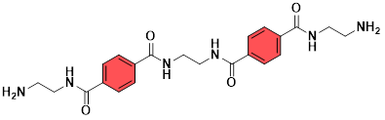
α,ω-aminoligo (ethylene terephthalamide) (AOET) dimer
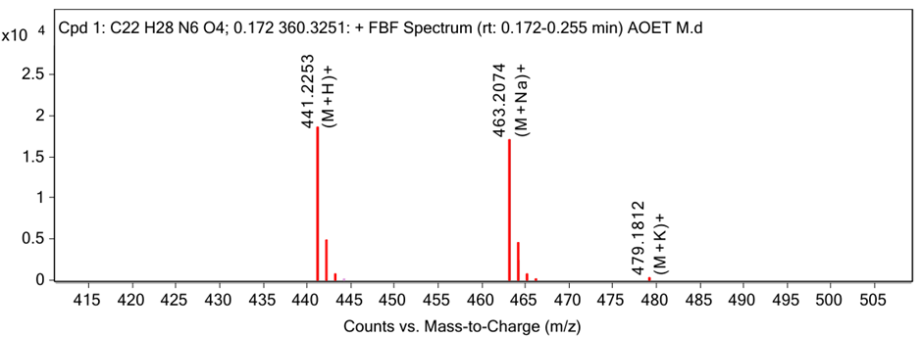
Figure S9. HR-MS m/z: [M + Na]⁺ calculated for α,ω-aminoligo (ethylene terephthalamide) as a dimer with the molecular formula (C₂₂H₂₈N₆O₄) (found 440.2172)
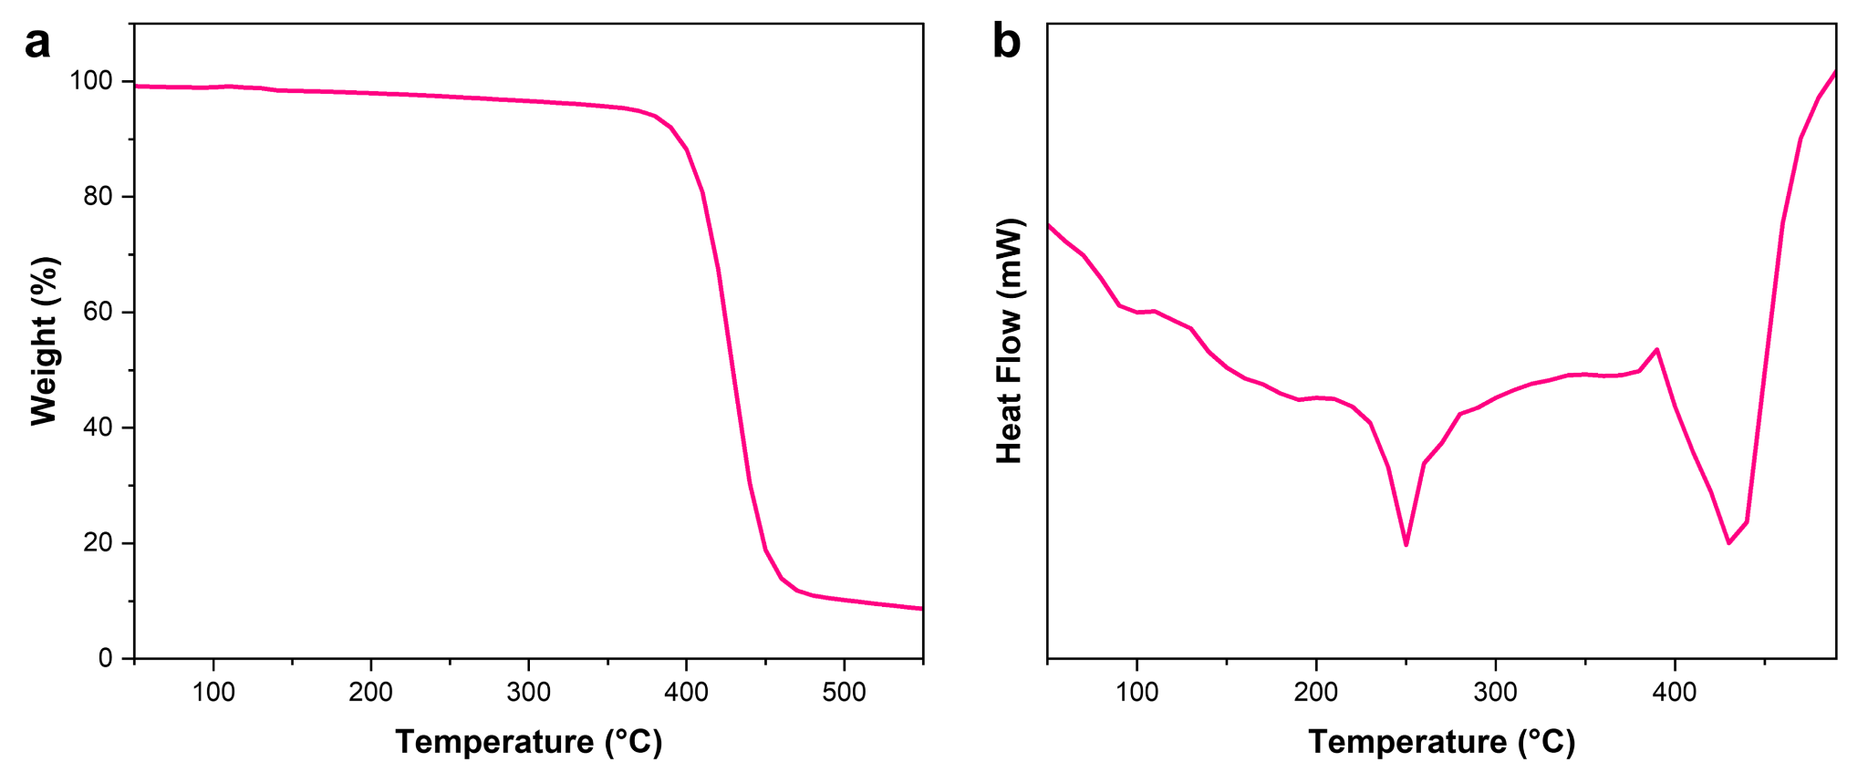
Figure S10. (a)TGA and (b) DSC thermographs of PET.

Figure S11. (a) TGA and (b) DSC thermographs of BAET and AOET (dimer).

Table S1. Aminolysis of various colored PET bottles at optimized reaction conditions.

S. No. | Colored PET bottle | Colored PET chips | Product (BAET) | Yield (%)ª
1 | Kinley white PET |  |  | 92
2 | 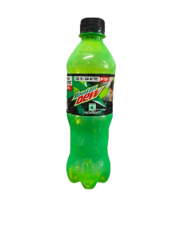  Mountain Dew green PET |  |  | 82
3 | Ocean fruit drink purple PET |  |  | 80
4 | 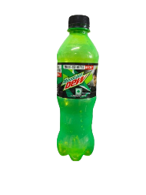  Mixed PET |  |  | 80

Reaction conditions: colored PET (1 g), ethylene diamine (5.5 mL), α-Al₂O₃ 550 (50 mg), 70 °C, 7 h. ªIsolated yields.

S2. Green metrics calculations
The environmental impact and sustainability of the glycolysis of PET to BAET were systematically evaluated using green chemistry metrics.
Mass of the EDA = 5 g (5.5 mL)
Molar mass of BAET = 250.14 g/mol
Molar mass of the PET repeating unit = 192.2 g/mol
Mass of the catalyst = 0.05 g
Mass of the PET = 1 g
1. Environmental factor (E-factor)¹
In green chemistry, the E-factor is a key parameter for evaluating the sustainability of chemical processes. It reflects the quantity of waste generated in relation to the amount of desired product, thus providing an understanding of process efficiency. A value of 0.1 in the applied formula indicates that approximately 10% of the solvent is lost during filtration. Generally, a larger E-factor implies higher waste formation and greater environmental concern.
$$E - factor = \frac{\left[0.1*\left(\frac{solvent}{PET }ratio\right)+\left(\frac{catalyst}{PET}ratio\right)+\left(\frac{other substrate}{PET}ratio\right)\right]}{yield* \frac{molar mass of product}{molar mass of reactant}}$$
$$E - factor = \frac{\left[0.1*\left(\frac{5}{1 }\right)+\left(\frac{0.05}{1}\right)+\left(\frac{0}{1}\right)\right]}{0.92* \frac{250.14}{192.17}}$$
$$E - factor = \frac{0.550}{ 1.196}$$
$$E - factor = 0.45$$

2. Energy economy coefficient (ε)¹
The energy economy coefficient (ε) links the product yield to the operating temperature and reaction time. This metric helps in comparing reaction efficiency across different systems. A higher ε value signifies better energy utilization and economic feasibility of the process.
$$ε =\frac{Y}{T×t}$$
Where Y is the yield of product (in mole fraction), T is the reaction temperature (°C), and t is the reaction time (in min).
Yield = 92%, Temperature = 70 °C, Time = 420 min:
$$ε =\frac{0.92}{70*420}$$
$$ε =\frac{0.89}{29400}$$
$$ε =3.1 ×{10}^{-5}$$
3. Solvent intensity (SI)²
The solvent intensity measures the mass of solvent used relative to the product obtained. Higher SI values indicate more solvent usage, increasing costs, and potential environmental burden. For this solvent-free system, no solvent is consumed, resulting in an SI of zero.
Yield = 92%, Mass of product at 92% yield = 1.196 g, Mass of solvent = 0 (solvent-free conditions)
$$Solvent intensity \left(SI\right)=\frac{ Mass of solvent}{Mass of product}$$
$$Solvent intensity \left(SI\right)=\frac{ 0 g}{1.196 g}$$
$$Solvent intensity \left(SI\right)=0$$
4. Process mass intensity (PMI)^{2,3}
The process mass intensity quantifies the total mass of materials used (including reactants and catalysts) per unit mass of product formed. Lower PMI values represent environmentally benign processes with reduced material input. In this case, solvents used during filtration are excluded from calculations.
PET = 1 g, Catalyst = 0.05 g, Ethylenediamine = 5 g, Yield = 92%, Mass of product at 92% yield = 1.196 g. We have not included any solvent that is used during the filtration process.

$$Process mass intensity \left(PMI\right)=\frac{ Total mass in process (incl. solvent)}{Mass of product}$$
$$Process mass intensity \left(PMI\right)=\frac{ 1 g of PET+0.05 g of catalyst+5 g of Ethylenediamine}{1.196 g}$$
$$Process mass intensity \left(PMI\right)=\frac{ 6.05 g}{1.196 g}$$
$$Process mass intensity \left(PMI\right)=5.05$$
5. Renewable intensity (RI)⁴
The renewable intensity expresses the fraction of renewable feedstocks relative to the product mass. A higher RI indicates greater use of renewable resources in the reaction process.
Ethylenediamine = 5 g, Yield = 92%, Mass of product at 92% yield = 1.196 g

$$Renewable intensity \left(RI\right)=\frac{ Mass of all renewable derivable materials used}{Mass of product}$$
$$Renewable intensity \left(RI\right)=\frac{ 5 g}{1.196}$$
$$Renewable intensity \left(RI\right)=4.18$$
6. Renewable percentage (RP)^{4,5}
The renewable percentage compares renewable intensity with PMI to assess how sustainable the overall process is. A higher RP denotes a greener process.
Renewable intensity = 4.18, Process mass intensity = 5.05
$$Renewable percentage \left(RP\right)=\frac{ Renewable intensity (RI)}{Process mass intensity (PMI)}×100$$
$$Renewable percentage \left(RP\right)=\frac{4.18 }{5.05}×100$$
$$Renewable percentage \left(RP\right)=82.77\%$$

S3. Carbon balance calculation of PET aminolysis⁶

Mass of PET used in the reaction: 1 g
Mass of recrystallized BAET monomer: 1.196 g
Molar mass of PET monomer or single unit: 192.2 g/mol
Molar mass of BAET molecule: 250.14 g/mol

$$Mass \% caliculation =\frac{Molar mass of PET monomer}{Molar mass of BAET monomer}×100$$

$=\frac{192.17 g/mol}{250.14 g/mol}×100 = 76.82\%$

The carbon ratio before and after the reaction = $\frac{1.196 g × 76.82\%}{1 g}×100=91.41\%$

91.41% of the carbon in the PET reactant was converted into BAET monomers; the remaining are oligomers.

S4. HR-MS analysis of reactants, oligomers, and monomer

Ethylene glycol

Figure S12. HR-MS m/z: [M + Na]⁺ calculated for ethylene glycol with the molecular formula (C₂H₆O₂) (found 62.0368).

Ethylenediamine (EDA)

Figure S13. HR-MS m/z: [M]⁺ calculated for ethylenediamine with the molecular formula (C₂H₈N₂) (found 60.0687).

bis(2-hydroxyethyl) terephthalate (BHET) detected at 5 h, and 5 h of reaction

Figure S14. HR-MS m/z: [M + 2Na]⁺² calculated for bis(2-hydroxyethyl) terephthalate with the molecular formula (C₁₂H₁₄O₆) (found 254.0790).

2-hydroxyethyl 4-((2-aminoethyl) carbamoyl) benzoate (HACB) detected at 3 h, and 6 h of reaction

Figure S15. HR-MS m/z: [M + Na]⁺ calculated for 2-hydroxyethyl 4-((2-aminoethyl) carbamoyl) benzoate with the molecular formula (C₁₂H₁₆N₂O₄) (found 252.1110).

BAET trimer

Figure S16. HR-MS m/z: [M + K]⁺ calculated for BAET trimer with the molecular formula (C₃₂H₃₈N₈O₆) (found 630.2914).

BAET tetramer

Figure S17. HR-MS m/z: [M + 2Na]⁺² calculated for BAET tetramer with the molecular formula (C₄₂H₄₈N₁₀O₈) (found 820.3657).

amide-based tetramer (a) detected at 1 h, 2 h, and 7 h of reaction

Figure S18. HR-MS m/z: [M + 2H]⁺² calculated for amide-based tetramer (a) with the molecular formula (C₄₂H₄₀N₂O₁₆) (found 828.2378).

ester-based tetramer (b) detected at 1 h reaction time

Figure S19. HR-MS m/z: [M + Na]⁺ calculated for ester-based tetramer (b) with the molecular formula (C₄₂H₃₈O₁₈) (found 830.2058).

trimeric ester-based oligomer (c) detected at 2 h, 3 h, and 6 h of reaction

Figure S20. HR-MS m/z: [M + NH₄]⁺² calculated for trimeric ester-based oligomer (c) with the molecular formula (C₃₂H₃₀O₁₄) (found 638.1636).

trimeric amide-based oligomer (d) detected at 3 h, 4 h, 5 h, and 6 h of reaction

Figure S21. HR-MS m/z: [M + NH₄]⁺² calculated for trimeric amide-based oligomer (d) with the molecular formula (C₃₂H₃₂N₂O₁₂) (found 636.1955).

dimeric ester-based oligomer (e) detected at 4 h of reaction

Figure S22. HR-MS m/z: [M + H₂O]⁺ calculated for dimeric ester-based oligomer (e) with the molecular formula (C₂₂H₂₂O₁₀) (found 446.1213).

dimeric diamide-based oligomer (f) detected at 4 h of reaction

Figure S23. HR-MS m/z: [M + 2(H₂O)]⁺² calculated for dimeric diamide-based oligomer (f) with the molecular formula (C₂₂H₂₆N₄O₆) (found 442.1852).

dimeric amide-based oligomer (g) detected at 4 h of reaction

Figure S24. HR-MS m/z: [M + 2Na]⁺² calculated for dimeric amide-based oligomer (g) with the molecular formula (C₂₂H₂₄N₂O₈) (found 444.1533).

trimeric diamide-based oligomer (h) detected at 5 h of reaction

Figure S25. HR-MS m/z: [M]⁺ calculated for trimeric diamide-based oligomer (h) with the molecular formula (C₃₂H₃₄N₄O₁₀) (found 634.2275).

tetrameric diamide-based oligomer (i) detected at 7 h of reaction

Figure S26. HR-MS m/z: [M + 2NH₄]⁺² calculated for tetrameric diamide-based oligomer (i) with the molecular formula (C₄₂H4₂N₄O₁₄) (found 826.2698).

dimeric diamide-based oligomer

Figure S27. HR-MS m/z: [M + Na]⁺ calculated for dimeric diamide-based oligomer
with the molecular formula (C₂₂H₂₆N₄O₆) (found 442.1852).

trimeric triamide-based oligomer

Figure S28. HR-MS m/z: [M + 2(NH₄)]⁺² calculated for trimeric triamide-based oligomer
with the molecular formula (C₃₂H₃₆N₆O₈) (found 632.2595).

tetrameric triamide-based oligomer

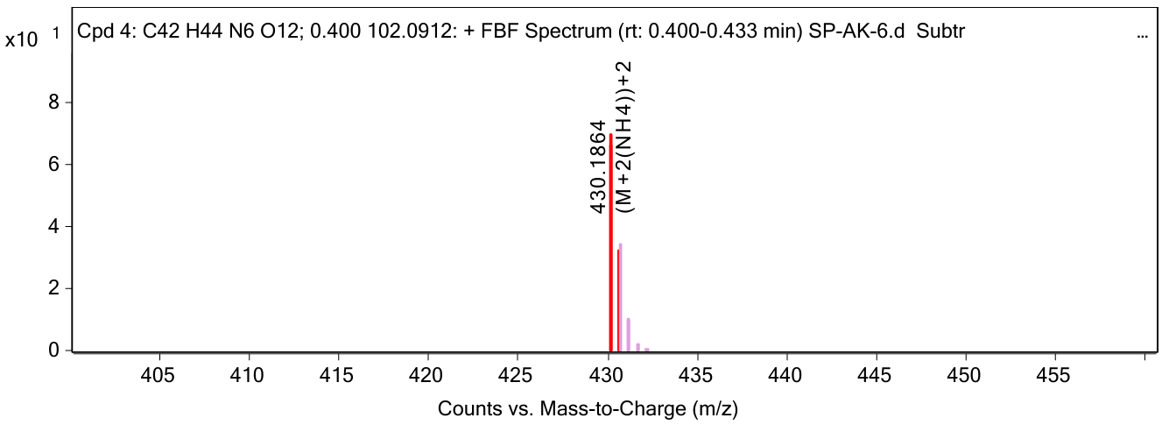
Figure S29. HR-MS m/z: [M + 2(NH₄)]⁺² calculated for tetrameric triamide-based oligomer with the molecular formula (C₄₂H₄₄N₆O₁₂) (found 824.3017).

tetrameric tetramide-based oligomer
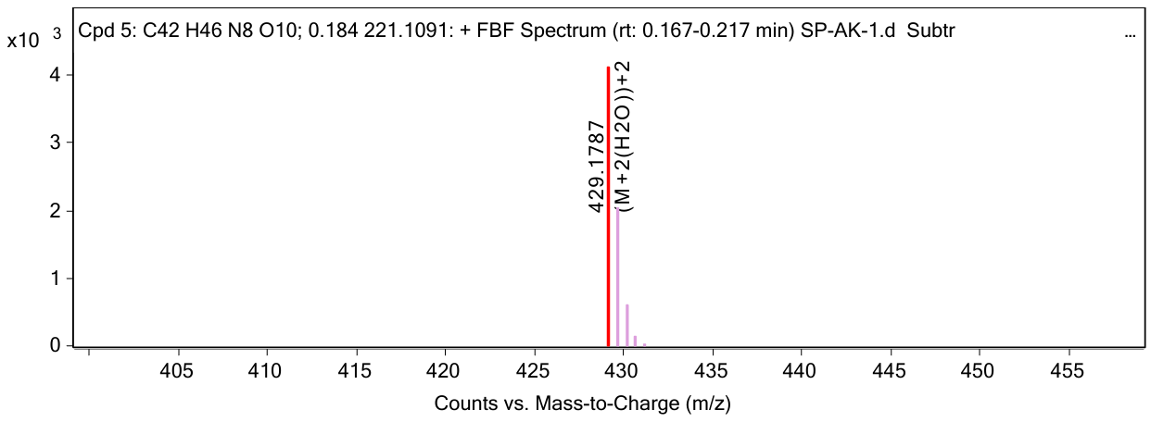

Figure S30. HR-MS m/z: [M + 2(NH₄)]⁺² calculated for tetrameric tetramide-based oligomer with the molecular formula (C₄₂H₄₆N₈O₁₀) (found 822.3337).
References:

(1) Barnard, E.; Rubio Arias, J. J.; Thielemans, W. Chemolytic Depolymerisation of PET: A Review. Green Chemistry 2021, 23 (11), 3765–3789. https://doi.org/10.1039/D1GC00887K.
(2) Sheldon, R. A. Metrics of Green Chemistry and Sustainability: Past, Present, and Future. ACS Sustain Chem Eng 2018, 6 (1), 32–48. https://doi.org/10.1021/acssuschemeng.7b03505.
(3) Kumar, V.; Kumar, S.; Sharma, D.; Krishnan, V. Nanoarchitectonics of ZnFe‐Layered Double Hydroxide Catalysts for Valorization of Waste Polyethylene Terephthalate Bottles into Value‐Added Products. Macromol Rapid Commun 2025. https://doi.org/10.1002/marc.202500497.
(4) McElroy, C. R.; Constantinou, A.; Jones, L. C.; Summerton, L.; Clark, J. H. Towards a Holistic Approach to Metrics for the 21st Century Pharmaceutical Industry. Green Chemistry 2015, 17 (5), 3111–3121. https://doi.org/10.1039/C5GC00340G.
(5) Sharma, D.; Choudhary, P.; Kumar, S.; Krishnan, V. Integrated Chemical Upcycling of Poly(Ethylene Terephthalate) Waste to Multiple Value-Added Products Catalyzed by Ni 2 P Supported on SiO₂: From Trash-to-Treasure. ACS ES&T Engineering 2025. https://doi.org/10.1021/acsestengg.5c00357.
(6) Liu, Y.; Zhang, C.; Feng, J.; Wang, X.; Ding, Z.; He, L.; Zhang, Q.; Chen, J.; Yin, Y. Integrated Photochromic‐Photothermal Processes for Catalytic Plastic Upcycling. Angewandte Chemie International Edition 2023, 62 (38). https://doi.org/10.1002/anie.202308930.

