Table of Appendices
Appendices | Study
Appendix A: SMM Scale items | Study 1
Appendix B: Math Self-Regulated Learning Strategies Use Scale items | Study 1
Appendix C: Academic Support Scale items | Study 1 and Study 2
Appendix D: Manipulation checks questions | Study 2
Appendix E: Manipulation materials | Study 2
Appendix F: Microanalytic processes measure | Study 2
Appendix G:  Validity analysis of SMM | Study 1

Appendix A
Table S1
SMM Scale items in Study 1
Items | Responses
1. When you are stuck on math questions, how often do you ask yourself: "What are things I can do to help myself?" | 1 (never) - 5 (always)
2. Whenever you feel like you are not making progress in math, how often do you ask yourself: "Is there a better way of doing this?" | 1 (never) - 5 (always)
3. Whenever you feel frustrated with math questions, how often do you ask yourself: "How can I do this better?" | 1 (never) - 5 (always)
4. In math when you feel challenged, how often do you ask yourself: "What are things I can do to make myself better at this?" | 1 (never) - 5 (always)
5. When you are struggling with math, how often do you ask yourself: "What can I do to help myself?" | 1 (never) - 5 (always)
6. Whenever math feels difficult, how often do you ask yourself: "What can I do to get better at this?" | 1 (never) - 5 (always)

Appendix B
Table S2
Math Self-Regulated Learning Strategies Use Scale items used in Study 1 (1 = never, 2 = rarely, 3 = sometimes, 4 = often, 5 = always)
Items | Responses
1. How often do you try to decide what you are supposed to learn, rather than just read the material when you are doing math work? | 1 (never) - 5 (always)
2. How often do you try to relate what you are studying to other math things you know about? | 1 (never) - 5 (always)
3. How often do you try to plan what you have to do for math assignments before you get started? | 1 (never) - 5 (always)
4. How often do you check your math assignment to make sure it’s done correctly when you finish it? | 1 (never) - 5 (always)

Appendix C
Table S3
Academic Support Scale items used in Study 1 (during the past semester…) and Study 2 (in the current class session.…)
Items | Responses
Teacher Academic Support
1. My math teacher pays attention to my problem-solving process. | 1 (never) - 5 (always)
2. My math teacher cares about how much knowledge I have acquired. | 1 (never) - 5 (always)
3. My math teacher hopes I can do my best in my studies. | 1 (never) - 5 (always)
4. If I fall behind in my studies, my math teacher will help me catch up. | 1 (never) - 5 (always)
Student Academic Support
5. In math class, other classmates hope I can excel in my learning. | 1 (never) - 5 (always)
6. In math class, other classmates hope I can achieve success. | 1 (never) - 5 (always)
7. In math class, other classmates are concerned about how much I have learned. | 1 (never) - 5 (always)

Appendix D
Table S4
Manipulation checks questions
Items | Responses
1. Strategic mindset in math is the wisdom that people ask themselves: "Are there any other ways for me to learn mathematics well?" | 1 (disagree strongly) - 5 (agree strongly)
2. Stanley et al. found that a strategic mindset in math was an effective predictor of students' success in solving mathematical problems. | 1 (disagree strongly) - 5 (agree strongly)
3. Students who think strategically in mathematics are better able to find new solutions to problems and people who can guide them. | 1 (disagree strongly) - 5 (agree strongly)

Appendix E
Manipulation materials in Study 2
Study 2 SMM Article

The Secret to Mathematical Success: Strategic Mindset in Math.

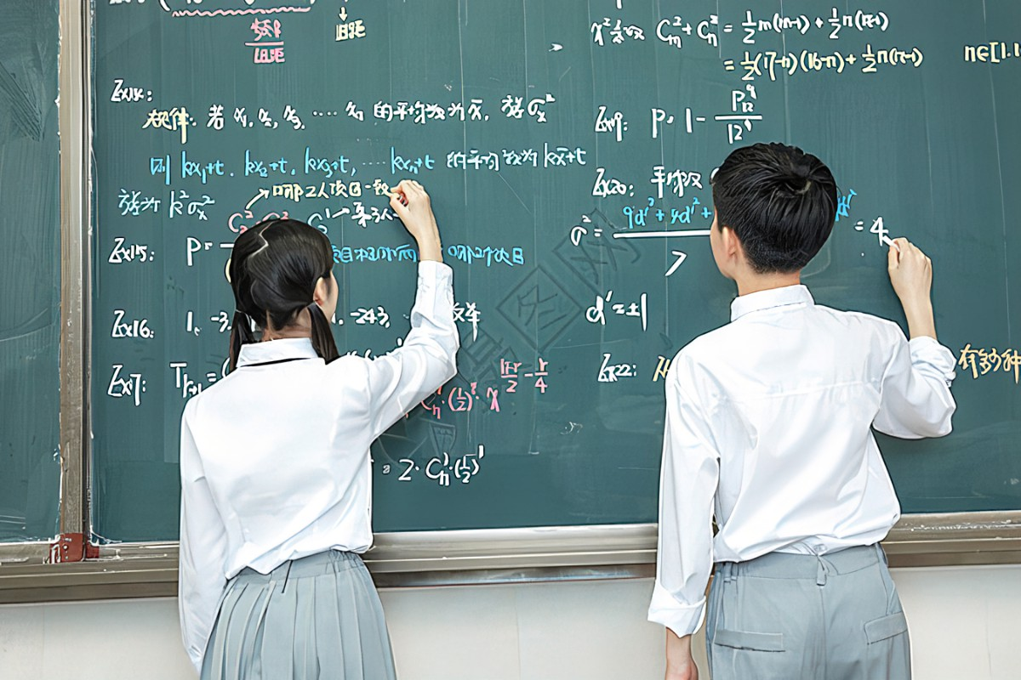
April 15, 2022 08:32 | Source: People's Daily
Author: XXX, professor at Harvard University
They are the excellent students at the top of their mathematical classroom, and the mathematicians who finish with the gold medal atop the podium. That’s right, I’m talking about the top math performers whose secrets to success often seem exactly that— Strategic Mindset in Math.
What we often cannot observe is the psychology behind their mathematical success. These are the mindsets and behaviors that spur them to achieve what others only admire. Now, recent breakthroughs in psychological science are illuminating the one crucial ingredient that many of these successful mathematicians share in common: Strategic Mindset in Math.
Strategic Mindset in Math is the process of evaluating the way you are thinking about math problems. This is the wisdom to take a step back from whatever you are doing and ask: "How else can I do this math problem?" As simple as it seems, people caught amid frustration and anxiety rarely practice this. Yet, when faced with a seemingly overwhelming mathematical challenge, this brief moment of self-awareness can make a solution of difference. It gives you a pause from unproductive ways of thinking about the mathematical problem, prompts you to scan the environment and mind for new resources, information, or people who can help you, and allows you to direct your efforts more productively.
____________________________________________________
The wisdom to take a step back from what you are doing and ask: "How else can I do this mathematical problem?"
____________________________________________________
In a recent breakthrough publication in Science magazine, a team of researchers led by Professor Stanley Krosnick followed 216 high school students throughout their lives to study the factors that distinguished those who became highly successful mathematical problem solvers from those who did not. Out of all the possible factors, the Strategic Mindset in Math stood out as a strong predictor of mathematical achievement. When these successful students were stuck on a mathematical problem, they often paused to ask themselves: “How else can I do this mathematical problem? What other steps can I take to get better at mathematical problems? What else can I do?” This Strategic Mindset in Math enabled successful students to come up with ways to meet the mathematical challenge effectively.
This psychology behind mathematical success applies to successful college students majoring in mathematics as well. Harvard Graduate School of Education Professor, Dr. Star, identified the very same Strategic Mindset in Math that enables college students majoring in mathematics to succeed. He shared, “I’ve learned that mathematical achievement comes from being thoughtful and strategic about how you approach math. It's about questioning yourself about which strategies and resources you can use to effectively navigate mathematical problems.” When faced with a challenging mathematical problem in school, successful mathematics students know how to break out of their routines and practice this psychology (Strategic Mindset in Math). They ask themselves: “How else can I go about this mathematical problem? Are there strategies that I can do differently? Are there ways to do this mathematical problem even better?
____________________________________________________
Successful students know how to break out of their routines and
practice Strategic Mindset in Math by asking: "How else can I go about this mathematical problem?"
____________________________________________________
Why is a Strategic Mindset in Math so key to mathematical success? While it may sound simple, the crux of this mindset is that it enables you to step back from the same way of thinking about a mathematical problem and view this problem in a new light. Rather than mindlessly going forward, people who pause and ask, "How else can I do this mathematical problem?", are more likely to recognize resources that can help them, new methods of solving, people who could give them guidance, or different ways of thinking about their mathematical problem.
Math is full of challenges, ranging from complex algebra problems to geometry problems. As you are tackling your next mathematical challenge, one useful thing you can do when your efforts are not paying off is to practice Strategic Mindset in Math. Just take a step back from the mathematical problem and ask yourself, “How else can I do this mathematical problem?”
_________________________________________________________________________________
Love this article? Share it with your friends on WeChat ↗️

Study 2 Control Article
The Secret to Mental Health: Take Cold Showers.


April 15, 2022 08:32 | Source: People's Daily
Author: XXX, professor at Harvard University
In today’s dog-eat-dog world, frustrations at school are inevitable. Not only are 5% of Americans clinically depressed, but many more people experience bouts of intense sadness and aggravation with the challenges of everyday life. Is there anything we can do to make ourselves happier in our daily lives?
What might surprise you is the very simple answer that research has found: Cold showers. While this may seem rather counterintuitive (most of us don’t even enjoy taking cold showers), recent findings in health science show that several ways taking cold showers regularly can benefit our mental health.
In a recent breakthrough publication in Science magazine, a team of researchers led by Professor Stanley Krosnick studied 216 doctors and nurses to learn how they kept alert and productive under high levels of stress and often little sleep. They found that, up on the list of ways to keep mentally alert on the job, cold morning showers were right up there next to coffee.
__________________________________________________
Up on the list of ways to keep mentally alert on the job, cold morning showers were right up there next to coffee.
___________________________________________________
Harvard School of Medicine Professor, Dr. Lara King, has been studying natural forms of therapy for stress and anxiety for decades. Over two years, she tracked a group of people who took cold showers to deal with stress and compared them to a comparable group of people who did not take cold showers. “We found that people who take cold showers when stressed show decreased levels of the stress hormone cortisol," King shared. "What surprised us was that the people who sustained this habit regularly reported feeling more energetic, less stressed, and more satisfied with their lives, compared to those who did not take cold showers over the two years."
Speaking on behalf of the scientific community whose research is converging on the beneficial effects of cold showers, King said, "Taking a cold shower is such a simple yet overlooked solution to coping with stress. I wish more people knew about this."
While this idea is new to some of us, many highly acclaimed surgeons who are called to emergencies know this trick: Taking a chilling shower before work or splashing your face with cold water in the middle of the workday is an immediate, healthy way to energize yourself, and it isn’t just people who constantly experience high levels of stress who benefit from cold showers. Cold showers also build physical resilience to discomfort. In a well-cited medical paper published in 2010, Columbia Professor Harvey Robinson found that athletes who took cold showers right after training developed faster muscle recovery rates and greater mental hardiness to physical pain. Compared to their peers who were relaxing in hot showers after their workout, these athletes were training their bodies’ resilience while enjoying an invigorating mental lift!
____________________________________________________
Taking a cold shower or splashing your face with cold water is an immediate, healthy way to energize yourself, lower stress, and refocus.
____________________________________________________
Why would cold showers promote better mental health? Medical researchers and clinical psychologists say it could be that the cold-water shock triggers our body’s natural healing process.
When exposed to sudden changes in temperature, the brain immediately releases stress-relieving hormones, noradrenaline and endorphins. These hormones flood the body, trying to help it cope with the radical change. This seems to be a naturally evolved way to protect our psychological health when we are exposed to changes in the physical environment.
Another explanation offered is that running cold water over one’s face stimulates mental alertness and emotional calm. Many of us are used to running cold water over our faces just after we have cried to relieve puffiness around the eyes, and administering cool, moisturizing liquid to the face is often part of “de-stress” facial treatments. That’s why rinsing your face can make you feel refreshed and happier in a second!
The next time you feel a little stressed, tired, or down, try this one easy thing that you can do for yourself: Take a refreshingly cold shower.
_________________________________________________________________________________
Love this article? Share it with your friends on WeChat ↗️

Appendix F
Microanalytic processes measure
Table S5
Examples of microanalytic processes measure (DiBenedetto & Zimmerman, 2013)
Phases | Learning stages | Dimensions |  | Question form | Scoring
Phase 1 | Before learning | Strategic planning | What strategies do you plan to use to better grasp the material you are about to learn? | Open question | Count the number of strategies
Phase 2 | During learning -1 | Strategy use | Please answer what specific strategies you use to help you learn in this class. | Open question | Count the number of strategies
 | During learning - 2 | Confidence | How do you think your performance in this class can be scored? | Closed question | 10-point Likert scale
Phase 3 | After learning | self-reflection | What do you think you can score for your understanding of this lesson? | Closed question | 10-point Likert scale

Appendix G
Table S6
Validity analysis of SMM
Items | Mean | SD | Loading | t-value
1. When you are stuck on math questions, how often do you ask yourself: "What are things I can do to help myself?" | 3.640 | 1.044 | 0.836 | -40.384
2. Whenever you feel like you are not making progress in math, how often do you ask yourself: "Is there a better way of doing this?" | 3.812 | 0.965 | 0.870 | -17.548
3. Whenever you feel frustrated with math questions, how often do you ask yourself: "How can I do this better?" | 3.847 | 1.006 | 0.888 | -15.838
4. In math when you feel challenged, how often do you ask yourself: "What are things I can do to make myself better at this?" | 3.888 | 0.959 | 0.911 | -15.230
5. When you are struggling with math, how often do you ask yourself: "What can I do to help myself?" | 3.836 | 1.002 | 0.912 | -17.129
6. Whenever math feels difficult, how often do you ask yourself: "What can I do to get better at this?" | 3.859 | 0.971 | 0.923 | -17.137

