Supporting Information
A coumarin derived 2-methylthio-4-hydroxypyrimidine[3,4-b]coumarin fluorescent chemosensor for detection of hypochlorite ions in aqueous medium
Arunaª, Kanchanª, Arunava Agarwala^{b} and Rahul Shrivastava^{a*}
ªDepartment of Chemistry, Manipal University Jaipur, VPO- Dehmi-Kalan, Off Jaipur-Ajmer Express Way, Jaipur (Rajasthan), 303007 India, E-mail: chem.rahul@gmail.com
^{b}Department of Chemistry, Malda College, Malda, 732101, West Bengal, India

Content:
- ¹H NMR Spectra coumarin based 2-methylthio-4-hydroxypyrimidine[3,4-b]coumarin fluorescent chemosensor (CTH)
- ¹³C NMR Spectra of coumarin based 2-methylthio-4-hydroxypyrimidine[3,4-b]coumarin fluorescent chemosensor (CTH)
- Mass Spectra of coumarin based 2-methylthio-4-hydroxypyrimidine[3,4-b]coumarin fluorescent chemosensor (CTH)

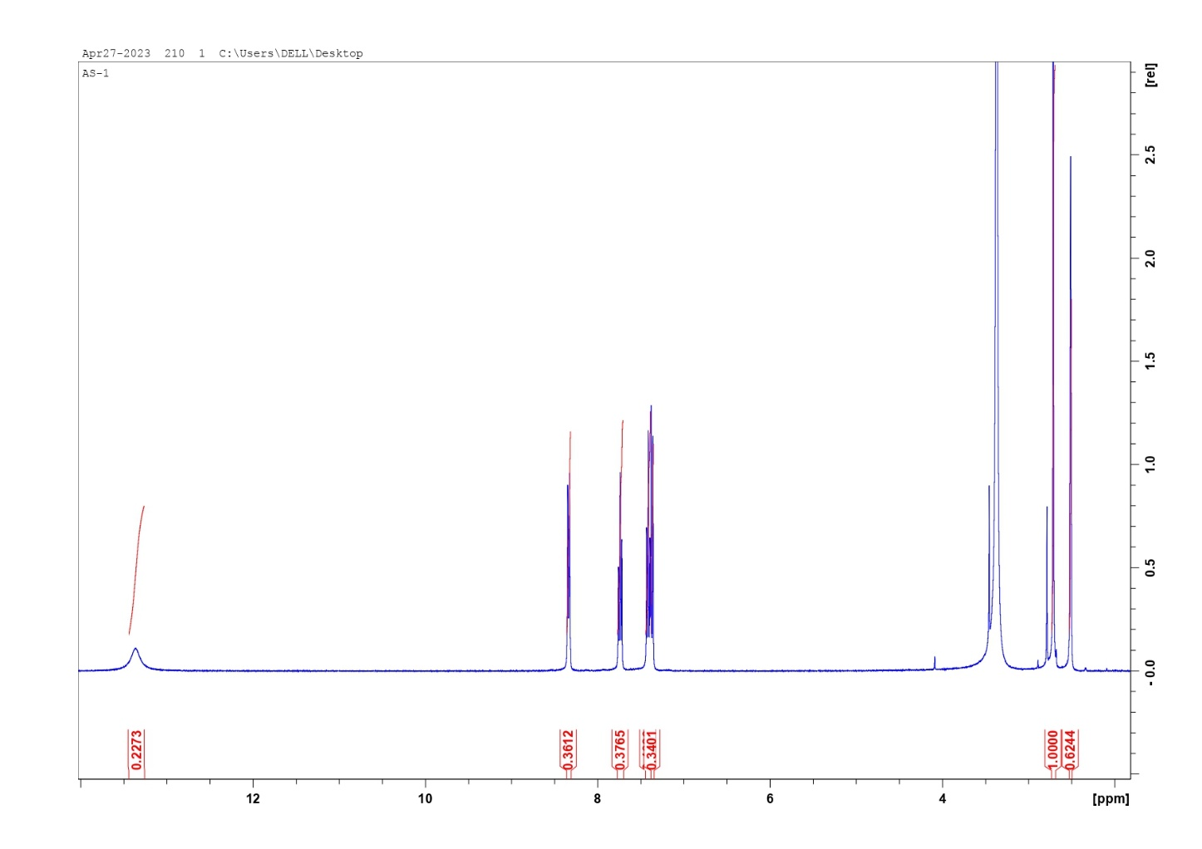
Figure S1. ¹H NMR Spectra coumarin based 2-methylthio-4-hydroxypyrimidine[3,4-b]coumarin fluorescent chemosensor (CTH)

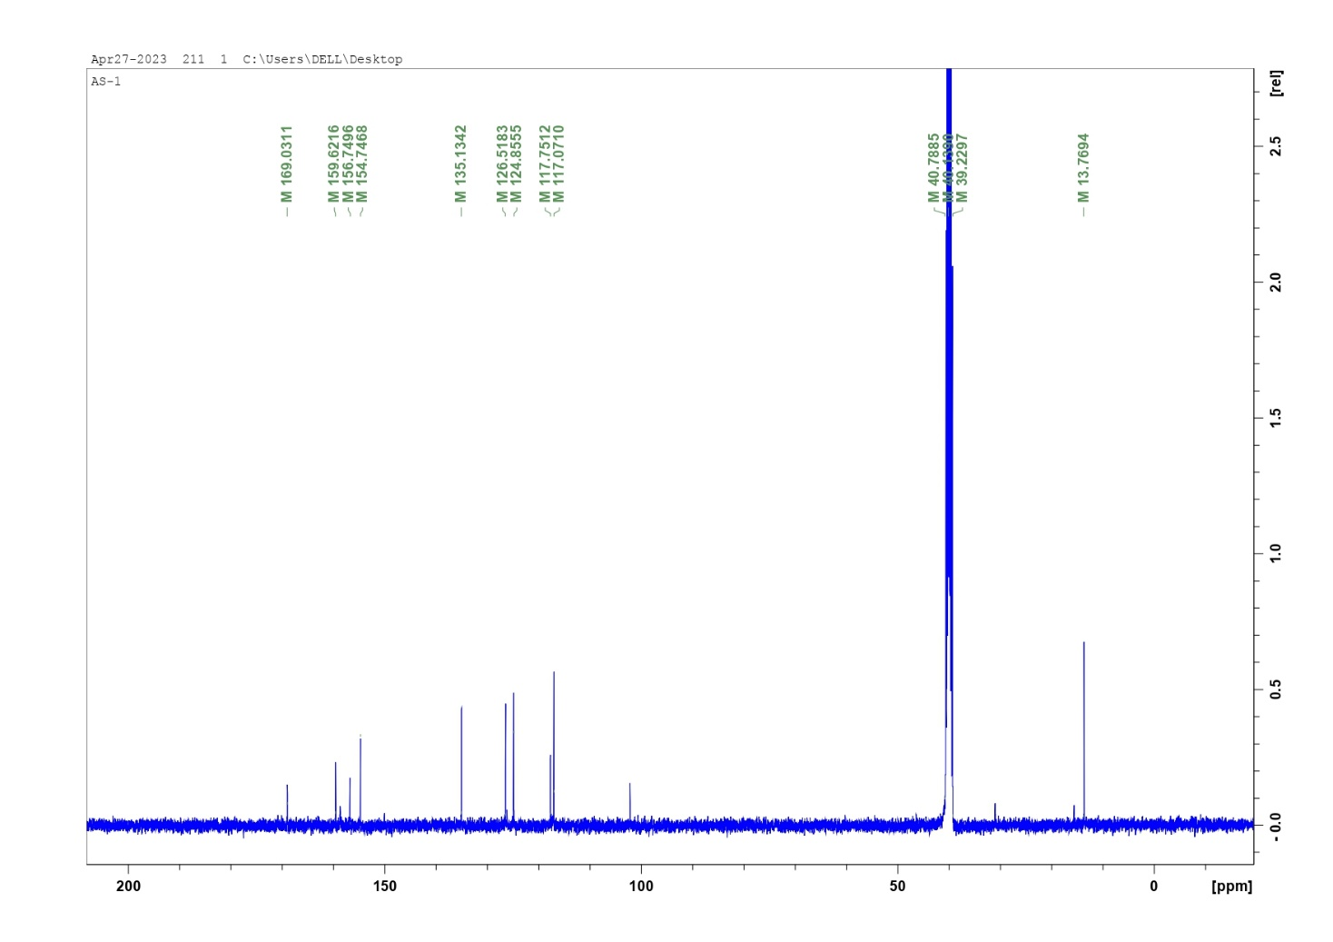
Figure S2. ¹³C NMR Spectra of coumarin based 2-methylthio-4-hydroxypyrimidine[3,4-b]coumarin fluorescent chemosensor (CTH)

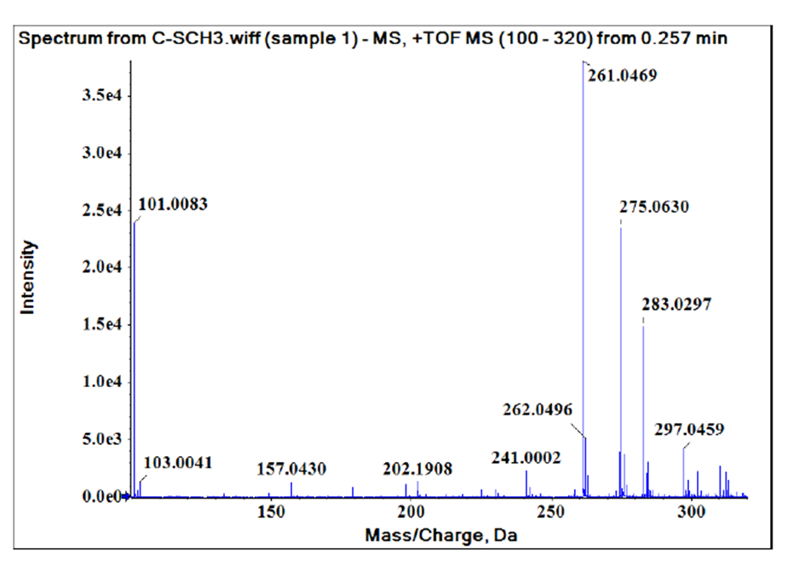

Figure S3. Mass Spectra of coumarin based 2-methylthio-4-hydroxypyrimidine[3,4-b]coumarin fluorescent chemosensor (CTH)

