Supplementary Materials for

Microwave Photonic Ising Machine
Qizhuang Cen^{1. †}, Tengfei Hao^{2, 3, 4 †}, Hao Ding¹, Shanhong Guan¹, Zhiqiang Qin¹, Kun Xu¹, Yitang Dai^{1,} *, Ming Li^{2, 3, 4} *.

¹State Key Laboratory of Information Photonics and Optical Communications, Beijing University of Posts and Telecommunications, Beijing 100876, China.
²State Key Laboratory on Integrated Optoelectronics, Institute of Semiconductors, Chinese Academy of Sciences, Beijing 100083, China.
³School of Electronic, Electrical and Communication Engineering, University of Chinese Academy of Sciences, Beijing 100049, China.
⁴Center of Materials Science and Optoelectronics Engineering, University of Chinese Academy of Sciences, Beijing 100190, China.

†These authors contributed equally to this work.
*Corresponding authors: ytdai@bupt.edu.cn; ml@semi.ac.cn.

- Binary-phase oscillation in degenerate OEPO
In a conventional optoelectronic oscillator (OEO) cavity, microwave signal is up-converted to optical domain through an electro-optic modulator, and then recovers itself in a photodetector (PD) after propagates along a long optical fiber. The recovered microwave signal is then amplified, filtered, and finally feedback to the modulator. In an optoelectronic parametric oscillator (OEPO), microwave signal passes through the optoelectronic cavity and interacts with a local oscillation (LO) through an electrical second-order nonlinear device, i.e. an electrical mixer. The second-order parametric process produces the sum frequency and the difference frequency of the two input signals. In our scheme, the difference frequency is reserved and serviced as the artificial Ising spin while the sum frequency is blocked by a microwave bandpass filter. If the central frequency and the bandwidth of the microwave filter are properly designed, the signals before and after the frequency conversion, known as radio frequency (RF) and intermediate frequency (IF) signal respectively, would have the same frequency. In this case, the parametric process is degenerate and there would be a phase conjugate operation in the mixer that reverses the phase of the input RF signal (28). The phase-reversed RF signal transfers to the IF port and mixes with the leaked RF signal, which directly transfers to the IF port without interaction with the LO signal. In a commercial electrical mixer, a typical rejection between the leaked RF and IF (phase-reversed RF signal) is from −10 dB to −30 dB. Since the leaked RF and the phase-reversed RF signal have the same frequency, they cannot be separated from each other. In this case, the loss of the signal passing through the mixer depends on the phase difference between the phase-reversed one and the leaked one. The minimum loss is realized when the two parts have the same phase. As a result, the signal before and after the parametric process are the same, which means phase of the oscillating microwave signal is either 0 or π. The binary-phase oscillation then can be used to represent the artificial spin of the Ising machine. The spin evolution in the proposed optoelectronic cavity can be described as (28, 32)
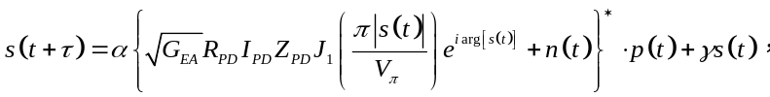 (S1)
where s(t) is the oscillating signal, τ is the cavity delay, α is the frequency conversion coefficient of the mixer, G_{EA} is the power gain of the electrical amplifier, R_{PD} is the responsivity of the PD, I_{PD} is the power that launched into the PD, Z_{PD} is the PD impedance, J₁ is the 1st-order Bessel function of the first kind, V_{π} is the half-wave voltage of the modulator, $p\left(t\right)=Ae^{iω_{LO}t}$ is the external microwave signal with fixed amplitude A and frequency $ω_{LO}$, γ is the signal leakage coefficient of the mixer, and n(t) is the link noise which includes thermal noise and shot noise. In the OEPO, oscillation starts from noise and the noise iterates in the cavity after each roundtrip and obtains constructive or destructive interference. With enough cavity gain, the interference finally gets stable and oscillator outputs the desired microwave signal.
Here, we run a simulation with Matlab. The simulation is run at baseband and parameters are modeled as follows: $α=0.4$, $G_{EA}=40$ dB, $R_{PD}=1$ A/W, $I_{PD}=6$ dBm, $Z_{PD}=50 Ω$, $V_{π}=2π$ volts, p(t)$=1$, $γ=0.1$ and the noise floor is modeled as Gaussian white noise with power spectral density of −150 dBm/Hz. The frequency conversion coefficient $α=0.4$ corresponds to a power loss of 8 dB in the mixer. The leakage coefficient $γ=0.1$ corresponds to a power rejection of 20 dB between the leaked RF and IF. The cavity net gain is calculated to be 2 dB. The results of ten spins are shown in Fig. S1. After less than 30 roundtrips, the oscillation amplitude reaches the maximum and then stays stable, as can be seen in Fig.1SA. Different from the monotonic increasing in the amplitude, the spin phase jumps back and forth at the beginning because of the phase conjugate operator, as shown in Fig. S1B. As the roundtrip number increase, the wobbles become smaller and finally the spin phases converge to either 0 or π. The stability of the oscillation is also evaluated by the calculating the jitter 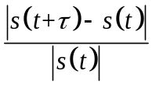 and results are shown in Fig. S1C. One can conclude that the spin is highly stable and jitters drops down to around 10⁻⁶ after 100 roundtrips. The cavity net gains are around 2 dB at the beginning and decrease to one when the spin amplitudes are stable.

- Mapping the Ising problem onto the OEPO network
In an N-spin, non-interaction oscillation network, assuming each of spin has a normalized loss of one, we obtain the global loss N. If the i-th spin is injected by the j-th spin with a coupling coefficient of J_{i,j}, the loss of the i-th spin would be changed. If the sign of J_{i,j}σ_{i}σ_{j} is positive/negative, the loss would decrease/increase from 1 to 1−J_{i,j}σ_{i}σ_{j}. As a result, all the couplings from other spins have an integrated loss contribution of 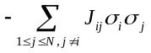, and the total loss of the i-th spin is then given by 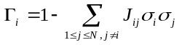 (19). Accordingly, the global loss of the N-spin oscillation network can be expressed as
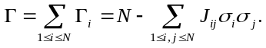 (S2)
Noted that 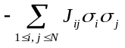 is the Hamiltonian of the N-spin Ising model without external field, so that we can conclude that the potential phase configurations in an N-spin oscillation network under the given interaction matrix J corresponds to the global loss and maps onto the Ising energy landscape of a given Ising model. Based on the minimum-loss principle, the oscillation network most likely operates at this state. To solve an Ising problem, one can program the corresponding matrix J into the oscillation network, and then gradually increase the cavity gain to search the minimum-loss state. As the cavity gain exceeds its loss, oscillation starts with an increase in amplitude and adjustment of phase. When the oscillation network runs stably, one can measure the corresponding phase configuration, from which the given problems can be solved.

- Other experimental results
The temporal waveforms of the oscillating microwave pulses and the demodulated baseband pulses are shown in Fig. S2A. The microwave pulse lasts several periods. In the non-interaction oscillation, 100 tests are performed. The ratios between the numbers of the positive and negative pulses are calculated and the results fall into the range from 0.97 to 1.02, as shown in Fig. S2B. The power spectrum of the non-interaction oscillation is also measured by an electrical spectrum analyzer (ESA, Keysight N9030A) and the results are shown in Fig. S3C. One can find that the power spectrum is actually a microwave frequency comb whose frequency spacing equals to the FSR of the optoelectronic cavity. Clear comb line under high-resolution bandwidth (RBW) suggests the microwave signal is highly stable, which corresponds to high spin coherence.
The temporal waveform of the demodulated baseband pulses in the 1D positive coupling Ising simulation is shown in Fig. S3A. Since the energy couplings are positive, all the spins share the same value. The period of the signal is 10 ns, which equals to the interval of two neighboring spins. This results in a much sparser comb line in the frequency domain, as shown in Fig. S3B and C.

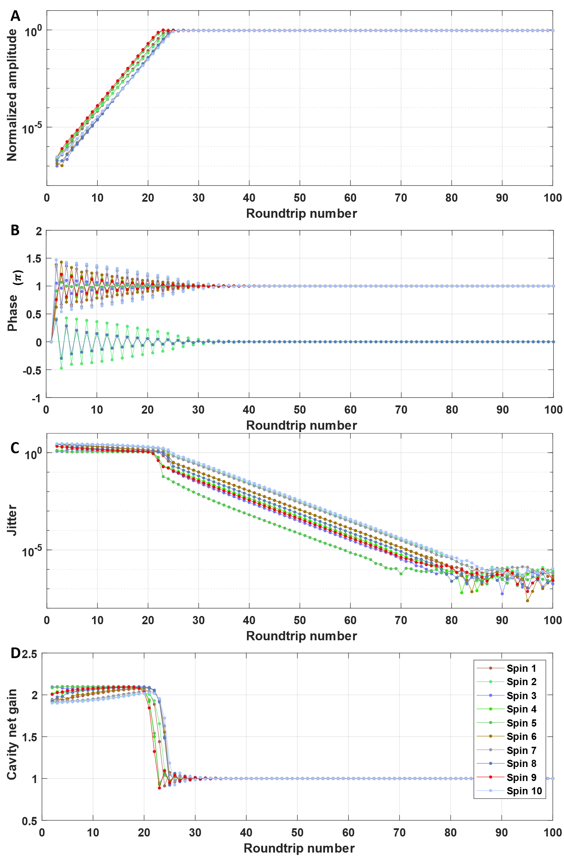

Fig. S1. Simulation of the Ising spin of the proposed microwave photonics Ising machine. (A) Spin amplitude evolution. (B) Spin phase evolution. (C) Jitter of the spin as a function of round-trip number. (D) Cavity net gain as a function of roundtrip number.

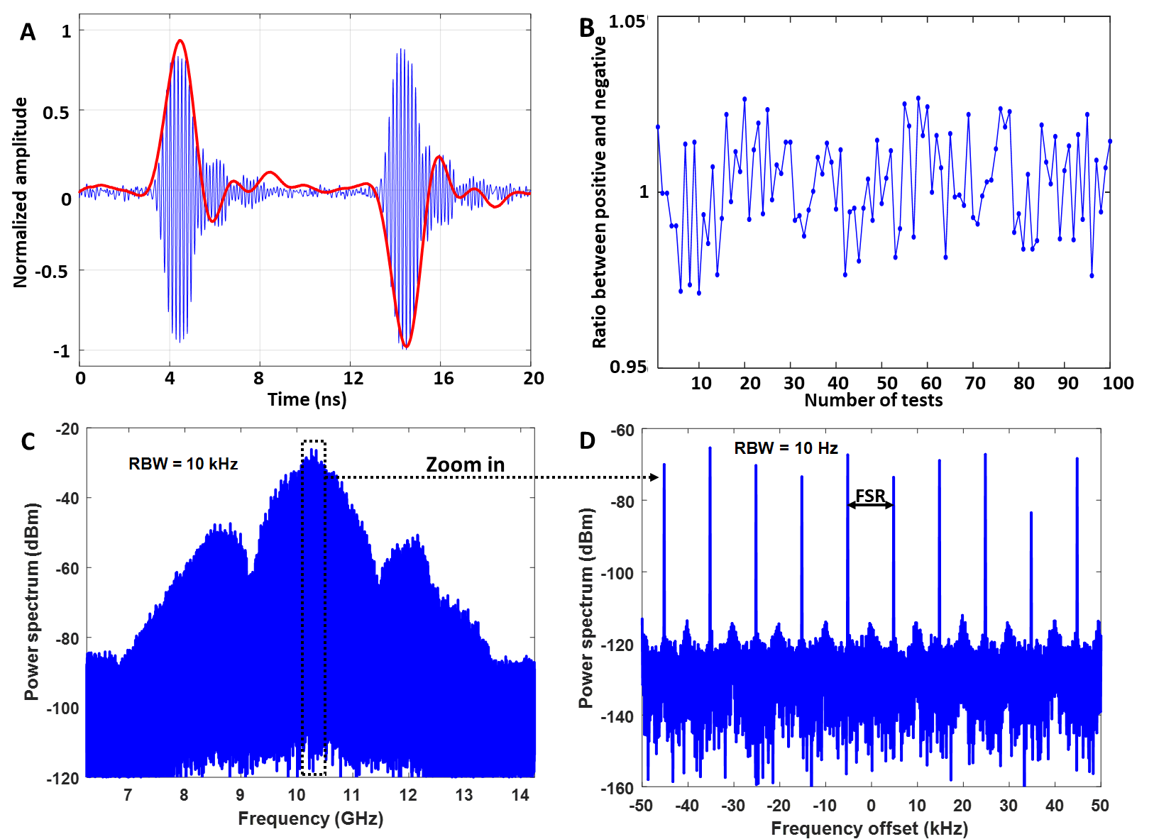

Fig. S2. Experimental results of non-interaction oscillation. (A) The temporal waveforms of the short microwave pulses and the demodulated baseband pulses; (B) The ratios between the positive and negative pulses in 100 non-interaction tests; (C) 6-GHz span power spectrum in 100-kHz resolution bandwidth (RBW); (D) Detail of power spectrum in 10-Hz RBW.

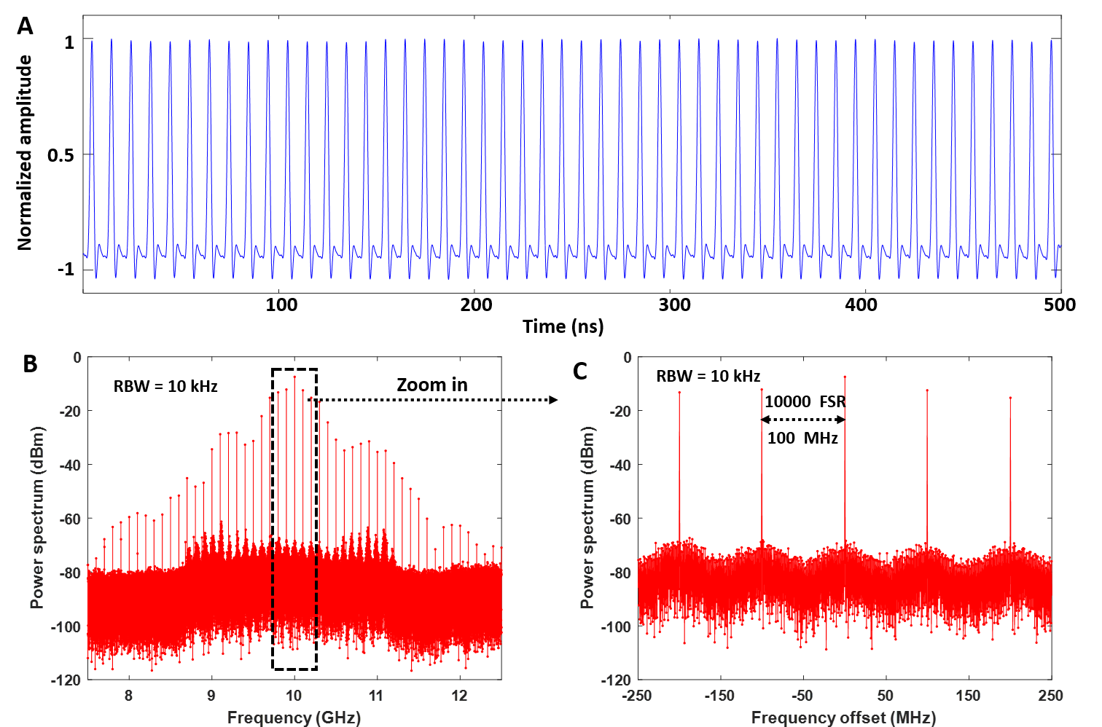

Fig. S3. Temporal waveform and spectrum of the 1D Ising simulator. (A) The temporal waveform of the demodulated baseband pulse; (B) 5-GHz span power spectrum in 10-kHz RBW. (C) Detail of power spectrum.

