SUPPLEMENTARY DATA

Cangrelor in critically ill patients with cardiogenic shock or post-cardiac arrest: a systematic review and meta-analysis

Running Title: Cangrelor in cardiogenic shock or arrest

Hendrianus Hendrianus^{1,2,3}, Young-Hoon Jeong^{2,3,4}*, Sang Yeub Lee^{2,3}, Jun Hwan Cho^{2,3}, Jinhwan Jo^{2,3}, Diana A. Gorog^{5,6}, Jacek Kubica⁷, Udaya S. Tantry⁸, Paul A. Gurbel⁸, Sang-Wook Kim^{2,3}

¹Division of Cardiology, Natuna General Hospital, Natuna, Indonesia
²Heart and Brain Hospital, Chung-Ang University Gwangmyeong Hospital, Gwangmyeong, South Korea
³Department of Internal Medicine, Chung-Ang University College of Medicine, Seoul, South Korea
⁴CAU Thrombosis and Biomarker Center, Chung-Ang University Gwangmyeong Hospital, Gwangmyeong, South Korea
⁵Cardiovascular Division, Faculty of Medicine, National Heart and Lung Institute, Imperial College London, London, United Kingdom
⁶Centre for Health Services and Clinical Research, Postgraduate Medical School, University of Hertfordshire, Hertfordshire, United Kingdom
⁷Department of Cardiology and Internal Medicine, Collegium Medicum, Nicolaus Copernicus University, Bydgoszcz, Poland
⁸Sinai Center for Thrombosis Research and Drug Development, Sinai Hospital, Baltimore, Maryland, USA

TABLE OF CONTENTS

- Supplementary Table 1. PRISMA checklist.
- Supplementary Table 2. Search strategy.
- Supplementary Table 3. Reported endpoints across included studies.
- Supplementary Table 4. Major bleeding endpoint definition across included studies.
- Supplementary Table 5. Risk of bias assessment for the randomized controlled trial using the Cochrane RoB 2.0 tool.
- Supplementary Table 6. Quality assessment of observational studies using the Newcastle-Ottawa Scale.

- Supplementary Fig. 1. Funnel plots for all-cause mortality and major bleeding.
- Supplementary Fig. 2. Forest plot of post-PCI TIMI grade 3 flow achievement.
- Supplementary Fig. 3. Forest plot of minor bleeding.
- Supplementary Fig. 4. Forest plots of outcomes in cardiogenic shock patients with mechanical circulatory support.
- Supplementary Fig. 5. Forest plots of outcomes in out-of-hospital cardiac arrest.
- Supplementary Fig. 6. Forest plots of outcomes in cardiac arrest with targeted temperature management.
- Supplementary Fig. 7. Sensitivity analysis of all-cause mortality stratified by study design.
- Supplementary Fig. 8. Sensitivity analysis of major bleeding stratified by study design.
- Supplementary Fig. 9. Leave-one-out sensitivity analysis.
- Supplementary Fig. 10. Meta-regression of all-cause mortality by age, STEMI proportion, and MCS utilization.
- Supplementary Fig. 11. Meta-regression of major bleeding by age, STEMI proportion, and MCS utilization.
SUPPLEMENTARY TABLES

Supplementary Table 1. PRISMA checklist
Section and Topic | Item # | Checklist item | Location where item is reported
TITLE
Title | 1 | Identify the report as a systematic review. | 1
ABSTRACT
Abstract | 2 | See the PRISMA 2020 for Abstracts checklist. | 2
INTRODUCTION
Rationale | 3 | Describe the rationale for the review in the context of existing knowledge. | 3
Objectives | 4 | Provide an explicit statement of the objective(s) or question(s) the review addresses. | 3
METHODS
Eligibility criteria | 5 | Specify the inclusion and exclusion criteria for the review and how studies were grouped for the syntheses. | 4
Information sources | 6 | Specify all databases, registers, websites, organisations, reference lists and other sources searched or consulted to identify studies. Specify the date when each source was last searched or consulted. | 4,5
Search strategy | 7 | Present the full search strategies for all databases, registers and websites, including any filters and limits used. | Table S2
Selection process | 8 | Specify the methods used to decide whether a study met the inclusion criteria of the review, including how many reviewers screened each record and each report retrieved, whether they worked independently, and if applicable, details of automation tools used in the process. | 4,5
Data collection process | 9 | Specify the methods used to collect data from reports, including how many reviewers collected data from each report, whether they worked independently, any processes for obtaining or confirming data from study investigators, and if applicable, details of automation tools used in the process. | 4,5
Data items | 10a | List and define all outcomes for which data were sought. Specify whether all results that were compatible with each outcome domain in each study were sought (e.g. for all measures, time points, analyses), and if not, the methods used to decide which results to collect. | 4,5
Data items | 10b | List and define all other variables for which data were sought (e.g. participant and intervention characteristics, funding sources). Describe any assumptions made about any missing or unclear information. | 4,5
Study risk of bias assessment | 11 | Specify the methods used to assess risk of bias in the included studies, including details of the tool(s) used, how many reviewers assessed each study and whether they worked independently, and if applicable, details of automation tools used in the process. | 5
Effect measures | 12 | Specify for each outcome the effect measure(s) (e.g. risk ratio, mean difference) used in the synthesis or presentation of results. | 5,6
Synthesis methods | 13a | Describe the processes used to decide which studies were eligible for each synthesis (e.g. tabulating the study intervention characteristics and comparing against the planned groups for each synthesis (item #5)). | 4
Synthesis methods | 13b | Describe any methods required to prepare the data for presentation or synthesis, such as handling of missing summary statistics, or data conversions. | 5,6
Synthesis methods | 13c | Describe any methods used to tabulate or visually display results of individual studies and syntheses. | 5,6
Synthesis methods | 13d | Describe any methods used to synthesize results and provide a rationale for the choice(s). If meta-analysis was performed, describe the model(s), method(s) to identify the presence and extent of statistical heterogeneity, and software package(s) used. | 5,6
Synthesis methods | 13e | Describe any methods used to explore possible causes of heterogeneity among study results (e.g. subgroup analysis, meta-regression). | 6
Synthesis methods | 13f | Describe any sensitivity analyses conducted to assess robustness of the synthesized results. | 6
Reporting bias assessment | 14 | Describe any methods used to assess risk of bias due to missing results in a synthesis (arising from reporting biases). | 5
Certainty assessment | 15 | Describe any methods used to assess certainty (or confidence) in the body of evidence for an outcome. | 5
RESULTS
Study selection | 16a | Describe the results of the search and selection process, from the number of records identified in the search to the number of studies included in the review, ideally using a flow diagram. | 6
Study selection | 16b | Cite studies that might appear to meet the inclusion criteria, but which were excluded, and explain why they were excluded. | 6,7
Study characteristics | 17 | Cite each included study and present its characteristics. | 6,7
Risk of bias in studies | 18 | Present assessments of risk of bias for each included study. | 7, Supp Table 5 & 6
Results of individual studies | 19 | For all outcomes, present, for each study: (a) summary statistics for each group (where appropriate) and (b) an effect estimate and its precision (e.g. confidence/credible interval), ideally using structured tables or plots. | 7
Results of syntheses | 20a | For each synthesis, briefly summarise the characteristics and risk of bias among contributing studies. | 7 – 10
Results of syntheses | 20b | Present results of all statistical syntheses conducted. If meta-analysis was done, present for each the summary estimate and its precision (e.g. confidence/credible interval) and measures of statistical heterogeneity. If comparing groups, describe the direction of the effect. | 7 – 10
Results of syntheses | 20c | Present results of all investigations of possible causes of heterogeneity among study results. | 7 – 10, Supp Figure 10 & 11
Results of syntheses | 20d | Present results of all sensitivity analyses conducted to assess the robustness of the synthesized results. | 10, Supp Figure 7-9
Reporting biases | 21 | Present assessments of risk of bias due to missing results (arising from reporting biases) for each synthesis assessed. | 7
Certainty of evidence | 22 | Present assessments of certainty (or confidence) in the body of evidence for each outcome assessed. | 7 – 10
DISCUSSION
Discussion | 23a | Provide a general interpretation of the results in the context of other evidence. | 11
Discussion | 23b | Discuss any limitations of the evidence included in the review. | 13 – 14
Discussion | 23c | Discuss any limitations of the review processes used. | 13 – 14
Discussion | 23d | Discuss implications of the results for practice, policy, and future research. | 13
OTHER INFORMATION
Registration and protocol | 24a | Provide registration information for the review, including register name and registration number, or state that the review was not registered. | 4
Registration and protocol | 24b | Indicate where the review protocol can be accessed, or state that a protocol was not prepared. | 4
Registration and protocol | 24c | Describe and explain any amendments to information provided at registration or in the protocol. | 4
Support | 25 | Describe sources of financial or non-financial support for the review, and the role of the funders or sponsors in the review. | 1
Competing interests | 26 | Declare any competing interests of review authors. | 1
Availability of data, code and other materials | 27 | Report which of the following are publicly available and where they can be found: template data collection forms; data extracted from included studies; data used for all analyses; analytic code; any other materials used in the review. | 1

Supplementary Table 2. Search strategy

A. Database Search
Database | Strategy
PubMed | (infarct* OR coronary OR angina) AND (shock OR hypotens* OR arrest OR coma* OR resuscitat*) AND cangrelor
Embase | (infarct* OR coronary OR 'angina'/exp OR angina) AND ('shock'/exp OR shock OR hypotens* OR 'arrest'/exp OR arrest OR coma* OR resuscitat*) AND ('cangrelor'/exp OR cangrelor)
Cochrane | (infarct* OR coronary OR angina) AND (shock OR hypotens* OR arrest OR coma* OR resuscitat*) AND cangrelor

B. Snowball Search
We screened the reference lists of all included studies identified through database searches to identify any additional eligible publications.

Supplementary Table 3. Available endpoints across included studies

 | All-cause death | Cardiovascular death | Stent thrombosis | Myocardial infarction | Stroke | Major bleeding
Kordis 2024 | x |  | x
DAPT-SHOCK-AMI 2025 | x | x | x | x | x | x
Emilsson 2025 | x |  | x | x | x | x
Droppa 2019 | x |  | x |  | x | x
Zeymer 2023 |  | x | x
Abusnina 2025 | x | x
Cohan 2023 | x | x |  |  | x | x
Ferlini 2025 | x |  |  |  |  | x
Fiore 2018 |  |  | x |  |  | x
Gelbenegger 2025 |  | x | x | x | x | x
Prüller 2018 | x |  |  |  |  | x
Spahr 2023 | x | x |  | x | x | x

The table shows the availability of the prespecified endpoints (rows) for each trial (columns), which is shown if available.

Supplementary Table 4. Major bleeding definition across included studies

 | Major bleeding definition
DAPT-SHOCK-AMI 2025 | BARC bleeding type 3 or 5
Emilsson 2025 | Criteria used was not mentioned
Droppa 2019 | GUSTO moderate severe
Cohan 2023 | BARC bleeding type 3 or 5
Ferlini 2025 | BARC bleeding type 3 or 5
Fiore 2018 | Criteria used was not mentioned
Gelbenegger 2025 | BARC bleeding type 3 or 5
Prüller 2018 | BARC bleeding type 3 or 5
Spahr 2023 | BARC bleeding type 3 or 5

Abbreviations: BARC, Bleeding Academic Research Consortium; GUSTO, Global Use of Strategies to Open Occluded Coronary Arteries; MI, Myocardial Infarction.

Supplementary Table 5. Critical appraisal according to the Cochrane Collaboration’s Tool for Assessing Risk Of Bias In Randomized Trials

 | D1 | D2 | D3 | D4 | D5
Kordis 2024 | Some concerns | Low | Low | Some concerns | Low
DAPT-SHOCK-AMI 2025 | Low | Low | Low | Low | Low
Domains:
D1: Bias arising from the randomization process.
D2: Bias due to deviations from intended intervention.
D3: Bias due to missing outcome data.
D4: Bias in measurement of the outcome.
D5: Bias in selection of the reported result.

Supplementary Table 6. Critical appraisal of non-randomized studies according to the Newcastle-Ottawa Scale

Studies | Selection |  |  |  | Comparability of Cohorts |  | Exposure of Outcome |  |  | Total
Studies | Representative of the exposed cohort | Selection of non-exposed | Ascertainment of exposure | Outcome not present at start | Main factor | Additional factor | Assessment of outcomes | Sufficient follow-up time | Adequacy of follow-up | Total
Emilsson 2025 | ✭ | ✭ | ✭ | ✭ | ✭ | ✭ | ✭ | ✭ | ✭ | 9
Droppa 2019 | ✭ | - | ✭ | ✭ | ✭ | ✭ | ✭ | ✭ | ✭ | 8
Zeymer 2023 | ✭ | - | ✭ | ✭ | ✭ | ✭ | - | ✭ | ✭ | 7
Abusnina 2025*
Cohan 2023 | ✭ | ✭ | ✭ | ✭ | - | - | ✭ | ✭ | ✭ | 7
Ferlini 2025 | ✭ | ✭ | ✭ | ✭ | ✭ | - | ✭ | ✭ | ✭ | 8
Fiore 2018 | ✭ | ✭ | ✭ | ✭ | - | - | ✭ | ✭ | ✭ | 7
Gelbenegger 2025 | ✭ | ✭ | ✭ | ✭ | ✭ | - | ✭ | ✭ | ✭ | 8
Prüller 2018 | ✭ | ✭ | ✭ | ✭ | - | - | ✭ | ✭ | ✭ | 7
Spahr 2023*

*These studies were not amenable to full appraisal because only conference abstracts were available.

SUPPLEMENTARY FIGURES

Supplementary Fig. 1. Funnel plots for (a) all-cause mortality and (b) major bleeding

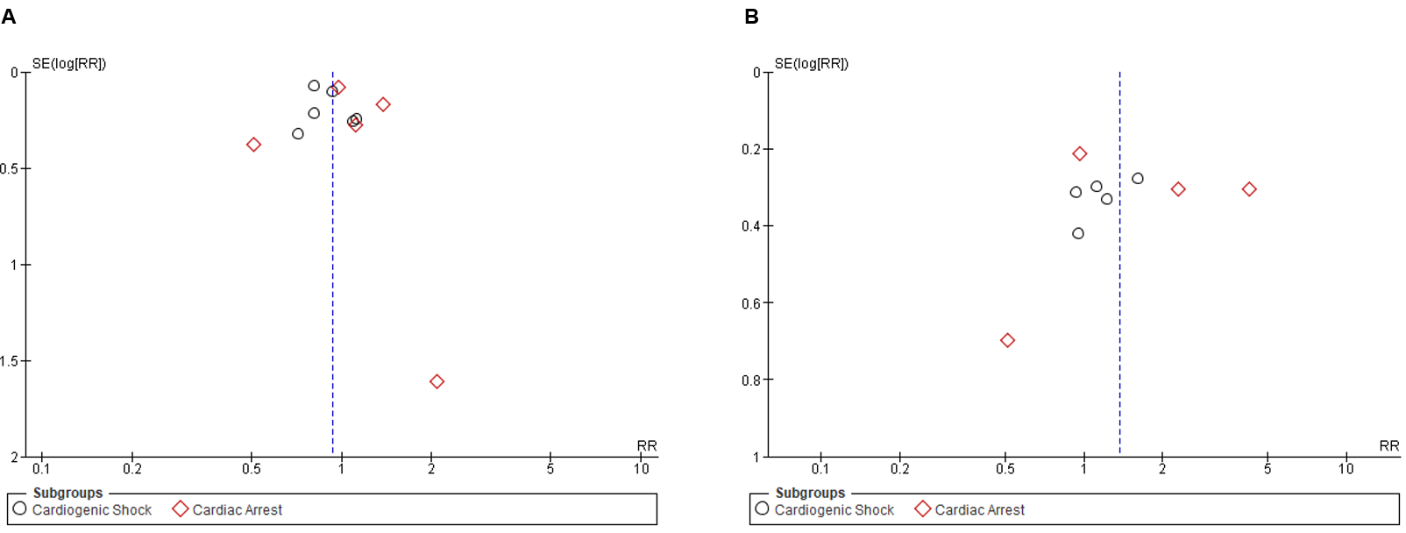

Supplementary Fig. 2. Forest plot of post-PCI TIMI grade 3 flow

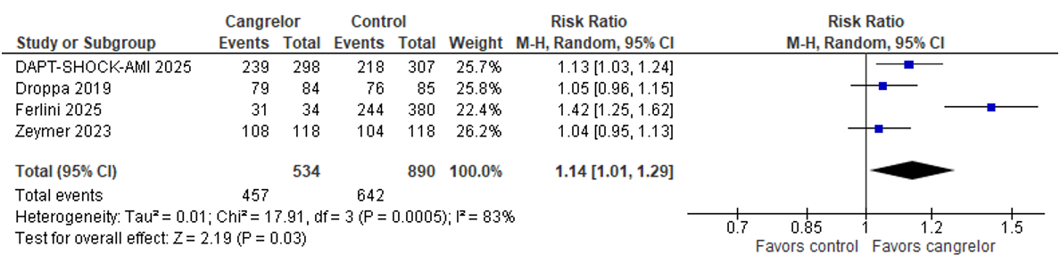

Supplementary Fig. 3. Forest plot of minor bleeding

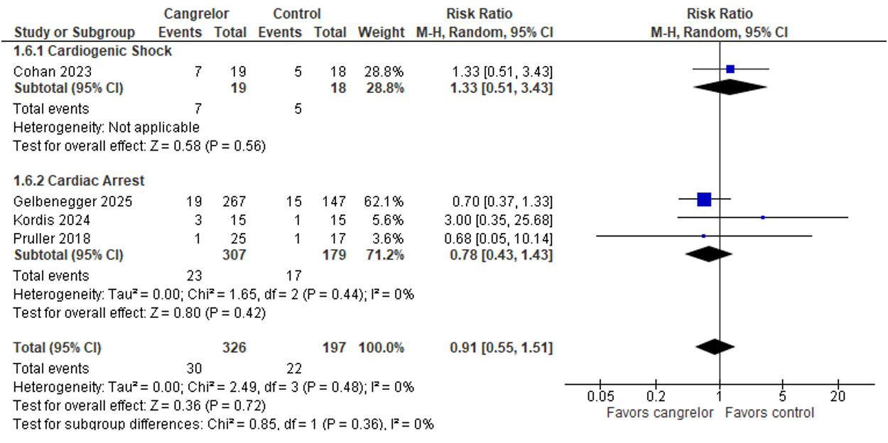
Supplementary Fig. 4. Forest plots of outcomes in cardiogenic shock with mechanical circulatory support devices (MCSD): (a) all-cause mortality; (b) access/cannula-site bleeding; and (c) major bleeding (BARC type 3 or 5)

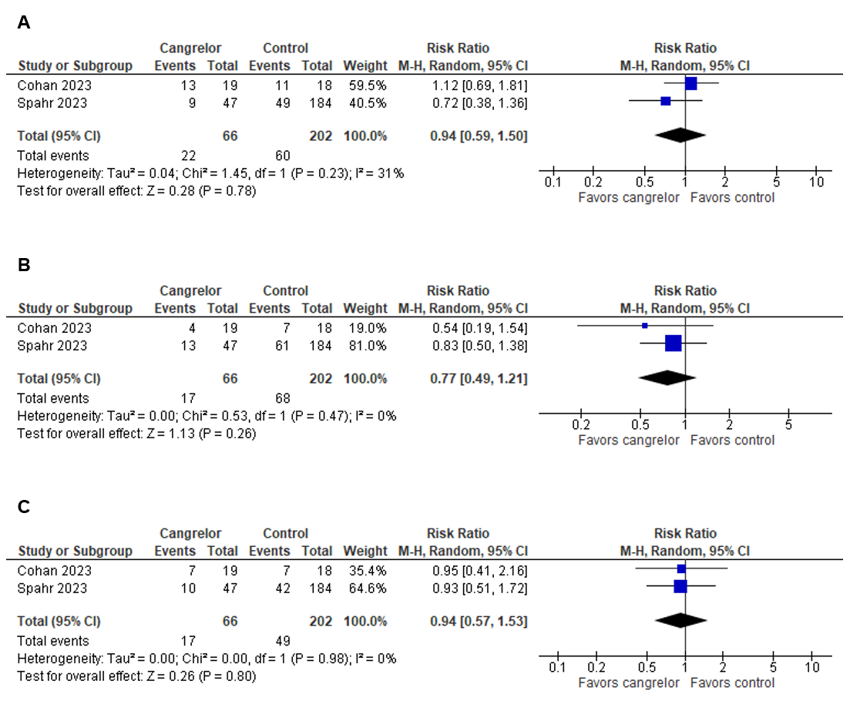

Supplementary Fig. 5. Forest plots of outcomes in out-of-hospital cardiac arrest (OHCA): (a) all-cause mortality; (b) stent thrombosis; and (c) major bleeding

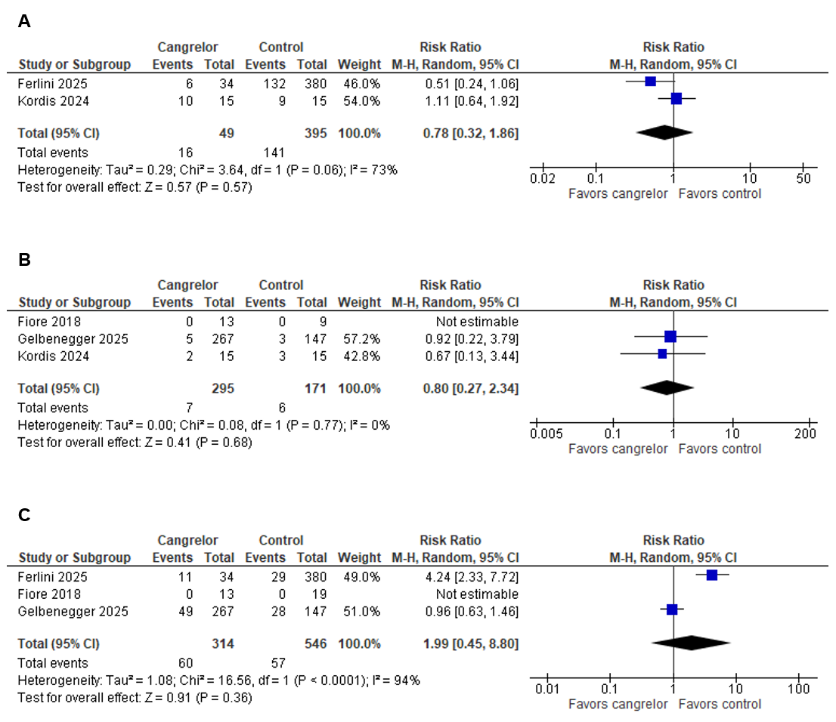

Supplementary Fig. 6. Forest plots of outcomes in cardiac arrest with targeted temperature management (TTM): (a) all-cause mortality; (b) stent thrombosis; and (c) major bleeding

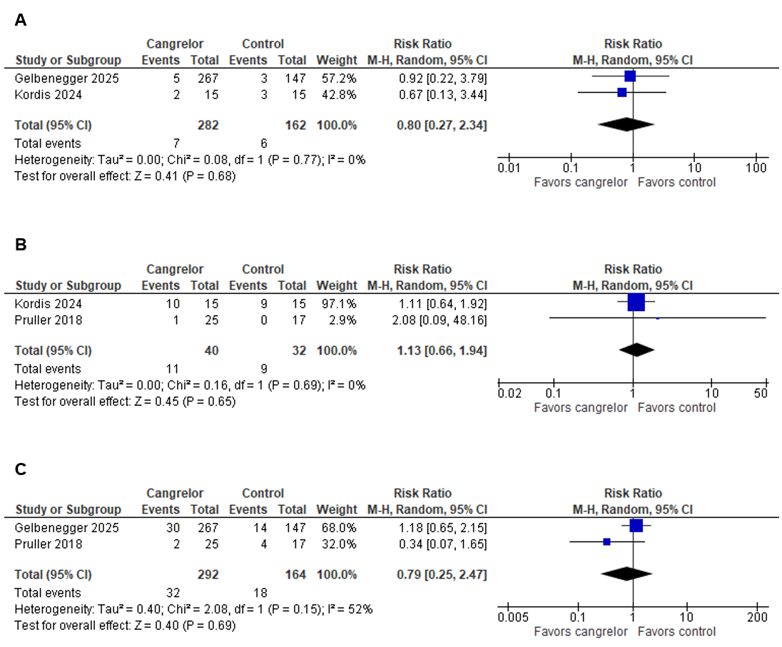

Supplementary Fig. 7. Sensitivity analysis of all-cause mortality stratified by study design (randomized controlled trials vs. observational studies)

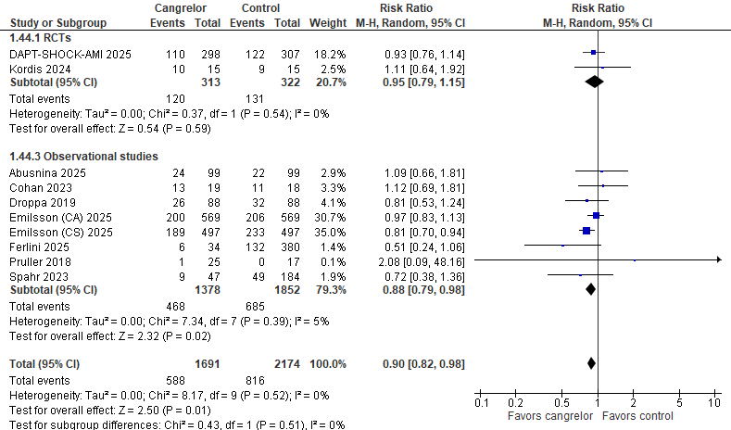
Supplementary Fig. 8. Sensitivity analysis of major bleeding stratified by study design (randomized controlled trials vs. observational studies)

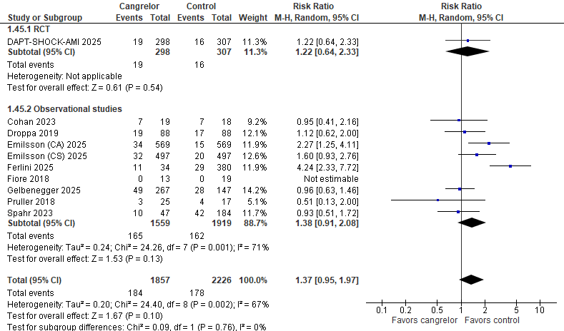
Supplementary Fig. 9. Leave-one-out sensitivity analysis
This analysis indicated that the Emilsson 2025 (CS cohort) study contributed substantially to the pooled mortality estimate. When this study was excluded, the risk ratio for all-cause mortality shifted from 0.90 (0.82–0.98) to 0.94 (0.85–1.05) in the overall cohort and from 0.86 (0.78–0.96) to 0.93 (0.80–1.09) in the CS subgroup. This suggests the overall mortality signal was driven significantly by this large, real-world cohort, providing important context for the interpretation of the pooled results.

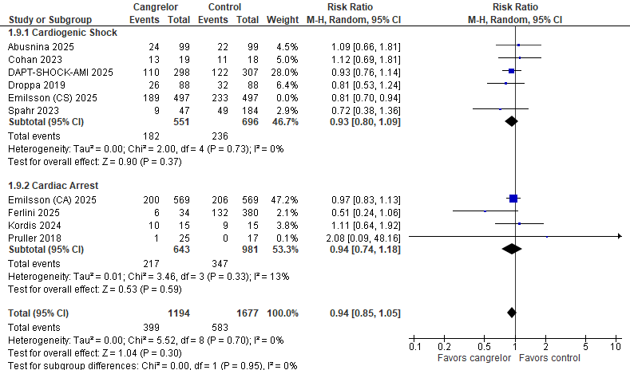

Supplementary Fig. 10. Meta-regression of all-cause mortality by age, STEMI proportion, and mechanical circulatory support (MCS) utilization

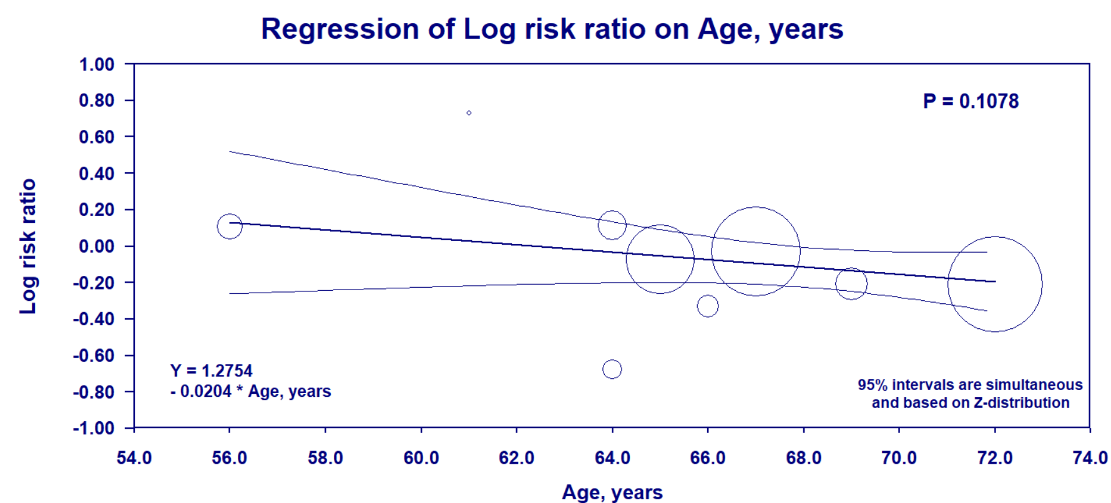
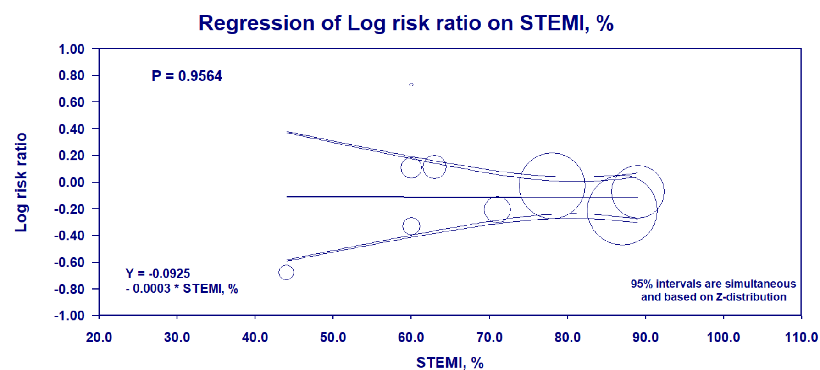
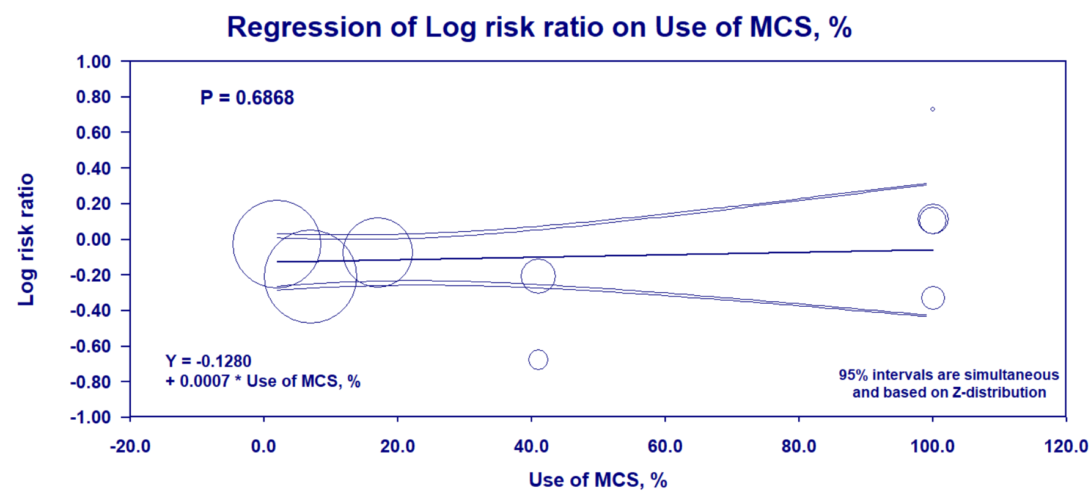
Supplementary Fig. 11. Meta-regression of major bleeding by age, STEMI proportion, diabetes proportion and MCS utilization
