Supplementary information
Supplementary Table S1 Primers used in this study
name | sequence | application
TcpanD-NcoI | GCTAACAGGAGGAATTAACCATGCCAGCAACCGGTGAGGATCAGGA | pXB1K/ pSB1K/ pLB1K / pAB1K -TcpanD
TcpanD-XhoI | GTACCAGATCTACCCTCGAGTTAAAGGTCGCTGCCCAGACGTTC | pXB1K/ pSB1K/ pLB1K / pAB1K -TcpanD
AspA- NcoI | GCTAACAGGAGGAATTAACCATGTCAAACAACATTCGTATCGAA | pSB1a-aspA
AspA- XhoI | GTACCAGATCTACCCTCGAGTTACTGTTCGCTTTCATCAGTATAG | pSB1a-aspA
AspC- NcoI | GCTAACAGGAGGAATTAACCATGTTTGAGAACATTACCGCCGCTC | pSB1a-aspC
AspC- XhoI | GTACCAGATCTACCCTCGAGTTACAGCACTGCCACAATCGCTT | pSB1a-aspC
RocG-aspC-FP | AGCGGCGGTAATGTTCTCAAACATAGGAGATGTCAGCAAAGCAAGTC | pSB1a-aspC-RocG
RocG- XhoI | GTACCAGATCTACCCTCGAGTTAGACCCATCCGCGGAAAC | pSB1a-aspC-RocG
icd-Lox71-F | AGGACGCAAACGCATATGCAACGTGGTGGCAGACGAGCAAACCAGTAGCGCTCGAAGGAGAGGTGATCTCGAGAATATCCTCCTT | icd-Knockout
icd-Lox66-R | GCAGCCTAACAAAAAACAACGGGAGCGTTACGCTCCCGTTAATAAATTTAACAAACTACGGCATAGCTTCATAACTTGGTATAGC | icd-Knockout
SucA-Lox71-F | ACAAGTCATTACCCGTAGGCCTGATAAGCGCAGCGCATCAGGCGTAACAAAGAAATGCAGGAAATCTCTCGAGAATATCCTCCTT | SucA-Knockout
SucA-Lox66-R | CATCGGCTACGGATTCAGGCAGGTCAGGGACCAGAATATCTACGCTACTCATTGTGTATCCTTTATTAGCTTCATAACTTGGTATAGC | SucA-Knockout
FumA-250F | TTCGCCAAAGCGTTTGGCAACGGCC | FumAC-Knockout
FumC-250R | GCAAAGAAAACTGGAGCGAGAGTAT | FumAC-Knockout
IclR-250F | CCATACCGCCGTCCAGCACCAGA | IclR-Knockout
IclR-250R | TATGATTACAACTAAAGAAATATCAT | IclR-Knockout
FadR-250F | ATGAGGAAAATTAACGGGTTTACG | FadR-Knockout
FadR-250R | GGAACGTGGATTTGCGCGGCGAC | FadR-Knockout
FadD-Lox71-F | TTCTGCATTCTTACGGTAAAGATAAAAATAAATAGTGACGCGCTTCGCAACCTTTTCGTTGGGTAATCTCGAGAATATCCTCCTT | FadD-promoter PCPA1
FadD-CPA1-R | ATAACGGTCAGGGTTGATCTCCGTCGGAACGTCCGCGGGATAACGGTTAAGCCAAACCTTCTTCAATATATCTCCTTCTTAAAAG | FadD-promoter PCPA1
FumB-250-F | CTACGGTTATTACATCCTGCCGAC | FumB-Knockout
FumB-250-R | CAGTAGCTGCACGACAATAATCAC | FumB-Knockout
AceB-Lox71-F | AATAAATTTTATTCATATTGTTATCAACAAGTTATCAAGTATTTTTAATTAAAATGGAAATTGTTTTCTCGAGAATATCCTCCTT | AceBAK-promoter P119
AceB-119-R | TTGCTTCTCCTGCTCGCCATACGGCCTTGTGAAAGCCAGTTCATCGGTTGTTGTTGCCTGTTCAGTCATGGCTAGTATTTCTCCTC | AceBAK-promoter P119
BtuE-Lox71-F | GTCACCGCAACGTTAGGTGCGCCGGTGTTTATCTGGTTATTGTTAAAAGCAGGACGTTAGCCGCAATCTCGAGAATATCCTCCTT | BtuE-promoter P119
BtuE-119-R | GAACTTCTCCAGCGTGGTCACTTCACCGTCGATATCTTTCACTACGGTCGTCAGAATGGAATCTTGCATGGCTAGTATTTCTCCTC | BtuE-promoter P119
gor-Lox71-F | AGCCATTGCTGGCACCTATTACGTCTCGCGCTACAATCGCGGTAATCAACGATAAGGACACTTTGTTCTCGAGAATATCCTCCTT | gor-promoter P119
gor-119-R | CGCGCGGTTGATGGAGGCGATACCGCCGCTGCCGCCGCCGATGGCGATGTAATCATAGTGTTTAGTCATGGCTAGTATTTCTCCTC | gor-promoter P119
AspC-200F | GAAAGACGTAGAAGGTATCGGTG | aspC-knockout
AspC-200R | TGATATTTATTCCGGGTCACGGAC | aspC-knockout
aceB-Nco1-F | GCTAACAGGAGGAATTAACCATGACTGAACAGGCAACAACAACC | aceBA overexpression
aceA-xho1-R | GTACCAGATCTACCCTCGAGTTAGAACTGCGATTCTTCAGTGGA | aceBA overexpression
glcB-Nco1-F | GCTAACAGGAGGAATTAACCATGAGTCAAACCATAACCCAGAGC | GlcB-aceA overexpression
GlcB-RBS-R | AATTTGTTGTGTACGGGTTTTCATCCTCCTTTAATGACTTTCTTTTTCGCGTAAACG | aspC-knockout
RBS-aceA-F | CGTTTACGCGAAAAAGAAAGTCATTAAAGGAGGATGAAAACCCGTACACAACAAATT | aspC-knockout
MaeA-200F | AAATCGAACCGTCAGGCACGTCATA | MaeA-Knockout
MaeA-200R | TAATGAGGTGACACCTGGACCCAC | MaeA-Knockout
BspanD- NcoI | GCTAACAGGAGGAATTAACCATGGGTCACCACCACCACCACCACA | pSL91k-BspanD
BspanD- XhoI | GTACCAGATCTACCCTCGAGTTACAGGATGGTGCGAGCCGGTT | pSL91k-BspanD
MaeB-200F | TTCATAGGAAATACTCCTTGAA | MaeB-Knockout
MaeB-200R | GGCACAAATTCCTGAATGATGCG | MaeB-Knockout
ptsG-200F | ATCCGTTGAATGAGTTTTTTTAAAG | ptsG-Knockout
ptsG-200R | CCGAGCAAGGTAGCTACGCGCT | ptsG-Knockout
galR-200F | ACCCGAAGTTGACTTCACCTATCAA | galR-Knockout
galR-200R | CACGCGCCAACGGTGGAAACCGT | galR-Knockout
glk- NcoI | GCTAACAGGAGGAATTAACCATGACAAAGTATGCATTAGTCGGT | pSL91k-glk
glk- XhoI | GTACCAGATCTACCCTCGAGTTACAGAATGTGACCTAAGGTC | pSL91k-glk

Supplementary Table S2 cell growth of icd knockout strains at fed-batch level
OD600  Strains | 0h | 13h | 21.4h
BA72 | 0.01 | 31 | 68
BA93 (totally 29 g/l L-glutamate) icd knockout | 0.01 | 25.4 | 60.8

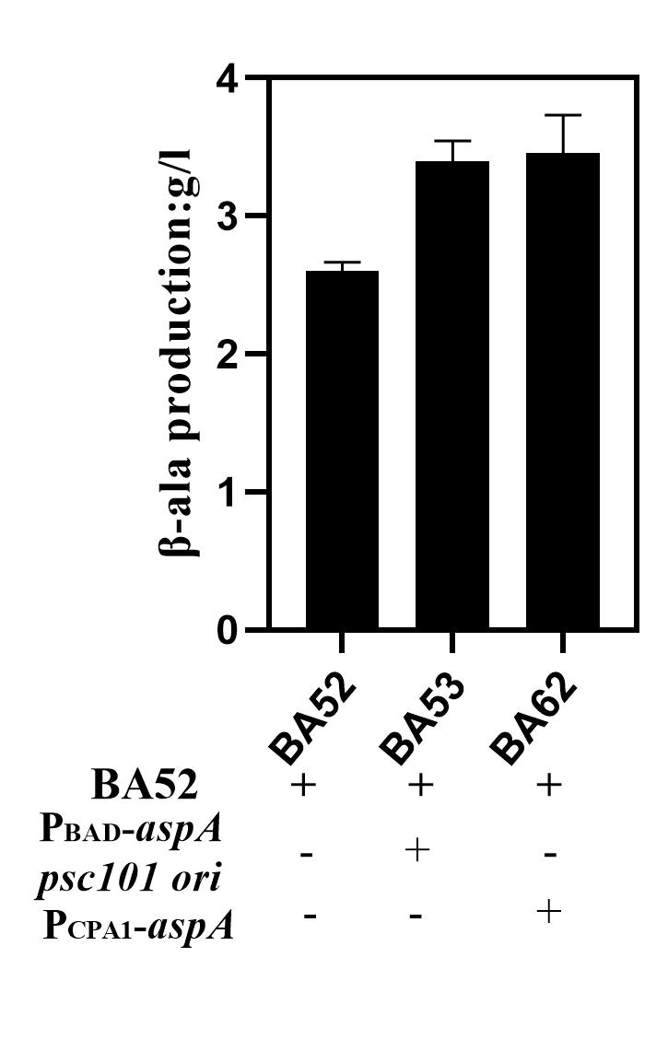
Supplementary Fig S1. β-alanine production with aspA overexpression. BA52: without-aspA expressed; BA53: plasmid pSB1a-aspA overexpression; BA62: chromosomal aspA expressed.
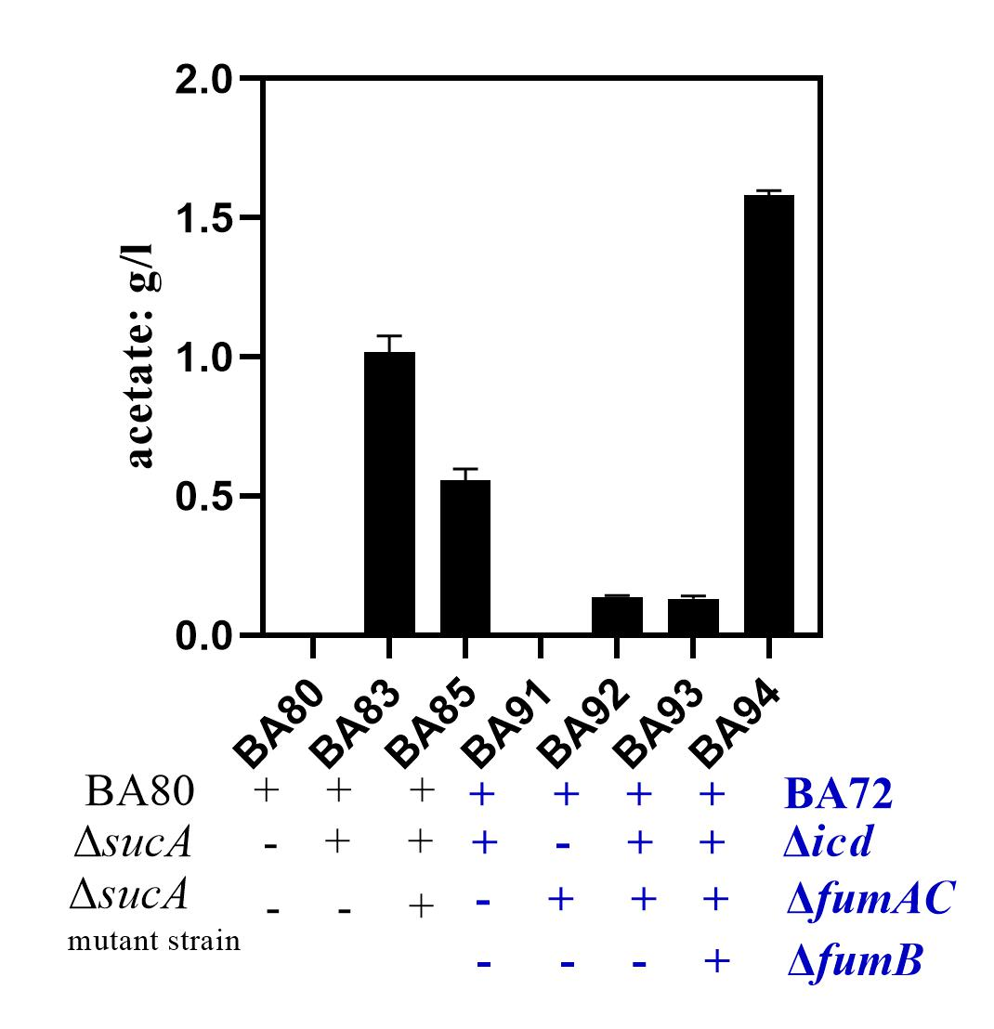
Supplementary Fig S2. Strains with the accumulation of by-product acetate bioconversion for 24 hrs. BA83: sucA knockout; BA85: sucA-knockout evolved strains; BA91: icd- knockout; BA92: fumAC- knockout; BA93: icd and - fumAC double knockout; BA94: icd and – fumACB triple knockout.

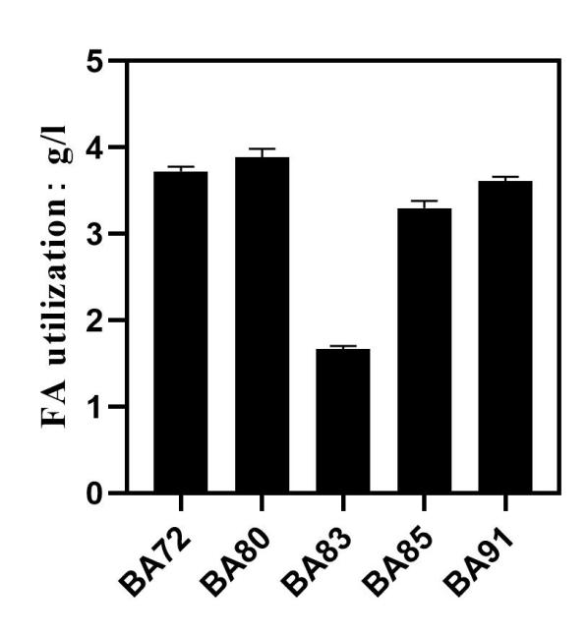
Supplementary Fig S3. Strains with FAs utilization for 3 hrs. BA72: WT without icd/sucA knockout with aspA overexpressed; BA80: WT without icd/sucA knockout with aspC-rocG overexpressed BA83: sucA-knockout; BA85: sucA-knockout evolved strains; BA91: icd- knockout.

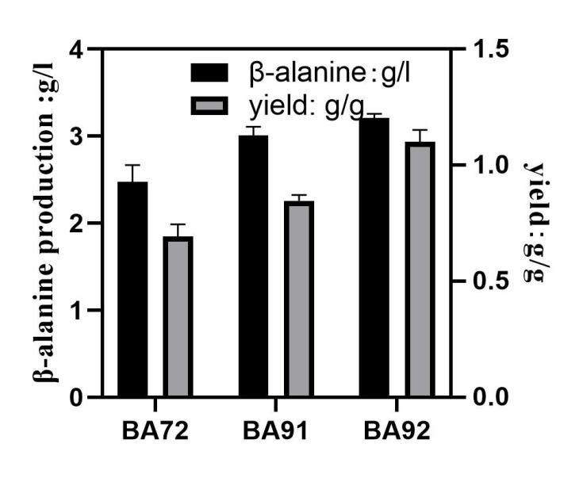
Supplementary Fig S4. Strains with ICD/fumAC single knockout for 3 hrs. BA72: WT without icd/fumAC knockout; BA91: icd- knockout; BA92: fumAC- knockout.

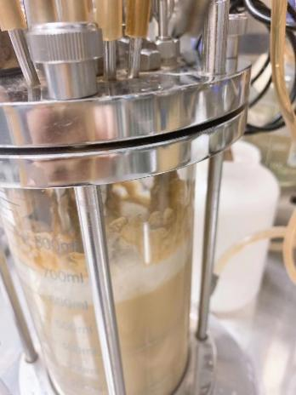
Supplementary Fig S5. Strains with BA93 at fed-batch level for insoluble oil-source accumulation

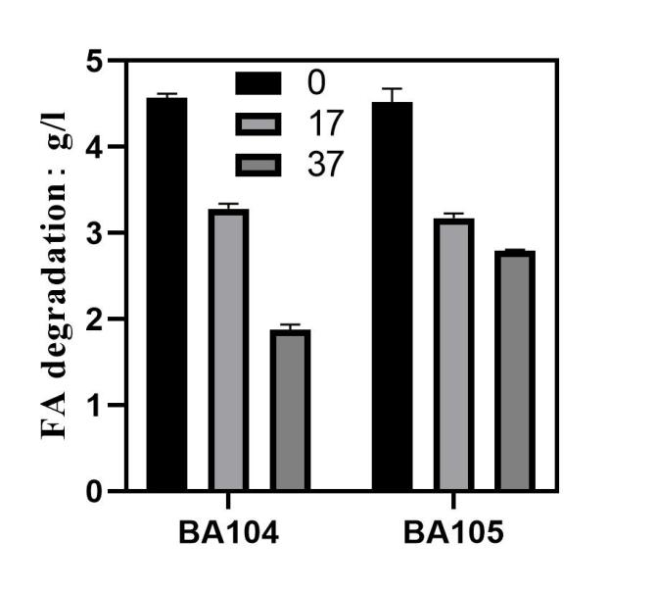
Supplementary Fig S6. BA104 and BA105 with FAs utilization at flask level for 3 hrs from fermenters at 0 h, 17 h, 37 h, 30 OD/ml (approximately).

