Supplementary material 1: The compositions of BG11 medium
 | Component | Quality(g) | Concentration of stock solution （g/L） |  | Volume(ml) |  | Concentration of work solution （mg/L）
stock1  (100ml) | C₆H₈O₇ | 0.6g | 6 | 1 |  | 6
stock1  (100ml) | C₆H₁₀FeNO₈ | 0.6g | 6 | 1 |  | 6
stock1  (100ml) | EDTANa₂ | 0.1g | 1 | 1 |  | 1
stock2  (100ml) | K₂HPO₄ | 4.0g | 40 | 1 |  | 40
stock2  (100ml) | Na₂CO₃ | 2.0 | 20 | 1 |  | 20
stock3  (100ml) | CaCl₂·2H₂O | 3.58g | 35.8 | 1 |  | 35.8
stock4  (100ml) | MgSO₄·7H₂O | 7.0g | 70 | 1 |  | 70
stock5  (1000ml) | H₃BO₄ | 2.86g | 2.86 | 1 |  | 2.86
stock5  (1000ml) | MnCl₂·4H₂O | 1.81g | 1.81 | 1 |  | 1.81
stock5  (1000ml) | ZnSO₄·7H₂O | 0.222g | 0.222 | 1 |  | 0.222
stock5  (1000ml) | Na₂MO₄·2H₂O | 0.391g | 0.391 | 1 |  | 0.391
stock5  (1000ml) | CuSO₄·5H₂O | 0.079g | 0.079 | 1 |  | 0.079
stock5  (1000ml) | Co(NO₃)₂·6H₂O | 0.049g | 0.049 | 1 |  | 0.049
stock6 | NaNO₃ |  |  |  |  | 1.5g/L
Adjust the pH to 7.1-7.5 by HCl and NaOH, and the medium must be autoclaved at 121ºC for 30min before use.
Supplementary material 2: The concentrations of Lindane in algal cells of M. aeruginosa (96h)
Lindane in the M.aeruginosa solution (μg/L) | Lindane in the M.aeruginosa cells (mean ± SD, μg/L)
0 | ND
50 | 0.767±0.063
89 | 1.142±0.108
158 | 2.437±0.156
281 | 3.490±0.074
500 | 5.353±0.428
(ND—not deteced)
Supplementary material 3:
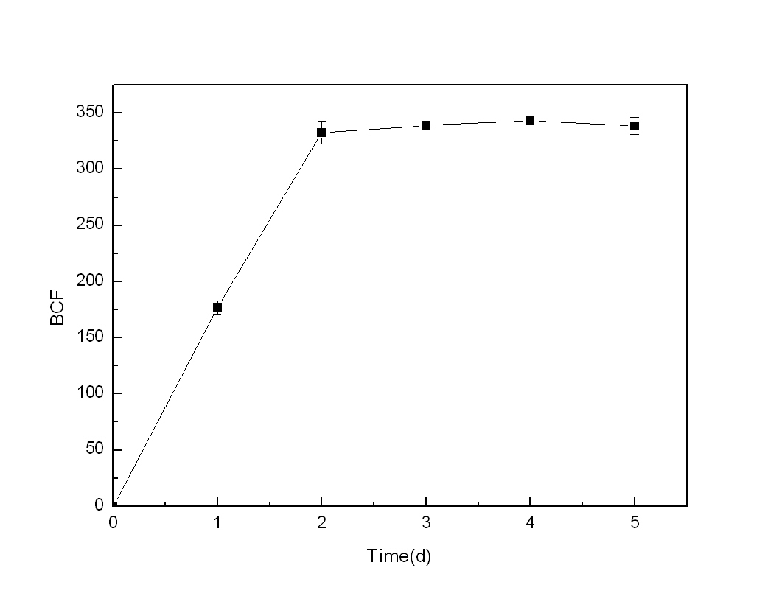
The BCF of Lindane in M. aeruginosa cells. Initial concentrations of Lindane and algal cells are 400 μg/L and 2.0 × 10⁴ cells/mL, respectively. Each value is the mean ± S.D.

