Supplement material
Figure:
Fig.1：The age-gender trend for KAP-related LRIs in Adults ≥55 Years in 2021. A, AB-related LRIs. B, PA-related LRIs. C, KP-related LRIs.
Fig.2：The district-age analysis for KAP-related LRIs in Adults ≥55 Years in 2021. A, AB-related LRIs. B, PA-related LRIs. C, KP-related LRIs.
Fig.3：The cases and ASR for Disability-adjusted life-years (DALYs) of KAP-related LRIs in people aged 55 years and older among 204 countries and territories in 1990 (per 100,000 population). A, B. The cases and ASR for DALYs of AB-related LRIs in 1990; C,D. The cases and ASR for DALYs of PA-related LRIs in 1990; E,F. The cases and ASR for DALYs of KP-related LRIs in 1990.
Fig.4：The estimated annual percentage change (EAPC) for Disability-adjusted life-years (DALYs) of KAP-related LRIs in people aged 55 years and older among 204 countries and territories from 1990 to 2021. A.The EAPC for DALYs of AB-related LRIs; B.The EAPC for DALYs of PA-related LRIs; C.The EAPC for DALYs of KP-related LRIs.

Table:
Table 1: The cases and ASR for DALYs of AB-related LRIs in people aged 55 years and older among 204 countries and territories in 1990 and 2021.
Table 2: The cases and ASR for DALYs of PA-related LRIs in people aged 55 years and older among 204 countries and territories in 1990 and 2021.
Table 3: The cases and ASR for DALYs of KP-related LRIs in people aged 55 years and older among 204 countries and territories in 1990 and 2021.

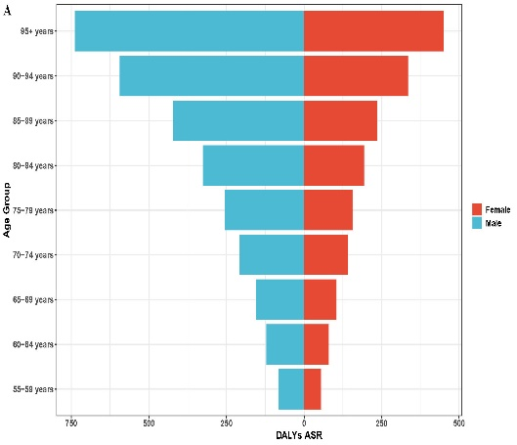 | 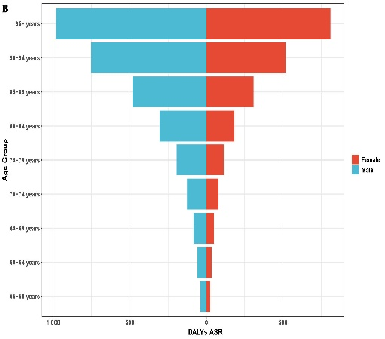 | 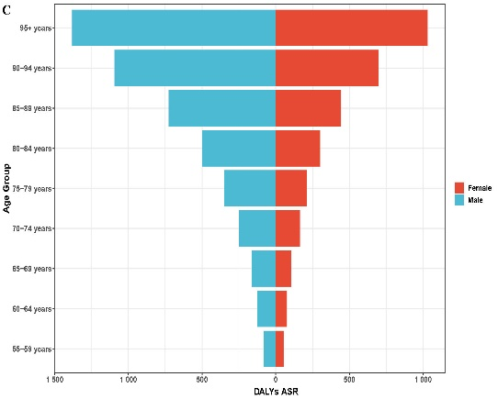
Fig.1：The age-gender trend for KAP-related LRIs in Adults ≥55 Years in 2021. A, AB-related LRIs. B, PA-related LRIs. C, KP-related LRIs.

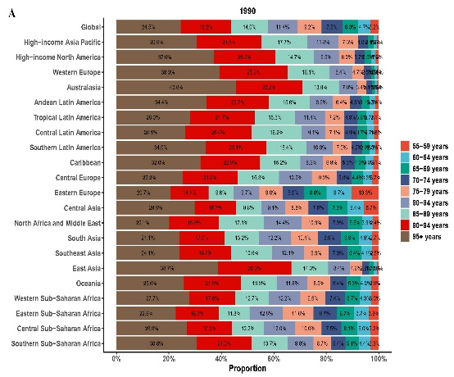 | 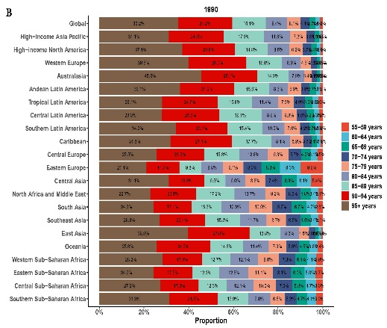 | 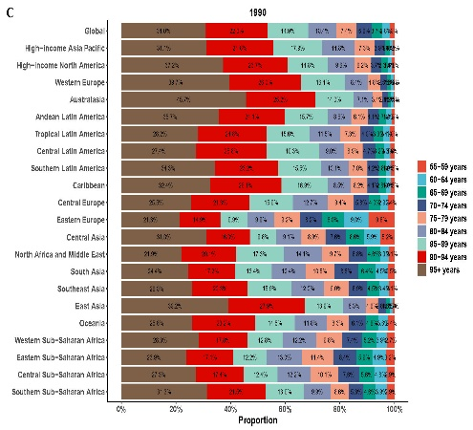
Fig.2：The district-age analysis for KAP-related LRIs in Adults ≥55 Years in 2021. A, AB-related LRIs. B, PA-related LRIs. C, KP-related LRIs.

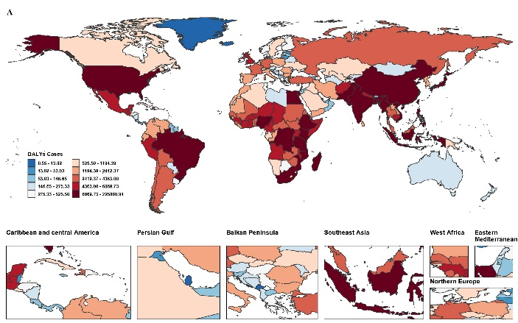 | 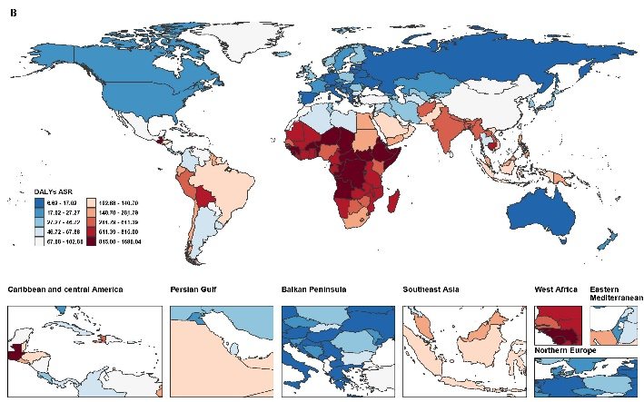
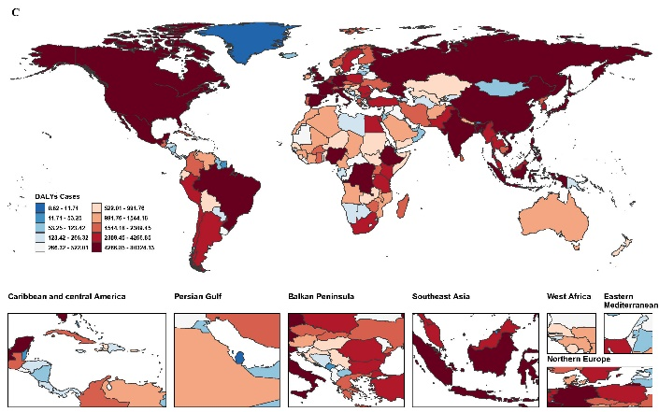 | 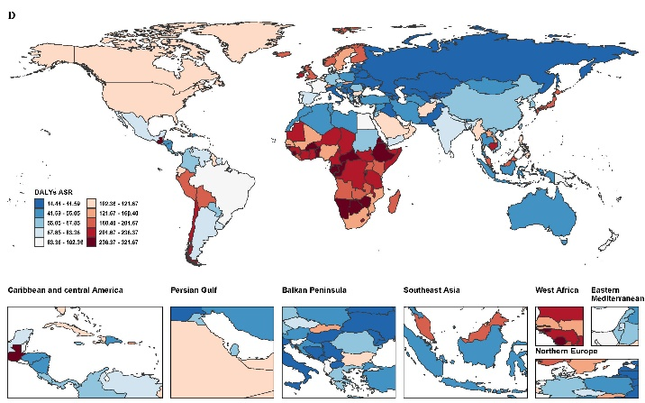
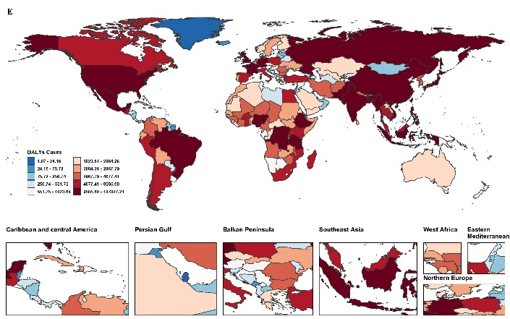 | 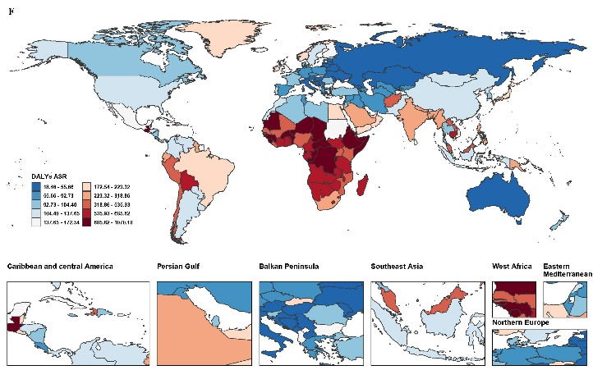
Fig.3：The cases and ASR for Disability-adjusted life-years (DALYs) of KAP-related LRIs in people aged 55 years and older among 204 countries and territories in 1990 (per 100,000 population). A, B. The cases and ASR for DALYs of AB-related LRIs in 1990; C,D. The cases and ASR for DALYs of PA-related LRIs in 1990; E,F. The cases and ASR for DALYs of KP-related LRIs in 1990.

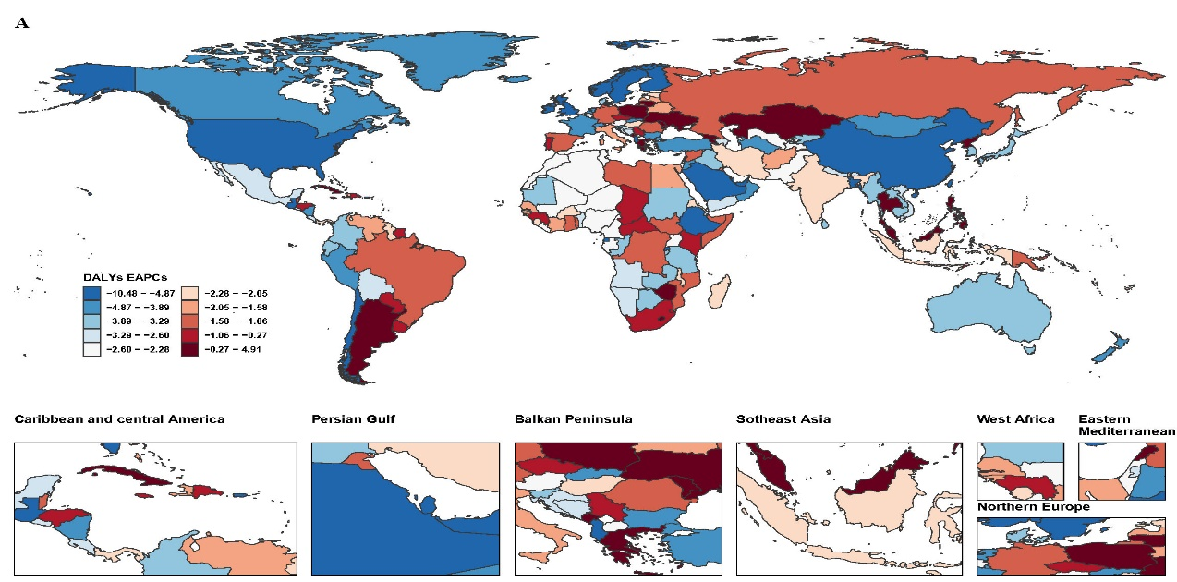
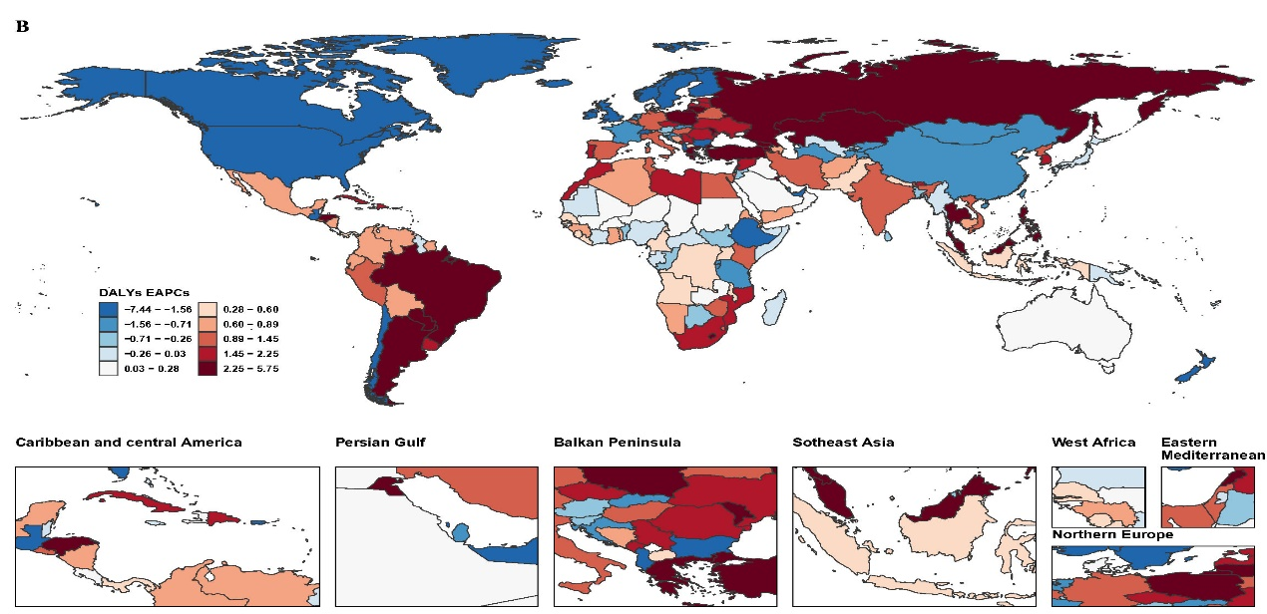
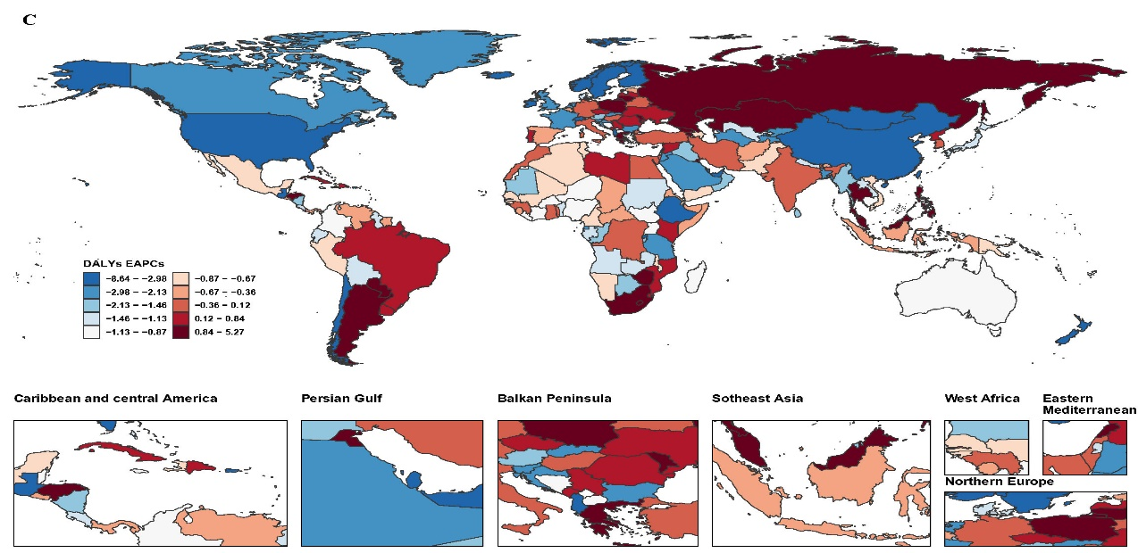
Fig.4：The estimated annual percentage change (EAPC) for Disability-adjusted life-years (DALYs) of KAP-related LRIs in people aged 55 years and older among 204 countries and territories from 1990 to 2021. A.The EAPC for DALYs of AB-related LRIs; B.The EAPC for DALYs of PA-related LRIs; C.The EAPC for DALYs of KP-related LRIs.

Table 1: The cases and ASR for DALYs of AB-related LRIs in people aged 55 years and older among 204 countries and territories in 1990 and 2021.
 | 1990 |  | 2021 |  | 1990-2021
 | DALYs cases (95% UI) | ASR of DALYs (per 100,000 population) | DALYs cases (95% UI) | ASR of DALYs (per 100,000 population) | EAPCs of ASR(95% CI)
Global | 863576.06(729944.09-1027773.17) | 128.62(108.72-153.07) | 951777.08(817985.69-1102615.61) | 64.05(55.05-74.20) | -2.40(-2.48,-2.32)
American Samoa | 6354.71(4685.57-8285.35) | 522.94(385.58-681.82) | 3325.75(2456.30-4380.04) | 270.66(199.90-356.46) | -1.95(-2.25,-1.65)
Antigua and Barbuda | 257.89(202.67-304.80) | 74.31(58.40-87.83) | 79.77(61.32-105.88) | 10.15(7.80-13.47) | -6.31(-6.86,-5.76)
Arab Republic of Egypt | 1194.39(900.67-1601.30) | 57.01(42.99-76.43) | 1466.08(1140.61-1916.41) | 24.14(18.78-31.55) | -2.57(-2.72,-2.41)
Argentine Republic | 3.65(3.01-4.35) | 99.79(82.28-118.96) | 6.12(4.89-7.77) | 72.49(57.93-91.98) | -1.40(-1.63,-1.17)
Australia | 0.82(0.57-1.10) | 8.36(5.77-11.10) | 0.89(0.60-1.20) | 3.35(2.25-4.55) | -2.22(-2.69,-1.75)
Barbados | 6280.70(4677.69-8383.03) | 1008.28(750.94-1345.78) | 8302.21(6178.06-10901.14) | 429.36(319.51-563.77) | -3.01(-3.17,-2.85)
Belize | 9.07(7.87-10.45) | 104.99(91.12-120.97) | 12.94(11.40-14.75) | 68.59(60.45-78.17) | -1.79(-2.06,-1.51)
Bermuda | 3520.88(3063.16-3951.46) | 63.27(55.05-71.01) | 10420.96(8922.87-11928.19) | 111.65(95.60-127.80) | 3.18(2.49,3.88)
Bolivarian Republic of Venezuela | 87.39(75.34-100.35) | 17.95(15.48-20.62) | 216.65(186.70-255.56) | 27.54(23.74-32.49) | 1.07(0.39,1.75)
Bosnia and Herzegovina | 275.33(233.11-322.90) | 8.39(7.10-9.84) | 248.00(194.73-292.68) | 3.35(2.63-3.95) | -3.29(-3.91,-2.66)
Brunei Darussalam | 222.17(187.27-255.67) | 11.42(9.62-13.14) | 148.93(121.14-173.81) | 5.04(4.10-5.88) | -2.45(-2.97,-1.92)
Burkina Faso | 310.81(249.90-386.57) | 35.63(28.65-44.32) | 329.32(240.70-446.77) | 17.19(12.56-23.32) | -2.70(-3.53,-1.85)
Canada | 24.85(21.40-28.72) | 101.21(87.16-116.95) | 34.91(27.90-42.63) | 48.51(38.77-59.24) | -1.99(-2.23,-1.75)
Central African Republic | 19.79(16.36-23.75) | 70.53(58.30-84.64) | 16.43(13.27-20.47) | 10.12(8.17-12.61) | -6.95(-7.78,-6.11)
Commonwealth of Dominica | 21377.72(16945.09-26403.25) | 282.23(223.71-348.57) | 15985.07(12115.65-21890.92) | 68.41(51.85-93.69) | -4.90(-5.16,-4.65)
Commonwealth of the Bahamas | 34.31(29.60-39.22) | 73.18(63.13-83.66) | 36.88(27.78-45.86) | 40.47(30.48-50.33) | -1.94(-2.62,-1.26)
Cook Islands | 194.75(167.78-223.88) | 8.41(7.25-9.67) | 190.80(149.47-244.39) | 6.63(5.20-8.50) | -1.95(-2.81,-1.08)
Czech Republic | 617.57(522.84-713.49) | 23.55(19.94-27.21) | 418.50(329.82-492.99) | 11.07(8.72-13.04) | -2.41(-2.95,-1.86)
Democratic People's Republic of Korea | 18.70(16.14-21.69) | 121.47(104.87-140.91) | 52.44(43.64-61.87) | 104.70(87.12-123.52) | -1.19(-1.75,-0.63)
Democratic Republic of Sao Tome and Principe | 2770.76(2239.38-3430.29) | 866.07(699.97-1072.22) | 3085.03(2300.84-4088.83) | 373.01(278.19-494.38) | -2.60(-2.81,-2.39)
Democratic Republic of Timor-Leste | 3.78(3.26-4.28) | 35.70(30.78-40.50) | 2.95(2.33-3.72) | 12.68(10.00-15.98) | -4.05(-4.50,-3.59)
Democratic Republic of the Congo | 70.64(44.95-100.80) | 178.01(113.25-254.00) | 74.10(45.15-105.21) | 74.40(45.33-105.65) | -3.11(-3.44,-2.78)
Democratic Socialist Republic of Sri Lanka | 3402.03(2719.05-4260.40) | 648.83(518.57-812.54) | 2991.76(2259.34-3962.01) | 193.58(146.19-256.36) | -3.25(-3.58,-2.92)
Dominican Republic | 180.43(146.49-218.93) | 24.60(19.97-29.85) | 127.35(90.30-163.64) | 11.63(8.24-14.94) | -2.71(-3.28,-2.14)
Eastern Republic of Uruguay | 519.62(359.72-717.86) | 558.92(386.92-772.15) | 406.65(294.62-552.97) | 167.74(121.53-228.10) | -3.80(-4.30,-3.30)
Federal Democratic Republic of Ethiopia | 18575.79(16103.91-21372.85) | 125.69(108.97-144.62) | 29392.12(25355.97-33604.24) | 67.87(58.55-77.59) | -1.06(-1.52,-0.60)
Federal Democratic Republic of Nepal | 16.97(14.01-20.49) | 108.42(89.50-130.89) | 27.26(21.85-32.66) | 45.53(36.49-54.55) | -2.13(-2.50,-1.75)
Federal Republic of Germany | 1286.36(1117.32-1460.25) | 56.84(49.37-64.52) | 369.73(314.07-431.55) | 15.56(13.21-18.16) | -4.47(-4.82,-4.11)
Federal Republic of Nigeria | 6672.87(5326.09-8623.53) | 922.64(736.42-1192.35) | 6992.75(5404.16-8972.72) | 465.12(359.46-596.82) | -2.09(-2.33,-1.84)
Federal Republic of Somalia | 4814.95(3642.64-6375.89) | 1279.39(967.89-1694.15) | 3834.06(2791.70-5194.39) | 478.94(348.73-648.87) | -3.71(-3.94,-3.48)
Federated States of Micronesia | 92.30(72.08-123.16) | 233.85(182.62-312.05) | 146.70(113.46-183.17) | 191.40(148.03-238.98) | -1.49(-1.98,-0.99)
Federative Republic of Brazil | 5712.54(4496.86-7136.80) | 771.01(606.93-963.23) | 6074.63(4597.65-7673.76) | 279.45(211.50-353.01) | -3.30(-3.49,-3.11)
French Republic | 5144.21(3798.84-6755.45) | 694.75(513.05-912.35) | 6616.33(4572.72-9370.59) | 325.05(224.65-460.36) | -2.59(-3.02,-2.16)
Gabonese Republic | 1146.33(972.08-1315.34) | 21.00(17.81-24.09) | 686.57(561.67-794.19) | 5.59(4.58-6.47) | -4.83(-5.28,-4.38)
Georgia | 2865.47(2152.23-3765.38) | 1517.62(1139.88-1994.24) | 4218.30(2991.77-5796.31) | 1179.29(836.39-1620.44) | -0.96(-1.11,-0.80)
Grand Duchy of Luxembourg | 4641.56(3298.54-6423.27) | 1001.62(711.80-1386.10) | 7473.49(5667.48-9677.68) | 804.88(610.38-1042.27) | -0.95(-1.24,-0.67)
Greenland | 2567.91(2233.91-2918.81) | 152.70(132.83-173.56) | 804.86(681.07-927.69) | 17.97(15.21-20.72) | -6.94(-7.49,-6.40)
Grenada | 113185.00(90321.71-134791.89) | 78.86(62.93-93.92) | 45222.44(36877.22-56845.63) | 11.93(9.73-15.00) | -7.26(-7.75,-6.77)
Guam | 1938.99(1678.97-2208.70) | 67.35(58.32-76.72) | 2019.18(1639.32-2441.62) | 21.11(17.14-25.53) | -3.31(-3.74,-2.87)
Hashemite Kingdom of Jordan | 256.81(182.64-342.89) | 791.31(562.75-1056.51) | 352.94(250.41-491.07) | 436.64(309.80-607.53) | -2.34(-2.67,-2.02)
Hellenic Republic | 1631.38(1220.50-2147.84) | 916.44(685.63-1206.57) | 1647.60(1187.54-2159.47) | 379.17(273.29-496.97) | -3.32(-3.64,-3.01)
Hungary | 2.88(2.38-3.48) | 134.74(111.40-163.08) | 3.37(2.66-4.14) | 71.56(56.42-87.80) | -2.32(-2.70,-1.93)
Independent State of Papua New Guinea | 99.92(85.77-114.56) | 35.13(30.16-40.28) | 146.70(124.24-171.94) | 15.32(12.98-17.96) | -3.08(-3.47,-2.68)
Independent State of Samoa | 162.57(139.28-187.17) | 14.60(12.51-16.81) | 170.64(144.61-199.24) | 11.44(9.70-13.36) | -3.02(-4.11,-1.92)
Ireland | 1043.62(902.47-1180.23) | 61.58(53.25-69.64) | 2472.35(2079.90-2868.74) | 72.35(60.87-83.95) | -0.09(-0.47,0.30)
Islamic Republic of Afghanistan | 36.44(28.50-45.09) | 26.08(20.40-32.28) | 15.37(12.15-19.11) | 4.40(3.48-5.47) | -6.07(-6.26,-5.89)
Islamic Republic of Iran | 573.01(496.40-655.44) | 24.20(20.96-27.68) | 796.04(663.23-926.64) | 22.79(18.98-26.52) | -0.27(-0.77,0.24)
Islamic Republic of Mauritania | 4535.89(3561.17-5742.89) | 707.70(555.62-896.02) | 7579.43(5399.56-10317.30) | 422.68(301.12-575.36) | -1.80(-2.11,-1.48)
Islamic Republic of Pakistan | 1570.46(1144.68-2066.10) | 59.01(43.01-77.63) | 3295.18(2451.97-4351.62) | 58.47(43.51-77.21) | 0.27(0.09,0.45)
Jamaica | 25396.66(16133.45-38354.16) | 961.72(610.94-1452.40) | 37734.97(23964.64-55505.59) | 624.77(396.78-918.99) | -1.37(-1.64,-1.09)
Japan | 314.01(264.62-362.62) | 24.07(20.28-27.79) | 190.15(154.68-221.31) | 9.88(8.03-11.50) | -3.39(-3.92,-2.87)
Kingdom of Bahrain | 126.23(94.30-174.87) | 588.36(439.52-815.11) | 304.78(210.78-427.68) | 293.90(203.25-412.40) | -2.69(-3.07,-2.32)
Kingdom of Belgium | 11.51(9.70-13.74) | 117.20(98.77-139.99) | 14.18(11.28-17.37) | 94.01(74.77-115.13) | -0.64(-0.95,-0.33)
Kingdom of Bhutan | 438.82(359.78-549.40) | 71.77(58.85-89.86) | 777.81(591.29-1041.19) | 46.55(35.38-62.31) | -0.48(-0.83,-0.13)
Kingdom of Cambodia | 1910.34(1643.21-2191.34) | 222.17(191.11-254.85) | 1567.18(1229.63-1940.64) | 56.63(44.43-70.12) | -3.52(-4.05,-2.99)
Kingdom of Denmark | 7641.79(6320.13-9518.62) | 170.90(141.35-212.88) | 9243.80(7156.86-11512.42) | 83.53(64.68-104.04) | -1.83(-2.09,-1.58)
Kingdom of Eswatini | 727.15(591.06-873.55) | 148.71(120.88-178.65) | 547.97(418.38-687.26) | 53.59(40.91-67.21) | -3.06(-3.33,-2.80)
Kingdom of Lesotho | 433.08(316.92-581.18) | 1356.73(992.82-1820.68) | 222.36(157.36-309.62) | 281.12(198.95-391.45) | -5.80(-6.40,-5.19)
Kingdom of Morocco | 2971.07(1719.18-4840.62) | 1681.23(972.83-2739.14) | 3491.31(1990.92-5798.42) | 792.38(451.86-1316.00) | -2.22(-2.42,-2.02)
Kingdom of Norway | 42.24(36.86-48.52) | 11.78(10.28-13.54) | 50.06(41.84-58.79) | 11.44(9.56-13.44) | -2.07(-2.89,-1.24)
Kingdom of Saudi Arabia | 265.69(202.19-344.39) | 588.40(447.77-762.68) | 378.14(269.29-529.28) | 417.65(297.43-584.58) | -0.39(-1.30,0.52)
Kingdom of Spain | 50339.81(37131.05-65755.47) | 1566.76(1155.66-2046.56) | 21965.71(17830.75-27289.28) | 320.87(260.47-398.64) | -5.74(-5.98,-5.49)
Kingdom of Sweden | 79.31(63.64-99.67) | 140.70(112.90-176.83) | 102.31(73.62-136.46) | 74.82(53.84-99.79) | -1.98(-2.38,-1.58)
Kingdom of Thailand | 485.47(413.76-552.90) | 40.89(34.85-46.57) | 68.39(54.54-80.14) | 3.40(2.71-3.98) | -10.38(-11.54,-9.21)
Kingdom of Tonga | 3142.93(2641.77-3651.00) | 22.58(18.98-26.23) | 1437.85(1140.88-1673.81) | 6.50(5.16-7.57) | -4.52(-4.88,-4.16)
Kingdom of the Netherlands | 629.47(474.54-807.19) | 642.96(484.71-824.50) | 588.36(413.00-797.40) | 329.15(231.05-446.09) | -2.36(-2.54,-2.17)
Kyrgyz Republic | 470.49(354.55-603.81) | 849.60(640.24-1090.35) | 808.62(591.33-1066.80) | 522.91(382.39-689.86) | -1.47(-2.03,-0.92)
Lao People's Democratic Republic | 197.69(168.94-228.98) | 17.80(15.21-20.61) | 581.82(484.32-689.39) | 55.42(46.13-65.66) | 4.86(3.23,6.52)
Lebanese Republic | 3433.35(2908.48-3944.53) | 16.36(13.86-18.80) | 2481.99(2012.91-2880.16) | 7.88(6.39-9.14) | -1.29(-1.63,-0.94)
Malaysia | 6313.24(4771.02-8357.22) | 618.22(467.20-818.37) | 8754.12(6393.55-11363.63) | 321.00(234.44-416.68) | -1.34(-1.90,-0.79)
Mongolia | 327.67(280.69-378.59) | 12.26(10.50-14.16) | 646.78(517.63-750.33) | 17.60(14.08-20.41) | 1.72(1.42,2.03)
Montenegro | 4.89(3.87-5.85) | 88.71(70.26-106.11) | 2.51(1.99-3.24) | 18.52(14.63-23.85) | -4.82(-5.22,-4.41)
New Zealand | 26.14(22.23-30.26) | 216.76(184.33-250.90) | 23.55(19.75-27.41) | 117.23(98.31-136.46) | -1.81(-2.08,-1.54)
North Macedonia | 5.62(4.50-6.77) | 43.55(34.93-52.52) | 7.32(5.78-8.94) | 19.41(15.34-23.74) | -1.98(-2.63,-1.33)
Northern Mariana Islands | 4891.61(4267.32-5687.69) | 850.58(742.03-989.01) | 3210.47(2706.41-3884.86) | 175.36(147.83-212.20) | -5.58(-5.97,-5.19)
Palestine | 5341.33(3918.13-7212.85) | 965.19(708.02-1303.38) | 7218.30(5366.64-9666.12) | 790.13(587.44-1058.07) | -0.50(-0.67,-0.32)
People's Democratic Republic of Algeria | 988.05(774.85-1272.62) | 1547.86(1213.88-1993.66) | 978.86(755.88-1261.75) | 852.15(658.03-1098.42) | -1.75(-1.91,-1.59)
People's Republic of Bangladesh | 129.84(110.72-153.49) | 211.82(180.62-250.40) | 116.66(88.05-157.03) | 103.59(78.19-139.43) | -2.11(-2.55,-1.67)
People's Republic of China | 2964.45(1903.20-4343.74) | 549.63(352.87-805.36) | 3499.65(2317.93-4982.74) | 295.31(195.59-420.45) | -1.88(-2.01,-1.75)
Plurinational State of Bolivia | 384.25(307.28-468.40) | 115.28(92.19-140.53) | 840.78(643.30-1117.24) | 79.95(61.17-106.23) | -0.53(-0.99,-0.07)
Portuguese Republic | 321.76(282.68-367.27) | 12.49(10.97-14.26) | 220.07(185.36-253.88) | 6.92(5.83-7.98) | -2.06(-2.51,-1.60)
Principality of Andorra | 13.02(10.71-15.06) | 27.29(22.45-31.56) | 7.36(5.77-8.79) | 7.56(5.92-9.03) | -4.37(-4.70,-4.04)
Principality of Monaco | 223644.49(179732.15-279237.38) | 291.70(234.43-364.21) | 309725.15(254136.54-371381.08) | 154.06(126.41-184.73) | -2.23(-2.34,-2.12)
Puerto Rico | 20977.56(15108.18-27347.89) | 129.85(93.52-169.28) | 29362.93(22403.42-36135.17) | 70.11(53.49-86.28) | -2.17(-2.35,-1.99)
Republic of Albania | 1873.95(1586.81-2157.84) | 40.65(34.42-46.81) | 2417.55(1986.80-2768.25) | 18.61(15.29-21.31) | -2.05(-2.24,-1.87)
Republic of Angola | 575.70(438.59-770.38) | 45.61(34.75-61.03) | 751.49(548.72-1004.43) | 19.34(14.12-25.85) | -3.54(-3.80,-3.28)
Republic of Armenia | 355.37(303.72-411.40) | 52.21(44.62-60.44) | 96.61(76.23-113.73) | 7.36(5.81-8.67) | -7.05(-7.73,-6.37)
Republic of Austria | 152.83(130.57-175.14) | 18.85(16.11-21.61) | 151.74(121.18-176.45) | 7.59(6.06-8.83) | -2.29(-2.90,-1.69)
Republic of Azerbaijan | 1217.89(1018.37-1403.03) | 8.00(6.69-9.22) | 909.21(713.55-1068.72) | 4.00(3.14-4.70) | -1.93(-2.36,-1.50)
Republic of Belarus | 146.65(127.63-167.54) | 49.79(43.34-56.88) | 206.06(155.87-265.95) | 38.96(29.47-50.28) | -0.90(-1.48,-0.31)
Republic of Benin | 11511.48(9807.51-13315.56) | 38.87(33.12-44.96) | 7124.88(5584.71-8324.31) | 13.65(10.70-15.95) | -3.31(-3.59,-3.03)
Republic of Botswana | 130.14(102.83-168.95) | 60.53(47.82-78.58) | 230.87(176.47-290.86) | 18.36(14.04-23.14) | -4.01(-4.33,-3.68)
Republic of Bulgaria | 561.60(477.44-664.21) | 26.85(22.83-31.76) | 966.03(786.75-1170.64) | 30.44(24.79-36.89) | -0.16(-0.83,0.52)
Republic of Burundi | 6917.31(4914.17-9280.20) | 519.02(368.72-696.31) | 13330.12(10117.02-17560.43) | 356.35(270.45-469.43) | -0.72(-1.27,-0.16)
Republic of Cabo Verde | 14.06(10.95-18.00) | 235.91(183.74-302.16) | 21.44(16.77-27.89) | 170.45(133.37-221.75) | -1.26(-1.39,-1.12)
Republic of Cameroon | 23.72(20.13-27.65) | 25.94(22.02-30.24) | 63.20(50.76-76.79) | 13.56(10.89-16.47) | -1.20(-2.28,-0.10)
Republic of Chad | 194.82(164.22-234.50) | 37.84(31.89-45.54) | 133.83(108.07-169.33) | 15.82(12.78-20.02) | -3.50(-4.18,-2.81)
Republic of Chile | 2096.67(1552.26-2802.63) | 611.39(452.64-817.25) | 1579.09(1189.70-2021.42) | 204.24(153.88-261.45) | -3.68(-3.89,-3.46)
Republic of Colombia | 79.63(70.47-90.87) | 12.74(11.27-14.53) | 67.19(58.44-77.92) | 10.21(8.88-11.84) | -1.59(-2.46,-0.71)
Republic of Costa Rica | 202.56(154.07-320.17) | 53.43(40.64-84.45) | 340.27(262.15-420.42) | 34.72(26.75-42.90) | -0.16(-0.83,0.52)
Republic of Croatia | 831.81(627.40-1093.14) | 594.83(448.66-781.71) | 1292.84(973.95-1715.71) | 716.04(539.42-950.25) | 1.62(0.91,2.32)
Republic of Cuba | 1286.22(987.32-1629.69) | 682.56(523.94-864.84) | 1165.83(824.44-1539.67) | 353.15(249.74-466.39) | -2.34(-2.65,-2.02)
Republic of Cyprus | 168.54(122.60-222.27) | 54.19(39.42-71.46) | 271.43(204.00-369.84) | 32.46(24.39-44.22) | -1.10(-1.32,-0.88)
Republic of Côte d'Ivoire | 53.03(46.23-60.86) | 6.69(5.83-7.68) | 115.41(99.10-134.10) | 11.93(10.24-13.86) | 1.51(0.66,2.37)
Republic of Djibouti | 15.77(13.63-18.05) | 16.88(14.59-19.33) | 7.18(5.84-8.37) | 4.04(3.29-4.71) | -4.62(-5.24,-4.00)
Republic of Ecuador | 6871.61(5614.92-8476.07) | 813.30(664.56-1003.19) | 7960.54(5831.48-10615.40) | 431.07(315.78-574.84) | -2.05(-2.24,-1.86)
Republic of El Salvador | 4920.78(3735.67-6228.32) | 782.34(593.93-990.23) | 5171.96(4049.20-6578.00) | 442.38(346.34-562.64) | -2.12(-2.55,-1.70)
Republic of Equatorial Guinea | 3024.21(2439.57-3857.58) | 204.91(165.29-261.37) | 9311.32(7419.63-10889.30) | 189.92(151.33-222.10) | 0.19(-0.19,0.58)
Republic of Estonia | 19.56(15.51-25.05) | 127.59(101.20-163.41) | 11.43(9.00-14.04) | 21.02(16.54-25.81) | -6.26(-6.59,-5.92)
Republic of Fiji | 4363.00(3517.75-5581.59) | 652.50(526.09-834.75) | 4117.99(2993.87-5496.55) | 284.51(206.85-379.76) | -2.34(-2.61,-2.07)
Republic of Finland | 17.89(15.17-20.68) | 24.70(20.94-28.54) | 25.32(20.31-29.98) | 16.04(12.87-19.00) | -2.10(-2.52,-1.66)
Republic of Ghana | 8.16(6.49-10.30) | 319.97(254.65-403.84) | 11.96(8.98-15.76) | 204.21(153.33-268.91) | -1.58(-1.89,-1.26)
Republic of Guatemala | 1320.60(1017.29-1657.53) | 795.49(612.78-998.44) | 1014.82(725.68-1355.05) | 282.87(202.28-377.71) | -3.45(-3.55,-3.36)
Republic of Guinea | 134.26(116.95-152.85) | 110.38(96.15-125.66) | 150.07(131.15-170.64) | 44.35(38.76-50.44) | -2.76(-3.52,-2.00)
Republic of Guinea-Bissau | 6869.73(6025.85-7787.24) | 98.81(86.67-112.00) | 8736.42(7473.83-10391.42) | 40.54(34.68-48.22) | -2.70(-3.40,-1.99)
Republic of Guyana | 27.08(21.26-34.31) | 340.12(267.04-430.95) | 20.07(15.22-26.80) | 152.52(115.65-203.69) | -2.83(-3.03,-2.63)
Republic of Haiti | 2.07(1.50-2.66) | 18.64(13.50-23.97) | 1.50(1.13-1.91) | 9.60(7.20-12.19) | -2.16(-2.87,-1.45)
Republic of Honduras | 176.89(137.58-220.44) | 102.08(79.39-127.22) | 123.90(97.26-155.81) | 31.38(24.64-39.47) | -4.74(-5.28,-4.20)
Republic of Iceland | 10.56(8.41-13.11) | 9.69(7.72-12.03) | 16.77(12.99-20.85) | 9.62(7.45-11.96) | -0.08(-0.30,0.14)
Republic of India | 2412.37(1880.75-3147.57) | 102.88(80.21-134.23) | 2698.86(2049.95-3450.75) | 44.92(34.12-57.44) | -2.28(-2.56,-2.00)
Republic of Indonesia | 7964.11(6270.37-10124.93) | 815.00(641.67-1036.13) | 8394.54(6166.29-10826.65) | 469.20(344.65-605.13) | -1.21(-1.54,-0.88)
Republic of Iraq | 14400.27(10679.50-19254.43) | 367.87(272.82-491.87) | 10568.25(8179.03-13448.85) | 125.18(96.88-159.31) | -3.88(-4.16,-3.59)
Republic of Italy | 782.96(560.83-1081.50) | 721.56(516.85-996.69) | 716.07(512.61-987.49) | 316.92(226.87-437.05) | -2.85(-3.34,-2.36)
Republic of Kazakhstan | 1.51(1.15-1.95) | 208.89(159.38-270.03) | 1.84(1.36-2.40) | 198.68(146.74-259.31) | -0.47(-0.86,-0.07)
Republic of Kenya | 4597.59(3116.15-6836.26) | 298.68(202.44-444.11) | 4236.98(2805.05-6017.54) | 107.05(70.87-152.04) | -3.21(-3.54,-2.89)
Republic of Kiribati | 526.12(435.69-606.14) | 15.89(13.16-18.31) | 378.03(308.45-439.32) | 6.46(5.27-7.51) | -4.60(-5.77,-3.41)
Republic of Korea | 152.23(126.32-177.90) | 23.14(19.20-27.04) | 69.54(55.07-82.09) | 4.88(3.86-5.75) | -4.77(-5.74,-3.78)
Republic of Latvia | 175.01(143.46-206.35) | 70.43(57.74-83.04) | 142.43(113.12-177.14) | 17.50(13.90-21.76) | -4.14(-4.69,-3.58)
Republic of Liberia | 4460.67(3381.97-5782.13) | 1014.95(769.51-1315.62) | 7002.83(5103.93-9767.09) | 503.00(366.61-701.55) | -2.36(-2.53,-2.20)
Republic of Lithuania | 31423.04(23985.45-40956.10) | 431.34(329.24-562.20) | 33179.20(25473.83-41947.39) | 221.17(169.81-279.62) | -2.42(-2.66,-2.18)
Republic of Madagascar | 0.56(0.44-0.71) | 152.78(121.33-194.19) | 0.26(0.20-0.32) | 65.52(52.13-81.02) | -2.87(-3.18,-2.56)
Republic of Malawi | 55.58(45.27-68.35) | 16.90(13.76-20.78) | 48.19(35.94-62.00) | 8.13(6.06-10.46) | -2.50(-2.72,-2.28)
Republic of Maldives | 1.40(1.12-1.81) | 57.23(45.71-74.07) | 2.96(2.40-3.58) | 30.48(24.66-36.79) | -1.79(-2.10,-1.47)
Republic of Mali | 430.42(359.06-499.78) | 39.75(33.16-46.15) | 121.74(97.94-141.42) | 7.51(6.04-8.72) | -6.04(-6.36,-5.71)
Republic of Malta | 106.35(78.08-139.07) | 105.81(77.68-138.37) | 57.89(44.53-73.55) | 18.53(14.26-23.55) | -4.60(-5.01,-4.19)
Republic of Mauritius | 12691.30(8908.44-18184.38) | 139.17(97.69-199.40) | 14386.84(9354.37-21583.72) | 72.57(47.18-108.87) | -2.51(-2.94,-2.08)
Republic of Moldova | 1.65(1.29-2.16) | 103.30(80.44-134.90) | 2.13(1.64-2.78) | 50.80(39.08-66.29) | -2.20(-2.54,-1.85)
Republic of Mozambique | 122.76(95.16-160.53) | 84.58(65.56-110.60) | 122.94(99.26-152.31) | 28.57(23.07-35.40) | -3.16(-3.64,-2.69)
Republic of Namibia | 128.08(110.61-146.65) | 52.86(45.65-60.53) | 137.71(103.35-170.65) | 18.52(13.90-22.95) | -2.05(-2.80,-1.30)
Republic of Nauru | 791.89(576.96-1112.29) | 267.64(195.00-375.93) | 1349.76(982.00-2083.02) | 164.34(119.57-253.62) | -1.30(-1.42,-1.17)
Republic of Nicaragua | 265.62(216.67-329.24) | 73.22(59.72-90.76) | 497.48(368.74-665.44) | 50.25(37.24-67.21) | -0.64(-1.11,-0.17)
Republic of Niue | 6593.88(5402.07-7936.50) | 334.42(273.98-402.52) | 5507.95(4184.01-6973.70) | 98.47(74.80-124.68) | -3.89(-4.14,-3.64)
Republic of Palau | 8578.51(7258.11-10746.50) | 179.69(152.03-225.10) | 33029.02(26076.42-40274.32) | 236.85(186.99-288.81) | 1.68(1.32,2.04)
Republic of Panama | 2242.37(1966.92-2539.75) | 29.10(25.52-32.96) | 4060.41(3507.15-4645.97) | 33.51(28.95-38.35) | 0.57(0.03,1.11)
Republic of Paraguay | 866.12(744.95-990.68) | 35.53(30.56-40.64) | 843.14(680.84-981.64) | 21.67(17.50-25.23) | -1.03(-1.44,-0.61)
Republic of Peru | 367.10(323.33-416.55) | 60.50(53.29-68.65) | 159.76(127.95-192.17) | 13.69(10.96-16.46) | -5.63(-6.05,-5.22)
Republic of Poland | 8.24(6.42-10.56) | 50.47(39.31-64.62) | 7.52(5.68-9.87) | 4.91(3.71-6.45) | -7.78(-8.53,-7.01)
Republic of Rwanda | 1921.88(1572.17-2441.53) | 38.62(31.59-49.06) | 1677.15(1261.09-2061.53) | 10.03(7.54-12.33) | -3.31(-4.01,-2.61)
Republic of San Marino | 210.54(185.17-240.27) | 27.27(23.98-31.12) | 273.26(231.38-320.11) | 25.88(21.91-30.32) | 0.00(-0.59,0.60)
Republic of Senegal | 2071.66(1810.72-2347.32) | 41.40(36.19-46.91) | 1988.30(1691.09-2301.49) | 33.11(28.16-38.32) | -1.51(-2.37,-0.65)
Republic of Serbia | 3945.91(3501.61-4392.75) | 12.50(11.09-13.92) | 5089.52(4407.48-5864.32) | 11.97(10.37-13.80) | -1.24(-2.65,0.19)
Republic of Seychelles | 5658.65(4464.88-7323.96) | 1209.25(954.14-1565.12) | 2593.29(1798.94-3601.07) | 245.24(170.12-340.54) | -6.55(-7.11,-6.00)
Republic of Sierra Leone | 8.44(7.34-9.57) | 132.03(114.81-149.72) | 8.38(6.81-10.03) | 65.10(52.90-77.87) | -2.63(-2.94,-2.33)
Republic of Singapore | 16.23(14.19-18.56) | 110.91(97.03-126.83) | 26.87(21.31-33.17) | 63.86(50.64-78.81) | -2.29(-2.79,-1.79)
Republic of Slovenia | 12.10(10.50-13.89) | 100.72(87.42-115.60) | 25.75(21.81-30.69) | 101.28(85.79-120.71) | -0.18(-0.52,0.17)
Republic of South Africa | 24.58(19.66-31.40) | 170.58(136.42-217.89) | 34.55(27.90-43.45) | 140.30(113.33-176.46) | -0.61(-0.96,-0.27)
Republic of South Sudan | 0.61(0.48-0.73) | 10.43(8.26-12.50) | 0.48(0.30-0.67) | 4.03(2.57-5.65) | -1.73(-2.27,-1.19)
Republic of Sudan | 77.89(63.82-95.12) | 695.57(569.91-849.49) | 61.16(50.46-76.34) | 334.50(275.98-417.54) | -2.37(-2.79,-1.95)
Republic of Suriname | 1164.27(872.52-1514.23) | 130.68(97.94-169.97) | 743.77(592.13-920.07) | 24.70(19.67-30.56) | -5.11(-5.62,-4.59)
Republic of Tajikistan | 2723.24(2192.89-3448.49) | 515.34(414.98-652.59) | 3654.51(2646.24-4843.01) | 283.04(204.95-375.09) | -1.80(-1.98,-1.62)
Republic of Trinidad and Tobago | 353.90(286.93-435.94) | 17.02(13.80-20.96) | 351.40(275.23-436.72) | 12.53(9.81-15.57) | -0.91(-1.15,-0.67)
Republic of Tunisia | 28.80(23.96-34.04) | 300.30(249.75-354.84) | 27.29(22.76-32.40) | 131.54(109.73-156.20) | -2.11(-2.35,-1.86)
Republic of Turkey | 2958.62(2274.37-3808.61) | 892.61(686.17-1149.05) | 2744.52(2036.13-3625.21) | 454.33(337.06-600.12) | -2.05(-2.47,-1.62)
Republic of Uganda | 347.74(298.73-393.44) | 95.91(82.39-108.51) | 372.17(308.91-431.96) | 24.50(20.34-28.44) | -4.72(-4.95,-4.49)
Republic of Uzbekistan | 704.22(564.29-827.07) | 67.88(54.39-79.72) | 253.49(206.24-313.83) | 15.45(12.57-19.13) | -4.51(-4.82,-4.21)
Republic of Vanuatu | 108.93(93.72-126.01) | 25.29(21.76-29.26) | 68.94(56.34-81.44) | 9.41(7.69-11.12) | -3.58(-4.24,-2.92)
Republic of Yemen | 176.03(109.02-238.76) | 778.56(482.18-1056.01) | 253.75(194.67-322.27) | 467.78(358.86-594.10) | -1.60(-1.83,-1.37)
Republic of Zambia | 4703.87(3438.35-6464.51) | 1306.38(954.91-1795.35) | 9492.11(6861.14-12842.31) | 1006.52(727.54-1361.77) | -1.22(-1.38,-1.06)
Republic of Zimbabwe | 7445.20(6029.14-9363.40) | 220.57(178.62-277.40) | 14332.51(12311.20-16643.13) | 181.69(156.06-210.98) | -0.36(-1.60,0.89)
Republic of the Congo | 3795.71(2825.81-5121.46) | 915.29(681.41-1234.98) | 4322.63(3063.80-5972.92) | 694.15(492.00-959.16) | -1.41(-1.72,-1.11)
Republic of the Gambia | 1573.62(1324.10-1809.23) | 16.46(13.85-18.92) | 1339.57(1069.49-1574.36) | 8.66(6.91-10.17) | -1.31(-1.53,-1.08)
Republic of the Marshall Islands | 1700.79(1382.70-2061.27) | 95.56(77.69-115.82) | 1499.53(931.95-2103.03) | 31.13(19.35-43.66) | -3.74(-3.94,-3.53)
Republic of the Niger | 2567.35(1736.44-3635.38) | 172.65(116.77-244.47) | 1821.41(1224.73-2693.03) | 58.49(39.33-86.49) | -3.31(-3.51,-3.11)
Republic of the Philippines | 53.14(43.57-62.39) | 122.12(100.12-143.38) | 96.24(65.32-130.20) | 86.16(58.48-116.56) | -0.75(-0.97,-0.53)
Republic of the Union of Myanmar | 556.31(460.30-647.23) | 23.43(19.39-27.26) | 167.76(134.23-201.55) | 4.98(3.99-5.99) | -5.12(-5.31,-4.93)
Romania | 353.92(295.78-413.79) | 20.95(17.51-24.50) | 140.10(109.68-165.98) | 4.78(3.74-5.66) | -4.55(-4.81,-4.30)
Russian Federation | 525.50(398.69-690.09) | 59.60(45.22-78.27) | 846.51(617.30-1113.72) | 35.83(26.13-47.14) | -1.48(-1.83,-1.14)
Saint Kitts and Nevis | 1295.76(1127.06-1481.65) | 46.72(40.63-53.42) | 1444.70(1211.77-1667.98) | 19.19(16.09-22.15) | -2.06(-2.50,-1.62)
Saint Lucia | 479.92(392.16-576.02) | 102.48(83.74-123.00) | 617.26(472.75-782.51) | 60.10(46.03-76.18) | -2.58(-3.25,-1.91)
Saint Vincent and the Grenadines | 3704.80(2684.62-6550.08) | 62.43(45.24-110.38) | 11332.88(7979.69-15055.68) | 58.30(41.05-77.45) | 0.41(-0.03,0.85)
Slovak Republic | 142.56(98.93-196.67) | 328.02(227.62-452.52) | 342.06(240.84-454.91) | 240.83(169.57-320.29) | -1.02(-1.36,-0.68)
Socialist Republic of Viet Nam | 1364.03(1059.22-1790.98) | 699.23(542.98-918.10) | 2950.18(2141.84-4012.48) | 472.26(342.87-642.32) | -1.28(-1.63,-0.94)
Solomon Islands | 0.53(0.41-0.69) | 222.61(173.59-290.07) | 0.25(0.19-0.33) | 99.80(76.79-129.86) | -2.85(-2.95,-2.76)
State of Eritrea | 16.53(13.27-20.40) | 174.20(139.86-214.96) | 24.35(18.56-30.61) | 181.30(138.22-227.91) | 0.19(0.04,0.33)
State of Israel | 147.78(128.76-168.91) | 107.64(93.78-123.02) | 114.49(85.04-147.53) | 32.87(24.41-42.35) | -4.26(-4.49,-4.02)
State of Kuwait | 377.80(293.27-513.50) | 43.39(33.68-58.97) | 507.19(360.62-698.74) | 21.70(15.43-29.90) | -2.52(-2.62,-2.43)
State of Libya | 178.93(153.47-208.47) | 55.09(47.25-64.19) | 159.58(121.50-203.47) | 22.55(17.17-28.75) | -4.18(-4.72,-3.63)
State of Qatar | 3.32(2.67-4.29) | 285.64(230.00-368.86) | 3.08(2.47-3.86) | 168.86(135.27-211.76) | -1.76(-2.02,-1.50)
Sultanate of Oman | 4167.15(3327.47-5460.06) | 69.75(55.69-91.39) | 3082.44(2386.75-3838.32) | 18.66(14.45-23.23) | -4.29(-4.87,-3.71)
Swiss Confederation | 6421.22(4761.23-8582.36) | 613.93(455.22-820.56) | 7985.16(5957.55-10590.85) | 336.71(251.22-446.59) | -2.28(-2.67,-1.89)
Syrian Arab Republic | 982.75(845.86-1142.89) | 7.88(6.78-9.17) | 1384.32(922.15-1962.97) | 10.20(6.79-14.46) | -0.14(-0.69,0.40)
Taiwan (Province of China) | 74.91(57.67-98.64) | 133.47(102.75-175.75) | 110.37(82.89-146.61) | 15.37(11.54-20.42) | -5.44(-6.36,-4.51)
Togolese Republic | 5395.92(4582.25-6212.95) | 36.33(30.85-41.83) | 2699.45(2222.08-3088.33) | 12.84(10.57-14.69) | -4.87(-5.72,-4.01)
Tokelau | 13483.43(10786.27-16662.37) | 747.35(597.85-923.55) | 11730.80(8902.95-15328.08) | 284.58(215.98-371.84) | -3.47(-3.73,-3.21)
Turkmenistan | 6.17(4.97-7.58) | 44.19(35.58-54.24) | 4.26(3.18-5.58) | 13.24(9.87-17.33) | -4.19(-4.51,-3.87)
Tuvalu | 12259.85(10371.07-14107.93) | 23.37(19.77-26.89) | 6468.82(5466.58-7390.95) | 6.45(5.45-7.37) | -5.10(-5.51,-4.68)
Ukraine | 325.55(281.19-371.24) | 48.25(41.67-55.02) | 311.90(266.81-360.95) | 34.49(29.50-39.92) | -1.05(-1.74,-0.35)
Union of the Comoros | 649.01(568.18-736.48) | 33.19(29.05-37.66) | 743.77(607.70-906.83) | 16.00(13.07-19.51) | -2.38(-3.09,-1.66)
United Arab Emirates | 28.09(21.12-36.50) | 281.79(211.91-366.22) | 59.46(46.72-78.07) | 207.37(162.93-272.26) | -0.89(-1.07,-0.71)
United Kingdom of Great Britain and Northern Ireland | 1262.09(1089.74-1451.49) | 80.60(69.59-92.70) | 2081.11(1557.55-2701.63) | 39.78(29.77-51.63) | -1.88(-2.75,-1.01)
United Mexican States | 7750.02(5750.67-10865.11) | 111.16(82.48-155.84) | 7966.31(6163.40-10170.36) | 45.60(35.28-58.22) | -2.84(-2.98,-2.70)
United Republic of Tanzania | 1452.66(929.44-2157.67) | 181.13(115.89-269.03) | 1976.64(1281.00-2973.44) | 87.89(56.96-132.22) | -2.66(-2.79,-2.53)
United States Virgin Islands | 3616.03(2885.44-4425.50) | 785.54(626.83-961.38) | 3535.47(2626.59-4585.95) | 327.31(243.17-424.56) | -3.29(-3.91,-2.67)
United States of America | 3526.25(2835.06-4398.75) | 532.00(427.72-663.63) | 7910.08(5843.24-10244.91) | 714.38(527.72-925.24) | 1.66(0.57,2.77)
ASR:Age-standardized rate, DALYs:Disability-adjusted life-years,EAPC Estimated annual percentage change, CI Confidence interval, UI Uncertainty interval

Table 2: The cases and ASR for DALYs of PA-related LRIs in people aged 55 years and older among 204 countries and territories in 1990 and 2021.
 | 1990 |  | 2021 |  | 1990-2021
 | DALYs cases (95% UI) | ASR of DALYs (per 100,000 population) | DALYs cases (95% UI) | ASR of DALYs (per 100,000 population) | EAPCs of ASR(95% CI)
Global | 558374.61(508216.59-603950.56) | 83.16(75.69-89.95) | 1406482.17(1266130.01-1517577.21) | 94.65(85.20-102.13) | 0.33(0.24,0.43)
American Samoa | 1284.55(956.17-1624.11) | 105.71(78.68-133.65) | 1420.04(1056.96-1784.19) | 115.57(86.02-145.20) | 0.72(0.59,0.86)
Antigua and Barbuda | 336.45(268.21-386.67) | 96.95(77.29-111.43) | 435.80(342.34-571.37) | 55.42(43.54-72.67) | -1.83(-2.43,-1.23)
Arab Republic of Egypt | 1028.72(814.91-1337.14) | 49.10(38.90-63.82) | 3724.97(2951.58-4736.36) | 61.33(48.60-77.99) | 0.78(0.73,0.83)
Argentine Republic | 3.28(2.76-3.85) | 89.60(75.50-105.18) | 7.82(6.45-9.60) | 92.54(76.38-113.68) | -0.16(-0.29,-0.03)
Australia | 4.51(3.23-5.94) | 45.67(32.75-60.18) | 11.26(7.71-15.20) | 42.54(29.15-57.43) | 0.30(-0.15,0.76)
Barbados | 1168.06(890.62-1542.59) | 187.52(142.98-247.64) | 3968.27(3016.47-5008.50) | 205.22(156.00-259.02) | 0.30(0.18,0.41)
Belize | 11.71(10.66-12.87) | 135.52(123.40-148.92) | 26.35(24.19-28.74) | 139.63(128.19-152.30) | -0.36(-0.60,-0.11)
Bermuda | 4266.85(3928.32-4599.55) | 76.68(70.59-82.66) | 29891.48(27133.25-32153.64) | 320.27(290.71-344.50) | 5.69(5.10,6.28)
Bolivarian Republic of Venezuela | 109.44(98.65-122.17) | 22.48(20.27-25.10) | 707.63(623.66-803.35) | 89.96(79.28-102.13) | 4.62(3.82,5.43)
Bosnia and Herzegovina | 1479.99(1328.09-1619.21) | 45.10(40.47-49.34) | 3640.55(3004.30-4056.06) | 49.14(40.56-54.75) | 0.09(-0.45,0.64)
Brunei Darussalam | 1031.07(932.88-1117.74) | 52.99(47.94-57.44) | 1357.45(1146.52-1487.42) | 45.93(38.80-50.33) | -0.56(-1.15,0.04)
Burkina Faso | 266.32(217.90-324.20) | 30.53(24.98-37.17) | 693.95(515.70-914.66) | 36.22(26.92-47.74) | 0.63(0.12,1.14)
Canada | 28.13(25.30-30.94) | 114.54(103.03-126.01) | 71.27(58.57-86.21) | 99.04(81.39-119.80) | -0.25(-0.44,-0.06)
Central African Republic | 20.22(17.53-23.50) | 72.08(62.48-83.75) | 81.43(65.74-100.22) | 50.15(40.49-61.72) | -1.63(-2.29,-0.96)
Commonwealth of Dominica | 5770.69(4767.75-7232.65) | 76.18(62.94-95.48) | 16567.17(12547.36-21711.97) | 70.90(53.70-92.92) | -0.57(-0.82,-0.31)
Commonwealth of the Bahamas | 47.44(42.97-52.22) | 101.18(91.65-111.37) | 118.04(95.21-143.30) | 129.55(104.49-157.27) | 0.60(-0.04,1.25)
Cook Islands | 374.46(338.50-413.99) | 16.18(14.62-17.88) | 863.48(675.30-1095.12) | 30.02(23.48-38.07) | 1.38(0.75,2.02)
Czech Republic | 2716.91(2450.48-2952.38) | 103.62(93.46-112.60) | 5205.32(4232.98-5791.29) | 137.68(111.96-153.18) | 1.01(0.58,1.44)
Democratic People's Republic of Korea | 15.73(14.28-17.29) | 102.20(92.77-112.32) | 65.42(56.72-75.14) | 130.62(113.25-150.01) | 0.02(-0.58,0.63)
Democratic Republic of Sao Tome and Principe | 780.89(635.91-968.91) | 244.09(198.77-302.86) | 1767.13(1327.21-2302.89) | 213.66(160.47-278.44) | -0.33(-0.42,-0.24)
Democratic Republic of Timor-Leste | 7.65(6.96-8.25) | 72.33(65.84-78.02) | 16.25(13.53-19.86) | 69.76(58.10-85.27) | -0.81(-1.10,-0.51)
Democratic Republic of the Congo | 18.96(12.16-27.51) | 47.78(30.64-69.33) | 76.91(46.96-107.96) | 77.23(47.16-108.40) | 1.82(1.68,1.97)
Democratic Socialist Republic of Sri Lanka | 977.01(815.40-1197.27) | 186.33(155.51-228.34) | 3256.30(2499.82-4328.06) | 210.70(161.75-280.05) | 0.83(0.68,0.98)
Dominican Republic | 247.25(204.36-294.68) | 33.71(27.86-40.17) | 412.13(301.43-522.32) | 37.63(27.52-47.69) | 0.65(0.46,0.83)
Eastern Republic of Uruguay | 258.18(179.29-352.97) | 277.71(192.85-379.66) | 570.22(417.49-758.10) | 235.22(172.21-312.72) | -0.60(-0.88,-0.32)
Federal Democratic Republic of Ethiopia | 13954.25(12787.91-15016.11) | 94.42(86.53-101.61) | 69444.48(61814.66-75129.85) | 160.35(142.73-173.48) | 2.47(2.09,2.85)
Federal Democratic Republic of Nepal | 23.76(20.36-27.73) | 151.74(130.02-177.10) | 63.46(53.08-73.98) | 105.99(88.66-123.56) | -0.70(-0.88,-0.51)
Federal Republic of Germany | 2670.47(2452.34-2879.86) | 117.99(108.35-127.24) | 1664.95(1436.46-1897.34) | 70.05(60.43-79.82) | -1.81(-2.37,-1.25)
Federal Republic of Nigeria | 1793.62(1459.30-2240.62) | 248.00(201.77-309.80) | 3837.68(2974.48-4785.59) | 255.26(197.85-318.31) | 0.17(0.07,0.26)
Federal Republic of Somalia | 987.56(745.61-1275.81) | 262.41(198.12-339.00) | 1782.04(1307.61-2325.23) | 222.61(163.34-290.46) | -0.81(-0.93,-0.69)
Federated States of Micronesia | 53.25(43.28-67.58) | 134.91(109.65-171.21) | 203.26(162.86-248.79) | 265.19(212.49-324.60) | 1.96(1.60,2.32)
Federative Republic of Brazil | 1607.71(1275.48-1980.65) | 216.99(172.15-267.32) | 5854.93(4458.16-7395.44) | 269.34(205.09-340.21) | 0.87(0.76,0.99)
French Republic | 1544.18(1166.13-1958.47) | 208.55(157.49-264.50) | 4662.31(3261.60-6714.27) | 229.05(160.24-329.86) | 0.38(0.26,0.51)
Gabonese Republic | 5849.02(5281.67-6326.04) | 107.14(96.75-115.88) | 7988.36(6862.62-8815.64) | 65.10(55.92-71.84) | -2.01(-2.50,-1.51)
Georgia | 522.01(401.36-673.50) | 276.47(212.57-356.70) | 908.68(645.94-1236.17) | 254.03(180.58-345.59) | -0.21(-0.27,-0.16)
Grand Duchy of Luxembourg | 1085.95(790.97-1478.50) | 234.34(170.69-319.05) | 2324.28(1794.60-3003.02) | 250.32(193.27-323.42) | 0.11(0.01,0.22)
Greenland | 3577.97(3258.49-3897.35) | 212.76(193.76-231.75) | 4020.33(3522.00-4399.49) | 89.79(78.66-98.25) | -3.09(-3.70,-2.48)
Grenada | 79528.84(65452.15-91021.06) | 55.41(45.61-63.42) | 197779.54(161758.75-242502.00) | 52.19(42.69-63.99) | -0.81(-1.01,-0.62)
Guam | 1795.74(1639.16-1946.55) | 62.37(56.94-67.61) | 6996.49(5866.93-8210.20) | 73.16(61.35-85.85) | 0.76(0.41,1.12)
Hashemite Kingdom of Jordan | 58.22(42.54-75.19) | 179.39(131.09-231.67) | 158.56(114.33-212.78) | 196.17(141.45-263.24) | 0.30(0.13,0.48)
Hellenic Republic | 423.66(322.56-533.52) | 237.99(181.20-299.71) | 954.21(700.16-1246.13) | 219.60(161.13-286.78) | -0.26(-0.35,-0.17)
Hungary | 4.60(3.93-5.31) | 215.62(184.20-249.00) | 8.99(7.39-10.77) | 190.67(156.90-228.57) | -0.74(-1.03,-0.44)
Independent State of Papua New Guinea | 180.80(163.03-197.41) | 63.57(57.33-69.41) | 674.82(583.50-752.41) | 70.48(60.94-78.58) | 0.05(-0.53,0.63)
Independent State of Samoa | 548.16(499.36-595.59) | 49.24(44.86-53.50) | 1026.38(899.46-1143.08) | 68.82(60.31-76.65) | -1.03(-2.13,0.08)
Ireland | 1940.14(1789.35-2076.00) | 114.48(105.59-122.50) | 7706.87(6705.63-8716.92) | 225.54(196.24-255.10) | 1.60(1.21,1.99)
Islamic Republic of Afghanistan | 105.00(85.83-123.35) | 75.16(61.45-88.30) | 165.03(134.54-197.43) | 47.22(38.50-56.49) | -1.56(-1.70,-1.42)
Islamic Republic of Iran | 1609.03(1479.57-1749.84) | 67.95(62.49-73.90) | 4577.60(3972.64-5093.55) | 131.03(113.72-145.80) | 1.74(1.35,2.13)
Islamic Republic of Mauritania | 1404.56(1136.59-1713.22) | 219.14(177.33-267.30) | 3825.72(2715.77-5168.39) | 213.35(151.45-288.22) | -0.14(-0.26,-0.01)
Islamic Republic of Pakistan | 1840.44(1395.90-2356.42) | 69.15(52.45-88.54) | 4354.06(3313.69-5638.81) | 77.26(58.80-100.05) | 0.94(0.63,1.26)
Jamaica | 5950.53(3859.82-8835.66) | 225.34(146.16-334.59) | 16106.29(10633.14-23379.23) | 266.67(176.05-387.09) | 0.57(0.50,0.65)
Japan | 1335.42(1204.74-1445.27) | 102.36(92.34-110.78) | 2268.03(1934.63-2493.00) | 117.81(100.49-129.49) | 0.22(-0.17,0.62)
Kingdom of Bahrain | 36.52(27.62-48.43) | 170.20(128.74-225.72) | 206.89(144.45-293.01) | 199.50(139.29-282.54) | 0.63(0.57,0.69)
Kingdom of Belgium | 12.33(10.79-14.09) | 125.63(109.95-143.54) | 16.61(13.84-20.18) | 110.15(91.79-133.80) | -0.35(-0.47,-0.23)
Kingdom of Bhutan | 259.38(220.11-317.39) | 42.42(36.00-51.91) | 1120.27(868.84-1512.38) | 67.04(51.99-90.51) | 1.90(1.53,2.27)
Kingdom of Cambodia | 991.76(902.51-1082.54) | 115.34(104.96-125.90) | 3415.14(2740.33-4198.12) | 123.40(99.02-151.69) | 0.75(0.38,1.13)
Kingdom of Denmark | 3996.48(3455.61-4717.67) | 89.38(77.28-105.51) | 13729.20(11040.24-16655.48) | 124.07(99.77-150.51) | 1.45(1.30,1.60)
Kingdom of Eswatini | 442.06(374.64-508.91) | 90.41(76.62-104.08) | 1380.31(1063.18-1715.32) | 134.98(103.97-167.74) | 1.33(1.12,1.54)
Kingdom of Lesotho | 69.61(51.89-89.02) | 218.07(162.55-278.86) | 172.97(124.42-232.98) | 218.68(157.31-294.55) | 0.13(-0.08,0.33)
Kingdom of Morocco | 461.91(268.62-738.49) | 261.38(152.01-417.88) | 1381.74(801.64-2211.42) | 313.60(181.94-501.90) | 0.68(0.60,0.75)
Kingdom of Norway | 85.79(78.20-93.66) | 23.93(21.81-26.13) | 243.25(213.11-274.93) | 55.60(48.71-62.85) | 1.57(0.94,2.21)
Kingdom of Saudi Arabia | 103.00(79.69-132.21) | 228.10(176.48-292.79) | 252.67(181.84-355.31) | 279.08(200.84-392.44) | 1.14(0.77,1.51)
Kingdom of Spain | 8753.92(6706.19-11379.74) | 272.45(208.72-354.18) | 12363.34(10259.75-15008.75) | 180.60(149.87-219.25) | -1.66(-1.92,-1.41)
Kingdom of Sweden | 49.64(40.44-60.24) | 88.07(71.75-106.87) | 106.84(79.56-137.60) | 78.14(58.18-100.63) | -0.55(-0.69,-0.42)
Kingdom of Thailand | 1954.31(1764.62-2100.87) | 164.59(148.62-176.94) | 743.78(621.20-829.00) | 36.95(30.86-41.19) | -7.37(-8.60,-6.12)
Kingdom of Tonga | 12983.42(11749.02-14091.06) | 93.29(84.42-101.25) | 18119.38(14990.77-20088.98) | 81.95(67.80-90.86) | -0.81(-1.12,-0.51)
Kingdom of the Netherlands | 231.74(175.07-290.86) | 236.71(178.82-297.10) | 406.90(284.22-549.02) | 227.63(159.00-307.14) | -0.11(-0.20,-0.03)
Kyrgyz Republic | 158.14(121.43-200.15) | 285.56(219.28-361.42) | 552.97(416.06-697.23) | 357.59(269.05-450.87) | 0.85(0.67,1.04)
Lao People's Democratic Republic | 329.47(296.41-371.74) | 29.66(26.69-33.47) | 1370.23(1165.69-1600.02) | 130.51(111.03-152.40) | 5.55(3.86,7.27)
Lebanese Republic | 14036.59(12764.55-15190.46) | 66.89(60.83-72.39) | 23082.36(19431.75-25508.88) | 73.24(61.66-80.94) | 1.03(0.77,1.30)
Malaysia | 2303.36(1761.54-3014.10) | 225.55(172.50-295.15) | 7179.47(5424.50-8960.46) | 263.26(198.91-328.56) | 0.89(0.64,1.13)
Mongolia | 1655.23(1504.57-1792.01) | 61.91(56.27-67.02) | 6121.80(5115.28-6701.67) | 166.56(139.17-182.34) | 3.62(3.36,3.88)
Montenegro | 5.73(4.63-6.73) | 103.98(84.00-122.14) | 7.61(6.15-9.76) | 56.09(45.33-71.90) | -1.78(-1.92,-1.64)
New Zealand | 22.12(19.54-24.90) | 183.42(162.02-206.51) | 33.99(29.25-38.14) | 169.23(145.62-189.88) | -0.57(-0.94,-0.20)
North Macedonia | 9.34(7.82-11.02) | 72.41(60.63-85.47) | 14.68(11.87-17.23) | 38.94(31.50-45.71) | -1.74(-2.12,-1.36)
Northern Mariana Islands | 1774.12(1620.09-1942.98) | 308.50(281.71-337.86) | 3931.41(3406.44-4615.74) | 214.74(186.07-252.12) | -1.81(-2.08,-1.54)
Palestine | 1204.09(890.34-1569.28) | 217.58(160.89-283.57) | 2459.45(1871.28-3248.94) | 269.22(204.83-355.64) | 0.88(0.69,1.07)
People's Democratic Republic of Algeria | 201.03(156.86-250.49) | 314.93(245.73-392.42) | 357.48(282.26-445.88) | 311.21(245.72-388.16) | 0.19(0.11,0.28)
People's Republic of Bangladesh | 71.25(62.66-80.43) | 116.23(102.22-131.21) | 136.63(107.09-174.14) | 121.32(95.09-154.63) | -0.25(-0.62,0.13)
People's Republic of China | 645.88(425.26-914.67) | 119.75(78.85-169.59) | 1393.55(937.87-1974.80) | 117.59(79.14-166.64) | 0.13(0.05,0.20)
Plurinational State of Bolivia | 173.59(142.95-205.43) | 52.08(42.89-61.63) | 1120.51(886.55-1424.86) | 106.55(84.30-135.49) | 2.81(2.49,3.13)
Portuguese Republic | 729.01(676.64-784.72) | 28.30(26.27-30.47) | 1451.42(1282.71-1598.96) | 45.64(40.34-50.28) | 1.18(0.62,1.73)
Principality of Andorra | 77.78(69.22-85.09) | 163.02(145.06-178.33) | 91.53(74.25-103.59) | 93.99(76.25-106.37) | -2.10(-2.42,-1.77)
Principality of Monaco | 63109.75(52109.29-75626.98) | 82.31(67.97-98.64) | 218133.60(184733.63-252136.63) | 108.50(91.89-125.41) | 1.04(0.90,1.17)
Puerto Rico | 8134.07(6018.06-10569.22) | 50.35(37.25-65.42) | 25121.01(19216.25-30245.38) | 59.98(45.88-72.22) | 0.50(0.39,0.60)
Republic of Albania | 1917.51(1701.23-2136.40) | 41.60(36.90-46.34) | 6893.63(5912.97-7564.03) | 53.06(45.52-58.23) | 1.00(0.84,1.15)
Republic of Angola | 428.26(339.06-556.39) | 33.93(26.86-44.08) | 1470.46(1090.03-1925.81) | 37.85(28.06-49.57) | 0.16(-0.04,0.35)
Republic of Armenia | 1477.19(1358.91-1591.70) | 217.00(199.63-233.83) | 1273.88(1049.08-1411.51) | 97.07(79.94-107.55) | -3.24(-3.84,-2.63)
Republic of Austria | 480.39(433.40-521.46) | 59.27(53.47-64.33) | 1426.48(1190.30-1569.59) | 71.38(59.56-78.54) | 1.35(0.83,1.87)
Republic of Azerbaijan | 6039.77(5372.99-6544.85) | 39.69(35.30-43.00) | 12401.24(10210.13-13761.65) | 54.59(44.95-60.58) | 1.32(0.81,1.83)
Republic of Belarus | 185.20(168.39-201.17) | 62.88(57.17-68.30) | 351.35(277.46-446.09) | 66.43(52.46-84.34) | -0.01(-0.43,0.42)
Republic of Benin | 51993.83(47195.24-55847.80) | 175.58(159.37-188.59) | 82854.11(68086.25-91591.38) | 158.72(130.43-175.46) | -0.20(-0.46,0.06)
Republic of Botswana | 119.85(94.73-152.09) | 55.74(44.06-70.74) | 605.65(473.48-756.56) | 48.17(37.66-60.18) | -0.26(-0.56,0.04)
Republic of Bulgaria | 662.25(575.40-752.77) | 31.67(27.51-35.99) | 2988.21(2472.43-3553.96) | 94.16(77.91-111.99) | 3.93(3.53,4.34)
Republic of Burundi | 2413.67(1804.81-3077.76) | 181.10(135.42-230.93) | 8766.80(6673.81-11239.12) | 234.36(178.41-300.45) | 1.28(1.03,1.54)
Republic of Cabo Verde | 3.96(3.06-4.94) | 66.45(51.31-82.99) | 9.80(7.64-13.07) | 77.88(60.71-103.91) | 0.17(0.06,0.28)
Republic of Cameroon | 54.26(47.67-60.68) | 59.34(52.14-66.36) | 487.22(396.67-575.08) | 104.50(85.08-123.35) | 3.14(2.37,3.91)
Republic of Chad | 178.22(156.45-205.22) | 34.61(30.38-39.86) | 252.82(202.00-313.64) | 29.89(23.88-37.08) | -0.93(-1.41,-0.44)
Republic of Chile | 456.66(344.47-597.97) | 133.16(100.45-174.37) | 1057.16(794.73-1326.69) | 136.73(102.79-171.60) | 0.14(0.06,0.21)
Republic of Colombia | 152.56(139.61-166.93) | 24.40(22.33-26.70) | 332.83(292.68-373.21) | 50.58(44.48-56.72) | 2.02(1.36,2.69)
Republic of Costa Rica | 237.50(181.66-358.67) | 62.64(47.91-94.60) | 1742.51(1394.54-2080.30) | 177.80(142.30-212.27) | 4.90(4.16,5.65)
Republic of Croatia | 283.97(220.26-368.04) | 203.07(157.51-263.18) | 614.39(473.83-774.47) | 340.28(262.43-428.94) | 2.44(2.14,2.75)
Republic of Cuba | 324.41(257.23-402.68) | 172.15(136.50-213.69) | 645.19(467.50-881.65) | 195.44(141.62-267.07) | 0.36(0.20,0.52)
Republic of Cyprus | 169.80(127.14-224.72) | 54.59(40.88-72.25) | 630.23(481.78-869.74) | 75.36(57.61-104.00) | 1.78(1.51,2.06)
Republic of Côte d'Ivoire | 115.55(104.76-128.93) | 14.58(13.22-16.27) | 469.66(411.28-530.73) | 48.53(42.50-54.84) | 3.76(2.96,4.57)
Republic of Djibouti | 65.44(59.81-70.75) | 70.08(64.04-75.76) | 103.62(90.05-115.31) | 58.31(50.67-64.89) | -0.60(-1.18,-0.02)
Republic of Ecuador | 1686.52(1404.52-2049.10) | 199.61(166.23-242.52) | 3700.48(2741.01-4844.71) | 200.39(148.43-262.35) | -0.08(-0.17,0.01)
Republic of El Salvador | 1310.82(1012.73-1635.40) | 208.40(161.01-260.01) | 2836.53(2230.46-3528.93) | 242.62(190.78-301.84) | 0.46(0.27,0.65)
Republic of Equatorial Guinea | 2486.21(2096.42-3148.25) | 168.46(142.04-213.31) | 19320.22(15542.37-22032.84) | 394.07(317.01-449.39) | 3.37(3.05,3.68)
Republic of Estonia | 11.36(9.25-13.76) | 74.08(60.35-89.77) | 33.67(27.37-40.32) | 61.91(50.32-74.13) | -0.55(-0.68,-0.41)
Republic of Fiji | 1015.51(825.99-1246.81) | 151.87(123.53-186.46) | 2167.18(1573.85-2891.13) | 149.73(108.74-199.75) | 0.24(0.12,0.35)
Republic of Finland | 69.26(63.18-75.26) | 95.61(87.21-103.89) | 177.48(146.58-200.64) | 112.47(92.89-127.14) | -0.26(-0.76,0.24)
Republic of Ghana | 3.41(2.81-4.15) | 133.63(110.23-162.86) | 7.92(5.89-10.44) | 135.10(100.51-178.13) | -0.10(-0.25,0.06)
Republic of Guatemala | 392.40(312.69-496.46) | 236.37(188.36-299.05) | 830.95(599.89-1091.71) | 231.62(167.21-304.30) | -0.22(-0.41,-0.02)
Republic of Guinea | 174.78(160.30-188.93) | 143.69(131.78-155.32) | 353.89(321.82-382.48) | 104.60(95.12-113.05) | -1.32(-2.05,-0.58)
Republic of Guinea-Bissau | 5372.06(4958.48-5790.20) | 77.27(71.32-83.28) | 22925.91(19546.29-26481.14) | 106.38(90.70-122.88) | 0.84(0.15,1.52)
Republic of Guyana | 11.01(8.81-13.66) | 138.28(110.67-171.60) | 19.34(14.88-25.93) | 146.98(113.04-197.02) | -0.06(-0.18,0.06)
Republic of Haiti | 12.87(9.43-15.63) | 116.14(85.13-141.03) | 20.99(16.46-25.46) | 134.19(105.22-162.74) | 0.56(0.12,1.00)
Republic of Honduras | 86.31(68.39-106.65) | 49.81(39.47-61.54) | 138.49(110.80-171.15) | 35.08(28.06-43.35) | -1.38(-1.74,-1.02)
Republic of Iceland | 30.65(25.21-36.61) | 28.14(23.14-33.61) | 72.77(58.86-89.05) | 41.73(33.76-51.07) | 1.68(1.53,1.82)
Republic of India | 1199.85(971.82-1509.71) | 51.17(41.45-64.38) | 4535.32(3506.07-5623.43) | 75.49(58.36-93.60) | 1.60(1.45,1.75)
Republic of Indonesia | 1443.07(1179.34-1781.04) | 147.68(120.69-182.26) | 3964.12(3009.91-5080.98) | 221.57(168.23-283.99) | 1.87(1.68,2.06)
Republic of Iraq | 4194.27(3144.42-5477.21) | 107.15(80.33-139.92) | 9037.81(7068.24-11252.21) | 107.06(83.73-133.29) | -0.19(-0.30,-0.07)
Republic of Italy | 264.83(191.96-358.73) | 244.06(176.91-330.60) | 711.51(516.14-965.13) | 314.90(228.43-427.15) | 0.86(0.66,1.06)
Republic of Kazakhstan | 1.25(0.96-1.57) | 172.43(133.21-217.90) | 2.07(1.57-2.70) | 224.08(170.08-292.25) | 0.46(0.34,0.59)
Republic of Kenya | 1142.54(813.19-1643.42) | 74.22(52.83-106.76) | 3371.93(2222.79-4745.56) | 85.20(56.16-119.90) | 0.54(0.31,0.77)
Republic of Kiribati | 2938.08(2600.44-3198.85) | 88.74(78.54-96.61) | 5766.75(4883.22-6338.58) | 98.56(83.46-108.34) | -1.11(-2.03,-0.18)
Republic of Korea | 672.16(597.92-740.69) | 102.16(90.87-112.57) | 781.29(636.85-875.53) | 54.77(44.65-61.38) | -1.81(-3.01,-0.59)
Republic of Latvia | 123.42(104.71-139.71) | 49.67(42.14-56.23) | 397.48(323.74-495.22) | 48.83(39.77-60.84) | 0.62(0.24,0.99)
Republic of Liberia | 925.24(709.98-1177.17) | 210.52(161.54-267.84) | 2923.43(2137.78-3982.04) | 209.98(153.55-286.02) | 0.08(-0.05,0.20)
Republic of Lithuania | 9922.12(7953.53-12346.88) | 136.20(109.18-169.48) | 20138.42(15500.34-25833.79) | 134.24(103.33-172.21) | -0.03(-0.13,0.08)
Republic of Madagascar | 0.63(0.51-0.77) | 171.73(140.73-210.32) | 0.73(0.59-0.90) | 187.00(151.14-228.91) | 0.20(0.01,0.39)
Republic of Malawi | 81.59(67.84-95.79) | 24.80(20.62-29.12) | 163.39(128.61-203.53) | 27.56(21.69-34.33) | 0.37(0.22,0.52)
Republic of Maldives | 2.53(2.10-3.17) | 103.53(85.97-129.95) | 8.02(6.71-9.38) | 82.52(69.03-96.49) | -1.05(-1.24,-0.87)
Republic of Mali | 2183.90(1942.92-2358.40) | 201.67(179.41-217.78) | 1827.57(1521.00-2010.67) | 112.69(93.79-123.98) | -2.47(-2.78,-2.15)
Republic of Malta | 120.28(91.45-157.87) | 119.67(90.99-157.07) | 310.38(243.67-383.21) | 99.37(78.01-122.68) | 0.08(-0.23,0.39)
Republic of Mauritius | 3792.79(2748.15-5172.10) | 41.59(30.13-56.71) | 9936.71(6734.00-14236.18) | 50.12(33.97-71.81) | 0.51(0.38,0.63)
Republic of Moldova | 2.25(1.80-2.77) | 140.92(112.51-173.19) | 5.66(4.43-7.17) | 135.24(105.84-171.17) | -0.35(-0.51,-0.20)
Republic of Mozambique | 120.99(94.85-151.66) | 83.36(65.35-104.49) | 333.28(273.02-396.02) | 77.46(63.45-92.04) | 0.03(-0.10,0.16)
Republic of Namibia | 154.07(139.78-168.16) | 63.59(57.69-69.40) | 440.45(340.88-527.59) | 59.24(45.84-70.95) | 0.58(0.16,0.99)
Republic of Nauru | 260.78(188.84-367.43) | 88.14(63.82-124.19) | 669.04(490.31-971.90) | 81.46(59.70-118.34) | -0.21(-0.33,-0.09)
Republic of Nicaragua | 208.33(174.16-248.10) | 57.43(48.01-68.39) | 1037.32(782.63-1342.07) | 104.77(79.05-135.55) | 2.26(2.05,2.47)
Republic of Niue | 3775.51(3199.50-4352.01) | 191.48(162.27-220.72) | 14920.64(11465.21-18571.41) | 266.75(204.98-332.02) | 1.40(1.22,1.58)
Republic of Palau | 5287.42(4583.42-6496.53) | 110.75(96.01-136.08) | 33398.62(27036.23-40011.85) | 239.50(193.88-286.92) | 3.22(2.95,3.49)
Republic of Panama | 3639.67(3383.07-3890.28) | 47.23(43.90-50.48) | 18502.18(16308.67-20274.54) | 152.72(134.61-167.35) | 4.11(3.67,4.55)
Republic of Paraguay | 2309.45(2116.25-2489.79) | 94.73(86.80-102.13) | 6596.61(5575.33-7248.84) | 169.55(143.30-186.31) | 2.21(1.78,2.65)
Republic of Peru | 755.81(692.37-808.22) | 124.56(114.11-133.20) | 980.32(802.26-1154.96) | 83.98(68.72-98.94) | -1.79(-2.11,-1.46)
Republic of Poland | 9.72(7.90-12.32) | 59.53(48.33-75.42) | 56.49(42.68-72.89) | 36.88(27.86-47.58) | -1.03(-1.80,-0.26)
Republic of Rwanda | 3171.33(2678.37-3859.65) | 63.72(53.82-77.55) | 15643.47(11984.17-18413.53) | 93.54(71.66-110.10) | 2.08(1.66,2.50)
Republic of San Marino | 272.99(249.30-300.03) | 35.36(32.29-38.86) | 758.06(665.02-859.82) | 71.80(62.98-81.44) | 2.78(2.31,3.25)
Republic of Senegal | 3060.52(2797.94-3326.01) | 61.16(55.92-66.47) | 7925.99(6978.20-8825.08) | 131.98(116.20-146.95) | 1.84(1.10,2.59)
Republic of Serbia | 6840.20(6441.19-7245.89) | 21.67(20.41-22.96) | 21352.34(18922.95-23558.97) | 50.23(44.52-55.43) | 2.45(1.39,3.52)
Republic of Seychelles | 1102.76(869.34-1393.65) | 235.66(185.78-297.82) | 1946.58(1362.88-2680.23) | 184.08(128.88-253.46) | -1.46(-1.71,-1.20)
Republic of Sierra Leone | 10.92(9.89-11.97) | 170.74(154.59-187.27) | 18.87(15.97-21.92) | 146.51(123.99-170.22) | -1.12(-1.63,-0.61)
Republic of Singapore | 14.90(13.69-16.31) | 101.86(93.59-111.45) | 44.21(35.89-52.92) | 105.05(85.29-125.75) | -0.60(-0.96,-0.24)
Republic of Slovenia | 11.57(10.38-12.70) | 96.30(86.42-105.73) | 31.33(27.79-35.65) | 123.21(109.29-140.23) | 0.55(0.28,0.82)
Republic of South Africa | 18.18(14.86-22.41) | 126.15(103.13-155.51) | 37.67(30.98-46.03) | 152.99(125.82-186.96) | 0.42(0.27,0.58)
Republic of South Sudan | 3.50(2.87-4.10) | 59.53(48.93-69.83) | 4.37(2.88-6.00) | 36.91(24.37-50.70) | -0.39(-0.95,0.17)
Republic of Sudan | 28.04(23.42-33.21) | 250.41(209.18-296.62) | 60.19(50.43-73.58) | 329.19(275.84-402.42) | 1.04(0.89,1.20)
Republic of Suriname | 1084.00(811.74-1371.81) | 121.67(91.11-153.98) | 3498.45(2860.59-4295.83) | 116.20(95.01-142.69) | 0.07(-0.14,0.28)
Republic of Tajikistan | 794.18(643.93-971.59) | 150.29(121.86-183.86) | 2128.53(1577.25-2811.51) | 164.85(122.16-217.75) | 0.39(0.26,0.52)
Republic of Trinidad and Tobago | 583.33(485.69-691.58) | 28.05(23.35-33.25) | 1405.48(1155.13-1720.29) | 50.10(41.18-61.32) | 2.25(2.02,2.48)
Republic of Tunisia | 25.18(21.80-28.71) | 262.47(227.28-299.30) | 49.86(42.31-57.81) | 240.39(203.97-278.68) | 0.28(0.08,0.49)
Republic of Turkey | 797.27(634.28-1009.29) | 240.54(191.36-304.50) | 1552.70(1170.23-1983.02) | 257.03(193.72-328.27) | 0.46(0.30,0.62)
Republic of Uganda | 997.54(916.60-1078.43) | 275.13(252.81-297.44) | 3561.58(3087.16-3886.57) | 234.50(203.26-255.89) | -0.71(-0.95,-0.47)
Republic of Uzbekistan | 1664.13(1371.22-1906.05) | 160.40(132.17-183.72) | 1797.80(1489.28-2144.81) | 109.60(90.79-130.76) | -1.09(-1.22,-0.95)
Republic of Vanuatu | 367.61(335.42-401.12) | 85.35(77.88-93.13) | 540.37(464.18-607.97) | 73.80(63.40-83.03) | -0.70(-1.29,-0.10)
Republic of Yemen | 72.01(45.99-94.61) | 318.49(203.40-418.44) | 191.71(147.96-250.30) | 353.42(272.76-461.42) | 0.05(-0.24,0.34)
Republic of Zambia | 843.12(622.94-1103.69) | 234.15(173.01-306.52) | 2163.83(1647.54-2907.30) | 229.45(174.70-308.28) | 0.02(-0.05,0.08)
Republic of Zimbabwe | 4264.35(3552.44-5084.12) | 126.33(105.24-150.62) | 17237.11(15418.78-19281.37) | 218.51(195.46-244.42) | 2.20(1.62,2.78)
Republic of the Congo | 890.12(678.57-1152.32) | 214.64(163.63-277.87) | 1263.93(930.19-1703.10) | 202.97(149.37-273.49) | -0.44(-0.63,-0.25)
Republic of the Gambia | 6802.31(6115.58-7321.60) | 71.15(63.97-76.58) | 12812.61(10552.36-14166.64) | 82.80(68.19-91.54) | 1.01(0.79,1.24)
Republic of the Marshall Islands | 1574.58(1326.42-1881.94) | 88.47(74.53-105.74) | 3826.56(2409.24-5165.24) | 79.45(50.02-107.24) | -0.30(-0.49,-0.11)
Republic of the Niger | 954.25(665.62-1324.78) | 64.17(44.76-89.09) | 2085.97(1406.98-3018.12) | 66.99(45.18-96.93) | 0.15(0.08,0.23)
Republic of the Philippines | 35.51(30.08-40.67) | 81.59(69.11-93.46) | 97.37(70.28-127.95) | 87.17(62.92-114.55) | 0.62(0.40,0.84)
Republic of the Union of Myanmar | 3253.02(2910.56-3524.30) | 137.02(122.60-148.45) | 2205.56(1853.37-2490.45) | 65.52(55.05-73.98) | -2.71(-3.07,-2.34)
Romania | 2073.75(1837.46-2262.84) | 122.77(108.78-133.96) | 1724.07(1389.91-1930.82) | 58.83(47.42-65.88) | -2.32(-2.65,-1.99)
Russian Federation | 408.56(311.67-527.74) | 46.34(35.35-59.86) | 1775.73(1335.21-2303.39) | 75.16(56.51-97.49) | 2.00(1.77,2.23)
Saint Kitts and Nevis | 3197.56(2943.72-3448.65) | 115.28(106.13-124.34) | 12731.12(11057.21-13910.28) | 169.07(146.84-184.73) | 2.04(1.66,2.43)
Saint Lucia | 340.21(286.90-395.85) | 72.65(61.26-84.53) | 577.65(449.26-714.73) | 56.24(43.74-69.58) | -1.48(-2.08,-0.89)
Saint Vincent and the Grenadines | 3266.88(2440.31-5533.51) | 55.05(41.12-93.25) | 31873.44(23050.66-40662.01) | 163.98(118.59-209.19) | 4.55(4.04,5.07)
Slovak Republic | 37.68(27.16-50.62) | 86.70(62.49-116.48) | 232.13(168.52-304.00) | 163.44(118.65-214.04) | 2.56(2.26,2.85)
Socialist Republic of Viet Nam | 472.86(373.49-603.53) | 242.40(191.46-309.38) | 1781.10(1328.02-2379.13) | 285.12(212.59-380.85) | 0.66(0.61,0.71)
Solomon Islands | 0.32(0.25-0.39) | 133.64(105.56-164.00) | 0.36(0.28-0.44) | 140.51(111.04-172.63) | 0.05(-0.02,0.12)
State of Eritrea | 11.79(9.52-13.99) | 124.26(100.30-147.45) | 24.60(19.65-30.05) | 183.18(146.33-223.72) | 1.19(1.05,1.32)
State of Israel | 137.66(125.85-149.50) | 100.26(91.66-108.89) | 221.94(170.21-281.06) | 63.71(48.86-80.68) | -1.87(-2.12,-1.61)
State of Kuwait | 427.26(339.19-563.81) | 49.07(38.95-64.75) | 1575.20(1132.89-2123.51) | 67.40(48.47-90.86) | 0.91(0.75,1.07)
State of Libya | 148.31(131.88-164.86) | 45.67(40.61-50.76) | 254.99(198.61-326.29) | 36.03(28.06-46.11) | -1.46(-1.88,-1.03)
State of Qatar | 1.59(1.29-1.97) | 136.56(111.22-169.29) | 2.71(2.22-3.34) | 148.56(121.60-183.10) | -0.02(-0.16,0.12)
Sultanate of Oman | 2959.66(2438.45-3710.61) | 49.54(40.81-62.11) | 14638.95(11446.50-17761.17) | 88.61(69.28-107.50) | 2.56(1.96,3.17)
Swiss Confederation | 1804.94(1376.78-2456.84) | 172.57(131.63-234.90) | 4680.82(3630.67-6005.87) | 197.38(153.10-253.25) | 0.30(0.10,0.50)
Syrian Arab Republic | 1961.03(1768.69-2170.19) | 15.73(14.19-17.41) | 4183.01(2808.52-5781.31) | 30.81(20.68-42.58) | 1.95(1.60,2.30)
Taiwan (Province of China) | 65.95(50.96-83.71) | 117.50(90.80-149.16) | 308.42(234.58-394.60) | 42.95(32.67-54.95) | -1.96(-2.73,-1.19)
Togolese Republic | 25318.81(22979.74-27172.79) | 170.46(154.71-182.94) | 32180.68(27841.78-34696.38) | 153.02(132.39-164.98) | -1.66(-2.44,-0.87)
Tokelau | 4200.18(3417.55-5036.36) | 232.80(189.42-279.15) | 7611.70(5946.06-9656.63) | 184.65(144.25-234.26) | -1.12(-1.31,-0.93)
Turkmenistan | 7.99(6.61-9.57) | 57.22(47.33-68.54) | 13.35(10.24-17.17) | 41.46(31.81-53.34) | -1.04(-1.28,-0.80)
Tuvalu | 57367.38(51299.85-61845.67) | 109.35(97.78-117.89) | 63691.13(56311.43-68016.25) | 63.53(56.17-67.85) | -2.37(-2.65,-2.09)
Ukraine | 516.05(470.47-559.51) | 76.48(69.72-82.92) | 1272.84(1124.51-1387.19) | 140.76(124.35-153.40) | 2.01(1.53,2.49)
Union of the Comoros | 634.15(581.64-690.19) | 32.43(29.74-35.29) | 1448.47(1189.62-1690.46) | 31.16(25.59-36.36) | -0.02(-0.54,0.50)
United Arab Emirates | 10.81(8.37-14.12) | 108.42(83.97-141.66) | 28.84(23.01-35.68) | 100.58(80.23-124.44) | -0.25(-0.44,-0.06)
United Kingdom of Great Britain and Northern Ireland | 1160.06(1058.21-1264.36) | 74.08(67.58-80.75) | 4501.20(3567.08-5704.51) | 86.03(68.18-109.03) | 0.76(0.25,1.26)
United Mexican States | 4730.83(3506.22-6681.52) | 67.85(50.29-95.83) | 15485.39(12209.25-19481.13) | 88.65(69.89-111.52) | 1.19(0.92,1.46)
United Republic of Tanzania | 562.14(370.97-807.66) | 70.09(46.25-100.70) | 1872.51(1213.20-2836.81) | 83.26(53.95-126.14) | 0.69(0.60,0.78)
United States Virgin Islands | 892.91(734.26-1077.51) | 193.97(159.51-234.07) | 2365.67(1804.52-3013.09) | 219.01(167.06-278.95) | 0.22(0.01,0.43)
United States of America | 1858.54(1496.98-2268.04) | 280.39(225.85-342.18) | 4334.60(3198.70-5618.67) | 391.47(288.88-507.43) | 1.32(0.97,1.66)
ASR:Age-standardized rate, DALYs:Disability-adjusted life-years,EAPC Estimated annual percentage change, CI Confidence interval, UI Uncertainty interval

Table 3: The cases and ASR for DALYs of KP-related LRIs in people aged 55 years and older among 204 countries and territories in 1990 and 2021.
 | 1990 |  | 2021 |  | 1990-2021
 | DALYs cases (95% UI) | ASR of DALYs (per 100,000 population) | DALYs cases (95% UI) | ASR of DALYs (per 100,000 population) | EAPCs of ASR(95% CI)
Global | 1045623.48(955686.94-1141047.75) | 155.73(142.34-169.94) | 1865590.23(1699228.82-2032351.00) | 125.55(114.35-136.77) | -0.82(-0.89,-0.74)
American Samoa | 6.09(5.15-7.10) | 166.50(140.72-194.02) | 12.66(10.56-15.46) | 149.89(124.98-183.04) | -0.65(-0.79,-0.51)
Antigua and Barbuda | 19.21(17.61-20.88) | 222.37(203.77-241.68) | 31.45(28.95-34.39) | 166.70(153.42-182.26) | -1.51(-1.76,-1.26)
Arab Republic of Egypt | 9208.67(7998.21-11131.48) | 205.95(178.87-248.95) | 19732.96(15960.79-23770.40) | 178.32(144.23-214.81) | -0.02(-0.20,0.16)
Argentine Republic | 7122.76(6619.74-7641.19) | 128.00(118.96-137.32) | 34068.85(30710.58-36741.88) | 365.02(329.04-393.66) | 4.38(3.85,4.92)
Australia | 1364.08(1226.51-1473.49) | 41.57(37.38-44.90) | 2395.83(1980.23-2659.24) | 32.34(26.73-35.90) | -1.05(-1.58,-0.51)
Barbados | 75.72(69.98-81.75) | 161.49(149.25-174.36) | 134.01(108.05-161.27) | 147.07(118.58-176.99) | -0.56(-1.18,0.06)
Belize | 30.50(27.72-33.38) | 198.13(180.07-216.87) | 96.54(84.23-109.79) | 192.75(168.18-219.19) | -0.94(-1.57,-0.32)
Bermuda | 10.43(9.63-11.22) | 98.57(91.04-106.07) | 14.90(12.60-18.29) | 63.98(54.10-78.52) | -2.10(-2.44,-1.77)
Bolivarian Republic of Venezuela | 2155.47(1981.64-2314.49) | 137.65(126.55-147.81) | 5529.79(4348.92-6980.67) | 105.69(83.12-133.42) | -0.62(-1.25,0.01)
Bosnia and Herzegovina | 389.03(324.23-459.07) | 53.03(44.20-62.58) | 421.81(307.06-532.89) | 38.51(28.04-48.65) | -1.04(-1.32,-0.77)
Brunei Darussalam | 37.43(32.20-43.26) | 239.04(205.67-276.30) | 71.16(59.42-83.64) | 118.86(99.23-139.69) | -1.82(-2.02,-1.62)
Burkina Faso | 5429.59(4366.34-6606.73) | 750.73(603.72-913.49) | 8557.89(6726.05-10716.41) | 569.23(447.38-712.80) | -0.91(-1.04,-0.78)
Canada | 5319.64(4795.85-5717.38) | 97.45(87.85-104.73) | 5412.99(4616.49-5944.51) | 44.11(37.62-48.44) | -2.97(-3.49,-2.44)
Central African Republic | 1822.66(1386.26-2310.59) | 965.33(734.20-1223.75) | 2956.82(2128.74-3966.24) | 826.62(595.12-1108.82) | -0.55(-0.64,-0.46)
Commonwealth of Dominica | 21.75(19.00-24.99) | 221.54(193.51-254.57) | 25.06(20.71-29.94) | 166.14(137.31-198.48) | -0.89(-0.98,-0.80)
Commonwealth of the Bahamas | 48.01(43.27-53.55) | 195.50(176.21-218.08) | 92.61(75.92-110.92) | 128.70(105.50-154.15) | -1.22(-1.39,-1.06)
Cook Islands | 6.80(5.87-7.85) | 318.86(274.87-367.65) | 10.05(8.30-12.01) | 213.17(176.04-254.81) | -1.62(-1.89,-1.35)
Czech Republic | 1914.30(1787.20-2046.33) | 80.85(75.48-86.42) | 3598.44(3127.16-3983.68) | 103.00(89.51-114.03) | 0.36(-0.06,0.78)
Democratic People's Republic of Korea | 3097.95(2348.86-3928.42) | 116.40(88.26-147.61) | 6552.28(5023.08-8511.57) | 116.26(89.13-151.03) | 0.50(0.32,0.69)
Democratic Republic of Sao Tome and Principe | 75.55(64.80-88.97) | 674.72(578.69-794.53) | 108.38(90.37-133.32) | 592.76(494.25-729.17) | -0.37(-0.62,-0.11)
Democratic Republic of Timor-Leste | 114.31(82.91-153.88) | 263.02(190.76-354.05) | 465.43(342.10-601.80) | 327.70(240.86-423.71) | 1.00(0.75,1.26)
Democratic Republic of the Congo | 18867.20(11980.25-27711.51) | 714.47(453.67-1049.38) | 40035.35(26656.44-57515.17) | 662.86(441.35-952.27) | -0.26(-0.36,-0.15)
Democratic Socialist Republic of Sri Lanka | 2904.68(2450.78-3447.21) | 163.20(137.70-193.69) | 4227.89(2694.77-5793.13) | 87.78(55.95-120.28) | -2.06(-2.24,-1.87)
Dominican Republic | 577.17(493.02-697.82) | 94.40(80.64-114.13) | 1651.88(1278.24-2209.46) | 98.85(76.49-132.22) | 0.64(0.34,0.95)
Eastern Republic of Uruguay | 775.69(711.51-833.72) | 114.96(105.44-123.56) | 1335.76(1176.16-1458.98) | 147.71(130.06-161.34) | 0.77(0.35,1.19)
Federal Democratic Republic of Ethiopia | 31335.63(24369.63-40059.08) | 975.28(758.47-1246.79) | 28105.04(23561.75-33279.47) | 410.56(344.19-486.15) | -3.28(-3.48,-3.08)
Federal Democratic Republic of Nepal | 3544.05(2539.25-4989.98) | 230.23(164.96-324.17) | 6313.76(4201.60-8821.78) | 159.52(106.16-222.89) | -1.15(-1.38,-0.92)
Federal Republic of Germany | 14406.59(13011.93-15410.56) | 68.66(62.01-73.44) | 16275.52(13754.64-18006.42) | 51.65(43.65-57.14) | -0.10(-0.34,0.14)
Federal Republic of Nigeria | 28133.63(22383.58-34430.35) | 386.18(307.25-472.62) | 43812.75(34015.55-54836.43) | 292.06(226.75-365.54) | -1.02(-1.15,-0.88)
Federal Republic of Somalia | 2967.79(2176.35-3928.48) | 824.23(604.42-1091.03) | 6791.39(5096.56-8987.62) | 720.14(540.43-953.03) | -0.53(-0.60,-0.46)
Federated States of Micronesia | 28.19(23.00-34.70) | 354.14(288.95-435.87) | 34.86(26.55-45.81) | 264.94(201.76-348.12) | -1.29(-1.42,-1.17)
Federative Republic of Brazil | 28029.35(26194.66-29936.94) | 189.66(177.25-202.57) | 86667.77(77382.51-93275.04) | 200.12(178.68-215.38) | 0.83(0.45,1.21)
French Republic | 13400.71(12188.49-14363.31) | 96.29(87.58-103.21) | 12227.47(10189.05-13569.52) | 55.30(46.08-61.37) | -2.24(-2.55,-1.93)
Gabonese Republic | 617.55(471.99-769.59) | 630.79(482.11-786.08) | 782.21(542.59-1055.71) | 437.59(303.54-590.60) | -1.25(-1.38,-1.12)
Georgia | 474.03(426.26-531.62) | 42.68(38.38-47.86) | 1698.27(1443.62-1994.21) | 161.76(137.50-189.95) | 5.22(3.58,6.88)
Grand Duchy of Luxembourg | 67.12(62.00-72.09) | 71.87(66.39-77.20) | 67.80(58.91-75.85) | 38.15(33.15-42.68) | -2.09(-2.55,-1.63)
Greenland | 9.59(7.85-11.15) | 174.10(142.43-202.37) | 8.97(7.24-11.31) | 66.06(53.34-83.33) | -2.92(-3.06,-2.79)
Grenada | 42.93(38.64-47.79) | 356.01(320.44-396.26) | 46.74(40.15-52.71) | 232.69(199.89-262.43) | -1.63(-1.96,-1.29)
Guam | 13.51(11.37-16.15) | 104.74(88.21-125.22) | 19.68(16.12-23.01) | 52.21(42.77-61.07) | -1.84(-2.30,-1.38)
Hashemite Kingdom of Jordan | 221.16(175.27-285.04) | 102.86(81.52-132.57) | 646.45(509.24-808.31) | 51.42(40.50-64.29) | -2.31(-2.63,-1.99)
Hellenic Republic | 1566.58(1427.71-1677.49) | 58.59(53.40-62.74) | 4419.69(3742.67-4842.87) | 120.25(101.83-131.76) | 2.65(2.46,2.85)
Hungary | 938.11(884.40-996.80) | 36.42(34.34-38.70) | 1212.13(1073.80-1338.20) | 38.12(33.77-42.08) | -0.31(-0.90,0.30)
Independent State of Papua New Guinea | 720.35(518.99-1030.93) | 243.46(175.41-348.43) | 1535.80(1141.53-2302.53) | 187.00(138.99-280.35) | -0.77(-0.84,-0.70)
Independent State of Samoa | 36.64(30.04-45.20) | 254.21(208.41-313.64) | 61.23(50.93-75.17) | 248.69(206.85-305.30) | -0.20(-0.37,-0.02)
Ireland | 1520.19(1395.41-1613.35) | 223.32(204.99-237.01) | 826.92(681.24-922.42) | 63.01(51.91-70.29) | -4.82(-5.42,-4.23)
Islamic Republic of Afghanistan | 4355.34(3248.39-5407.68) | 358.41(267.32-445.01) | 3570.46(2631.07-4462.27) | 290.58(214.13-363.15) | -0.38(-0.53,-0.24)
Islamic Republic of Iran | 3377.76(3005.07-3765.03) | 73.27(65.19-81.67) | 7688.11(6587.38-8405.68) | 59.18(50.71-64.70) | -0.35(-0.48,-0.22)
Islamic Republic of Mauritania | 1143.34(920.99-1419.06) | 688.71(554.77-854.79) | 1602.99(1177.24-2100.14) | 446.82(328.14-585.39) | -1.58(-1.70,-1.45)
Islamic Republic of Pakistan | 11001.83(8116.09-15145.73) | 120.64(89.00-166.08) | 20500.73(13789.72-29532.55) | 103.40(69.55-148.96) | -0.78(-1.02,-0.53)
Jamaica | 306.41(281.14-330.29) | 104.03(95.45-112.14) | 452.53(355.06-563.99) | 85.56(67.13-106.64) | -0.87(-1.32,-0.42)
Japan | 51590.92(47163.04-54460.86) | 174.22(159.26-183.91) | 58716.32(48456.67-64731.69) | 112.48(92.83-124.00) | -1.33(-1.59,-1.07)
Kingdom of Bahrain | 35.81(30.70-41.84) | 127.65(109.40-149.11) | 77.87(62.99-95.98) | 47.96(38.79-59.11) | -3.86(-4.50,-3.22)
Kingdom of Belgium | 2724.05(2450.77-2918.42) | 103.90(93.47-111.31) | 3541.60(2927.27-3949.73) | 93.67(77.43-104.47) | -0.36(-0.77,0.06)
Kingdom of Bhutan | 57.00(36.68-81.11) | 143.62(92.43-204.38) | 125.88(76.60-175.64) | 126.39(76.91-176.36) | -0.38(-0.52,-0.23)
Kingdom of Cambodia | 4771.00(3821.85-5860.13) | 643.93(515.82-790.92) | 10383.41(7916.02-12837.14) | 477.66(364.15-590.54) | -0.93(-1.03,-0.84)
Kingdom of Denmark | 1362.05(1229.95-1455.80) | 104.40(94.28-111.59) | 1578.34(1340.20-1758.07) | 81.98(69.61-91.32) | -1.16(-1.54,-0.79)
Kingdom of Eswatini | 266.92(204.36-338.53) | 591.13(452.58-749.70) | 513.21(368.81-705.01) | 566.83(407.35-778.68) | 0.38(-0.20,0.97)
Kingdom of Lesotho | 778.51(612.29-1018.53) | 556.72(437.85-728.36) | 1409.98(1098.32-1788.22) | 780.92(608.30-990.41) | 1.88(1.42,2.34)
Kingdom of Morocco | 2849.60(2295.54-3587.11) | 121.53(97.90-152.98) | 6403.69(4934.95-7934.17) | 106.59(82.14-132.06) | -0.17(-0.29,-0.05)
Kingdom of Norway | 2084.26(1850.01-2225.82) | 192.47(170.83-205.54) | 1176.39(982.83-1298.38) | 72.54(60.60-80.06) | -3.75(-4.12,-3.39)
Kingdom of Saudi Arabia | 1991.61(1482.69-2516.36) | 223.55(166.43-282.45) | 3338.29(2728.80-4078.58) | 110.88(90.64-135.47) | -2.16(-2.41,-1.91)
Kingdom of Spain | 6865.46(6196.11-7380.74) | 71.81(64.81-77.20) | 8633.62(7131.13-9630.38) | 55.79(46.08-62.23) | -0.39(-0.61,-0.17)
Kingdom of Sweden | 2927.74(2606.03-3158.05) | 123.32(109.77-133.02) | 1443.54(1205.41-1633.82) | 42.88(35.81-48.53) | -3.68(-4.08,-3.27)
Kingdom of Thailand | 6155.85(4579.21-10582.55) | 103.73(77.17-178.33) | 37929.29(27365.74-48275.65) | 195.13(140.78-248.36) | 2.89(2.42,3.37)
Kingdom of Tonga | 24.16(19.78-29.07) | 254.63(208.49-306.40) | 40.47(32.43-49.46) | 301.36(241.46-368.23) | 0.45(0.32,0.58)
Kingdom of the Netherlands | 2691.23(2380.37-2912.87) | 81.28(71.89-87.98) | 3687.34(3119.02-4059.59) | 63.02(53.31-69.38) | -2.39(-3.28,-1.50)
Kyrgyz Republic | 326.65(286.79-370.01) | 63.44(55.70-71.86) | 328.90(265.67-406.78) | 38.89(31.41-48.10) | -2.18(-2.79,-1.57)
Lao People's Democratic Republic | 1499.83(1107.16-1945.92) | 437.35(322.85-567.43) | 2209.40(1664.27-2782.27) | 285.77(215.26-359.86) | -1.45(-1.55,-1.34)
Lebanese Republic | 399.18(307.50-613.41) | 105.29(81.11-161.79) | 1564.18(1248.20-1886.42) | 159.61(127.36-192.49) | 2.60(1.92,3.29)
Malaysia | 4811.76(4096.36-6045.31) | 326.03(277.55-409.60) | 22935.80(18394.43-25936.63) | 467.81(375.18-529.02) | 1.60(1.30,1.89)
Mongolia | 203.85(165.19-249.52) | 117.64(95.33-144.00) | 208.60(168.62-254.21) | 52.84(42.71-64.39) | -3.19(-3.56,-2.82)
Montenegro | 35.70(29.67-43.16) | 32.77(27.24-39.62) | 65.13(52.64-78.74) | 37.35(30.19-45.16) | 0.61(0.47,0.75)
New Zealand | 676.03(603.65-732.48) | 102.74(91.74-111.32) | 554.31(455.12-620.03) | 38.86(31.91-43.47) | -2.98(-4.21,-1.73)
North Macedonia | 125.14(105.50-146.07) | 38.04(32.07-44.40) | 163.99(129.16-206.98) | 27.66(21.78-34.91) | -1.08(-1.20,-0.96)
Northern Mariana Islands | 3.52(2.91-4.44) | 144.22(119.34-181.96) | 9.54(7.99-11.18) | 98.19(82.19-115.03) | -1.37(-1.56,-1.17)
Palestine | 218.72(171.23-273.17) | 150.69(117.97-188.21) | 400.86(324.94-480.27) | 93.17(75.52-111.62) | -1.32(-1.53,-1.11)
People's Democratic Republic of Algeria | 1965.07(1554.65-2536.27) | 93.80(74.21-121.06) | 4386.57(3471.84-5549.77) | 72.23(57.16-91.38) | -0.82(-0.88,-0.76)
People's Republic of Bangladesh | 17376.20(14304.83-20816.08) | 229.40(188.85-274.81) | 28296.15(21525.37-37488.68) | 121.10(92.12-160.44) | -2.48(-2.75,-2.20)
People's Republic of China | 164758.04(135783.00-189902.01) | 114.80(94.61-132.32) | 186716.43(153140.69-226777.50) | 49.27(40.41-59.84) | -3.63(-3.93,-3.33)
Plurinational State of Bolivia | 2896.02(2376.98-3472.53) | 552.33(453.34-662.28) | 5415.62(4185.03-7080.44) | 350.42(270.79-458.14) | -1.13(-1.26,-1.01)
Portuguese Republic | 2822.01(2631.43-3014.09) | 115.75(107.94-123.63) | 4879.28(4103.81-5398.21) | 125.41(105.48-138.75) | 0.49(0.11,0.87)
Principality of Andorra | 4.12(2.91-5.46) | 41.78(29.51-55.32) | 7.38(5.06-9.83) | 27.88(19.12-37.16) | -0.83(-1.22,-0.45)
Principality of Monaco | 11.26(8.31-13.74) | 101.64(74.99-123.97) | 13.70(10.80-16.54) | 87.56(69.05-105.73) | -0.44(-0.80,-0.08)
Puerto Rico | 1023.64(950.10-1086.82) | 168.70(156.58-179.12) | 872.12(719.92-1023.05) | 74.71(61.67-87.64) | -3.28(-3.55,-3.00)
Republic of Albania | 545.61(435.12-619.16) | 157.23(125.39-178.42) | 406.81(320.53-532.36) | 51.74(40.76-67.71) | -3.61(-4.20,-3.01)
Republic of Angola | 4056.57(3102.28-5266.98) | 651.23(498.03-845.54) | 9312.85(7084.34-11667.98) | 481.63(366.38-603.42) | -1.13(-1.19,-1.07)
Republic of Armenia | 176.04(159.03-193.53) | 36.16(32.67-39.76) | 776.26(683.76-880.37) | 98.68(86.92-111.92) | 3.16(2.39,3.92)
Republic of Austria | 1012.34(921.11-1082.21) | 52.02(47.34-55.61) | 950.36(802.21-1046.91) | 32.16(27.15-35.43) | -1.64(-2.27,-1.01)
Republic of Azerbaijan | 499.65(408.01-611.75) | 57.29(46.78-70.14) | 917.91(683.82-1217.60) | 47.91(35.69-63.56) | -0.67(-1.32,-0.02)
Republic of Belarus | 506.15(458.26-557.80) | 21.86(19.80-24.10) | 805.10(636.52-1007.09) | 27.99(22.13-35.01) | -0.06(-0.79,0.68)
Republic of Benin | 2326.63(1930.86-2774.31) | 727.25(603.54-867.18) | 3924.36(3019.64-4993.85) | 474.49(365.10-603.81) | -1.34(-1.45,-1.24)
Republic of Botswana | 604.48(429.20-808.84) | 650.19(461.66-870.01) | 891.58(648.33-1183.84) | 367.78(267.44-488.33) | -1.87(-2.22,-1.53)
Republic of Bulgaria | 3556.36(3301.46-3829.40) | 157.13(145.87-169.20) | 1683.06(1454.21-1887.45) | 70.81(61.18-79.41) | -2.79(-3.27,-2.31)
Republic of Burundi | 3327.44(2589.71-4265.46) | 884.14(688.12-1133.38) | 4285.72(3242.81-5597.76) | 535.36(405.08-699.26) | -2.11(-2.29,-1.93)
Republic of Cabo Verde | 119.83(98.42-152.58) | 303.60(249.36-386.58) | 291.38(232.93-354.24) | 380.16(303.91-462.17) | 0.26(-0.14,0.67)
Republic of Cameroon | 4460.09(3390.83-5637.04) | 602.35(457.94-761.30) | 9692.02(6711.57-13912.66) | 476.15(329.73-683.51) | -0.79(-1.02,-0.57)
Republic of Chad | 3485.34(2506.28-4696.56) | 752.11(540.84-1013.49) | 6344.04(4861.52-8056.90) | 683.24(523.58-867.71) | -0.48(-0.67,-0.28)
Republic of Chile | 5655.66(5225.08-6032.88) | 336.30(310.70-358.73) | 3727.69(3278.94-4092.72) | 83.25(73.23-91.40) | -4.86(-5.51,-4.21)
Republic of Colombia | 3324.82(3082.33-3580.84) | 115.49(107.06-124.38) | 7532.58(6386.77-8895.22) | 78.76(66.78-93.01) | -1.06(-1.46,-0.66)
Republic of Costa Rica | 257.30(232.46-277.24) | 90.47(81.74-97.48) | 665.19(582.86-744.12) | 69.47(60.88-77.72) | -1.32(-1.91,-0.72)
Republic of Croatia | 603.02(557.45-647.55) | 54.17(50.08-58.17) | 796.77(702.30-886.42) | 53.43(47.09-59.44) | -2.32(-3.44,-1.19)
Republic of Cuba | 2745.70(2560.37-2932.40) | 162.02(151.08-173.03) | 7755.10(6776.21-8845.75) | 226.95(198.31-258.87) | 0.37(-0.04,0.78)
Republic of Cyprus | 125.34(101.34-149.10) | 89.73(72.55-106.74) | 114.61(92.82-136.32) | 32.79(26.56-39.00) | -3.53(-3.70,-3.37)
Republic of Côte d'Ivoire | 3986.09(3172.50-4831.92) | 621.92(494.98-753.89) | 8791.45(6326.40-11720.60) | 490.27(352.80-653.62) | -0.90(-1.10,-0.71)
Republic of Djibouti | 106.34(80.49-141.60) | 495.65(375.19-660.01) | 426.46(297.80-592.10) | 411.23(287.17-570.95) | -0.77(-0.90,-0.64)
Republic of Ecuador | 2340.01(2146.98-2525.36) | 272.15(249.70-293.70) | 4452.08(3647.07-5432.33) | 160.87(131.78-196.29) | -1.16(-1.53,-0.80)
Republic of El Salvador | 973.51(830.07-1113.73) | 199.10(169.76-227.78) | 1703.82(1315.62-2117.05) | 166.62(128.66-207.03) | -0.60(-0.77,-0.44)
Republic of Equatorial Guinea | 256.74(193.87-326.61) | 804.31(607.34-1023.17) | 332.89(234.23-456.19) | 420.86(296.13-576.75) | -2.32(-2.65,-1.99)
Republic of Estonia | 112.99(103.87-122.69) | 31.52(28.97-34.23) | 201.31(176.98-228.19) | 46.02(40.45-52.16) | -0.36(-1.08,0.37)
Republic of Fiji | 106.24(87.75-130.61) | 188.49(155.68-231.73) | 182.61(138.91-236.78) | 133.55(101.58-173.16) | -1.32(-1.47,-1.18)
Republic of Finland | 1960.18(1774.85-2097.36) | 165.09(149.48-176.64) | 505.54(422.97-566.35) | 25.12(21.02-28.14) | -8.55(-9.77,-7.31)
Republic of Ghana | 6134.72(4752.93-7971.90) | 600.74(465.43-780.64) | 13485.99(10298.55-16951.89) | 494.50(377.63-621.59) | -0.24(-0.53,0.05)
Republic of Guatemala | 4763.64(4405.72-5185.36) | 828.33(766.09-901.66) | 6232.99(5389.33-7232.33) | 340.46(294.37-395.04) | -3.54(-3.83,-3.25)
Republic of Guinea | 3916.61(2869.96-4990.57) | 707.74(518.61-901.81) | 6404.11(4790.27-8393.18) | 701.01(524.35-918.73) | 0.12(-0.09,0.32)
Republic of Guinea-Bissau | 676.37(531.00-833.18) | 1059.59(831.86-1305.24) | 915.02(715.54-1135.03) | 796.57(622.91-988.09) | -0.79(-0.85,-0.72)
Republic of Guyana | 162.75(144.72-182.45) | 265.51(236.09-297.65) | 225.14(178.13-285.59) | 199.92(158.18-253.59) | -1.21(-1.55,-0.86)
Republic of Haiti | 2126.04(1429.75-3021.62) | 394.18(265.09-560.23) | 3419.45(2277.33-4870.47) | 288.54(192.17-410.98) | -0.84(-0.90,-0.78)
Republic of Honduras | 427.38(354.41-506.71) | 128.22(106.33-152.02) | 1753.24(1365.59-2244.36) | 166.71(129.85-213.41) | 1.22(0.94,1.50)
Republic of Iceland | 67.96(59.36-73.75) | 142.43(124.40-154.57) | 59.60(49.04-67.33) | 61.19(50.35-69.14) | -2.98(-3.34,-2.63)
Republic of India | 185967.54(153478.84-221430.04) | 242.56(200.18-288.81) | 433019.22(367947.67-497676.02) | 215.38(183.02-247.54) | -0.35(-0.44,-0.25)
Republic of Indonesia | 21142.71(15715.73-27145.05) | 130.87(97.28-168.02) | 45909.25(34967.31-54161.33) | 109.62(83.49-129.33) | -0.66(-0.82,-0.50)
Republic of Iraq | 860.20(678.53-1125.95) | 68.15(53.75-89.20) | 1929.63(1449.44-2529.89) | 49.67(37.31-65.12) | -1.47(-1.63,-1.31)
Republic of Italy | 5770.10(5173.03-6165.65) | 37.91(33.99-40.51) | 8055.12(6677.22-8925.47) | 35.46(29.39-39.29) | -0.03(-0.59,0.52)
Republic of Kazakhstan | 1093.44(961.27-1236.02) | 52.28(45.96-59.10) | 3342.25(2754.69-3965.92) | 105.32(86.80-124.97) | 2.23(1.80,2.66)
Republic of Kenya | 6589.85(4844.79-8331.76) | 494.45(363.51-625.15) | 18185.44(13987.77-23266.10) | 486.14(373.93-621.96) | 0.27(-0.01,0.55)
Republic of Kiribati | 11.68(9.21-14.40) | 196.01(154.60-241.65) | 23.43(18.12-29.89) | 186.31(144.08-237.62) | -0.51(-0.61,-0.42)
Republic of Korea | 4677.41(3995.50-5692.95) | 93.99(80.28-114.39) | 11803.66(9037.94-13972.30) | 70.58(54.04-83.55) | -0.05(-0.58,0.49)
Republic of Latvia | 206.27(189.86-223.53) | 32.99(30.37-35.75) | 303.43(268.07-340.31) | 46.11(40.74-51.72) | 0.38(-0.31,1.07)
Republic of Liberia | 1009.91(807.37-1210.11) | 535.93(428.45-642.17) | 1428.07(1052.89-1889.36) | 432.59(318.94-572.32) | -0.87(-1.05,-0.69)
Republic of Lithuania | 147.76(135.44-163.00) | 18.65(17.09-20.57) | 444.64(388.19-500.89) | 45.94(40.11-51.76) | 2.57(1.73,3.43)
Republic of Madagascar | 5264.13(4439.56-6261.88) | 623.04(525.45-741.13) | 8918.10(6495.02-11317.35) | 482.93(351.71-612.85) | -0.93(-1.02,-0.84)
Republic of Malawi | 3962.54(3073.35-4860.38) | 629.99(488.63-772.74) | 6337.81(4959.48-7763.12) | 542.10(424.20-664.01) | -0.76(-1.01,-0.51)
Republic of Maldives | 25.05(20.45-30.21) | 163.38(133.37-197.08) | 36.79(30.18-44.00) | 67.64(55.48-80.89) | -3.00(-3.12,-2.89)
Republic of Mali | 3240.31(2655.35-3930.52) | 484.60(397.12-587.82) | 4986.52(3686.74-6496.79) | 344.52(254.72-448.87) | -0.85(-1.00,-0.70)
Republic of Malta | 72.93(66.66-78.29) | 100.67(92.01-108.07) | 132.37(109.67-149.19) | 83.88(69.50-94.54) | -1.46(-1.95,-0.96)
Republic of Mauritius | 281.82(262.32-303.67) | 231.69(215.66-249.65) | 416.81(376.47-448.65) | 123.19(111.27-132.61) | -2.21(-2.90,-1.51)
Republic of Moldova | 429.69(396.05-465.16) | 55.66(51.30-60.25) | 849.08(743.31-956.74) | 80.42(70.40-90.61) | 1.48(0.96,2.01)
Republic of Mozambique | 5093.43(4108.55-6192.51) | 521.23(420.45-633.71) | 9508.12(7324.63-12057.30) | 531.44(409.40-673.92) | 0.55(0.34,0.76)
Republic of Namibia | 723.71(525.44-961.54) | 666.96(484.23-886.14) | 1235.06(887.15-1648.69) | 546.62(392.64-729.68) | -0.77(-1.08,-0.45)
Republic of Nauru | 2.38(1.85-3.01) | 328.64(255.80-415.96) | 3.17(2.42-4.09) | 342.72(261.90-442.41) | -0.25(-0.46,-0.03)
Republic of Nicaragua | 254.69(219.77-285.15) | 102.50(88.45-114.76) | 468.62(382.23-585.03) | 57.57(46.95-71.87) | -1.49(-1.82,-1.16)
Republic of Niue | 1.08(0.89-1.33) | 296.36(243.16-364.48) | 0.87(0.70-1.05) | 221.48(179.22-267.17) | -1.17(-1.33,-1.00)
Republic of Palau | 3.55(2.80-4.41) | 222.05(174.93-275.59) | 6.74(5.27-8.69) | 160.94(125.74-207.51) | -1.27(-1.42,-1.13)
Republic of Panama | 257.39(235.00-278.38) | 106.23(96.99-114.89) | 492.04(387.42-589.26) | 66.17(52.10-79.25) | -0.65(-1.12,-0.17)
Republic of Paraguay | 414.06(345.38-499.49) | 114.14(95.21-137.69) | 1349.27(1021.70-1723.85) | 136.28(103.19-174.11) | 0.86(0.60,1.11)
Republic of Peru | 8513.94(7257.66-9948.32) | 431.80(368.09-504.55) | 18193.28(13911.72-22615.88) | 325.26(248.71-404.33) | -0.80(-1.00,-0.60)
Republic of Poland | 5380.14(5078.85-5678.13) | 69.82(65.91-73.68) | 16406.90(14509.15-18050.46) | 135.42(119.76-148.99) | 2.25(1.81,2.69)
Republic of Rwanda | 3766.82(3017.91-4663.29) | 804.96(644.92-996.54) | 3960.01(2799.24-5394.77) | 374.48(264.71-510.16) | -3.55(-3.93,-3.17)
Republic of San Marino | 3.17(2.59-3.70) | 53.97(44.08-62.94) | 2.99(1.96-4.13) | 25.30(16.56-34.95) | -1.36(-1.87,-0.85)
Republic of Senegal | 2327.20(1892.39-2774.41) | 440.40(358.11-525.03) | 4584.30(3371.61-5958.79) | 355.05(261.13-461.50) | -0.69(-0.77,-0.61)
Republic of Serbia | 852.64(712.44-1005.60) | 41.00(34.26-48.35) | 1321.51(1086.16-1622.72) | 47.11(38.72-57.85) | 0.65(0.49,0.81)
Republic of Seychelles | 47.84(41.02-54.27) | 498.70(427.66-565.74) | 65.08(55.31-74.49) | 313.74(266.63-359.13) | -0.95(-1.15,-0.75)
Republic of Sierra Leone | 2420.87(1956.78-2990.59) | 730.37(590.36-902.26) | 3507.91(2680.01-4434.81) | 580.70(443.65-734.14) | -0.60(-0.83,-0.37)
Republic of Singapore | 1178.60(1089.76-1262.86) | 325.07(300.57-348.31) | 2686.67(2308.95-2925.00) | 176.89(152.02-192.58) | -2.23(-2.45,-2.00)
Republic of Slovenia | 406.31(371.44-438.28) | 94.34(86.24-101.76) | 390.58(333.63-438.42) | 53.34(45.57-59.88) | -2.26(-2.85,-1.67)
Republic of South Africa | 9505.60(7964.31-11391.42) | 281.61(235.95-337.48) | 28493.89(25480.71-31529.72) | 361.21(323.01-399.69) | 1.06(0.30,1.82)
Republic of South Sudan | 2843.27(2189.49-3669.13) | 685.62(527.97-884.76) | 3558.26(2599.43-4828.97) | 571.40(417.43-775.46) | -0.94(-1.14,-0.73)
Republic of Sudan | 2543.55(1794.33-3471.77) | 171.05(120.66-233.47) | 3508.06(2426.25-4942.30) | 112.66(77.92-158.72) | -1.33(-1.38,-1.29)
Republic of Suriname | 75.09(65.19-84.90) | 172.54(149.80-195.11) | 152.89(109.60-198.32) | 136.87(98.12-177.54) | -0.39(-0.62,-0.16)
Republic of Tajikistan | 691.98(586.81-802.37) | 147.76(125.30-171.33) | 945.41(743.79-1181.44) | 92.04(72.41-115.02) | -2.27(-2.97,-1.57)
Republic of Trinidad and Tobago | 256.45(237.95-273.81) | 186.78(173.30-199.42) | 297.92(229.92-373.82) | 85.53(66.01-107.32) | -3.06(-3.36,-2.77)
Republic of Tunisia | 730.01(583.96-960.55) | 83.84(67.07-110.32) | 1666.56(1205.43-2241.60) | 71.31(51.58-95.91) | -0.71(-0.86,-0.56)
Republic of Turkey | 6090.92(5063.16-7741.53) | 101.95(84.75-129.58) | 14539.56(11263.45-17826.31) | 88.01(68.18-107.90) | -0.14(-0.74,0.47)
Republic of Uganda | 5362.26(4100.45-6976.79) | 512.69(392.04-667.05) | 10004.98(7797.67-13040.56) | 421.89(328.81-549.89) | -0.97(-1.23,-0.71)
Republic of Uzbekistan | 1127.63(1044.08-1215.51) | 57.66(53.39-62.15) | 1887.83(1558.82-2223.28) | 40.61(33.53-47.83) | -1.13(-1.73,-0.53)
Republic of Vanuatu | 28.10(21.71-36.32) | 281.94(217.83-364.41) | 65.50(53.26-82.97) | 228.41(185.75-289.35) | -0.64(-0.78,-0.51)
Republic of Yemen | 1462.68(960.99-2077.51) | 182.37(119.82-259.03) | 3390.70(2195.39-5139.40) | 150.77(97.62-228.53) | -0.73(-0.81,-0.66)
Republic of Zambia | 2788.07(2261.71-3364.57) | 605.67(491.33-730.91) | 4796.73(3675.60-5994.48) | 444.08(340.28-554.96) | -1.41(-1.78,-1.05)
Republic of Zimbabwe | 4263.88(3454.06-5142.55) | 643.28(521.11-775.85) | 9689.38(7181.94-12243.61) | 875.07(648.62-1105.75) | 1.36(0.73,2.00)
Republic of the Congo | 1290.63(979.62-1611.43) | 725.02(550.31-905.23) | 2114.04(1519.54-2719.19) | 486.51(349.70-625.78) | -1.52(-1.66,-1.37)
Republic of the Gambia | 436.96(341.09-557.39) | 789.05(615.93-1006.52) | 1159.23(859.12-1443.77) | 749.63(555.56-933.63) | -0.10(-0.28,0.09)
Republic of the Marshall Islands | 8.61(7.10-10.24) | 337.54(278.31-401.39) | 16.19(12.04-21.40) | 276.26(205.52-365.30) | -0.92(-1.04,-0.80)
Republic of the Niger | 3090.48(2363.70-3918.28) | 703.18(537.82-891.53) | 7234.77(5336.54-9620.18) | 519.66(383.31-691.00) | -1.04(-1.16,-0.92)
Republic of the Philippines | 11494.53(10174.17-14144.59) | 240.77(213.12-296.28) | 57776.84(45901.34-68740.91) | 414.32(329.16-492.94) | 2.48(2.16,2.80)
Republic of the Union of Myanmar | 12237.30(9252.97-15614.46) | 312.61(236.38-398.89) | 16980.53(13402.77-21160.24) | 201.14(158.76-250.65) | -1.73(-1.91,-1.55)
Romania | 4657.35(4311.59-5028.35) | 93.08(86.17-100.49) | 7733.14(6806.29-8666.29) | 128.77(113.34-144.31) | 0.30(-0.45,1.05)
Russian Federation | 9619.22(9215.71-10066.25) | 30.48(29.20-31.89) | 21598.56(19379.37-23834.84) | 50.81(45.59-56.08) | 1.02(-0.15,2.21)
Saint Kitts and Nevis | 17.85(16.34-19.36) | 279.12(255.48-302.73) | 21.44(18.16-25.03) | 166.47(141.00-194.37) | -2.33(-2.80,-1.85)
Saint Lucia | 27.90(25.93-30.37) | 190.74(177.23-207.57) | 58.02(46.85-68.80) | 137.87(111.33-163.50) | -1.78(-2.17,-1.38)
Saint Vincent and the Grenadines | 21.36(19.39-23.35) | 177.78(161.36-194.31) | 46.13(40.59-52.32) | 181.41(159.63-205.77) | -0.24(-0.53,0.04)
Slovak Republic | 2112.49(1752.04-2398.38) | 203.62(168.88-231.18) | 1489.10(1229.19-1770.53) | 90.78(74.94-107.94) | -2.57(-2.68,-2.45)
Socialist Republic of Viet Nam | 10365.25(7787.97-14732.43) | 148.67(111.70-211.31) | 19811.25(15804.24-25033.25) | 113.41(90.47-143.30) | -0.68(-0.96,-0.40)
Solomon Islands | 182.11(117.78-235.19) | 805.46(520.92-1040.24) | 368.16(287.87-465.84) | 678.69(530.68-858.75) | -0.78(-0.97,-0.59)
State of Eritrea | 1713.11(1014.66-2726.04) | 969.39(574.16-1542.58) | 3423.26(2038.36-5412.76) | 776.94(462.62-1228.47) | -0.66(-0.72,-0.60)
State of Israel | 551.75(501.98-591.91) | 68.07(61.93-73.03) | 1072.36(892.63-1180.74) | 53.66(44.66-59.08) | -0.14(-0.63,0.36)
State of Kuwait | 69.19(60.98-76.84) | 75.67(66.69-84.04) | 401.24(325.19-469.32) | 86.06(69.75-100.66) | 1.47(0.69,2.25)
State of Libya | 303.50(224.76-399.38) | 97.58(72.26-128.41) | 777.75(589.08-1067.85) | 93.00(70.44-127.69) | 0.46(0.23,0.68)
State of Qatar | 16.20(13.17-20.79) | 99.16(80.60-127.24) | 47.24(35.95-60.28) | 30.84(23.47-39.35) | -3.60(-4.23,-2.97)
Sultanate of Oman | 204.58(155.95-268.28) | 203.54(155.16-266.92) | 290.51(228.25-358.43) | 93.01(73.07-114.75) | -1.81(-2.10,-1.53)
Swiss Confederation | 1848.07(1650.67-1993.46) | 109.41(97.72-118.01) | 1132.03(911.52-1264.64) | 38.62(31.10-43.15) | -3.25(-3.63,-2.87)
Syrian Arab Republic | 805.94(633.10-1037.75) | 91.41(71.81-117.70) | 2132.61(1616.67-2762.66) | 90.26(68.42-116.93) | 0.15(-0.02,0.33)
Taiwan (Province of China) | 3992.07(3689.92-4284.01) | 143.93(133.04-154.46) | 9802.93(8477.99-10761.35) | 130.19(112.59-142.91) | 0.35(0.07,0.63)
Togolese Republic | 1289.30(1012.90-1631.46) | 660.92(519.24-836.33) | 3788.94(2810.90-4925.69) | 606.53(449.97-788.50) | -0.28(-0.40,-0.15)
Tokelau | 0.70(0.55-0.88) | 294.00(230.95-369.84) | 0.56(0.45-0.70) | 221.06(176.16-276.28) | -1.10(-1.18,-1.03)
Turkmenistan | 282.10(254.11-310.35) | 86.86(78.24-95.56) | 343.33(266.95-434.21) | 48.51(37.72-61.36) | -2.83(-3.28,-2.37)
Tuvalu | 3.78(3.06-4.69) | 325.20(263.23-403.48) | 4.79(3.99-5.89) | 262.71(218.97-323.22) | -0.91(-1.05,-0.78)
Ukraine | 2605.52(2373.28-2856.87) | 20.90(19.04-22.92) | 4354.48(2937.06-6094.46) | 32.07(21.63-44.88) | 0.84(0.42,1.26)
Union of the Comoros | 187.72(135.34-242.84) | 578.41(417.01-748.25) | 361.53(258.20-481.77) | 447.26(319.43-596.03) | -1.00(-1.17,-0.82)
United Arab Emirates | 123.90(96.05-159.40) | 220.76(171.14-284.00) | 377.27(281.54-489.81) | 52.54(39.21-68.21) | -3.32(-4.05,-2.58)
United Kingdom of Great Britain and Northern Ireland | 24852.07(22675.00-26170.67) | 167.32(152.66-176.20) | 22443.25(19304.54-24209.93) | 106.72(91.79-115.12) | -2.83(-3.61,-2.05)
United Mexican States | 10675.62(10042.20-11324.73) | 153.55(144.44-162.88) | 27847.82(23744.26-32033.46) | 129.22(110.18-148.64) | -0.73(-1.50,0.04)
United Republic of Tanzania | 11969.06(9973.10-14349.00) | 663.41(552.78-795.32) | 16108.20(12614.11-20518.27) | 390.77(306.01-497.75) | -2.13(-2.34,-1.93)
United States Virgin Islands | 12.95(10.73-15.29) | 92.73(76.83-109.44) | 15.86(12.25-20.23) | 49.27(38.07-62.84) | -2.13(-2.38,-1.88)
United States of America | 55924.24(50213.24-59374.91) | 106.60(95.71-113.18) | 48499.26(42436.58-52044.77) | 48.38(42.33-51.92) | -3.15(-3.43,-2.88)
ASR:Age-standardized rate, DALYs:Disability-adjusted life-years,EAPC Estimated annual percentage change, CI Confidence interval, UI Uncertainty interval

