First-in-Human Dengue Serotype 4 Live Virus Human Challenge: A Phase 1 Dose Optimization and Homologous Rechallenge Study
Chua JV et al., and the Dengue Challenge Consortium

SUPPLEMENTAL APPENDIX
SUPPLEMENTARY METHODS:
Immunological Assays:
PBMC and Serum Isolation – Whole blood was processed by overlay density gradient centrifugation within two hours of acquisition, utilizing lymphocyte separation medium (Corning Inc, Tewksbury, MA) following standard techniques. Plasma was collected before blood dilution. Peripheral blood mononuclear cells were aliquoted and frozen in vapor phase liquid nitrogen while plasma samples were stored at -80°C. Sera was processed as previously described.¹
Non-structural 1 (NS1) Antigen Quantification – Quantification of DENV NS1 antigen was done following instructions provided by the manufacturer of the Dengue virus NS1 ELISA EUROIMMUN kit (# EQ 266a-9601-1). Briefly, a standard NS1 antigen curve (Relative Unit/milliliter (RU/ml)) was established using synthetic NS1 proteins provided by the kit. Prior to testing, all plasma samples were thawed on ice and analyzed without a dilution of the sample. The assay was performed on a SpectraMax iD5 using a photometric measurement wavelength of 450nm and a reference wavelength of 620 nm. Samples from four timepoints for each participant were tested: Day 0 (baseline, pre-challenge) and at onset (first day with detectable RNA; or Day 8 if undetectable), peak (day with the highest RNAemia; or Day 16 if undetectable for RNA), and end of RNAemia (last day with detectable RNA; or Day 28 if undetectable). The results were interpreted as described in the kit instructions: ≥11 RU/ml as positive, <8 RU/ml as negative, and between 8 and 11 RU/ml as borderline.
Spectral Flow Cytometry analysis – In parallel to fully stained specimens, unmixing controls were processed following the same protocol. Unmixing controls were pre-optimized with cells or beads as previously described²⁻⁴, using the same mAb-fluorophore combinations as for the full panel. Each experiment also included PBMC from a single healthy adult donor, for normalization purposes. After unmixing, the .fcs files were imported to FlowJo (V10.10.0, Beckton-Dickinson subsidiary, Ashland, OR, USA). For supervised analyses, the same hierarchical gating strategy was applied to all specimens, to exclude doublets, cell debris/dead cells and define nodes/subsets of interest. For semi-supervised analyses, events in select, manually defined nodes were exported as individual .fcs files from FlowJo to R using the CytoML and flowWorkspace R packages.^{5,6} Samples were bi-exponentially transformed, using the PeacoQC and Luciernaga packages for quality control checks on individual specimens.^{7,8} Normalization was conducted using CytoNorm (version 2.0)^{9,10} in R, plotting the data before and after normalization to visually assess the effect of CytoNorm on every marker for each specimen. After normalization, all the individual .fcs files for the same node were downsampled (to 40% of the initial event number), concatenated and imported back into FlowJo for dimensionality reduction and visualization using the UMAP plugin.¹¹ In unsupervised analyses, we selected the UMAP algorithm, which performed better than the PaCMAP (Pairwise Controlled Manifold Approximation) given the structure of the B cell population (data not shown). To validate the UMAP results, we overlaid the manually drawn PB cluster (shown in Extended Data Fig. 2) on the UMAP and compared the localization of PB to the CD38 distribution in the heatmap function (Fig. 4C, middle and right panels). The localization of specific B cell subsets in the visualization plots was confirmed by overlaying manually defined subpopulations on the UMAP. The gating strategy for total B cells and plasmablasts is described in Extended Data Fig. 2, showing also the concatenated file for the pre-challenge time point.

SUPPLEMENTAL TABLES AND FIGURES
Supplemental Table 1: B cell panel included in the spectral flow cytometry analyses.
Fluorochrome | B cell marker | Clone number
BUV395 | CD3 | UCHT1
 | CD56 | NCAM16.2
 | CD14 | MFP9
BUV563 | CD20 | 2H7
BUV615 | IgD | IA6-2
BUV661 | CD11c | B-ly6
BUV737 | CD38 | HB7
BUV805 | CD23 | M-L233
BV421 | CD5 | L17F12
Efluor450 | CD62L | DREG-56
BV480 | CD43 | L50
BV570 | CD44 | IM7
BV605 | HLA-DR | L243
BV650 | CD69 | FN50
BV711 | CD71 | CY1G4
BV786 | IgG | G18-145
Vio-Bright FITC | IgA | IS11-8E10
SB550 | IgM | MHM-88
PE | FcRL5 | 509f6
PE-CF594 | CD21 | B-ly4
PE-Cy5 | CD10 | HI10a
PE-Fire 700 | CD85j + SA | GHI/75
cFluorBYG750 | CD19 | HIB19
PECy7 | CD24 | ML5
PE-Fire 810 | CD40 | 5C3
Alexa Fluor 647 | CD319 | CRACC
APC-R700 | CD27 | M-T271
Zombie NIR | Viability | Viability
APC/Fire 750 | CD45 | HI30
APC/Fire 810 | CD95 | DX2

Supplemental Table 2: Participants samples and timepoints included in transcriptomic analyses. DEG: differentially expressed genes.
Participant ID | Study year | Challenge | Study days included | Included in DEG
4007 | 2022 | Primary | 0, 2, 4, 5, 14, 30 | Yes
4010 | 2022 | Primary | 0, 2, 4, 5, 12, 30 | Yes
4017 | 2022 | Primary | 0, 2, 4, 5, 15, 30 | Yes
4020 | 2022 | Primary | 0, 2, 4, 6, 16, 30 | No
4007 | 2023 | Rechallenge | 0, 2, 4, 6, 8, 10, 12, 14, 28 | No
4010 | 2023 | Rechallenge | 0, 2, 4, 6, 8, 10, 12, 14, 28 | No
4017 | 2023 | Rechallenge | 0, 2, 4, 6, 8, 10, 12, 14, 28 | No
4020 | 2023 | Rechallenge | 0, 2, 4, 6, 8, 10, 12, 14, 28 | No
4021 | 2023 | Primary | 0, 2, 4, 6, 8, 10, 12, 14, 28 | Yes
4022 | 2023 | Primary | 0, 2, 4, 6, 8, 10, 12, 14, 28 | Yes
4028 | 2023 | Primary | 0, 2, 4, 6, 8, 10, 12, 14, 28 | Yes
4029 | 2023 | Primary | o, 2, 4, 6, 8, 10, 12, 14, 28 | Yes

Supplemental Table 3: Antibodies and dilutions used in anti-DENV virion capture antibody ELISA and microneutralization assays.
Essay | Antibody | Clone name | Catalog # | Lot # | Supplier name | Dilution or Concentration
mAb Anti-DENV virion Capture ELISA | Flavivirus group antigen Antibody 4G2 | D1-4G2-4-15 (4G2) | NBP2-52709 | T2249B14 | Novus | 2µg/ml
mAb Anti-DENV virion Capture ELISA | Anti-Human IgG | N/A | 2044-05 | RI37295 | Southern Biotech | 1:16000
mAb Anti-DENV virion Capture ELISA | Anti-Human IgM | N/A | 5220-0328 | 10613451 | Sera Care | 1:5000
mAb Anti-DENV virion Capture ELISA | Anti-human IgA | Poly24110 | 411002 | B431089 | BioLegend | 1:2000
Cell-ELISA (After microneutralization) | Flavivirus group antigen Antibody 4G2 | D1-4G2-4-15 (4G2) | NBP2-52709 | T2249B14 | Novus | 1:5000
Cell-ELISA (After microneutralization) | Anti-Mouse IgG | N/A | A0168 | 0000149717 | Sigma | 1:2000

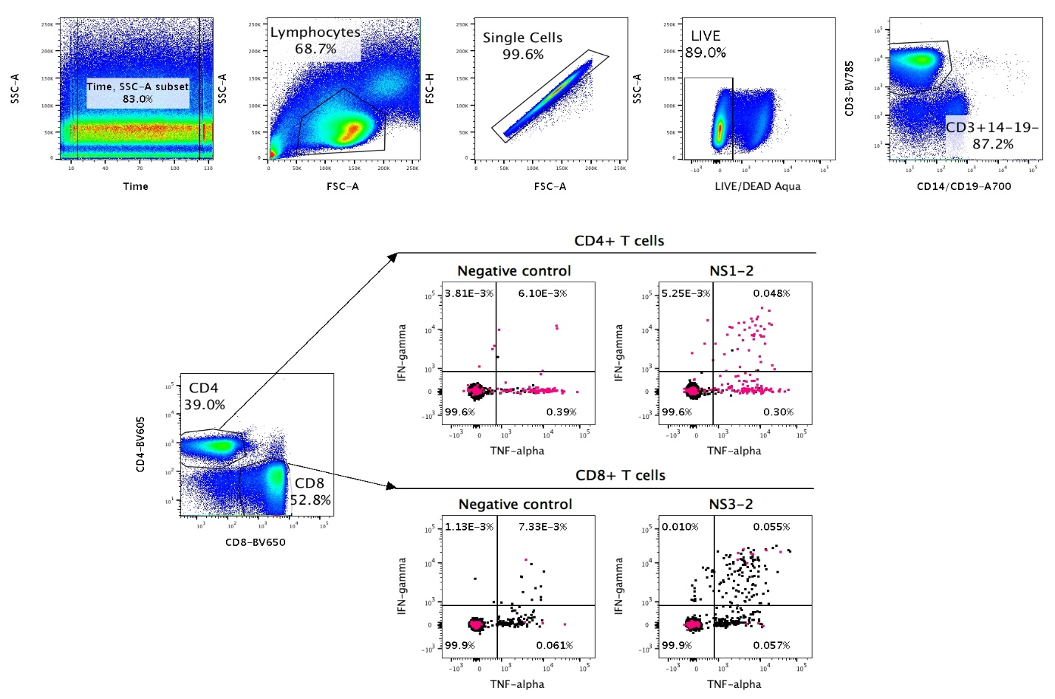
Supplemental Figure 1: Gating strategy for the Flow-ICS assay
IL-2
IL-2
IL-2
IL-2
IFNγ
IFNγ
IFNγ
IFNγ
TNFα
TNFα
TNFα
TNFα
NS1-4
NS3-4
Negative control
Negative control

Supplemental Figure 2: Normalization and quality control (QC) data from all samples in the transcriptomic analyses
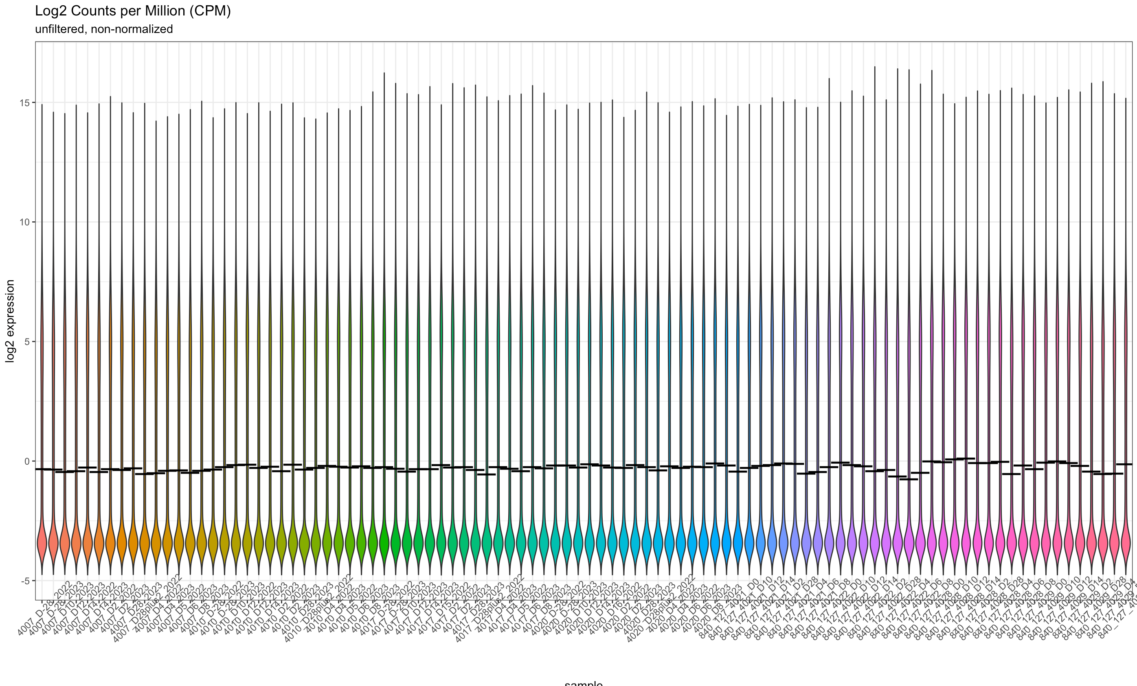

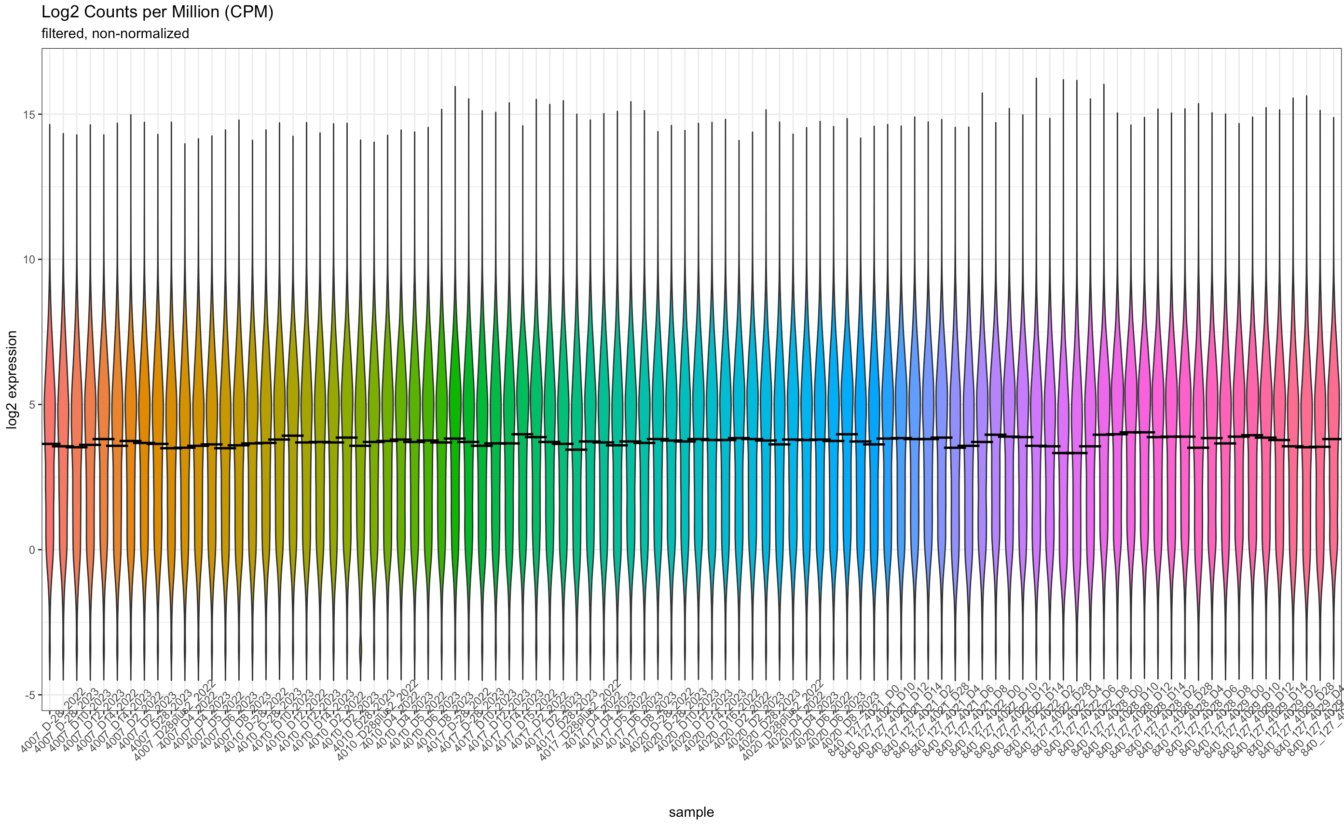

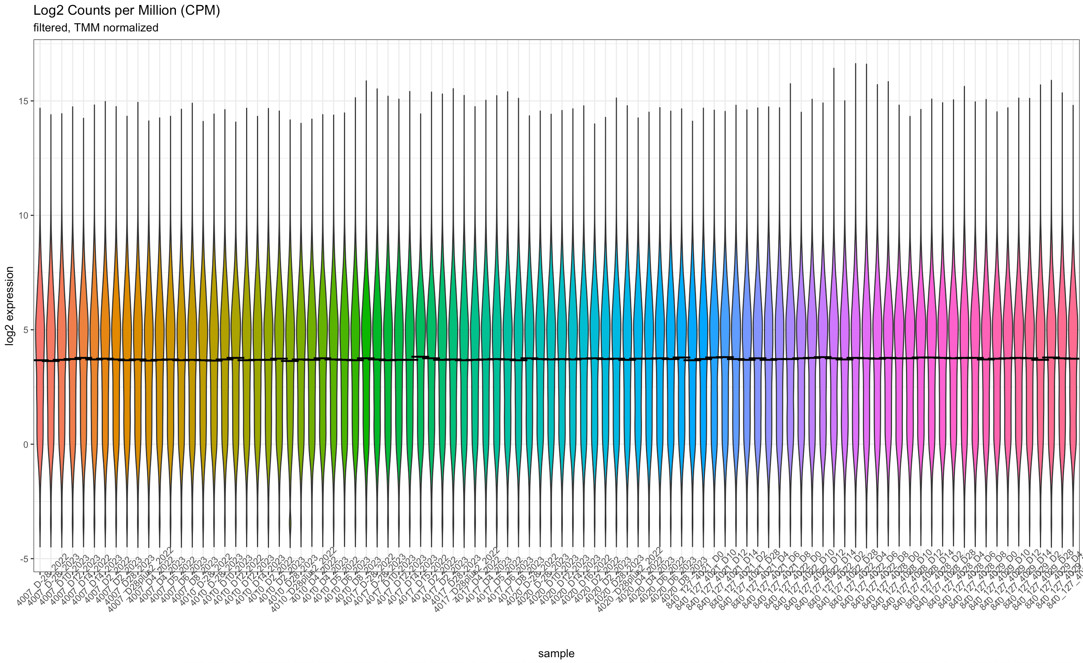

REFERENCES
1. Lyke, K.E., et al. Multidose Priming and Delayed Boosting Improve Plasmodium falciparum Sporozoite Vaccine Efficacy Against Heterologous P. falciparum Controlled Human Malaria Infection. Clin Infect Dis 73, e2424–e2435 (2021).
2. Herzenberg, L.A., Tung, J., Moore, W.A., Herzenberg, L.A. & Parks, D.R. Interpreting flow cytometry data: a guide for the perplexed. Nat Immunol 7, 681–685 (2006).
3. Liechti, T., et al. An updated guide for the perplexed: cytometry in the high-dimensional era. Nat Immunol 22, 1190–1197 (2021).
4. Rach, D., et al. Cord Blood Innate-like T cell responses in neonates born to healthy women and women living with HIV. Frontiers in Immunology 16(2025).
5. Finak, G., Jiang, W. & Gottardo, R. CytoML for cross-platform cytometry data sharing. Cytometry A 93, 1189–1196 (2018).
6. Finak, G. & Jiang, M. flowWorkspace: Infrastructure for representing and interacting with gated and ungated cytometry data sets. (2025).
7. Emmaneel, A., et al. PeacoQC: Peak-based selection of high quality cytometry data. Cytometry A 101, 325–338 (2022).
8. Rach, D. Luciernaga: Tools for the evaluation of Spectral Flow Cytometry (SFC) unmixing controls. (2025).
9. Quintelier, K.L.A., et al. CytoNorm 2.0: A flexible normalization framework for cytometry data without requiring dedicated controls. Cytometry A 107, 69–87 (2025).
10. Van Gassen, S., Gaudilliere, B., Angst, M.S., Saeys, Y. & Aghaeepour, N. CytoNorm: A Normalization Algorithm for Cytometry Data. Cytometry A 97, 268–278 (2020).
11. Wang, Y., Huang, H., Rudin, C. & Shaposhnik, Y. Understanding How Dimension Reduction Tools Work: An Empirical Approach to Deciphering t-SNE, UMAP, TriMAP, and PaCMAP for Data Visualization. Journal of Machine Learning Research 22, 1–73 (2020).

