Epimedokoreanin C, a prenylated flavonoid isolated from Epimedium koreanum, induces non-apoptotic cell death with the characteristics of methuosis in lung cancer cells
Xiaoqing Liu, Shuqi Wang, Hao Zheng, Qingying Liu, Tao Shen, Xiaoning Wang, Dongmei Ren*
Key Laboratory of Chemical Biology (Ministry of Education), School of Pharmaceutical Sciences, Cheeloo College of Medicine, Shandong University, 44 West Wenhua Road, Jinan 250012, P. R. China; liuxiaoqing@mail.sdu.edu.cn (X.L.); wangsq@sdu.edu.cn (S.W.); ZhengH_ao@163.com (H.Z.); 1041679565@qq.com (Q.L.); shentao@sdu.edu.cn (T.S.); wangxn@sdu.edu.cn (X.W.)
* Correspondence: rendom@sdu.edu.cn (D.R.); Tel.: +86-531-88382012

Figure S1. A schematic procedure for the isolation of 27 prenylated flavonoids from E. koreanum.
Table S1. Prenylated flavonoids from E. koreanum and their IC₅₀ values.
No | Name | Structure | IC₅₀ (μM)
1 | Epimedokoreanin C  (EKC) | 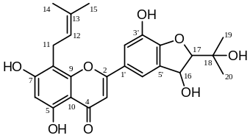 | 17.04
2 | Epicornunin A | 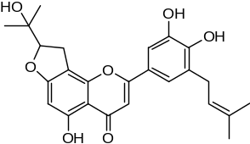 | ＞50
3 | Epicornunin B | 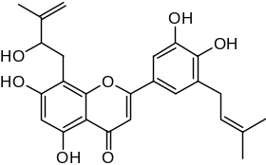 | 44.80
4 | Epicornunin F | 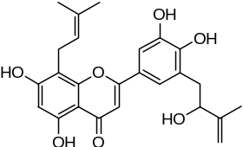 | ＞50
5 | Epimedokoreanin B | 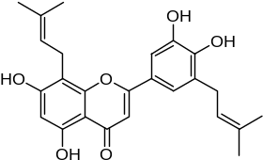 | 13.69
6 | Koreanoside F | 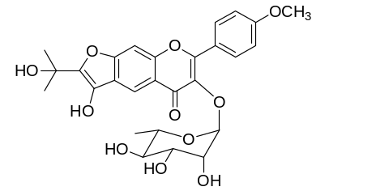 | ＞50
7 | Epimedokoreanin D | 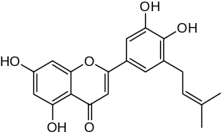 | 23.53
8 | Icaritin | 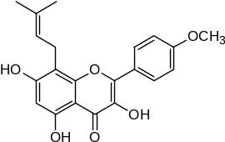 | 33.96
9 | β-anhydroicaritin | 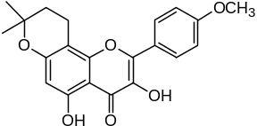 | 10.08
10 | Epimedonin C | 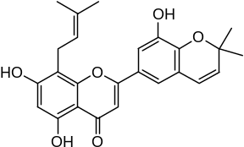 | >50
11 | 5,7-dihydroxy-2-(p-hydroxyphenoxy)-6-prenyl  chromone | 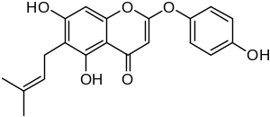 | 25.03
12 | Epimedonin B | 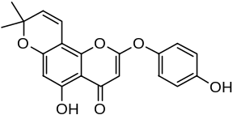 | 15.90
13 | Icariside Ι | 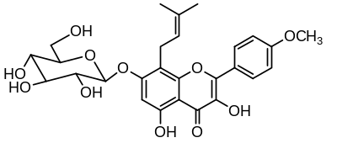 | 40.11
14 | Baohuoside Ι | 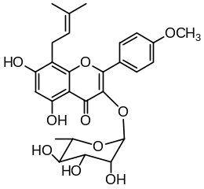 | 17.17
15 | Koreanoside D | 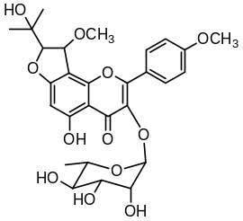 | ＞50
16 | Koreanoside E | 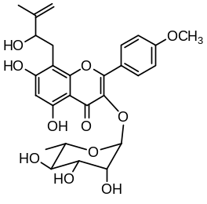 | ＞50
17 | Icarrin | 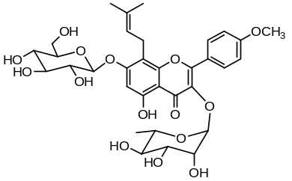 | ＞50
18 | Epimedoside C | 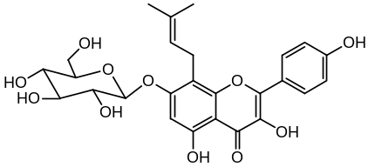 | >50
19 | Icaritin-3-O-rhamnoside | 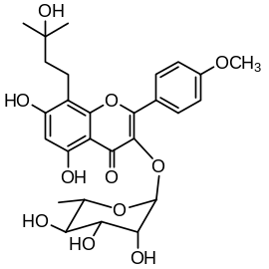 | ＞50
20 | Caohuoside C | 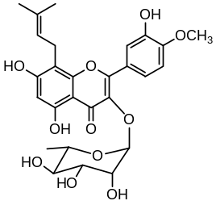 | ＞50
21 | Ikarisoside A | 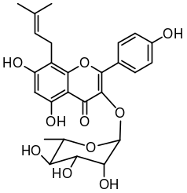 | 35.32
22 | Korepimeoside A | 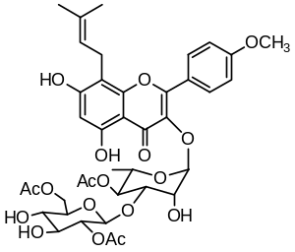 | 35.15
23 | Korepimeoside B | 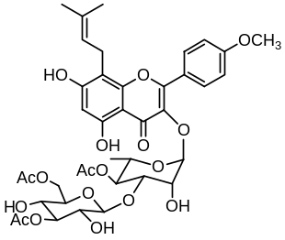 | 26.55
24 | Korepimedoside A | 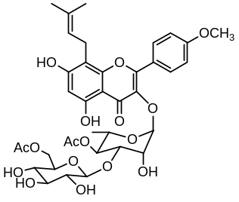 | 30.65
25 | Sagittatoside C | 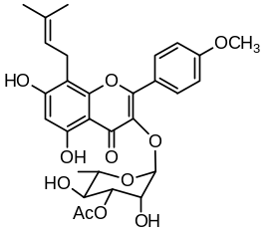 | >50
26 | Epimedokoreanoside Ⅲ | 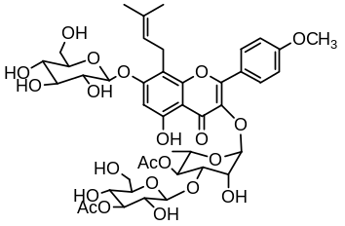 | >50
27 | Epimedokoreanoside Ι | 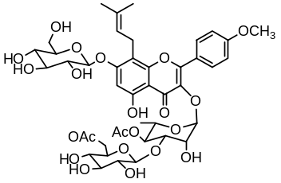 | >50
Figure S2. EKC induced vacuoles in four cancer tumor cells.
Figure S3. Effects of EKC and four closely related compounds in NCI-H292 cells.
Figure S4. NCI-H292 cells were cultured with the EKC for 7.5 h to produce vacuoles, and Baf A1 was added to continue co-culture for 26 h.

