Table S1 Prenylated flavonoids from Epimedium koreanum and their IC₅₀ values
No | Name | Structure | IC₅₀ (μM)
1 | Epimedokoreanin C  (EKC) | 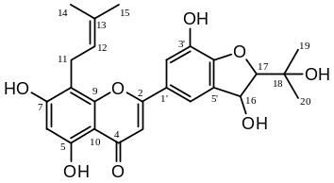 | 17.04
2 | Epicornunin A | 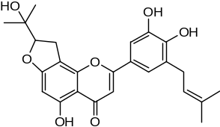 | ＞50
3 | Epicornunin B | 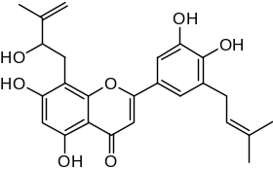 | 44.80
4 | Epicornunin F | 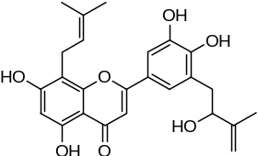 | ＞50
5 | Epimedokoreanin B | 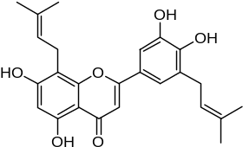 | 13.69
6 | Koreanoside F | 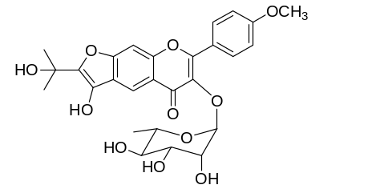 | ＞50
7 | Epimedokoreanin D | 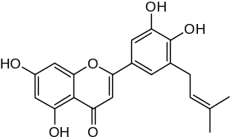 | 23.53
8 | Icaritin | 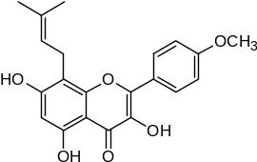 | 33.96
9 | β-anhydroicaritin | 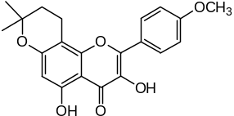 | 10.08
10 | Epimedonin C | 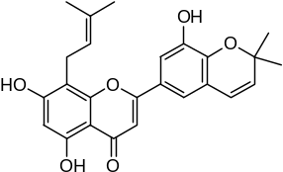 | >50
11 | 5,7-dihydroxy-2-(p-hydroxyphenoxy)-6-prenyl  chromone | 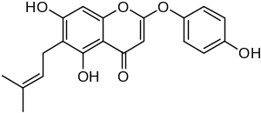 | 25.03
12 | Epimedonin B | 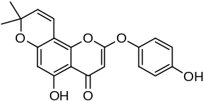 | 15.90
13 | Icariside Ι | 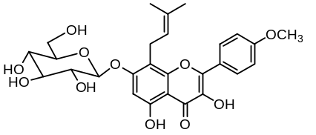 | 40.11
14 | Baohuoside Ι | 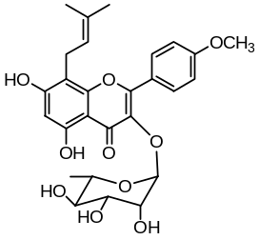 | 17.17
15 | Koreanoside D | 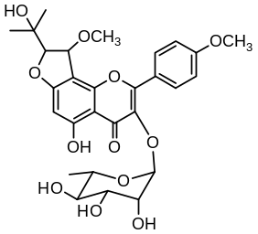 | ＞50
16 | Koreanoside E | 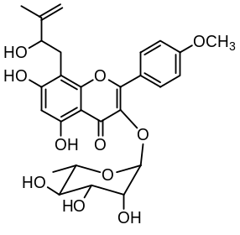 | ＞50
17 | Icarrin | 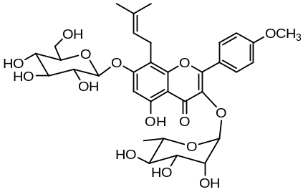 | ＞50
18 | Epimedoside C | 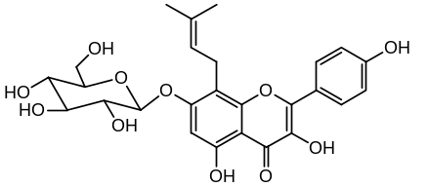 | >50
19 | Icaritin-3-O-rhamnoside | 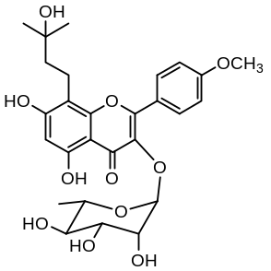 | ＞50
20 | Caohuoside C | 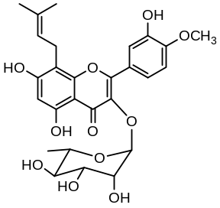 | ＞50
21 | Ikarisoside A | 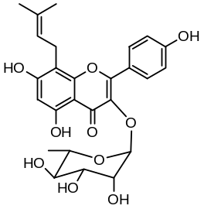 | 35.32
22 | Korepimeoside A | 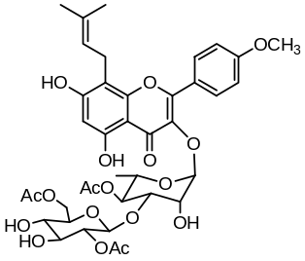 | 35.15
23 | Korepimeoside B | 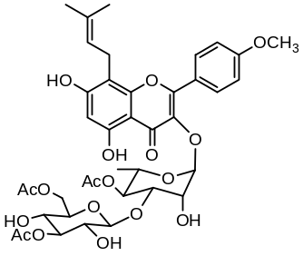 | 26.55
24 | Korepimedoside A | 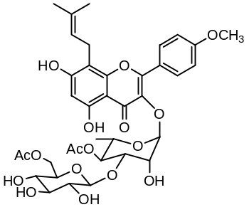 | 30.65
25 | Sagittatoside C | 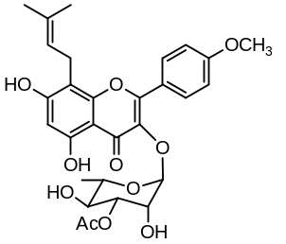 | >50
26 | Epimedokoreanoside Ⅲ | 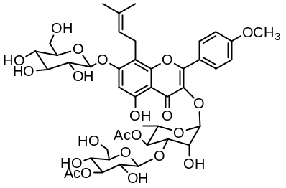 | >50
27 | Epimedokoreanoside Ι | 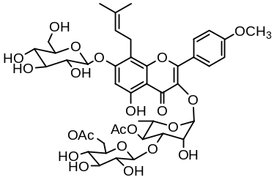 | >50

