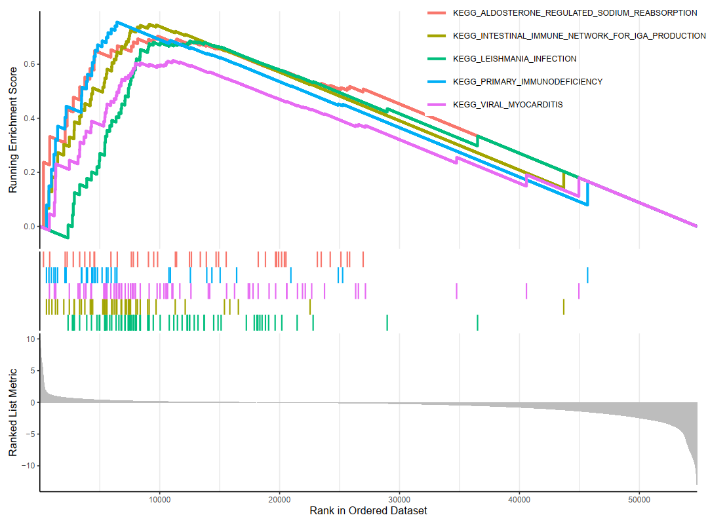
Figure S1. GSEA enrichment analysis

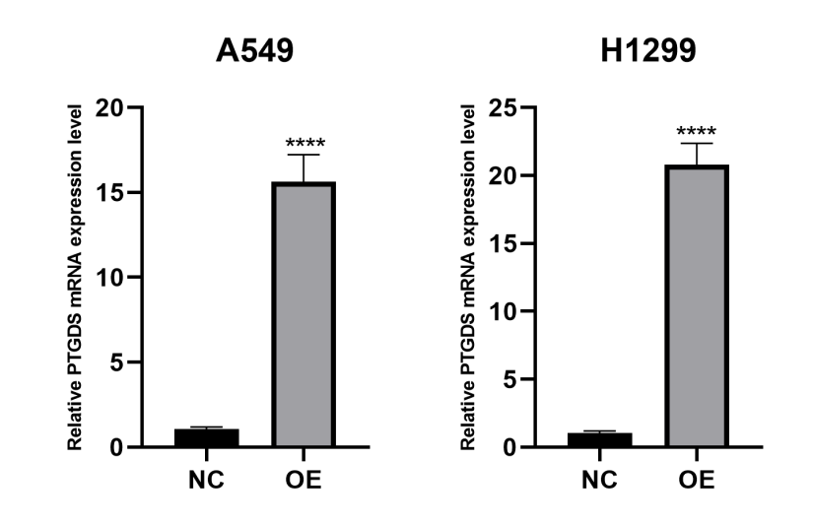
Figure S2. PTGDS expression level between NC and OE cell lines by qRT-PCR

Variables | expression |  | total | χ2 | P value
Variables | low | high | total | χ2
adjacent tissues | 9 | 22 | 31 | 5.314 | 0.021
tumor tissues | 18 | 13 | 31 | 5.314 | 0.021

Table S1. Significance of PTGDS expression in normal tissues and tumor tissues

