Title: When Digital Health Falls Short: Limited Validity of an AI-Powered App for Dietary Assessment in Females with Obesity

Michele Serra^{1,2,}*, Daniela Alceste^{2,}*, Nicole Jucker¹, Lotta Haupt³, Sebastian Elben³, Samuel Müller³, Paul J M Hulshof⁴, Harro A J Meijer⁵, Andreas Thalheimer⁶, Robert E Steinert², Philipp A Gerber¹, Alan C Spector⁷, Daniel Gero², Marco Bueter⁶

* Contributed equally
¹Department of Endocrinology, Diabetology and Clinical Nutrition, University Hospital Zurich, Zurich, Switzerland
²Department of Visceral and Transplant Surgery, University Hospital Zurich, Zurich, Switzerland
³Department of Health Sciences and Technology, ETH Zürich, Zurich, Switzerland
⁴Division of Human Nutrition, Wageningen University, Wageningen, The Netherlands
⁵Centre for Isotope Research (CIO), Energy and Sustainability Research Institute Groningen, University of Groningen, The Netherlands
⁶Department of General Surgery, Hospital Männedorf, Switzerland
⁷Department of Psychology and Program in Neuroscience, Florida State University, Tallahassee, FL, USA

Correspondance to:
Prof Marco Bueter PhD, Department of General Surgery, Hospital Männedorf, Switzerland.
marco.bueter@uzh.ch
Supplementary Material
Supplementary figures 5
Supplementary Figure 1: Analysis of normal distribution of the data 5
Supplementary Figure 2: Bland-Altman plots for agreement between the app and the 24HR 6
Supplementary Figure 3: Measurement differences of total daily energy intake estimated with the SNAQ app and the 24-hour dietary recall (24HR) in relation to the doubly labelled water (DLW) technique 7
Supplementary Figure 4: Absolute values of total daily energy intake 8
Supplementary Figure 5: Boxplots of the total daily energy intake 9
Supplementary Figure 6: Percentage of the measurement differences of total daily energy intake 10
Supplementary Figure 7: Changes in body weight during the study period and correlation analysis of linear models of relationship between measurement differences of SNAQ and the 24-hour dietary recall (24HR). 11
Supplementary Figure 8: Linear model of the relationship between daily energy intake estimated with SNAQ and daily energy intake estimated with the 24-hour dietary recall (24HR) 13
Supplementary tables 14
Supplementary Table 1: Reporting of the study according to the STROBE-nut checklist table. 14
Supplementary Table 2: Eligibility criteria 21
Supplementary Table 3: Doses of doubly labelled water (DLW) for each study participant and relative DLW batch 22
Supplementary Table 4: Description of the composition of the three doubly labelled water batches 23
Supplementary Table 5: Calculations of BMR performed using both the actual and adjusted patient body weights according to the equations of both Mifflin-St Jeor and Harris-Benedict and estimates of Resting Energy Expenditure (REE) calculated with seca analytics 125 using a proprietary regression model based on impedance-derived body composition. 24
Supplementary Table 6: Baseline bioelectrical impedance vector analysis of the study population 25
Supplementary Table 7: Nationality of the study population 26
Supplementary Table 8: Results of the doubly labelled water (DLW) analysis 27
Supplementary Table 9: Dilution spaces of the isotopes deuterium and 18-oxygen for each study participant 28
Supplementary Table 10: Elimination rates of the isotopes deuterium and 18-oxygen for each study participant 29
Supplementary Table 11: Results of the Shapiro–Wilk test for normality of the distribution of the energy estimates of the SNAQ app, the 24-hour dietary recall, and the DLW technique 30
Supplementary Table 12: Absolute and percentage measurement differences of total daily energy intake estimated with the SNAQ app in relation to total daily energy expenditure estimated with DLW technique 31
Supplementary Table 13: Absolute and percentage measurement differences of total daily energy intake estimated with the 24-hour dietary recall in relation to estimates with the DWL technique 32
Supplementary Table 14: Comparison of energy intake, macronutrient intake, and eating occasions between SNAQ and 24HR 33
Supplementary Table 15: Overall difference, and over- and underestimations of total daily energy intake estimated with SNAQ and 24HR in relation to DLW 34
Supplementary Table 16: Over- and underestimations of energy and macronutrient intake estimated with SNAQ in relation to 24HR 35
Supplementary Table 17: Classification of study participants as plausible, over- or under-reporters of total daily energy intake estimated with SNAQ according to the Goldberg cut-off method,[1] using adjusted Basal Metabolic Rate (BMR) estimated by the Mifflin-St Jeor equation and Physical Activity Level (PAL) calculated as a ratio of DLW-based estimates of total daily energy expenditures (TDEE) and BMR. 36
Supplementary Table 18: Classification of the study participants as plausible, over- or under-reporters of total daily energy intake estimated with the 24-hour dietary recall (24HR) according to the Goldberg cut-off method,[1] using adjusted Basal Metabolic Rate (BMR) estimated by the Mifflin-St Jeor equation and Physical Activity Level (PAL) calculated as a ratio of DLW-based estimates of total daily energy expenditures (TDEE) and BMR. 37
Supplementary Table 19: Classification of study participants as plausible, over- or under-reporters of total daily energy intake estimated with SNAQ according to the Goldberg cut-off method,[1] using adjusted Basal Metabolic Rate (BMR) estimated by the Mifflin-St Jeor equation and Physical Activity Level (PAL) selected based on lifestyle using the software seca analytics 125. 38
Supplementary Table 20: Classification of study participants as plausible, over- or under-reporters of total daily energy intake estimated with the 24-hour dietary recall (24HR) according to the Goldberg cut-off method,[1] using adjusted Basal Metabolic Rate (BMR) estimated by the Mifflin-St Jeor equation and Physical Activity Level (PAL) selected based on lifestyle using the software seca analytics 125. 39
Supplementary Table 21: Classification of study participants as plausible, over- or under-reporters of total daily energy intake estimated with SNAQ according to the Goldberg cut-off method,[1] using adjusted Basal Metabolic Rate (BMR) estimated by the Mifflin-St Jeor equation and Physical Activity Level (PAL) calculated as a ratio of DLW-based estimates of total daily energy expenditures (TDEE) and Resting Energy Expenditure (REE) calculated with seca analytics 125 using a proprietary regression model based on impedance-derived body composition. 40
Supplementary Table 22: Classification of study participants as plausible, over- or under-reporters of total daily energy intake estimated with the 24-hour dietary recall (24HR) according to the Goldberg cut-off method,[1] using adjusted Basal Metabolic Rate (BMR) estimated by the Mifflin-St Jeor equation and Physical Activity Level (PAL) calculated as a ratio of DLW-based estimates of total daily energy expenditures (TDEE) and Resting Energy Expenditure (REE) calculated with seca analytics 125 using a proprietary regression model based on impedance-derived body composition. 41
Supplementary Table 23: Classification of study participants as plausible, over- or under-reporters of total daily energy intake estimated with SNAQ according to the Goldberg cut-off method,[1] using Resting Energy Expenditure (REE) calculated with seca analytics 125 using a proprietary regression model based on impedance-derived body composition, and Physical Activity Level (PAL) calculated as a ratio of DLW-based estimates of total daily energy expenditures (TDEE) and adjusted Basal Metabolic Rate (BMR) estimated by the Mifflin-St Jeor equation. 42
Supplementary Table 24: Classification of study participants as plausible, over- or under-reporters of total daily energy intake estimated with the 24-hour dietary recall (24HR) according to the Goldberg cut-off method,[1] using Resting Energy Expenditure (REE) calculated with seca analytics 125 using a proprietary regression model based on impedance-derived body composition, and Physical Activity Level (PAL) calculated as a ratio of DLW-based estimates of total daily energy expenditures (TDEE) and adjusted Basal Metabolic Rate (BMR) estimated by the Mifflin-St Jeor equation. 43
Supplementary Table 25: Classification of study participants as plausible, over- or under-reporters of total daily energy intake estimated with SNAQ according to the Goldberg cut-off method,[1] using Resting Energy Expenditure (REE) calculated with seca analytics 125 using a proprietary regression model based on impedance-derived body composition, and Physical Activity Level (PAL) selected based on lifestyle using the software seca analytics 125. 44
Supplementary Table 26: Classification of study participants as plausible, over- or under-reporters of total daily energy intake estimated with the 24-hour dietary recall (24HR) according to the Goldberg cut-off method,[1] using Resting Energy Expenditure (REE) calculated with seca analytics 125 using a proprietary regression model based on impedance-derived body composition, and Physical Activity Level (PAL) selected based on lifestyle using the software seca analytics 125. 45
Supplementary Table 27: Classification of study participants as plausible, over- or under-reporters of total daily energy intake estimated with SNAQ according to the Goldberg cut-off method,[1] using Resting Energy Expenditure (REE) calculated with seca analytics 125 using a proprietary regression model based on impedance-derived body composition, and Physical Activity Level (PAL) calculated as a ratio of DLW-based estimates of total daily energy expenditures (TDEE) and REE. 46
Supplementary Table 28: Classification of study participants as plausible, over- or under-reporters of total daily energy intake estimated with the 24-hour dietary recall (24HR) according to the Goldberg cut-off method,[1] using Resting Energy Expenditure (REE) calculated with seca analytics 125 using a proprietary regression model based on impedance-derived body composition, and Physical Activity Level (PAL) calculated as a ratio of DLW-based estimates of total daily energy expenditures (TDEE) and REE. 47
Supplementary Table 29: Summary of the number of plausible, under-, and over-reporters across all combinations of BMR, REE, and PAL estimation methods for the SNAQ and 24-hour dietary recall (24HR), calculated using both a study-specific S factor and the reference values proposed by Black.[1] 48
Supplementary Table 30: Results of the Bland-Altman plot for agreement between bioelectrical impedance (BIA) and isotope dilution of DLW for measurements of body composition 49
References 50

Supplementary figures

Supplementary Figure 1: Analysis of normal distribution of the data
(A) Quantile-Quantile plots of energy estimates of the SNAQ app, the 24-hour dietary recall (24HR), and the doubly labelled water (DLW) technique. The diagonal dashed line represents the perfect match between the observed (empirical) and theoretical quantiles. If the data follows the theoretical distribution, the points will closely align with this line. 95 % confidence intervals are above and below the diagonal line. (B) Density plots of the energy estimates of the three methods.

Supplementary Figure 2: Bland-Altman plots for agreement between the app and the 24HR
(A) Bland-Altman plot for sugar intake. (B) Bland-Altman plots for intake of saturated fats. The bias is represented as a black horizontal line. The value of the bias is estimated by the mean difference in intake estimation between 24HR and the app for total daily energy intake and macronutrient intake. The 95% limits of agreement (LoA) are represented as two dotted lines and are defined as mean difference ± 1.96 standard deviations.

Supplementary Figure 3: Measurement differences of total daily energy intake estimated with the SNAQ app and the 24-hour dietary recall (24HR) in relation to the doubly labelled water (DLW) technique
(A) Absolute values of energy estimates with SNAQ, 24HR, and DLW. (B) Percentage of measurement differences of SNAQ and 24HR in relation to DLW. Vertical dotted red lines mark 50-% breaks to support the interpretation of the bars on the top of the panel.

Supplementary Figure 4: Absolute values of total daily energy intake
(A) macronutrient intake (B-G) and eating occasions (H) estimated with the SNAQ app and the 24-hour dietary recall (24HR).

Supplementary Figure 5: Boxplots of the total daily energy intake
(A) of the macronutrient intake (B-G) and eating occasions (H) estimated with the SNAQ app and the 24-hour dietary recall. Paired Student’s t-test have been performed on the datasets of SNAQ and 24HR for each variable. The results of the t-tests are reported on top of each panel. Paired measurements are connected with a grey line.

Supplementary Figure 6: Percentage of the measurement differences of total daily energy intake
(A) macronutrient intake (B-G) and eating occasions (H) estimated with the SNAQ app in relation to the 24-hour dietary recall (24HR).

Supplementary Figure 7: Changes in body weight during the study period and correlation analysis of linear models of relationship between measurement differences of SNAQ and the 24-hour dietary recall (24HR).
(A) Changes of body weight of the study participants during the study week. Bars on the left of the y-axis represent body weight loss. Bars on the right of the y-axis represent body weight gain. (B) Linear model of the relationship between changes of body weight during the study week and percentage of measurement differences of daily energy intake estimated with SNAQ in relation to DLW. (C) Linear model of the relationship between estimations of daily energy expenditure during the study week and percentage of measurement differences of daily energy intake estimated with SNAQ in relation to DLW. (D) Linear model of the relationship between changes of body weight during the study week and percentage of measurement differences of daily energy intake estimated with 24HR in relation to DLW. (E) Linear model of the relationship between estimations of daily energy expenditure during the study week and percentage of measurement differences of daily energy intake estimated with 24HR in relation to DLW. Δ=difference from baseline. %Δ=percentage difference. 24HR=24-hour dietary recall. DLW=doubly labelled water. K= decimal unit suffix for thousand. P=p-value of the coefficient of determination. R²=coefficient of determination of the linear relationship.

Supplementary Figure 8: Linear model of the relationship between daily energy intake estimated with SNAQ and daily energy intake estimated with the 24-hour dietary recall (24HR)
24HR=24-hour dietary recall. p=p-value of the coefficient of determination. R²=coefficient of determination of the linear model.

Supplementary tables

Supplementary Table 1: Reporting of the study according to the STROBE-nut checklist table.

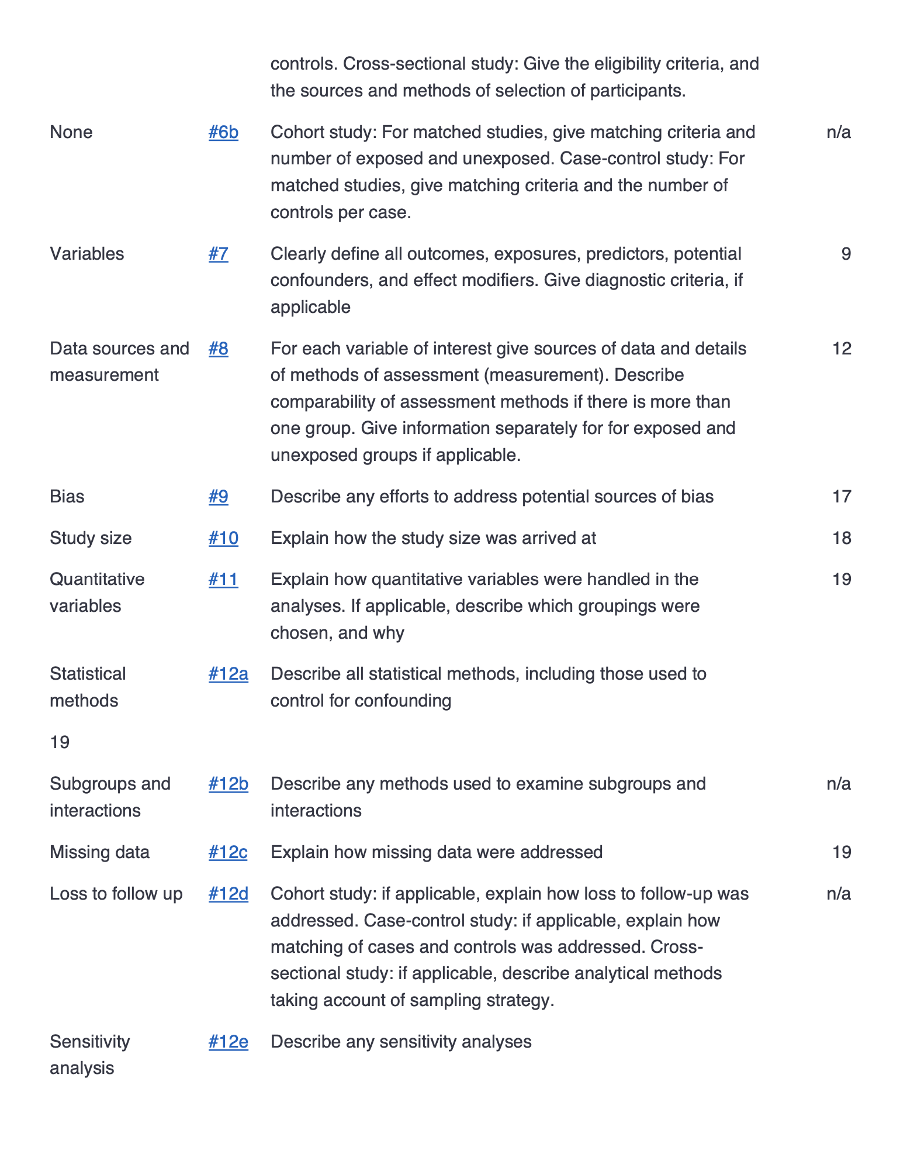

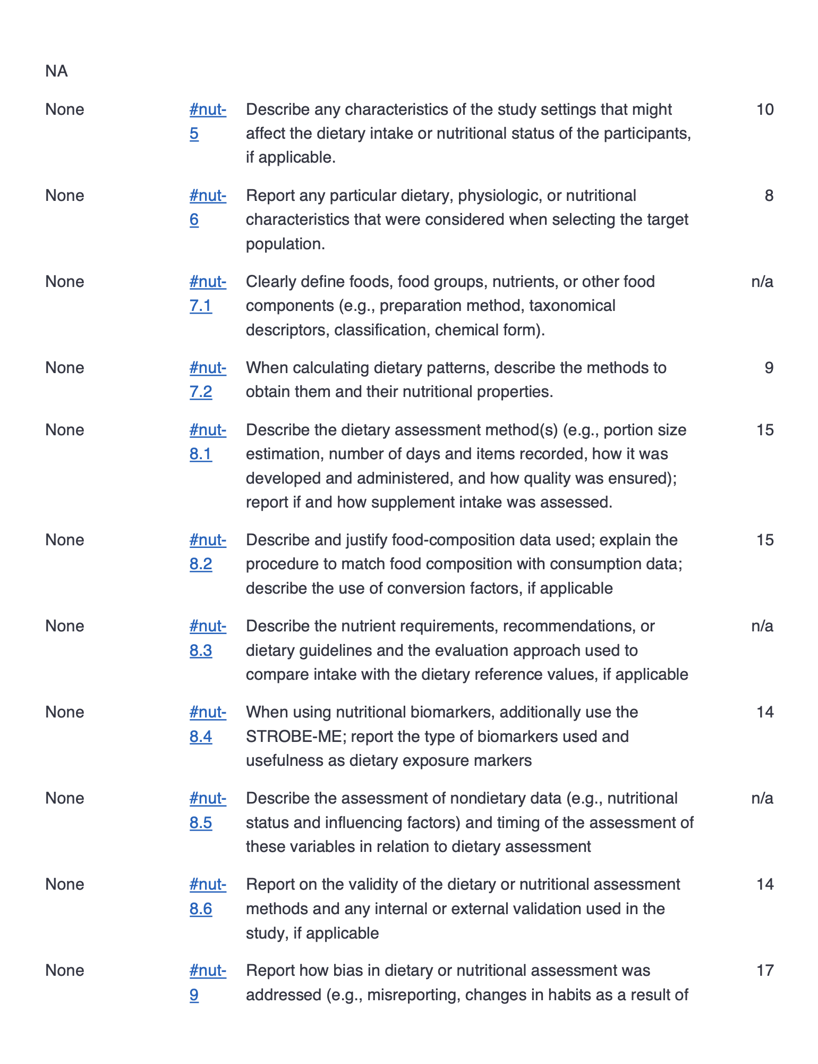

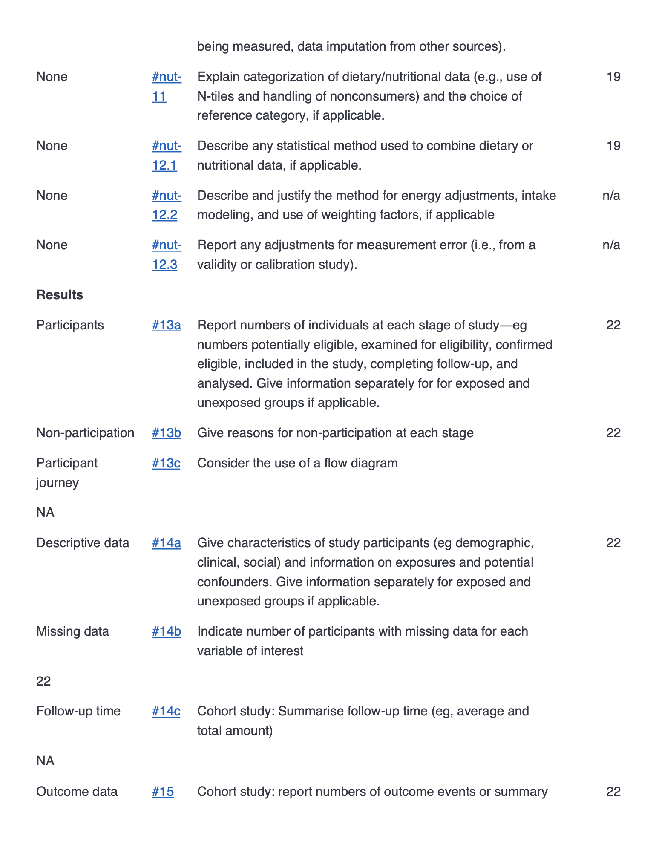

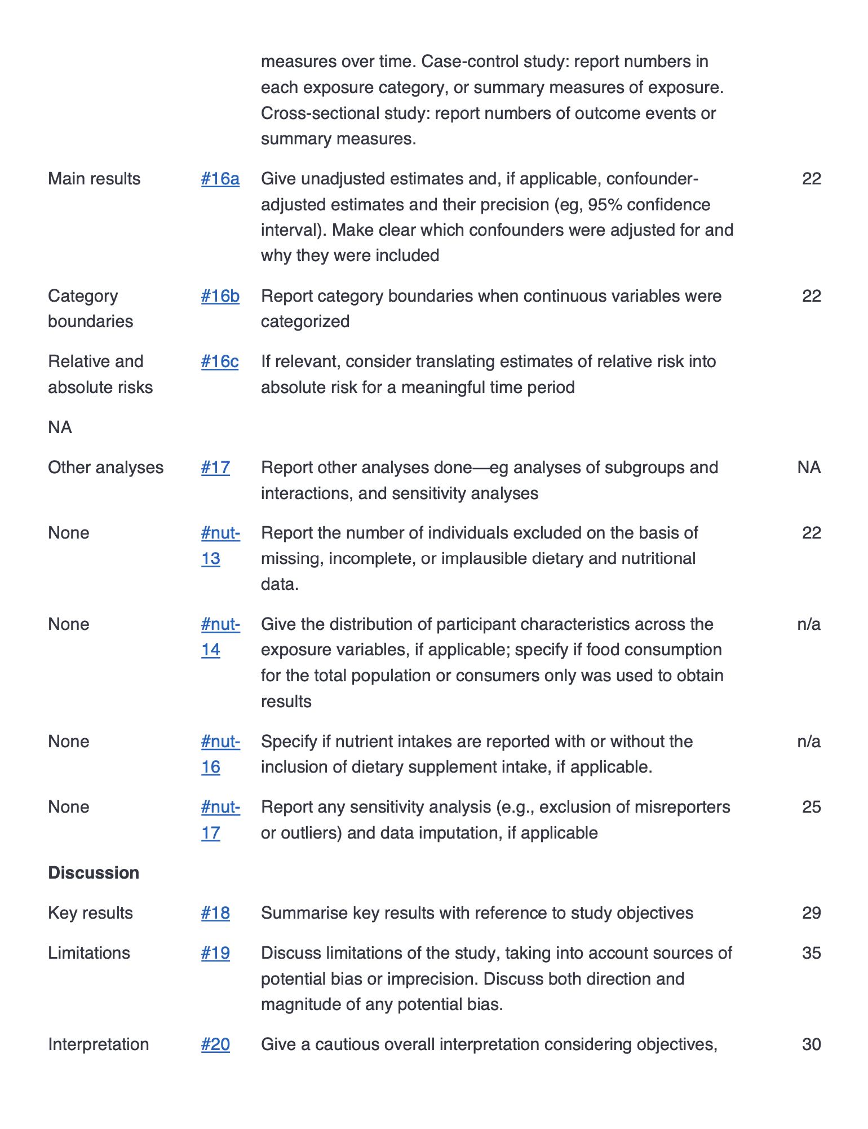

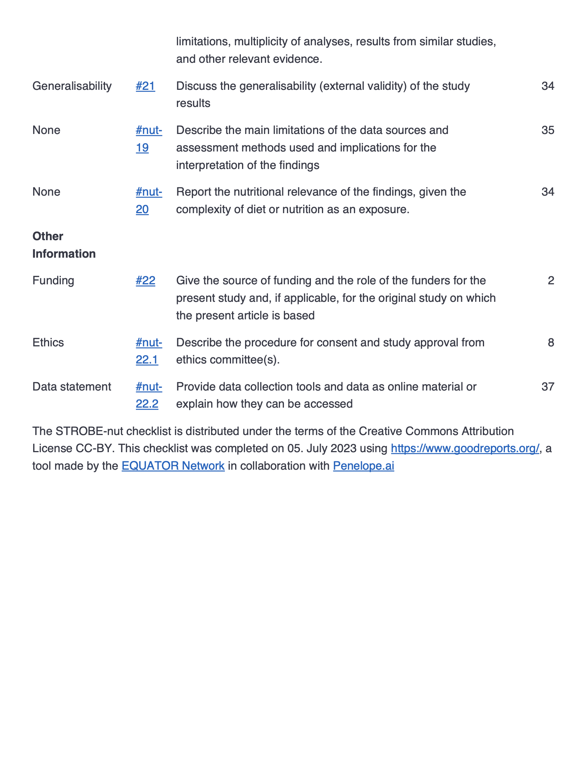

Supplementary Table 2: Eligibility criteria

Inclusion Criteria
- Adult aged 18 years or older
- BMI of 30 kg/m² or larger
- No history of bariatric surgery
- Independently mobile
- Digital literacy
- Ability to communicate fluently in English or German
- Capacity to consent to participate.
Exclusion Criteria
- Pregnancy/lactation
- History of have undergone any metabolic or bariatric surgery
- Inability to understand instructions
- Systemic or gastrointestinal condition which may affect food intake or preference
- Diabetes Mellitus (type I and II)
- Any diet for the purpose of weight-loss or weight gain
- Active and significant psychiatric illness including substance misuse
- Suffering from heart or kidney failure or malabsorption
- Significant cognitive or communication issues
- Medications with documented effect on food intake or food preference
- History of significant food allergy and certain dietary restrictions
- Recent travel history (overnight trip of more than 200 miles) within 2 weeks before or during the study period after dose administration of the doubly labelled water
- Need for intravenous therapy during 2 weeks before and during the study period

Supplementary Table 3: Doses of doubly labelled water (DLW) for each study participant and relative DLW batch

Study identifier | DLW dose (mL) | DLW batch*
USZO02 | 101.1689 | Batch 1
USZO04 | 100.6944 | Batch 2
USZO05 | 101.3982 | Batch 2
USZO06 | 101.1638 | Batch 2
USZO08 | 111.3606 | Batch 3
USZO09 | 101.044 | Batch 2
USZO10 | 101.5941 | Batch 2
USZP01 | 100.1023 | Batch 1
USZP03 | 100.137 | Batch 1
USZP04 | 100.0811 | Batch 1
USZP05 | 100.7038 | Batch 1
USZP06 | 101.3027 | Batch 1
USZP07 | 100.264 | Batch 2
USZP08 | 100.6855 | Batch 2
USZP09 | 101.0574 | Batch 2
USZP10 | 102.9755 | Batch 2
USZP11 | 101.5197 | Batch 2
USZP12 | 100.7739 | Batch 2
USZP13 | 100.3823 | Batch 1
USZP14 | 100.2059 | Batch 2
USZP15 | 101.3051 | Batch 2
USZP21 | 100.1933 | Batch 3
* The description of the composition of the three doubly labelled water batches is available in supplementary table 5.

Supplementary Table 4: Description of the composition of the three doubly labelled water batches

DLW Batch | Batch date | Deuterium (g) | Lot Number D₂O | 18-Oxygen (g) | Lot Number H₂¹⁸O
Batch 1 | 06.05.2020 | 120.64 | I-22828E | 1803.23 | I-E2581
Batch 2 | 28.01.2021 | 121.47 | I-22828E | 1802.69 | I-E2581
Batch 3 | 16.08.2022 | 42.59 | PR-33098 | 632.7 | I-E2581

Supplementary Table 5: Calculations of BMR performed using both the actual and adjusted patient body weights according to the equations of both Mifflin-St Jeor and Harris-Benedict and estimates of Resting Energy Expenditure (REE) calculated with seca analytics 125 using a proprietary regression model based on impedance-derived body composition.

Study identifier | Height  (m) |  | Body weight  (kg) | Age  (years) | IBW  (kg) | ABW  (kg) | BMR  (Harris-Benedict) | BMR  (Mifflin-St Jeor) | aBMR  (Harris-Benedict) | aBMR  (Mifflin-St Jeor) | REE  (seca)
USZO02 | 1.75 |  | 103.9 | 25 | 70.5 | 80.5 | 1937.3 | 1846.3 | 1694.2 | 1612.6 | NA
USZO04 | 1.63 |  | 108.8 | 64 | 59.6 | 74.3 | 1910.1 | 1625.3 | 1552.3 | 1281.2 | 1723
USZO05 | 1.63 |  | 97.6 | 42 | 59.6 | 71.0 | 1794.2 | 1623.8 | 1517.5 | 1357.7 | 1585
USZO06 | 1.64 |  | 82.9 | 39 | 60.5 | 67.2 | 1647.8 | 1498.0 | 1484.8 | 1341.2 | 1540
USZO08 | 1.68 |  | 102.5 | 34 | 64.1 | 75.6 | 1877.7 | 1744.0 | 1598.3 | 1475.4 | 1681
USZO09 | 1.54 |  | 87.5 | 38 | 51.4 | 62.3 | 1630.5 | 1486.5 | 1368.1 | 1234.1 | 1558
USZO10 | 1.72 |  | 103.0 | 52 | 67.7 | 78.3 | 1908.9 | 1684.0 | 1652.3 | 1437.2 | 1682
USZP01 | 1.58 |  | 102.9 | 40 | 55.1 | 69.4 | 1816.7 | 1655.5 | 1468.5 | 1320.7 | 1668
USZP03 | 1.71 |  | 112.1 | 36 | 66.8 | 80.4 | 1997.1 | 1848.8 | 1667.6 | 1531.9 | 1776
USZP04 | 1.66 |  | 114.5 | 18 | 62.3 | 78.0 | 1988.9 | 1931.0 | 1609.4 | 1566.1 | NA
USZP05 | 1.66 |  | 99.9 | 30 | 62.3 | 73.6 | 1837.6 | 1725.5 | 1564.0 | 1462.4 | 2191
USZP06 | 1.66 |  | 99.2 | 19 | 62.3 | 73.4 | 1830.3 | 1773.5 | 1561.8 | 1515.3 | 1646
USZP07 | 1.68 |  | 101.2 | 27 | 64.1 | 75.2 | 1863.6 | 1765.5 | 1594.1 | 1506.3 | 1945
USZP08 | 1.69 |  | 158.5 | 34 | 65.0 | 93.1 | 2466.6 | 2310.3 | 1786.1 | 1656.0 | NA
USZP09 | 1.58 |  | 105.8 | 45 | 55.1 | 70.3 | 1846.9 | 1659.5 | 1477.6 | 1304.4 | 1978
USZP10 | 1.70 |  | 126.8 | 63 | 65.9 | 84.2 | 2143.4 | 1854.5 | 1700.3 | 1428.5 | 2129
USZP11 | 1.74 |  | 105.8 | 55 | 69.6 | 80.4 | 1950.5 | 1709.0 | 1687.1 | 1455.7 | 1695
USZP12 | 1.69 |  | 131.3 | 31 | 65.0 | 84.9 | 2183.2 | 2052.8 | 1701.1 | 1589.2 | 1876
USZP13 | 1.68 |  | 116.9 | 45 | 64.1 | 79.9 | 2026.9 | 1832.5 | 1643.1 | 1463.4 | 1702
USZP14 | 1.60 |  | 107.0 | 21 | 56.9 | 71.9 | 1871.9 | 1803.5 | 1507.4 | 1453.0 | 1922
USZP15 | 1.75 |  | 103.9 | 25 | 70.5 | 80.5 | 1937.3 | 1846.3 | 1694.2 | 1612.6 | NA
USZP21 | 1.63 |  | 108.8 | 64 | 59.6 | 74.3 | 1910.1 | 1625.3 | 1552.3 | 1281.2 | 2070
 |  | aBMR=adjusted basal metabolic rate. ABW=adjusted body weight. BMR=basal metabolic rate. IBW=ideal body weight.

Supplementary Table 6: Baseline bioelectrical impedance vector analysis of the study population

 | Cohort – Obesity, N = 20*
 | Bioelectrical impedance | Isotope Dilution
Fat mass  Fat mass (kg)  Fat mass (%)  Fat mass index (kg/m²) | 52.9 (12.5)  48.6 (4.2)  19.4 (4.3) | 54.4 (17.3)  49.3 (8.8)  n/a
Fat-free mass  Fat-free mass (kg)  Fat-free mass (%)  Fat-free mass index (kg/m²) | 54.9 (6.3)  51.3 (4.2)  20.0 (1.9) | 54.0 (6.0)  n/a  n/a
Body water  Total body water (L)  Total body water (%)  Extracellular water (L)  Extracellular water (%)  ECW/TBW | 41.2 (4.9)  38.3 (3.1)  18.5 (2.1)  17.2 (1.2)  44.9 (1.5) | 39.5 (4.4)  n/a  n/a  n/a  n/a
Visceral fat (L) | 4.3 (2.4)
* Mean (SD). SD, standard deviation.
ECW=extracellular water. n/a=not available. TBW=total body water.

Supplementary Table 7: Nationality of the study population

 | Cohort
 | Obesity, N = 20*
Nationality  Algeria  France  Germany  India  Italy  Kosovo  Serbia  Spain  Switzerland  Tibet | 1 / 20 (5.0 %)  1 / 20 (5.0 %)  3 / 20 (15.0 %)  1 / 20 (5.0 %)  2 / 20 (10.0 %)  1 / 20 (5.0 %)  1 / 20 (5.0 %)  2 / 20 (5.0 %)  6 / 20 (30.0 %)  1 / 20 (5.0 %)
* Frequency (%). %=percentage.

Supplementary Table 8: Results of the doubly labelled water (DLW) analysis

Study identifier | TBW_{d}  (L) | TBW_{O}  (L) | TBW  (L) | TBW  (mol) | rCO₂  (ppm) | TDEE  (kcal/day) | PAL | AEE  (kcal/day) | Turnover  (L) | %TBF
USZO02 | 41.4 | 41.1 | 41.3 | 2291.2 | 586.0 | 3364.5 | 2.09 | 1415.5 | −3.9 | 45.7
USZO04 | 40.0 | 40.2 | 40.1 | 2225.6 | 477.1 | 2739.1 | 2.14 | 1184.0 | −3.7 | 49.6
USZO05 | 39.8 | 40.0 | 39.9 | 2214.9 | 519.1 | 2980.1 | 2.19 | 1324.3 | −3.5 | 44.1
USZO06 | 31.3 | 31.3 | 31.3 | 1736.2 | 392.9 | 2255.6 | 1.68 | 688.8 | −2.2 | 48.5
USZO08 | 39.3 | 39.3 | 39.3 | 2183.1 | 579.1 | 3324.9 | 2.25 | 1517.0 | −4.2 | 47.6
USZO09 | 42.4 | 42.3 | 42.3 | 2349.2 | 578.3 | 3320.1 | 2.69 | 1754.0 | −5.4 | 33.9
USZO10 | 38.1 | 37.4 | 37.8 | 2096.2 | 528.3 | 3032.8 | 2.11 | 1292.3 | −3.9 | 49.9
USZP01 | 41.2 | 40.9 | 41.0 | 2276.7 | 460.9 | 2646.2 | 2.00 | 1060.9 | −3.3 | 45.5
USZP03 | 35.5 | 35.2 | 35.3 | 1961.3 | 470.2 | 2699.4 | 1.76 | 897.5 | −3.2 | 56.9
USZP05 | 39.5 | 39.2 | 39.3 | 2184.2 | 605.5 | 3476.4 | 2.22 | 1562.7 | −2.6 | 53.0
USZP06 | 39.0 | 38.8 | 38.9 | 2158.9 | 473.8 | 2720.0 | 1.86 | 985.6 | −3.1 | 46.8
USZP07 | 41.0 | 40.5 | 40.7 | 2261.8 | 611.7 | 3512.2 | 2.32 | 1645.6 | −2.8 | 43.9
USZP09 | 51.0 | 50.7 | 50.8 | 2822.2 | 612.0 | 3513.9 | 2.33 | 1656.1 | −3.1 | 31.3
USZP10 | 41.1 | 41.3 | 41.2 | 2286.5 | 474.4 | 2723.8 | 1.64 | 795.5 | −3.5 | 64.5
USZP11 | 43.2 | 42.7 | 42.9 | 2383.8 | 556.1 | 3192.6 | 2.45 | 1568.9 | −4.2 | 44.5
USZP12 | 35.5 | 35.3 | 35.4 | 1964.1 | 490.9 | 2818.2 | 1.97 | 1107.9 | −4.1 | 61.9
USZP13 | 44.5 | 44.0 | 44.3 | 2456.9 | 724.5 | 4159.5 | 2.86 | 2287.9 | −2.5 | 42.8
USZP14 | 41.6 | 41.3 | 41.5 | 2301.4 | 510.5 | 2931.2 | 1.84 | 1048.9 | −2.0 | 56.8
USZP15 | 31.5 | 31.6 | 31.5 | 1750.1 | 410.6 | 2357.4 | 1.61 | 658.3 | −3.6 | 63.1
USZP21 | 35.6 | 35.1 | 35.4 | 1962.5 | 403.5 | 2316.9 | 1.59 | 632.2 | −3.2 | 54.8
TBW_{d}=total body water estimated with deuterium. TBW_{O}=total body water estimated with oxygen18. TBW=average estimation of total body water. rCO₂=daily respiratory carbon dioxide. TDEE=total daily energy expenditure. PAL=physical activity level. AEE=activity-related energy expenditure. Turnover=water turnover during the study week. %TBF=percentage of the total body fat.

Supplementary Table 9: Dilution spaces of the isotopes deuterium and 18-oxygen for each study participant

Study identifier | N_{d} | N_{O} | N_{d}/N_{O}
USZO02 | 43.13824616 | 41.40096908 | 1.041962232
USZO04 | 41.66439527 | 40.44742301 | 1.030087758
USZO05 | 41.47110015 | 40.24539115 | 1.030455885
USZO06 | 32.55702182 | 31.50003241 | 1.033555185
USZO08 | 40.95265406 | 39.59291288 | 1.034343045
USZO09 | 44.09198506 | 42.58392624 | 1.035413804
USZO10 | 39.66851194 | 37.68237622 | 1.052707284
USZP01 | 42.85308376 | 41.15157221 | 1.041347425
USZP03 | 36.95401366 | 35.4137313 | 1.04349393
USZP05 | 41.16855611 | 39.4260336 | 1.044197256
USZP06 | 40.56969795 | 39.08602878 | 1.037959067
USZP07 | 42.69923417 | 40.76023043 | 1.047570971
USZP09 | 53.10884321 | 51.02183992 | 1.040904117
USZP10 | 42.79887576 | 41.55987609 | 1.029812401
USZP11 | 44.96895216 | 42.99095894 | 1.046009516
USZP12 | 36.95379277 | 35.51661342 | 1.040464988
USZP13 | 46.35350069 | 44.30190573 | 1.046309407
USZP14 | 43.27743491 | 41.6382099 | 1.039368287
USZP15 | 32.78974649 | 31.77855613 | 1.031819896
USZP21 | 37.05484747 | 35.36166885 | 1.047881751
N_{d}=dilution space of the isotope deuterium (²H). N_{O}=dilution space of the isotope oxygen18 (¹⁸O). N_{d}/N_{O}=dilution space ratio.

Supplementary Table 10: Elimination rates of the isotopes deuterium and 18-oxygen for each study participant

Study identifier | k_{d} | k_{O} | k_{d}/k_{O}
USZO02 | −0.084062165 | −0.112123206 | 1.333812979
USZO04 | −0.096580742 | −0.121032814 | 1.253177518
USZO05 | −0.082343407 | −0.108244411 | 1.314548604
USZO06 | −0.086884569 | −0.112157577 | 1.290880279
USZO08 | −0.084703535 | −0.113718492 | 1.342547181
USZO09 | −0.092211126 | −0.119622133 | 1.297263551
USZO10 | −0.080697494 | −0.108269221 | 1.341667692
USZP01 | −0.110209425 | −0.133981069 | 1.215695195
USZP03 | −0.083913497 | −0.110397047 | 1.315605367
USZP05 | −0.063047884 | −0.092458182 | 1.466475562
USZP06 | −0.069258716 | −0.09323147 | 1.346133377
USZP07 | −0.086896437 | −0.116497814 | 1.340651212
USZP09 | −0.075669581 | −0.099619141 | 1.316501831
USZP10 | −0.077023241 | −0.100102722 | 1.299643083
USZP11 | −0.069273482 | −0.094601236 | 1.365619757
USZP12 | −0.100252600 | −0.128318965 | 1.279956483
USZP13 | −0.070698923 | −0.102113657 | 1.444345286
USZP14 | −0.085002574 | −0.109772985 | 1.291407762
USZP15 | −0.114548082 | −0.141627237 | 1.2363999
USZP21 | −0.070272373 | −0.092927652 | 1.322392403
k_{d}=elimination rate of the isotope deuterium (²H). k_{O}=elimination rate of the isotope oxygen18 (¹⁸O). k_{d}/k_{O}=elimination rate ratio.

Supplementary Table 11: Results of the Shapiro–Wilk test for normality of the distribution of the energy estimates of the SNAQ app, the 24-hour dietary recall, and the DLW technique

 | Statistic* | p-value*
SNAQ | 0.87 | 0.01
DLW | 0.93 | 0.51
24HR | 0.96 | 0.21
* Shapiro–Wilk test.
DLW=doubly labelled water technique. SNAQ=the SNAQ app. 24HR=24-hour dietary recall.

Supplementary Table 12: Absolute and percentage measurement differences of total daily energy intake estimated with the SNAQ app in relation to total daily energy expenditure estimated with DLW technique

Study identifier | Absolute difference  (kcal/day) | Percentage difference  (%)
USZO02 | −2473.4 | −73.5
USZO04 | −1126.5 | −41.1
USZO05 | −1822.1 | −61.1
USZO06 | 1951.7 | 86.5
USZO08 | −1599.5 | −48.1
USZO09 | −2658.6 | −80.1
USZO10 | −302.1 | −10.0
USZP01 | 2916.1 | 110.2
USZP03 | −660.5 | −24.5
USZP05 | −2872.0 | −82.6
USZP06 | −840.7 | −30.9
USZP07 | −589.3 | −16.8
USZP09 | 1349.0 | 38.4
USZP10 | −1515.1 | −55.6
USZP11 | −1575.0 | −49.3
USZP12 | −1618.5 | −57.4
USZP13 | −426.4 | −10.3
USZP14 | −1419.2 | −48.4
USZP15 | −861.0 | −36.5
USZP21 | −201.6 | −8.7

Supplementary Table 13: Absolute and percentage measurement differences of total daily energy intake estimated with the 24-hour dietary recall in relation to estimates with the DWL technique

Study identifier | Absolute difference  (kcal/day) | Percentage difference  (%)
USZO02 | −1372.7 | −40.8
USZO04 | −466.9 | −17.0
USZO05 | −2144.2 | −72.0
USZO06 | −692.3 | −30.7
USZO08 | −1371.1 | −41.2
USZO09 | −2440.8 | −73.5
USZO10 | −678.3 | −22.4
USZP01 | −1344.6 | −50.8
USZP03 | −1608.9 | −59.6
USZP05 | −2855.8 | −82.2
USZP06 | −1145.6 | −42.1
USZP07 | −1465.0 | −41.7
USZP09 | −1809.3 | −51.5
USZP10 | −1880.3 | −69.0
USZP11 | −1942.3 | −60.8
USZP12 | −1883.8 | −66.8
USZP14 | −729.8 | −24.9
USZP15 | −903.7 | −38.3
USZP21 | −1374.9 | −59.3

Supplementary Table 14: Comparison of energy intake, macronutrient intake, and eating occasions between SNAQ and 24HR

 | Dietary assessment method |  | Difference† | 95 % CI†,‡ | p-value†
 | SNAQ, N = 20* | 24HR, N = 20* | Difference† | 95 % CI†,‡ | p-value†
Energy intake**  Energy (kcal/day)  Energy (kJ/day) | 2,105.6 (1,389.8)  8,810.0 (5,815.0) | 1,464.0 (554.1)  6,125.2 (2,318.3) | 641.7 (+44 %)  2,684.8 (+44 %) | –67, 1,351  –282, 5,652 | 0.22  0.22
Macronutrient intake  Carbohydrates (g/day)  Sugars (g/day)  Fats (g/day)  Saturated Fats (g/day)  Proteins (g/day)  Fibers (g/day) | 220.0 (147.6)  101.0 (107.1)  96.7 (78.4)  45.7 (54.1)  81.2 (32.4)  19.7 (14.3) | 159.1 (100.5)  62.1 (43.5)  59.1 (28.1)  24.1 (16.0)  73.2 (32.7)  12.0 (9.3) | 60.8 (+38 %)  38.9 (+63 %)  37.7 (+64 %)  21.6 (+90 %)  8.0 (+11 %)  7.7 (+64 %) | –23, 144  –16, 94  –12.0, 19.0  –5, 48  –13, 29  –0.3, 16 | 0.2  0.2  0.06  0.1  0.5  0.06
Temporal organization  Eating occasions (n/day) | 5.4 (2.3) | 3.3 (0.6) | 2.1 (+63 %) | –1.0, 3.2 | < 0.001
* Mean (SD). SD, standard deviation.
** Total daily energy intake.
† Welch Two Sample t-test.
‡ CI = Confidence interval

Supplementary Table 15: Overall difference, and over- and underestimations of total daily energy intake estimated with SNAQ and 24HR in relation to DLW
 |  | n | Δ DLW, N = 20* | MPD DLW, N = 20* | p†
Overall  difference | Energy intake SNAQ  Energy (kcal/day)  Energy (kJ/day) | 30 | −817.2 (1474.5)  −3,420.1 (6,172.6) | −25.0 % (51.1) | 0.01
Overall  difference | Energy intake 24HR  Energy (kcal/day)  Energy (kJ/day) | 30 | −1,479.5 (635.5)  −6,193.8 (2,659.2) | −49.7 % (18.7) | <0.001
Overestimations | Energy intake SNAQ  Energy (kcal/day)  Energy (kJ/day) | 4 | 2,072.3 (790.5)  8,670.3 (3,308.2) | 78.4 % (36.6)
Overestimations | Energy intake 24HR  Energy (kcal/day)  Energy (kJ/day) | 0 | n/a  n/a | n/a
Underestimations | Energy intake SNAQ  Energy (kcal/day)  Energy (kJ/day) | 26 | −1,327.1 (813.7)  −5,555.6 (3,403.7) | −43.2 % (24.0)
Underestimations | Energy intake 24HR  Energy (kcal/day)  Energy (kJ/day) | 20 | −1,479 (635.5)  −6,190.6 (2,659.2) | −49.7 % (18.7)
* Mean (SD). SD, standard deviation.
† Wilcoxon signed-rank test
24HR=24-hour dietary recall. DLW=doubly labelled water. MPD DLW=mean percentage difference from DLW values. n=number of cases. NA=not available. Δ DLW=difference from DLW values.

Supplementary Table 16: Over- and underestimations of energy and macronutrient intake estimated with SNAQ in relation to 24HR
 |  | n | Δ 24HR, N = 30* | Δ% 24HR, N = 30*
Overestimations | Energy intake**  Energy (kcal/day)  Energy (kJ/day) | 14  14 | 1,161.9 (1,332.03)  4,861.2 (5,573.2) | +85.7 % (93.6)  +85.7 % (93.6)
Overestimations | Macronutrient intake  Carbohydrates (g/day)  Sugars (g/day)  Fats (g/day)  Saturated Fats (g/day)  Proteins (g/day)  Fibers (g/day) | 15  11  13  11  10  13 | 108.9 (132.3)  98.1 (117.3)  71.8 (85.8)  50.8 (66.0)  43.1 (39.4)  16.0 (13.9) | +121.8 % (171.2)  +268.7 % (246.2)  +175.7 % (270.4)  +352.9 % (574.8)  +115.7 % (116.6)  +271.9 % (234)
Overestimations | Temporal organization  Dietary occasions (n/day) | 17 | 2.7 (1.8) | +83.1 % (52.1)
Underestimations | Energy intake  Energy (kcal/day)  Energy (kJ/day) | 6  6 | −485.3 (402.1)  −2,030.8 (1,682.5) | −25.8 % (18.1)  −25.8 % (18.1)
Underestimations | Macronutrient intake  Carbohydrates (g/day)  Sugars (g/day)  Fats (g/day)  Saturated Fats (g/day)  Proteins (g/day)  Fibers (g/day) | 5  9  7  9  10  7 | −73.8 (48.3)  −26.8 (29.3)  −20.8 (35.1)  −10.9 (21.0)  −23.7 (25.8)  −6.6 (8.6) | −27.7 % (14.4)  −27.6 % (22.3)  −22.5 % (26.2)  −30.3 % (27.9)  −24.5 % (20.9)  −32.4 % (19.8)
Underestimations | Temporal organization  Dietary occasions (n/day) | 3 | −0.4 (0.3) | −10.7 % (8.1)
* Mean (SD). SD, standard deviation.
** Total daily energy intake.
Δ 24HR=difference from 24HR values. Δ% 24HR=percentage difference from 24HR values. n=number of over- or underestimations per variable

Supplementary Table 17: Classification of study participants as plausible, over- or under-reporters of total daily energy intake estimated with SNAQ according to the Goldberg cut-off method,[1] using adjusted Basal Metabolic Rate (BMR) estimated by the Mifflin-St Jeor equation and Physical Activity Level (PAL) calculated as a ratio of DLW-based estimates of total daily energy expenditures (TDEE) and BMR.

Study identifier | Energy Intake  (kcal/day) | BMR  (kcal/day) | PAL  (TDEE:BMR) | TDEI:BMR | Classification (I)* | Classification (II)§
USZO02 | 891.1 | 1612.6 | 2.09 | 0.55 | under-reporter | under-reporter
USZO04 | 1612.6 | 1281.2 | 2.14 | 1.26 | under-reporter | under-reporter
USZO05 | 1158.0 | 1357.7 | 2.19 | 0.85 | under-reporter | under-reporter
USZO06 | 4207.3 | 1341.2 | 1.68 | 3.14 | over-reporter | over-reporter
USZO08 | 1725.4 | 1475.4 | 2.25 | 1.17 | under-reporter | under-reporter
USZO09 | 661.6 | 1234.1 | 2.69 | 0.54 | under-reporter | under-reporter
USZO10 | 2730.7 | 1437.2 | 2.11 | 1.90 | plausible reporter | under-reporter
USZP01 | 5562.3 | 1320.7 | 2.00 | 4.21 | over-reporter | over-reporter
USZP03 | 2038.9 | 1531.9 | 1.76 | 1.33 | under-reporter | under-reporter
USZP05 | 604.4 | 1566.1 | 2.22 | 0.39 | under-reporter | under-reporter
USZP06 | 1879.3 | 1462.4 | 1.86 | 1.29 | under-reporter | under-reporter
USZP07 | 2922.9 | 1515.3 | 2.32 | 1.93 | plausible reporter | plausible reporter
USZP09 | 4862.9 | 1506.3 | 2.33 | 3.23 | over-reporter | over-reporter
USZP10 | 1208.7 | 1656.0 | 1.64 | 0.73 | under-reporter | under-reporter
USZP11 | 1617.6 | 1304.4 | 2.45 | 1.24 | under-reporter | under-reporter
USZP12 | 1199.7 | 1428.5 | 1.97 | 0.84 | under-reporter | under-reporter
USZP13 | 3733.1 | 1455.7 | 2.86 | 2.56 | plausible reporter | over-reporter
USZP14 | 1512.0 | 1589.2 | 1.84 | 0.95 | under-reporter | under-reporter
USZP15 | 1496.4 | 1463.4 | 1.61 | 1.02 | under-reporter | under-reporter
USZP21 | 2115.3 | 1453.0 | 1.59 | 1.46 | under-reporter | under-reporter
* Classification with an S factor specific for the study population.
§ Classification with an S factor according to Black .[1]
BMR=adjusted basal metabolic rate estimated by the Mifflin-St Jeor equation. PAL=physical activity level. TDEE=total daily energy expenditure. TDEI=total daily energy intake.

Supplementary Table 18: Classification of the study participants as plausible, over- or under-reporters of total daily energy intake estimated with the 24-hour dietary recall (24HR) according to the Goldberg cut-off method,[1] using adjusted Basal Metabolic Rate (BMR) estimated by the Mifflin-St Jeor equation and Physical Activity Level (PAL) calculated as a ratio of DLW-based estimates of total daily energy expenditures (TDEE) and BMR.

Study identifier | Energy Intake  (kcal/day) | BMR  (kcal/day) | PAL  (TDEE:BMR) | TDEI:BMR | Classification (I)* | Classification (II)§
USZO02 | 1991.9 | 1612.6 | 2.09 | 1.24 | under-reporter | under-reporter
USZO04 | 2272.3 | 1281.2 | 2.14 | 1.77 | plausible reporter | under-reporter
USZO05 | 835.9 | 1357.7 | 2.19 | 0.62 | under-reporter | under-reporter
USZO06 | 1563.3 | 1341.2 | 1.68 | 1.17 | under-reporter | under-reporter
USZO08 | 1953.8 | 1475.4 | 2.25 | 1.32 | under-reporter | under-reporter
USZO09 | 879.4 | 1234.1 | 2.69 | 0.71 | under-reporter | under-reporter
USZO10 | 2354.6 | 1437.2 | 2.11 | 1.64 | under-reporter | under-reporter
USZP01 | 1301.7 | 1320.7 | 2.00 | 0.99 | under-reporter | under-reporter
USZP03 | 1090.5 | 1531.9 | 1.76 | 0.71 | under-reporter | under-reporter
USZP05 | 620.6 | 1566.1 | 2.22 | 0.40 | under-reporter | under-reporter
USZP06 | 1574.4 | 1462.4 | 1.86 | 1.08 | under-reporter | under-reporter
USZP07 | 2047.1 | 1515.3 | 2.32 | 1.35 | under-reporter | under-reporter
USZP09 | 1704.6 | 1506.3 | 2.33 | 1.13 | under-reporter | under-reporter
USZP10 | 843.5 | 1656.0 | 1.64 | 0.51 | under-reporter | under-reporter
USZP11 | 1250.2 | 1304.4 | 2.45 | 0.96 | under-reporter | under-reporter
USZP12 | 934.5 | 1428.5 | 1.97 | 0.65 | under-reporter | under-reporter
USZP13 | 24HR not available
USZP14 | 2201.4 | 1589.2 | 1.84 | 1.39 | under-reporter | under-reporter
USZP15 | 1453.7 | 1463.4 | 1.61 | 0.99 | under-reporter | under-reporter
USZP21 | 941.9 | 1453.0 | 1.59 | 0.65 | under-reporter | under-reporter
USZO02 | 1991.9 | 1612.6 | 2.09 | 1.24 | under-reporter | under-reporter
* Classification with an S factor specific for the study population.
§ Classification with an S factor according to Black .[1]
BMR=adjusted basal metabolic rate. PAL=physical activity level. TDEE=total daily energy expenditure. TDEI= total daily energy intake.

Supplementary Table 19: Classification of study participants as plausible, over- or under-reporters of total daily energy intake estimated with SNAQ according to the Goldberg cut-off method,[1] using adjusted Basal Metabolic Rate (BMR) estimated by the Mifflin-St Jeor equation and Physical Activity Level (PAL) selected based on lifestyle using the software seca analytics 125.

Study identifier | Energy Intake  (kcal/day) | BMR  (kcal/day) | PAL  (seca) | TDEI:BMR | Classification (I)* | Classification (II)§
USZO02 | PAL not available
USZO04 | 1612.6 | 1281.2 | 1.6 | 1.26 | plausible reporter | under-reporter
USZO05 | 1158.0 | 1357.7 | 1.6 | 0.85 | under-reporter | under-reporter
USZO06 | 4207.3 | 1341.2 | 1.6 | 3.14 | over-reporter | over-reporter
USZO08 | 1725.4 | 1475.4 | 1.8 | 1.17 | under-reporter | under-reporter
USZO09 | 661.6 | 1234.1 | 1.8 | 0.54 | under-reporter | under-reporter
USZO10 | 2730.7 | 1437.2 | 1.0 | 1.90 | plausible reporter | over-reporter
USZP01 | 5562.3 | 1320.7 | 1.6 | 4.21 | over-reporter | over-reporter
USZP03 | 2038.9 | 1531.9 | 1.6 | 1.33 | plausible reporter | under-reporter
USZP05 | 604.4 | 1566.1 | 1.8 | 0.39 | under-reporter | under-reporter
USZP06 | 1879.3 | 1462.4 | 1.8 | 1.29 | plausible reporter | under-reporter
USZP07 | 2922.9 | 1515.3 | 1.4 | 1.93 | plausible reporter | over-reporter
USZP09 | 4862.9 | 1506.3 | 1.6 | 3.23 | over-reporter | over-reporter
USZP10 | 1208.7 | 1656.0 | 1.8 | 0.73 | under-reporter | under-reporter
USZP11 | 1617.6 | 1304.4 | 1.4 | 1.24 | plausible reporter | under-reporter
USZP12 | 1199.7 | 1428.5 | 1.8 | 0.84 | under-reporter | under-reporter
USZP13 | 3733.1 | 1455.7 | 1.6 | 2.56 | over-reporter | over-reporter
USZP14 | 1512.0 | 1589.2 | 1.4 | 0.95 | under-reporter | under-reporter
USZP15 | PAL not available
USZP21 | 2115.3 | 1453.0 | 1.6 | 1.46 | plausible reporter | under-reporter
* Classification with an S factor specific for the study population.
§ Classification with an S factor according to Black .[1]
BMR=adjusted basal metabolic rate. PAL=physical activity level. TDEE=total daily energy expenditure. TDEI=total daily energy intake.

Supplementary Table 20: Classification of study participants as plausible, over- or under-reporters of total daily energy intake estimated with the 24-hour dietary recall (24HR) according to the Goldberg cut-off method,[1] using adjusted Basal Metabolic Rate (BMR) estimated by the Mifflin-St Jeor equation and Physical Activity Level (PAL) selected based on lifestyle using the software seca analytics 125.

Study identifier | Energy Intake  (kcal/day) | BMR  (kcal/day) | PAL  (seca) | TDEI:BMR | Classification (I)* | Classification (II)§
USZO02 | PAL not available
USZO04 | 2272.3 | 1281.2 | 1.6 | 1.77 | plausible reporter | over-reporter
USZO05 | 835.9 | 1357.7 | 1.6 | 0.62 | under-reporter | under-reporter
USZO06 | 1563.3 | 1341.2 | 1.6 | 1.17 | under-reporter | under-reporter
USZO08 | 1953.8 | 1475.4 | 1.8 | 1.32 | plausible reporter | under-reporter
USZO09 | 879.4 | 1234.1 | 1.8 | 0.71 | under-reporter | under-reporter
USZO10 | 2354.6 | 1437.2 | 1.0 | 1.64 | plausible reporter | plausible reporter
USZP01 | 1301.7 | 1320.7 | 1.6 | 0.99 | under-reporter | under-reporter
USZP03 | 1090.5 | 1531.9 | 1.6 | 0.71 | under-reporter | under-reporter
USZP05 | 620.6 | 1566.1 | 1.8 | 0.40 | under-reporter | under-reporter
USZP06 | 1574.4 | 1462.4 | 1.8 | 1.08 | under-reporter | under-reporter
USZP07 | 2047.1 | 1515.3 | 1.4 | 1.35 | plausible reporter | under-reporter
USZP09 | 1704.6 | 1506.3 | 1.6 | 1.13 | under-reporter | under-reporter
USZP10 | 843.5 | 1656.0 | 1.8 | 0.51 | under-reporter | under-reporter
USZP11 | 1250.2 | 1304.4 | 1.4 | 0.96 | under-reporter | under-reporter
USZP12 | 934.5 | 1428.5 | 1.8 | 0.65 | under-reporter | under-reporter
USZP13 | 24HR not available
USZP14 | 2201.4 | 1589.2 | 1.4 | 1.39 | plausible reporter | under-reporter
USZP15 | PAL not available
USZP21 | 941.9 | 1453.0 | 1.6 | 0.65 | under-reporter | under-reporter
* Classification with an S factor specific for the study population.
§ Classification with an S factor according to Black .[1]
BMR=adjusted basal metabolic rate. PAL=physical activity level. TDEE=total daily energy expenditure. TDEI=total daily energy intake.

Supplementary Table 21: Classification of study participants as plausible, over- or under-reporters of total daily energy intake estimated with SNAQ according to the Goldberg cut-off method,[1] using adjusted Basal Metabolic Rate (BMR) estimated by the Mifflin-St Jeor equation and Physical Activity Level (PAL) calculated as a ratio of DLW-based estimates of total daily energy expenditures (TDEE) and Resting Energy Expenditure (REE) calculated with seca analytics 125 using a proprietary regression model based on impedance-derived body composition.

Study identifier | Energy Intake  (kcal/day) | BMR  (kcal/day) | PAL  (TDEE:REE) | TDEI:BMR | Classification (I)* | Classification (II)§
USZO02 | PAL not available
USZO04 | 1612.6 | 1281.2 | 1.59 | 1.26 | plausible reporter | under-reporter
USZO05 | 1158.0 | 1357.7 | 1.88 | 0.85 | under-reporter | under-reporter
USZO06 | 4207.3 | 1341.2 | 1.46 | 3.14 | over-reporter | over-reporter
USZO08 | 1725.4 | 1475.4 | 1.98 | 1.17 | under-reporter | under-reporter
USZO09 | 661.6 | 1234.1 | 2.13 | 0.54 | under-reporter | under-reporter
USZO10 | 2730.7 | 1437.2 | 1.80 | 1.90 | plausible reporter | over-reporter
USZP01 | 5562.3 | 1320.7 | 1.59 | 4.21 | over-reporter | over-reporter
USZP03 | 2038.9 | 1531.9 | 1.52 | 1.33 | plausible reporter | under-reporter
USZP05 | 604.4 | 1566.1 | 1.59 | 0.39 | under-reporter | under-reporter
USZP06 | 1879.3 | 1462.4 | 1.65 | 1.29 | plausible reporter | under-reporter
USZP07 | 2922.9 | 1515.3 | 1.81 | 1.93 | plausible reporter | over-reporter
USZP09 | 4862.9 | 1506.3 | 1.78 | 3.23 | over-reporter | over-reporter
USZP10 | 1208.7 | 1656.0 | 1.28 | 0.73 | under-reporter | under-reporter
USZP11 | 1617.6 | 1304.4 | 1.88 | 1.24 | under-reporter | under-reporter
USZP12 | 1199.7 | 1428.5 | 1.50 | 0.84 | under-reporter | under-reporter
USZP13 | 3733.1 | 1455.7 | 2.44 | 2.56 | over-reporter | over-reporter
USZP14 | 1512.0 | 1589.2 | 1.53 | 0.95 | under-reporter | under-reporter
USZP15 | PAL not available
USZP21 | 2115.3 | 1453.0 | 1.12 | 1.46 | plausible reporter | under-reporter
* Classification with an S factor specific for the study population.
§ Classification with an S factor according to Black .[1]
BMR= adjusted basal metabolic rate. PAL=physical activity level. REE=resting energy expenditure by seca analytics 125. TDEE=total daily energy expenditure. TDEI=total daily energy intake.

Supplementary Table 22: Classification of study participants as plausible, over- or under-reporters of total daily energy intake estimated with the 24-hour dietary recall (24HR) according to the Goldberg cut-off method,[1] using adjusted Basal Metabolic Rate (BMR) estimated by the Mifflin-St Jeor equation and Physical Activity Level (PAL) calculated as a ratio of DLW-based estimates of total daily energy expenditures (TDEE) and Resting Energy Expenditure (REE) calculated with seca analytics 125 using a proprietary regression model based on impedance-derived body composition.

Study identifier | Energy Intake  (kcal/day) | BMR  (kcal/day) | PAL  (TDEE:REE) | TDEI:BMR | Classification (I)* | Classification (II)§
USZO02 | PAL not available
USZO04 | 2272.3 | 1281.2 | 1.59 | 1.77 | plausible reporter | plausible reporter
USZO05 | 835.9 | 1357.7 | 1.88 | 0.62 | under-reporter | under-reporter
USZO06 | 1563.3 | 1341.2 | 1.46 | 1.17 | under-reporter | under-reporter
USZO08 | 1953.8 | 1475.4 | 1.98 | 1.32 | plausible reporter | under-reporter
USZO09 | 879.4 | 1234.1 | 2.13 | 0.71 | under-reporter | under-reporter
USZO10 | 2354.6 | 1437.2 | 1.80 | 1.64 | plausible reporter | plausible reporter
USZP01 | 1301.7 | 1320.7 | 1.59 | 0.99 | under-reporter | under-reporter
USZP03 | 1090.5 | 1531.9 | 1.52 | 0.71 | under-reporter | under-reporter
USZP05 | 620.6 | 1566.1 | 1.59 | 0.40 | under-reporter | under-reporter
USZP06 | 1574.4 | 1462.4 | 1.65 | 1.08 | under-reporter | under-reporter
USZP07 | 2047.1 | 1515.3 | 1.81 | 1.35 | plausible reporter | under-reporter
USZP09 | 1704.6 | 1506.3 | 1.78 | 1.13 | under-reporter | under-reporter
USZP10 | 843.5 | 1656.0 | 1.28 | 0.51 | under-reporter | under-reporter
USZP11 | 1250.2 | 1304.4 | 1.88 | 0.96 | under-reporter | under-reporter
USZP12 | 934.5 | 1428.5 | 1.50 | 0.65 | under-reporter | under-reporter
USZP13 | 24HR not available
USZP14 | 2201.4 | 1589.2 | 1.53 | 1.39 | plausible reporter | under-reporter
USZP15 | PAL not available
USZP21 | 941.9 | 1453.0 | 1.12 | 0.65 | under-reporter | under-reporter
* Classification with an S factor specific for the study population.
§ Classification with an S factor according to Black .[1]
BMR= adjusted basal metabolic rate. PAL=physical activity level. REE=resting energy expenditure by seca analytics 125. TDEE=total daily energy expenditure. TDEI=total daily energy intake.

Supplementary Table 23: Classification of study participants as plausible, over- or under-reporters of total daily energy intake estimated with SNAQ according to the Goldberg cut-off method,[1] using Resting Energy Expenditure (REE) calculated with seca analytics 125 using a proprietary regression model based on impedance-derived body composition, and Physical Activity Level (PAL) calculated as a ratio of DLW-based estimates of total daily energy expenditures (TDEE) and adjusted Basal Metabolic Rate (BMR) estimated by the Mifflin-St Jeor equation.

Study identifier | Energy Intake  (kcal/day) | REE  (kcal/day) | PAL  (TDEE:BMR) | TDEI:REE | Classification (I)* | Classification (II)§
USZO02 | PAL not available
USZO04 | 1612.6 | 1723 | 2.1 | 0.94 | under-reporter | under-reporter
USZO05 | 1158.0 | 1585 | 2.2 | 0.73 | under-reporter | under-reporter
USZO06 | 4207.3 | 1540 | 1.7 | 2.73 | plausible reporter | over-reporter
USZO08 | 1725.4 | 1681 | 2.3 | 1.03 | under-reporter | under-reporter
USZO09 | 661.6 | 1558 | 2.7 | 0.42 | under-reporter | under-reporter
USZO10 | 2730.7 | 1682 | 2.1 | 1.62 | plausible reporter | under-reporter
USZP01 | 5562.3 | 1668 | 2.0 | 3.33 | over-reporter | over-reporter
USZP03 | 2038.9 | 1776 | 1.8 | 1.15 | under-reporter | under-reporter
USZP05 | 604.4 | 2191 | 2.2 | 0.28 | under-reporter | under-reporter
USZP06 | 1879.3 | 1646 | 1.9 | 1.14 | under-reporter | under-reporter
USZP07 | 2922.9 | 1945 | 2.3 | 1.50 | under-reporter | under-reporter
USZP09 | 4862.9 | 1978 | 2.3 | 2.46 | plausible reporter | over-reporter
USZP10 | 1208.7 | 2129 | 1.6 | 0.57 | under-reporter | under-reporter
USZP11 | 1617.6 | 1695 | 2.4 | 0.95 | under-reporter | under-reporter
USZP12 | 1199.7 | 1876 | 2.0 | 0.64 | under-reporter | under-reporter
USZP13 | 3733.1 | 1702 | 2.9 | 2.19 | plausible reporter | plausible reporter
USZP14 | 1512.0 | 1922 | 1.8 | 0.79 | under-reporter | under-reporter
USZP15 | PAL not available
USZP21 | 2115.3 | 2070 | 1.6 | 1.02 | under-reporter | under-reporter
* Classification with an S factor specific for the study population.
§ Classification with an S factor according to Black .[1]
BMR= adjusted basal metabolic rate. PAL=physical activity level. REE=resting energy expenditure by seca analytics 125. TDEE=total daily energy expenditure. TDEI=total daily energy intake.

Supplementary Table 24: Classification of study participants as plausible, over- or under-reporters of total daily energy intake estimated with the 24-hour dietary recall (24HR) according to the Goldberg cut-off method,[1] using Resting Energy Expenditure (REE) calculated with seca analytics 125 using a proprietary regression model based on impedance-derived body composition, and Physical Activity Level (PAL) calculated as a ratio of DLW-based estimates of total daily energy expenditures (TDEE) and adjusted Basal Metabolic Rate (BMR) estimated by the Mifflin-St Jeor equation.

Study identifier | Energy Intake  (kcal/day) | REE  (kcal/day) | PAL  (TDEE:BMR) | TDEI:REE | Classification (I)* | Classification (II)§
USZO02 | PAL not available
USZO04 | 2272.3 | 1723 | 2.14 | 1.32 | under-reporter | under-reporter
USZO05 | 835.9 | 1585 | 2.19 | 0.53 | under-reporter | under-reporter
USZO06 | 1563.3 | 1540 | 1.68 | 1.02 | under-reporter | under-reporter
USZO08 | 1953.8 | 1681 | 2.25 | 1.16 | under-reporter | under-reporter
USZO09 | 879.4 | 1558 | 2.69 | 0.56 | under-reporter | under-reporter
USZO10 | 2354.6 | 1682 | 2.11 | 1.40 | under-reporter | under-reporter
USZP01 | 1301.7 | 1668 | 2.00 | 0.78 | under-reporter | under-reporter
USZP03 | 1090.5 | 1776 | 1.76 | 0.61 | under-reporter | under-reporter
USZP05 | 620.6 | 2191 | 2.22 | 0.28 | under-reporter | under-reporter
USZP06 | 1574.4 | 1646 | 1.86 | 0.96 | under-reporter | under-reporter
USZP07 | 2047.1 | 1945 | 2.32 | 1.05 | under-reporter | under-reporter
USZP09 | 1704.6 | 1978 | 2.33 | 0.86 | under-reporter | under-reporter
USZP10 | 843.5 | 2129 | 1.64 | 0.40 | under-reporter | under-reporter
USZP11 | 1250.2 | 1695 | 2.45 | 0.74 | under-reporter | under-reporter
USZP12 | 934.5 | 1876 | 1.97 | 0.50 | under-reporter | under-reporter
USZP13 | 24HR not available
USZP14 | 2201.4 | 1922 | 1.84 | 1.15 | under-reporter | under-reporter
USZP15 | PAL not available
USZP21 | 941.9 | 2070 | 1.59 | 0.46 | under-reporter | under-reporter
* Classification with an S factor specific for the study population.
§ Classification with an S factor according to Black .[1]
BMR= adjusted basal metabolic rate. PAL=physical activity level. REE=resting energy expenditure by seca analytics 125. TDEE=total daily energy expenditure. TDEI=total daily energy intake.

Supplementary Table 25: Classification of study participants as plausible, over- or under-reporters of total daily energy intake estimated with SNAQ according to the Goldberg cut-off method,[1] using Resting Energy Expenditure (REE) calculated with seca analytics 125 using a proprietary regression model based on impedance-derived body composition, and Physical Activity Level (PAL) selected based on lifestyle using the software seca analytics 125.

Study identifier | Energy Intake  (kcal/day) | REE  (kcal/day) | PAL  (seca) | TDEI:REE | Classification (I)* | Classification (II)§
USZO02 | PAL not available
USZO04 | 1612.6 | 1723 | 1.6 | 0.94 | under-reporter | under-reporter
USZO05 | 1158.0 | 1585 | 1.6 | 0.73 | under-reporter | under-reporter
USZO06 | 4207.3 | 1540 | 1.6 | 2.73 | over-reporter | over-reporter
USZO08 | 1725.4 | 1681 | 1.8 | 1.03 | under-reporter | under-reporter
USZO09 | 661.6 | 1558 | 1.8 | 0.42 | under-reporter | under-reporter
USZO10 | 2730.7 | 1682 | 1.0 | 1.62 | plausible reporter | plausible reporter
USZP01 | 5562.3 | 1668 | 1.6 | 3.33 | over-reporter | over-reporter
USZP03 | 2038.9 | 1776 | 1.6 | 1.15 | under-reporter | under-reporter
USZP05 | 604.4 | 2191 | 1.8 | 0.28 | under-reporter | under-reporter
USZP06 | 1879.3 | 1646 | 1.8 | 1.14 | under-reporter | under-reporter
USZP07 | 2922.9 | 1945 | 1.4 | 1.50 | plausible reporter | plausible reporter
USZP09 | 4862.9 | 1978 | 1.6 | 2.46 | over-reporter | over-reporter
USZP10 | 1208.7 | 2129 | 1.8 | 0.57 | under-reporter | under-reporter
USZP11 | 1617.6 | 1695 | 1.4 | 0.95 | under-reporter | under-reporter
USZP12 | 1199.7 | 1876 | 1.8 | 0.64 | under-reporter | under-reporter
USZP13 | 3733.1 | 1702 | 1.6 | 2.19 | over-reporter | over-reporter
USZP14 | 1512.0 | 1922 | 1.4 | 0.79 | under-reporter | under-reporter
USZP15 | PAL not available
USZP21 | 2115.3 | 2070 | 1.6 | 1.02 | under-reporter | under-reporter
* Classification with an S factor specific for the study population.
§ Classification with an S factor according to Black .[1]
PAL=physical activity level. REE=resting energy expenditure by seca analytics 125. TDEE=total daily energy expenditure. TDEI=total daily energy intake.

Supplementary Table 26: Classification of study participants as plausible, over- or under-reporters of total daily energy intake estimated with the 24-hour dietary recall (24HR) according to the Goldberg cut-off method,[1] using Resting Energy Expenditure (REE) calculated with seca analytics 125 using a proprietary regression model based on impedance-derived body composition, and Physical Activity Level (PAL) selected based on lifestyle using the software seca analytics 125.

Study identifier | Energy Intake  (kcal/day) | REE  (kcal/day) | PAL  (seca) | TDEI:REE | Classification (I)* | Classification (II)§
USZO02 | PAL not available
USZO04 | 2272.3 | 1723 | 1.6 | 1.32 | plausible reporter | under-reporter
USZO05 | 835.9 | 1585 | 1.6 | 0.53 | under-reporter | under-reporter
USZO06 | 1563.3 | 1540 | 1.6 | 1.02 | under-reporter | under-reporter
USZO08 | 1953.8 | 1681 | 1.8 | 1.16 | under-reporter | under-reporter
USZO09 | 879.4 | 1558 | 1.8 | 0.56 | under-reporter | under-reporter
USZO10 | 2354.6 | 1682 | 1.0 | 1.40 | plausible reporter | under-reporter
USZP01 | 1301.7 | 1668 | 1.6 | 0.78 | under-reporter | under-reporter
USZP03 | 1090.5 | 1776 | 1.6 | 0.61 | under-reporter | under-reporter
USZP05 | 620.6 | 2191 | 1.8 | 0.28 | under-reporter | under-reporter
USZP06 | 1574.4 | 1646 | 1.8 | 0.96 | under-reporter | under-reporter
USZP07 | 2047.1 | 1945 | 1.4 | 1.05 | under-reporter | under-reporter
USZP09 | 1704.6 | 1978 | 1.6 | 0.86 | under-reporter | under-reporter
USZP10 | 843.5 | 2129 | 1.8 | 0.40 | under-reporter | under-reporter
USZP11 | 1250.2 | 1695 | 1.4 | 0.74 | under-reporter | under-reporter
USZP12 | 934.5 | 1876 | 1.8 | 0.50 | under-reporter | under-reporter
USZP13 | 24HR not available
USZP14 | 2201.4 | 1922 | 1.4 | 1.15 | under-reporter | under-reporter
USZP15 | PAL not available
USZP21 | 941.9 | 2070 | 1.6 | 0.46 | under-reporter | under-reporter
* Classification with an S factor specific for the study population.
§ Classification with an S factor according to Black .[1]
PAL=physical activity level. REE=resting energy expenditure by seca analytics 125. TDEE=total energy expenditure. TDEI=total daily energy intake.

Supplementary Table 27: Classification of study participants as plausible, over- or under-reporters of total daily energy intake estimated with SNAQ according to the Goldberg cut-off method,[1] using Resting Energy Expenditure (REE) calculated with seca analytics 125 using a proprietary regression model based on impedance-derived body composition, and Physical Activity Level (PAL) calculated as a ratio of DLW-based estimates of total daily energy expenditures (TDEE) and REE.

Study identifier | Energy Intake  (kcal/day) | REE  (kcal/day) | PAL  (TDEE:REE) | TDEI:REE | Classification (I)* | Classification (II)§
USZO02 | PAL not available
USZO04 | 1612.6 | 1723 | 1.59 | 0.94 | under-reporter | under-reporter
USZO05 | 1158.0 | 1585 | 1.88 | 0.73 | under-reporter | under-reporter
USZO06 | 4207.3 | 1540 | 1.46 | 2.73 | over-reporter | over-reporter
USZO08 | 1725.4 | 1681 | 1.98 | 1.03 | under-reporter | under-reporter
USZO09 | 661.6 | 1558 | 2.13 | 0.42 | under-reporter | under-reporter
USZO10 | 2730.7 | 1682 | 1.80 | 1.62 | plausible reporter | plausible reporter
USZP01 | 5562.3 | 1668 | 1.59 | 3.33 | over-reporter | over-reporter
USZP03 | 2038.9 | 1776 | 1.52 | 1.15 | under-reporter | under-reporter
USZP05 | 604.4 | 2191 | 1.59 | 0.28 | under-reporter | under-reporter
USZP06 | 1879.3 | 1646 | 1.65 | 1.14 | under-reporter | under-reporter
USZP07 | 2922.9 | 1945 | 1.81 | 1.50 | plausible reporter | under-reporter
USZP09 | 4862.9 | 1978 | 1.78 | 2.46 | over-reporter | over-reporter
USZP10 | 1208.7 | 2129 | 1.28 | 0.57 | under-reporter | under-reporter
USZP11 | 1617.6 | 1695 | 1.88 | 0.95 | under-reporter | under-reporter
USZP12 | 1199.7 | 1876 | 1.50 | 0.64 | under-reporter | under-reporter
USZP13 | 3733.1 | 1702 | 2.44 | 2.19 | plausible reporter | over-reporter
USZP14 | 1512.0 | 1922 | 1.53 | 0.79 | under-reporter | under-reporter
USZP15 | PAL not available
USZP21 | 2115.3 | 2070 | 1.12 | 1.02 | under-reporter | under-reporter
* Classification with an S factor specific for the study population.
§ Classification with an S factor according to Black .[1]
PAL=physical activity level. REE=resting energy expenditure by seca analytics 125. TDEE=total daily energy expenditure. TDEI=total daily energy intake.

Supplementary Table 28: Classification of study participants as plausible, over- or under-reporters of total daily energy intake estimated with the 24-hour dietary recall (24HR) according to the Goldberg cut-off method,[1] using Resting Energy Expenditure (REE) calculated with seca analytics 125 using a proprietary regression model based on impedance-derived body composition, and Physical Activity Level (PAL) calculated as a ratio of DLW-based estimates of total daily energy expenditures (TDEE) and REE.

Study identifier | Energy Intake  (kcal/day) | REE  (kcal/day) | PAL  (TDEE:REE) | TDEI:REE | Classification (I)* | Classification (II)§
USZO02 | PAL not available
USZO04 | 2272.3 | 1723 | 1.59 | 1.32 | plausible reporter | under-reporter
USZO05 | 835.9 | 1585 | 1.88 | 0.53 | under-reporter | under-reporter
USZO06 | 1563.3 | 1540 | 1.46 | 1.02 | under-reporter | under-reporter
USZO08 | 1953.8 | 1681 | 1.98 | 1.16 | under-reporter | under-reporter
USZO09 | 879.4 | 1558 | 2.13 | 0.56 | under-reporter | under-reporter
USZO10 | 2354.6 | 1682 | 1.80 | 1.40 | plausible reporter | under-reporter
USZP01 | 1301.7 | 1668 | 1.59 | 0.78 | under-reporter | under-reporter
USZP03 | 1090.5 | 1776 | 1.52 | 0.61 | under-reporter | under-reporter
USZP05 | 620.6 | 2191 | 1.59 | 0.28 | under-reporter | under-reporter
USZP06 | 1574.4 | 1646 | 1.65 | 0.96 | under-reporter | under-reporter
USZP07 | 2047.1 | 1945 | 1.81 | 1.05 | under-reporter | under-reporter
USZP09 | 1704.6 | 1978 | 1.78 | 0.86 | under-reporter | under-reporter
USZP10 | 843.5 | 2129 | 1.28 | 0.40 | under-reporter | under-reporter
USZP11 | 1250.2 | 1695 | 1.88 | 0.74 | under-reporter | under-reporter
USZP12 | 934.5 | 1876 | 1.50 | 0.50 | under-reporter | under-reporter
USZP13 | 24HR not available
USZP14 | 2201.4 | 1922 | 1.53 | 1.15 | under-reporter | under-reporter
USZP15 | PAL not available
USZP21 | 941.9 | 2070 | 1.12 | 0.46 | under-reporter | under-reporter
* Classification with an S factor specific for the study population.
§ Classification with an S factor according to Black .[1]
PAL=physical activity level. REE=resting energy expenditure by seca analytics 125. TDEE=total daily energy expenditure. TDEI=total daily energy intake.

Supplementary Table 29: Summary of the number of plausible, under-, and over-reporters across all combinations of BMR, REE, and PAL estimation methods for the SNAQ and 24-hour dietary recall (24HR), calculated using both a study-specific S factor and the reference values proposed by Black.[1]

Estimation method | PAL derivation | Dietary assessment tool | N | S factor  (specific for the study population) |  |  | S factor  (according to Black [1])
 |  |  |  | n  below | n  plausible | n  above | n  below | n  plausible | n  above
aBMR  (Mifflin-St Jeor) | PAL  (TDEE:BMR) | SNAQ | 20 | 14 | 3 | 3 | 15 | 1 | 4
aBMR  (Mifflin-St Jeor) | PAL  (TDEE:BMR) | 24HR | 19 | 17 | 2 | 0 | 19 | 0 | 0
aBMR  (Mifflin-St Jeor) | PAL  (seca) | SNAQ | 18 | 7 | 5 | 4 | 12 | 0 | 6
aBMR  (Mifflin-St Jeor) | PAL  (seca) | 24HR | 17 | 12 | 3 | 0 | 15 | 1 | 1
aBMR  (Mifflin-St Jeor) | PAL  (TDEE:REE) | SNAQ | 18 | 8 | 6 | 4 | 12 | 0 | 6
aBMR  (Mifflin-St Jeor) | PAL  (TDEE:REE) | 24HR | 17 | 12 | 5 | 0 | 15 | 2 | 0
REE  (seca) | PAL  (TDEE:BMR) | SNAQ | 18 | 13 | 4 | 1 | 14 | 1 | 3
REE  (seca) | PAL  (TDEE:BMR) | 24HR | 17 | 17 | 0 | 0 | 17 | 0 | 0
REE  (seca) | PAL  (seca) | SNAQ | 18 | 12 | 2 | 4 | 12 | 2 | 4
REE  (seca) | PAL  (seca) | 24HR | 17 | 15 | 2 | 0 | 17 | 0 | 0
REE  (seca) | PAL  (TDEE:REE) | SNAQ | 18 | 12 | 3 | 3 | 13 | 1 | 4
REE  (seca) | PAL  (TDEE:REE) | 24HR | 17 | 15 | 2 | 0 | 17 | 0 | 0
BMR=adjusted basal metabolic rate. PAL=physical activity level. REE=resting energy expenditure by seca analytics 125. TDEE=total daily energy expenditure. TDEI=total daily energy intake.

Supplementary Table 30: Results of the Bland-Altman plot for agreement between bioelectrical impedance (BIA) and isotope dilution of DLW for measurements of body composition

Agreement between: | Bias | lCI bias | uCI bias | SD bias | SE bias | lLoA | uLoA | SE LoA | lCI lLoA | uCI lLoA | lCI uLoA | uCI uLoA
TBW | −1.3 | −1.7 | 4.4 | 6.2 | 1.5 | −10.9 | 13.5 | 2.5 | −16.2 | −5.5 | 8.2 | 18.9
FFM | 0.5 | −3.7 | 4.6 | 8.3 | 1.9 | −15.8 | 16.7 | 3.9 | −22.9 | −8.6 | 9.6 | 23.8
FM | −0.9 | −4.7 | 3.0 | 7.8 | 1.8 | −16.1 | 14.3 | 3.2 | −22.7 | −9.4 | 7.7 | 21.0
TBW, FFM, and FM were calculated in kg. DLW was selected as reference method for the analysis.
DLW=doubly labelled water. TBW=Total Body Water. FFM=Fat-Free Mass. FM=Fat Mass.
Bias=bias of agreement. lCI=lower 95 % confidence interval. lLoA=lower limit of agreement. SD=standard deviation. SE=standard error. uCI=upper 95 % confidence interval. uLoA=upper limit of agreement.

References

1. Black, A.E., Critical evaluation of energy intake using the Goldberg cut-off for energy intake: basal metabolic rate. A practical guide to its calculation, use and limitations. International journal of obesity, 2000. 24(9): p. 1119-1130.

