PAHs metabolites | ROC（R²） | Detection limit（LOD,μg/L） | Detection rate（%） | Spiked recovery rate（%） | RSD
2-0HNap | 0.9993-1.0000 | 0.0053 | 96.8% | 101.00-127.13 | 11.05-18.78
1-0HNap | 0.9991-0.9999 | 0.024 | 93.9 | 100.22-123.67 | 3.84-7.85
3-OHFlu | 0.9990-1.0000 | 0.0041 | 93.9 | 97.59-126.83 | 3.06-3.73
2-OHFlu | 0.9992-0.9999 | 0.0017 | 97.9 | 95.08-129.48 | 3.47-4.84
2-0HPhe | 0.9991-1.0000 | 0.0014 | 98.3 | 92.44-137.99 | 2.83-3.28
9-0HPhe | 0.9991-1.0000 | 0.0441 | 98.7 | 93.02-114.149 | 3.75-10.16
1-OHPhe | 0.9990-1.0000 | 0.0142 | 78.9 | 88.31-128.86 | 5.58-6.52
1-0HPyr | 0.9990-0.9999 | 0.0098 | 97.6 | 122.81-125.35 | 6.26-9.87
3-0HChr | 0.9992-1.0000 | 0.0023 | 94.9 | 111.28-126.5 | 6.97-7.74
6-OHChr | 0.9989-1.0000 | 0.0041 | 88.9 | 110.84-111.83 | 6.80-9.90
9-OHBap | 0.9990-1.0000 | 0.0027 | 76.5 | 119.13-134.57 | 5.56-5.88
Table S1 Laboratory quality control data for metabolites of PAHs in urine

Biomarker | Pearson correlation coefficient between chronological age (CA) and biomarkers
BMI | -0.022**
Heart rate | 0.074**
FVC | 0.047**
FEV1 | -0.077**
FEV1/FVC | 0.077**
Systolic blood pressure（SBP） | 0.312**
Diastolic blood pressure（DBP） | 0.103**
Alanine transferase（ALT） | -0.123**
Aspartate aminotransferase（AST） | 0.018**
Total cholesterol（TC） | 0.132**
Triglyceride（TG） | 0.023**
High density lipoprotein（HDL） | 0.114**
Low density lipoprotein（LDL） | 0.093**
White blood cell count（WBC） | -0.067**
Urine pH（PH） | 0.056**
Erythrocyte（RBC） | -0.257**
Hemoglobin（HGB） | -0.192**
Hematocrit（PCT） | -0.208**
Hematocrit（HCT） | -0.146**
Mean corpuscular volume（MCV） | 0.215**
Mean corpuscular hemoglobin（MCH） | 0.074**
Mean corpuscular hemoglobin concentration（MCHC） | -0.197**
Red blood cell distribution width （RDW） | 0.352**
Coefficient of variation of red blood cell distribution width（RDW-CV） | 0.074**
Platelet count（PLT） | -0.170**
Platelet distribution width（PDW） | 0.024**
Mean platelet volume（MPV） | 0.030**
Large platelet ratio（PLCR） | 0.091**
Lymphocyte count（LYC） | -0.148**
Neutrophil count（NEUT） | -0.030**
Eosinophil number（EO） | 0.023
Basophil number（BASO） | -0.038**
White blood cell count（MXD） | 0.033**
Monocyte count（MONO） | 0.016
Uric acid（UA） | -0.086**
Serum creatinine（SCR） | 0.038**
Urea nitrogen（BUR） | 0.136**
Blood glucose（GLU） | 0.253**
注: ***p <0 .0001. **p <0 .01. *p < 0.05.
Table S2 Pearson correlation coefficient between chronological age (CA) and biomarkers

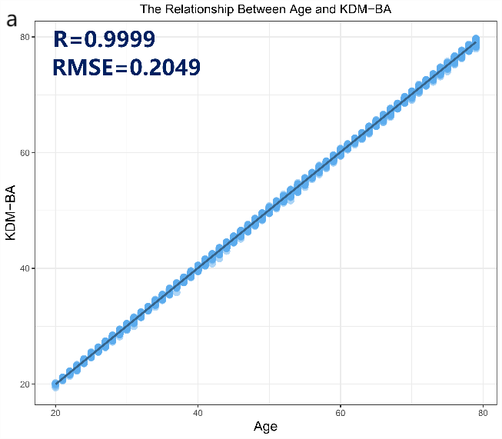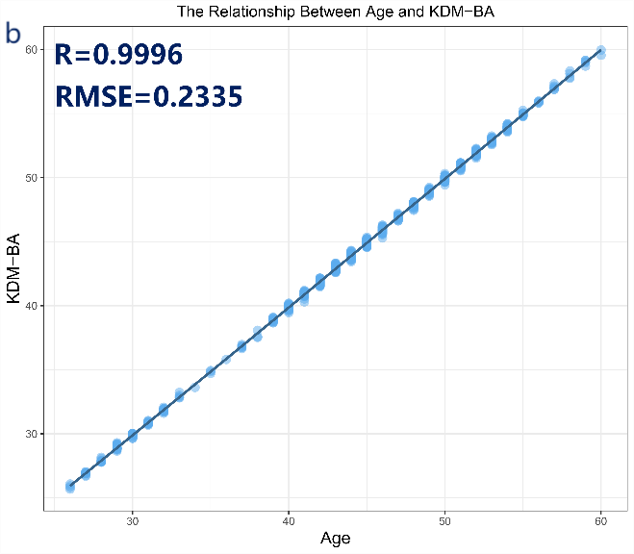
Fig.S1. Prospective cohort study data collection time chart
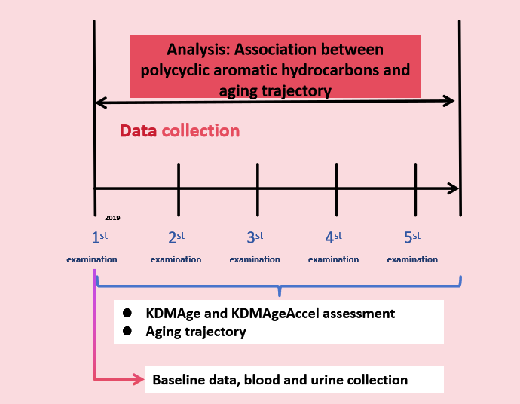
Fig.S2. Diagram of coking plant cohort study data collection time

Group | Avepp（%） | OCC | P_{j}（%） | π_{j}（%） | BIC^{#2} | △BIC^{#2} | E_{k}
1Group （2 ） | 100.00 |  | 100.00 | 100.00 | 749.29 |  | 0.000
2Group （1 1 ） | 87.24-89.53 | 9.5-6.2 | 41.01-58.99 | 41.95-58.05 | 992.92 | 243.63 | 0.636
3Group （1 2 3 ） | 85.72-84.17-83.78 | 30.2-4.2-13.7 | 14.86-59.14-26.00 | 16.59-56.09-27.31 | 1056.95 | 64.03 | 0.673
4Group （1 2 1 2 ） | 86.74-83.38-84.47-98.51 | 34.7-4.3-12.9-7689.1 | 13.97-57.06-28.23-0.74 | 15.88-53.68-29.58-0.85 | 1087.17 | 30.22 | 0.739
5Group （1 2 1 1 2 ） | 82.64-73.86-71.94-80.67-99.21 | 42.1-6.0-3.8-20.7-14477.6 | 9.21-31.65-44.28-14.12-0.74 | 10.17-32.02-40.21-16.75-0.86 | 1088.47 | 1.30 | 0.646
6Group （0 1 2 1 0 2 ） | 77.99-80.18-77.92-83.54-58.07-98.92 | 765.0-22.2-3.6-14.0-17.5-10568.7 | 0.45-15.30-55.27-25.71-2.53-0.74 | 0.46-15.41-49.29-26.66-7.32-0.86 | 1085.99 | -2.48 | 0.712
AIC（Akaike information criterion）， BIC^{#2}（Bayesian Information Criterion）, E_{k}（Relative entropy）， Avepp （Average posterior probability）。A good model fit is characterized by: (1) the correct classification advantage (OCC) for each class being greater than 5, and (2) a strong agreement between the posterior probability of group membership (Pj) and the actual group membership probability (πj).
TableS3 Evaluation indicators for the fitting effect of different aging trajectory models

Group | Class | OCC | Avepp（%） | P_{j}（%） | π_{j}（%）
1Group | Class1 |  | 100.00 | 100.00 | 100.00
2Group | Class1 | 9.5 | 87.24 | 41.01 | 41.95
 | Class2 | 6.2 | 89.53 | 58.99 | 58.05
3Group | Class1 | 30.2 | 85.72 | 14.86 | 16.59
 | Class2 | 4.2 | 84.17 | 59.14 | 56.09
 | Class3 | 13.7 | 83.78 | 26.00 | 27.31
4Group | Class1 | 34.7 | 86.74 | 13.97 | 15.88
 | Class2 | 4.3 | 83.38 | 57.06 | 53.68
 | Class3 | 12.9 | 84.47 | 28.23 | 29.58
 | Class4 | 7689.1 | 98.51 | 0.74 | 0.85
5Group | Class1 | 42.1 | 82.64 | 9.21 | 10.17
 | Class2 | 6.0 | 73.86 | 31.65 | 32.02
 | Class3 | 3.8 | 71.94 | 44.28 | 40.21
 | Class4 | 20.7 | 80.67 | 14.12 | 16.75
 | Class5 | 14477.6 | 99.21 | 0.74 | 0.86
6Group | Class1 | 765.0 | 77.99 | 0.45 | 0.46
 | Class2 | 22.2 | 80.18 | 15.30 | 15.41
 | Class3 | 3.6 | 77.92 | 55.27 | 49.29
 | Class4 | 14.0 | 83.54 | 25.71 | 26.66
 | Class5 | 17.5 | 58.07 | 2.53 | 7.32
 | Class6 | 10568.7 | 98.92 | 0.74 | 0.86
AIC（Akaike information criterion）， BIC^{#2}（Bayesian Information Criterion）, E_{k}（Relative entropy）， Avepp （Average posterior probability）。
Good model fit is characterized by: (1) the odds of correct classification (OCC) for each class being greater than 5, (2) a good consistency between the posterior probability of group membership (Pj) and the actual probability of group membership (πj).
TableS4 Aging trajectory model parameter estimation

Group | Class | Parameter | β | SE | t | P
1Group | Class.1 | Intercept | -0.10570 | 0.00660 | -16.015 | 0.00000
 |  | Linear | 0.05133 | 0.00859 | 5.976 | 0.00000
 |  | Quadratic | -0.00381 | 0.00214 | -1.780 | 0.07513
2Group | Class.1 | Intercept | -0.22002 | 0.00995 | -22.113 | 0.00000
 |  | Linear | 0.03426 | 0.00330 | 10.382 | 0.00000
 | Class.2 | Intercept | -0.01420 | 0.00839 | -1.692 | 0.09068
 |  | Linear | 0.03871 | 0.00276 | 14.025 | 0.00000
3Group | Class.1 | Intercept | -0.30307 | 0.01502 | -20.178 | 0.00000
 |  | Linear | 0.03287 | 0.00501 | 6.561 | 0.00000
 | Class.2 | Intercept | -0.12619 | 0.01023 | -12.335 | 0.00000
 |  | Linear | 0.05731 | 0.00939 | 6.103 | 0.00000
 |  | Quadratic | -0.00470 | 0.00234 | -2.009 | 0.04469
 | Class.3 | Intercept | 0.05147 | 0.01362 | 3.779 | 0.00016
 |  | Linear | 0.09706 | 0.03132 | 3.099 | 0.00196
 |  | Quadratic | -0.03939 | 0.02023 | -1.947 | 0.00000
 |  | Cubic | 0.00611 | 0.00333 | 1.835 | 0.00000
4Group | Class.1 | Intercept | -0.30801 | 0.01495 | -20.603 | 0.00000
 |  | Linear | 0.03321 | 0.00500 | 6.642 | 0.00000
 | Class.2 | Intercept | -0.13257 | 0.01013 | -13.087 | 0.00000
 |  | Linear | 0.05823 | 0.00935 | 6.228 | 0.00000
 |  | Quadratic | -0.00510 | 0.00234 | -2.179 | 0.02939
 | Class.3 | Intercept | 0.04004 | 0.01156 | 3.464 | 0.00054
 |  | Linear | 0.03995 | 0.00367 | 10.886 | 0.00000
 | Class.4 | Intercept | 0.20460 | 0.05511 | 3.713 | 0.00021
 |  | Linear | 0.34714 | 0.06489 | 5.350 | 0.00000
 |  | Quadratic | -0.11229 | 0.01578 | -7.116 | 0.00000
5Group | Class.1 | Intercept | -0.34100 | 0.01968 | -17.327 | 0.00000
 |  | Linear | 0.03384 | 0.00622 | 5.441 | 0.00000
 | Class.2 | Intercept | -0.18854 | 0.02297 | -8.208 | 0.00000
 |  | Linear | 0.06459 | 0.01301 | 4.965 | 0.00000
 |  | Quadratic | -0.00782 | 0.00321 | -2.436 | 0.01491
 | Class.3 | Intercept | -0.06268 | 0.02452 | -2.556 | 0.01064
 |  | Linear | 0.04103 | 0.00365 | 11.241 | 0.00000
 | Class.4 | Intercept | 0.07381 | 0.01707 | 4.324 | 0.00002
 |  | Linear | 0.04032 | 0.00519 | 7.769 | 0.00000
 | Class.5 | Intercept | 0.20428 | 0.05328 | 3.834 | 0.00013
 |  | Linear | 0.34745 | 0.06326 | 5.492 | 0.00000
 |  | Quadratic | -0.11245 | 0.01533 | -7.335 | 0.00000
6Group | Class.1 | Intercept | -0.48276 | 0.06464 | -7.468 | 0.00000
 | Class.2 | Intercept | -0.30791 | 0.01775 | -17.347 | 0.00000
 |  | Linear | 0.03759 | 0.00526 | 7.146 | 0.00000
 | Class.3 | Intercept | -0.12723 | 0.01067 | -11.924 | 0.00000
 |  | Linear | 0.06376 | 0.01018 | 6.263 | 0.00000
 |  | Quadratic | -0.00521 | 0.00245 | -2.127 | 0.03356
 | Class.4 | Intercept | 0.05031 | 0.01181 | 4.260 | 0.00002
 |  | Linear | 0.03878 | 0.00381 | 10.178 | 0.00000
 | Class.5 | Intercept | -0.12024 | 0.02387 | -5.037 | 0.00000
 | Class.6 | Intercept | 0.20454 | 0.05355 | 3.820 | 0.00014
 |  | Linear | 0.34722 | 0.06334 | 5.482 | 0.00000
 |  | Quadratic | -0.11236 | 0.01538 | -7.306 | 0.00000

TableS5 Evaluation of the fitting effect of each trajectory group in the aging trajectory model

Group | Class | Curve equation
1 Group | Class1 | ŷ= 0.00004-0.00004x+0.00001x²
2 Group | Class1 | ŷ= 0.00010-0.00002x
2 Group | Class2 | ŷ= 0.00003+0.00000x
3 Group | Class1 | ŷ= 0.00023-0.00005x
3 Group | Class2 | ŷ= 0.00005-0.00000x+0.00000x²
3 Group | Class3 | ŷ= 0.00004+0.00003x-0.00002x²+0.00000x³
4 Group | Class1 | ŷ= 0.00022-0.00005x
4 Group | Class2 | ŷ= 0.00004-0.00000x+0.00000x²
4 Group | Class3 | ŷ= 0.00004-0.00000x
4 Group | Class4 | ŷ= 0.00000+0.00000x-0.00000x²
5 Group | Class1 | ŷ= 0.00039-0.00006x
5 Group | Class2 | ŷ= 0.00022+0.00000x+0.00000x²
5 Group | Class3 | ŷ= 0.00020-0.00000x
5 Group | Class4 | ŷ= 0.00008+0.00001x
5 Group | Class5 | ŷ= -0.00000-0.00000x+0.00000x²
6 Group | Class1 | ŷ= 0.00418
6 Group | Class2 | ŷ= 0.00039-0.00001x
6 Group | Class3 | ŷ= 0.00007-0.00000x+0.00000x²
6 Group | Class4 | ŷ= 0.00004-0.00000x
6 Group | Class5 | ŷ= 0.00021
6 Group | Class6 | ŷ= -0.00000+0.00000x-0.00000x²
TableS6 Curve equations of each trajectory group within the aging trajectory model

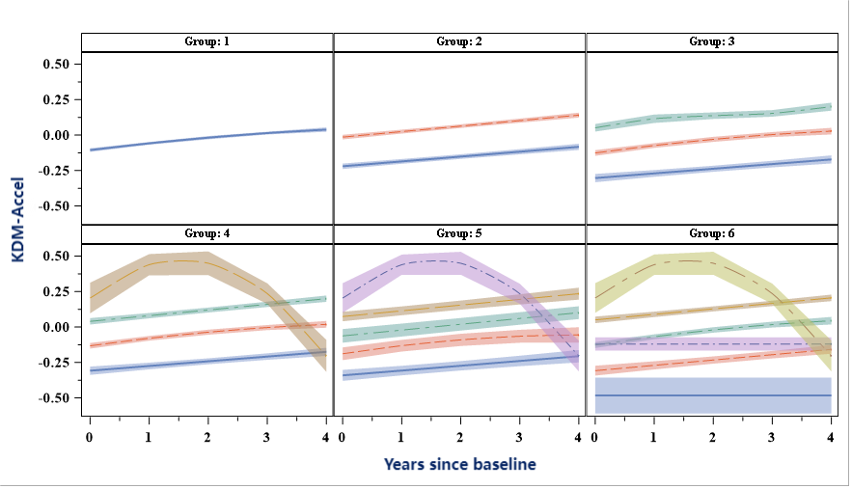
Fig.S3.Figure of each group's aging trajectory fitting

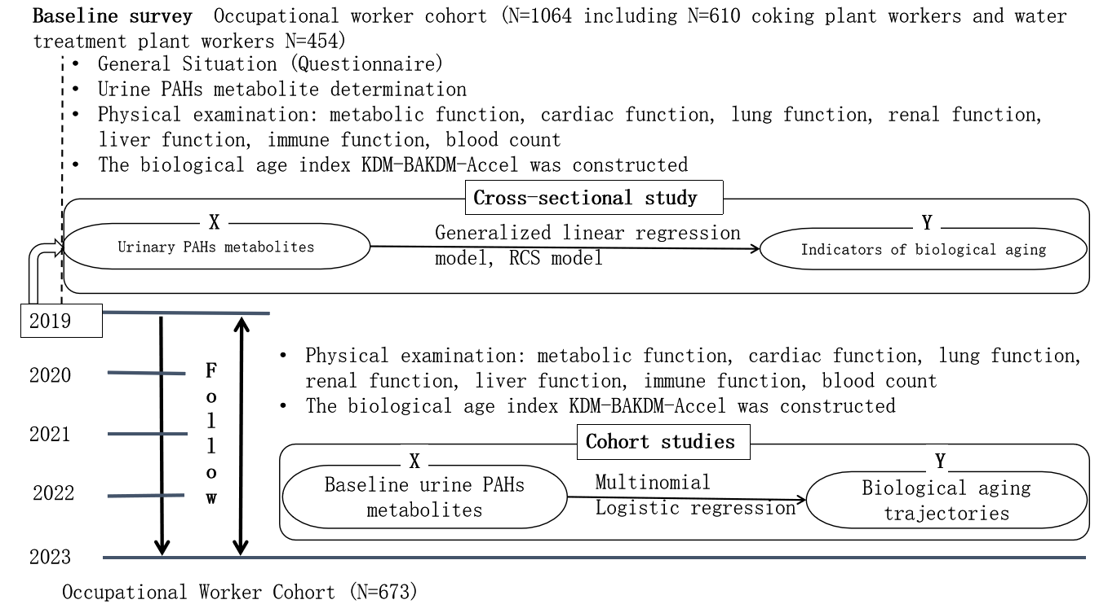
Fig.S4. Technology Roadmap

variable | Total population | Coke Plant | Water Treatment Plant | P
variable | n=673 | n=383 | n=290 | P
Age (years) | 44.71 ± 7.32 | 43.07 ± 7.96 | 46.89 ± 5.71 | <0.001
gender |  |  |  | 0.017
man | 602（89.45） | 352（91.91） | 250（86.21）
woman | 71（10.55） | 31（8.09） | 40（13.79）
Educational attainment (years, N%) |  |  |  | 0.401
1-9 | 176（26.15） | 95（24.80） | 81（27.93）
10-12 | 421（62.56） | 240（62.66） | 181（62.41）
≥13 | 76（11.29） | 48（12.53） | 28（9.66）
marital status  (Yes, N%) |  |  |  | 0.315
Yes | 636（94.50） | 359（93.73） | 277（95.52）
No | 37（5.50） | 24（6.27） | 13（4.48）
Smoking  (Yes, N%) | 409（60.77） | 171（44.65） | 148（51.03） | 0.100
Alcohol consumption  (Yes, n%) | 275（40.86） | 161（42.04） | 114（39.31） | 0.476
Tea drinking condition  (Yes, n%) | 426（63.30） | 232（60.57） | 194（66.90） | 0.092
Exercise status |  |  |  | <0.001
never | 186（27.64） | 126（32.90） | 60（20.69）
Occasionally | 243（36.11） | 132（34.46） | 111（38.28）
often | 244（36.26） | 125（32.64） | 119（41.03）
Night shift (yes, n%) | 467（69.60） | 272（71.02） | 195（67.71） | 0.356
KDM (years)
kdm_advance (years old) | 0.68 ± 1.22 | 0.94 ± 1.49 | 0.35 ± 0.53 | <0.001
Urine PAHs metabolites (μg/L) | 0.25 ± 1.16 | 0.36 ± 1.53 | 0.11 ± 1.14 | 0.003
2-OHNap | 0.09 ± 0.15 | 0.12 ± 0.18 | 0.07 ± 0.08 | <0.001
1-OHNap | 0.15 ± 0.18 | 0.18 ± 0.20 | 0.12 ± 0.15 | <0.001
3-OHFlu | 0.28 ± 0.47 | 0.40 ± 0.59 | 0.11 ± 0.09 | <0.001
2 OHFlu | 0.42 ± 0.55 | 0.46 ± 0.67 | 0.37 ± 0.35 | 0.173
2-OHPhe | 0.10 ± 0.16 | 0.12 ± 0.18 | 0.08 ± 0.13 | <0.001
9-OHPhe | 0.20 ± 0.25 | 0.24 ± 0.32 | 0.15 ± 0.09 | 0.161
1-OHPhe | 0.06 ± 0.09 | 0.07 ± 0.12 | 0.04 ± 0.03 | 0.833
1-OHPyr | 0.08 ± 0.08 | 0.09 ± 0.09 | 0.08 ± 0.06 | 0.017
3-OHChr | 0.06 ± 0.09 | 0.07 ± 0.10 | 0.05 ± 0.06 | 0.221
6-OHChr | 2.19 ± 2.67 | 2.82 ± 3.28 | 1.37 ± 1.04 | <0.001
9-OHBap | 44.61 ± 7.33 | 42.97 ± 7.97 | 46.77 ± 5.74 | <0.001
Ʃ-OH PAHs | -0.11 ± 0.17 | -0.09 ± 0.18 | -0.12 ± 0.16 | 0.321
Note: Bold represents P<0.05;
The continuous data were expressed as x±s, and the statistical differences were compared by ANOVA.
The numerical data were expressed as n (%), and the chi-square test was used to compare the statistical differences.
TableS7 Basic Characteristics of Coke Plant Queue Workers(n=673)

Urine metabolites of OH-PAHs | Moderate aging vs. slow aging |  |  | High aging vs. slow aging
Urine metabolites of OH-PAHs | OR （95% CI） | P |  | OR （95% CI） | P
Ʃ-OHPAHs ª | 1.453（1.001,2.108） | 0.049 |  | 1.631（1.082,2.459） | 0.019
2-OHNAP ^{b} | 1.185（0.937,1.497） | 0.156 |  | 0.981（0.771,1.247） | 0.875
1-OHNAP ^{b} | 0.893（0.642,1.242） | 0.502 |  | 0.985（0.688,1.408） | 0.932
3-OHFLU ^{b} | 1.142（0.867,1.505） | 0.344 |  | 1.158（0.864,1.551） | 0.328
2-OHFLU ^{b} | 0.622（0.390,0.991） | 0.046 |  | 0.565（0.337,0.946） | 0.030
2-OHPHE ^{b} | 1.118（0.878,1.423） | 0.366 |  | 1.622（1.156,2.277） | 0.005
9-OHPHE ^{b} | 1.255（0.807,1.950） | 0.313 |  | 1.267（0.785,2.045） | 0.332
1-OHPHE ^{b} | 0.999（0.760,1.312） | 0.993 |  | 0.868（0.614,1.227） | 0.422
1-OHPYR ^{b} | 1.467（1.010,2.131） | 0.044 |  | 1.503（1.113,2.029） | 0.008
3-OHChr ^{b} | 0.759（0.536,1.076 ） | 0.122 |  | 0.829（0.545,1.262） | 0.383
6-OHChr ^{b} | 1.125（0.862,1.468） | 0.388 |  | 1.015（0.707,1.457） | 0.937
9-OHBap ^{b} | 1.050（0.830,1.328） | 0.685 |  | 1.208（0.892,1.636） | 0.222
Table S8 The Relationship Between Urinary OH-PAHs Metabolites and the Aging Trajectory in Male Occupational Workers
Slow aging: Slow aging trajectory, Moderate aging: Moderately accelerated aging trajectory, High aging: Highly accelerated aging trajectory.
Model: a Adjusted for age, education level, smoking status, alcohol consumption, tea consumption, physical activity, monthly income, and night shift status. b Adjusted for age, education level, smoking status, alcohol consumption, tea consumption, physical activity, monthly income, night shift status, and other urinary OH-PAH metabolites. P<0.05.

Urine metabolites of OH-PAHs | Moderate aging vs. slow aging |  |  | High aging vs. slow aging
Urine metabolites of OH-PAHs | OR （95% CI） | P 值 |  | OR （95% CI） | P 值
Ʃ-OHPAHs ª | 1.097（0.470,2.561） | 0.830 |  | 1.333（0.209,8.485） | 0.761
2-OHNAP ^{b} | 0.854（0.408,1.789） | 0.676 |  | 0.659（0.156,2.783） | 0.570
1-OHNAP ^{b} | 1.006（0.342,2.964） | 0.991 |  | 1.218（0.421,3.525） | 0.716
3-OHFLU ^{b} | 2.597（0.880,7.661） | 0.084 |  | 1.457（0.615,3.450） | 0.392
2-OHFLU ^{b} | 0.226（0.056,0.909） | 0.036 |  | 0.044（0.002,0.904） | 0.043
2-OHPHE ^{b} | 1.314（0.593,2.907） | 0.501 |  | 0.725（0.231,2.277） | 0.581
9-OHPHE ^{b} | 0.569（0.089,3.647） | 0.552 |  | 0.158（0.008,3.049） | 0.222
1-OHPHE ^{b} | 1.660（0.480,5.741） | 0.424 |  | 0.436（0.157,1.209） | 0.111
1-OHPYR ^{b} | 2.520（0.592,10.727） | 0.211 |  | 3.113（0.7,13.832） | 0.136
3-OHChr ^{b} | 0.660（0.126,3.446 ） | 0.622 |  | 1.716（0.794,3.709） | 0.170
6-OHChr ^{b} | 2.150（0.660,6.999） | 0.204 |  | 1.966（0.322,12.011） | 0.464
9-OHBap ^{b} | 0.759（0.325,1.773 ） | 0.524 |  | 4.145（0.629,27.307） | 0.139
Table S9 The Relationship Between Urinary OH-PAHs Metabolites and the Aging Trajectory in Female Occupational Workers
Slow aging: Slow aging trajectory, Moderate aging: Moderately accelerated aging trajectory, High aging: Highly accelerated aging trajectory.
Model: a Adjusted for age, education level, smoking status, alcohol consumption, tea consumption, physical activity, monthly income, and night shift status. b Adjusted for age, education level, smoking status, alcohol consumption, tea consumption, physical activity, monthly income, night shift status, and other urinary OH-PAH metabolites. P<0.05.

