Supplementary

Fibrivirga algicola gen. nov., sp. nov., an algicidal bacterium isolated from a freshwater river

Sanghwa Park¹, Ja Young Cho¹, Dong-Hyun Jung¹, Seok Won Jang¹, Jung Hye Eom¹, Seung Won Nam², Dae Ryul Kwon², Jaewon Ryu³, Keug Tae Kim^{4*}

1. Bacteria Research Team. Freshwater Bacteria Research Department, Nakdonggang National Institute of Biological Resources (NNIBR), 137 Donam 2-gil, Sangju 37242, Republic of Korea
2. Protist Research Team. Freshwater Bacteria Research Department, Nakdonggang National Institute of Biological Resources (NNIBR), 137 Donam 2-gil, Sangju 37242, Republic of Korea
3. Department of Environmental Bio Research, Eco P&G Co., The University of Suwon, 17 Wauan-gil, Bongdam-eup, Hwaseong-si, Gyeonggi-do 18323, South Korea
4. Department of Environmental & Energy Engineering, The University of Suwon, 17 Wauan-gil, Bongdam-eup, Hwaseong-si, Gyeonggi-do 18323, South Korea

Supplementary Table 1. The genomic relatedness between strain JA-25^{T} and closely related members of genera in the family‘Spirosomaceae’ based on whole genome sequences containing the AAI, ANI and DDH (d4 formula) values

Closely related species | AAI | ANI | dDDH
Fibrella aestuarina BUZ 2^{T} | 73.58 | 67.03 | 20.50
Spirosoma lacussanchae CPCC 100624^{T} | 66.57 | 66.05 | 19.50
Spirosoma telluris HMF3257^{T} | 61.84 | 65.93 | 21.20
Rudanella lutea 5715S-11^{T} | 66.10 | 65.69 | 20.00
Rudanella paleaurantiibacter HX-22-17^{T} | 65.66 | 64.55 | 19.60

Supplementary Table 2. Cellular fatty acid composition (%) of strain JA-25^{T} and most related genus in the family ‘Spirosomaceae’
Strains: 1, Fibrivirga algicola JA-25^{T} (this study); 2, Fibrella aestuarina BUZ 2^{T} (this study); ND, not detected; TR, trace amount (< 1.0 %).
Fatty acid | 1 | 2
Saturated:
C_{14:0} | 1.3 | 1.5
C_{16:0} | 10 | 4.6
C_{18:0} | – | 1.2
Unsaturated:
C_{16:1} ω5c | 21.4 | 19.2
Branched:
iso-C_{14:0} | 1.3 | TR
iso-C_{15:0} | 7.4 | 7.3
iso-C_{16:0} | 1.4 | 1.1
anteiso-C_{15:0} | 2.9 | 4.7
Hydroxy:
C_{15:0} 3-OH | 3 | 5.6
iso-C_{15:0} 3-OH | 2.5 | 4.4.
iso-C_{16:0} 3-OH | 2.1 | 1.1
iso-C_{17:0} 3-OH | 3.4 | 3.3
Summed feature:
3 (C_{16:1} ω6c/C_{16:1} ω7c) | 40.8 | 44.5

Supplementary Fig. S1 Phylogenomic tree of Fibrovirga algicola JA-25^{T} and closely related member of genera in the family ‘Spirosomaceae’ based on ANI analysis. The similarity matrix of average nucleotide identity (ANI) between each genome was calculated by JSpecies, and the distance (1-similarity) was visualized by plot of R environment ver. 4.0.4 (https://www.r-project.org/). The scale bar represents distance in the dendrogram.

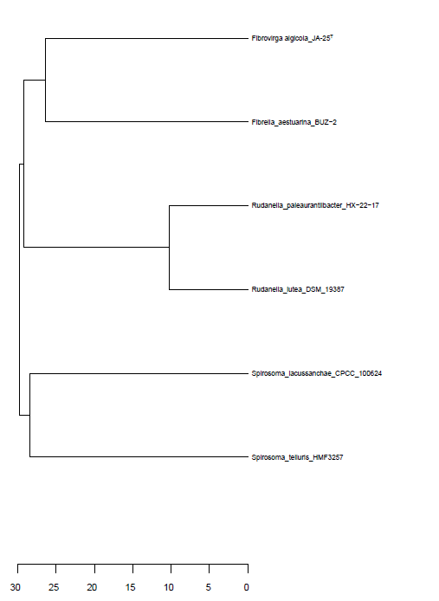

Supplementary Fig. S2. Transmission electron micrograph of a cell of strain JA-25^{T}. Bar, 0.5 μm.

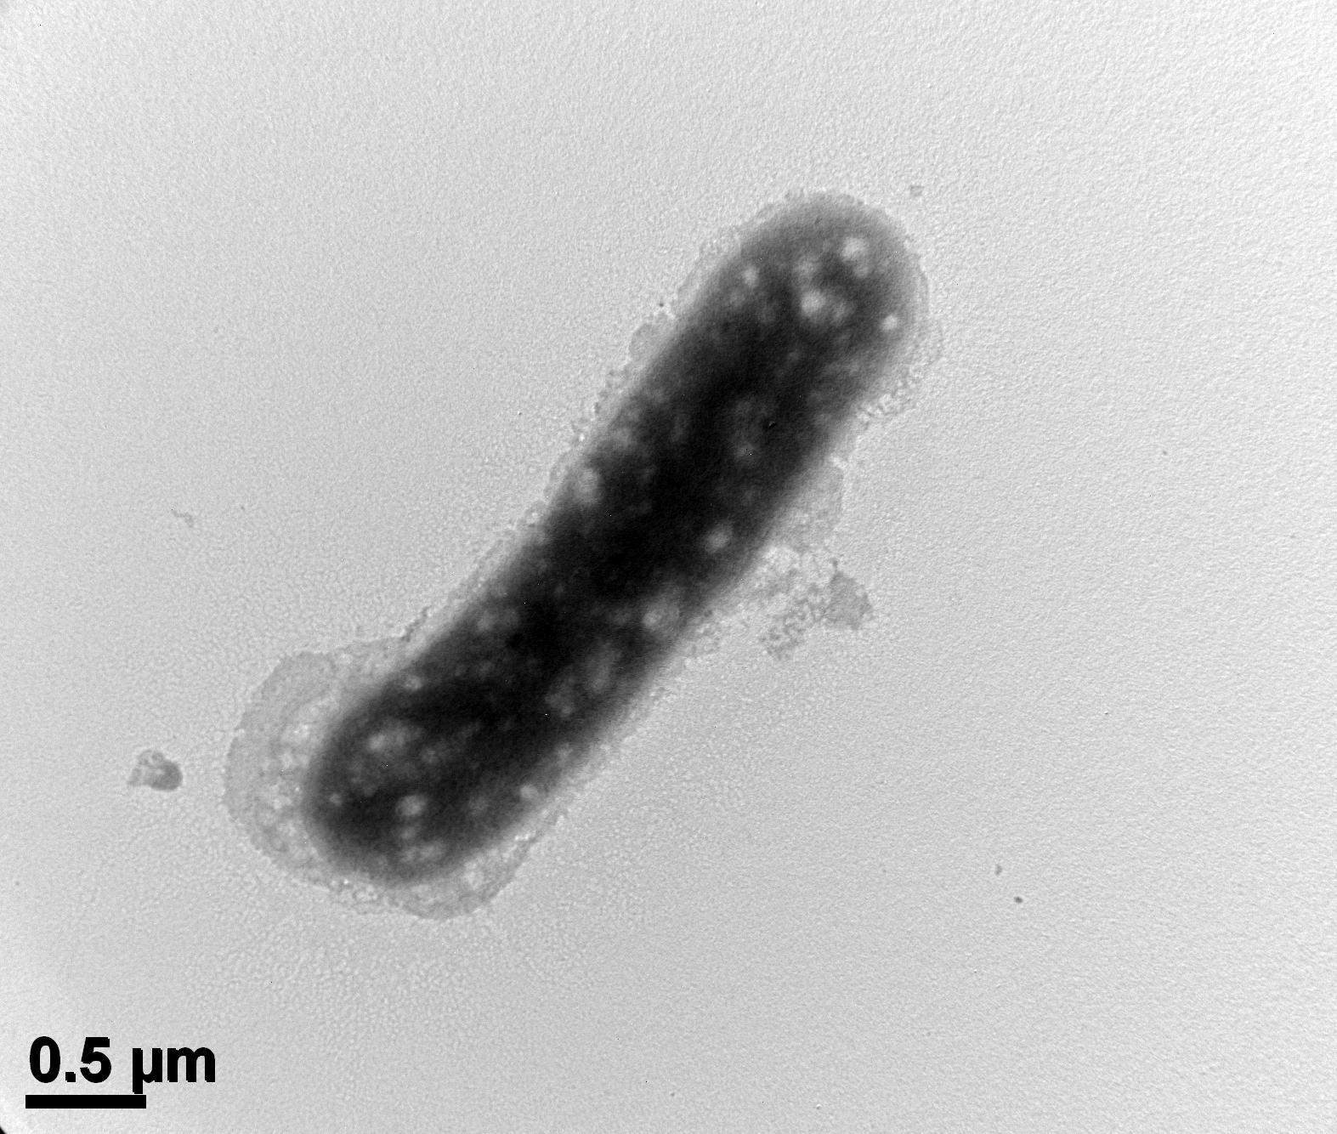

Supplementary Fig. S3. Two-dimensional thin-layer chromatograms (TLC) showing the polar lipids of strain JA-25^{T}. PE; phosphatidylethanolamine, APL1-2; unidentified aminophospholipids, PL1-2; unidentified phospholipids, L; unidentified lipid.
