Graphical abstract

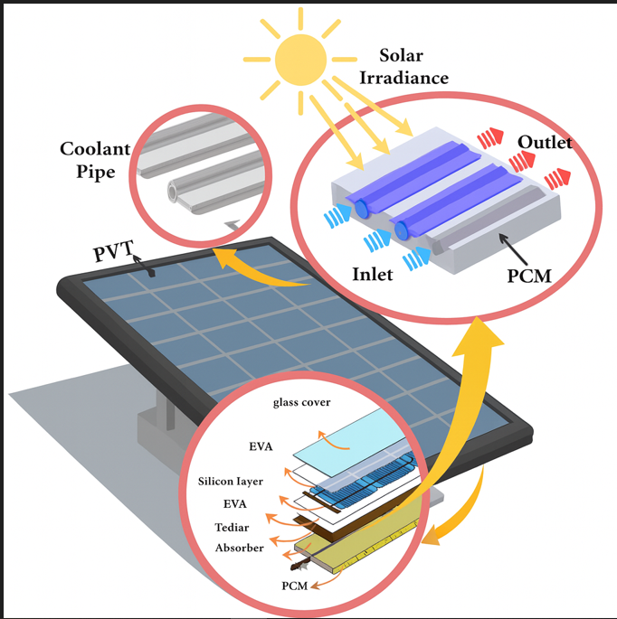
Graphical Abstract 1 Structure of a photovoltaic–thermal (PVT) system with integrated PCM and coolant pipes for energy harvesting and heat management.

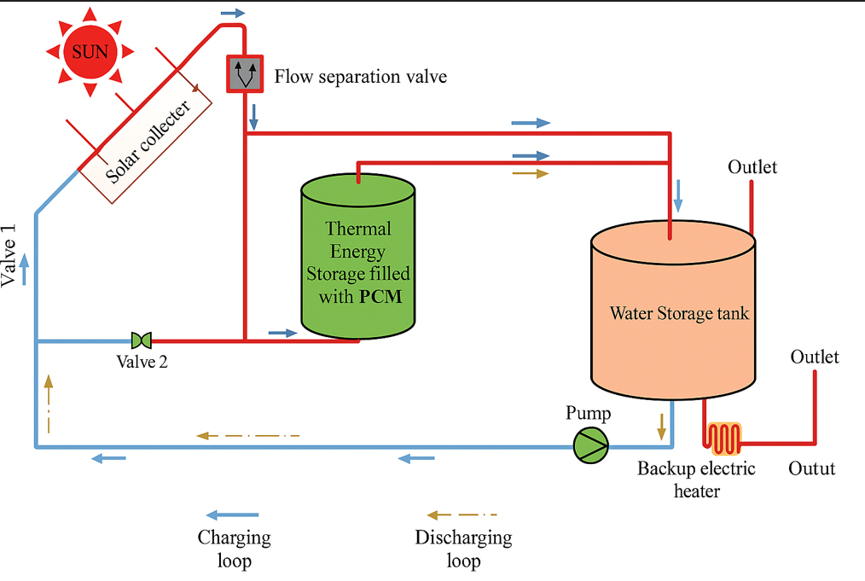
Graphical Abstract 2 Schematic diagram of a solar water heating system integrated with PCM thermal energy storage.

