Extended Fig. Legends

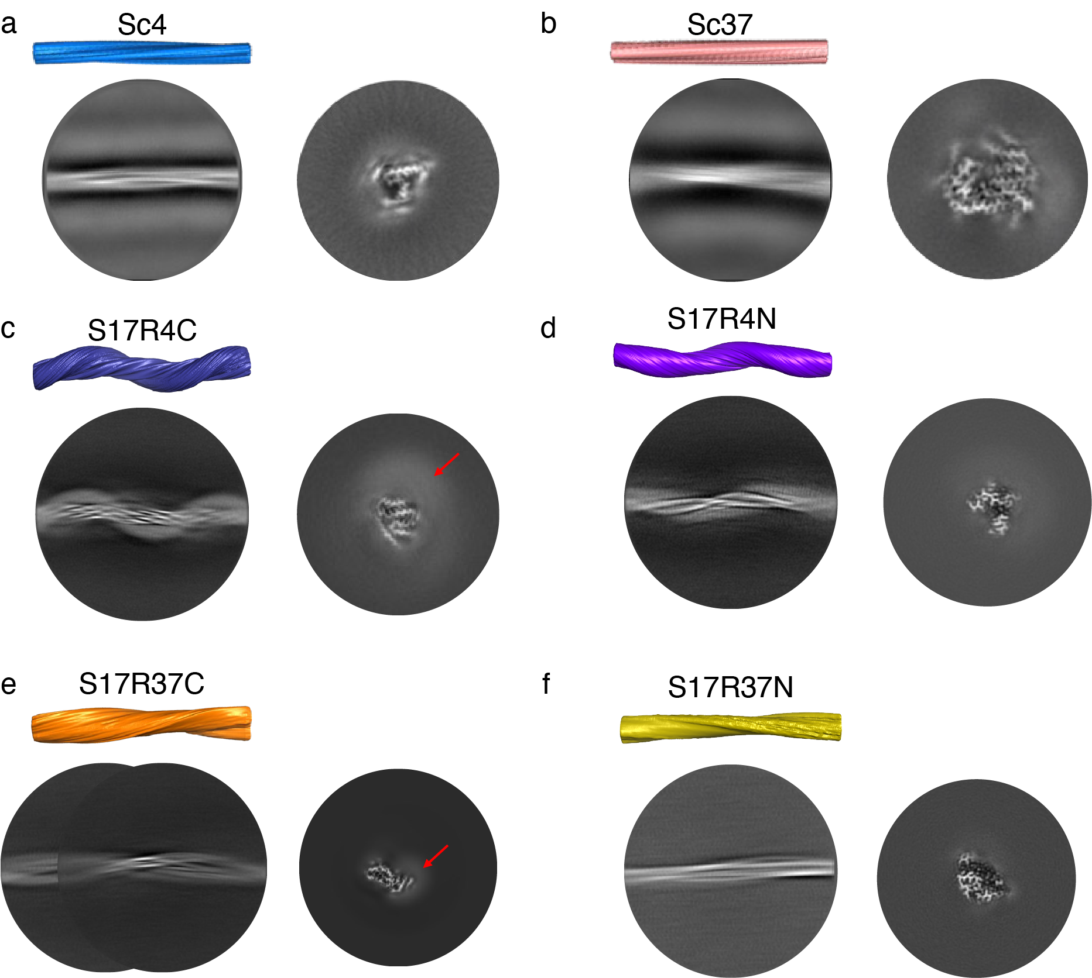

Extended Fig. 1
Side view of fibril reconstruction, 2D classes, and 3D cross-sections of amyloids formed by Sup35NM WT and S17R. a, Sc4, b, Sc37, c, S17R4C, d, S17R4N, e, S17R37C, and f, S17R37N. Red arrows indicate electron densities from the N-terminal prion domain.
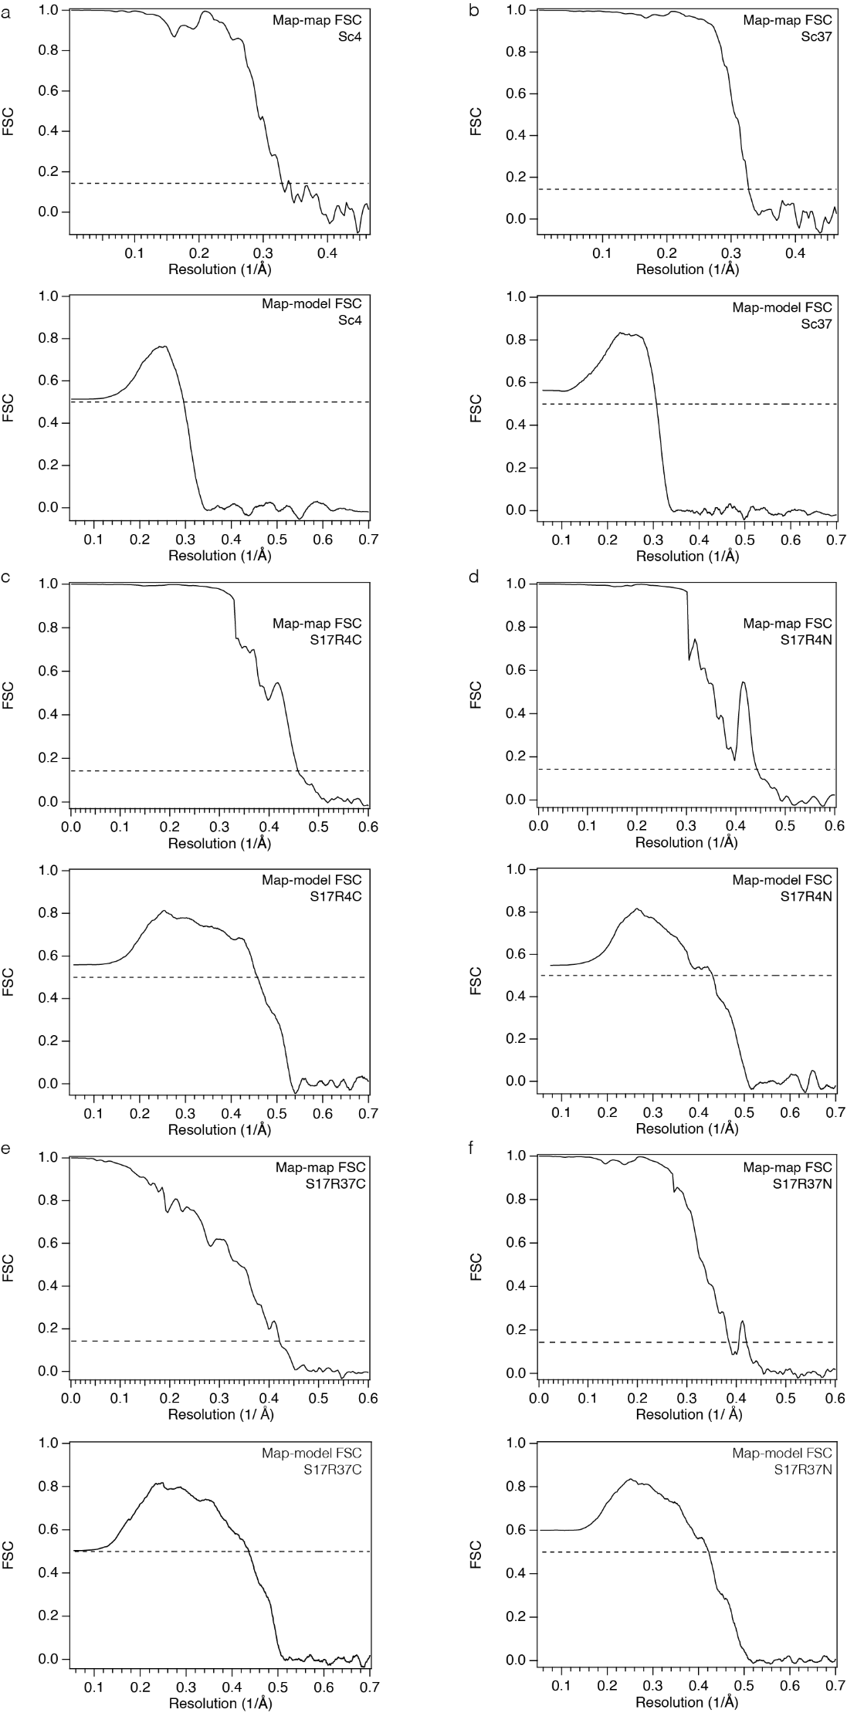

Extended Fig. 2
Map-map and map-model FSC curves of Sup35NM amyloids. a, Sc4, b, Sc37, c, S17R4C, d, S17R4N, e, S17R37C, and f, S17R37N.
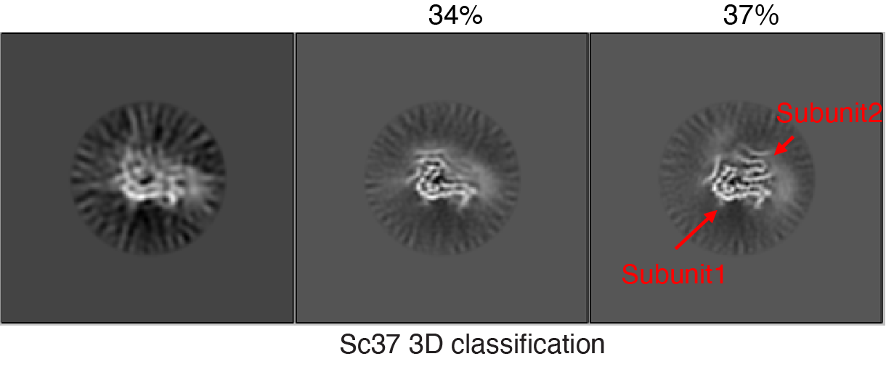

Extended Fig. 3
3D classification results for Sc37. The right panel displays a complete cross-section which has both subunit 1 and 2 (37%), while a class lacking Subunit 2 in the middle is also evident (34%).
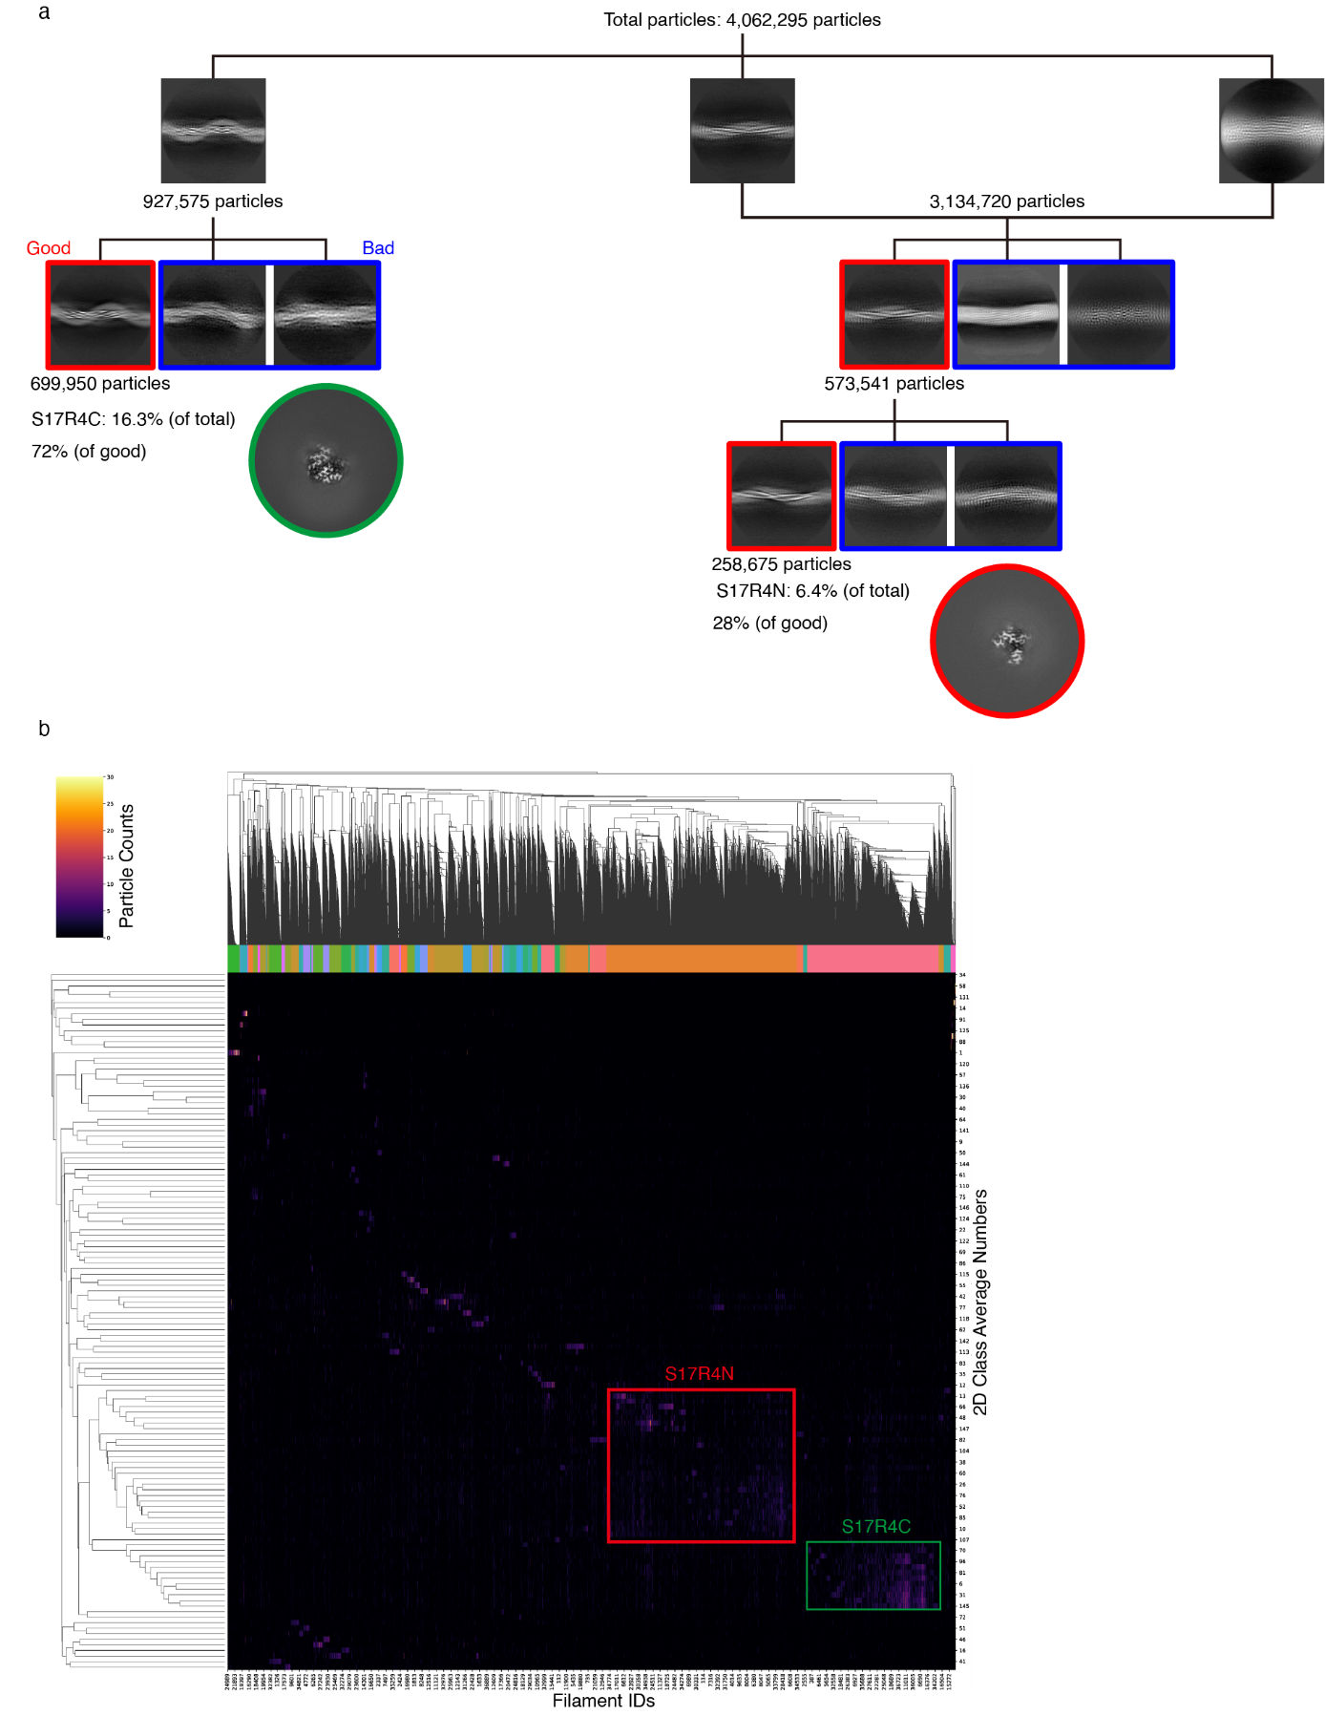

Extended Fig. 4
a, Classification of S17R4 polymorphs. The populations of each polymorph were calculated from the particles from the good 2D classes. b, Bi-hierarchical classification of S17R4 2D classes using RELION FilamentTools³⁹.
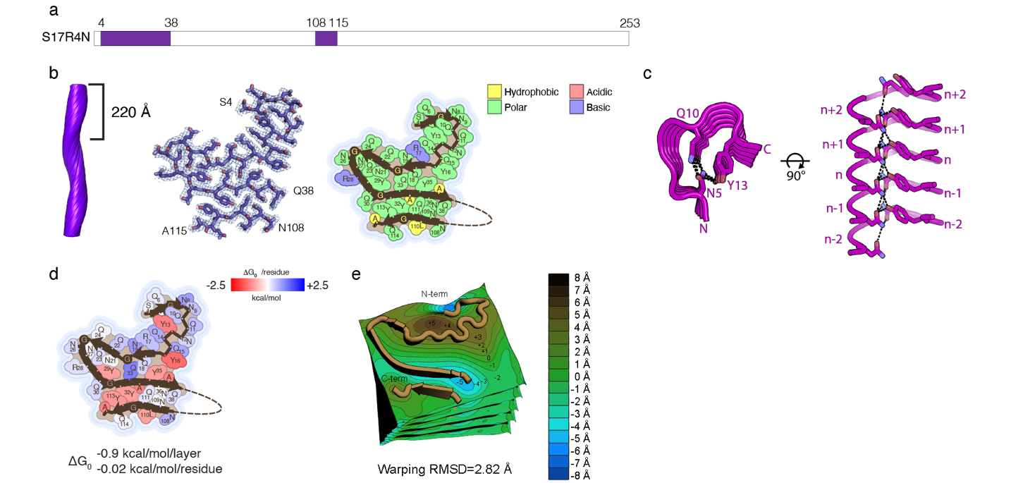

Extended Fig. 5
a, Schematic representation of the S17R4N fibril core region in the Sup35NM sequence. b, S17R4N fibril side-view, cross-section, and polarity map. c, S17R4N N-terminal residues showing a large elevation change and extensive inter-layer hydrogen bonding. d, S17R4N solvation energy map. e, S17R4N topographical map.
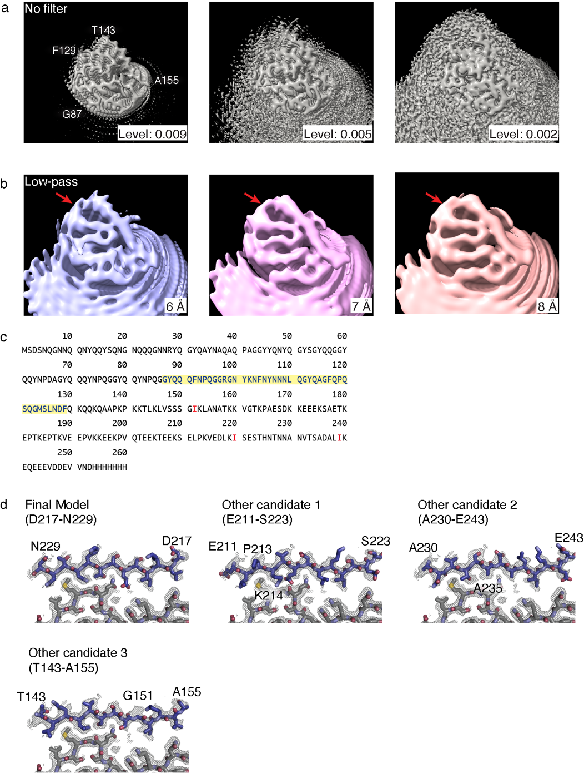

Extended Fig. 6
a, Sharpened S17R4C cryo-EM map with varying contour levels does not show a connecting density between the main fibril core (F129) and the discontinuous island density (theoretically labeled as being T143-A155). b, Applying various low-pass filters to the S17R4C cryo-EM map reveals a weak density connecting the main fibril core to the island density. c, Sup35NM sequence with residues forming the main fibril core highlighted in yellow. Isoleucine residues (colored red) were used as landmark residues to test the fit of different candidate sequences into the unidentified density. d, Model building revealed the best fitting model for the unidentified density was D217-N229. Other candidates with poorer fits are also shown. Notably, Other Candidate 3 is shown as it was initially considered due to the low-pass filtered maps in (b) suggesting that this residue sequence could form the unidentified density. However, further model building experiments identified that sequences further into the C-terminal of Sup35NM better fit the density.
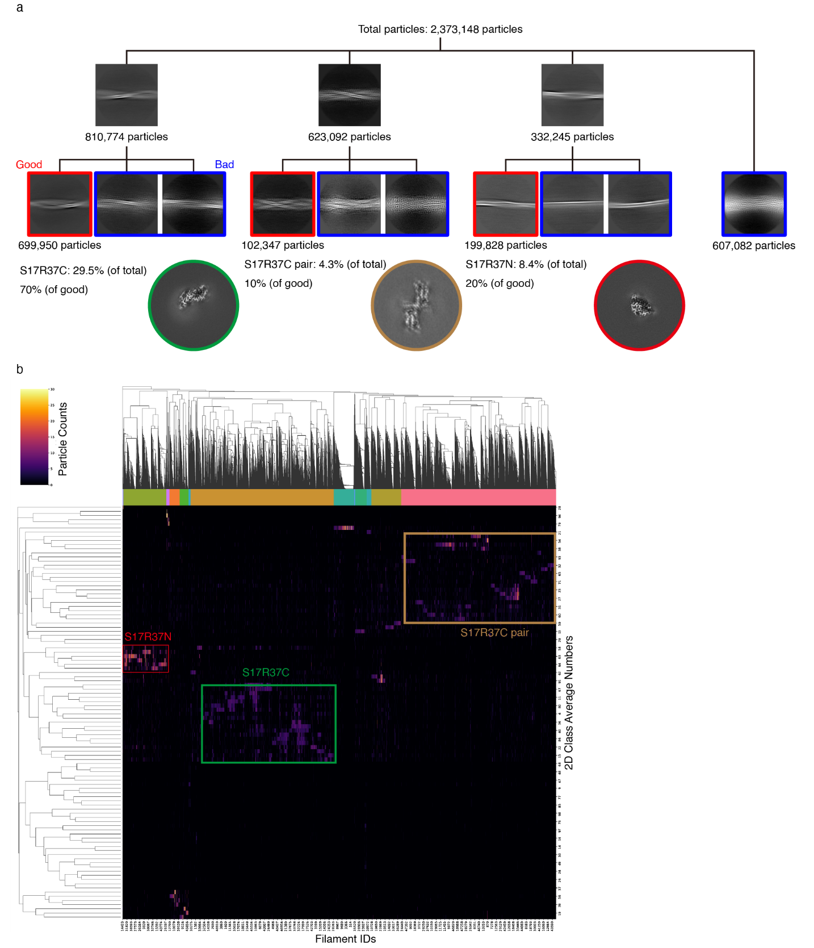

Extended Fig. 7
a, Classification of S17R37 polymorphs. The populations of each polymorph were calculated from the particles from the good 2D classes. b, Bi-hierarchical classification of S17R37 2D classes using RELION FilamentTools³⁹.
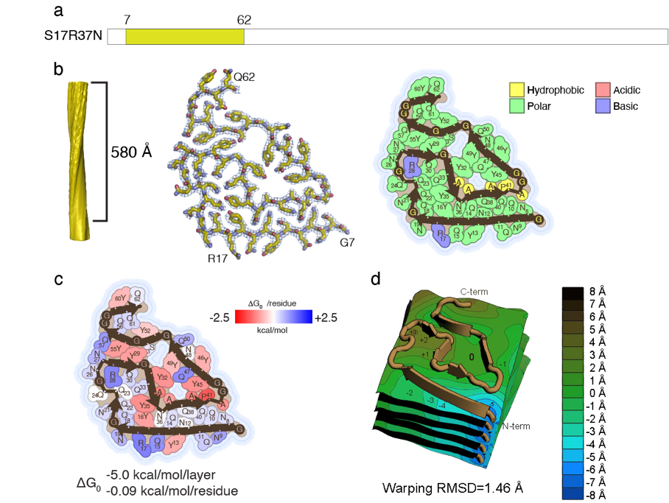

Extended Fig. 8
a, Schematic representation of the S17R37N fibril core region in the Sup35NM sequence. b, S17R37N fibril side-view, cross-section, and polarity map. c, S17R37N solvation energy map. d, S17R37N topographical map.
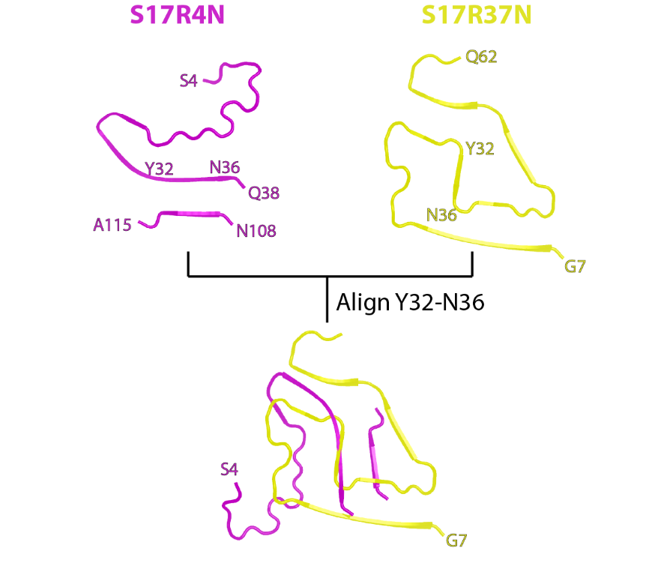

Extended Fig. 9
Structural comparison between S17R4N and S17R37N polymorphs.
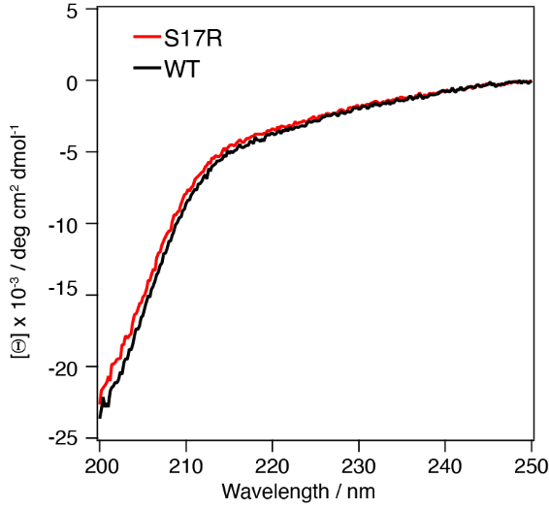

Extended Fig. 10
CD spectra of Sup35NM WT and S17R mutant monomers. Circular dichroism spectra of 10 M Sup35NM WT and S17R mutant monomer were measured at room temperature. The black and red lines show the CD spectra of WT and S17R mutant, respectively.
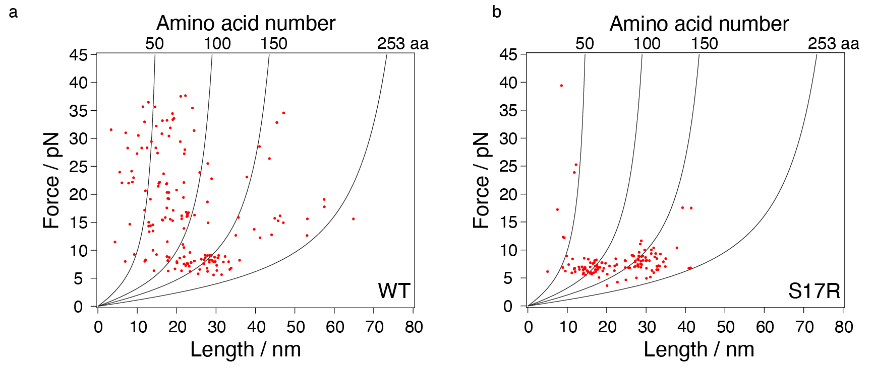

Extended Fig. 11
The scatter plots derived from force-extension curves by mechanical unfolding of Sup35NM a, WT and b, S17R mutant were shown. The X and Y axes indicate the number of amino acid residues unfolded by stretch of a single molecule and the force required for protein unfolding, respectively. The theoretical force-extension curves involving 50, 100, 150 and 253 residues are shown as black lines.
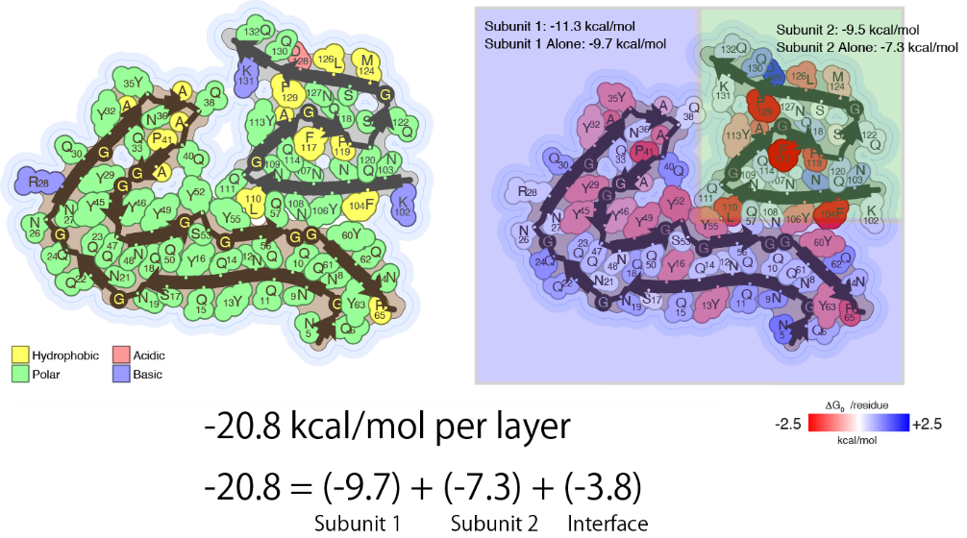

Extended Fig. 12
Stabilization energy analysis of Sc37. The sum of the stabilization energies of subunit 1 (-9.7 kcal/mol) and subunit 2 (-7.3 kcal/mol) alone was lower than that of the complete structure (-20.8 kcal/mol). This difference in stabilization energy is thought to reflect the stabilizing effect of the subunit 1 and 2 interaction interface (-3.8 kcal/mol) between subunits 1 and 2.
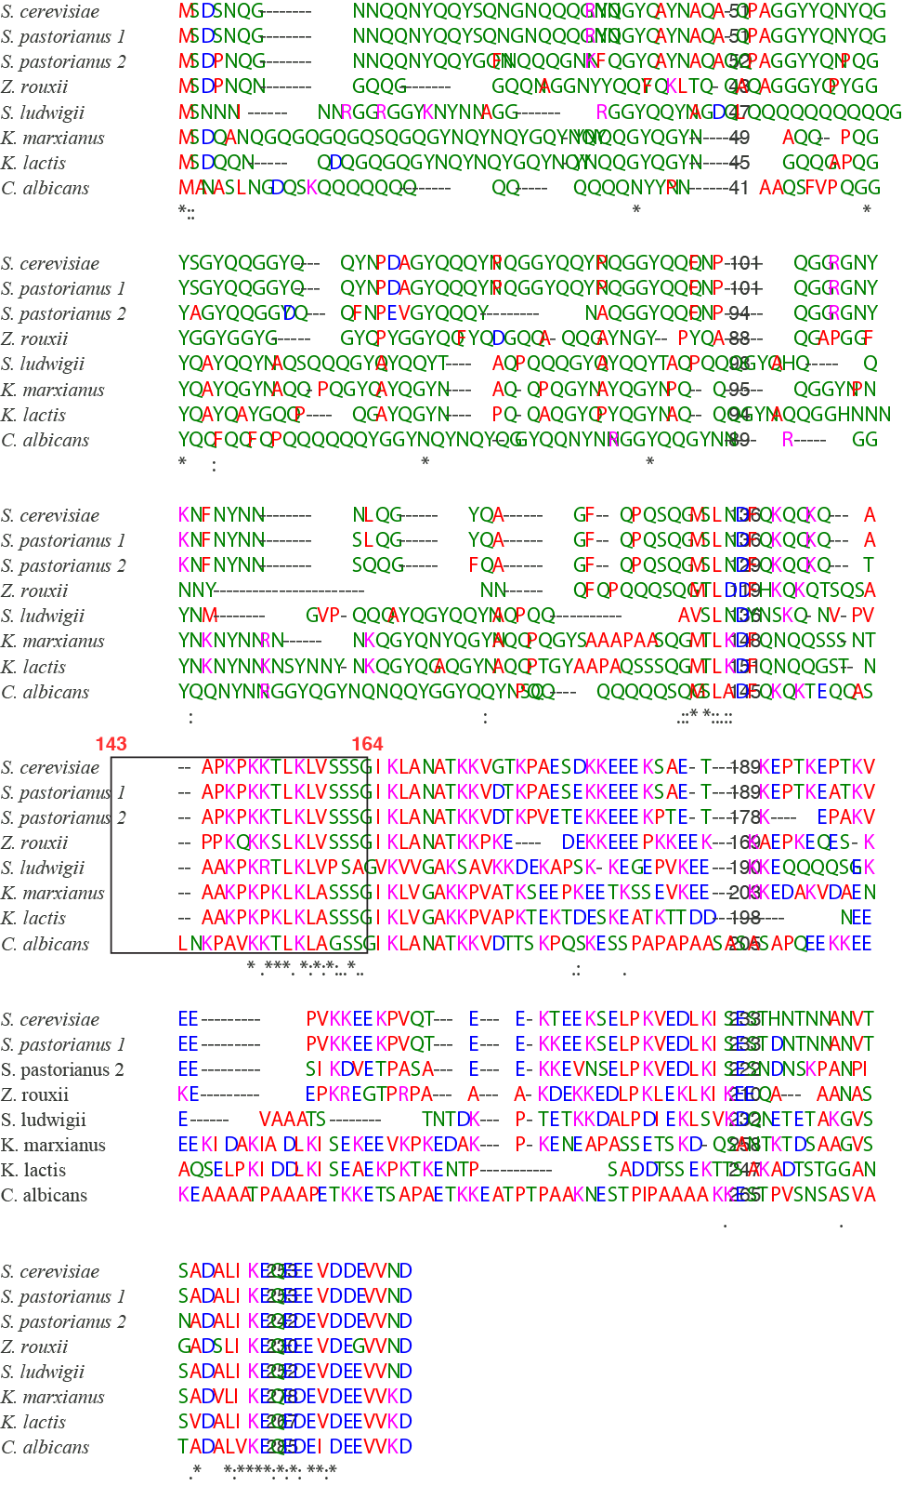

Extended Fig. 13
Alignment of amino acid sequence of Sup35 between various yeast species. The dotted box represents the Ssa1/Sis1-binding region. The analysis was performed by https://www.genome.jp/tools-bin/clustalw.

