Supplementary figures and figure legends
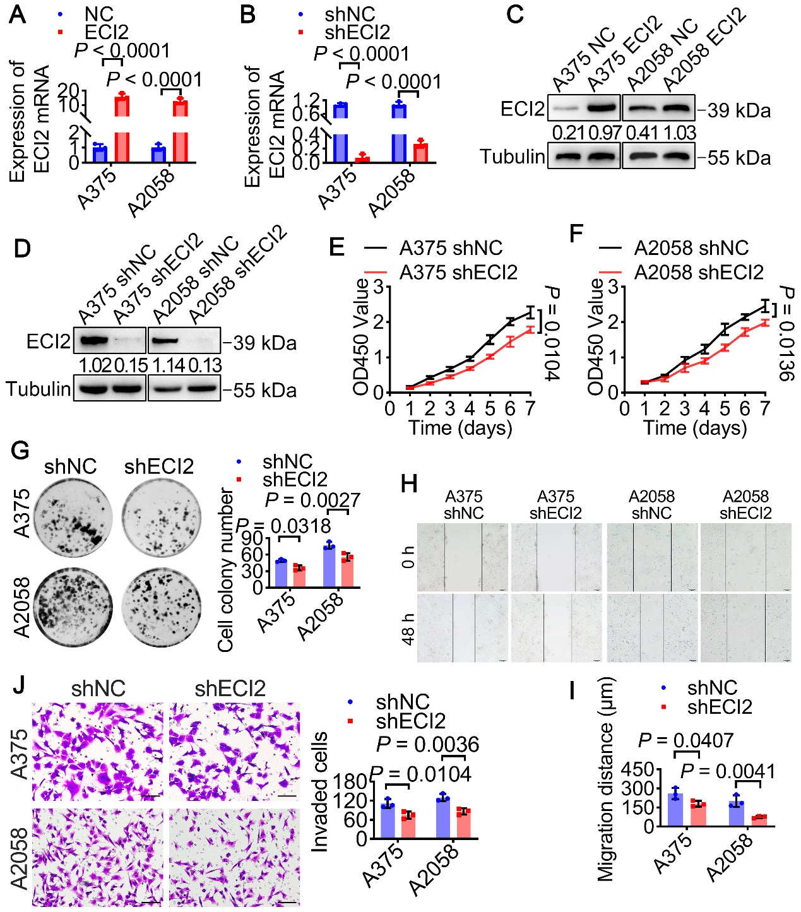
Figure S1. (A–B) Validation of ECI2 stable overexpression and knockdown efficiency via RT-qPCR (A–B) and Western blot (C–D). (E–F) CCK8 assay detecting proliferation changes in melanoma cells A375 (E) and A2058 (F) following ECI2 knockdown. (G) Representative images of colony formation by ECI2-knockdown melanoma cells. Quantitative analysis shown in the right panel. (H-I) Representative images of wound healing assays assessing migration ability in ECI2-knockdown melanoma cells (scale bar 100 μm). Quantitative analysis shown in panel I. (J) Representative images of Transwell invasion assay assessing ECI2-silenced melanoma cell invasion (scale bar 50 μm). Quantitative analysis shown in the right panel.

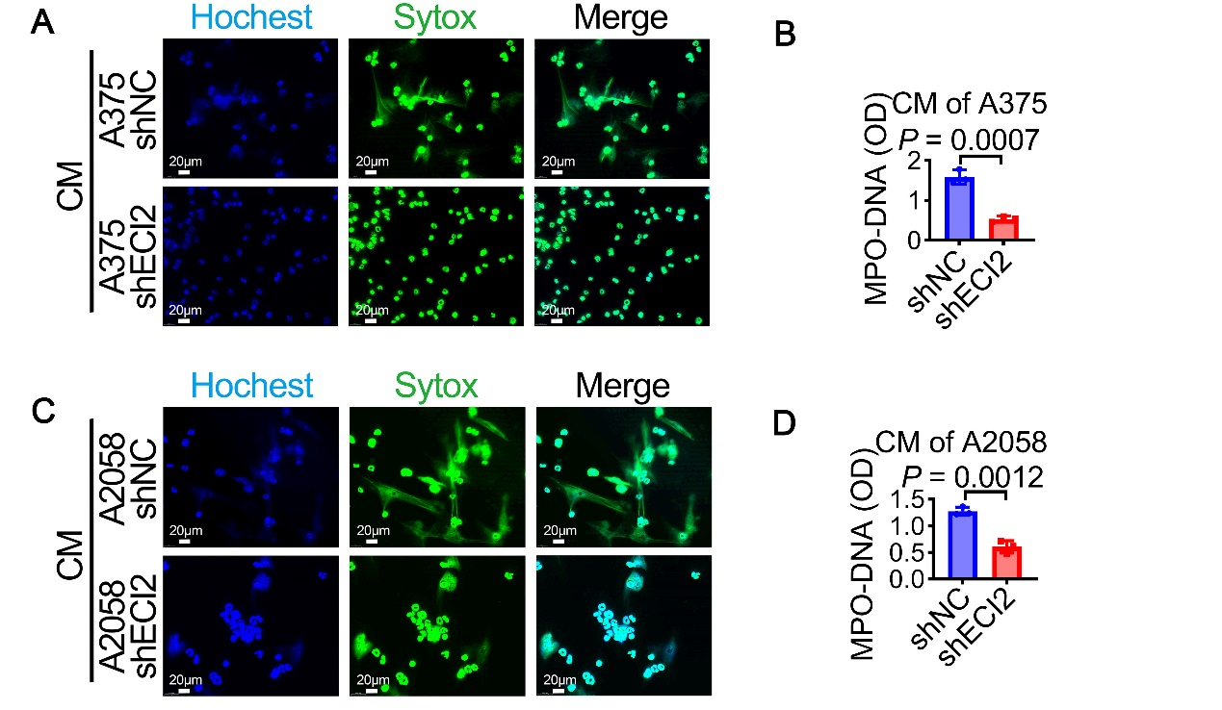
Figure S2. (A-D) NET formation by neutrophils incubated in conditioned medium from ECI2-knockdown melanoma cells, detected by Sytox immunofluorescence (A,C) and MPO-DNA ELISA (B,D) (scale bar 20 μm, n = 3).

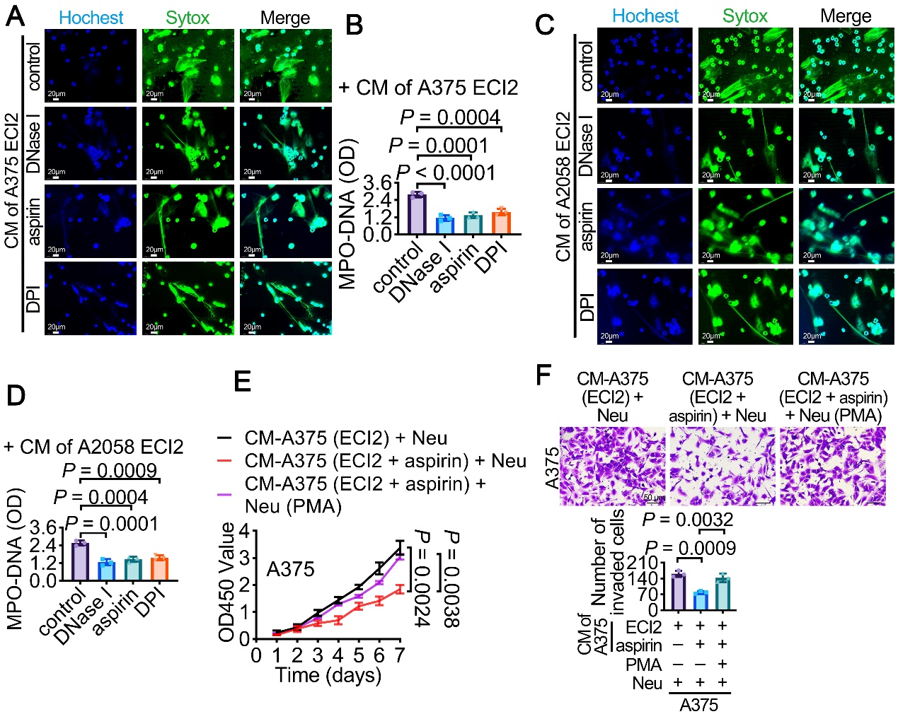
Figure S3. (A–D) NET formation by neutrophils incubated with supernatant from ECI2-overexpressing melanoma cells, labeled by Sytox immunofluorescence (A, C) and MPO-DNA ELISA (B, D), following sequential addition of DNase I, aspirin, or DPI (scale bar 20 μm). (E-F) Changes in proliferation and invasion of ECI2-overexpressing melanoma cells after co-culture with neutrophils (with or without aspirin and PMA) were assessed via CCK8 proliferation assay (E) and Transwell invasion assay (F) (scale bar 50 μm).

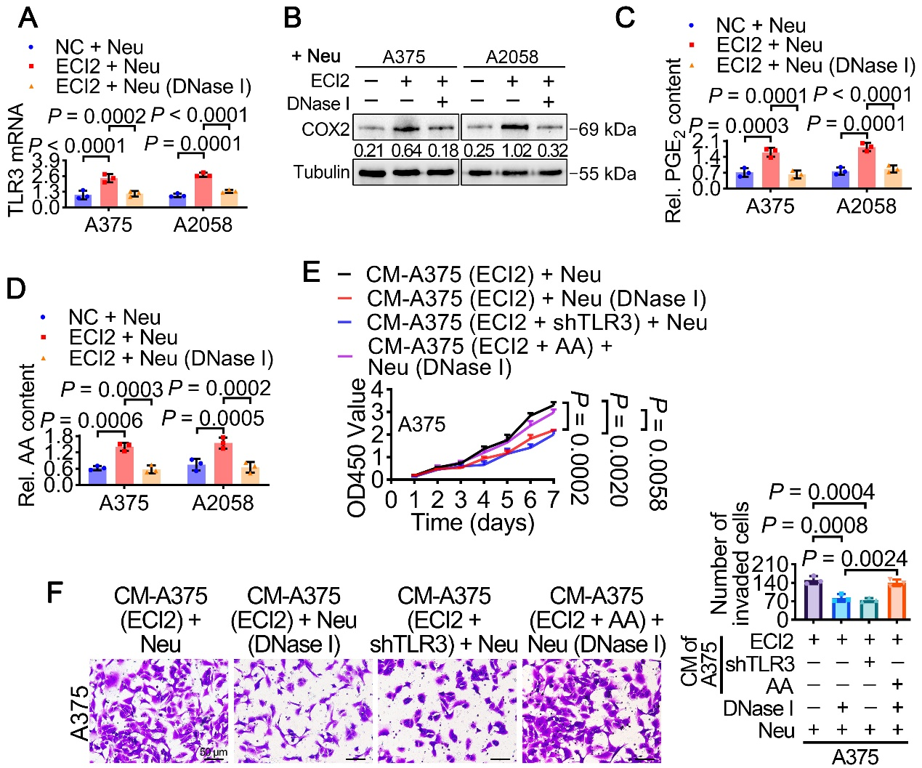
Figure S4. (A–D) RT-qPCR, WB, PGE2 ELISA, and AA ELISA assays detecting changes in TLR3 mRNA levels, COX2 protein content, PGE2, and AA levels in melanoma cells overexpressing ECI2 after co-culture with neutrophils (with or without DNase I). (E-F) CCK8 proliferation assay (E) and Transwell invasion assay (F) assessing melanoma cell proliferation and invasion after co-culture with neutrophils (with or without DNase I and AA) in ECI2-overexpressing cells (or cells simultaneously silenced for TLR3). (Scale bar: 50 μm).

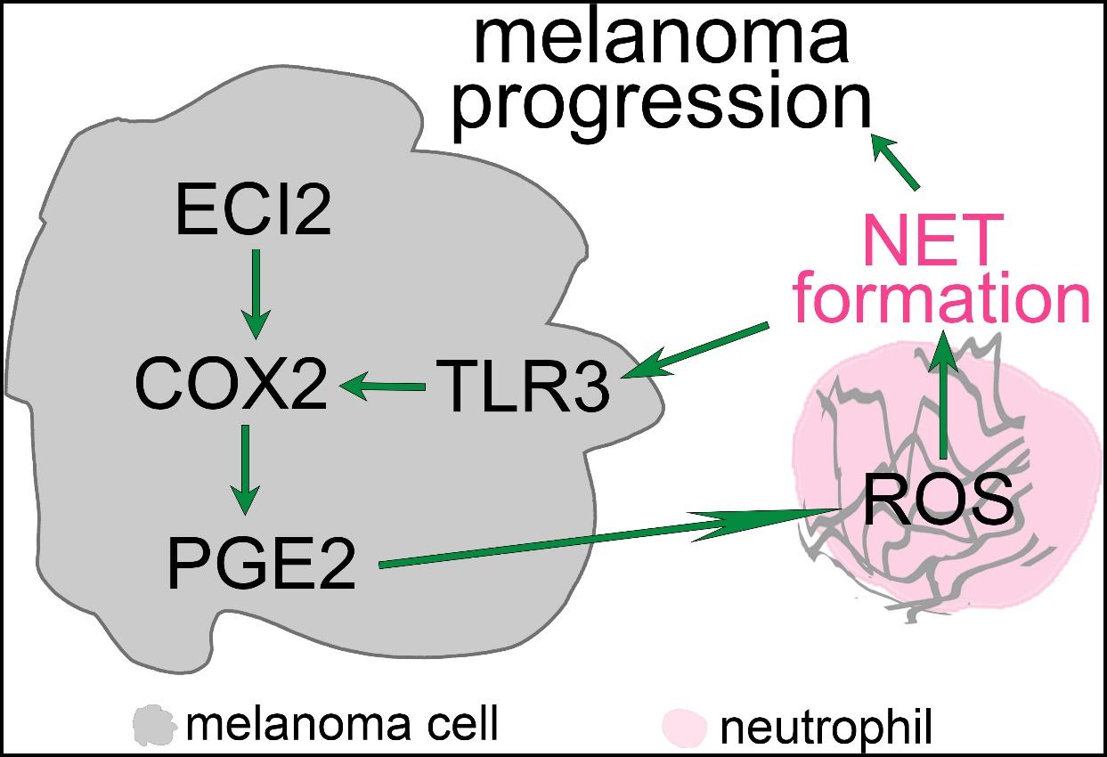
Figure S5. Schematic model of ECI2-mediated melanoma progression through the arachidonic acid metabolism and neutrophil extracellular trap-induced TLR3/COX2/PGE2 feedback loop.

