Supplementary material

This supplementary material contains the chemical soil analysis of the substrate before experiment installation and information on several analysis (ecophysiological, biochemical and nutritional) carried out with the target plants exposed to the eucalyptus extracts, which did not differ statistically.

Supplementary Table S1. Analysis of the substrate used in the pots in the greenhouse before the installation of the experiment.

Physical Analysis of the Substrate
Sample | Clay | Silt | Total sand | Coarse sand | Fine sand
 | <0,002mm | 0,053-0,002mm |  | 2,00-0,210mm | 0,210-0,053mm
 | ------------------------------------------------------- g kg⁻¹ -------------------------------------------------------
Substrate | 76 | 4 | 920 | 570 | 350
Substrate Chemical Analysis
Amostra |  | pH | M.O |  | P |  | K |  |  | Ca |  |  |  | Mg
 |  | CaCl₂ |  |  | resin
 |  |  | g dm⁻³ |  | mg dm⁻³ |  | ---------------------------------- mmol_{c} dm⁻³ ----------------------------------
Substrate |  | 4.8 | 30 |  | 63 |  | 1.6 |  |  | 43 |  |  |  | 21
Substrate Chemical Analysis
Sample | H+Al |  |  |  |  | Al |  | Soma |  |  |  | CEC | Sat. |  |  | Sat. | S
 |  |  |  |  |  |  |  | bases |  |  |  |  | bases |  |  | Al | SO₄
 | ------------------------------- mmolc dm⁻³ ------------------------------- |  |  |  |  |  |  |  |  |  |  |  | V% |  |  | m% | mg dm⁻³
Substrate | 16 |  |  |  |  | 1 |  | 66 |  |  |  | 82 | 80 |  |  | 2 | 55
Substrate Chemical Analysis
Sample | Cu |  |  | Fe |  |  |  |  | Zn |  | Mn |  |  |  | B
 | ------------------------------- DTPA --------------------------------- |  |  |  |  |  |  |  |  |  |  |  |  |  | (hot water)
 | ------------------------------------------------------ mg dm⁻³ --------------------------------------------------------
Substrate | 0.3 |  |  | 34 |  |  |  |  | 3.4 |  | 8.8 |  |  |  | 0.71

Marandu grass

Supplementary table S2. Effect of treatment with eucalyptus extracts on the quantum yield of Photosystem II (QY) of light-adapted Marandu grass leaves.

Treatment | QY | STE
CON | 0.47 | 0.01
URO | 0.50 | 0.03
CAM | 0.49 | 0.04
HEN | 0.49 | 0.02
GLO | 0.48 | 0.02

Supplementary table S3. Effect of treatment with eucalyptus extracts on the levels of chlorophyll (Clo), flavonoids (Flav), anthocyanins (Ant) and nitrogen balance (IBN) of Marandu grass.

Treatment | Clo | STE | Flav | STE | Ant | STE | IBN | STE
CON | 22.86 | 2.21 | 0.96 | 0.079 | 0.14 | 0.011 | 24.89 | 5.45
URO | 20.69 | 1.10 | 0.90 | 0.185 | 0.15 | 0.011 | 32.78 | 14.46
CAM | 28.11 | 1.69 | 0.65 | 0.156 | 0.12 | 0.009 | 58.62 | 15.68
HEN | 25.12 | 2.15 | 0.89 | 0.138 | 0.14 | 0.011 | 29.38 | 6.24
GLO | 24.60 | 0.68 | 0.40 | 0.031 | 0.13 | 0.005 | 70.29 | 9.37

Supplementary table S4. Effect of treatment with eucalyptus extracts on the content of K, Ca, P, S, Fe and Mn in Marandu grass leaves.

Treatment | -------------------- g.kg⁻¹ -------------------- |  |  |  | -------- mg.kg⁻¹ --------
 | K | Ca | P | S | Fe | Mn
CON | 12.50 | 4.08 | 0.83 | 2.02 | 186.09 | 47.07
URO | 11.83 | 4.47 | 0.64 | 2.23 | 87.53 | 59.02
CAM | 8.95 | 5.06 | 0.65 | 2.08 | 89.86 | 61.75
HEN | 11.33 | 4.00 | 0.76 | 2.08 | 58.14 | 52.64
GLO | 10.54 | 4.61 | 0.80 | 2.18 | 74.32 | 77.77

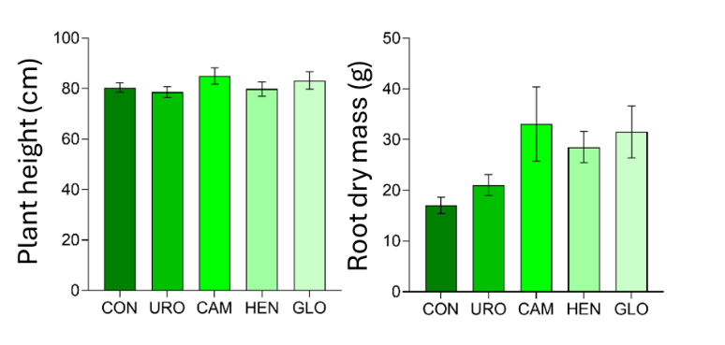
Supplementary Figure S1. Effects of eucalyptus extracts on plant height and root dry matter of Marandu grass. Bars indicate standard error. The treatments did not differ statistically by Tukey's test (p<0.05).

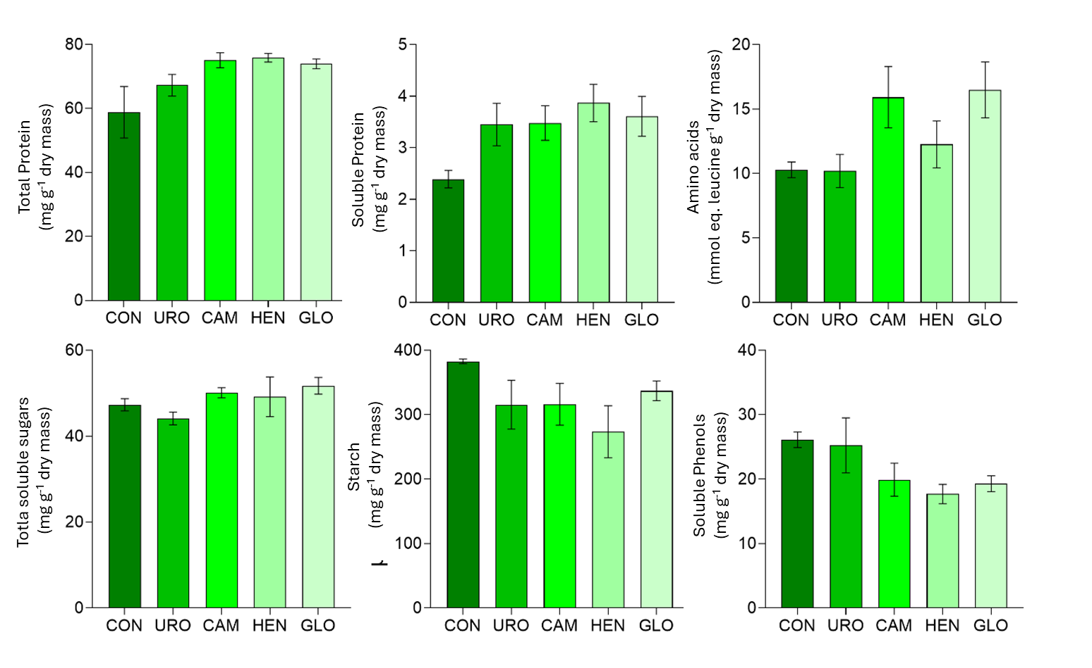
Supplementary Figure S2. Effects eucalyptus extracts on the content of total protein, soluble protein, amino acid, total soluble sugars, starch and total soluble phenols in Marandu grass leaves. Bars indicate standard error. The treatments did not differ statistically by Tukey's test (p<0.05).

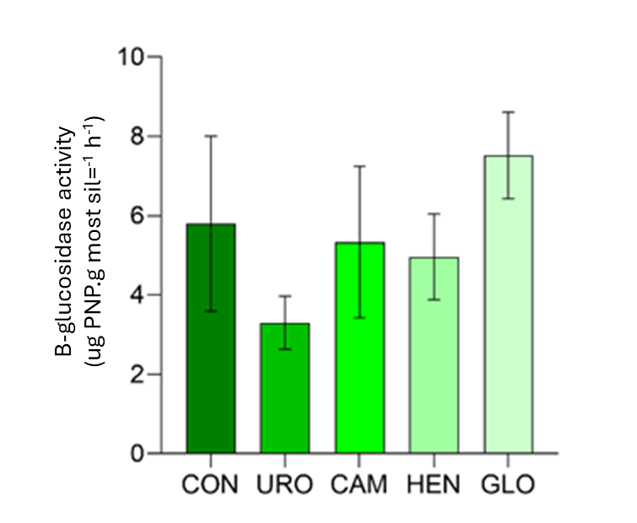
Supplementary Figure S3. Effects of eucalyptus extracts on the enzyme activity ꞵ-glucosidase of soil collected from pots with Marandu grass. Bars indicate standard error. The treatments did not differ statistically by Tukey's test (p<0.05).

Brachiaria ruziziensis

Supplementary table S5. Effects of eucalyptus extracts on the quantum yield of Photosystem II (QY) of light-adapted brachiaria ruziziensis leaves.

Treatment | QY | STE
CON | 0.54 | 0.03
URO | 0.55 | 0.05
CAM | 0.56 | 0.03
HEN | 0.56 | 0.03
GLO | 0.56 | 0.01

Supplementary table S6. Effects of eucalyptus extracts on the levels of chlorophyll (Clo), flavonoids (Flav), anthocyanins (Ant) and nitrogen balance (IBN) of brachiaria ruziziensis.

Treatment | Clo | STE | Flav | STE | Ant | STE | IBN | STE
CON | 18.49 | 1.14 | 0.36 | 0.026 | 0.17 | 0.007 | 40.39 | 5.92
URO | 16.90 | 0.86 | 0.56 | 0.111 | 0.16 | 0.010 | 27.83 | 5.65
CAM | 21.21 | 0.42 | 0.42 | 0.044 | 0.14 | 0.004 | 48.95 | 4.93
HEN | 19.38 | 1.46 | 0.47 | 0.078 | 0.16 | 0.011 | 43.53 | 6.45
GLO | 18.37 | 1.46 | 0.52 | 0.118 | 0.16 | 0.007 | 38.97 | 7.07

Supplementary table S7. Effects of eucalyptus extracts on the concentration of K, S, Fe and Mn in leaves of Brachiaria ruziziensis.

Treatment | -------------- g.kg⁻¹ -------------- |  | -------------- mg.kg⁻¹ --------------
 | K | S | Fe | Mn
CON | 9.07 | 2.26 | 106.47 | 35.56
URO | 7.94 | 1.82 | 77.35 | 36.89
CAM | 6.80 | 1.88 | 45.92 | 38.07
HEN | 9.70 | 1.79 | 58.15 | 37.77
GLO | 9.29 | 1.75 | 52.92 | 44.53

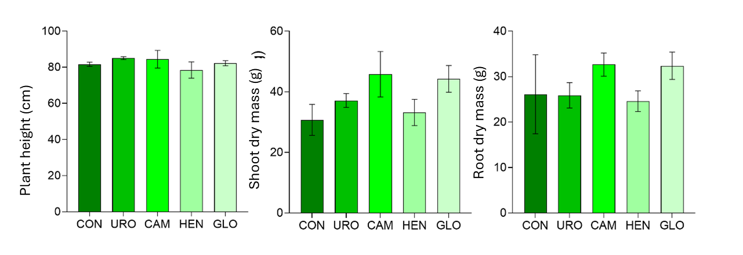

Supplementary Figure S4. Effects of eucalyptus extracts on plant height, shoot dry matter and root dry matter of Brachiaria ruziziensis. Bars indicate standard error. The treatments did not differ statistically by Tukey's test (p<0.05).

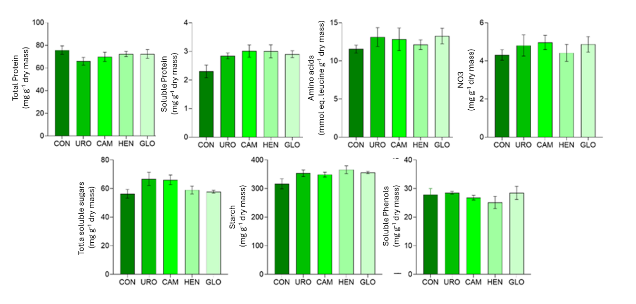
Supplementary Figure S5. Effects of eucalyptus extracts on the content of total protein, soluble protein, amino acid, nitrate, total soluble sugars, starch and total soluble phenols in leaves of Brachiaria ruziziensis. Bars indicate standard error. The treatments did not differ statistically by Tukey's test (p<0.05).

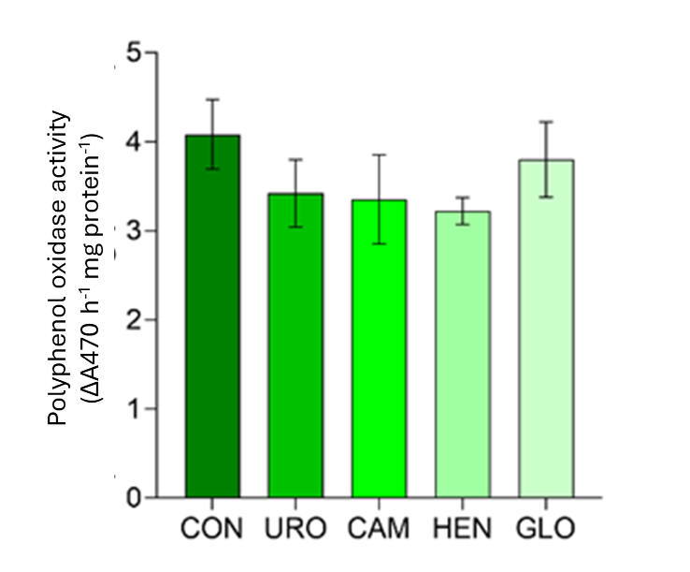

Supplementary Figure S6. Effects of eucalyptus extracts on the activity of polyphenoloxidase enzyme leaves of Brachiaria ruziziensis. Bars indicate standard error. The treatments did not differ statistically by Tukey's test (p<0.05).

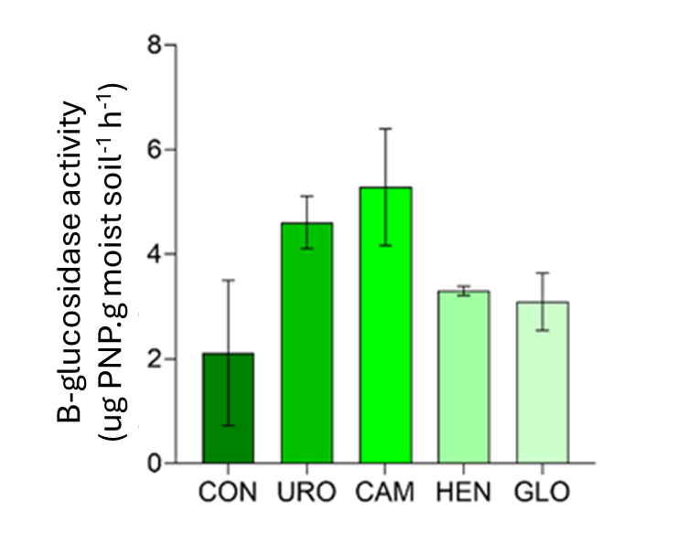

Supplementary Figure S7. Effects eucalyptus extracts on the enzyme activity ꞵ-glucosidase of soil collected from pots with Brachiaria ruziziensis. Bars indicate standard error. The treatments did not differ statistically by Tukey's test (p<0.05).

Mombaça grass

Supplementary Table S8. Effect of treatment with eucalyptus extracts on the content of K, Ca, P, S, Fe and Mn in Mombaça grass leaves.
Treatment | -------------------- g.kg⁻¹ -------------------- |  |  |  | -------- mg.kg⁻¹ --------
 | K | Ca | P | S | Fe | Mn
CON | 10.31 | 5.55 | 0.86 | 1.93 | 79.60 | 51.98
URO | 9.23 | 4.67 | 1.10 | 1.81 | 179.52 | 53.59
CAM | 10.52 | 4.97 | 0.99 | 1.82 | 142.91 | 54.48
HEN | 9.27 | 4.56 | 0.87 | 1.77 | 134.82 | 52.87
GLO | 10.72 | 5.98 | 0.64 | 1.72 | 93.40 | 57.14

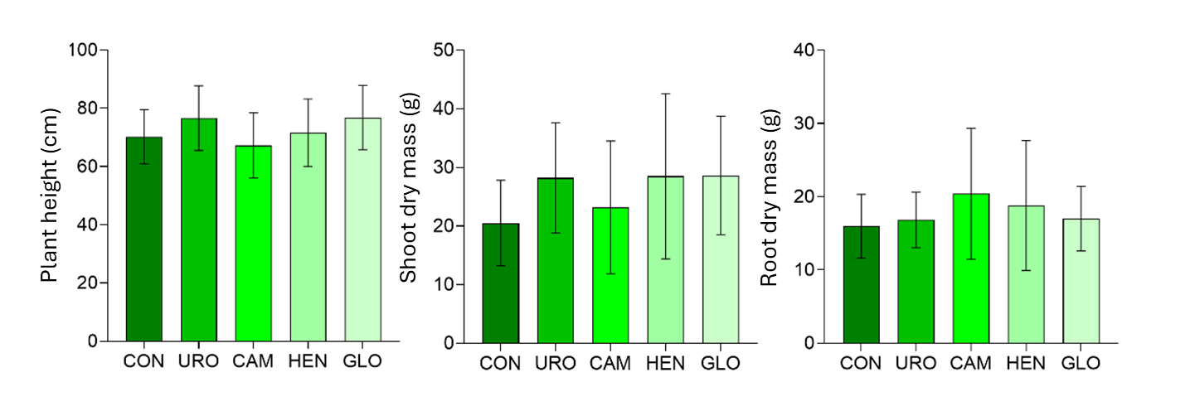
Supplementary Figure 8. Effects of eucalyptus extracts on plant height, shoot dry matter and Mombaça grass root dry matter. Bars indicate standard error. The treatments did not differ statistically by Tukey's test (p<0.05).

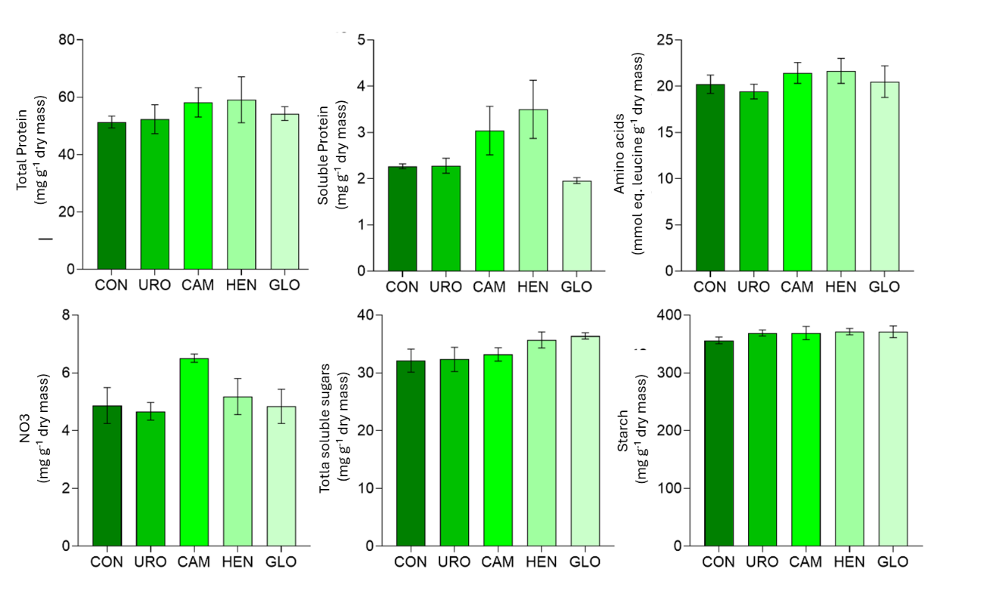
Supplementary Figure 9. Effects eucalyptus extracts on the concentration of total protein, soluble protein, amino acid, nitrate, total soluble sugars and starch in Mombaça grass leaves. Bars indicate standard error. The treatments did not differ statistically by Tukey's test (p<0.05).

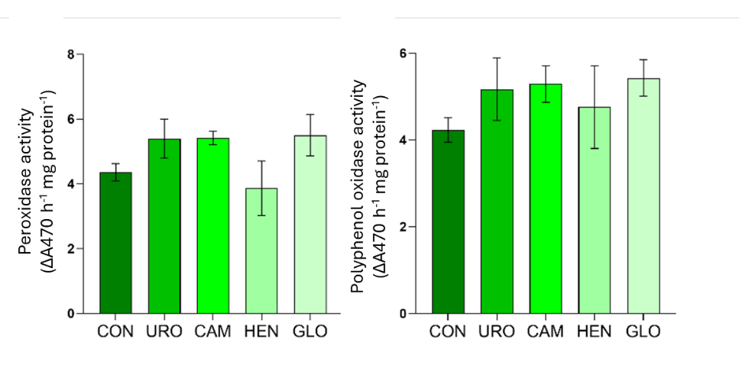
Supplementary Figure 10. Effects of eucalyptus extracts on the activity of peroxidase and polyphenoloxidase enzymes in Mombaça grass leaves. Bars indicate standard error. The treatments did not differ statistically by Tukey's test (p<0.05).

Maize

Supplementary table S9. Effect eucalyptus extracts on the quantum yield of Photosystem II (QY) of light-adapted maize leaves.

Treatment | QY | STE
COM | 0.58 | 0.02
URO | 0.57 | 0.03
CAM | 0.54 | 0.05
HEN | 0.58 | 0.03
GLO | 0.55 | 0.02

Supplementary table S10. Effects of eucalyptus extracts on the content of K, Ca, S, Fe and Mn in maize leaves.

Treatment | -------------------- g.kg⁻¹ -------------------- |  |  | ---------- mg.kg⁻¹ ----------
 | K | Ca | S | Fe | Mn
CON | 6.24 | 6.11 | 3.04 | 92.52 | 39.48
URO | 6.11 | 5.53 | 2.56 | 135.10 | 37.95
CAM | 6.08 | 5.46 | 2.43 | 51.73 | 34.81
HEN | 6.70 | 5.46 | 2.40 | 46.08 | 38.09
GLO | 5.92 | 6.15 | 2.54 | 61.61 | 43.64

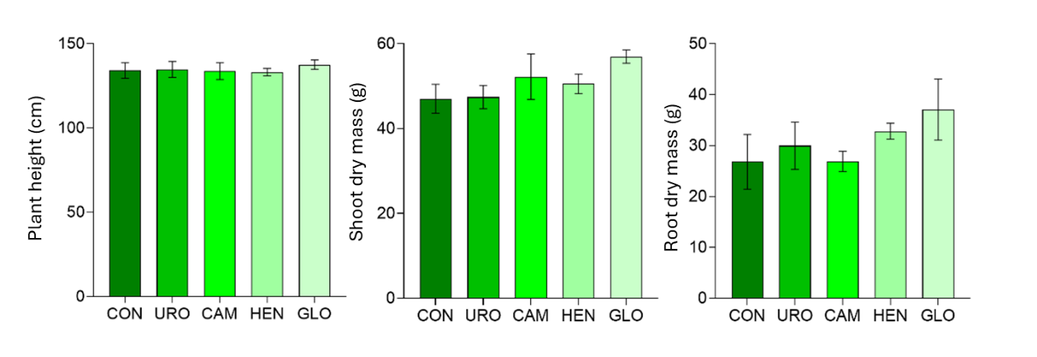
Supplementary Figure 11. Effects of eucalyptus extracts on plant height, shoot dry matter and maize root dry matter. Bars indicate standard error. The treatments did not differ statistically by Tukey's test (p<0.05).

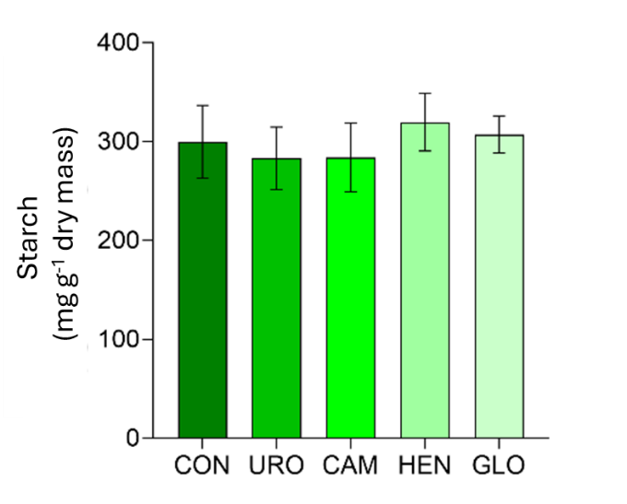

Supplementary Figure 12. Effect of eucalyptus extracts on starch content in corn leaves. Bars indicate standard error. The treatments did not differ statistically by Tukey's test (p<0.05).

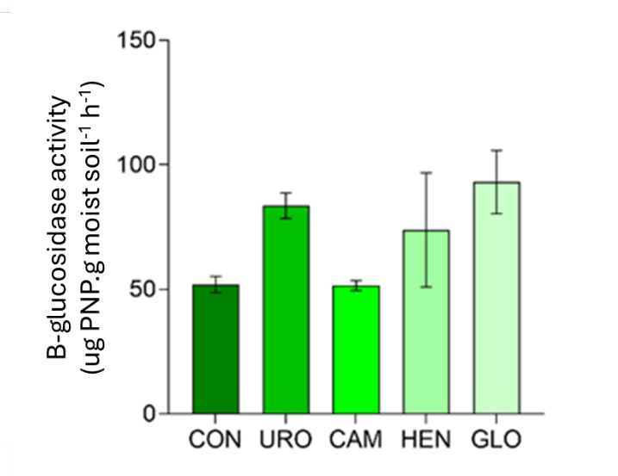
Supplementary Figure 13. Effect of eucalyptus extracts on the acid phosphatase enzyme activity of soil collected from pots with corn. Bars indicate standard error. The treatments did not differ statistically by Tukey's test (p<0.05).

Glycine max

Supplementary table S11. Effect of treatment with eucalyptus extracts on the quantum yield of Photosystem II (QY) of light-adapted soybean leaves.

Treatment | QY | STE
COM | 0.56 | 0.02
URO | 0.56 | 0.02
CAM | 0.55 | 0.01
HEN | 0.55 | 0.03
GLO | 0.57 | 0.01

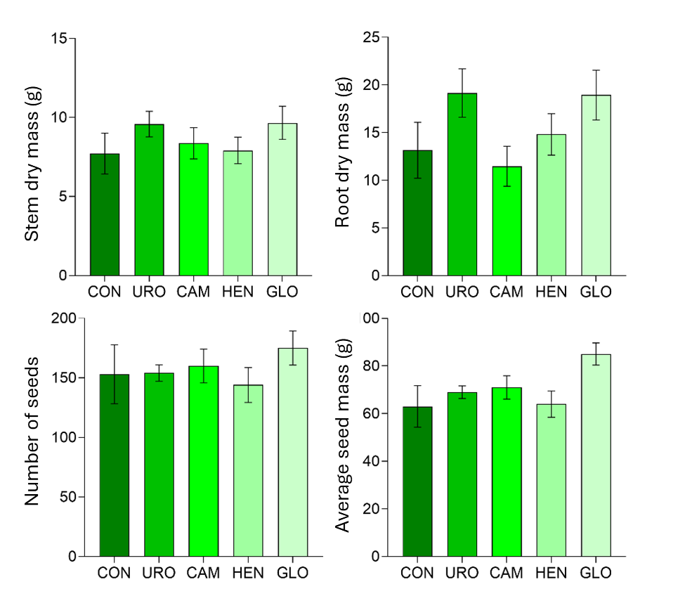

Supplementary Figure 14. Effects of eucalyptus extracts on shoot dry matter, root dry matter, seed number and average soybean seed mass. Bars indicate standard error. The treatments did not differ statistically by Tukey's test (p<0.05).

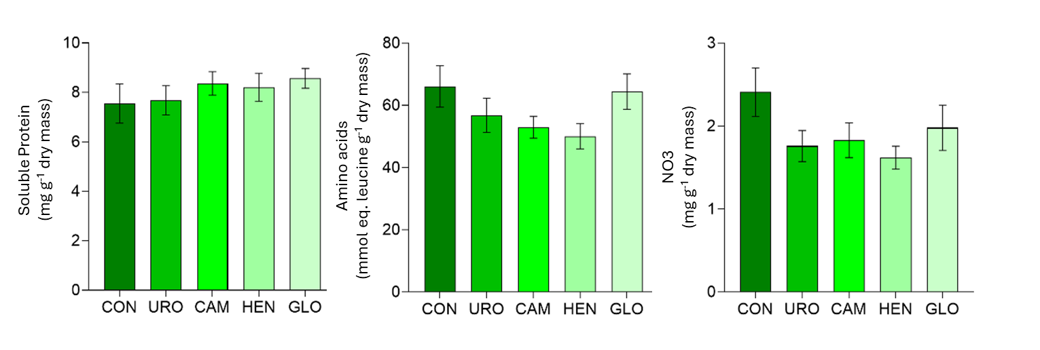
Supplementary Figure 15. Effect of eucalyptus extracts on soluble protein, amino acid and nitrate content in soybean leaves. Bars indicate standard error. The treatments did not differ statistically by Tukey's test (p<0.05).

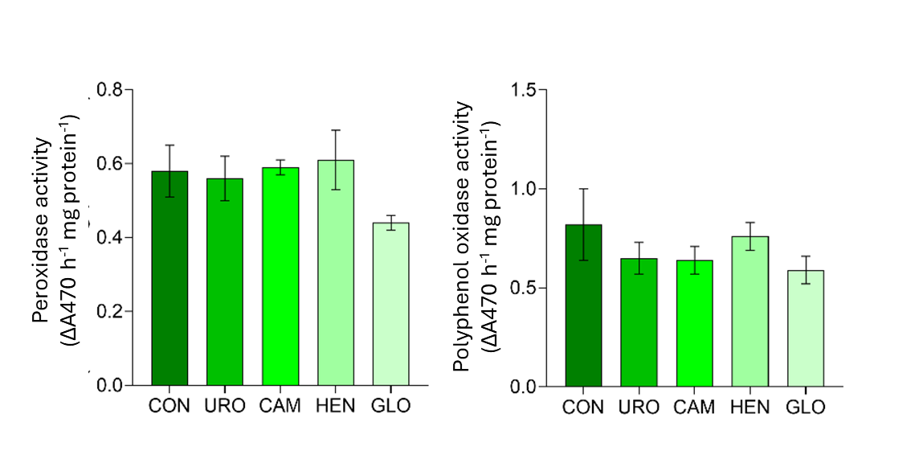
Supplementary Figure 16. Effects of eucalyptus extracts on the activity of peroxidase and polyphenoloxidase enzymes in soybean leaves. Bars indicate standard error. The treatments did not differ statistically by Tukey's test (p<0.05).

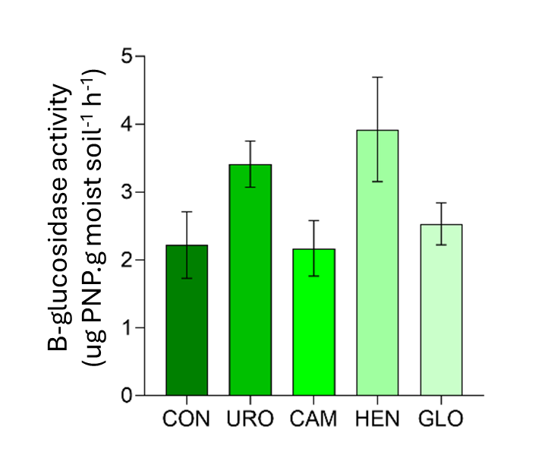
Supplementary Figure 17. Effect of eucalyptus extracts on the enzyme activity ꞵ-glucosidase of soil collected from pots with soybean. Bars indicate standard error. The treatments did not differ statistically by Tukey's test (p<0.05).

