Fig. 2
e Cell apoptosis was detected by western blot. g Cell cycle was detected by western blot.
U937 cell
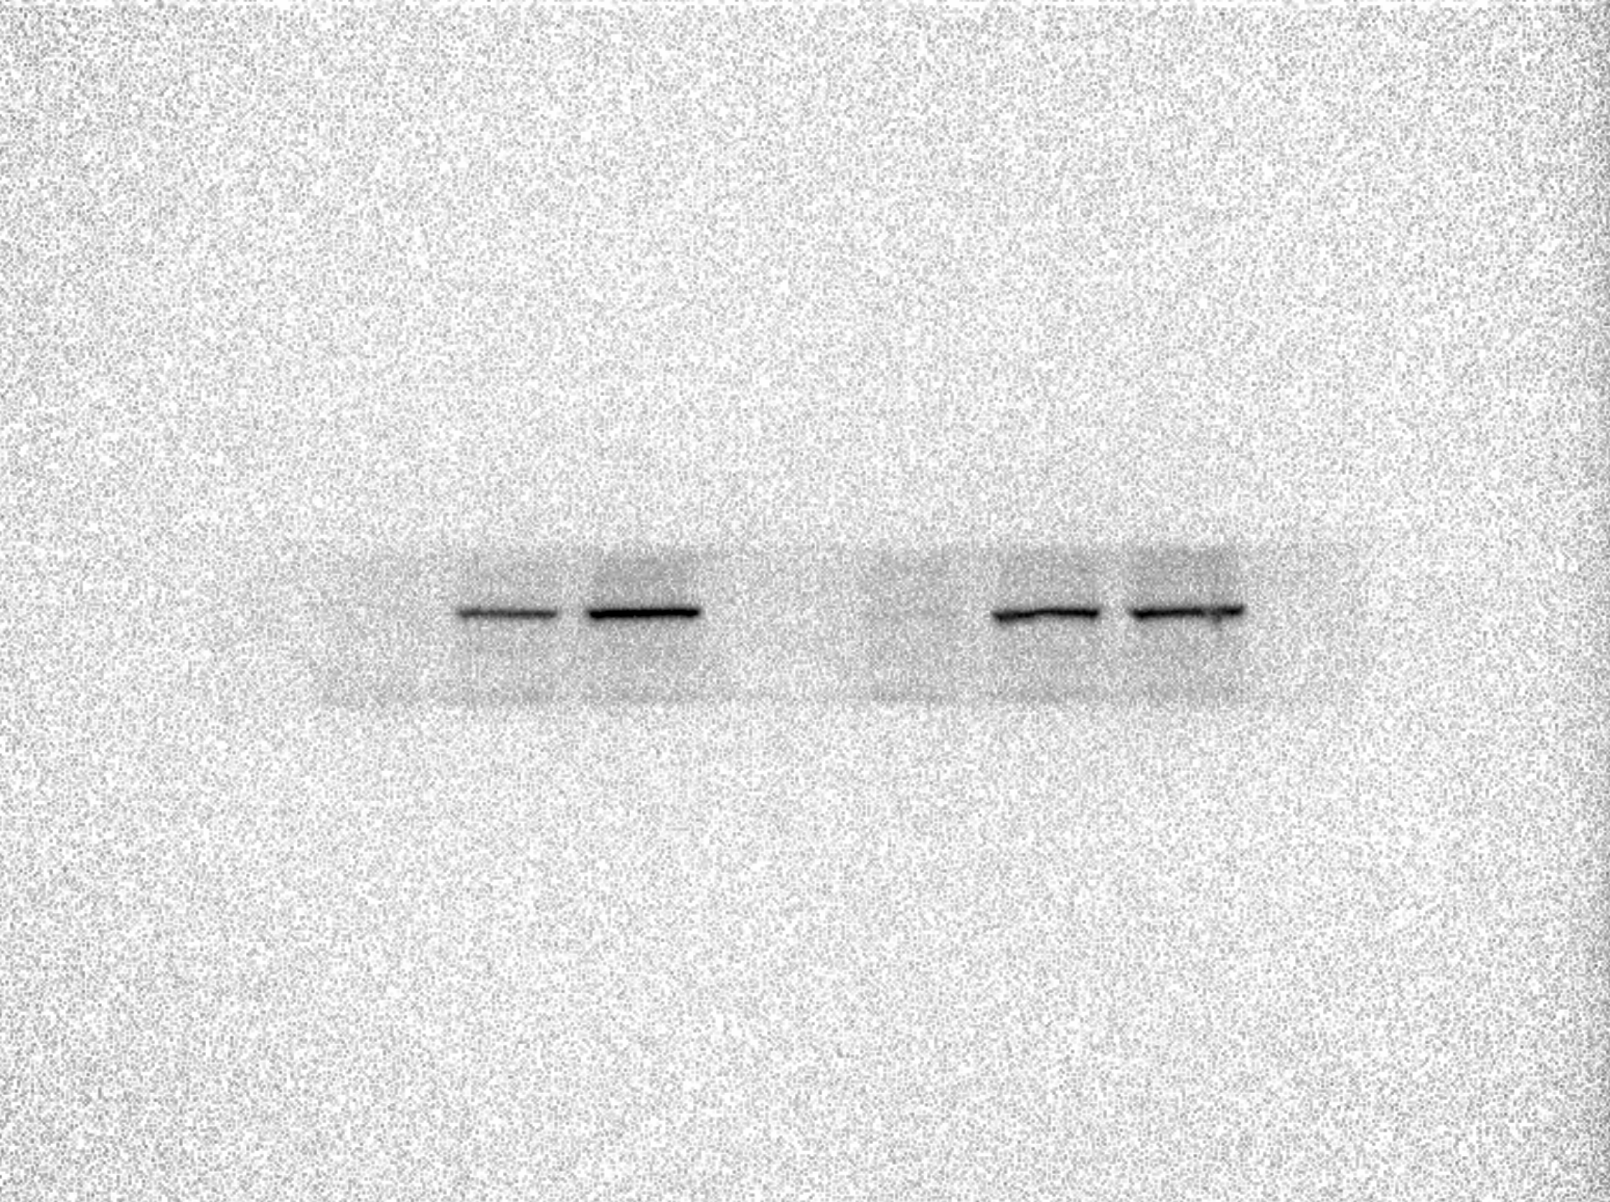
P53
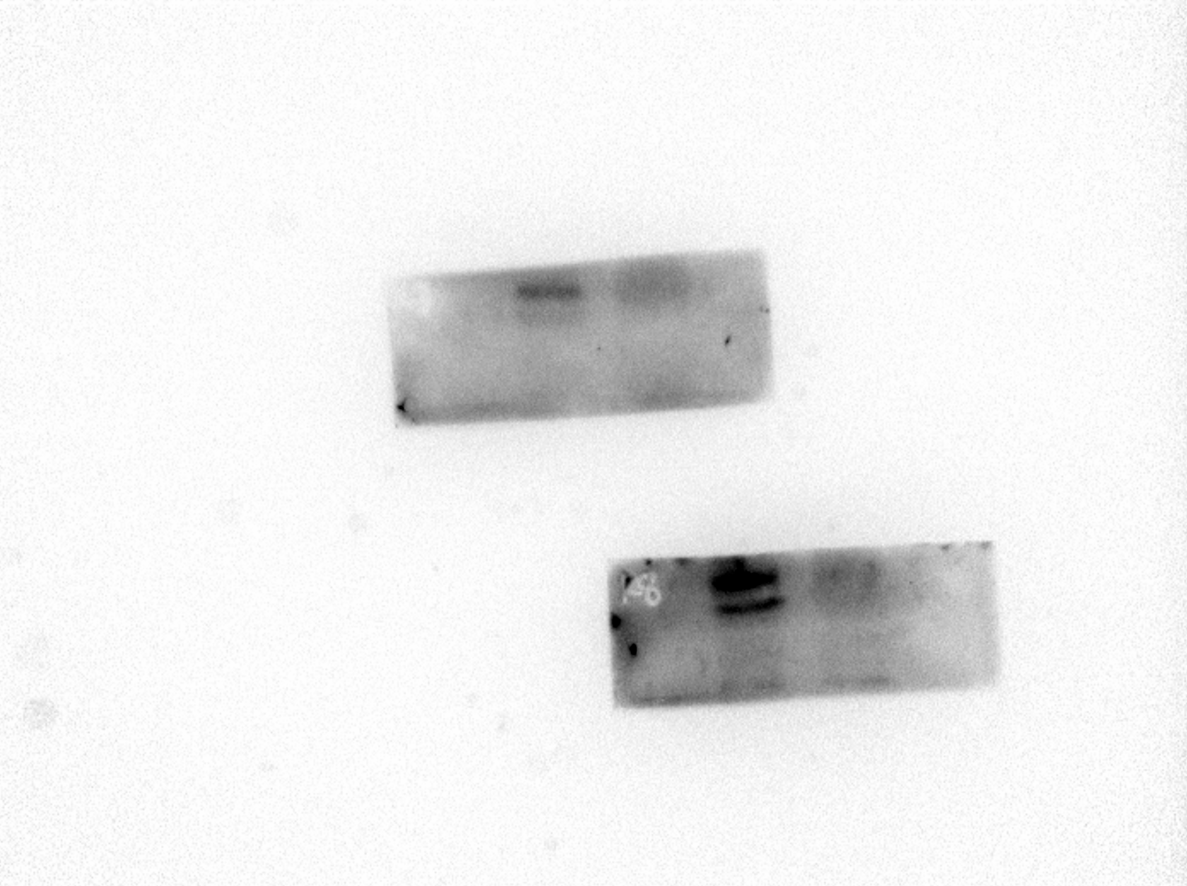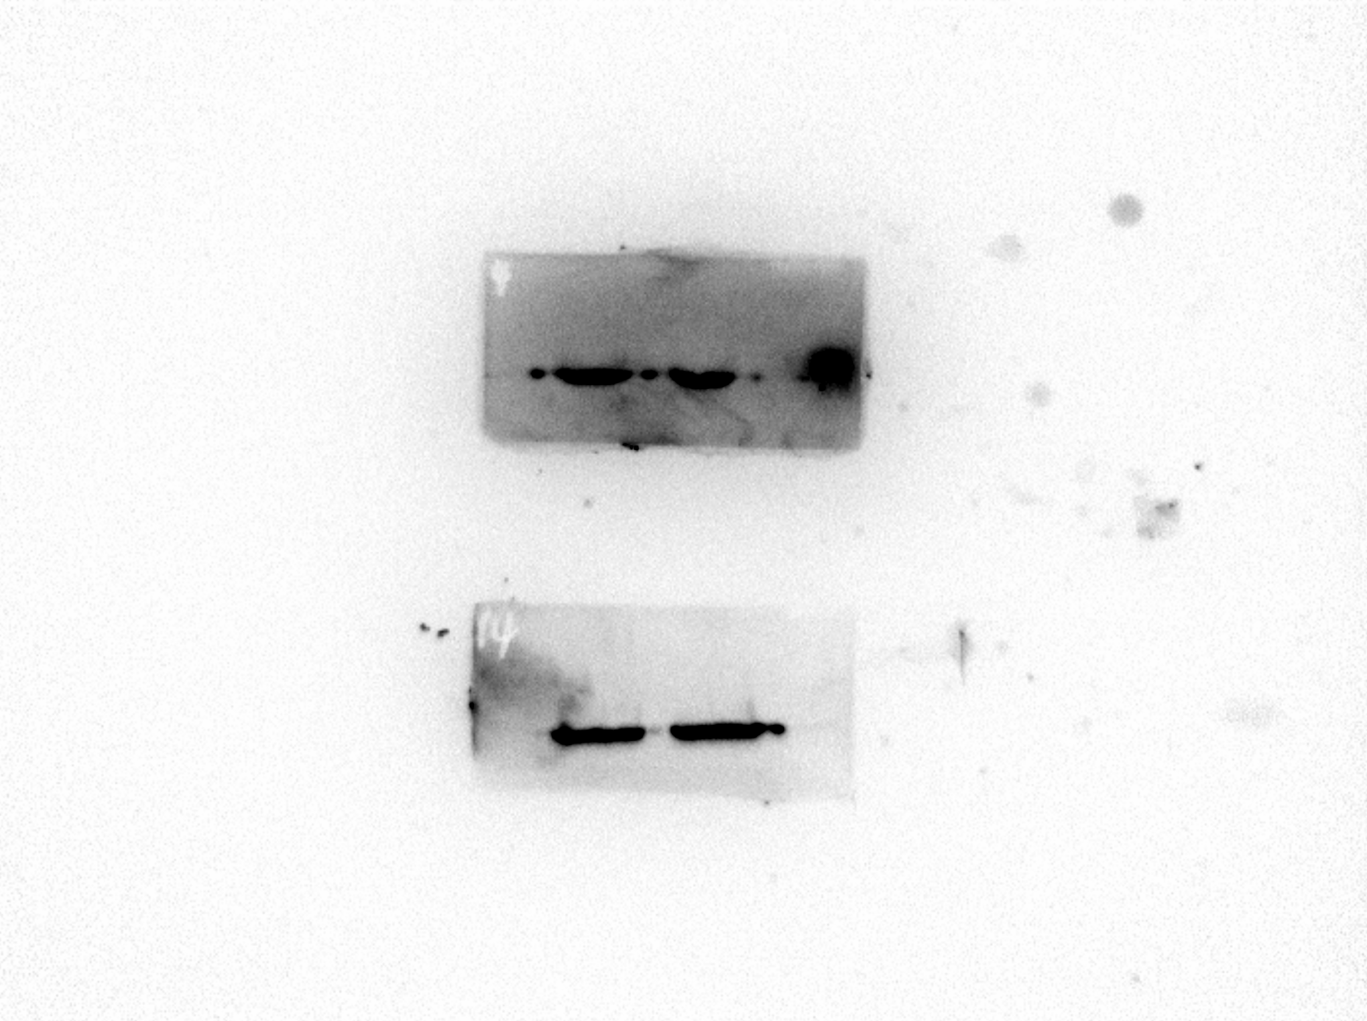
β-Actin
Bcl-2
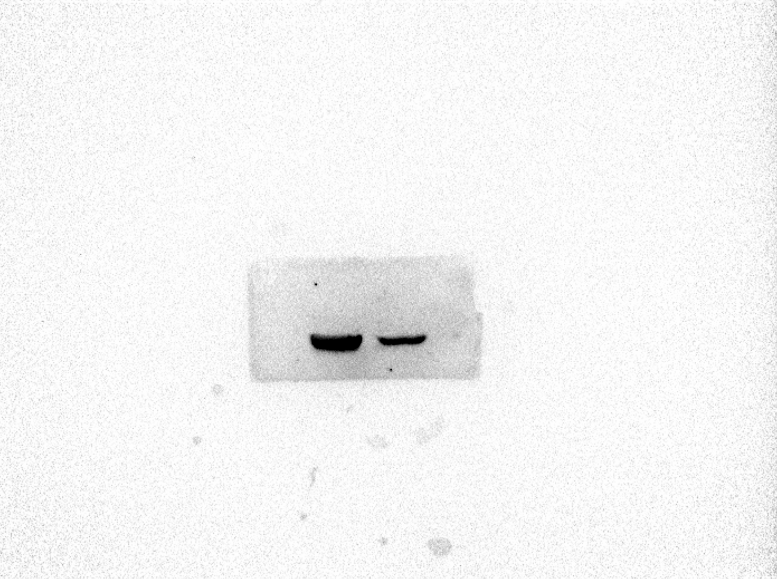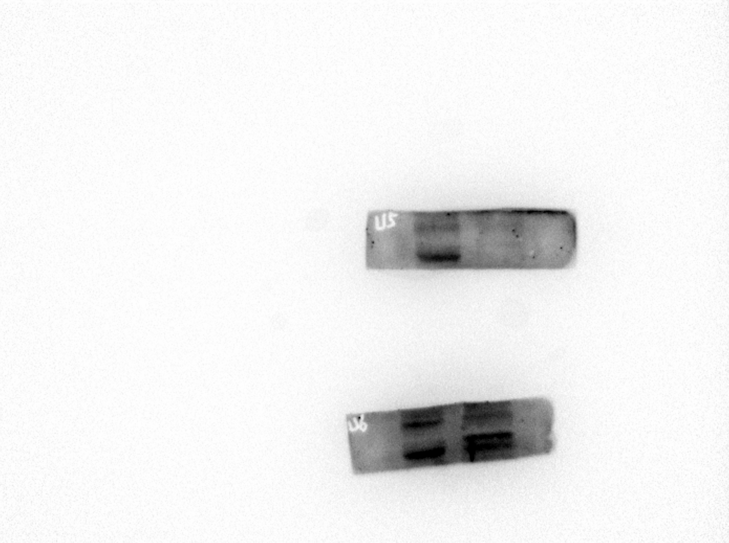
Cyclin D1
Cyclin A2
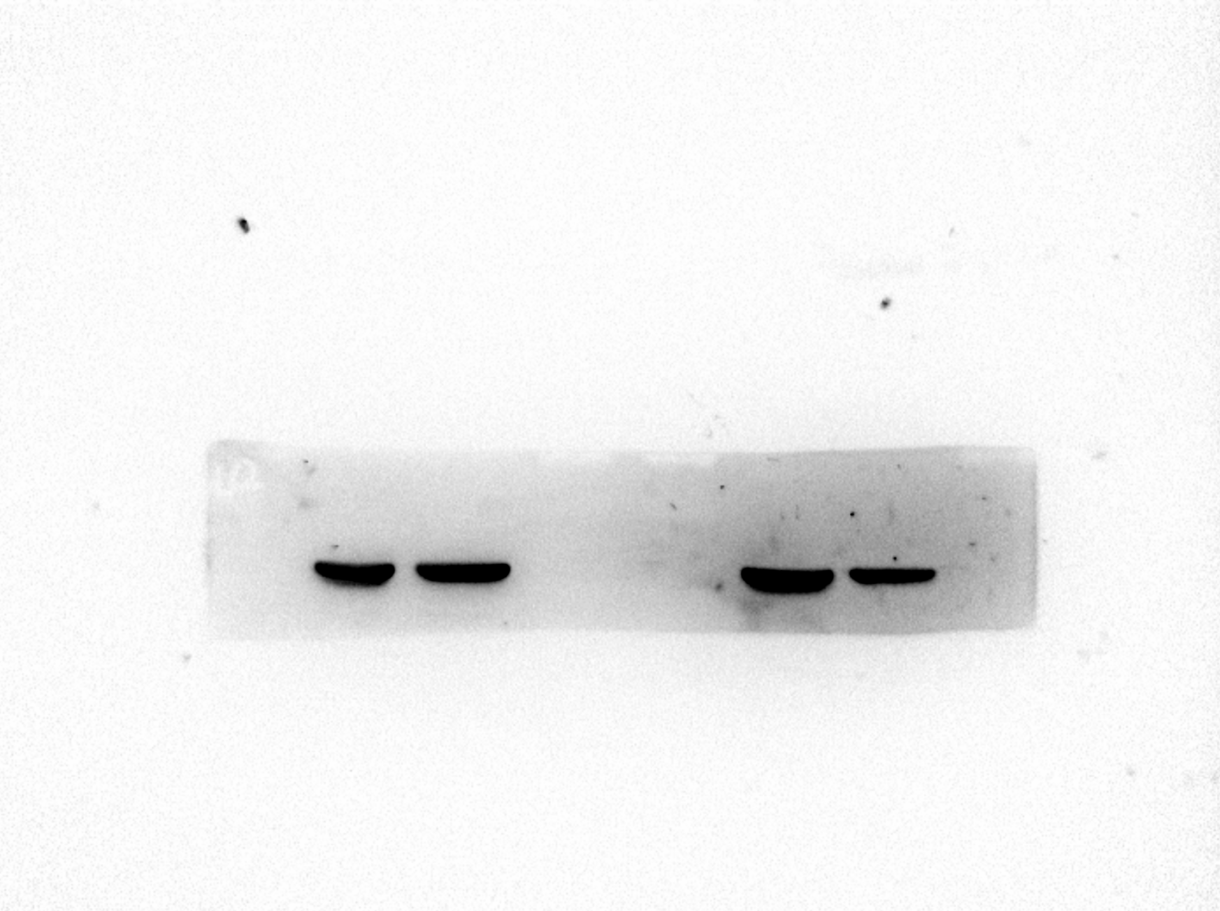
β-Actin
KG-1a cell
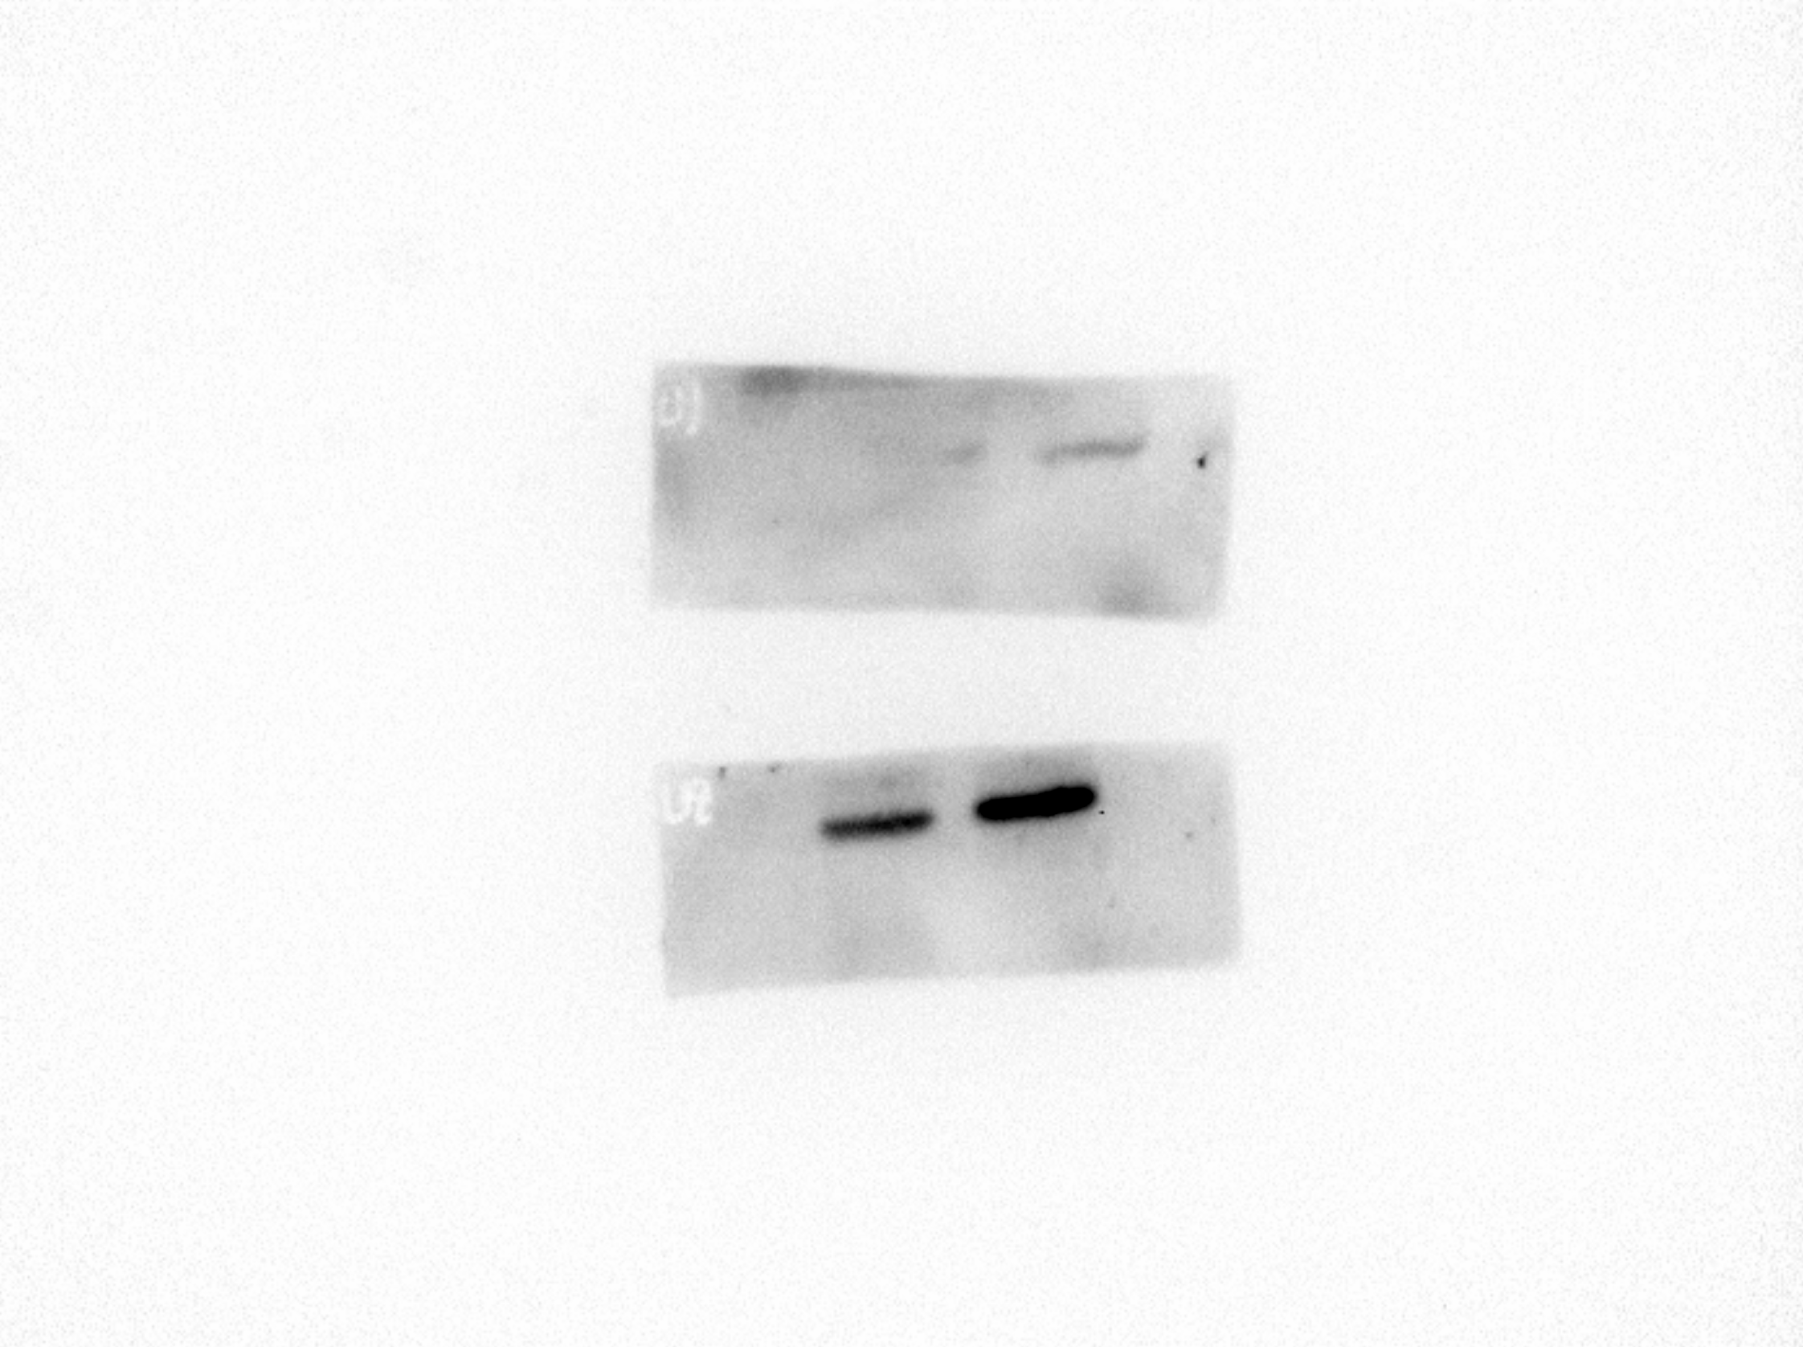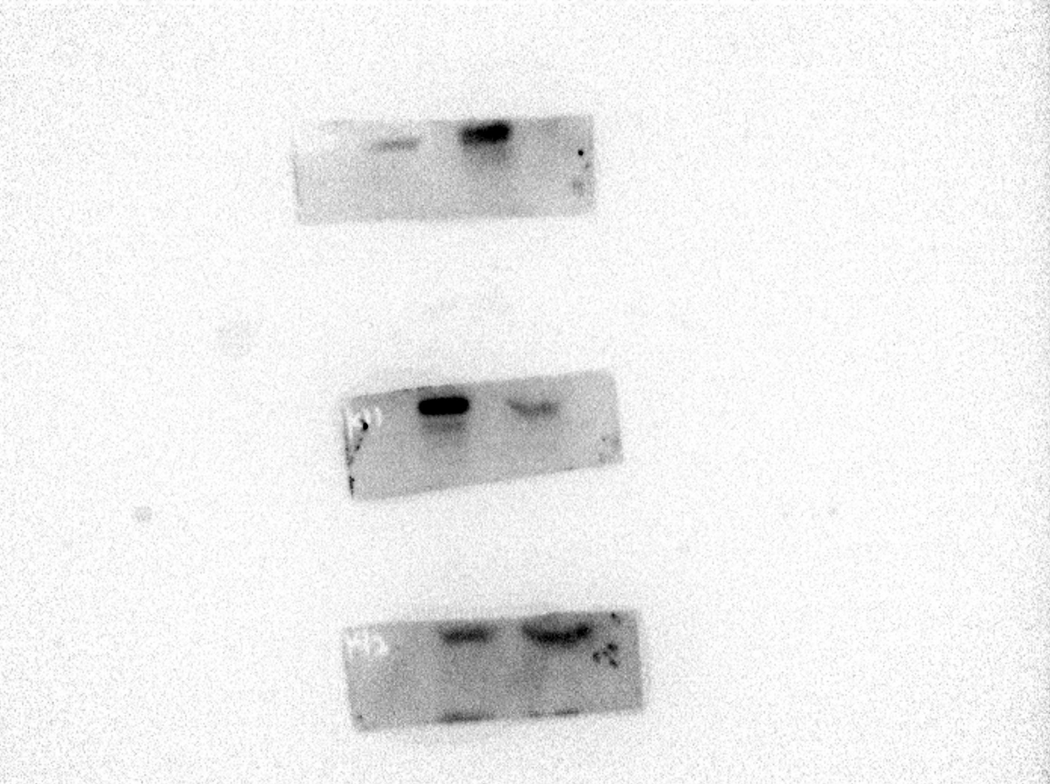
Bcl-2
P53
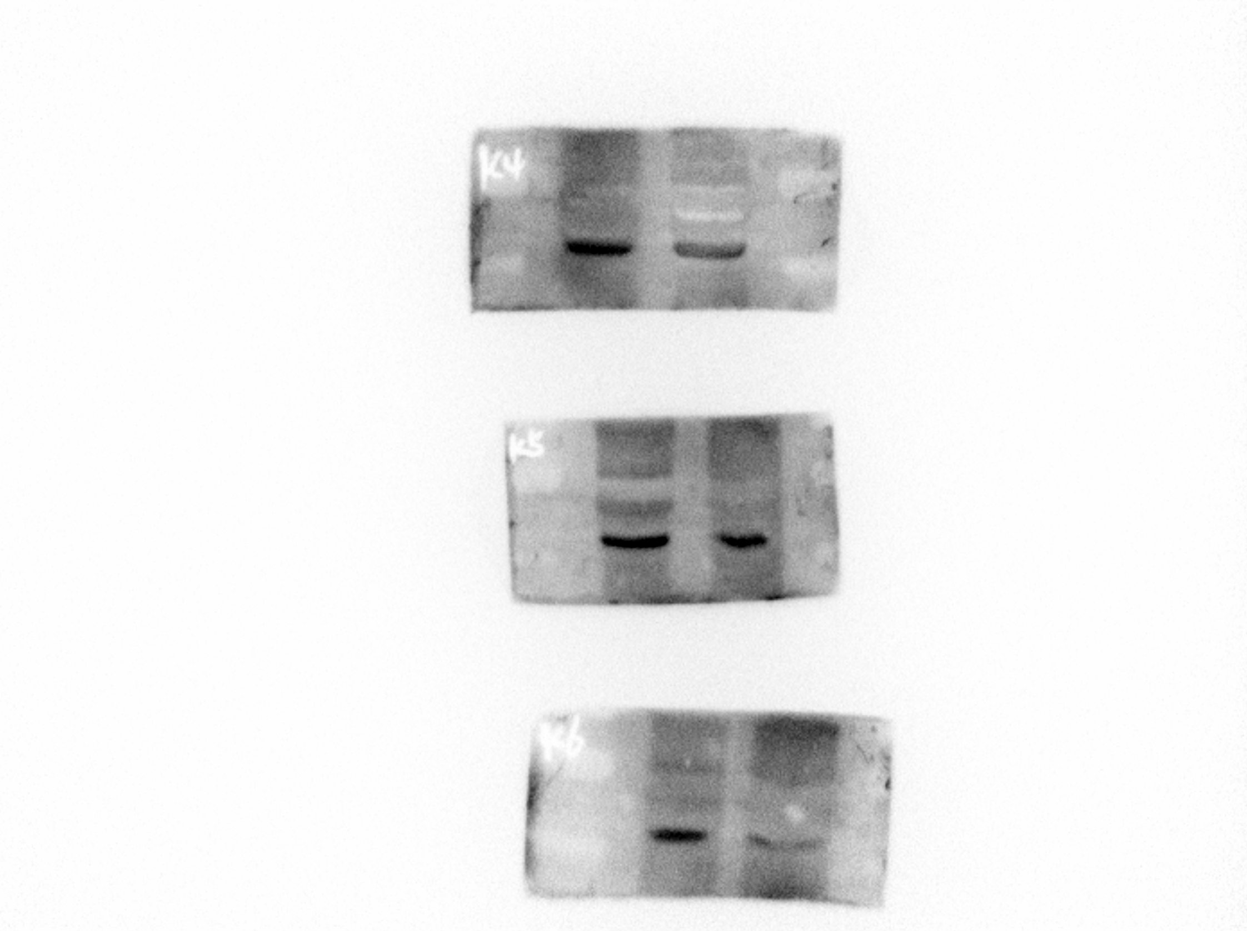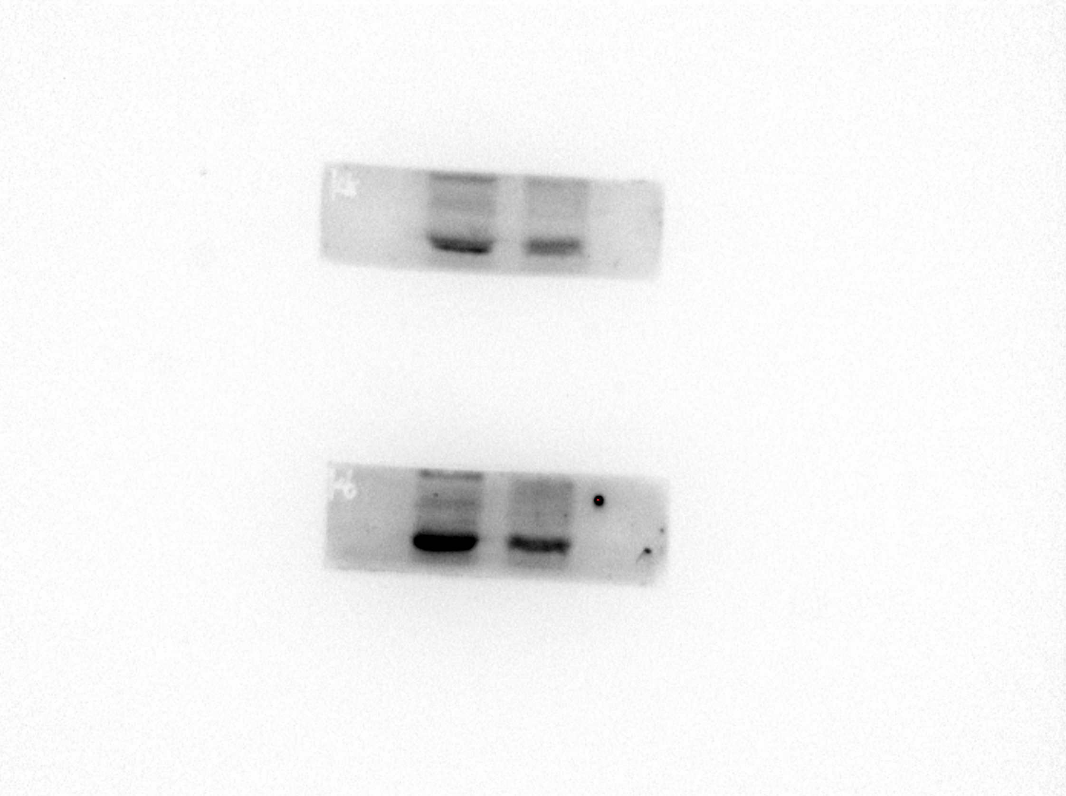
Cyclin D1
Cyclin A2
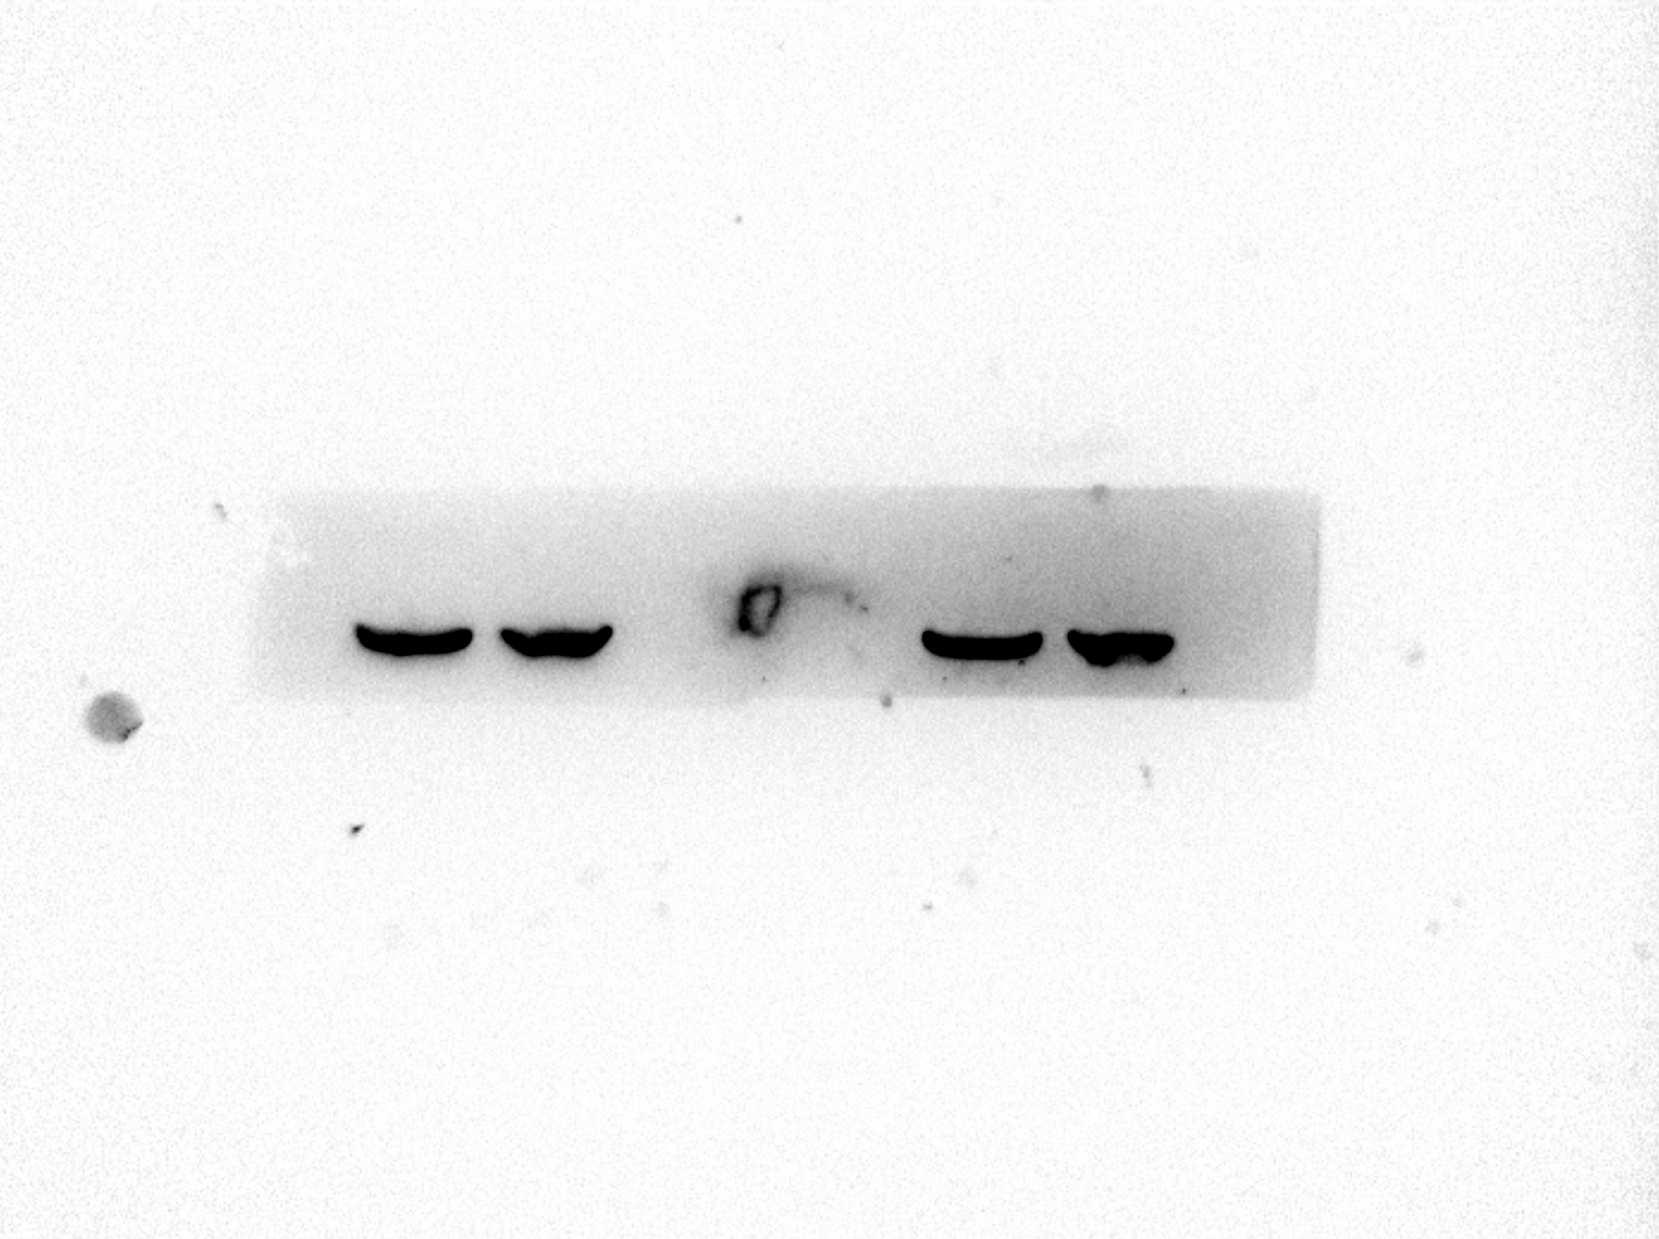
β-Actin
Fig. 5
c The expression of MCM5 protein was detected by western blot after translating mimics or inhibitors.
U937 cell
Mimic
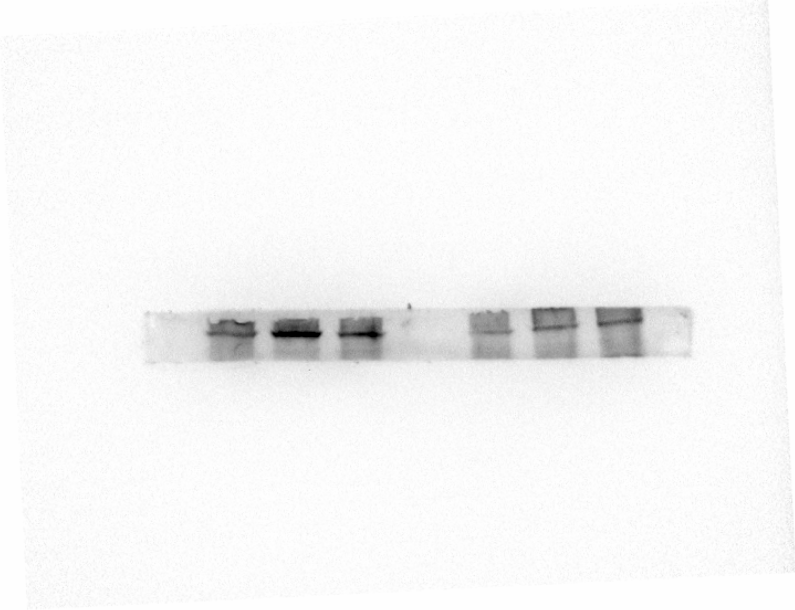
MCM5
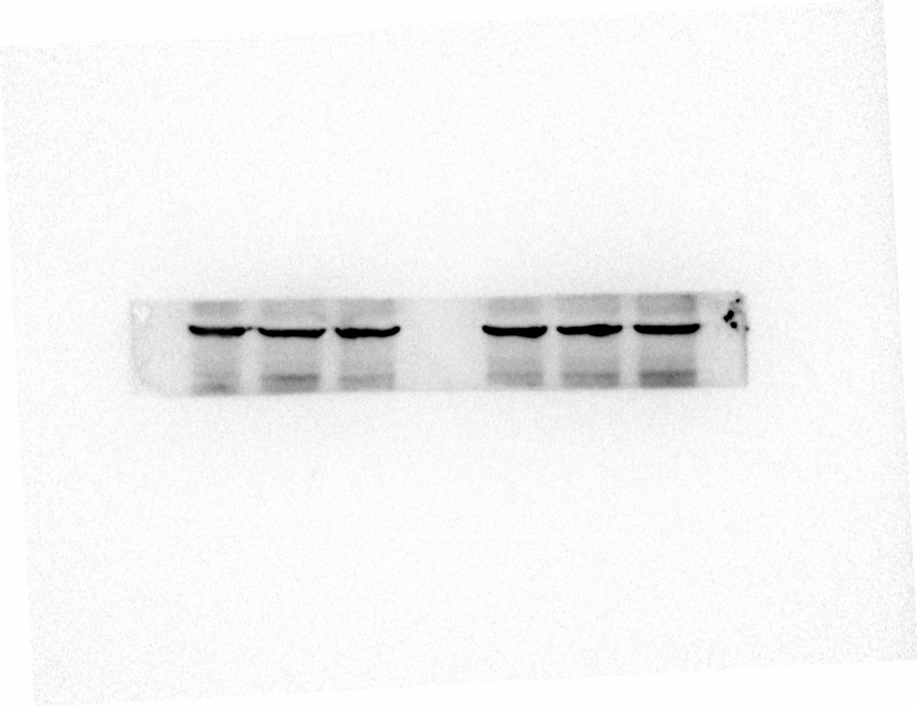
β-Actin
Inhibitor
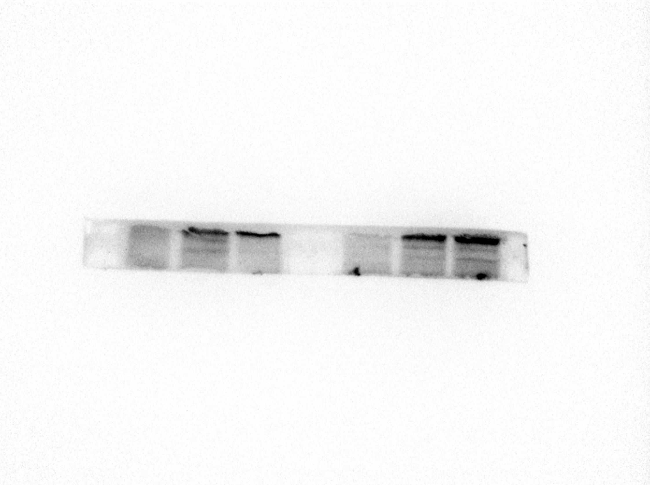
MCM5
β-Actin
KG-1a cell
Mimic
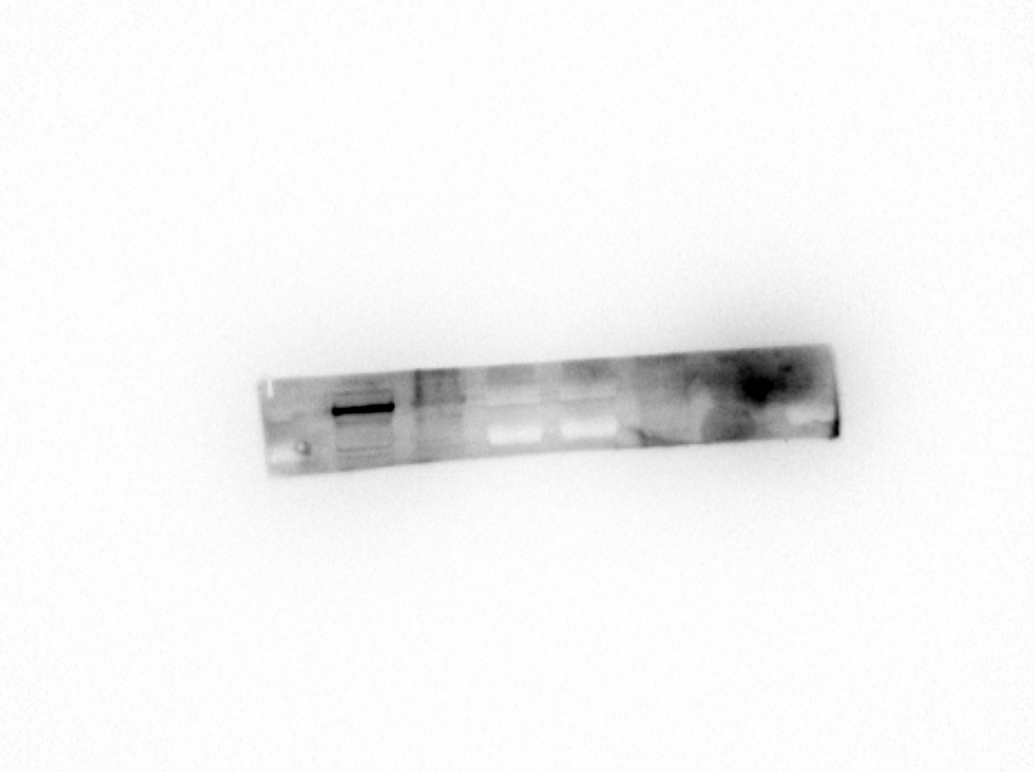
MCM5
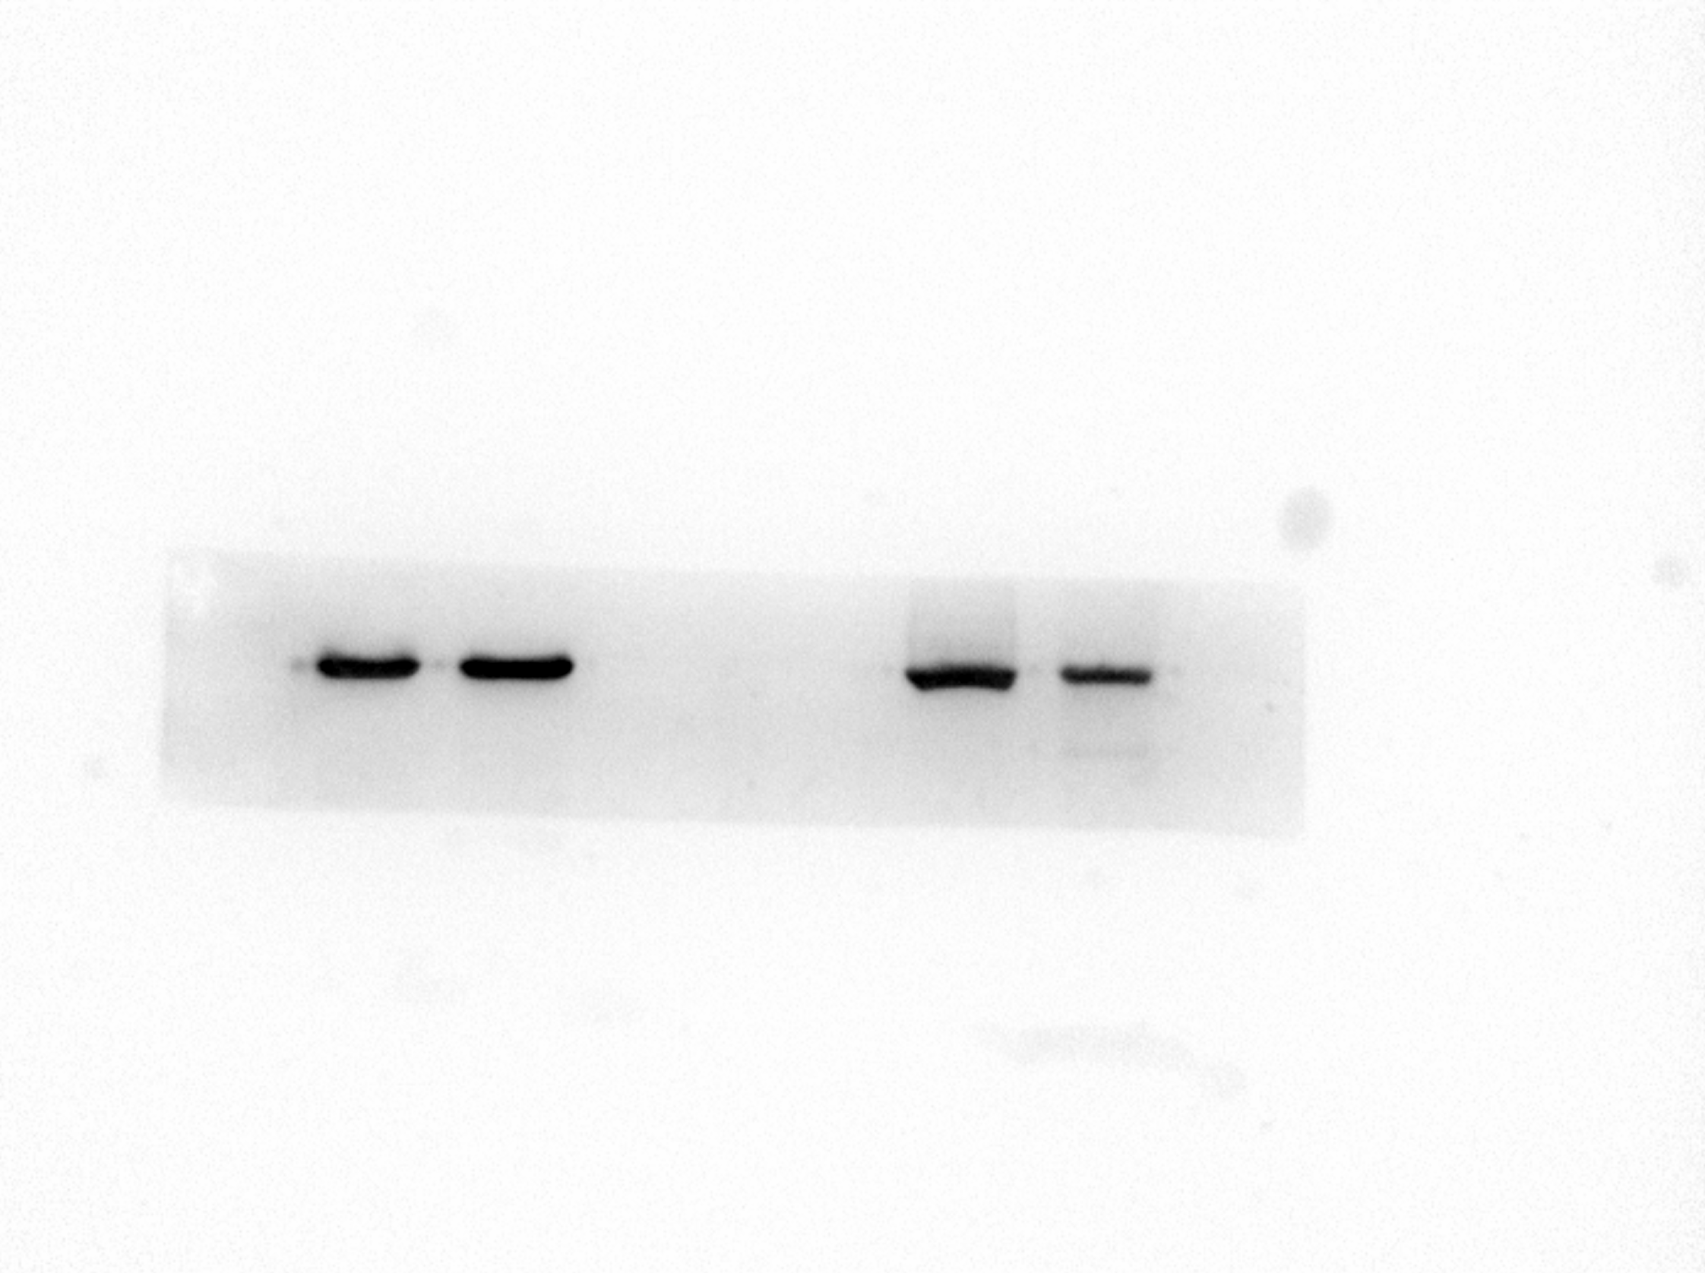
β-Actin
Inhibitor
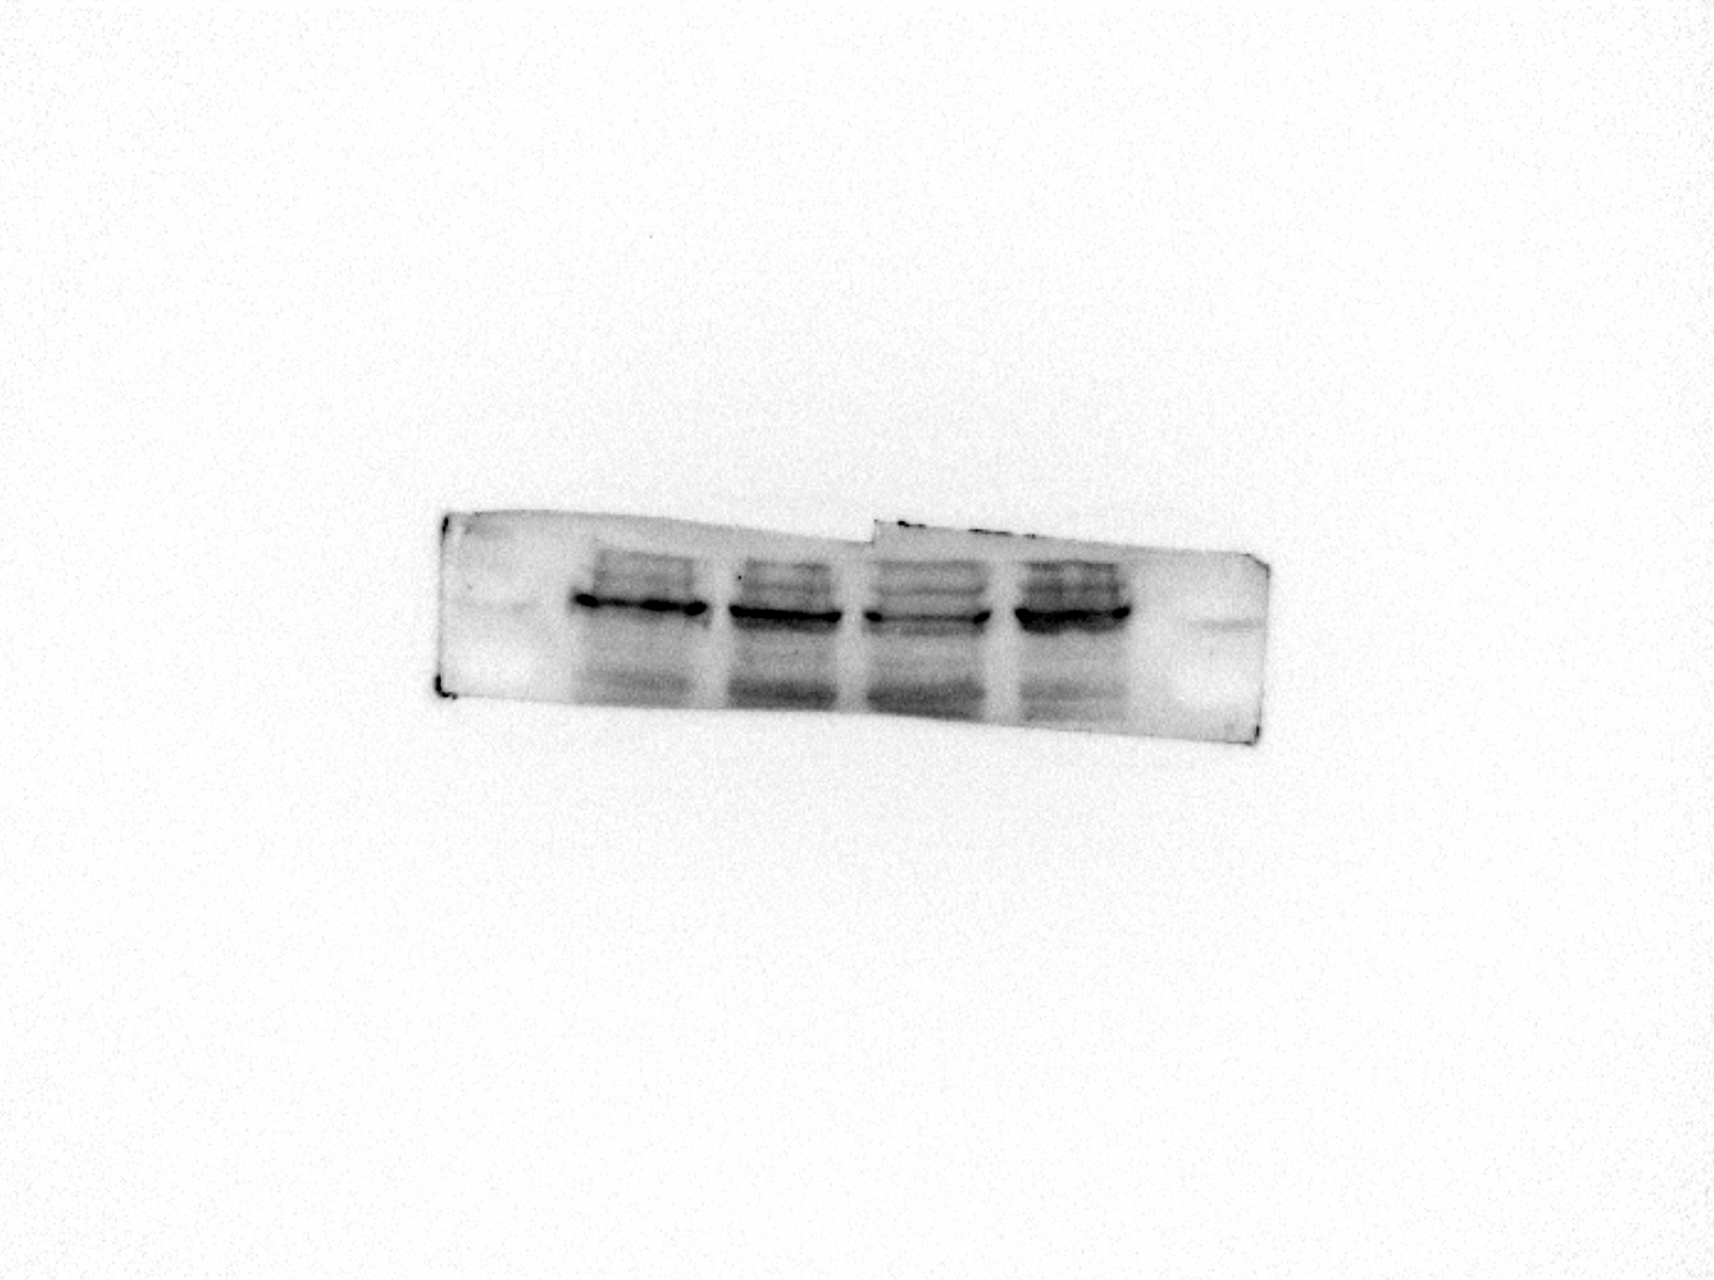
MCM5
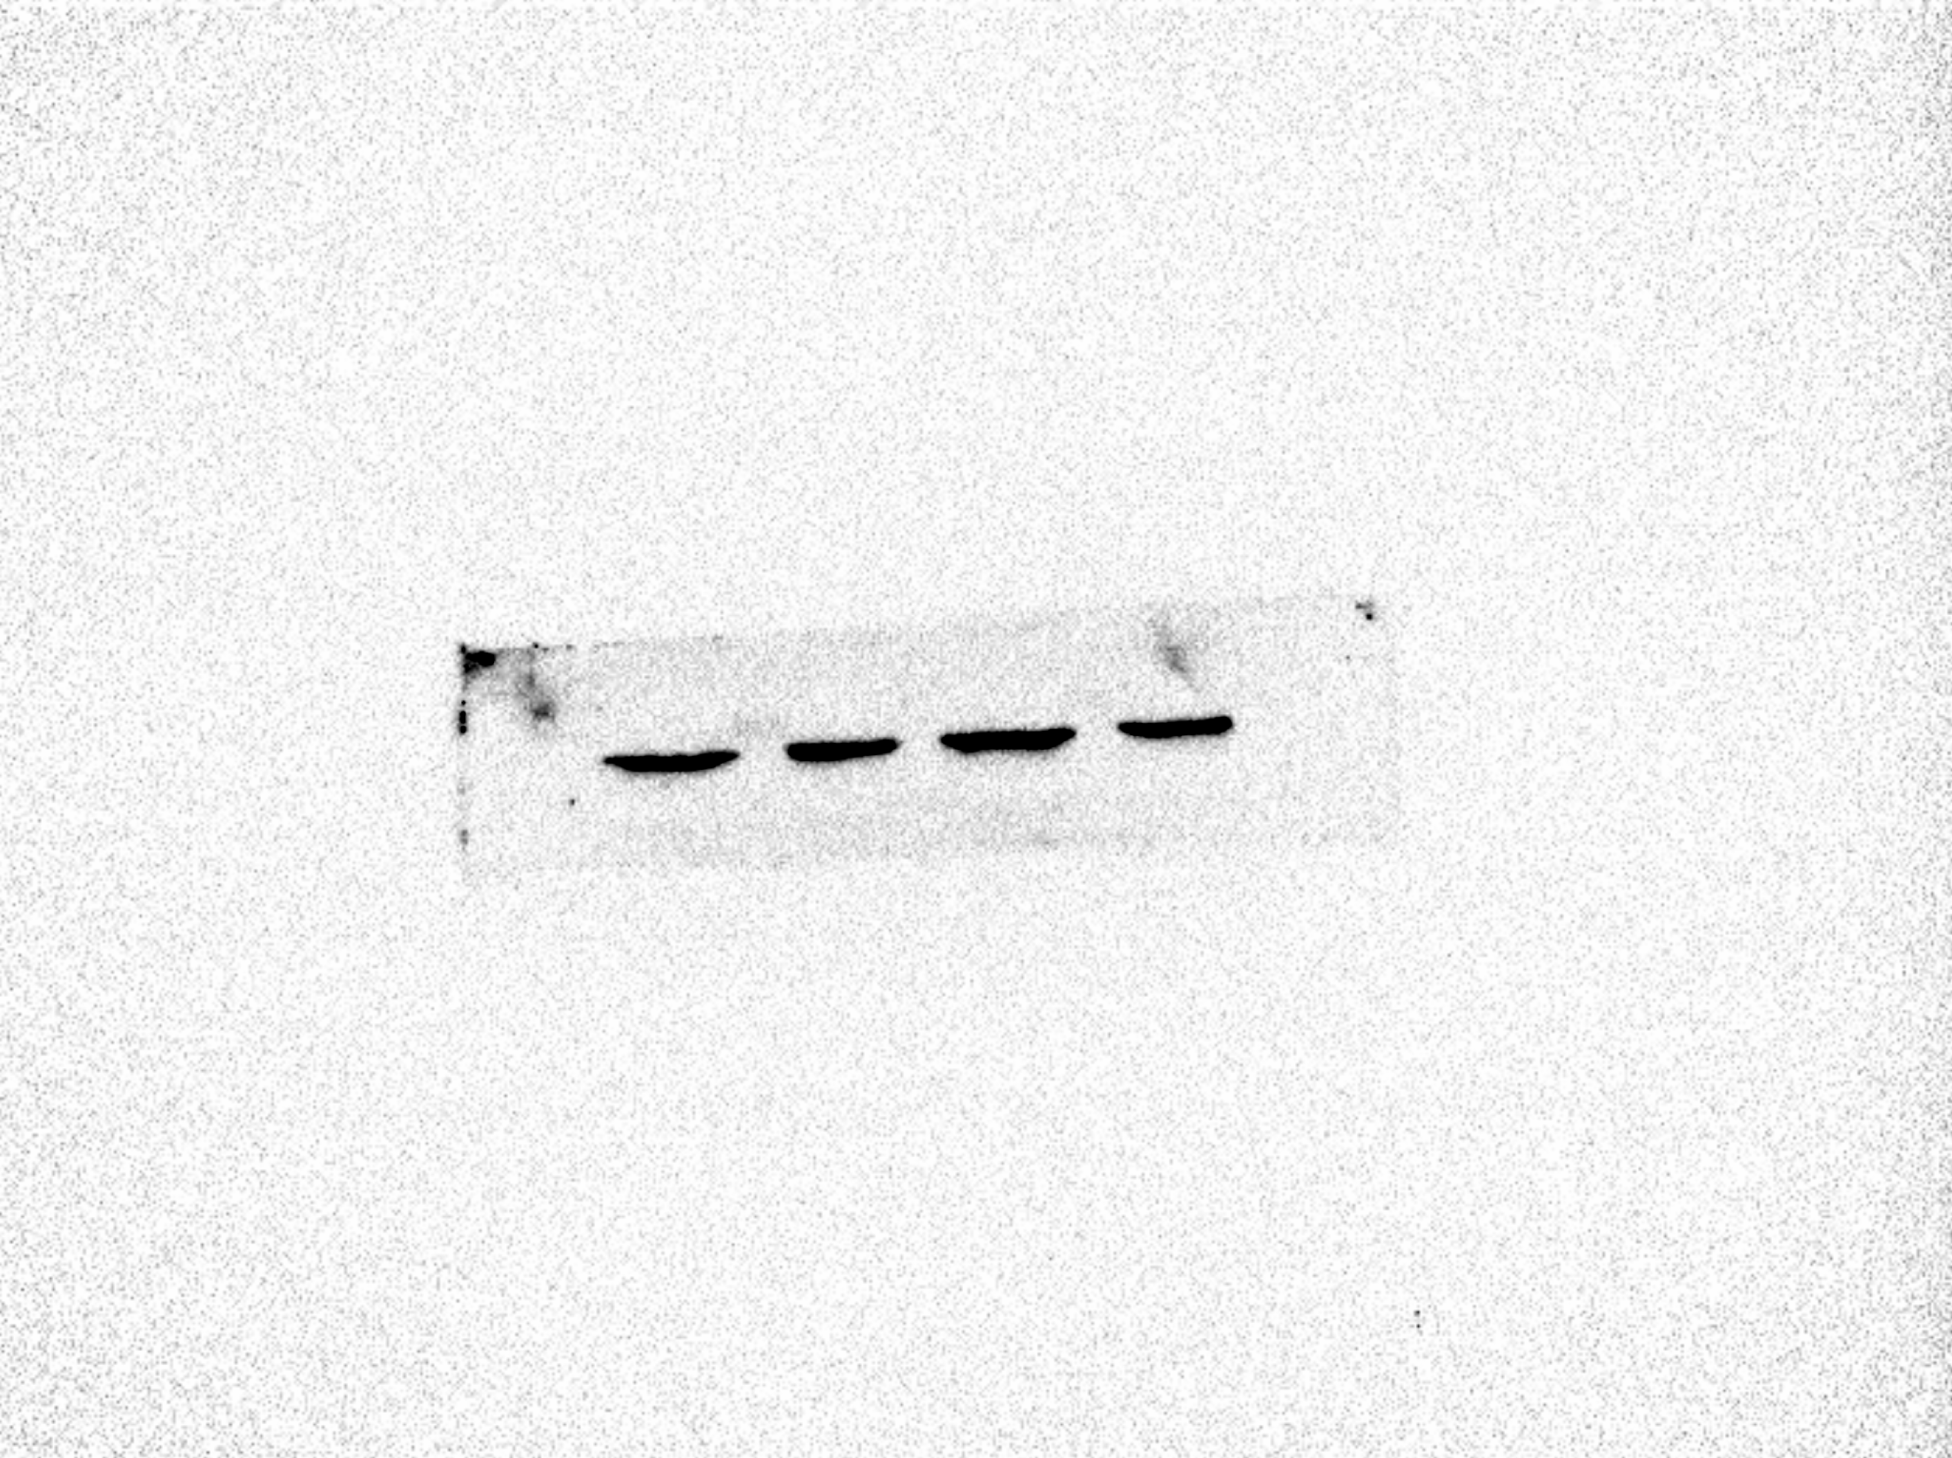
β-Actin
Fig. 6
d Western blot was used to detect the expression of MCM5 protein after knocking down CRNDE. f Rescue assay was performed to verify that the effects could be reversed by miR-136-5p inhibitors at protein levels.
KG-1a cell (left), U937 cell (right)
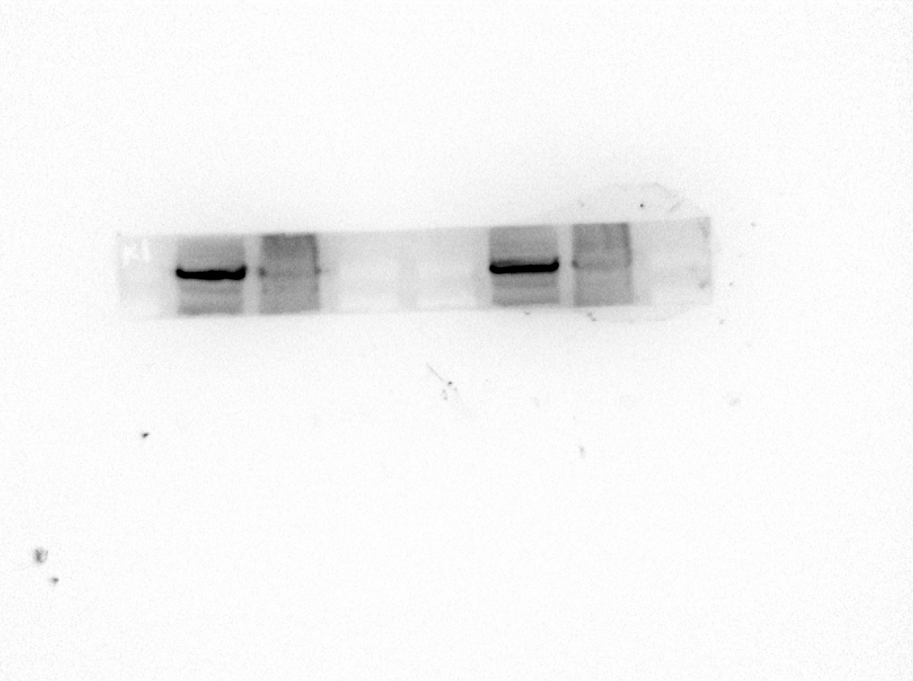
MCM5
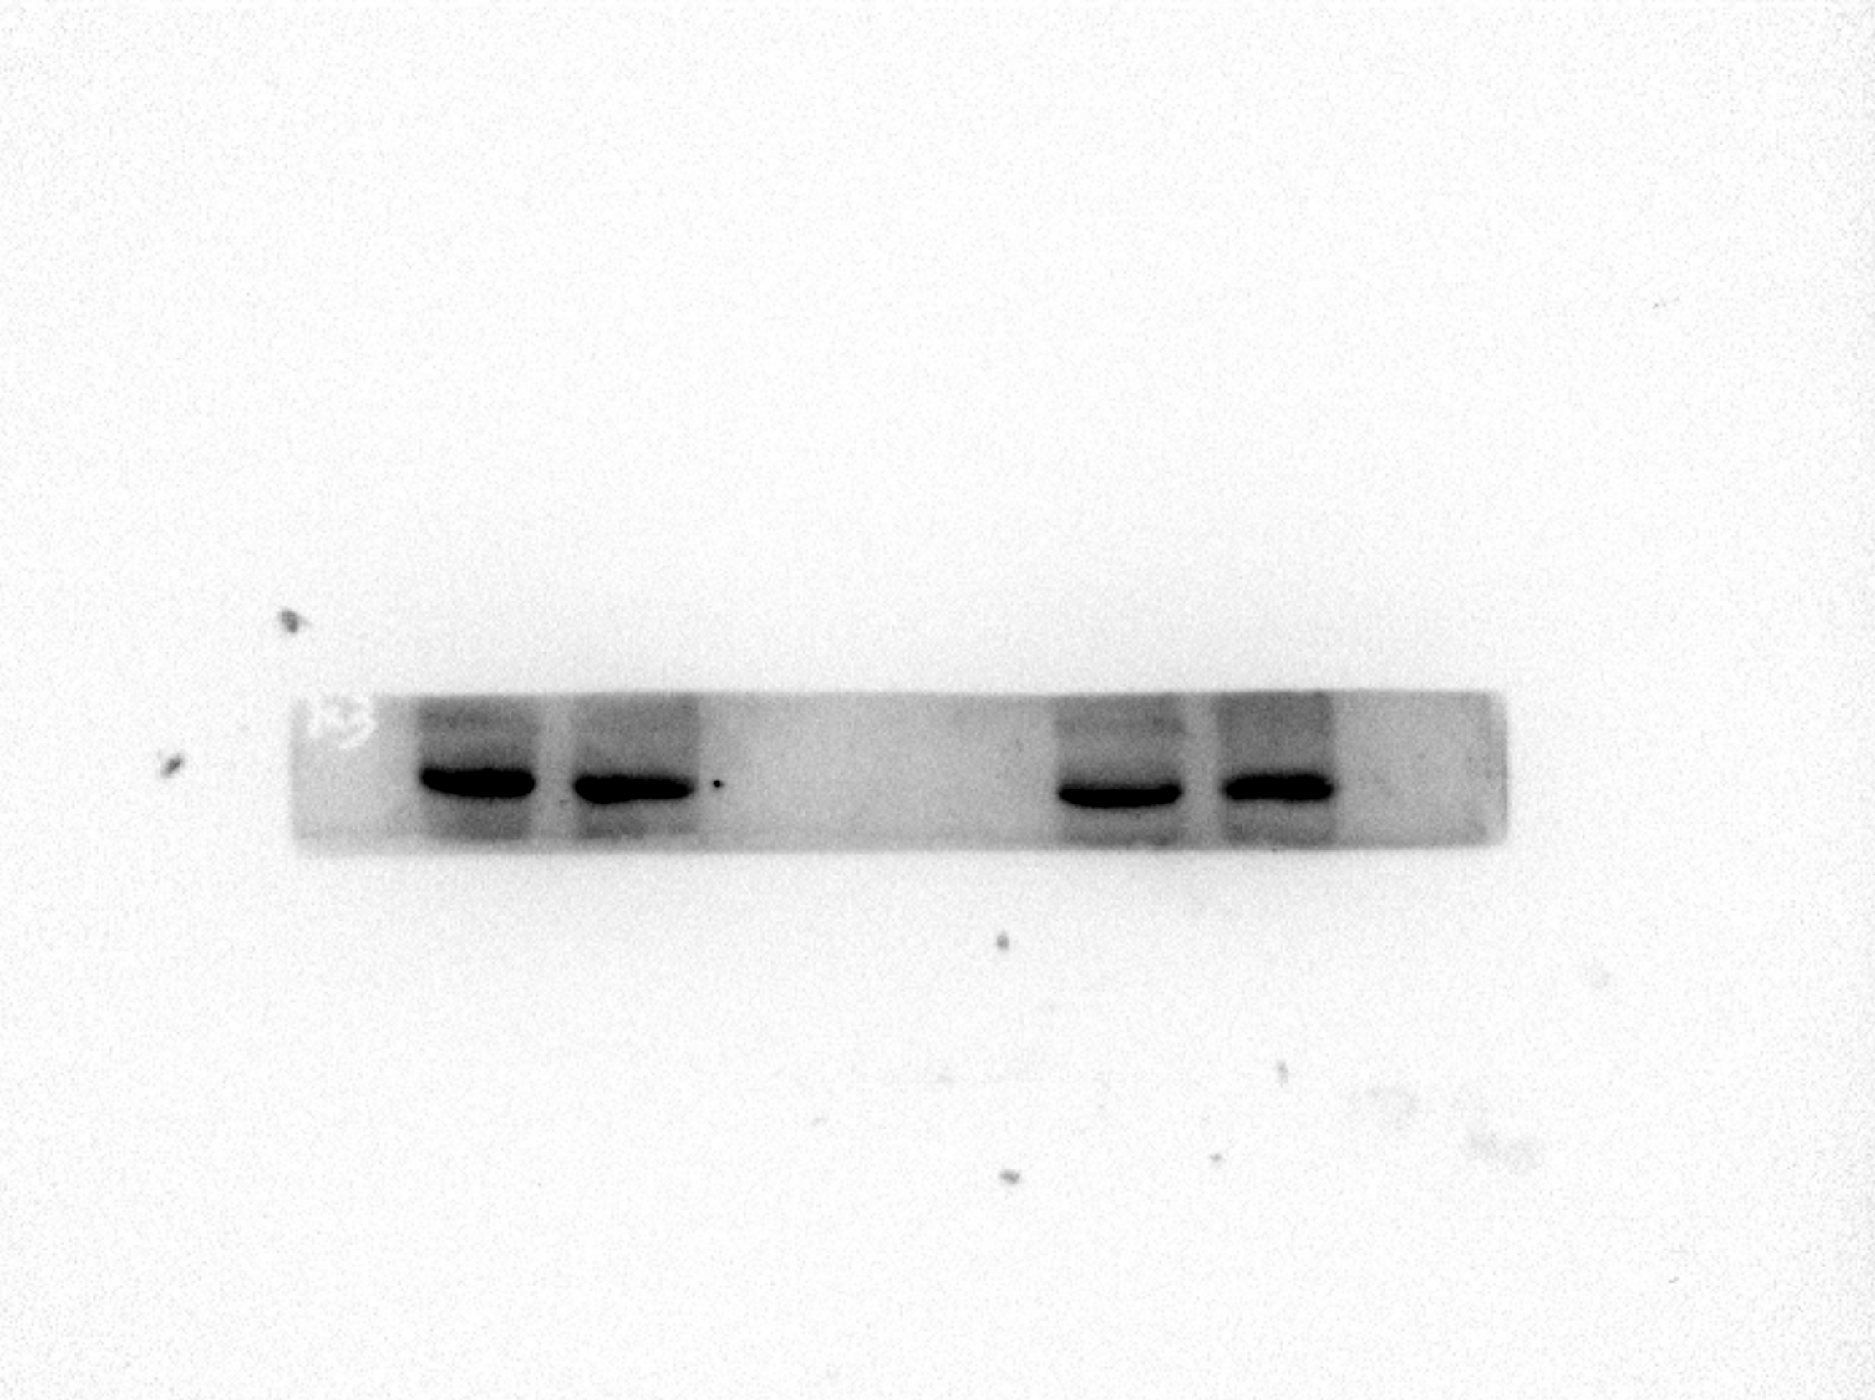
β-Actin
U937 cell
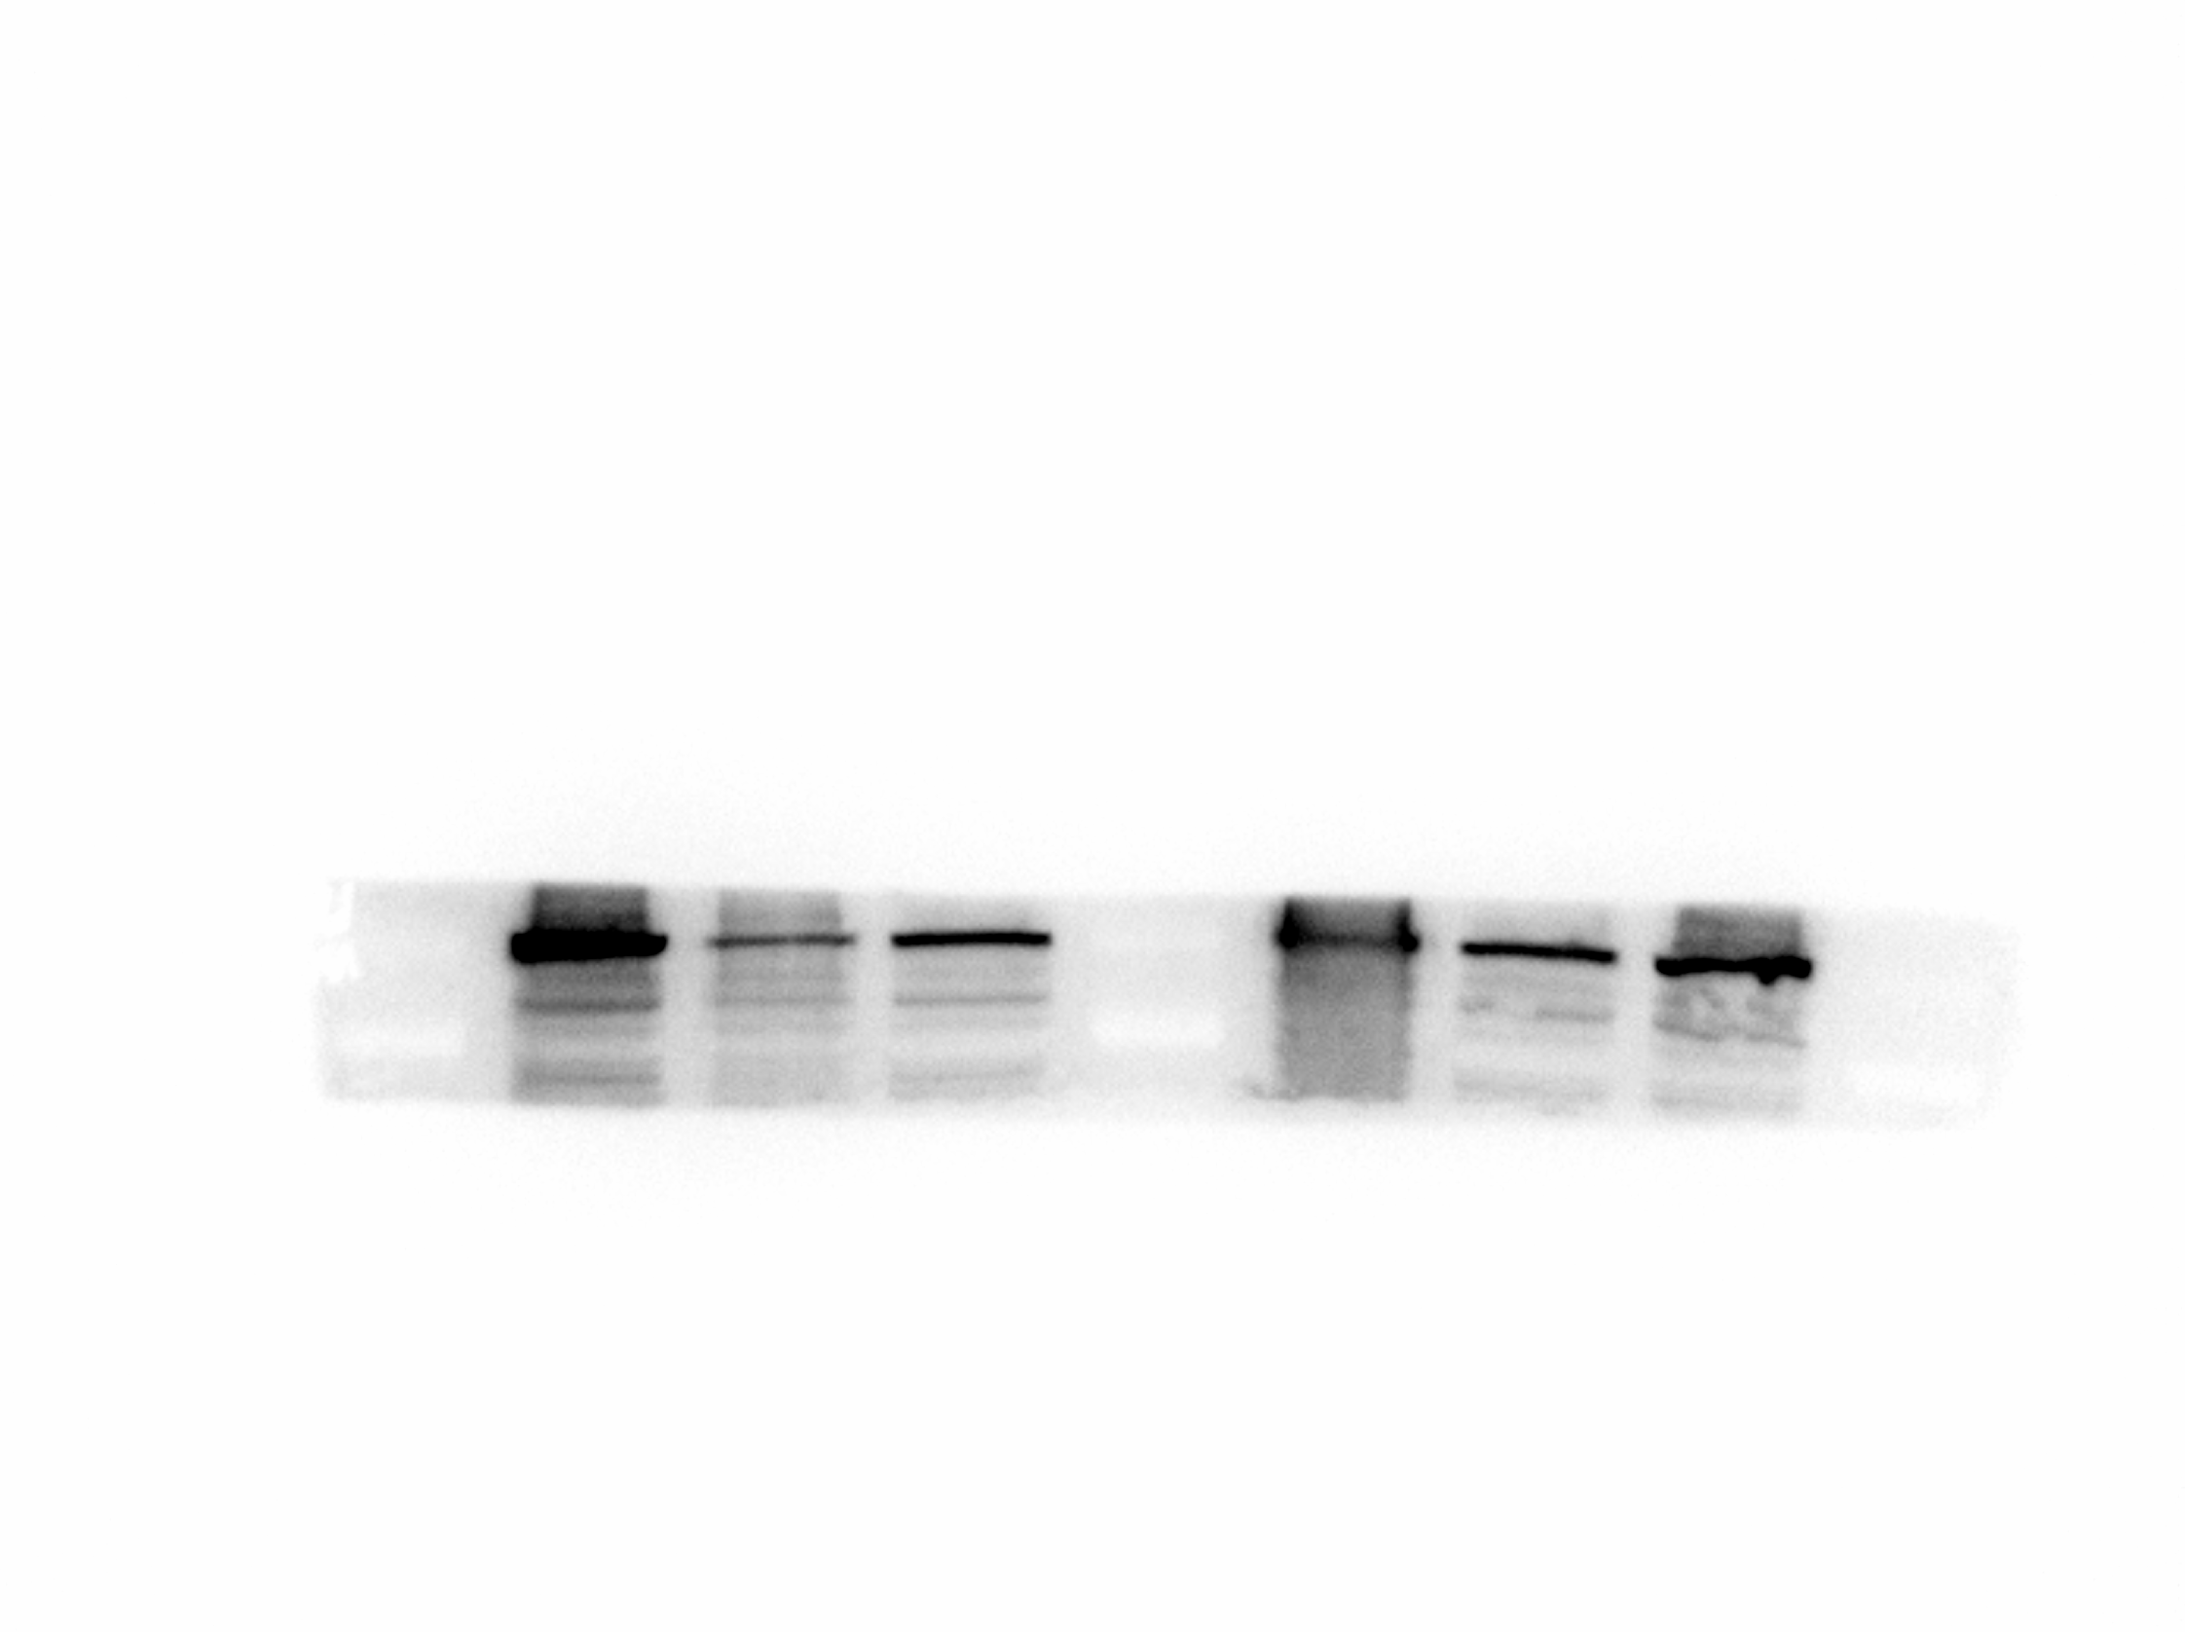
MCM5
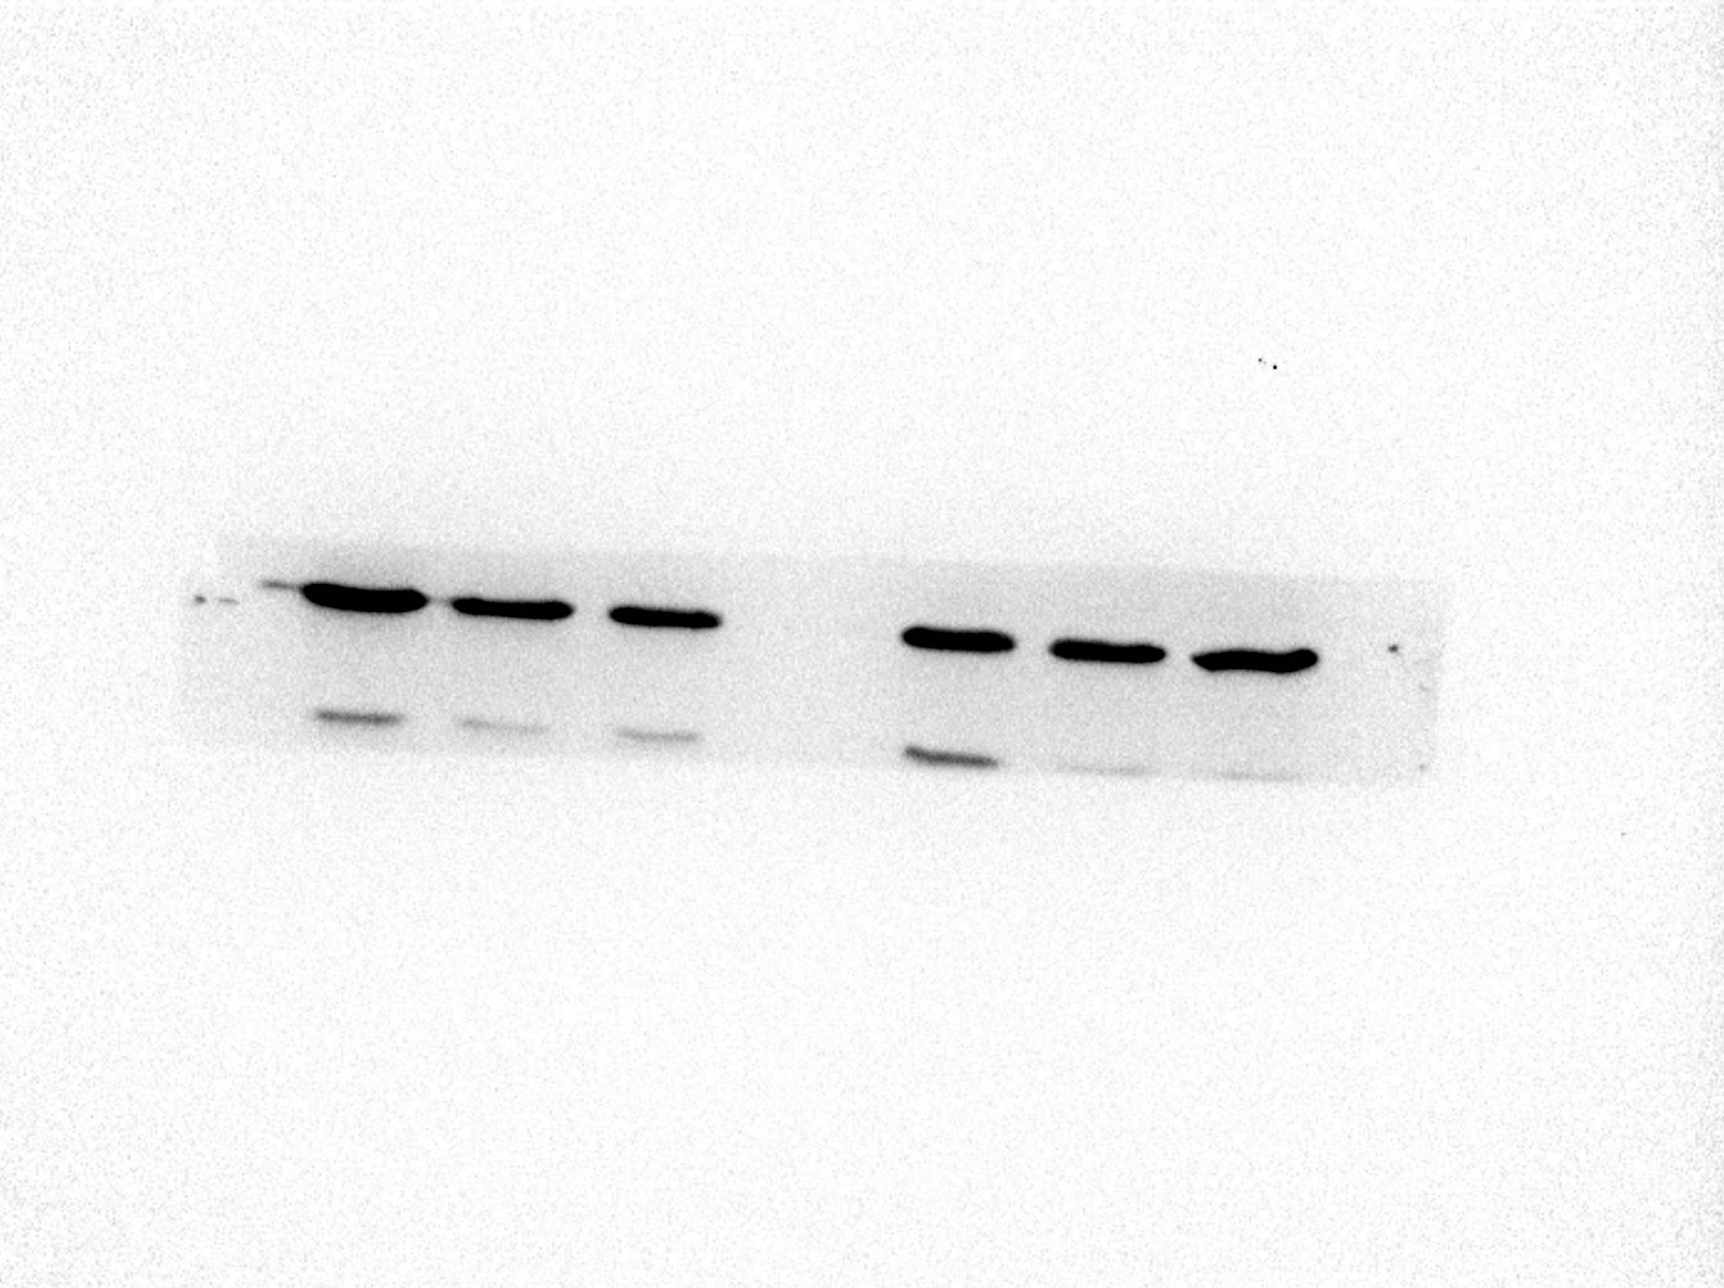
β-Actin
KG-1a cell
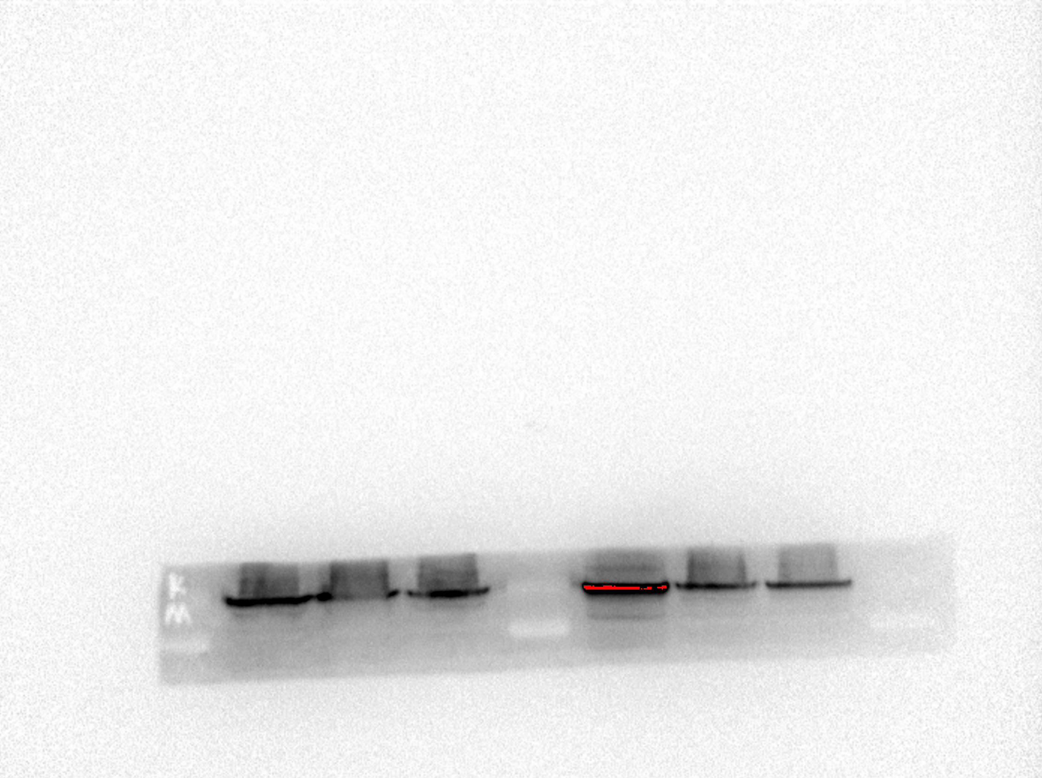
MCM5
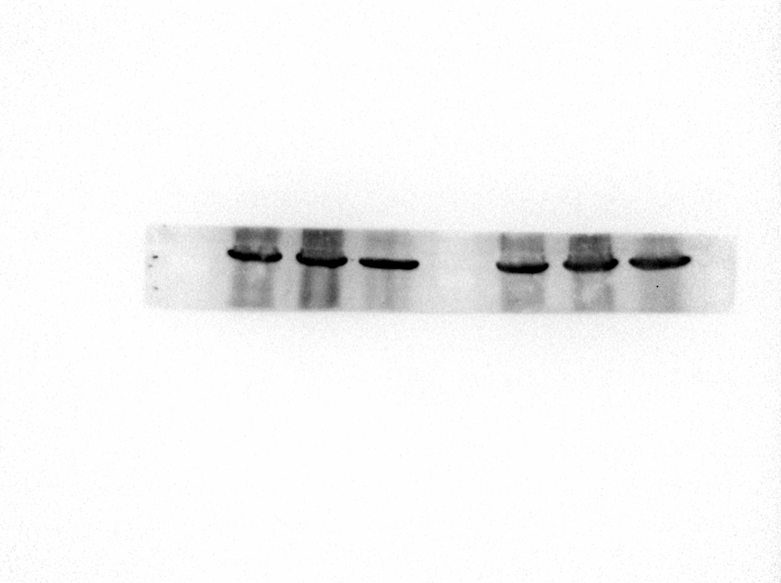
β-Actin

