Supplementary Information

Groove Depth (mm) | Material removed (%) | Von Mises Maximum Stress (MPa)
0 | 0 | 326
1 | 8.2 | 455
2 | 21.3 | 506
3 | 31.6 | 518
4 | 45.1 | 531
5 | 56.6 | 547
6 | 67.4 | 579
7 | 76 | 601

Table 1 Estimated percentage of cross-sectional material removed as a function of groove depth and von Mises maximum stress values at 8 kN, where the von Mises stress is averaged over the cross section.

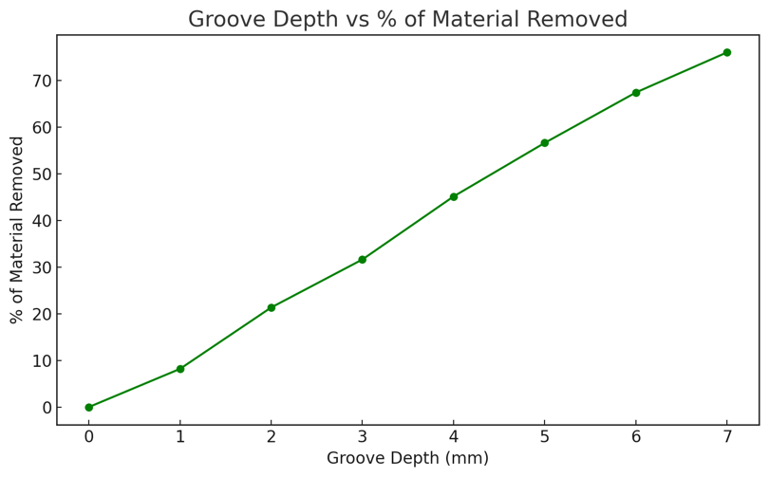

Fig. S1 Relationship between groove depth and percentage of cross-sectional material removed in the carabiner basket region.

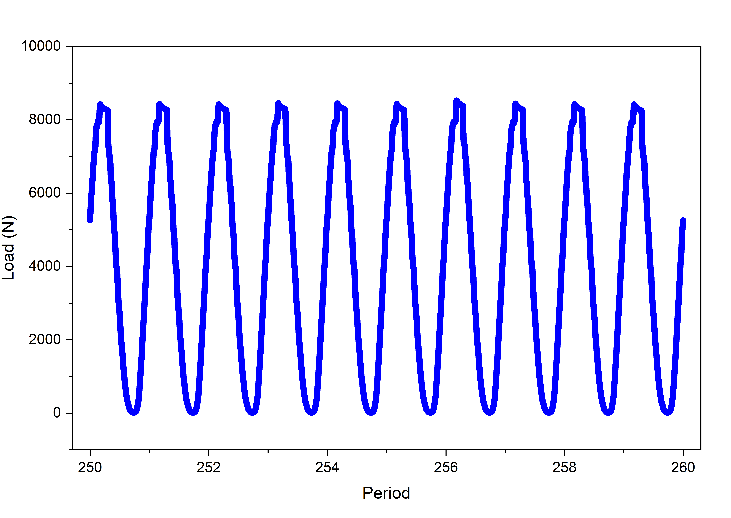
Fig. S2 The cyclic loading that occurred during a fatigue test with a carabiner with a groove depth of 5 mm. The load varied sinusoidally between a maximum force of approximately 8.5 kN and a minimum force of 0 N. Each period was 5 seconds, and by the 260th cycle, the carabiner fractured.

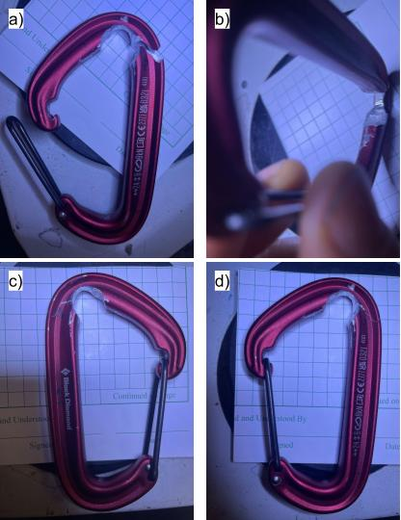

Fig. S3 Images of the carabiner with a 5 mm groove following catastrophic failure during fatigue testing. The fracture occurred on the upper curved section of the main body. (a) carabiner shown in two pieces, emphasizing the location of the crack, at the upper spine. (b) a top-down view of the groove region prior to testing (c) one side of the carabiner, shown with the gate facing towards the right. (d) the other side, shown with the gate facing left.

