Supporting Information
Hydrogen peroxide assisted photocatalytic dye degradation over reduced graphene oxide integrated ZnCr₂O₄ nanoparticles

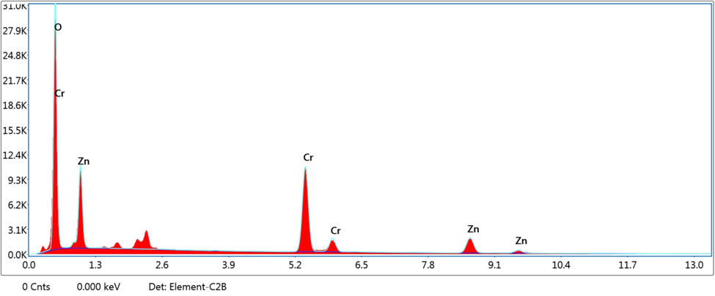

Fig. S1: EDX of bare ZnCr₂O₄ nanoparticles

