Supplementary Materials
Fig. S1 Expression of hTERT in different cervical lesions and association with overall survival among cervical cancer patients. (A) hTERT expressions in normal, CIN-I, CIN-III and cervical carcinoma tissues by immunohistochemistry (n=274, scale 100μm). (B) High expression of hTERT was marginally associated with worse overall survival in cervical cancer patients (n=156). Abbreviations: AC: adenocarcinoma; ASC: adenosquamous carcinoma; CINs: intraepithelial neoplasia; SCC: squamous cell carcinoma; * p<0.05, *** p<0.001.
Fig. S2 Significant correlation between TPP1 and MKI67 gene expressions in cervical cancer, evaluated by TCGA data from GEPIA database.
Fig. S3 Examples of TPP1 expression in other cancers and association of its high expression and cancer survival. (A) Expression of TPP1 in cancer of esophagus, stomach, and liver compared with normal tissues from TCGA and GTEx databases using GEPIA. (B) The Kaplan-Meier curve of TPP1 expression in normal tissues, and cancer of esophagus, stomach, and liver. * p<0.05.
Table S1 Scoring system for hTERT positive cells according to the intensity and distribution.
Table S2 Primers designed for GAPDH, hTERT, and TPP1
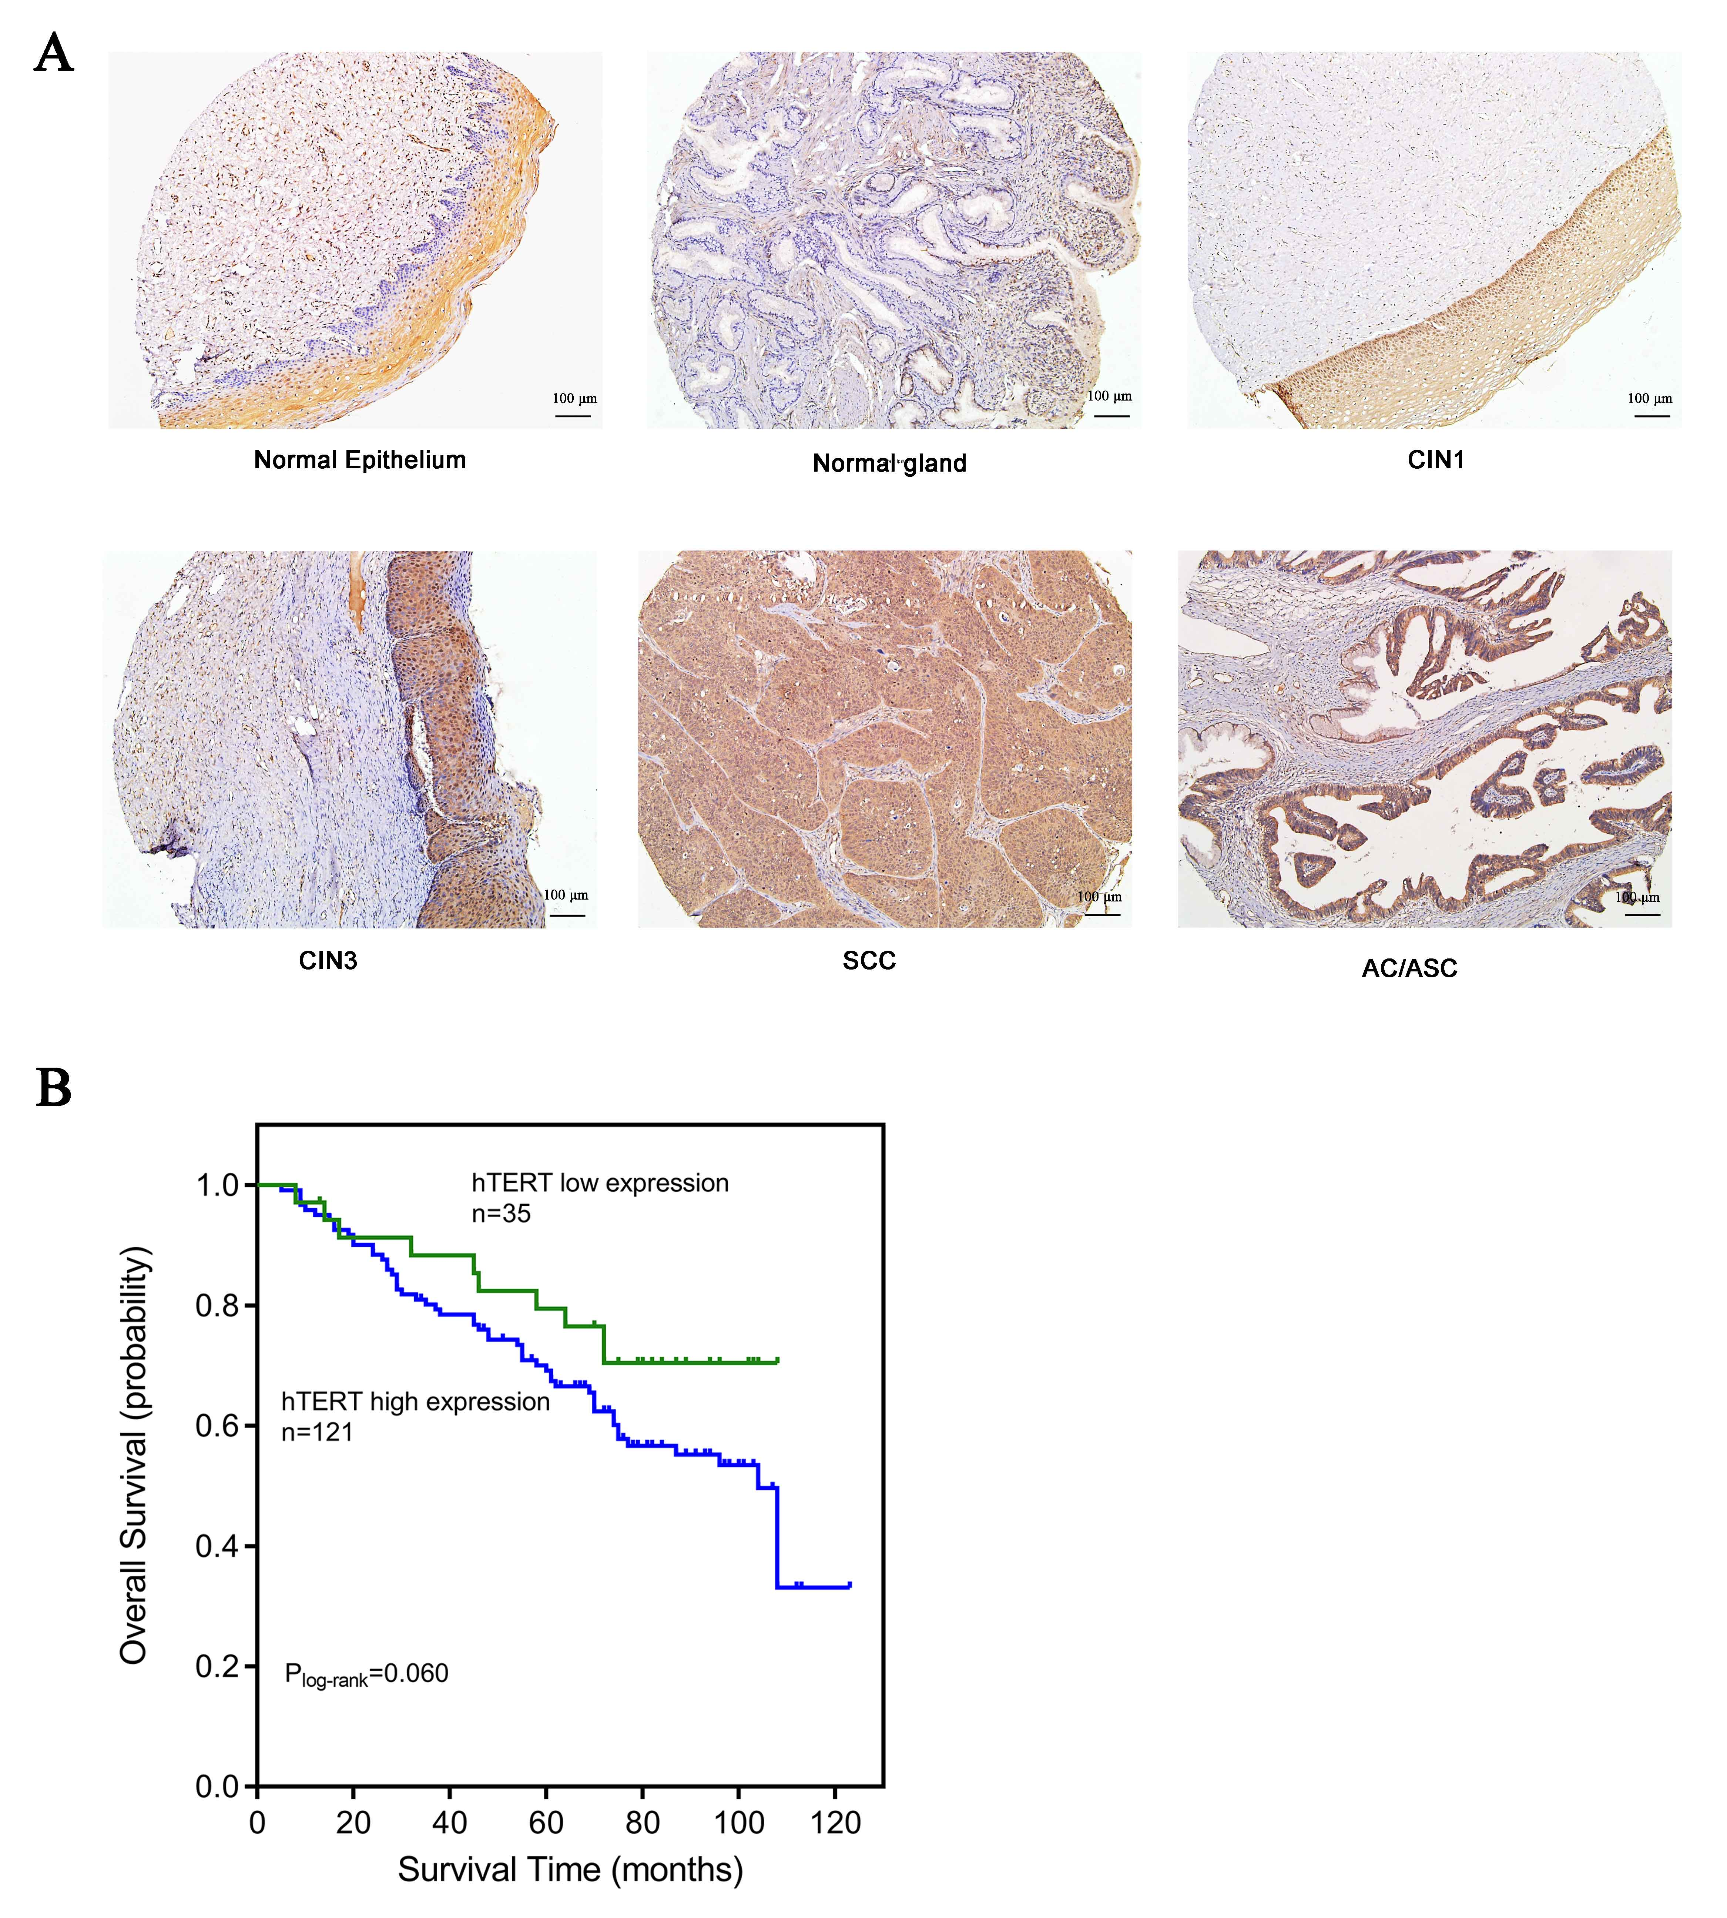
Fig. S1 Expression of hTERT in different cervical lesions and association with overall survival among cervical cancer patients. (A) hTERT expressions in normal, CIN-I, CIN-III and cervical carcinoma tissues by immunohistochemistry (n=274, scale 100μm). (B) High expression of hTERT was marginally associated with worse overall survival in cervical cancer patients (n=156). Abbreviations: AC: adenocarcinoma; ASC: adenosquamous carcinoma; CINs: intraepithelial neoplasia; SCC: squamous cell carcinoma; * p<0.05, *** p<0.001.

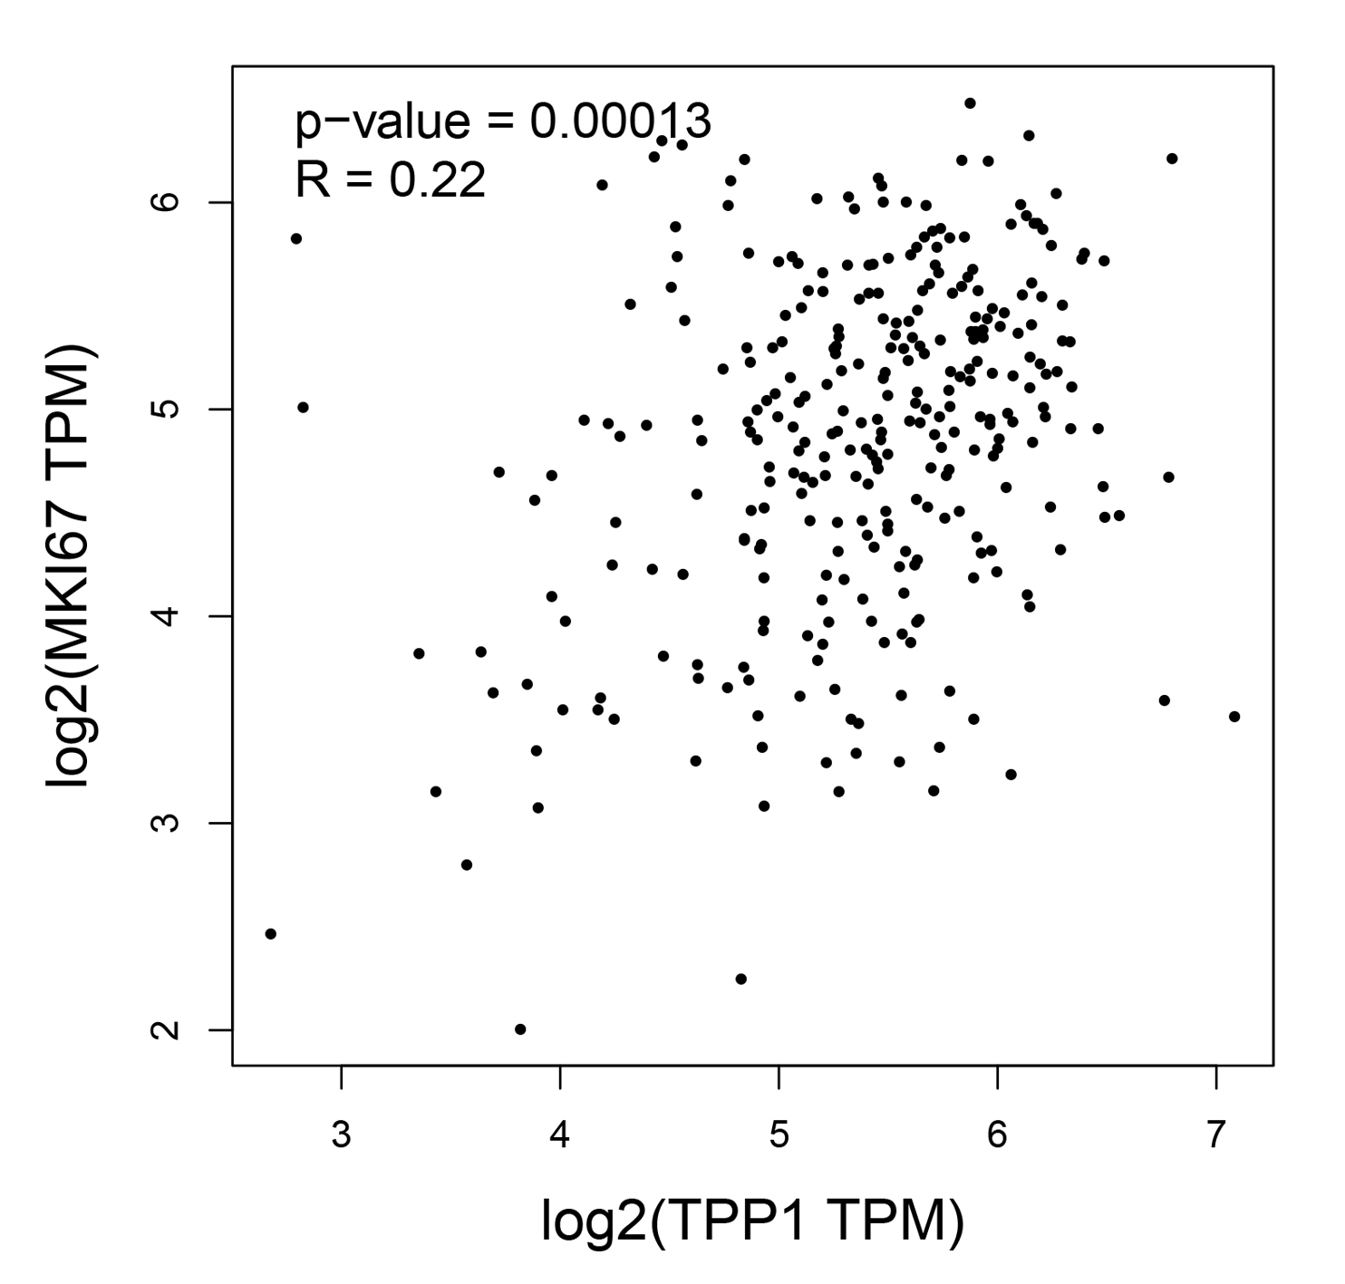
Fig. S2 Significant correlation between TPP1 and MKI67 gene expressions in cervical cancer, evaluated by TCGA data from GEPIA database.

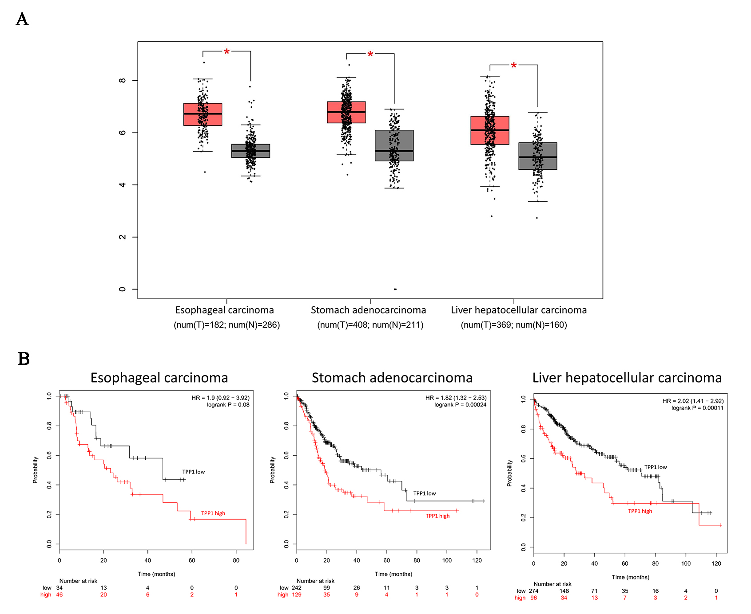 Fig. S3 Examples of TPP1 expression in other cancers and association of its high expression and cancer survival. (A) Expression of TPP1 in cancer of esophagus, stomach, and liver compared with normal tissues from TCGA and GTEx databases using GEPIA. (B) The Kaplan-Meier curve of TPP1 expression in normal tissues, and cancer of esophagus, stomach, and liver. * p<0.05.

Table S1 Scoring system for hTERT positive cells according to the intensity and distribution.
Parameters |  | Score
Positive cells (%)
 | <10% | 0
 | 10-50% | 1
 | 50-75% | 2
 | >75% | 3
Intensity of staining
 | Negative (no staining) | 0
 | Weak (yellow) | 1
 | Moderate (brown) | 2
 | Strong (dark brown) | 3
Overall score (positive cells × intensity) *
 | Negative (-) | 0
 | Weakly positive (+) | 1-3
 | Moderately positive (++) | 4-7
 | Strongly positive (+++) | 8-9
*An overall score was obtained by multiplying the intensity score and the positive score.

Table S2 Primers designed for GAPDH, hTERT, and TPP1
Primer | Sequence
GAPDH
forward primer | 5’-TGGAAGGACTCATGACCACA-3’
reverse primer | 5’-TTCAGCTCAGGGATGACCTT-3’
hTERT
forward primer | 5’-CGGAAGAGTGTCTGGAGCAA-3’
reverse primer | 5’-GGATGAAGCGGAGTCTGGA-3’
TPP1
forward primer | 5’-ATCTCGAAGTATGCCTGGCCGCTGTCAGAGTG-3’
reverse primer | 5’-AGCGGCCGCTATCACATCGGAGTTGGCTCAGAC-3’

