Supplementary Materials
The renoprotective effect of SGLT2 inhibitors in patients with type 2 diabetes and chronic kidney disease: A real-world cohort study

Supplementary Tables

Supplementary Table 1. Operational definitions of patient’s characteristics
 | ICD-9-CM | ICD-10-CM
Cohort
T2DM | 250.*0, 250.*2 | E11.***
Intervention | Procedural code
Kidney Replacement Therapy | 58001C, 58019C, 58020C, 58021C, 58022C, 58023C, 58024C, 58025C, 58029C, 58002C, 58009A, 58009B, 58010A, 58010B, 58011A, 58011AB, 58011B, 58011C, 58012A, 58012B, 58017B, 58017C, 58026C, 58028C, 76020
Comorbidities
Polycystic kidney disease | 753.12, 753.13, 753.14 | Q61.1, Q61.2, Q61.3
Lupus Nephritis | 710.0 and 580.81, 582.81, 583.81 | M32.14
Dyslipidemia | 272.2, 272.4, 272.9 | E78.2, E78.4, E78.5
Heart failure | 398.91, 402.01, 402.11, 402.91, 404.01, 404.03, 404.11, 404.13, 404.91, 404.93, 425.4 - 425.9, 428.x | I09.81, I11.0, I13.0, I13.2, I42.5-8, I43, I50.x
Hypertension | 401.x-405.x | I10.x, I11.x-113.x, I15.x
Liver disease | 070.22, 070.23, 070.32, 070.33, 070.44, 070.54, 070.6, 070.9, 570.x, 571.x, 573.3, 573.4, 573.8, 573.9, V42.7 | B18.x, K70.0 - K70.3, K70.9, K71.3 - K71.5, K71.7, K73.x, K74.x, K76.0, K76.2 - K76.4, K76.8, K76.9, Z94.4
Anemias | 280.1-280.9, 281.x | D50.8, D50.9, D51.x-D53.x
Co-medication | ATC code 4
Antithrombotic | B01AA, B01AC
Antianemic agents | B03BA, B03BB, B03XA, B03AB
Cardiac stimulants | C01AA
Diuretics | C03AA, C03BA, C03CA, C03DA
Beta blocking agents | C07AA, C07AB, C07AG
Calcium channel blockers | C08CA, C08DB
Renin angiotensin | C09AA, C09CA, C09DB, C09DX
Statin | C10AA
Lipid modifying agents | C10AB, C10AX, C10BA
NSAIDS | M01AB, M01AC, M01AH
Glucocorticoids | H02AB
Antigout | M04AA, M04AB, M04AC
Abbreviations: ICD-9-CM: International Classification of Diseases, 9th Revision, Clinical Modification; ICD-10-CM: International Classification of Diseases, 10th Revision, Clinical Modification; T2DM: Type 2 Diabetes Mellitus; NSAIDS: nonsteroidal anti-inflammatory drugs

Supplementary Table 2. Operational definitions of study outcomes
Outcomes | Definition
eGFR to levels ≤15 mL/min/1.73 m² | We use creatinine levels to calculate eGFR based on the CKD Epidemiology Collaboration (CKD-EPI) formula to determine the first time eGFR ≤15 mL/min/1.73 m²
a sustained eGFR decline of ≥50% from baseline | We use creatinine levels to calculate eGFR based on the CKD Epidemiology Collaboration (CKD-EPI) formula to determine the first time eGFR decline of ≥50% from baseline
Kidney Replacement Therapy | Procedural code (National Health Insurance Research Database (NHIRD)  58001C, 58019C, 58020C, 58021C, 58022C, 58023C, 58024C, 58025C, 58029C, 58002C, 58009A, 58009B, 58010A, 58010B, 58011A, 58011AB, 58011B, 58011C, 58012A, 58012B, 58017B, 58017C, 58026C, 58028C, 76020

Supplementary Table 3. Baseline characteristics of study cohort before propensity score matching

 | SGLT2is  (n= 448) | DPP4is  (n= 3,333) | TZDs  (n= 421) | nonSGLT2is  (n= 3,754)
Age, years
Mean (SD) | 69.5 (10.1) | 74.1 (11.3) | 71.4 (10.4) | 73.8 (11.2)
Year of index date
2008-2011 | 10 (2.2%) | 528 (15.8%) | 221 (52.5%) | 749 (20.0%)
2012-2016 | 90 (20.1%) | 1704 (51.1%) | 133 (31.6%) | 1837 (48.9%)
2017-2020 | 348 (77.7%) | 1101 (33.0%) | 67 (15.9%) | 1168 (31.1%)
Sex, n (%)
Male | 255 (56.9%) | 1755 (52.7%) | 248 (58.9%) | 2003 (53.4%)
Female | 193 (43.1%) | 1578 (47.3%) | 173 (41.1%) | 1751 (46.6%)
Comorbidities, n (%)
Dyslipidemia | 185 (41.3%) | 1476 (44.3%) | 177 (42.0%) | 1653 (44.0%)
Hypertension | 230 (51.3%) | 2086 (62.6%) | 245 (58.2%) | 2331 (62.1%)
Heart failure | 112 (25.0%) | 768 (23.0%) | 83 (19.7%) | 851 (22.7%)
Liver disease | 21 (4.7%) | 194 (5.8%) | 20 (4.8%) | 214 (5.7%)
Anemias | 18 (4.0%) | 216 (6.5%) | 16 (3.8%) | 232 (6.2%)
Charlson Comorbidity Index (CCI)
Mean (SD) | 2.79 (1.48) | 3.77 (1.75) | 3.20 (1.64) | 3.71 (1.75)
Co-medications, n (%)
Antithrombotic | 122 (27.2%) | 1032 (31.0%) | 125 (29.7%) | 1157 (30.8%)
Antianemic agents | 23 (5.1%) | 300 (9.0%) | 28 (6.7%) | 328 (8.7%)
Cardiac stimulants | 9 (2.0%) | 61 (1.8%) | 1 (0.2%) | 62 (1.7%)
Diuretics | 68 (15.2%) | 695 (20.9%) | 81 (19.2%) | 776 (20.7%)
Beta blocking agents | 99 (22.1%) | 807 (24.2%) | 85 (20.2%) | 892 (23.8%)
Calcium channel blockers | 85 (19.0%) | 895 (26.9%) | 108 (25.7%) | 1003 (26.7%)
Renin angiotensin | 156 (34.8%) | 1242 (37.3%) | 153 (36.3%) | 1395 (37.2%)
Statin | 124 (27.7%) | 1030 (30.9%) | 112 (26.6%) | 1142 (30.4%)
Lipid modifying agents | 50 (11.2%) | 293 (8.8%) | 42 (10.0%) | 335 (8.9%)
NSAIDS | 5 (1.1%) | 66 (2.0%) | 7 (1.7%) | 73 (1.9%)
Glucocorticoids | 1 (0.2%) | 46 (1.4%) | 5 (1.2%) | 51 (1.4%)
Antigout | 49 (10.9%) | 450 (13.5%) | 42 (10.0%) | 492 (13.1%)
Laboratory test, Mean (SD)
eGFR, mL/min/1.73m² | 44.7 (11.2) | 38.6 (11.8) | 39.4 (11.8) | 38.7 (11.8)
HbA1c, % | 7.96 (1.81) | 7.68 (1.70) | 8.01 (1.78) | 7.71 (1.71)
Missing, n (%) | 233 (52.0%) | 643 (19.3%) | 182 (43.2%) | 825 (22.0%)
Total Cholesterol, mg/dL | 174 (45.9) | 180 (50.9) | 191 (44.7) | 181 (50.5)
Missing, n (%) | 291 (65.0%) | 1301 (39.0%) | 212 (50.4%) | 1513 (40.3%)

Supplementary Figures

- SGLT2is vs. non-SGLT2is
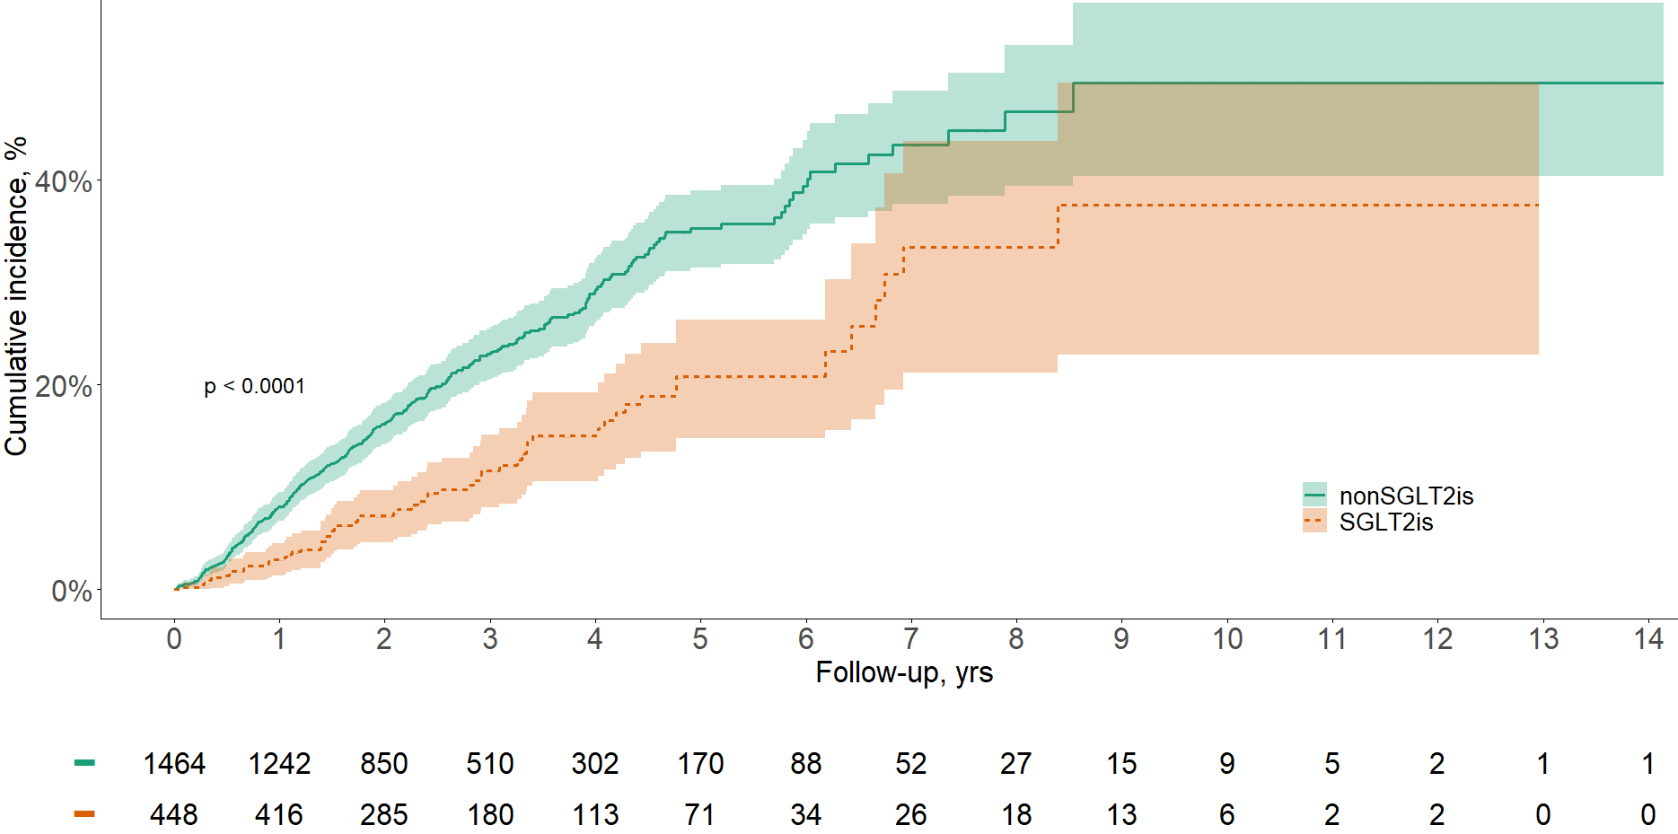

- SGLT2is vs. DPP4is
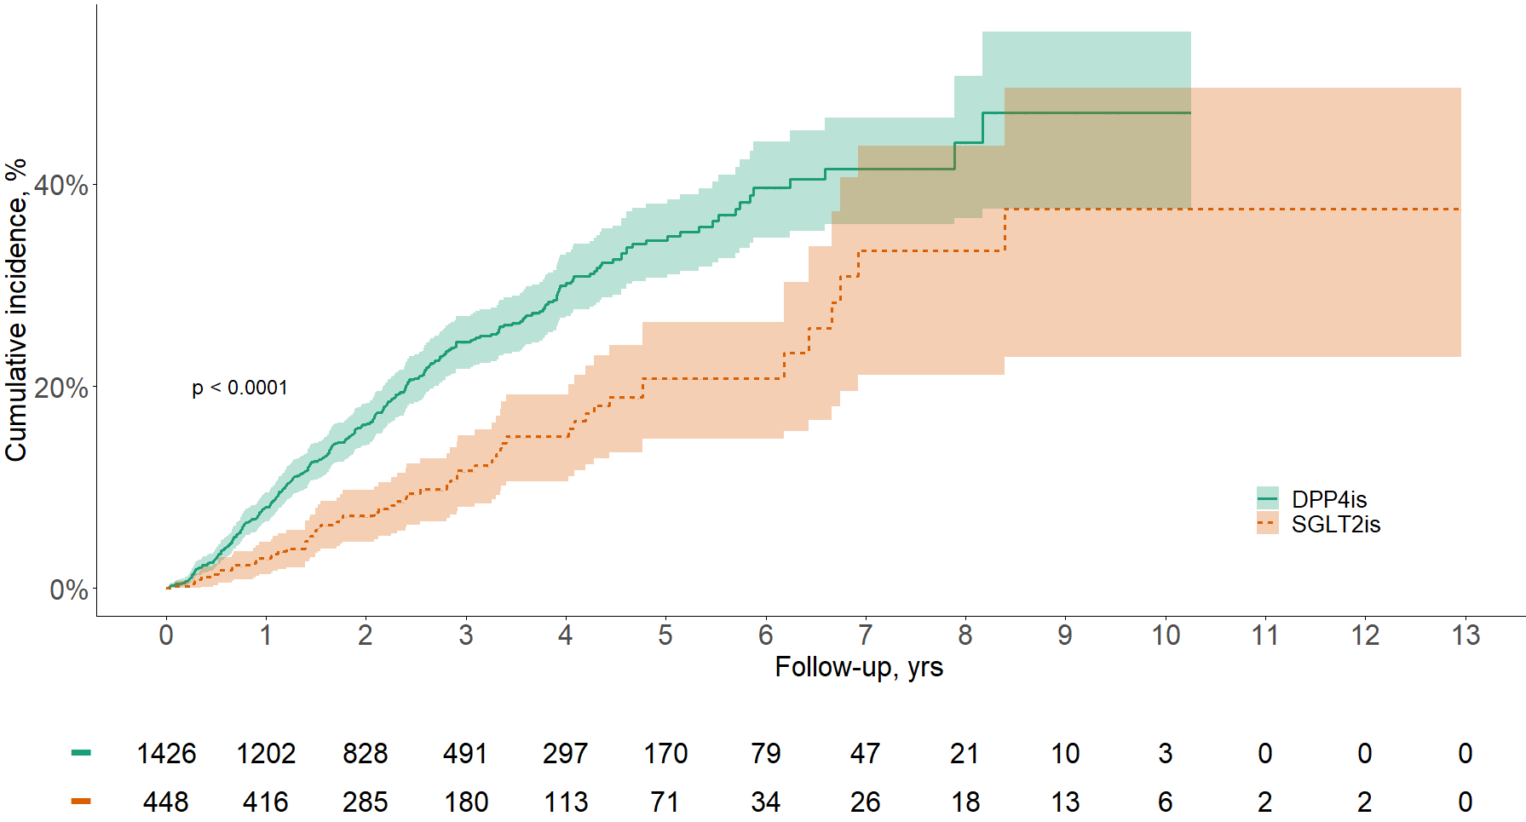

- SGLT2is vs. TZDs
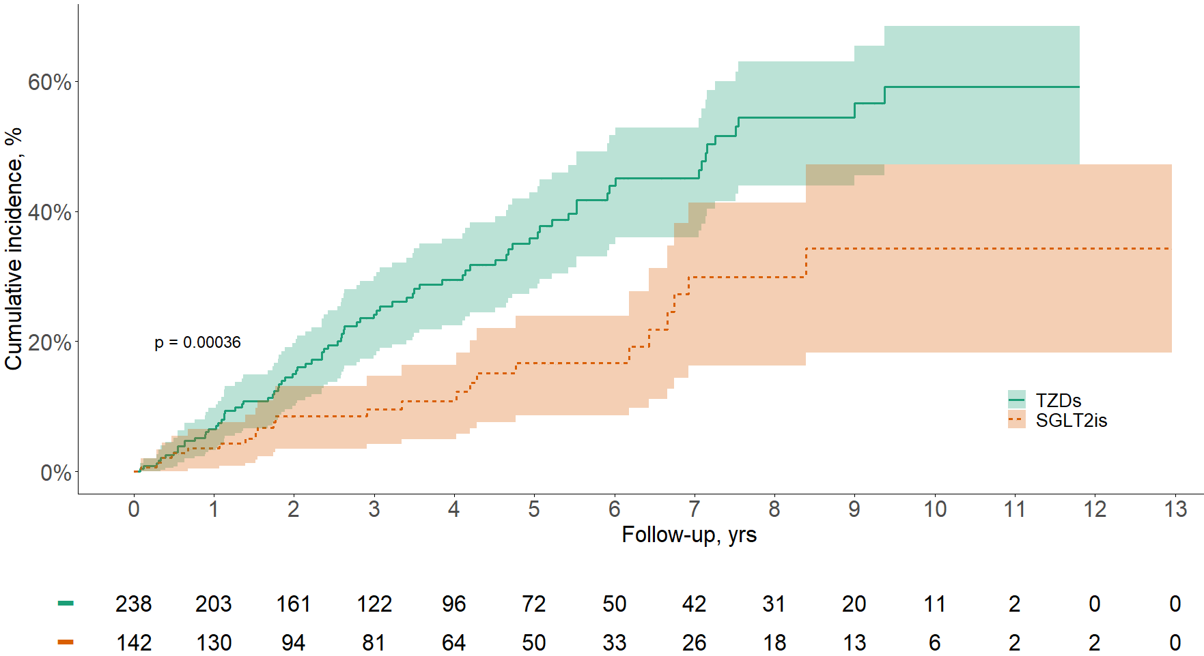

Supplementary Figure 1. Cumulative incidence of eGFR decline ≥50% of (A) SGLT2is versus non-SGLT2is users; (B) SGLT2is versus DPP4is users; (C) SGLT2is versus TZDs users using Kaplan–Meier survival method. Abbrevations: eGFR: estimated glomerular filtration rate, SGLT2is: sodium-glucose cotransporter-2 inhibitors, DPP4is: dipeptidyl peptidase-4 inhibitors, TZDs: thiazolidinediones.

- SGLT2is vs. non-SGLT2is
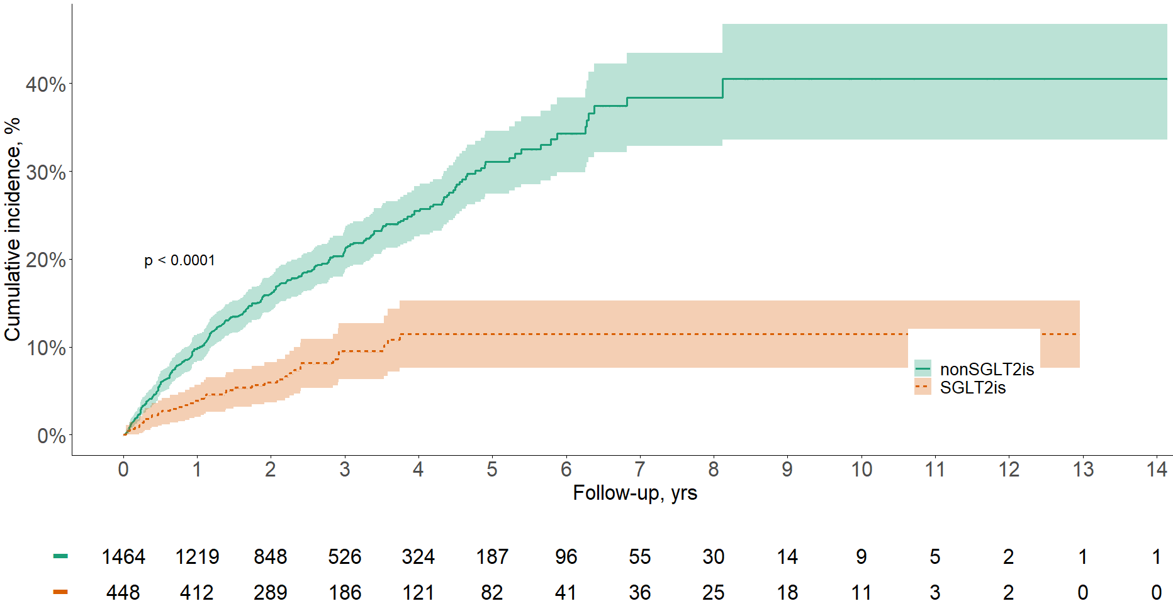

- SGLT2is vs. DPP4is
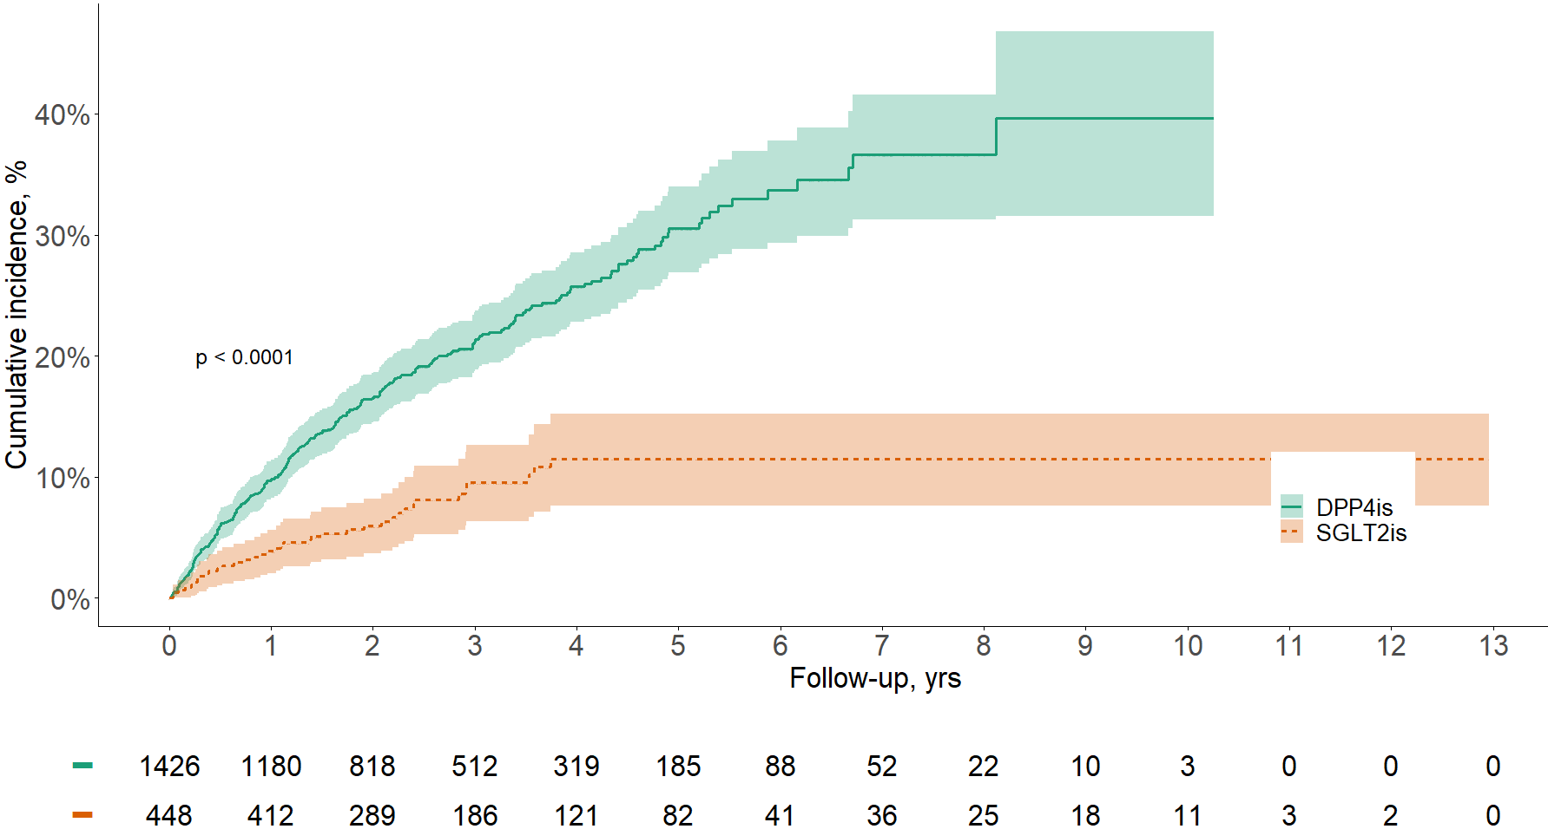

- SGLT2is vs. TZDs
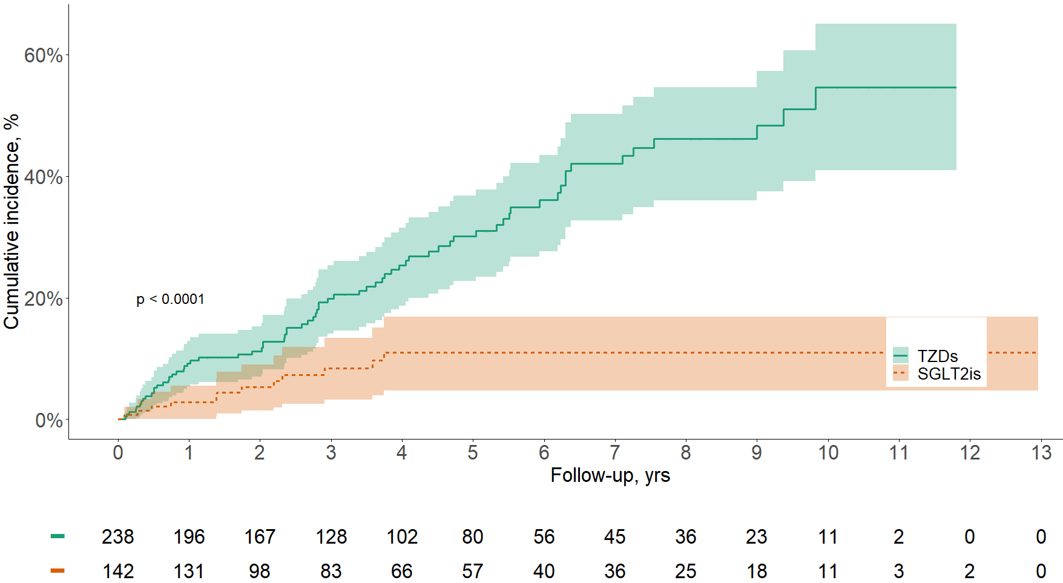

Supplementary Figure 2. Cumulative incidence of eGFR ≤15 mL/min/1.73 m² of (A) SGLT2is versus non-SGLT2is users; (B) SGLT2is versus DPP4is users; (C) SGLT2is versus TZDs users using Kaplan–Meier survival method. Abbrevations: eGFR: estimated glomerular filtration rate, SGLT2is: sodium-glucose cotransporter-2 inhibitors, DPP4is: dipeptidyl peptidase-4 inhibitors, TZDs: thiazolidinediones.

- SGLT2is vs. non-SGLT2is
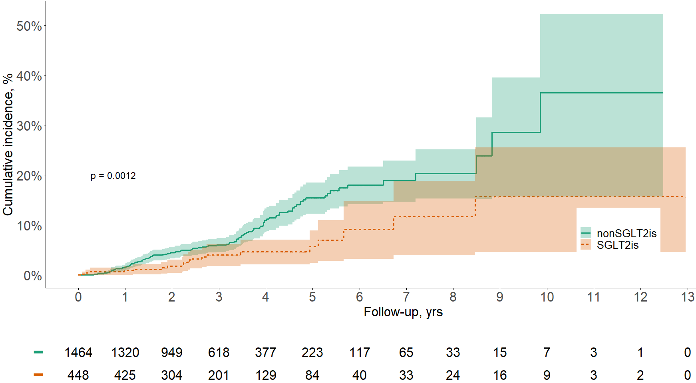

- SGLT2is vs. DPP4is
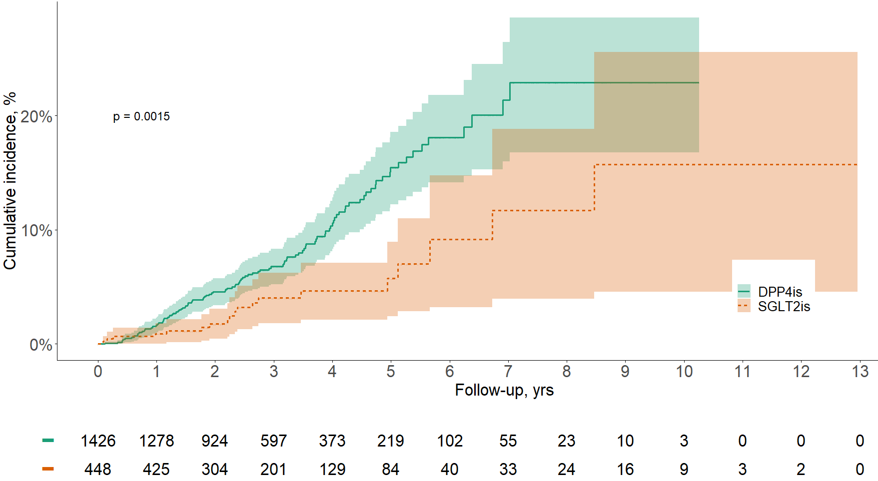

- SGLT2is vs. TZDs
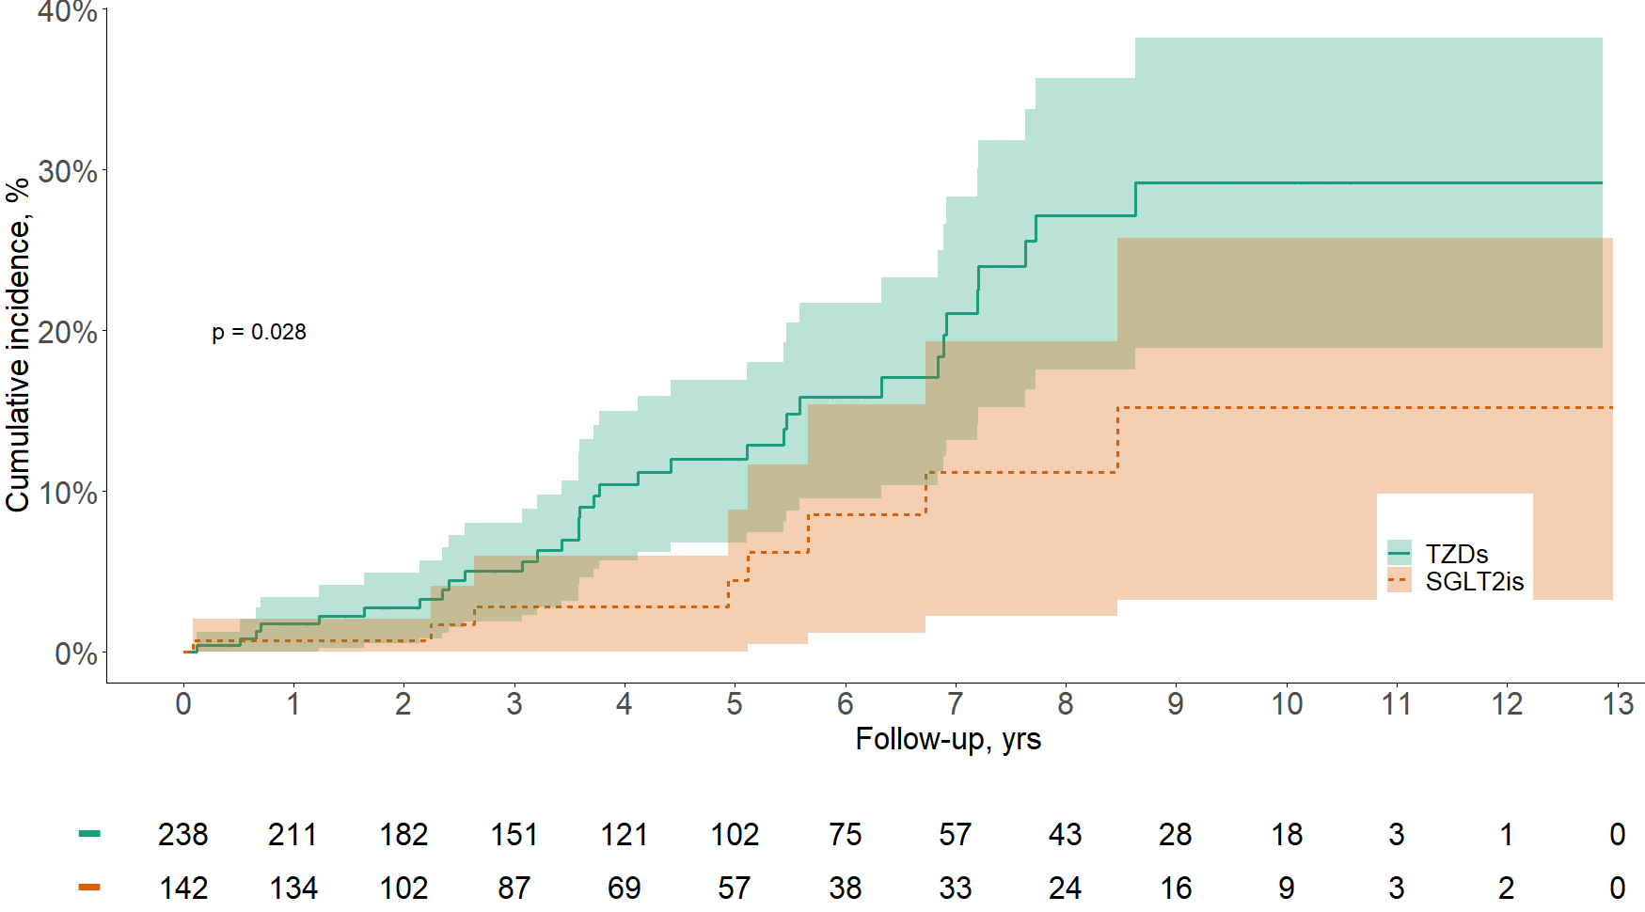

Supplementary Figure 3. Cumulative incidence of kidney replacement therapy of (A) SGLT2is versus non-SGLT2is users; (B) SGLT2is versus DPP4is users; (C) SGLT2is versus TZDs users using Kaplan–Meier survival method. Abbrevations: eGFR: estimated glomerular filtration rate, SGLT2is: sodium-glucose cotransporter-2 inhibitors, DPP4is: dipeptidyl peptidase-4 inhibitors, TZDs: thiazolidinediones.

