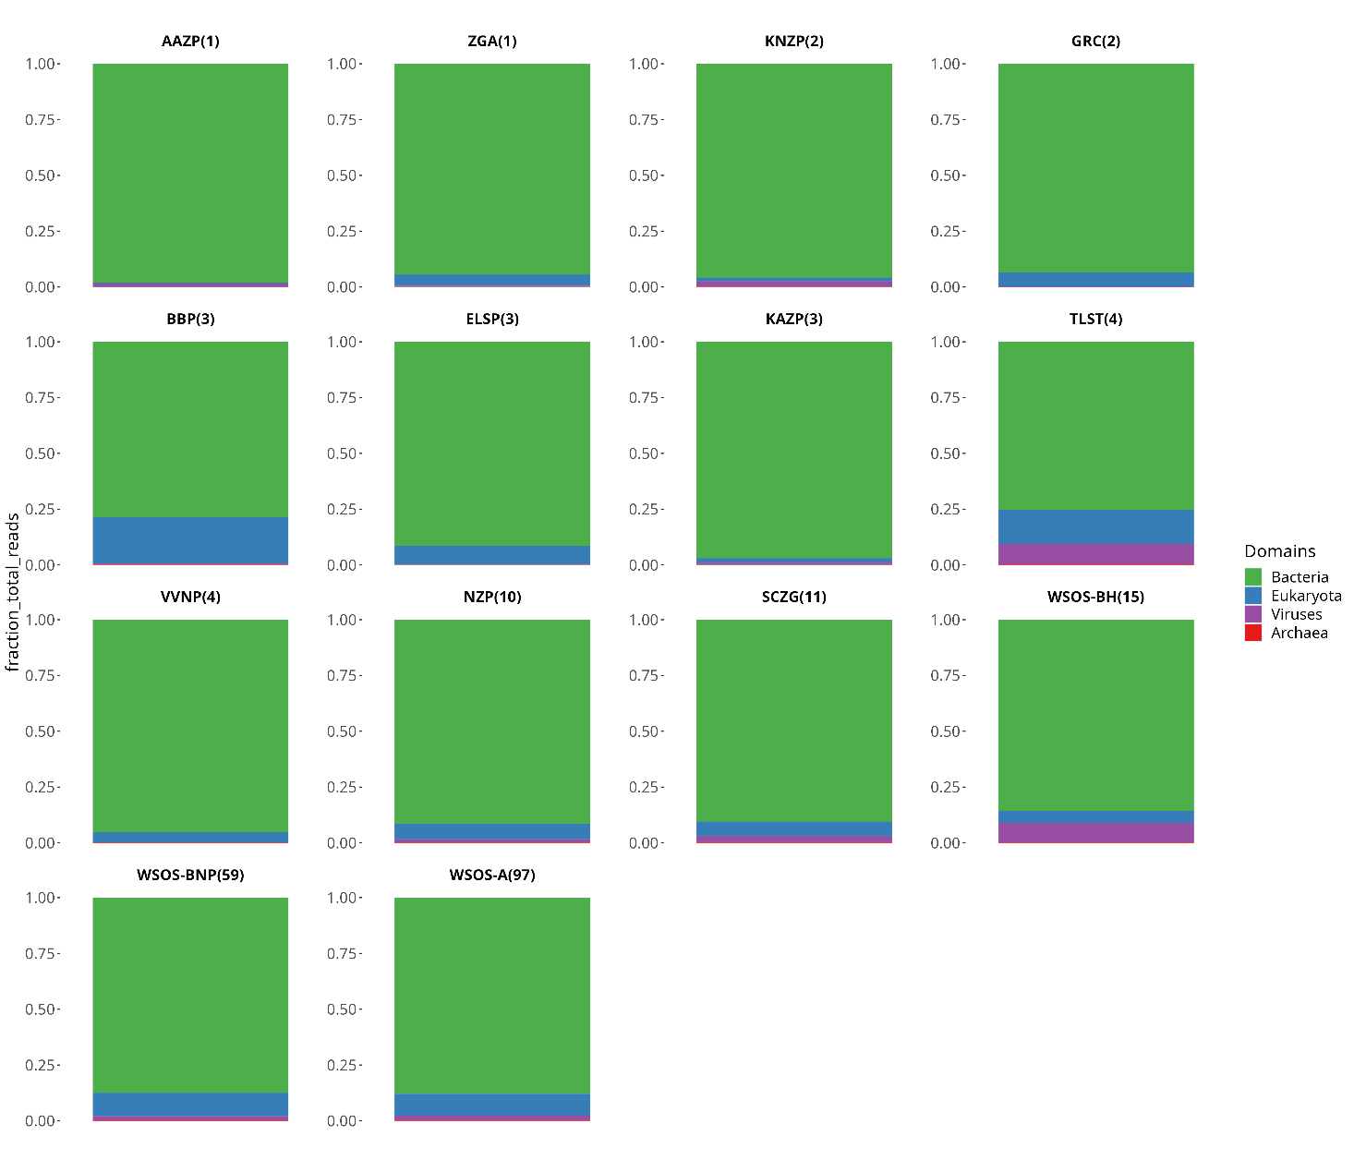

Figure S1 Gut microbial community profile at the domain level in sloth bear samples from 14 captive locations in India

