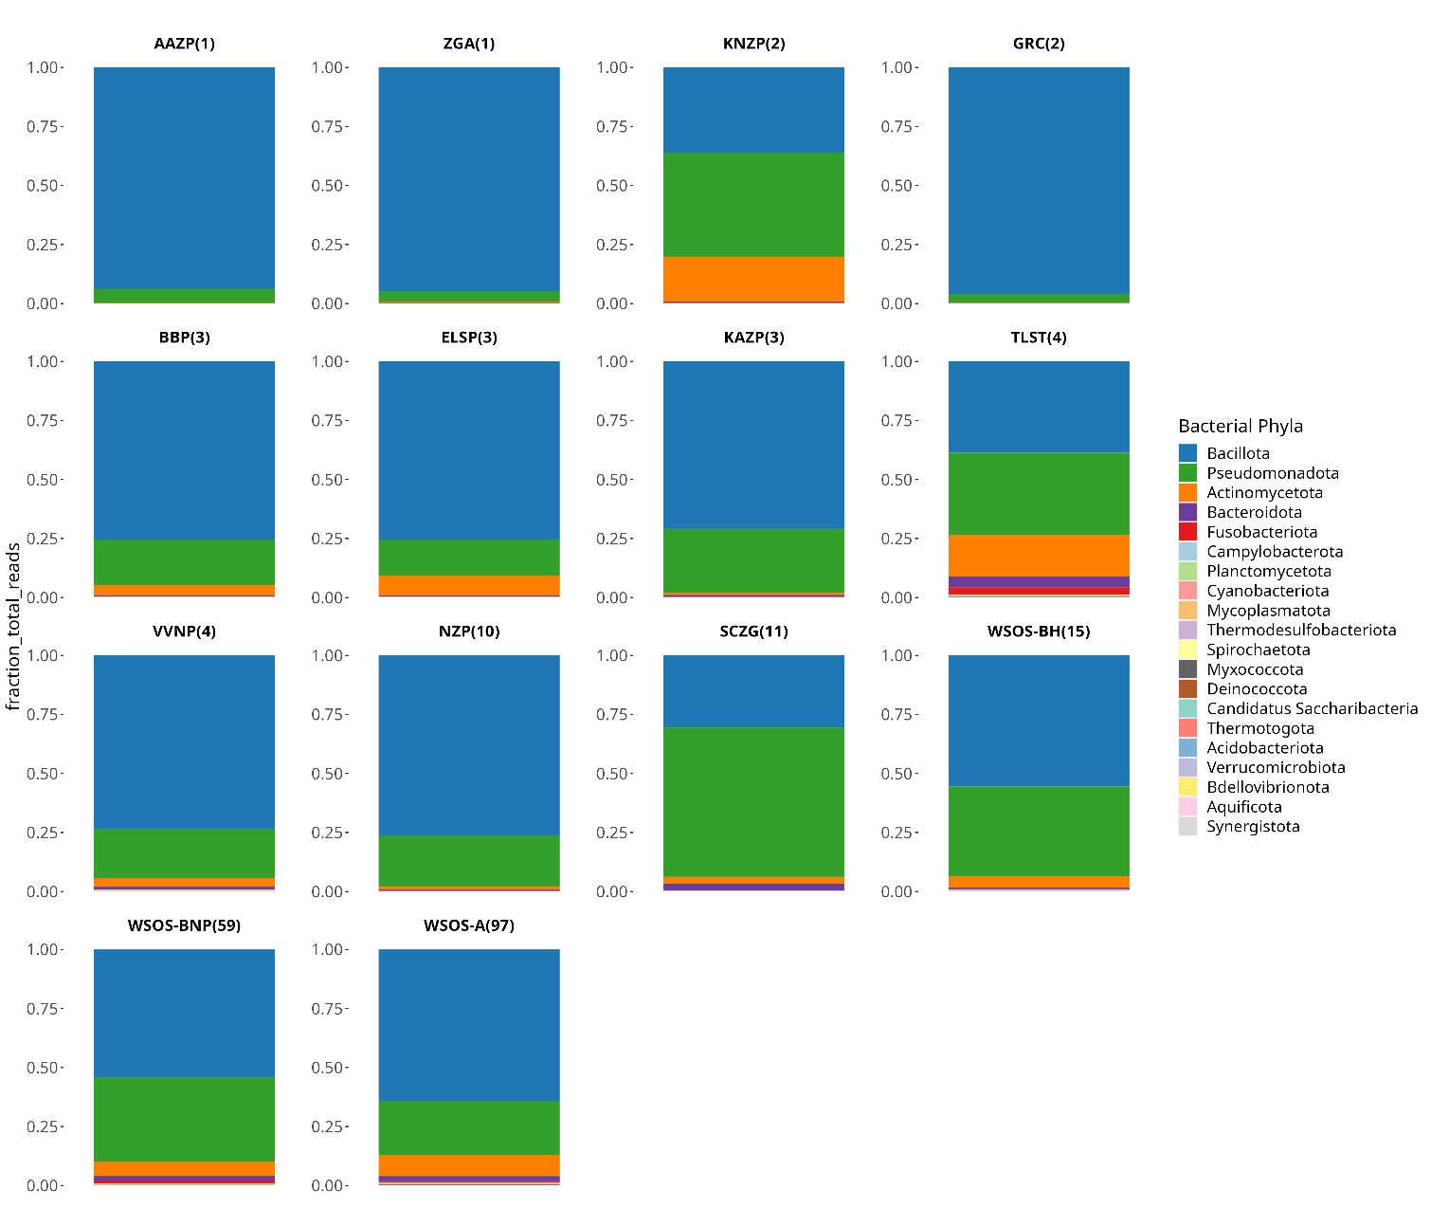

Figure S2 Gut bacterial community profile at the phylum level in sloth bear samples from 14 captive locations in India

