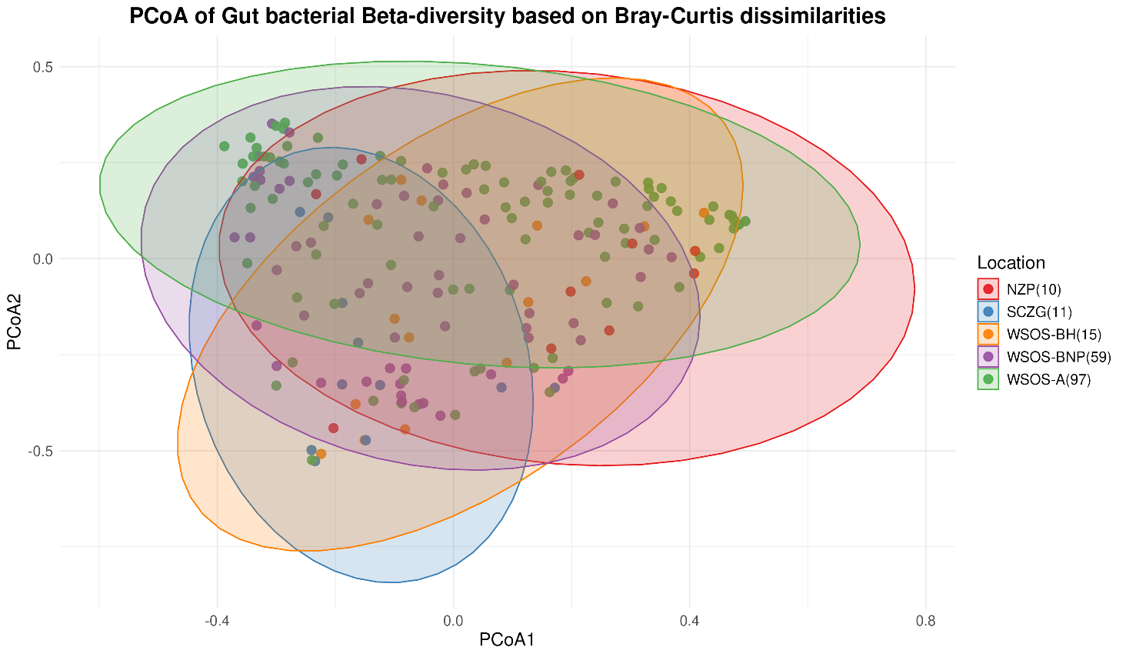
Figure S4 Beta diversity plot based on Bray-Curtis dissimilarity matrix for gut microbial diversity in captive sloth bear

