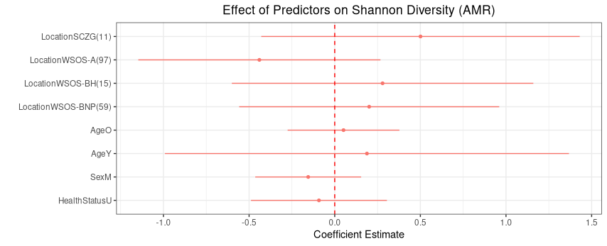
Figure S5 GLM (Generalised linear model) and GLMM (Generalised linear mixed model) analyses on effects of different variables on AMR diversities in captive sloth bear

