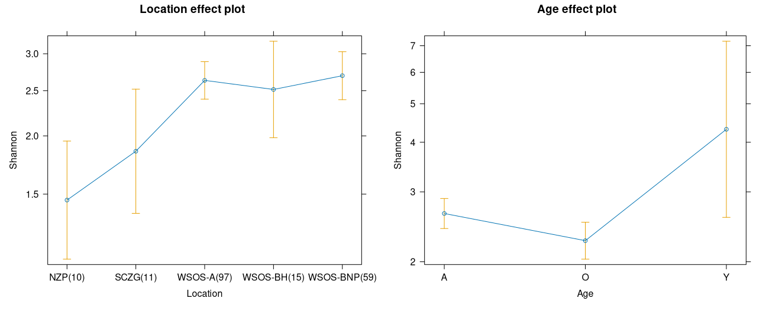
Figure S3 Generalised linear model (GLM) outputs showing the influence of location and age of the animal on gut microbial diversities of captive sloth bears

