Appendix A. Figures

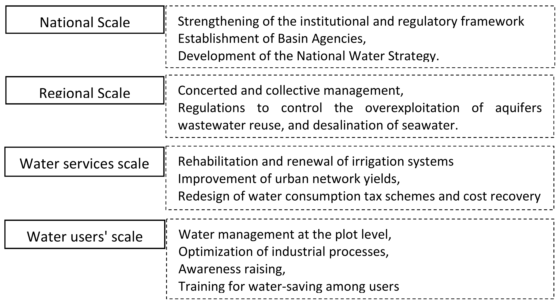
Appendix A. Fig. 1. Implementation scales of water policy in Morocco.

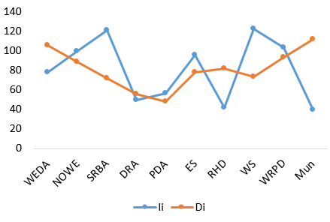
Appendix A. Fig. 2. Comparison between both indicators (Ii) and (Di)

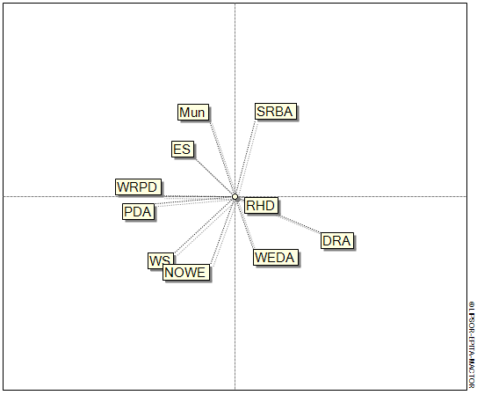
Appendix A. Fig. 3. Divergences between actors
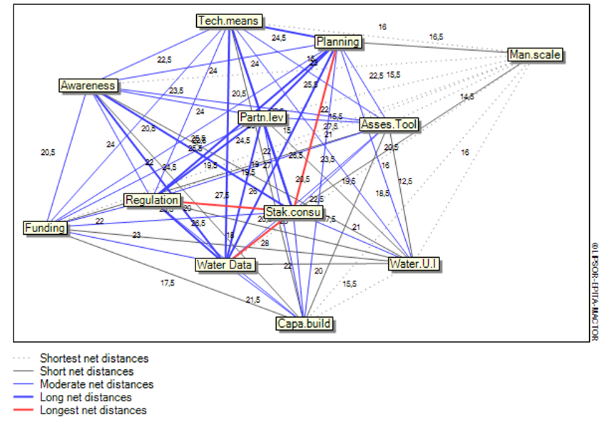
Appendix A. Fig. 4. Net distance between objectives

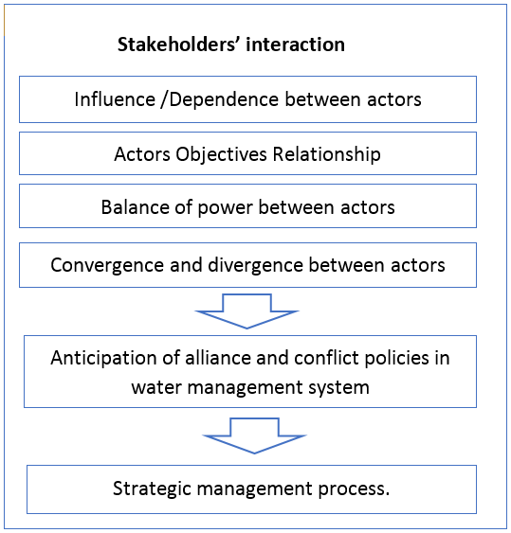
Appendix A. Fig. 5. Analysis of stakeholders’ interaction

