Thiazolo[5,4-d]thiazole-Based CMPs as Bifunctional Photocatalysts for H₂O₂ Production and Organic Pollutant Degradation
Yuting Ren, Mingyue Wang, Shuangjie Zhang, Chunhua Yuan, Jianmei Zhou, Dongmei Li*, Zhongzhen Tian*
Inner Mongolia Key Laboratory of Coal Chemical Engineering and Comprehensive Utilization, School of Chemistry and Chemical Engineering, Inner Mongolia University of Science & Technology, Baotou 014010, China
Corresponding E-mail: 2019951@imust.edu.cn Tel: +86 15047405248
2019952@imust.edu.cn Tel: +86 15044988327
Address: No. 7, Alding Street, Baotou 014010, Inner Mongolia, China

- H₂O₂ standard curve
The standard curve of H₂O₂ was determined by iodometric method. First, 1.66 g of potassium iodide (KI) and 1.24 g of ammonium molybdate, tetrahydrate （(NH₄)₆Mo₇O₂₄·4H₂O） were weighed into 100 mL volumetric flasks, respectively. Then, deionized water was added to them to fix the volume and this was used as a color developer. Five 250 mL volumetric flasks were prepared and configured with concentration gradients of 0 µM, 50 µM, 150 µM, 250 µM and 350 µM of H₂O₂ solution. 1.00 mL of solution was sampled from each volumetric flask with different H₂O₂ concentration gradients into the corresponding colorimetric tubes. Then, 2.00 mL of potassium iodide solution (0.10 mol L⁻¹) and 50.0 µL of ammonium molybdate solution (0.01 mol L⁻¹) were added to each cuvette and left to stand for 10 min. Finally, the reaction solution was poured into the cuvettes and placed in a UV-Vis spectrophotometer to measure the absorbance. The absorbance at 351 nm was analyzed for different concentrations of the solution, and the concentration-absorbance standard curve was plotted. The resulting absorbance curves for different concentrations of H₂O₂ and the corresponding standard curves are shown in Figure S1.

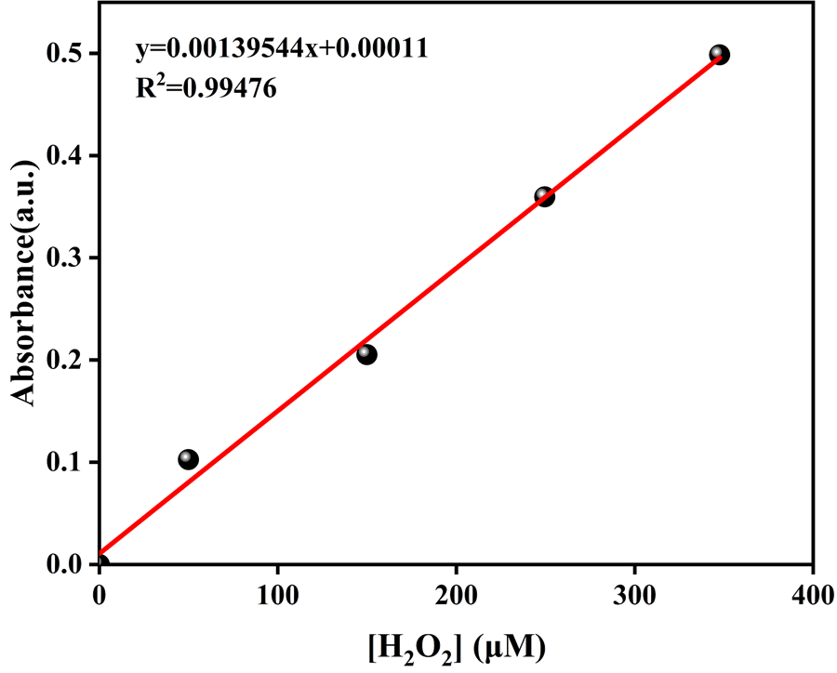
Figure S1. Fitting curve of absorbance and concentration at 351 nm.
- Apparent Quantum Yield (AQY) measurement
In this study, the H₂O₂ yields of the samples were determined under monochromatic light (λ=380 nm, 435 nm and 578 nm) irradiation for 60 min. Then, the apparent quantum yields of the samples under different monochromatic lights were calculated using the following equation:
$$AQY\%=\frac{Number of reacted electrons \left(N_{e}\right)}{Total number of incident photons \left(N_{P}\right)}×100\%$$
$$AQY\%=\frac{2×n×N_{A}×h×c }{S×P×t×λ}×100\%$$
where n is the amount of H₂O₂ molecules (mol), NA is Avogadro's constant (6.022 × 10²³ mol⁻¹), h is Planck's constant (6.626 × 10⁻³⁴ J·S), c is the speed of light (3 × 10⁸ m s⁻¹), S is the irradiated area，P is the irradiated light intensity (100 mW cm⁻²), t is the light time (3600 s), and λ is the wavelength of monochromatic light (m).

- Figures ang legends
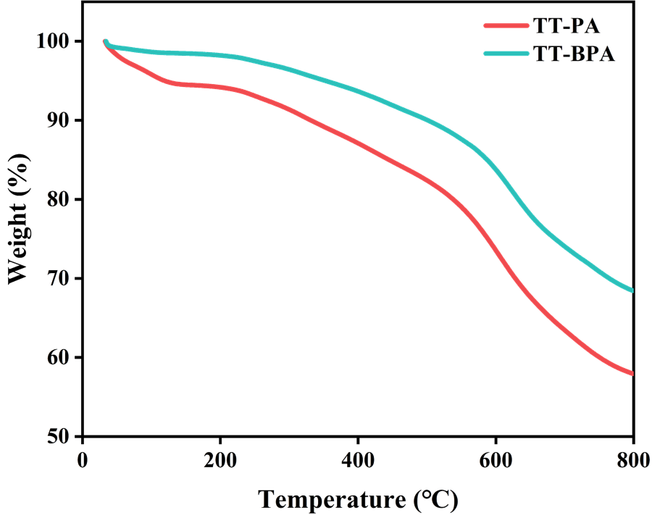
Figure S2. The thermogravimetric analysis (TGA) curve of TT-PA and TT-BPA.

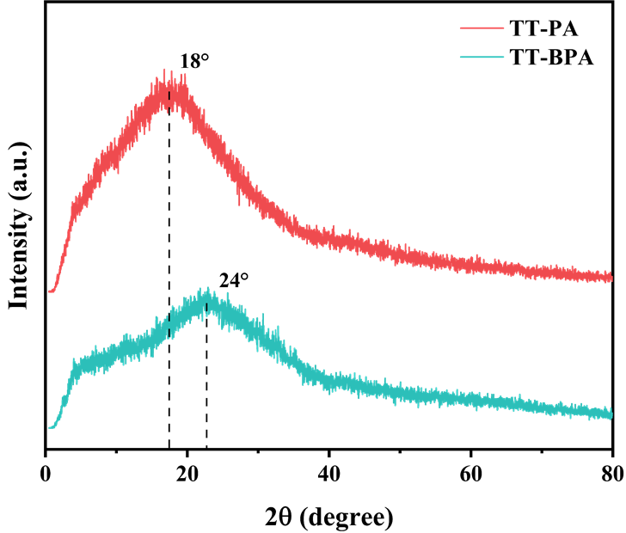
Figure S3. Powder X-ray diffraction profiles of TT-PA and TT-BPA.

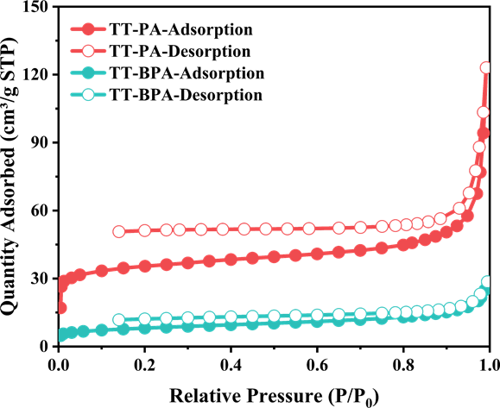
Figure S4. N₂ absorption-desorption isotherms of TT-PA and TT-BPA.

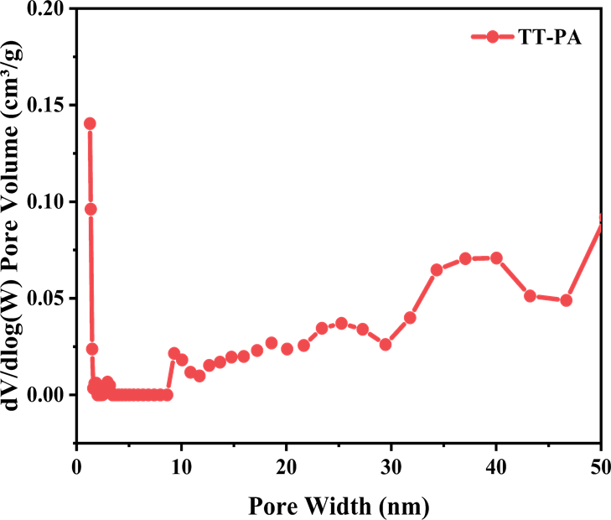
Figure S5. Pore size distribution of TT-PA.

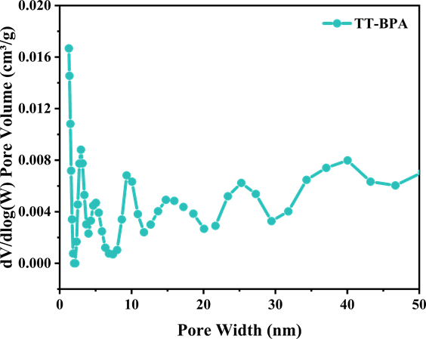
Figure S6. Pore size distribution of TT-BPA.

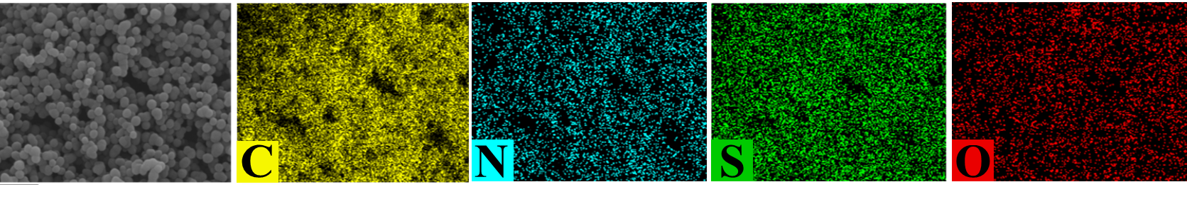

Figure S7. Elemental mapping shows the contents of C, O, N, and S for TT-PA and TT-BPA.

Figure S8. Mott–Schottky plots of TT-BPA.
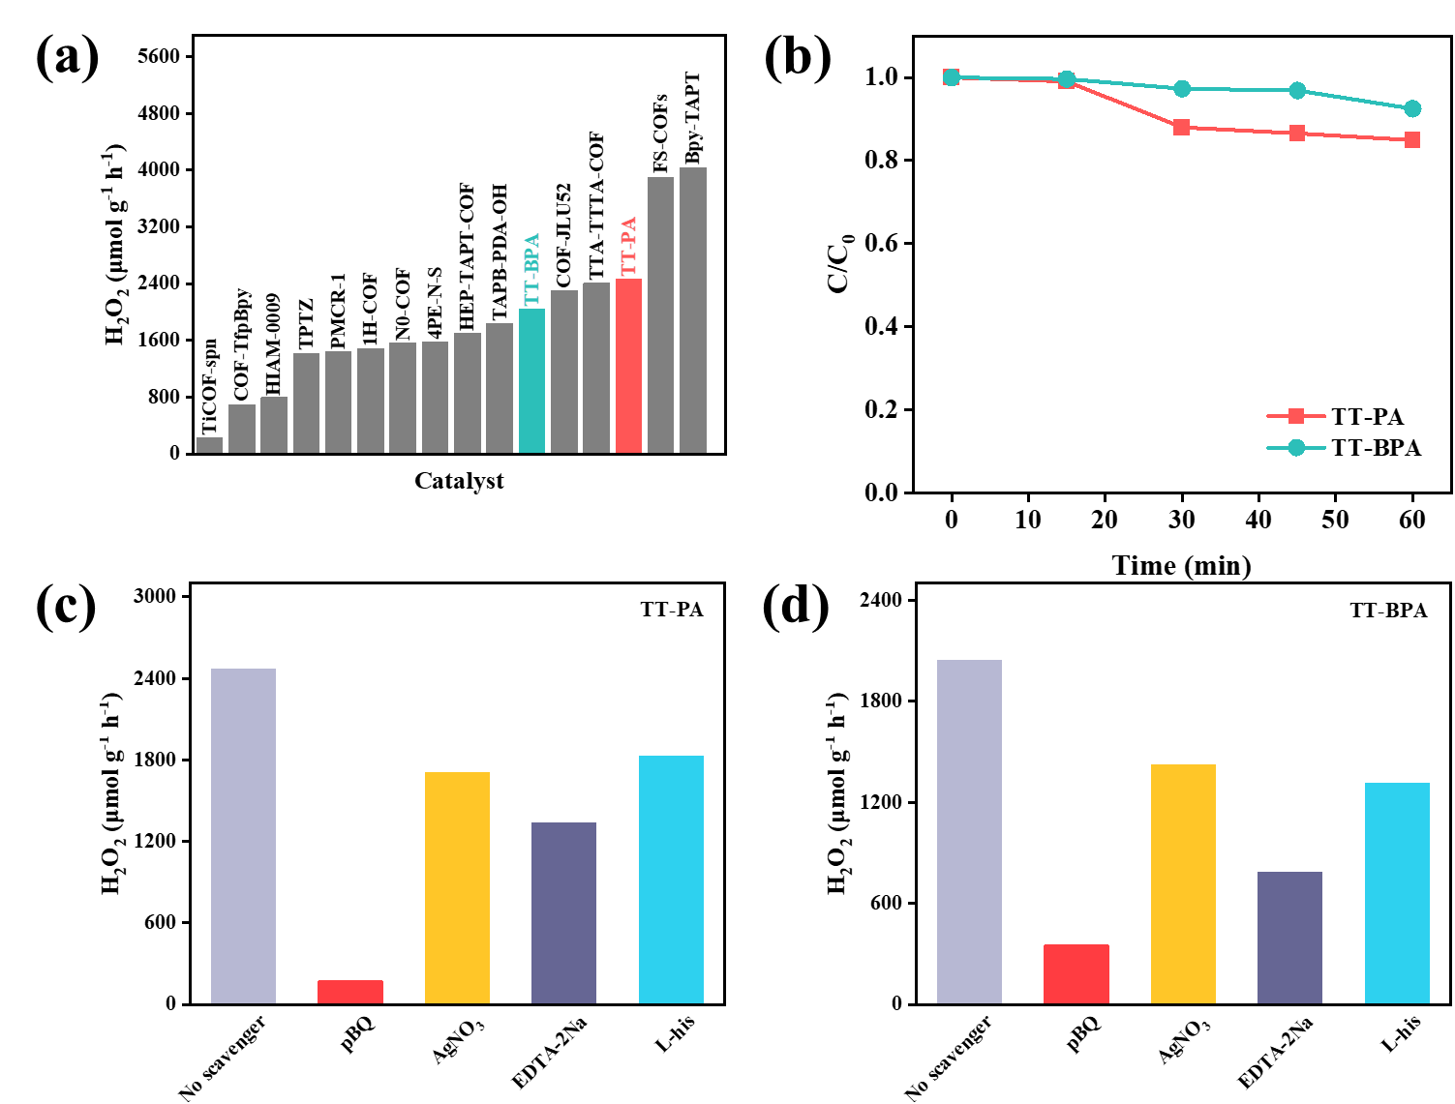
Figure S9. (a) Performance comparison of TT-PA and TT-BPA with other reported photocatalysts. (Table S2). (b) Comparison of the decomposition properties of TT-PA and TT-BPA. (c, d) Active species capture experiment of photocatalytic generation of H₂O₂.

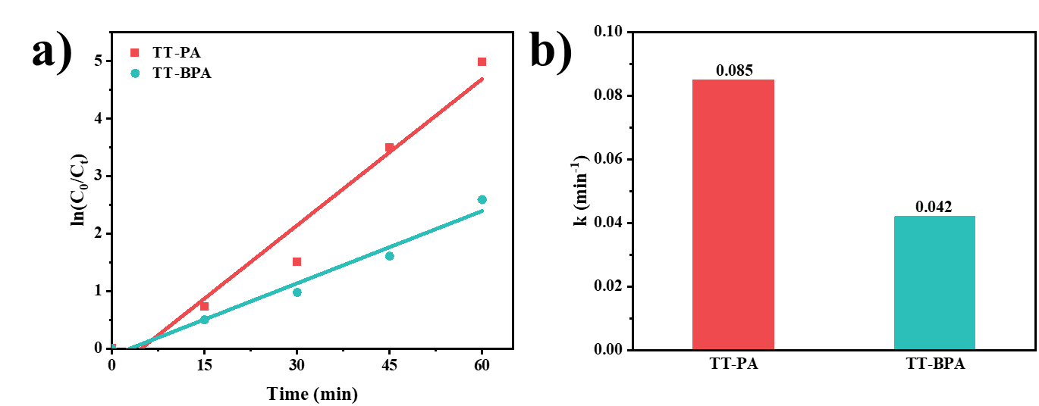
Figure S10. Degradation of RhB kinetic curves.

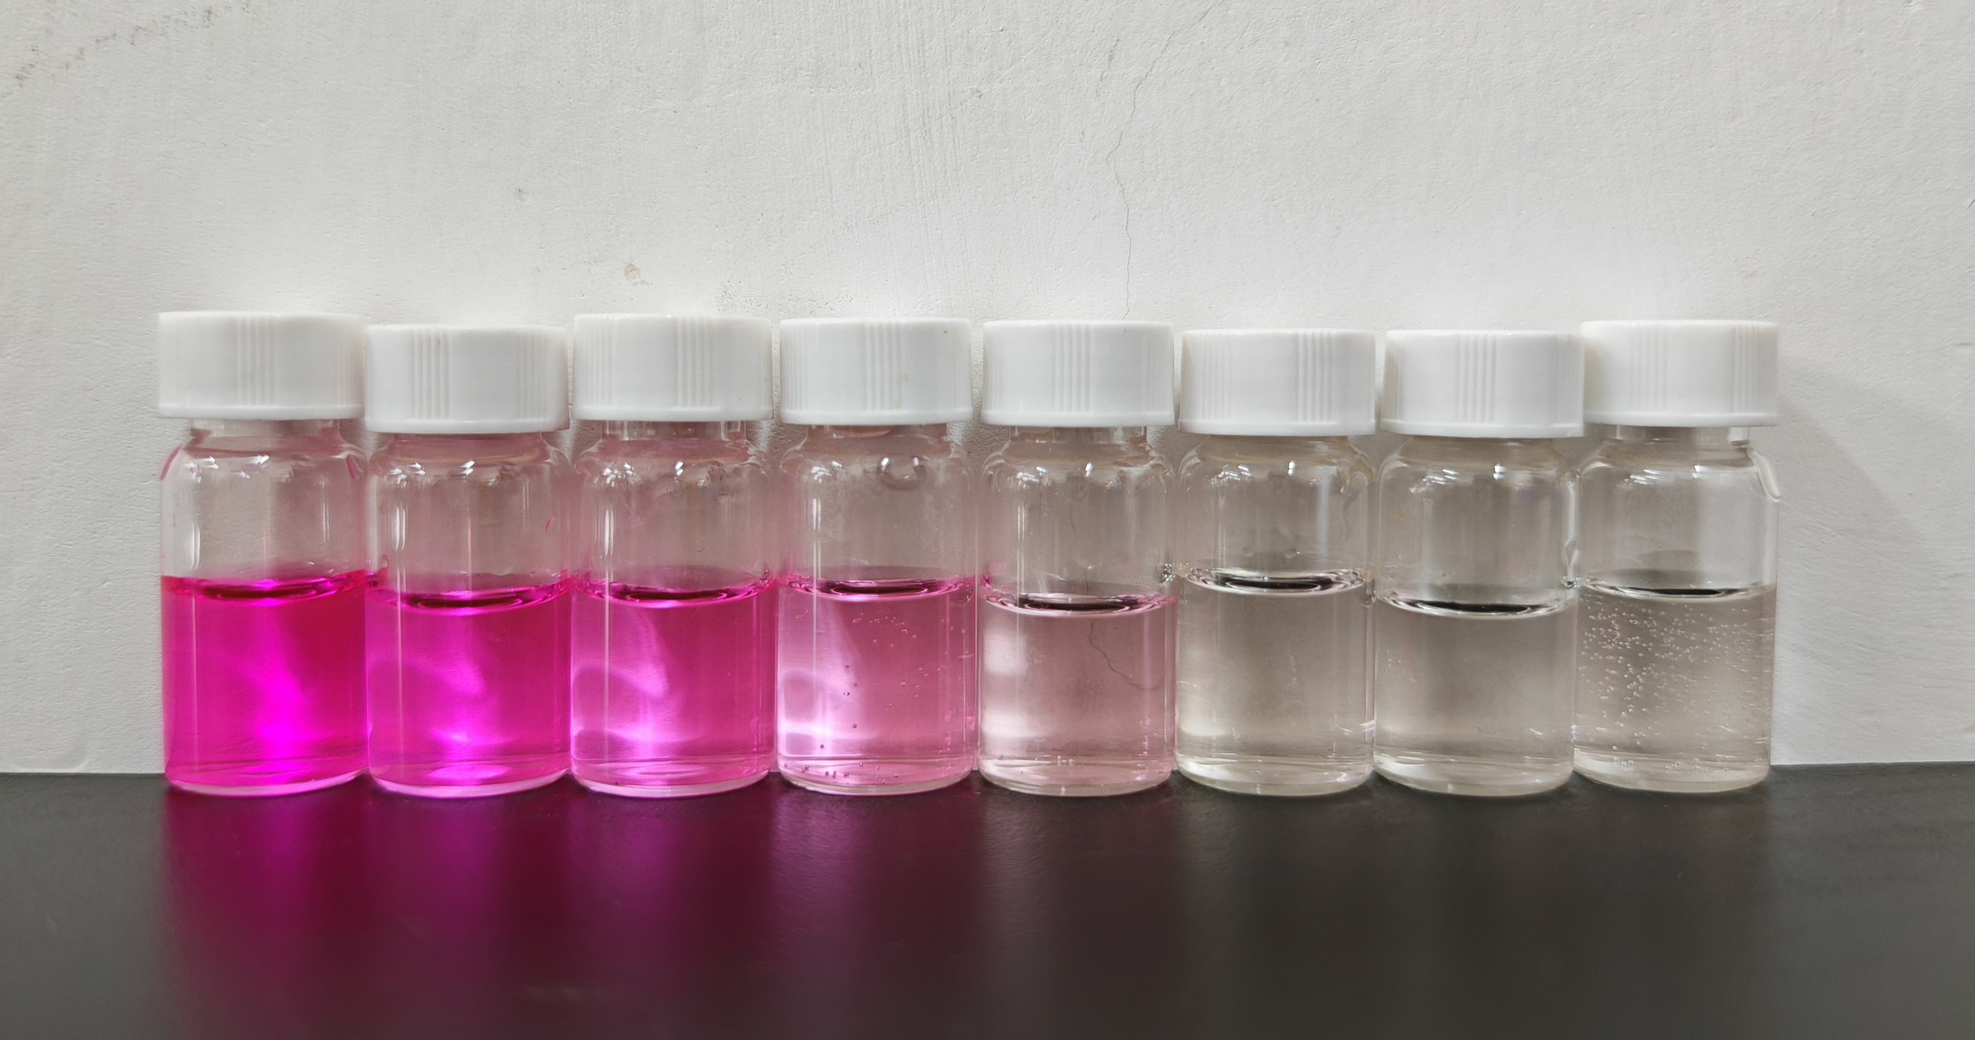
Figure S11. Color comparison of RhB degradation by photocatalysts(0min-105min).

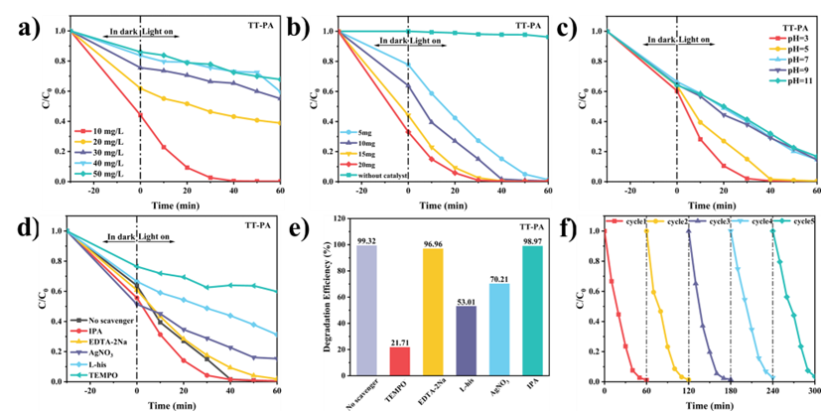
Figure S12. Photocatalytic degradation of RhB by TT-PA under visible light irradiation: (a) Different RhB concentrations, (b) Different catalyst qualities, (c) Different pH. (d, e) Effect of different trapping agents on the photocatalytic degradation of RhB (10 mg L⁻¹) by TT-PA (0.3 g L⁻¹). (f) Photocatalytic cycling experiment.

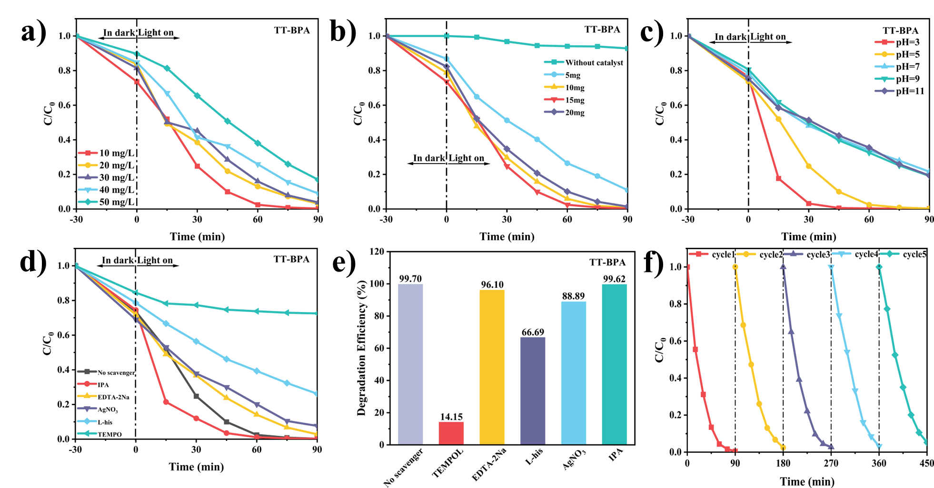
Figure S13. Photocatalytic degradation of RhB by TT-BPA under visible light irradiation: (a)Different RhB concentrations. (b)Different catalyst qualities. (c)Different pH. (d, e) Effect of different trapping agents on the photocatalytic degradation of RhB (10 mg L⁻¹) by TT-PA (0.3 g L⁻¹). (f) Photocatalytic cycling experiment.

Table S1. Performance of photocatalysts for overall H₂O₂ photosynthesis.
Photocatalysts |  | Wavelength(nm) | Solvent | H₂O₂ rate (μmol g⁻¹h⁻¹) | Ref.
TiCOF-spn | ＞420 |  | H₂O | 223.55 | [1]
COF-TfpBpy | ＞420 |  | H₂O | 695 | [2]
HIAM-0009 | ＞420 |  | H₂O | 796 | [3]
TPTZ | ＞420 |  | H₂O | 1418 | [4]
PMCR-1 | ＞420 |  | H₂O | 1445 | [5]
1H-COF | ＞420 |  | H₂O | 1483 | [6]
N0-COF | ＞495 |  | H₂O | 1570 | [7]
4PE-N-S | ＞420 |  | H₂O | 1574 | [8]
HEP-TAPT-COF | ＞420 |  | H₂O | 1705 | [9]
TAPB-PDA-OH | ＞420 |  | H₂O | 1841.3 | [10]
TT-BPA | ＞420 |  | H₂O | 2041 | This work
COF-JLU52 | ＞420 |  | H₂O | 2301 | [11]
TTA-TTTA-COF |  | ＞420 | H₂O | 2406 | [12]
TT-PA | ＞420 |  | H₂O | 2470 | This work
FS-COFs | ＞420 |  | H₂O | 3904.2 | [13]
Bpy-TAPT | ＞420 |  | H₂O | 4038 | [14]

Table S2. AQY of TT-PA and TT-BPA at different wavelength.
 | Wavelength(nm) | Light intensity (mW cm⁻²) | AQY(%)
TT-PA | 380 | 8.9 | 0.55
TT-PA | 435 | 37.7 | 0.13
TT-PA | 578 | 25.1 | 0.11
TT-BPA | 380 | 8.9 | 0.49
TT-BPA | 435 | 37.7 | 0.03
TT-BPA | 578 | 25.1 | 0.02

REFERENCES
[1] W.-K. Han, H.-S. Lu, J.-X. Fu, X. Liu, X. Zhu, X. Yan, J. Zhang, Y. Jiang, H. Dong, Z.-G. Gu. Targeted construction of a three-dimensional metal covalent organic framework with spn topology for photocatalytic hydrogen peroxide production, Chem. Eng. J. 449 (2022) 137802. http://doi.org/10.1016/j.cej.2022.137802.
[2] M. Kou, Y. Wang, Y. Xu, L. Ye, Y. Huang, B. Jia, H. Li, J. Ren, Y. Deng, J. Chen, Y. Zhou, K. Lei, L. Wang, W. Liu, H. Huang, T. Ma. Molecularly Engineered Covalent Organic Frameworks for Hydrogen Peroxide Photosynthesis, Angew. Chem. Int. Ed. 61 (2022) e202200413. http://doi.org/10.1002/anie.202200413.
[3] C.-Q. Han, J.-X. Guo, L. Wang, S. Sun, J. Lv, X. Sun, H. Hu, X. Huang, X.-Y. Liu. Linker engineering of benzothiadiazole and its derivative-based covalent organic frameworks for efficient photocatalytic oxidative amine coupling and hydrogen peroxide generation, J. Mater. Chem. C. 12 (2024) 16059-16066. http://doi.org/10.1039/d5qi00417a.
[4] Q. Liao, Q. Sun, H. Xu, Y. Wang, Y. Xu, Z. Li, J. Hu, D. Wang, H. Li, K. Xi. Regulating relative nitrogen locations of diazine functionalized covalent organic frameworks for overall H₂O₂ photosynthesis, Angew. Chem. Int. Ed. 135 (2023) e202310556. http://doi.org/10.1002/anie.202310556.
[5] P. Das, J. Roeser, A. Thomas. Solar light driven H₂O₂ production and selective oxidations using a covalent organic framework photocatalyst prepared by a multicomponent reaction, Angew. Chem. Int. Ed. 135 (2023) e202304349. http://doi.org/10.1002/anie.202304349.
[6] H. Hu, Y. Tao, D. Wang, C. Li, Q. Jiang, Y. Shi, J. Wang, J. Qin, S. Zhou, Y. Kong. Rational modification of hydroxy-functionalized covalent organic frameworks for enhanced photocatalytic hydrogen peroxide evolution, J. Colloid Interface Sci. 629 (2023) 750-762. http://doi.org/ 10.1016/j.jcis.2022.09.111.
[7] S. Chai, X. Chen, X. Zhang, Y. Fang, R.S. Sprick, X. Chen. Rational design of covalent organic frameworks for efficient photocatalytic hydrogen peroxide production, Environ. Sci.-Nano. 9 (2022) 2464-2469. http://doi.org/10.1039/d2en00135g.
[8] M. Deng, J. Sun, A. Laemont, C. Liu, L. Wang, L. Bourda, J. Chakraborty, K. Van Hecke, R. Morent, N. De Geyter. Extending the π-conjugation system of covalent organic frameworks for more efficient photocatalytic H₂O₂ production, Green Chem. 25 (2023) 3069-3076. http://doi.org/10.1039/d2gc04459e.
[9] D. Chen, W. Chen, Y. Wu, L. Wang, X. Wu, H. Xu, L. Chen. Covalent organic frameworks containing dual O2 reduction centers for overall photosynthetic hydrogen peroxide production, Angew. Chem. Int. Ed. 62 (2023) e202217479. http://doi.org/10.1002/anie.202217479.
[10] Y. Yang, J. Kang, Y. Li, J. Liang, J. Liang, L. Jiang, D. Chen, J. He, Y. Chen, J. Wang. Enhanced photocatalytic hydrogen peroxide production activity of imine-linked covalent organic frameworks via modification with functional groups, New J. Chem. 46 (2022) 21605-21614. http://doi.org/10.1039/d2nj03744k.
[11] Z. Zhang, Q. Zhang, Y. Hou, J. Li, S. Zhu, H. Xia, H. Yue, X. Liu. Tris (triazolo) triazine‐Based Covalent Organic Frameworks for Efficiently Photocatalytic Hydrogen Peroxide Production, Angew. Chem. Int. Ed. 63 (2024) e202411546. http://doi.org/10.1002/anie.202411546.
[12] F. Tan, Y. Zheng, Z. Zhou, H. Wang, X. Dong, J. Yang, Z. Ou, H. Qi, W. Liu, Z. Zheng. Aqueous synthesis of covalent organic frameworks as photocatalysts for hydrogen peroxide production, CCS Chem. 4 (2022) 3751-3761. http://doi.org/10.31635/ccschem.022.202101578.
[13] Y. Luo, B. Zhang, C. Liu, D. Xia, X. Ou, Y. Cai, Y. Zhou, J. Jiang, B. Han. Sulfone‐modified covalent organic frameworks enabling efficient photocatalytic hydrogen peroxide generation via one‐step two‐electron O₂ reduction, Angew. Chem. Int. Ed. 62 (2023) e202305355. http://doi.org/10.1002/ange.202305355.
[14] Y. Liu, W.-K. Han, W. Chi, Y. Mao, Y. Jiang, X. Yan, Z.-G. Gu. Substoichiometric covalent organic frameworks with uncondensed aldehyde for highly efficient hydrogen peroxide photosynthesis in pure water, Appl. Catal. B: Environ. 331 (2023) 122691. https://doi.org/10.1016/j.apcatb.2023.122691.

