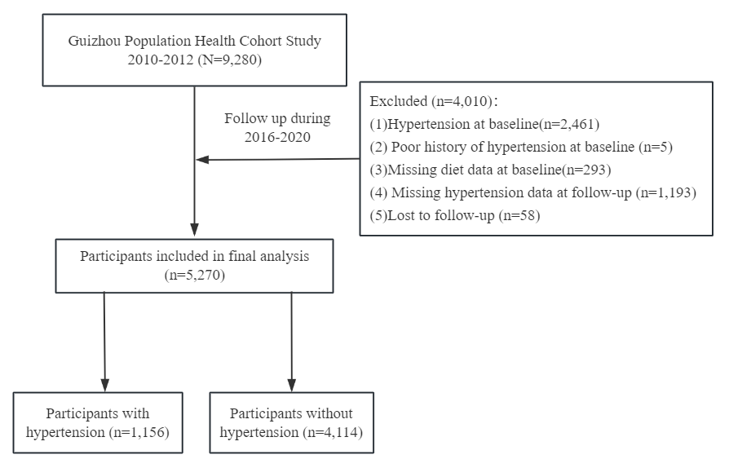
S1. Flowchart of the study design

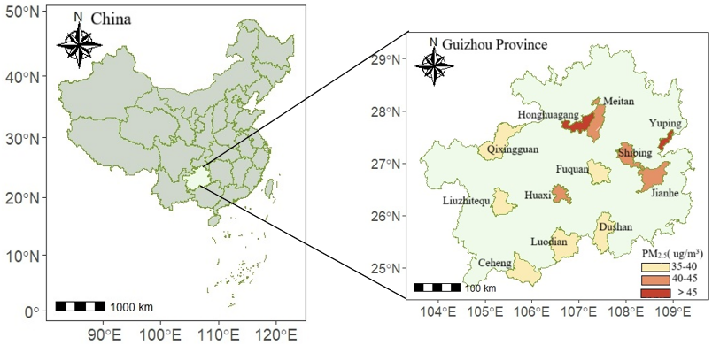

S2. Distribution of study sites and annual average PM_{2.5} concentration during the study period

The following abbreviations are used in this manuscript

CDAI | Composite Dietary Antioxidant Index
PM_{2.5} | Particulate Matter 2.5
SO42- | Sulfate
NO3- | Nitrate
NH4+ | Ammonium
BC | Black Carbon
OM | Organic Matter
HRs | Hazard Ratios
95%CIs | 95% Confidence Intervals
GPHCS | Guizhou Population Health Cohort Study
WHO | World Health Organization
NDVI | Normalized Difference Vegetation Index
O₃ | Ozone
NO2 | Nitrogen Dioxide
FFQ | Food Frequency Questionnaire
FPG | Fasting Plasma Glucose
TG | Triglycerides
TC | Total Cholesterol
HDL-C | High-density Lipoprotein Cholesterol
LDL-C | Low-density Lipoprotein Cholesterol
OGTT | Oral Glucose Tolerance Test
SBP | Systolic Blood Pressure
DBP | Diastolic Blood Pressure
BMI | Body Mass Index
OC | Organic Carbon
COPD | Chronic Obstructive Pulmonary Disease
SODs | Superoxide Dismutases
O₂⁻ | Superoxide Anions
GPx | Glutathione Peroxidase
TrxR | Thioredoxin Reductase
ROS | Reactive Oxygen Species

