Supplementary Information 1
Embryonic development and the hatching process.
In 2016, occasional checks on embryonic development at c. 20°C suggested that diapause was entered roughly 18 days after collection, with some variation related to differences in exact oviposition dates, which were not recorded. At this time embryos were fully formed, and the sclerotized tips of the mandibles were visible as jagged ventral dark spots beneath and behind the eyes (Fig. S1:1). Thus, at the start of chilling, the different egg batches were estimated to have been in diapause at c. 20°C between 3 and 5 weeks (cf. Fig. 1 in text).
Post-diapause development was not externally discernible from diapause (Fig. S1:1, S1:3j, k, S1:5a, probably post-diapause). It was assumed to have a duration of at least 2 days at 21°C, about the minimum time lag from chilling at 5°C. Imminent hatching was first seen as a bursting of the chorion by an expanding vesicle formed by the vitelline membrane (Fig. S1:5b-c; Ando¹, p. 70-71; Degrange²). This process took somewhere between 5 and 10 hours at 21°C, still within 24 hours at 10°C, and often 2-4 days at 5°C. Emergence of the prolarva from the egg was finished in a minute at 21°C (Fig. S5d-e). No observations were made at other temperatures. The prolarva normally moulted immediately thereafter (Fig S1:6).
The pictures below were taken on different occasions and with different techniques, and are not accurately timed relative to oviposition.
Figure S1:1 – Diapause eggs of L. sponsa – page 1
Figure S1:2 – Diapause eggs and one advanced egg of L. virens – page 2
Figure S1:3 – Embryonic stages in L. sponsa – page 3
Figure S1:4 – Heat damaged (?) L. sponsa eggs – page 4
Figure S1:5 – Hatching process to prolarva – page 5
Figure S1:6 – Moulting of prolarva – page 6
Figure S1:7 – Peculiar dead late-hatching prolarva – page 7

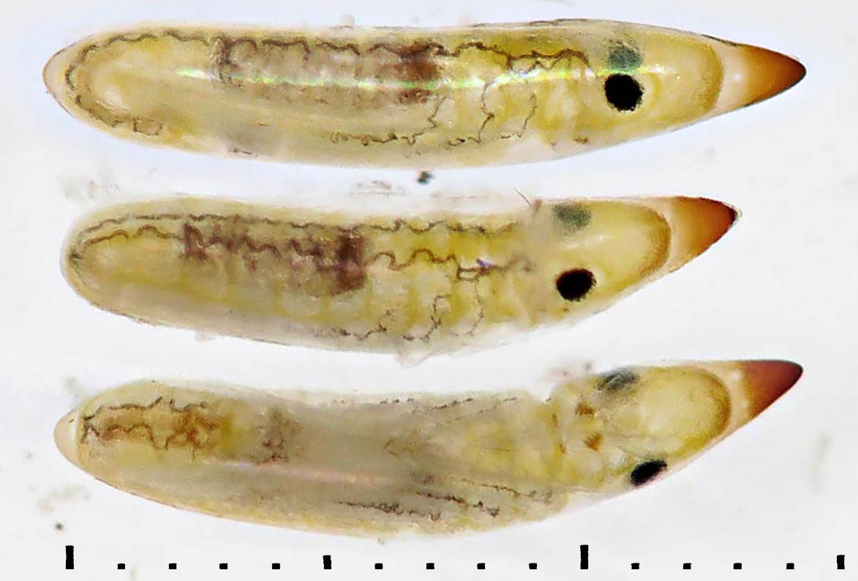
0 mm
1 mm
Figure S1:1. Diapause eggs of L. sponsa. Fully developed embryo with well-developed tracheal system and sclerotized mandible tips. Incident light on white background.

S1:2. Diapause L. virens
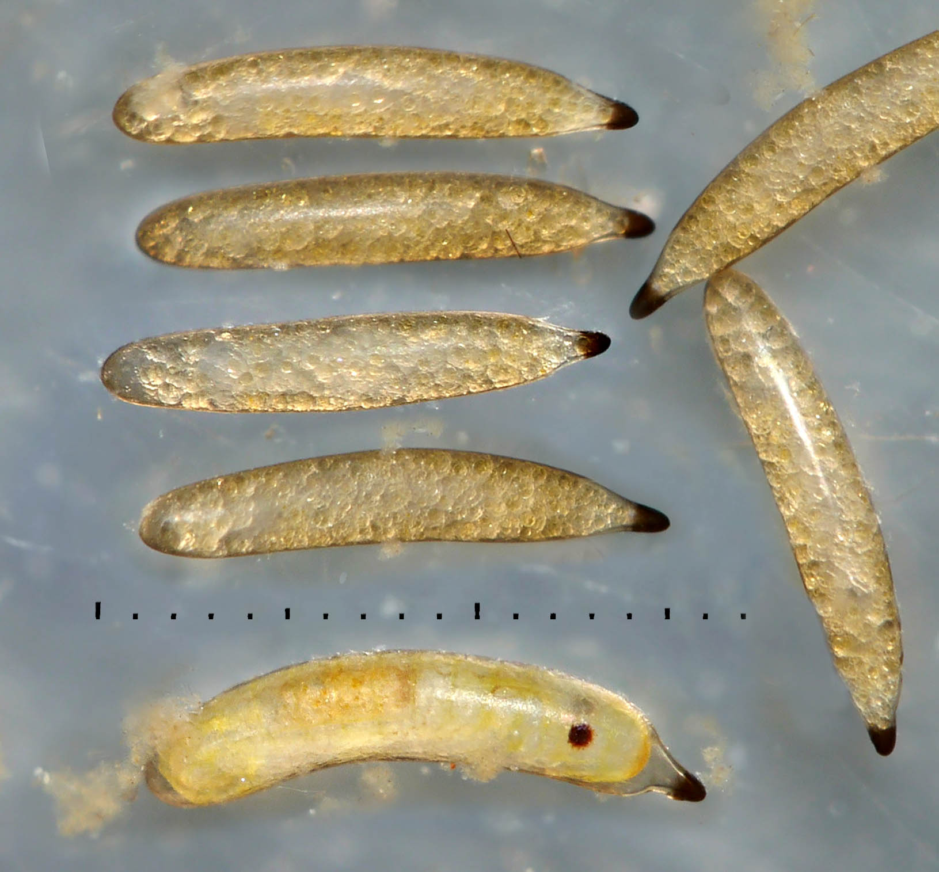
1 mm
0 mm
Postdiapause advanced L. virens
a
b
Figure S1:2. (a) Prekatatrepsis diapause eggs of L. virens, and (b) one advanced postdiapause egg. In the former ones, the embryo is still immersed in yolk and barely visible, comparable to an early embryo of L. sponsa (Fig. S1:3a-b). Incident light on dark background.

a
a

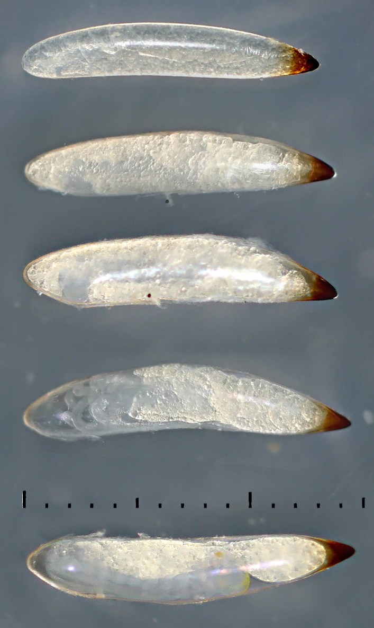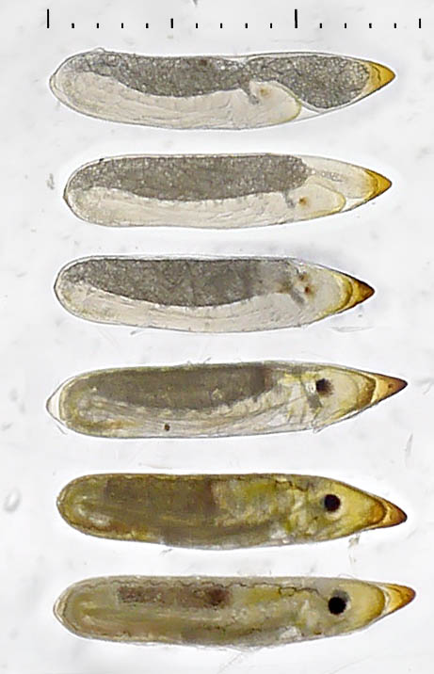
h
a

i
a

j
a

k
a

g
a

f
a

e
a

d
a

c
a

b
a

Katatrepsis
Figure S1:3. Embryonic stages in L. sponsa. (a) Relatively recently laid, probably with early embryo at the posterior (left) end, concealed by yolk. (b-c) Late pre-katatrepsis embryos, immersed in yolk but visible in the posterior end, in particular the head. (d) Ongoing katatrepsis, where the embryo turns itself “inside out”, directing the head anteriorly, and enclosing the yolk. (e, f) Early post-katatrepsis, with big yolk sac protruding anteriorly. Eye spot now visible. (g-i) Embryonic growth and differentiation, yolk is successively reduced, concentrating towards the mid-gut. (j) Late summer embryo, probably just barely entered diapause. (k) “Spring embryo”, still in diapause or in post-diapause development after 5 weeks of high temperature diapause followed by 14 weeks of cold treatment.
(a-e) Incident light on dark background, (f-k) mixed incident and narrow-beam transmitted light as described in Norling³. In (j), the incident component was strengthened.

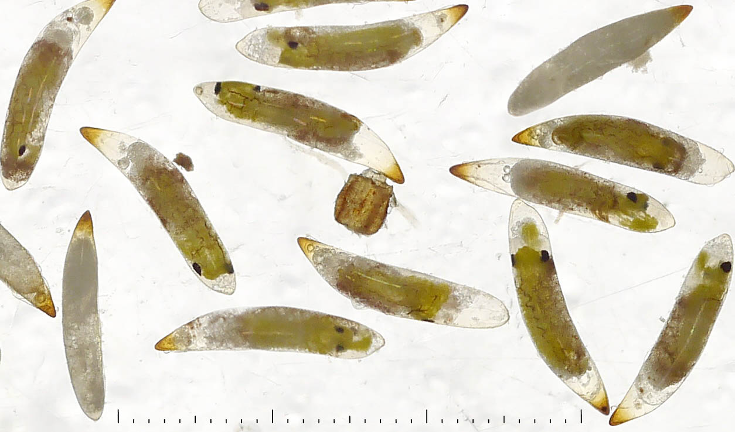
Figure S1:4. Dead eggs and differentiated embryos without previous katatrepsis in Polish eggs, previously sent to Sweden during a heat-wave, and so probably heat-damaged. Colour as late embryos, black eyes and tracheae present. Mixed incident and transmitted light.

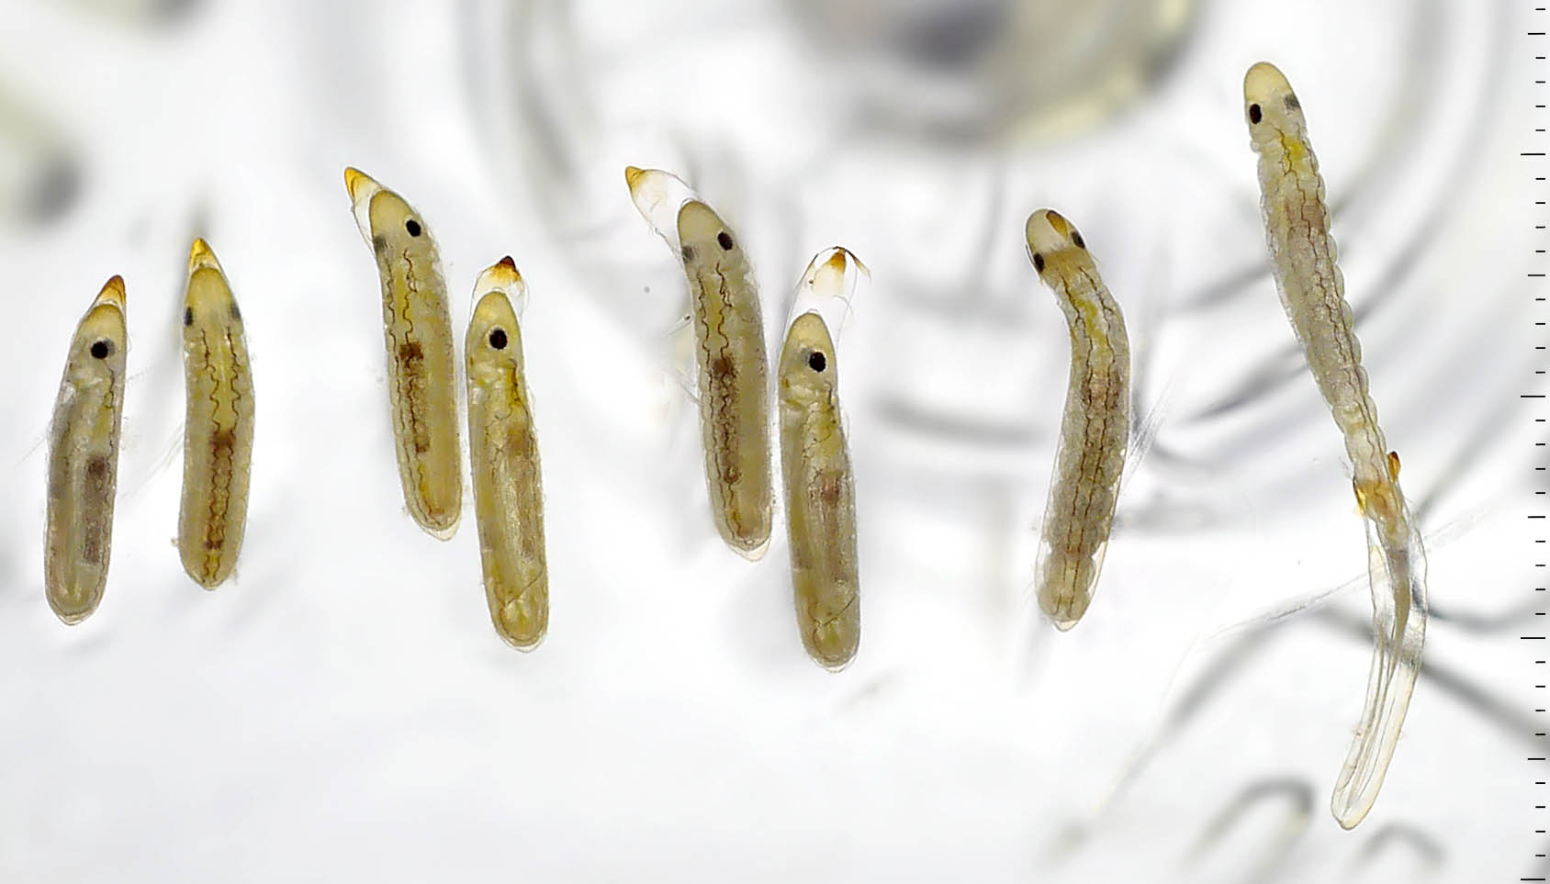
a
b
d
e
c
Figure S1:5. Hatching process in L. sponsa. (a) Eggs in diapause or, most likely, post-diapause development. (b) Initiation of hatching process: the embryonic vitelline membrane/cuticular envelope expands as a vesicle, bursting the chorion. (c) The same eggs, but three hours later. In nature this process probably assists the exit from plant tissues. (d) Prolarva starts emerging. (e) Prolarva emerged, one minute later. Mixed incident and transmitted light.

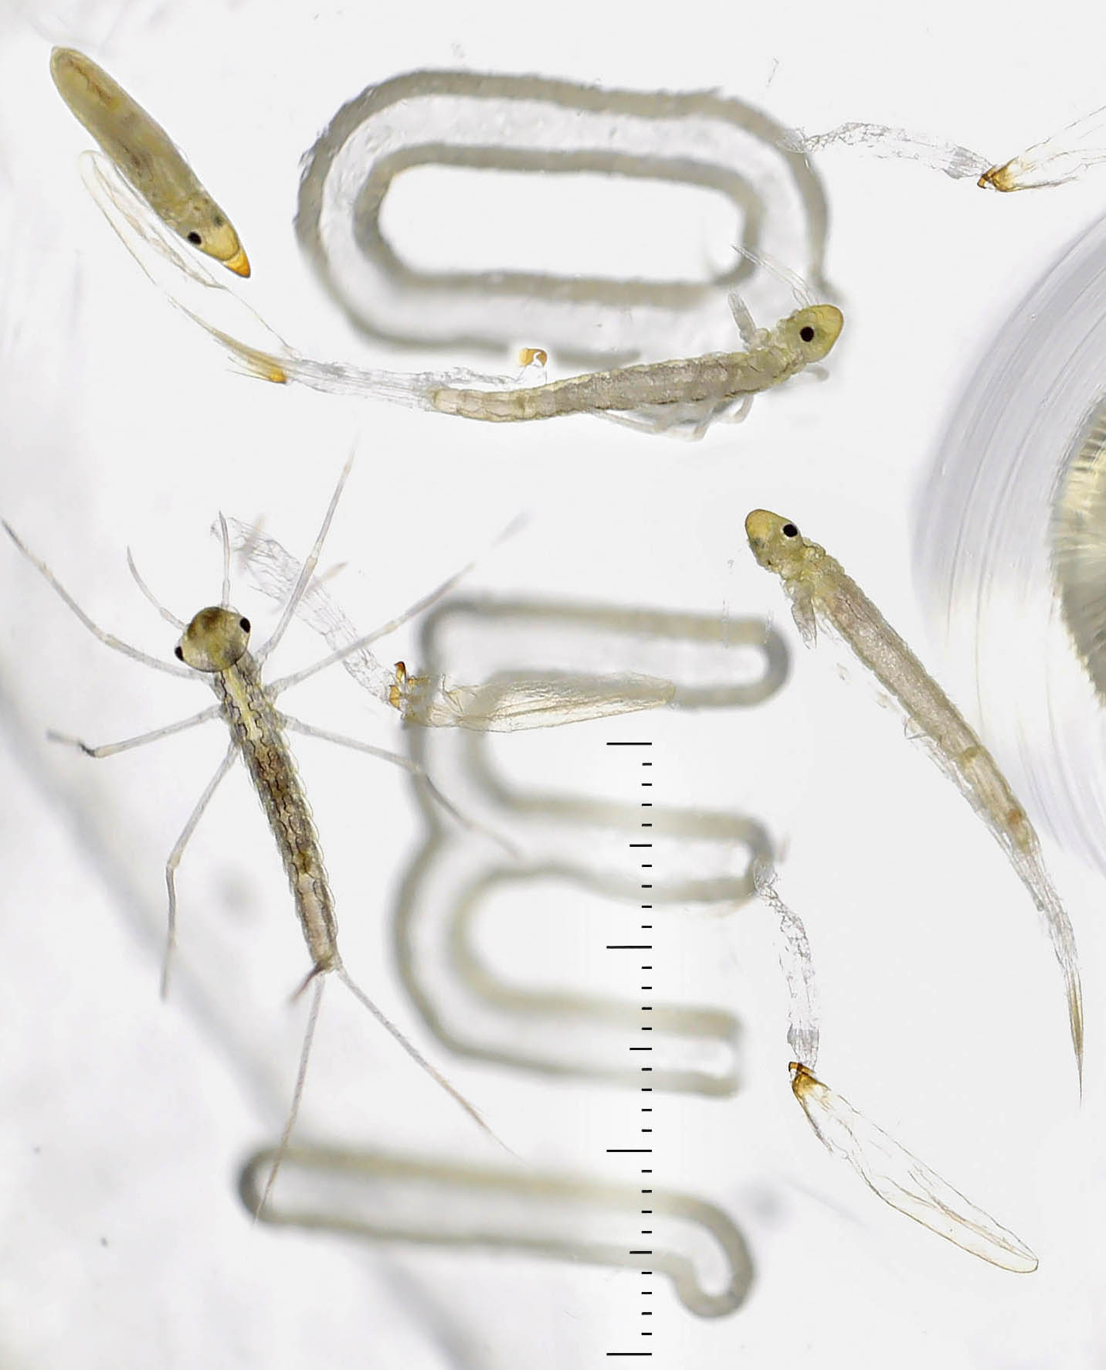
Figure S1:6. Prolarval ecdysis and second instar. Mixed incident and transmitted light.

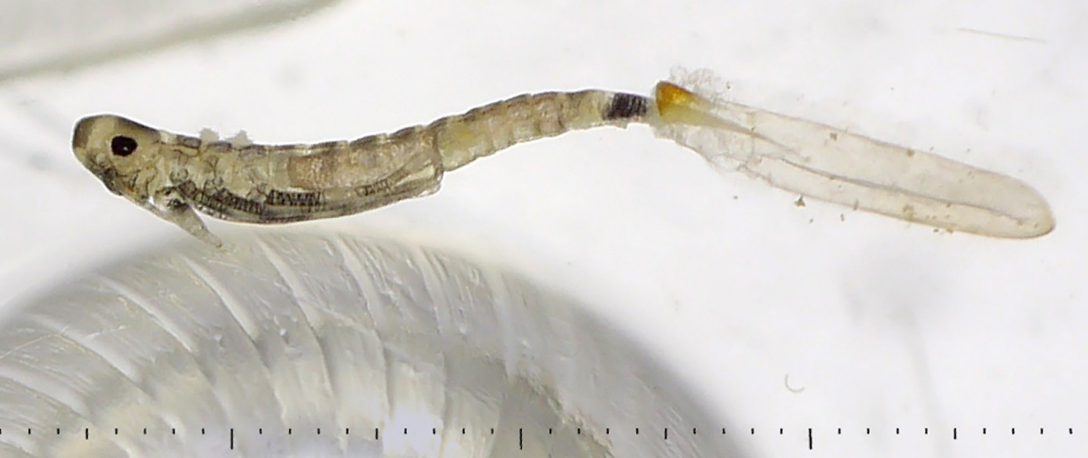

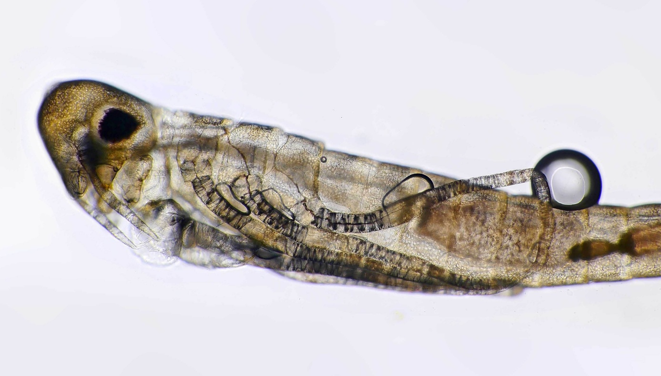
Figure S1:7. Dead, apparently unwell dark prolarva in a late hatch (14 weeks cold, LD 17:7 group, later at LD 19.5:4.5, after 80 days at 21°C, Fig. S3:2e). Mixed incident and transmitted light in macro, and transmission microscope with Nikon plan apo 10x, NA 0.40.
References
1. Ando, H. The Comparative Embryology of Odonata with Special Reference to a Relic Dragonfly Epiophlebia Superstes Selys. (The Japan Society for the Promotion of Science, Tokyo, 1962).
2. Degrange, C. L’oeuf et l’éclosion de Calopteryx virgo L. (Odonata, Zygoptera, Calopterygidae). Considérations générales sur l’éclosion des larves des odonates. Trav. Lab. Hydrobiol. Piscic. Univ. Grenoble; FR; DA 64–65, 269–286 (1972).
3. Norling, U. Constant and shifting photoperiods as seasonal cues during larval development of the univoltine damselfly Lestes sponsa (Odonata: Lestidae). Int J Odonatol 21, 129–150 (2018).

