Supplement Information 4
Observations on eggs and hatchlings from an earlier study

In a study on larval development initiated in 2013¹ some unpublished data are relevant here and described below. Egg treatment is graphically presented in Fig. S4:1. Collections, populations and methods are further described on p. 134-135 in¹.
In particular the inadvertent spring backlash experiment 3, not included earlier, is relevant. The hatched larvae were later used for a preliminary cold survival test, mimicking a brief cold snap after hatching, all at LD 16:8.
A group of eggs from population B was brought out from cold storage early on 22 January 2014, allowed to reach 18°C during the day, and kept at this temperature until mid-day of the 23 Jan, when it was decided they were not needed for larval experiments (see figure S4:1). They were then allowed to cool to 10° in the afternoon, and reached 6-7° in the morning of 24 January, when they were brought back to c. 4°C.
They were again brought out for hatching in the morning of 25 March (Exp. 3 in Fig. S4:1, time 0 in Fig. S4:2c), after two additional months of low temperatures, and slowly attained 18°C to the evening, c. 20°C during the night, and were placed in 21,5°C early on 26 March. The small larvae from this batch were subsequently subjected to low temperatures to test cold resistance. Five groups of 5 larvae were transferred to 4° for 5 (3 groups) or 10 (2 groups) days as newly hatched, 12 and 48 hours after hatching, when preparing for moulting, and as fresh third stadia. Two of the groups (fresh and 12-hour old hatchlings) were also subjected to 12 hours in ice water (0°C) during this treatment. Afterwards all larvae were tested for viability by keeping them at 21,5°C and feeding them until next moult or the termination on 11 April, when all larvae were transferred to an ordinary refrigerator at c. 3-7°C and darkness, where they were kept for another month without food.

Hatching time
Hatching in this study was always fast and synchronized (Fig. S4:2). In Experiment 1 and 2 all except single stragglers hatched between 2 and 5 days after start (during day 3 and 4, present notation), indicating that diapause termination was complete. In the bigger experiment 2, 93% hatched between 2,5 and 4,5 days, with a peak around 3 days after start (between 2.5 and 3.5 days). In Experiment 2, hatching was about 0,5 days earlier than in experiment 1.
In the partially high-temperature treated eggs in experiment 3, hatching was still earlier, mainly between 0,5 to 2,5 days, peaking around 1,5 days after start of acclimation. In addition to the 51 surviving eggs, about 12 decomposed remnants of larvae that evidently hatched or tried to hatch during the early part of the second cold period were found. It could be seen that some had hatched successfully, others not. Already after 12 hours after transfer from winter temperatures, still at 18°C during acclimation, a couple of eggs displayed a ruptured chorion, a sign of initiation of the hatching process.
No differences between photoperiods were evident, even in the early experiment 1, where eggs were immediately placed in the different photoperiods. In this experiment, with 9 weeks chilling, hatching was as fast as after 10 weeks in Fig. 3d, col. 1 and 3d, col. 4, but all eggs hatched within 7 days also in LD 16:8, indicating a higher level of diapause termination, probably from periods of 6-7°C, and from LD 16:8 in a part of the cold treatment (Fig. S4:1).
The inadvertent spring backlash experiment 3, with one day of 18°C exposure plus totally another day of transfer acclimations in January, followed by two extra months of winter temperatures, can be interpreted as follows. In the majority of eggs (n=50, plus 1 straggler), diapause was terminated, post diapause development was partly fulfilled but delayed by low temperature (quiescence), but the probably unstoppable hatching process was not yet triggered. These eggs survived the additional cold period well, and, after exposure to higher temperatures (21,5°C; first day slow acclimation to 20°C), hatching occurred 1,5 days earlier than in the previous experiment 2 (Fig. S4:2c). The first hatches were recorded within 24 hours after the start of acclimation, and, as mentioned, the first signs of the hatching process (Fig. S1:5b) were observed after 12 hours in a couple of eggs, still in acclimation. However, the previous short exposure to higher temperatures evidently had triggered the hatching process irreversibly in some of the eggs (n= c. 12), which hatched, successfully or unsuccessfully, early during the additional cold storage, with ultimately mortal consequences. Temperature may have fluctuated just around the threshold for successful hatching, which can then be assumed to be close to. 4°C. However, temperature may periodically have reached c. 6°C since it was not strictly controlled.

Cold tolerance of small larvae
The survival of the larvae in the cold treatment groups was not different from the normal experiments, only 3 of the 35 larvae, all in different groups, died 1,5-3 days after return to 21,5°C. Before termination of the experiment, 27 larvae had time to moult once or twice, showing no loss of viability. Ten days at winter temperatures, even with 12 hours in ice water included, did not seem to affect them. Even after the additional month in a refrigerator without food 6 larvae survived despite observed cannibalism, although these were no longer hatchlings.
Hatchlings at different interecdysis stages did not have any problems surviving a period of 5 to10 days at 4°C, even when including 12 hours in ice water.
The principal adaptation to short spring frosts simply seems to be cold resistance in hatchlings, and in eggs during post diapause development. Some third and fourth stadia even survived an extra month at uncontrolled low temperatures despite cannibalism. This is contrary to some previous assumptions, e.g.^{2–4}. However, the hatching process itself is probably cold sensitive, much like the process of ecdysis, which seems to require higher temperature than processes of larval development⁵.

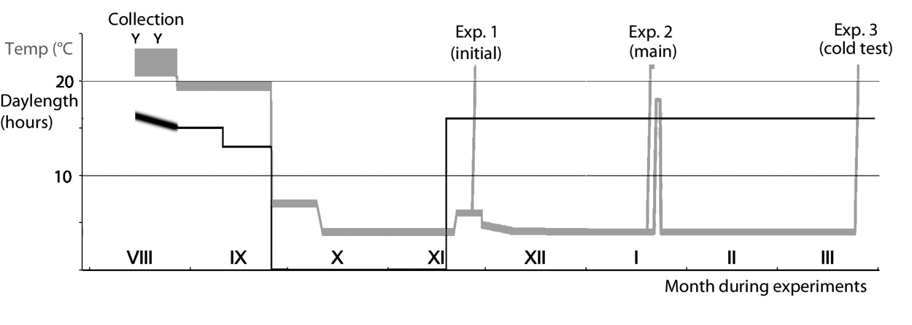
Figure S4:1. Graphical presentation of egg treatments. Temperature is shown in grey, and photoperiod (photophase) in black. The Y: s shows the collection dates for females. Note that temperatures during pretreatment were not strictly controlled, and could usually vary 1-2 degrees. Extended from¹, p. 134, where Experiment 1 and 2 are accounted for.

Day 1
a

Exp. 3. 25 March 2014. 17 weeks chill - brief 18°C - 8,6 weeks chill
Pop. “B”, roadside pond S. of Kävlinge
N=51
c
a

b
a

a
a

Exp. 2. 20 Jan. 2014. 16,7 weeks chill
Pop. “B”, roadside pond S. of Kävlinge
N=71
Exp. 1. 27 Nov. 2013. 9 weeks chill
Pop. “A”, Nöbbelövs mosse.
N= 18’
Figure S4:2. Hatching time in the different experiments on eggs from three single females. The occasion when eggs were brought out from cold storage to acclimation is shown as time 0, and hatchings are shown for the inspection interval of half a day preceding the record of the event. Specimens subsequently treated in LD 16:8 are shown in black, those in 19,5:4,5 in grey. In Experiment 2 (b), all eggs were in LD 16:8 until after the two-day inspection, the day when the first two hatchlings appeared (day 3 in present notation, day 2 in¹, where a day 0 was used). Some of the data in (a) and (b) are shown in Fig. 5 in¹.

References
1. Norling, U. Constant and shifting photoperiods as seasonal cues during larval development of the univoltine damselfly Lestes sponsa (Odonata: Lestidae). Int J Odonatol 21, 129–150 (2018).
2. Corbet, P. Dragonflies: Behaviour and Ecology of Odonata. (Harley Books, Colchester, UK, 1999).
3. Sniegula, S. & Johansson, F. Photoperiod affects compensating developmental rate across latitudes in the damselfly Lestes sponsa. Ecol Entomol 35, 149–157 (2010).
4. Sniegula, S., Golab, M. J. & Johansson, F. Time constraint effects on phenology and life history synchrony in a damselfly along a latitudinal gradient. Oikos 125, 414–423 (2016).
5. Norling, U. Life history patterns in the northern expansion of dragonflies. Adv. Odonatol. 2, 127–156 (1984).

